Gentrification in Philadelphia

# Abstract

# Introduction

This paper seeks to understand neighborhood change in Philadelphia. Neighborhoods are changing in Philadelphia, and many are gentrifying. Gentrification, “the invasion by relatively affluent households into marginal neighborhoods, with the concomitant rehabilitation of housing and the displacement of previous residents” (Beauregard 1990), has happened in cities around the United States and has been happening in Philadelphia for many years now. The “previous residents” noted by Beauregard are typically lower-income, meaning that gentrification puts a large financial burden (moving) on populations that are already financially-strained. There are policy measures that could mitigate this displacement, like tax abatements for long-term residents, if implemented correctly. Being able to predict which neighborhoods are likely to gentrify could help implement these programs in ample time so that the people who needed them could take advantage of them.

## Gentrification in Philadelphia

Although Philadelphia is the poorest of the ten largest cities in the United States [CITE - Census], 52.4% of housing units are owner-occupied (see Table 1, below). Additionally, almost 40% of all owner-occupied units in Philadelphia do not have a mortgage, which could mean that many of those homeowners are only paying monthly utility payments, making their housing very affordable. For someone living on a fixed income (social security payments, for instance) only having to pay for utilities monthly is no small thing: it could mean the difference between being able to stay in your house versus being forced to move. Affordable housing is a luxury in many parts of the United States and Philadelphia should be taking steps to preserve this relatively large stock of affordable housing through tax abatement programs to protect long-term homeowners from rising property taxes.

Table 1: Housing Characteristics, Philadelphia

|  |  |
| --- | --- |
| Total Housing Units | 671,125 |
| Occupied housing units | 86.8% (582,594) |
| Vacant Housing Units | 13.2% |
| Homeowner Vacancy Rate | 2.5 |
| Rental Vacancy Rate | 7.3 |
| Owner-occupied | 52.4% (305,214) |
| Renter-occupied | 47.6% |
| Householder moved into unit 1979 and earlier | 12% |
| Householder moved into unit 1980-1989 | 7.5% |
| Householder moved into unit 1990-1999 | 13% |
| Householder moved into unit 2000-2009 | 29.2% |
| Householder moved into unit 2010-2014 | 33% |
| Householder moved into unit 2015 or later | 5.5% |
| Median value | $147,300 |
| Owner-occupied units with a mortgage | 60.1% (183,436) |
| Owner-occupied units without a mortgage | 39.9% (121,778) |

Source: American Community Survey 2016 5-year Estimates

The following two graphs compare the number and percentage of owner-occupied units in metropolitan areas around the United States.

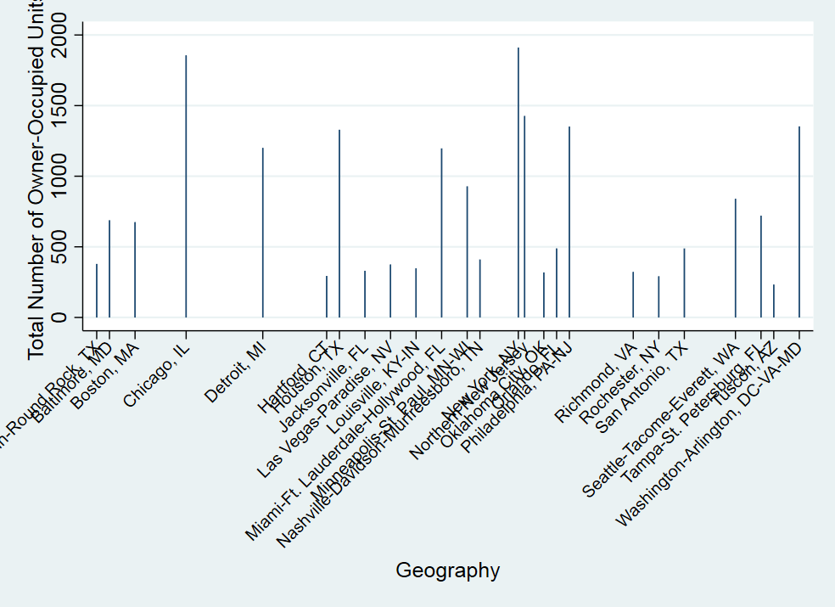

[Graph of AHS 2013 data for percent of owner-occupied housing units]

Philadelphia neighborhoods discussion?

Recent studies of gentrification in Philadelphia have focused on income, but a more precise measure of gentrification also includes education, especially post-college graduate or professional education. This paper expands on recent studies of gentrification in Philadelphia by looking at the change in educational attainment over time as an indicator of gentrification.

## The Actual Value Initiative (AVI)

Before 2013, Property taxes in Philadelphia were very low since there hadn’t been a city-wide assessment in a number of decades [CITE!] In 2013, Philadelphia reassessed all properties in advance of the Actual Value Initiative (AVI), an updated property tax program initiated in 2014. This provides a natural experiment analyzed by Ding et at (2018)

# Methodology

Stata Do File

Where my data came from (US Census, American Community Survey)

# Results

Education change 2000-2016

Graph

Map

Education change + income + house values

Graph

Map

Add in gentrification factor from Ding 2018

# Discussion

# References

Beauregard, R.A. Trajectories of Neighborhood Change: The Case of Gentrification. Environment and Planning A, 1990, volume 22, pages 855-874