**DataBase Notes**

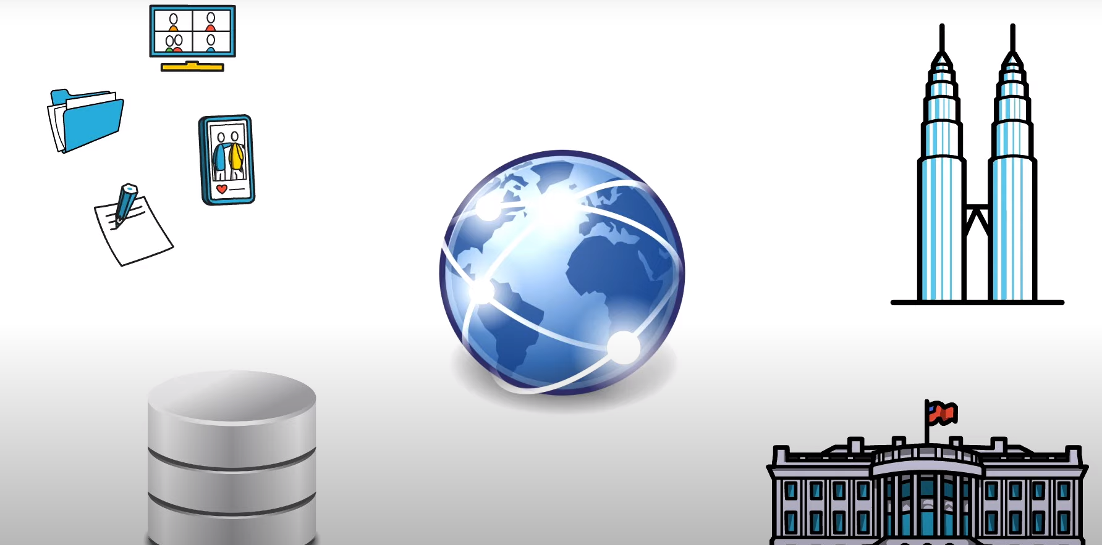

[In today's digital world data is more](javascript:;) [valuable than ever before](javascript:;)  
[data is the key to the smooth](javascript:;) [functioning of everything](javascript:;) [from a government to a local company the](javascript:;) [success of a company](javascript:;) [vastly depends on how well they utilize](javascript:;) [their data](javascript:;) [this is where database comes into](javascript:;) [picture you need a database to store](javascript:;).

[**what is**](javascript:;) **Data**

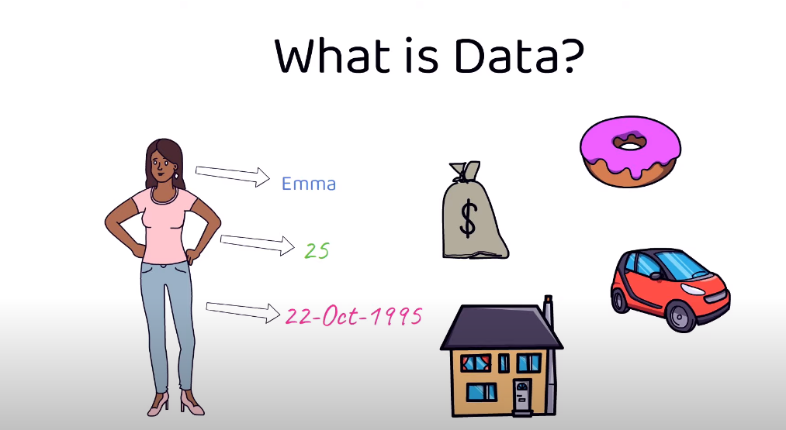

[Data can be anything and everything any](javascript:;) [information or fact](javascript:;) [can be considered as data your name](javascript:;) [age date of birth or any other](javascript:;) [information such as your house address](javascript:;) [your bank balance the vehicle you drive](javascript:;) [or even the food that you eat](javascript:;) [can be considered as data](javascript:;) [details related to a school or a](javascript:;) [technology](javascript:;)  
[or statistics or even mathematics](javascript:;) [can be considered as data and can be](javascript:;) [stored into a database](javascript:;)

[data can be in any form such as an image](javascript:;) [or a video or a file](javascript:;) [or even a plain text data in any of this](javascript:;) [format can be stored into a database](javascript:;) [for a school data can be detailed](javascript:;) [related to its teachers](javascript:;) [or its students or the subjects they](javascript:;) [teach](javascript:;) [all of these can be data as you can see](javascript:;) [data can be anything](javascript:;) [and everything and data can be in any](javascript:;) [form](javascript:;) [now that you know what data is it's time](javascript:;) [to understand](javascript:;)  
[where do we store them and the purpose](javascript:;) [of storing them](javascript:;)

[**what is database**    
  
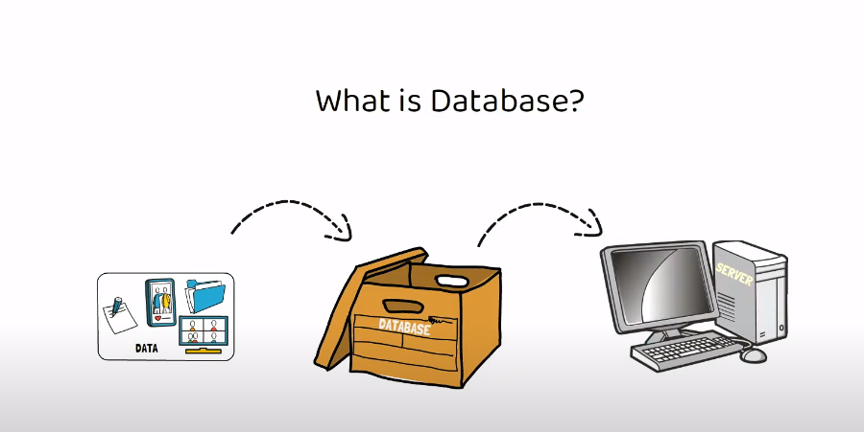  
 Database can be](javascript:;) [considered as a container filled with](javascript:;) [data or information](javascript:;)  
[which is electronically stored in a](javascript:;) [computer system](javascript:;)

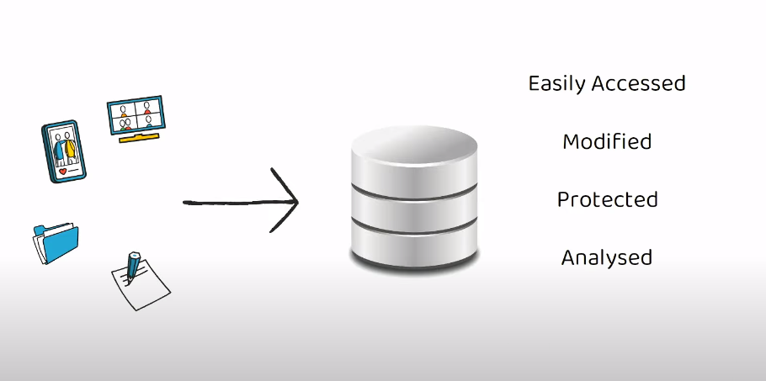  
[data in any form can be stored into the](javascript:;) [database](javascript:;) [the purpose of storing the data into the](javascript:;) [database is](javascript:;) [so it can be easily accessed modified](javascript:;) [protected](javascript:;) and analysed.

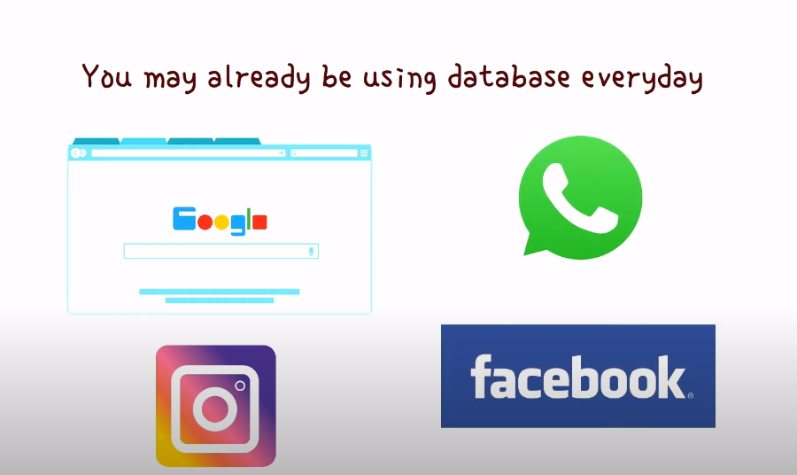

[you may already be using](javascript:;) [database](javascript:;) [in your day-to-day activities because](javascript:;)  
[most of the websites](javascript:;) [or mobile applications today such as](javascript:;) [google instagram](javascript:;)  
[whatsapp facebook already used database](javascript:;) [to store data](javascript:;).

[**Example** let's say for your college](javascript:;) demo project you plan to develop

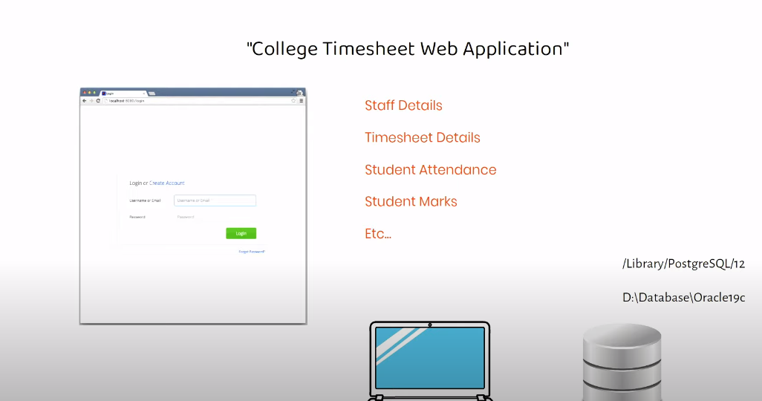  
   
[simple college timesheet web application](javascript:;) [basically this application should allow](javascript:;)  
[you to login through a url](javascript:;) [and then have options to enter staff](javascript:;)  
[details timesheet details](javascript:;) [student attendance student marks etc](javascript:;).  
[since this is a college demo project you](javascript:;) [may just use your personal computer to](javascript:;)  
[develop this project](javascript:;) [the first thing your application will](javascript:;) [need is a database to store and retrieve](javascript:;) [the data](javascript:;) [hence you need to first install a](javascript:;) [database on your laptop which will](javascript:;) [connect to this timesheet application](javascript:;) [like any other software installed on](javascript:;) [your computer](javascript:;) [database software will also be allocated](javascript:;) [to a specific location in your computer](javascript:;) [hard drive](javascript:;) [through your web application   
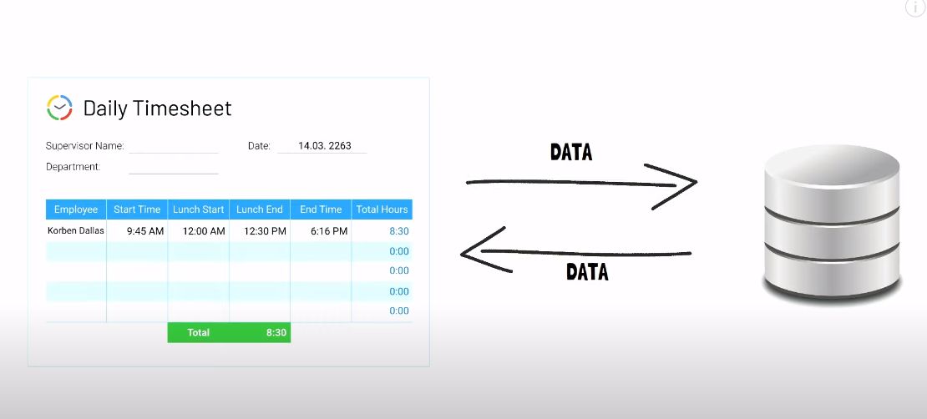  
  
  
  
whenever](javascript:;) [you try to save edit or retrieve](javascript:;) [information the application will](javascript:;)  
[actually connect to the database to](javascript:;) [store](javascript:;) [modify or extract the data in other](javascript:;)  
[words any information that is shown in](javascript:;) [your application](javascript:;) [is actually being retrieved from the](javascript:;) [database and any information you enter](javascript:;) [in the application](javascript:;)  
[will actually be stored into the](javascript:;) [database](javascript:;) [but since the database is installed on](javascript:;)  
[your computer](javascript:;) [the data is actually being stored into](javascript:;) [your computer memory](javascript:;)  
[this is a simple example of how an](javascript:;) [application uses a small database to](javascript:;) [store modify and retrieve data](javascript:;) [when it comes to bigger applications or](javascript:;) [bigger companies](javascript:;) [they need huge database to store huge](javascript:;) [data which may be installed on large](javascript:;) [servers](javascript:;) [this is true to any application that](javascript:;) [uses a database](javascript:;) [the images videos or posts or any other](javascript:;) [information that you see on Facebook is](javascript:;) [actually stored in a database](javascript:;) [and whenever you search for a specific](javascript:;) [post or friend Facebook actually](javascript:;) [searches for this data](javascript:;) [in its database so](javascript:;) [is database same as dams](javascript:;).  
  
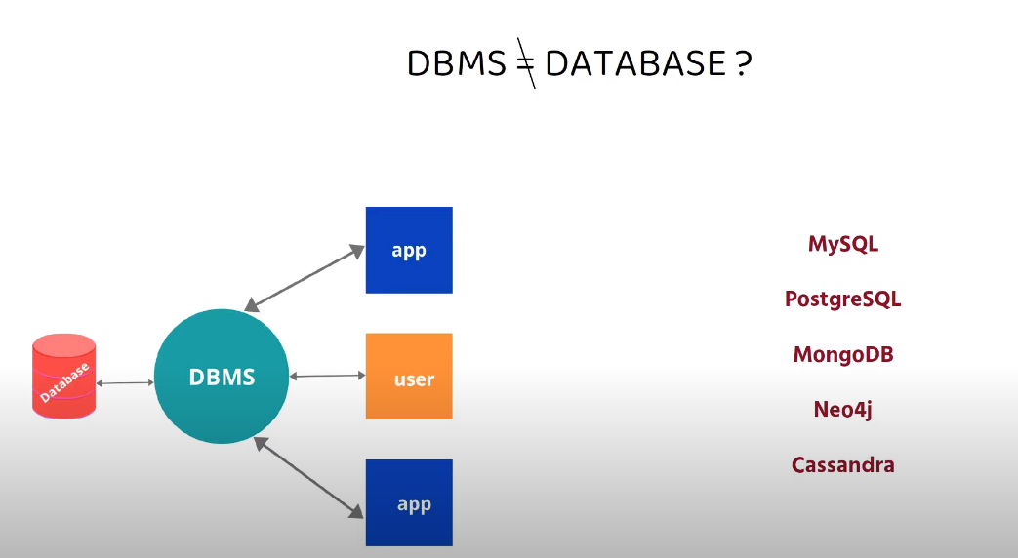  
  
  
[Lot of people referred to database as](javascript:;) [dbms](javascript:;) [but that's not entirely correct because](javascript:;) [database is just a container that stores](javascript:;) [data](javascript:;) [whereas dbms or database management](javascript:;) [system](javascript:;) [is a software which is used to manage](javascript:;) [your database](javascript:;) [you need dpms to interact with the](javascript:;) [database](javascript:;) [to store modify retrieve and protect](javascript:;) [data](javascript:;) [dbms is also required to create modify](javascript:;) [and delete database](javascript:;)  
[users like you and me can use dbms to](javascript:;) [enter commands in a specific language to](javascript:;) [interact with the database](javascript:;) [examples of dbms can be mysql](javascript:;) [postgresql mongodb neo4j cassandra etc](javascript:;)

[**Evolution of database started in 1960s**](javascript:;)  
  
  
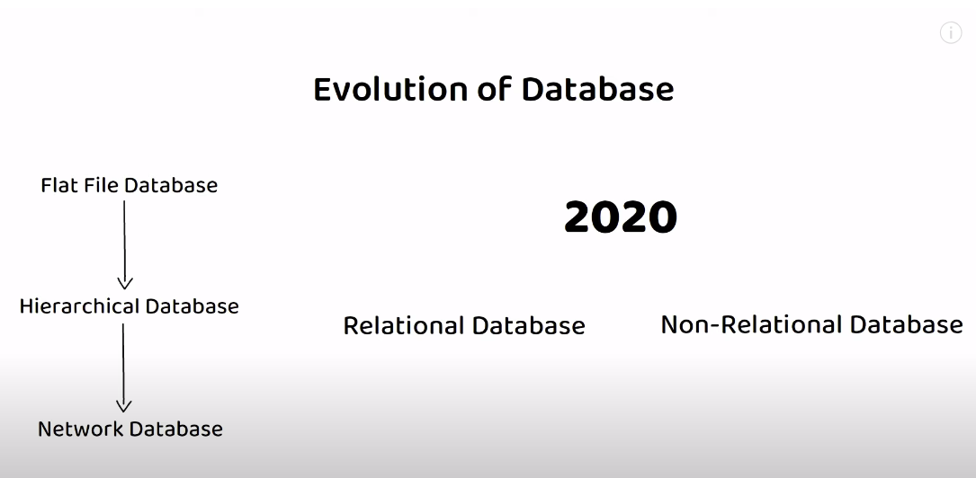  
[when the first type of database were](javascript:;) [made which was the flat file database](javascript:;)  
[here the data was stored in simple files](javascript:;) [such as csv file or fixed length file](javascript:;)  
[etc](javascript:;).

[Later on came the hierarchical database](javascript:;) [and then the network database](javascript:;)  
[both of this database stored data](javascript:;) [through parent-child relationship](javascript:;) [but both of these databases were](javascript:;) [incapable of storing complex data](javascript:;) [relationships](javascript:;) [hence were soon replaced by relational](javascript:;) [database](javascript:;) [fast forward to 2020 in today's world](javascript:;) [there are mainly](javascript:;) [two popular database types relational](javascript:;) [database](javascript:;) [and non-relational database as per the](javascript:;) [usage](javascript:;) [over 74 percent of the database used](javascript:;)  
[today](javascript:;) [are relational database but due to the](javascript:;) [immense rising data usage over the past](javascript:;) [decade mainly due to social media](javascript:;) [platforms](javascript:;) [non-relational database have become very](javascript:;) [popular](javascript:;) [however the biggest companies today who](javascript:;) [store data related to millions of users](javascript:;) [every day](javascript:;) [generally use combination of both](javascript:;)  
[relational and non-relational database](javascript:;) [hence both these database types are very](javascript:;) [popular and widely used](javascript:;) [oracle is the most widely used](javascript:;) [relational database](javascript:;) [whereas mongo dB is the most widely used](javascript:;) [non-relational database](javascript:;)

[let's briefly look at each of these](javascript:;)  
[database types](javascript:;)

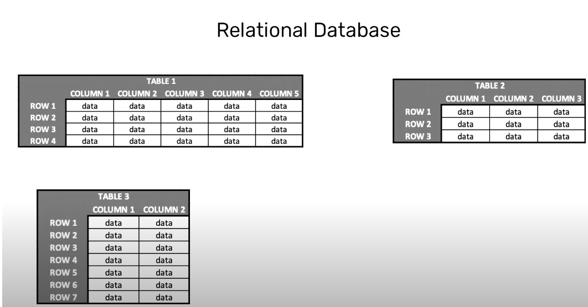

[relational database in a relational](javascript:;) [database data is stored through](javascript:;) [collection of tables](javascript:;) [these tables are related to one another](javascript:;) [each table consists of columns and rows](javascript:;) [each column has a name and a data type](javascript:;) [data type can be said](javascript:;) [as a data rule which is associated to](javascript:;) [every column](javascript:;) [only those data that satisfy this data](javascript:;) [rule can be inserted in the specific](javascript:;) [column](javascript:;) [a row can be treated as a record which](javascript:;) [is formed by single](javascript:;) [or multiple columns](javascript:;)  
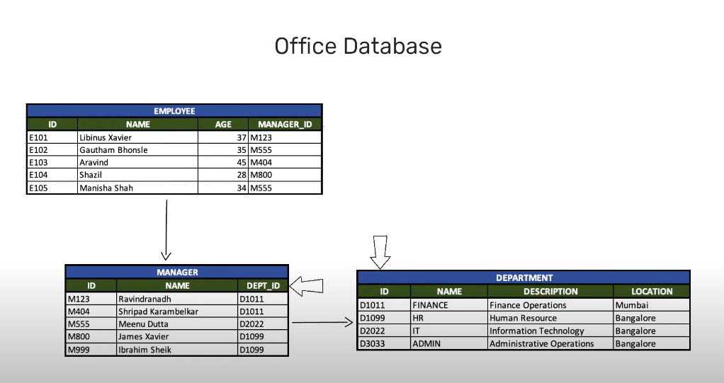

[**Example** if we consider an office](javascript:;)  
[database](javascript:;)

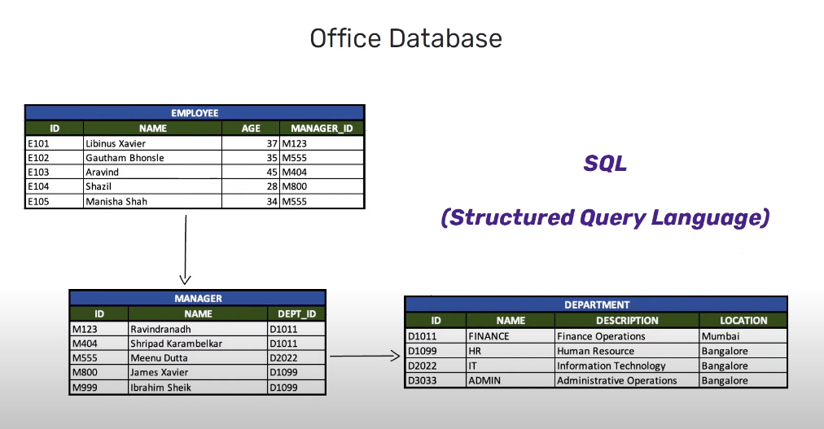  
[it will have information related to](javascript:;) [employees managers and departments](javascript:;)  
[these details are stored in different](javascript:;) [tables](javascript:;) [but these tables will be related to each](javascript:;) [other through certain columns](javascript:;) [here employee and manager table is](javascript:;)  
[related through](javascript:;) [the manager id column which is present](javascript:;) [in both these tables](javascript:;)  
[in a relational database foreign key](javascript:;) [constraint is used to form relation](javascript:;) [between different tables](javascript:;) [similarly manager and department tables](javascript:;) [are related through the department id](javascript:;) [column as you can see employee and the](javascript:;) [department table are not directly](javascript:;) [related to each other](javascript:;) [but still it is possible to fetch data](javascript:;)  
[from the employee table based on](javascript:;) [specific conditions from the department](javascript:;)  
[table](javascript:;) [this is how relational database works](javascript:;) [information is scattered across multiple](javascript:;) [tables which are related to one another](javascript:;) [hence using table relations it is](javascript:;) [possible to retrieve data](javascript:;) [from different tables in a relational](javascript:;) [database](javascript:;)



[using dbms you can enter commands in](javascript:;) [specific language to store retrieve and](javascript:;)  
[modify data](javascript:;) [this specific language is sql or](javascript:;) [structured query language sql is a](javascript:;)  
[programming language which follows a](javascript:;) [standard format for](javascript:;) [querying data across different](javascript:;) [relational database](javascript:;) [most of the financial institutions such](javascript:;)  
[as bank](javascript:;) [or insurance companies use relational](javascript:;) [database](javascript:;)

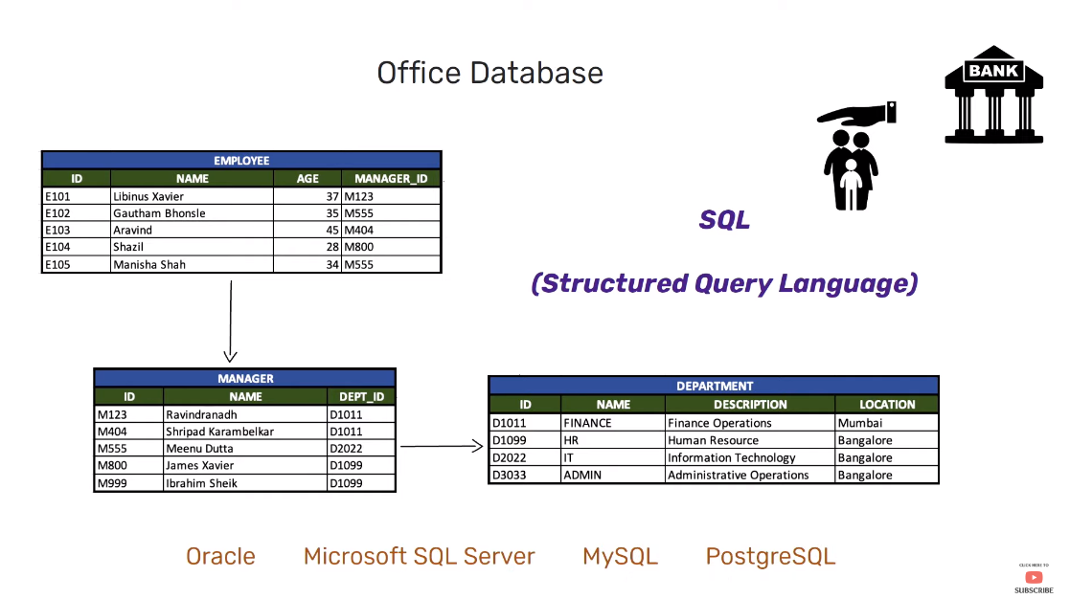  
[examples of relational database are](javascript:;) [oracle mysql](javascript:;)  
[microsoft sql server postgresql etc](javascript:;).

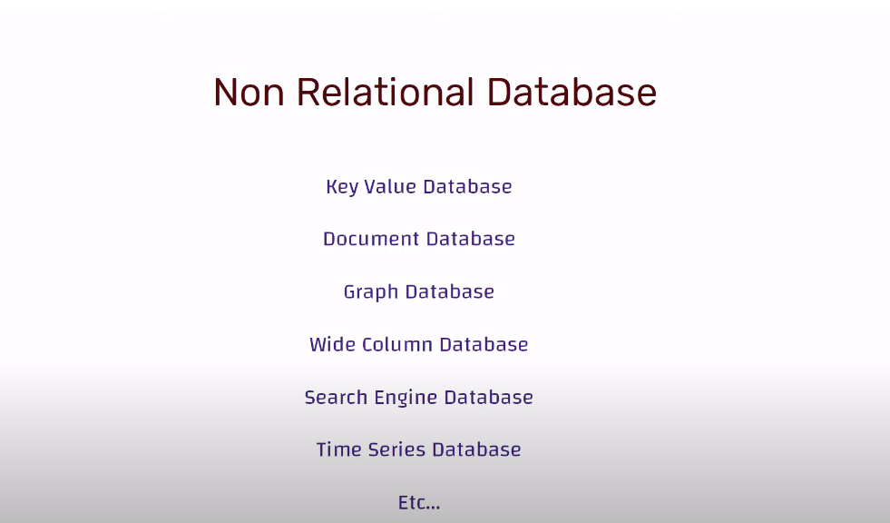  
[non-relational database when it comes to](javascript:;) [a non-relational database there are](javascript:;)  
[several categories of database](javascript:;) [such as key value store document](javascript:;)  
[database](javascript:;) [graph database wide column database](javascript:;) [search engine database](javascript:;)  
[time series database etc. each of these](javascript:;) [database](javascript:;) [store data differently and are useful](javascript:;) [for managing specific types of data](javascript:;) [let's briefly look at a few of them](javascript:;)

[**key value database**  
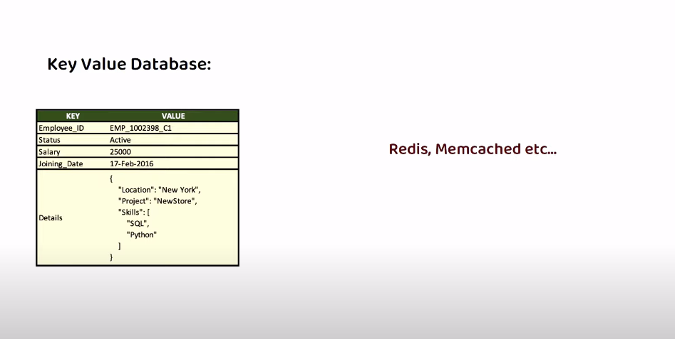  
 also called as key](javascript:;) [value store](javascript:;) [it is the simplest of the non-relational](javascript:;)  
[database and as the name suggests](javascript:;) [every data stored in this database will](javascript:;)  
[be assigned to a key](javascript:;) [to store data you provide a key and a](javascript:;) [blob of data such as an](javascript:;) [image text file json object etc](javascript:;) [once saved to retrieve the data just](javascript:;) the [key value database are very useful to](javascript:;) [store certain types of data](javascript:;) [such as configuration data state](javascript:;) [information](javascript:;) [or any data that might be represented by](javascript:;)  
[a dictionary or a hash in a programming](javascript:;) [language](javascript:;) [examples can be redis database memcache](javascript:;) [database etc](javascript:;).

**Document Database**

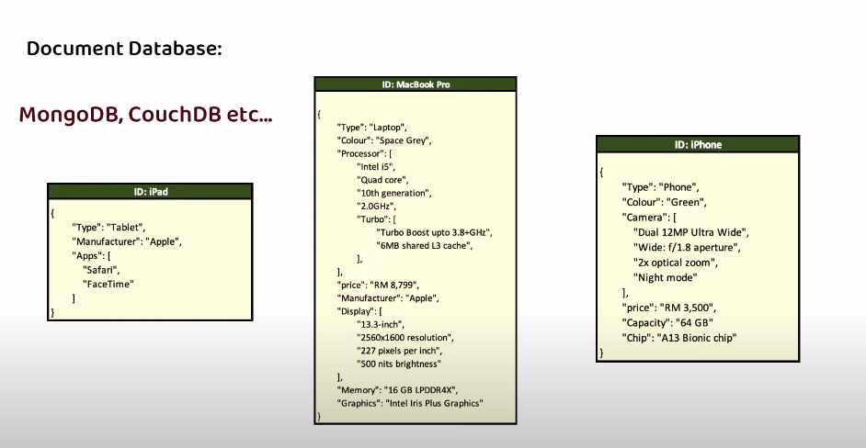  
[document database also called as](javascript:;) [document store](javascript:;) [these are these also use unique key to](javascript:;) [identify data stored in database](javascript:;) [however unlike key value store document](javascript:;) [database store](javascript:;) [data in structured format called](javascript:;) [documents often using json](javascript:;) [or xml format](javascript:;) [though each document within this](javascript:;) [database has structured data](javascript:;) [there is no specific format to be](javascript:;) [followed for all documents](javascript:;)  
[each document can have its own structure](javascript:;) [which the database understands](javascript:;)  
[so unlike key value store the data](javascript:;) [stored in document database can be](javascript:;) [queried and analysed](javascript:;) [examples can be mongo dB couch dB etc](javascript:;).

[**graph database**   
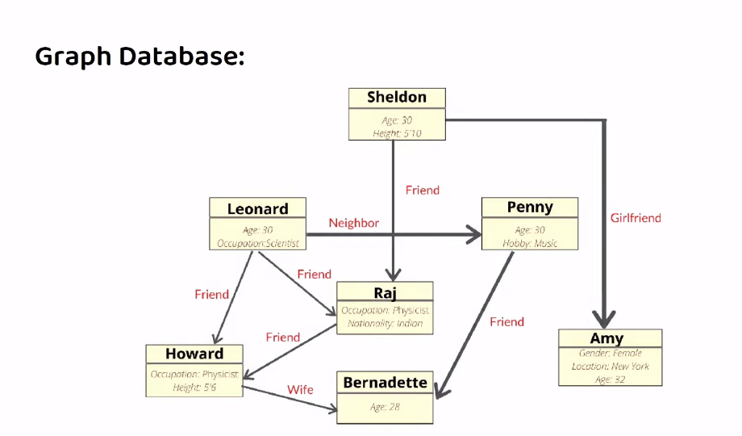  
graph database falls](javascript:;) [under the bracket of non-relational](javascript:;) [database and follows a different](javascript:;) [approach to forming relationships](javascript:;) [between data](javascript:;) [rather than using tables and foreign](javascript:;) [keys to form relation](javascript:;) [graph database forms relation by using](javascript:;)  
[nodes edges and properties](javascript:;) [data is represented through individual](javascript:;) [nodes and each node can have](javascript:;) [multiple properties between these nodes](javascript:;) [edges or relationships are established](javascript:;) [to represent different types of](javascript:;) [connections](javascript:;)  
[hence in a graph database data is stored](javascript:;) [as node](javascript:;) [and relationships are represented](javascript:;) [through edges](javascript:;) [if you are working with data where](javascript:;) [relationships or connections between](javascript:;) [data are most important](javascript:;) [then graph database is the right choice](javascript:;) [graph database is useful when searching](javascript:;) [for specific pattern like fraud](javascript:;)  
[detection through money laundering](javascript:;) [transactions etc. example can be neo4j](javascript:;)  
[database](javascript:;) [white column database also known as](javascript:;) [column family database](javascript:;) [white column database store data using](javascript:;) [rows and columns but they do not use](javascript:;)  
[tables](javascript:;) [instead of tables they use structure](javascript:;) [called as column families](javascript:;) [column families contain rows of data](javascript:;) [where each row has its own](javascript:;) [structure or schema each row comprises](javascript:;) [of unique row identifier and](javascript:;) [sets of column names and values each row](javascript:;) [can have different number of columns](javascript:;) [with different types of data examples](javascript:;) [can be](javascript:;)  
[Cassandra edge base etc](javascript:;).