POTBot
Automated Underwater Camera System

Operations Manual
Firmware Version 10

Open-Source Freeware
github.com/sdelestang/POTBot
2026

Contents

Introduction
The POTBot is an automated underwater camera and environmental monitoring system designed for use in crustacean fisheries research. It is deployed inside lobster pots (fishing traps) to record video footage of pot contents, log water temperature, and capture GPS coordinates upon retrieval.
The system operates autonomously once powered on. A conductivity-based wet switch detects immersion, triggering video recording. Upon retrieval from the water, the unit activates its GPS module to log the pot’s location. Temperature is recorded periodically while the unit remains submerged.
This manual covers software installation, firmware configuration, field deployment, data retrieval, and camera setup. It applies to POTBot firmware version 10 (PB_CodeV10).

System Overview

Hardware Components
Component | Description
Microcontroller | Adafruit ItsyBitsy M0 Express
Camera | Mobius ActionCam
GPS Module | Serial GPS (9600 baud, via Serial1)
Real-Time Clock | Gravity RTC module (I²C)
Temperature Sensor | Dallas DS18B20 (OneWire, pin A1)
Flash Storage | Adafruit SPI Flash (onboard, FAT filesystem)
Status LED | Adafruit DotStar (single NeoPixel)
Wet Switch | Conductivity-based (analog read with digital excitation)

Rear Panel Connections
The rear panel of each POTBot unit provides three connections, from left to right:
- Micro-USB for the ItsyBitsy M0 microcontroller (firmware upload and serial data access).
- Battery power connector (centre).
- Micro-USB for the Mobius camera (video file access).

Operational Flow
The diagram below illustrates the POTBot’s state machine. On power-up, the unit searches for GPS satellites to initialise the module. Once a lock is obtained, it enters a sleep/wake cycle monitoring the wet switch. Detection of water triggers video recording, followed by periodic temperature logging. When retrieved (dry), the GPS activates to record the retrieval position.
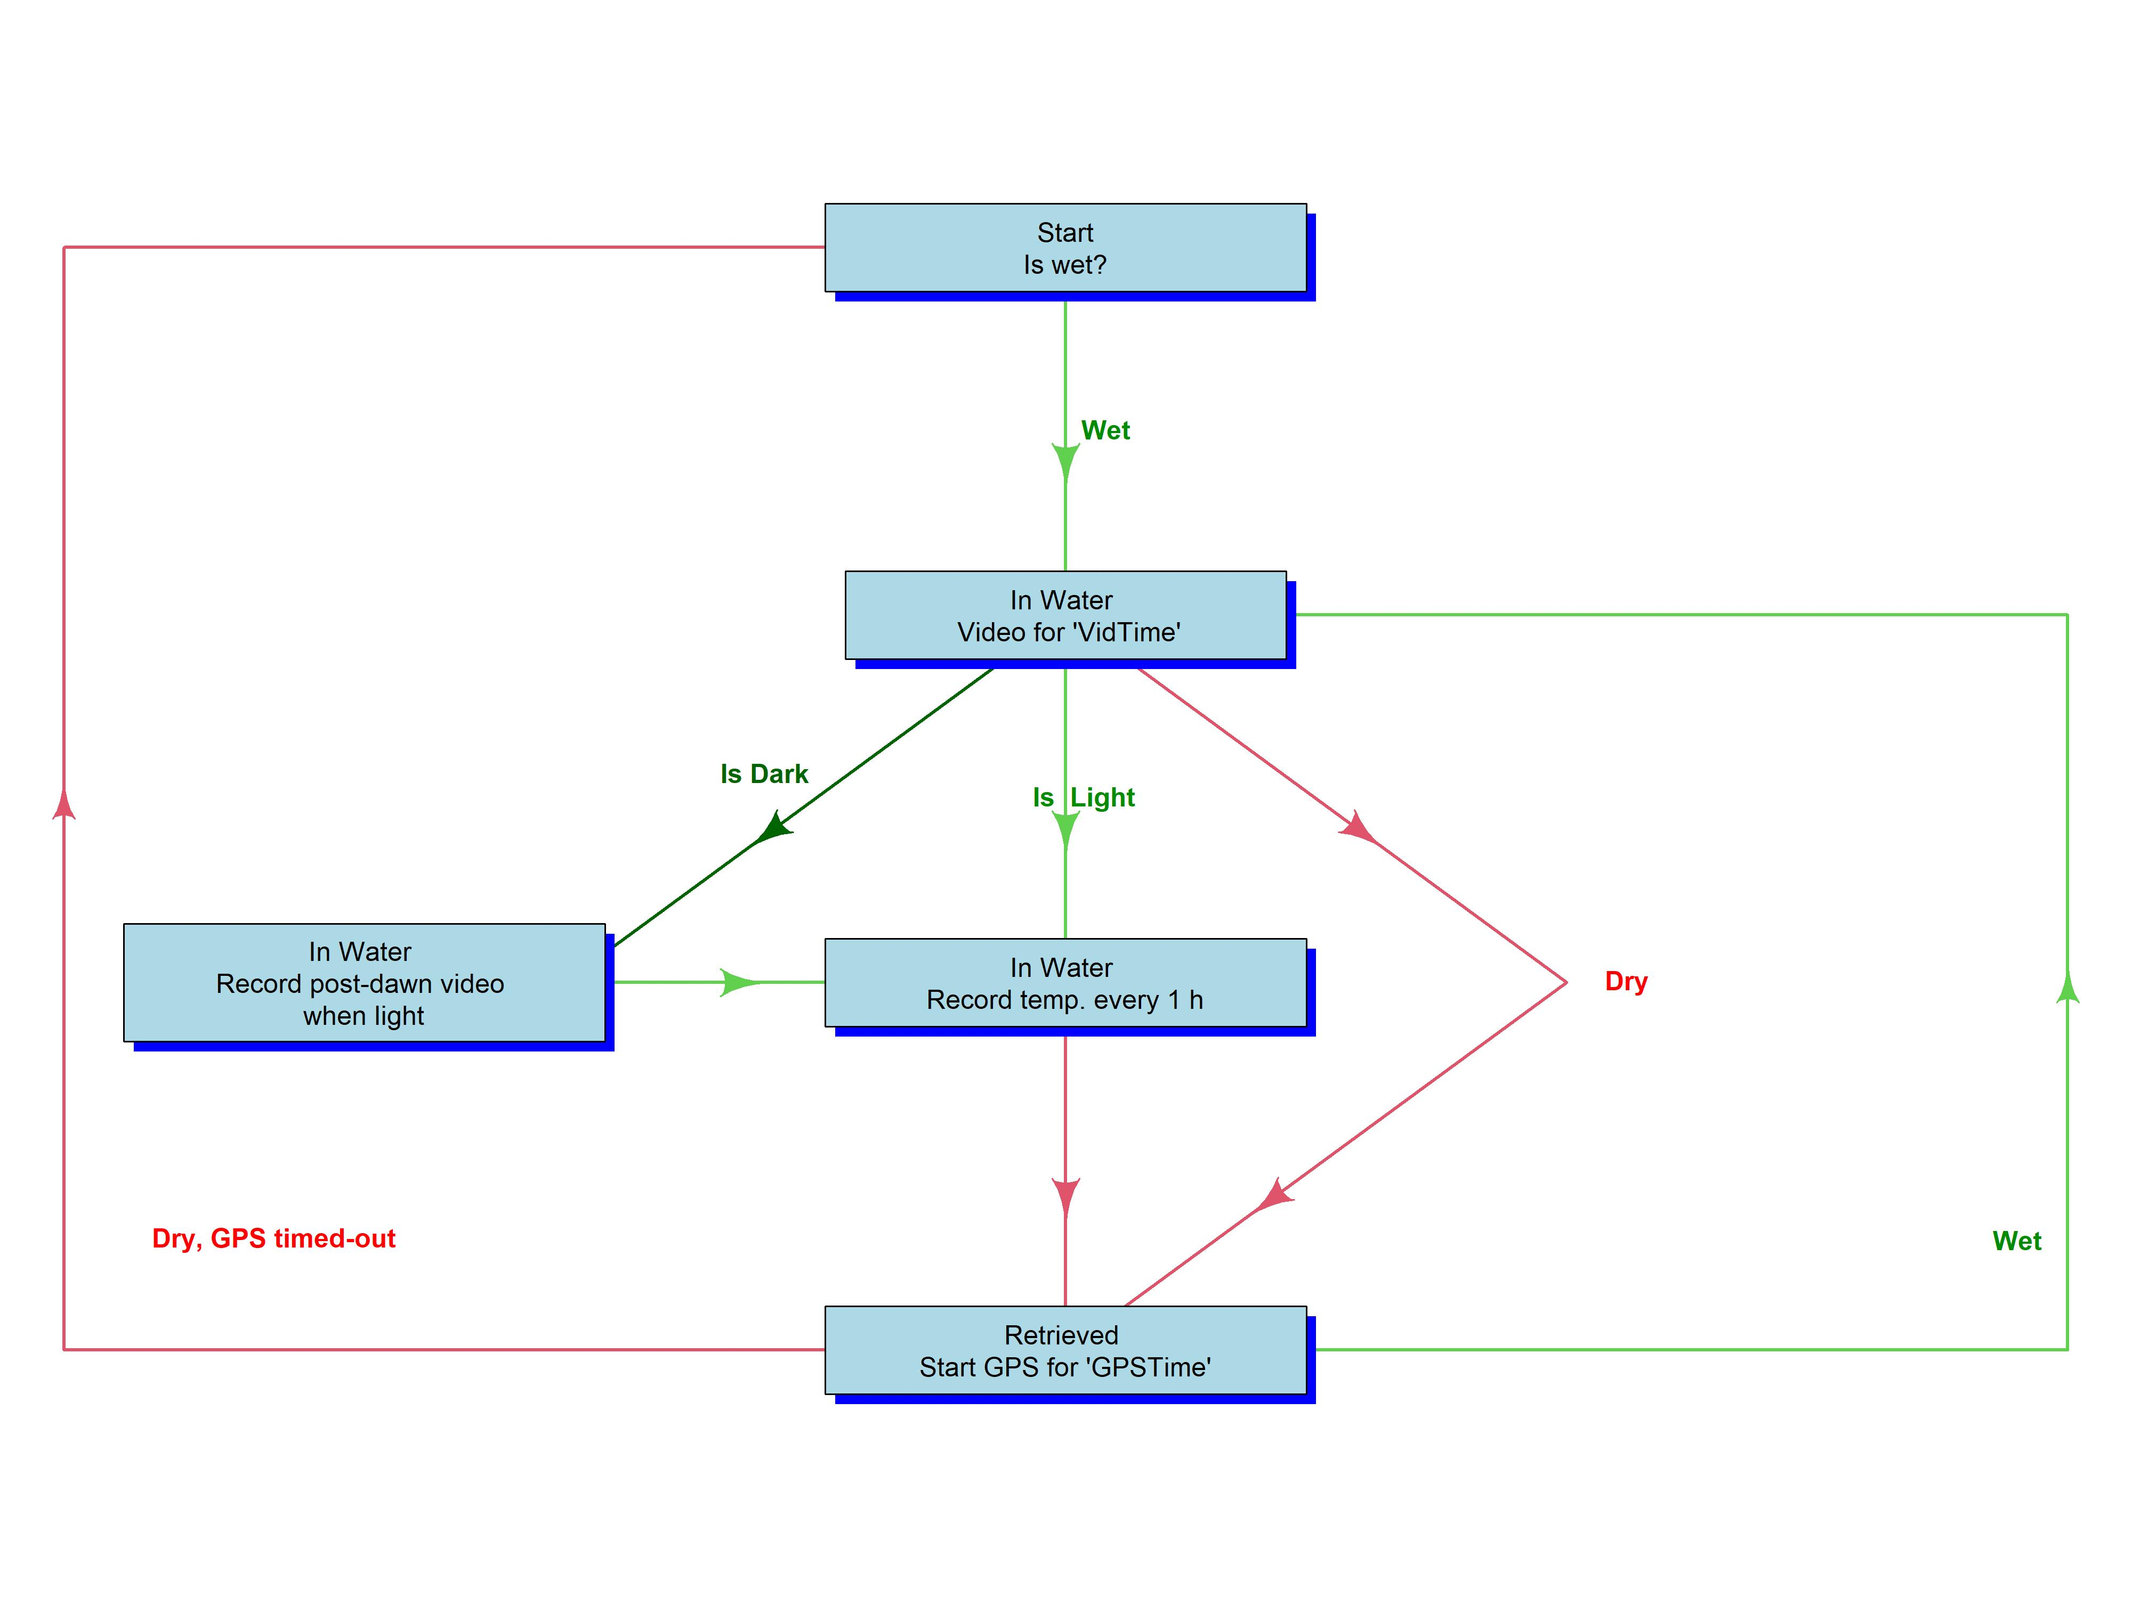
Figure 1. POTBot operational state diagram.

LED Status Indicators
The onboard DotStar LED provides visual feedback on the unit’s current state:
LED Colour | Meaning
Green (startup) | Battery voltage above 4.0 V
Red (startup) | Battery voltage below 4.0 V — charge or replace battery
Yellow | Searching for GPS satellites
Purple | GPS lock acquired
Off | Normal operation / sleep mode

Software Installation

Arduino IDE
- Download and install Arduino IDE from the Company Portal (Software Centre) or from https://www.arduino.cc.
- Launch the IDE and follow any prompts to update to the latest version. This can typically be done without administrator permissions.
Note: Board and library installation may fail if the IDE is not updated first. Always update before proceeding.

Board Support
- Open File → Preferences. In the “Additional Boards Manager URLs” field, enter: https://adafruit.github.io/arduino-board-index/package_adafruit_index.json
- Open Tools → Board → Boards Manager. Search for “Adafruit SAMD” and install the package.
- Restart the IDE. Under Tools → Board → Adafruit SAMD, select “Adafruit ItsyBitsy M0” (may appear as “ItsyBitsy M0 Express” depending on the package version).

Libraries
The following libraries must be installed via Sketch → Include Library → Manage Libraries:
- OneWire
- DallasTemperature
- Adafruit SleepyDog
- Adafruit SPIFlash (and its dependencies: SdFat – Adafruit Fork, Adafruit NeoPixel)
- TinyGPS++ (or TinyGPS depending on version)
- Adafruit DotStar (and its dependency: Adafruit BusIO)
- RTClib (required for Version 4 and later)

One additional library must be installed manually from a ZIP file: GravityRTC. This file is located at:
M:\Fisheries Research\Invertebrates Fisheries\Rock Lobster\Potbot\Version 4\GravityRTC.zip
Install via Sketch → Include Library → Add .ZIP Library and follow the prompts.
To verify installation, check File → Examples — installed libraries should appear with example sketches.

Programming the POTBot

Loading Firmware
- Open the firmware sketch PB_CodeV10.ino, located at: M:\Fisheries Research\Invertebrates Fisheries\Rock Lobster\Potbot\Version 10\PB_Code
- Disconnect the battery from the POTBot.
- Connect the POTBot to the computer using a micro-USB cable plugged into the left-hand port (ItsyBitsy board).
- Under Tools → Port, select the port with the suffix “(Adafruit ItsyBitsy M0)”.
- Verify that Tools → Board is set to “Adafruit ItsyBitsy M0”.
- Click the Upload button (right-arrow icon, top-left). The IDE will compile and then upload the firmware. Progress is shown in the status bar.
- On successful upload, open the Serial Monitor (magnifying glass icon, top-right) to verify the POTBot reports its firmware version and RTC time.

Setting the Real-Time Clock
The onboard RTC maintains accurate time even when unpowered. It only needs to be set on first use or if the time drifts significantly. The GPS will also automatically correct the RTC when a reliable fix is obtained.
To manually set the RTC:
- In the firmware sketch, locate the RTC calibration line (approximately line 113). Remove the comment markers so it reads:
rtc.adjustRtc(F(__DATE__), F(__TIME__));
- Upload the firmware. This sets the RTC to the computer’s current date and time.
- Immediately re-comment the line so it reads:
//rtc.adjustRtc(F(__DATE__), F(__TIME__));
- Upload the firmware a second time. This prevents the RTC from resetting on every power cycle.
Note: If you forget to re-comment the line, the RTC will reset to the compile time every time the POTBot restarts.

Configurable Parameters
The following parameters can be adjusted near the top of the firmware sketch (lines 88–91):
Parameter | Default | Unit | Description
VidTime | 2400 | seconds | Duration of video recording after deployment
GPSTime | 240 | minutes | Duration GPS remains active after retrieval before timeout
Dawn | 7 | hour (24h) | Start of daylight window for video assessment
Dusk | 17 | hour (24h) | End of daylight window for video assessment

Ensure each line ends with a semicolon after changing a value.

Field Deployment

Pre-Deployment Checklist
- Battery is fully charged (green LED on startup).
- SD card is inserted in the Mobius camera.
- Camera is configured correctly (see Section 8).
- Firmware is loaded and RTC time is correct.
- Previous data has been downloaded and cleared.

Deployment Procedure
- Connect the battery to the centre power connector on the rear panel.
- The POTBot will power on and display the battery status LED (green = good, red = low).
- The LED will turn yellow as the unit searches for GPS satellites. Wait for the LED to turn purple, indicating a successful GPS lock. After approximately one minute the LED will turn off and the unit is ready.
- Place the POTBot into the lobster pot. When the wet switch detects immersion, the camera will begin recording for the configured video duration.

Operational Behaviour
Once deployed, the POTBot operates autonomously through the following cycle:
- On immersion: records video for the configured duration (default 40 minutes).
- If deployed during darkness (outside the Dawn–Dusk window): a short additional video (2 minutes) is recorded once daylight is detected, to capture habitat imagery.
- While submerged: records water temperature at scheduled intervals (initially 2 hours after deployment, then at 23:00 daily).
- On retrieval (dry): activates GPS and records the first three position fixes. The GPS remains active for the configured timeout period (default 4 hours).
- If re-deployed before GPS timeout: records the last GPS position and begins a new video cycle.
- If GPS times out without re-deployment: the unit returns to its initial standby state.
Note: The RTC is automatically corrected from the GPS whenever a reliable fix is obtained with four or more satellites.

Data Retrieval

Downloading Video
- Connect a micro-USB cable to the right-hand port on the rear panel (Mobius camera).
- The camera will appear as a removable drive on your computer.
- Copy all video files to the appropriate Teams folder.
- Delete the files from the camera to free space for the next deployment.

Downloading Metadata
- Connect a micro-USB cable to the left-hand port on the rear panel (ItsyBitsy).
- Open Arduino IDE and launch the Serial Monitor (magnifying glass icon) within 7 seconds of connection.
- The POTBot will display its firmware version, RTC date/time, and begin monitoring the wet switch.
- Type Print (case-sensitive) and press Enter. The unit will output all stored deployment data.
- Select and copy all output text. Paste it into a Microsoft Word document, include the skipper name, location, and date in the title, and save to the Teams folder alongside the video files.
- Type Clear to delete all stored data from flash memory, readying the unit for the next deployment.
- Type Run to restart normal operation.

Serial Monitor Commands
Command | Action
Print | Stops the POTBot and prints all stored data (GPS positions, deployment times, temperatures) to the Serial Monitor.
Clear | Stops the POTBot and deletes all stored data from the onboard flash memory.
Run | Restarts the POTBot and resumes normal wet-switch monitoring.

Data Storage on Teams
All data and videos are stored on Microsoft Teams under:
Team Lobster / General / PotBot 2023 / Videos
Create a new folder for each deployment using the naming convention:
[LFB Number]_[DDMMYYYY]_[Camera ID]
For example, POTBot A027 deployed on 12 March 2023 to LFBF020 would be named: F020_12032023_A027

Mobius Camera Configuration
Each Mobius ActionCam must be configured before its first use with a POTBot. This only needs to be done once per camera unless settings are reset.

Setup Procedure
- Install the mSetup software from: M:\Fisheries Research\Invertebrates Fisheries\Rock Lobster\Potbot\Mobius setup\mSetup. Alternatively, download from: https://www.mytempfiles.info/mobius/
- Ensure an SD card is inserted in the camera before connecting it to the computer.
- Connect the camera via USB. In mSetup, click the camera line at the top of the window (showing “E Capacity = …”).
- On the first configuration tab, set the file system to match the SD card format. For larger SD cards, verify the file system (it may be exFAT) and select accordingly.
- On the Mode 1 tab, configure the recording settings as required for POTBot operation.
- Click “Set Parameters” to save the configuration to the camera.
Note: When configuring multiple cameras, close and reopen mSetup between each camera to avoid cross-contamination of settings.

Troubleshooting

POTBot Does Not Power On
- Verify the battery is connected to the centre port and is charged.
- Check the battery voltage: a red LED on startup indicates low voltage. Replace or charge the battery.

No GPS Lock
- Ensure the POTBot is outdoors with a clear view of the sky during initial GPS acquisition.
- The yellow LED will remain active while searching. Allow up to several minutes for a cold start.
- If the GPS consistently fails to lock, verify that the GPS module is connected to pin 5 and Serial1 is active.

Camera Does Not Record
- Confirm the Mobius camera has an SD card inserted and is properly configured (see Section 7).
- Check the camera USB connection to the POTBot mainboard.
- Verify the wet switch is functioning: connect via Serial Monitor and observe whether the POTBot detects immersion.

Serial Monitor Shows No Output
- The Serial Monitor must be opened within 7 seconds of connecting the USB cable.
- Ensure the correct COM port is selected under Tools → Port.
- Verify the baud rate is set to 9600 in the Serial Monitor.

Firmware Upload Fails
- Ensure the correct board (Adafruit ItsyBitsy M0) and port are selected.
- Disconnect the battery before uploading.
- Try double-pressing the reset button on the ItsyBitsy to enter bootloader mode.

Appendix: Pin Assignments
Variable | Pin | Function
curr_read | 0 (analog) | Wet switch: analog read for current sensing
temp_read | A1 | Dallas DS18B20 temperature sensor (OneWire)
curr_out | 11 | Wet switch: digital excitation output
curr_quite | 12 | Wet switch: reference current (held LOW)
camera | 7 | Mobius camera trigger
GPS | 5 | GPS module power control
LED | 13 | Onboard LED
pwrlsensor | 9 | Light sensor power
lsensor | A3 | Light sensor analog input
Voltage | A2 | Battery voltage monitor (via voltage divider)

