Enabling MS Word Spell checking for r.a.d.spell

Microsoft Word support is not enabled by default for r.a.d.spell. Two steps are required to enable it:

1) Copy all .dll files from RadControls/Spell/MsWordSupport to your web application’s bin directory. Those files contain the Microsoft Office Interop assemblies and the extra functionality that uses them.
2) Install and configure Microsoft Word at the server.

Microsoft Word Configuration
The Microsoft Office suite was not originally meant to run on a server machine and extra configuration is needed for the spell check to work. Most often web sites run under the ASPNET account that needs to be granted permissions to create and use the Word automation objects. The essential steps follow:
1) Create a special user that will run Microsoft Office and add it to the Administrators group.
2) Install Office under this user account.
3) Launch Word once, and open its macro editor. Using Alt-F11 should be the fastest way to do it. Close the application.
4) Run the "dcomcnfg" tool. It should be available on any Windows installation:
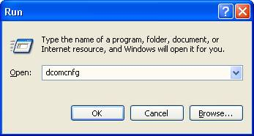
5) Edit the default access and launch permissions. This will affect all registered COM objects.
Go to the properties for the My Computer object:
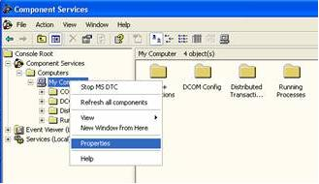
Select the Default COM Security tab:
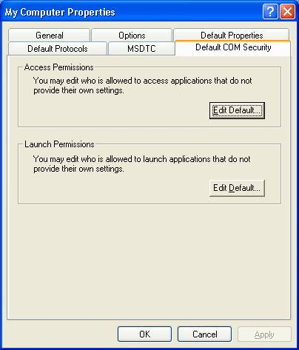
Grant access to the following users:
- SYSTEM
- INTERACTIVE
- Everyone
- Administrators
- OfficeAutomationUser
- IUSR_<machinename>*
- IWAM_<machinename>*
6) Find the "Microsoft Word Document" object in the list of registered COM objects:
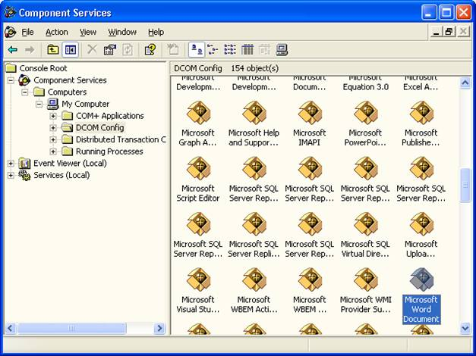
Right click it and edit its permissions. Go to the Identity tab and select the user identity that Word should run under. It is essential that you select the account under which you installed Office:
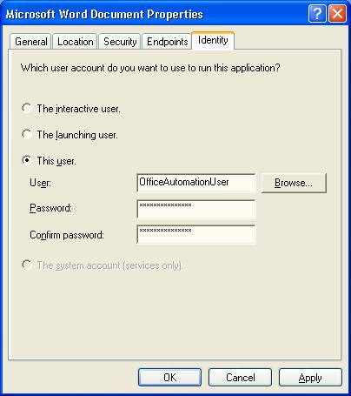
The steps are described in more detail in an official Microsoft knowledge base article – 288367, available
http://support.microsoft.com/default.aspx?scid=http://support.microsoft.com:80/support/kb/articles/q288/3/67.asp&NoWebContent=1.

