Data Processing

The raw data data produced by the Physics toolbox application consists of csv files with 4 columns: time, ax, ay, az , aT. The columns ax, ay, az are linear accelerations in the x, y, and z direction and aT is the vector sum calculated with the following equation. .

Most of the data contained large stretches of near zero acceleration due to the pause before performing an action and the delay before stopping data recording. Each csv file containing a particular action requires trimming near the beginning and the end. Each action has an approximate time duration of less than two seconds. In order to find the window of time to trim, the max value of the vector sum is computed. From the max value of the vector sum, we only keep the data from +/- 0.9 time frames of the time where the max vector sum occurs. See the figure below for the time versus acceleration graph of before and after data processing.

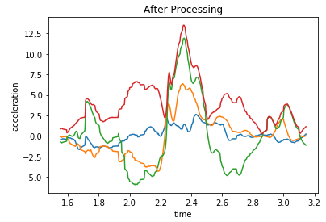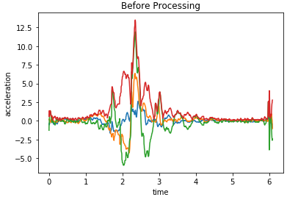

After processing each csv file for each action, the average acceleration in the x, y, z direction is calculated along with the average vector sum. Additionally, the maximum values of vector sum and acceleration in x, y ,z direction was extracted as well. The values obtained was then stored in a pandas dataframe as a row. Each dataframe created represented an action: fall, sit, lie down, or drop. Each row of each dataframe represents a sample of an action.

Analysis of Variance Test

An ANOVA test was performed on each of the various attributes collected from the data processing. Each of the averages of acceleration in each direction: x ,y ,z and averages of vector sum of each action was tested. Therefore 4 separate ANOVA tests were performed to determine if there was a difference in the means of each separate action for each attribute. Additionally, the same was performed for max values for a total of 8 separate ANOVA tests. The results of each of the 8 ANOVA tests produced a p-value significantly lower than 0.05. Therefore, the means of the tested attributes for each actions have some significant differences.

Post Hoc Analysis

Due to the significance of the 8 ANOVA tests, 8 separate post hoc analysis were performed to complement the ANOVA tests. For the testing of average vector sums, it was found that dropping our data collector (phone) and falling as similar means. This is expected as the two actions have similar linear acceleration graphs. For the average acceleration in the x direction, drop vs fall and fall vs lie have similar means. The remaining data regarding the fall action versus other actions against the remaining attributes resulted in significant differences in means.

This Post Hoc Analysis revealed that it could be possible to identify a falling action versus siting and lying down. However, it may be difficult to differentiate between dropping a phone and falling.