Quantum-Inspired Dynamic Decision-Making (QIDDM): A Superposition-Based Framework for Multi-Criteria Capacitated Supplier Selection

Abstract
Multi-criteria resource allocation in dynamic supply networks is a computationally hard problem in which classical decision-analysis methods and population-based metaheuristics suffer either from rigid linear aggregation or from premature convergence. Recent quantum-inspired evolutionary algorithms have improved exploration through superposition and phase rotation, yet they typically use static rotation schedules and a scalar fitness, leaving the multi-criteria structure of real-world supplier selection unexploited. This paper proposes Quantum-Inspired Dynamic Decision-Making (QIDDM), a hybrid framework that represents candidate decisions as a population of quantum bits in superposition, evolves them through a dynamic phase-rotation gate whose magnitude adapts to landscape feedback, and modulates rotations through a multi-criteria interference vector that biases search towards weak criteria of the current best. A criteria-guided local-search step intensifies the most promising regions, while a Q-NOT mutation operator preserves probabilistic diversity. The framework is evaluated on three benchmark instances of a Multi-Criteria Capacitated Supplier Selection Problem (MC-CSSP) of increasing scale (N = 20, 40, 80 candidates) augmented with non-linear synergy, risk and diversification terms, and compared against TOPSIS, AHP, a binary Genetic Algorithm and a discrete Particle Swarm Optimizer over twenty independent runs per stochastic method. QIDDM achieves the highest mean utility on the medium and large instances (0.6485 and 0.6792 versus 0.6403 and 0.6713 for the best baseline), the lowest variance (σ ≤ 0.002), and converges in fewer than half the iterations of GA and PSO. Mann–Whitney U tests confirm the improvements are statistically significant at p < 0.001. The results support quantum-inspired dynamic decision-making as a competitive paradigm for high-dimensional, conflict-laden allocation problems.

Keywords
Quantum-inspired computing; dynamic decision-making; multi-criteria optimization; supplier selection; metaheuristics; superposition; phase rotation; resource allocation.

1. Introduction
Resource allocation under conflicting criteria is a recurring task in modern supply networks, healthcare logistics and cloud-orchestration systems. The decision-maker must select a subset of candidate sources (suppliers, servers, providers) that jointly satisfies aggregate demand while balancing cost, quality, lead-time and reliability — quantities that typically pull the choice in opposite directions. Classical Multi-Criteria Decision Analysis (MCDA) techniques such as the Technique for Order Preference by Similarity to Ideal Solution (TOPSIS) and the Analytic Hierarchy Process (AHP) offer transparent, interpretable rankings, but they assume linear-additive utility and treat each alternative independently, ignoring pairwise synergies, diversification effects and bottleneck constraints that are pervasive in practice (Chai et al., 2013; Govindan et al., 2015; Tramarico et al., 2025).
Recent supplier-selection research has responded to these limitations with hybrid frameworks that integrate fuzzy reasoning, goal programming and chance-constrained risk modelling (Yousefi Babadi et al., 2025; Asadi et al., 2025; Messaoudi et al., 2025; Vitrano et al., 2025), and with machine-learning-augmented MCDA pipelines that condense criteria and learn data-driven weights (Gidiagba et al., 2025). These approaches improve robustness under uncertainty but remain anchored in classical search and do not exploit the parallelism inherent in probability-based exploration.
Population-based metaheuristics — most prominently the Genetic Algorithm (GA) and Particle Swarm Optimization (PSO) — overcome the linear-additivity assumption but tend to converge prematurely on rugged, multi-modal landscapes and provide little decision-theoretic guidance during the search. Quantum-inspired evolutionary algorithms (QEA), introduced by Han and Kim (2002) and surveyed by Zhang (2011), partly address this limitation by representing candidate solutions as quantum bits in superposition, thereby maintaining a probability distribution over the binary search space rather than a single discrete point. Recent comparative studies confirm that quantum-inspired variants such as QPSO, QIGA and QEA consistently improve convergence speed and global optimality on benchmark functions (Kaur, 2025), and a systematic review of quantum and quantum-inspired methods in transport and logistics documents performance gains over classical heuristics across vehicle routing, scheduling and network design (Liu et al., 2025).
Two threads of work are particularly close to ours. Zhang (2025a) proposes Quantum Superposition Interference Guided Optimization (QSIGO) that combines superposition with a phase-driven heuristic and a quantum interaction interference matrix, and Zhang (2025b) extends the idea to an algorithm inspired by quantum-information-material properties (entanglement attraction, topological barrier protection, tunnelling perturbation). Both works establish that phase-rotation guided amplitudes outperform single-trajectory heuristics on continuous benchmarks but stop short of (i) decision-theoretic feedback that adapts rotation magnitude to landscape progress, (ii) explicit multi-criteria coupling, and (iii) constrained discrete formulations such as cardinality-constrained supplier selection.
This paper extends the quantum-inspired evolutionary line in three directions that are critical for real-world allocation problems. First, the rotation magnitude is made dynamic — it shrinks as improvements accumulate and re-expands when the best-so-far utility stagnates, mimicking the exploration / exploitation trade-off recommended by dynamic decision theory (Edwards, 1962; Brehmer, 1992; Suneel Kumar et al., 2025). Second, the rotation phase is modulated by a multi-criteria interference vector that pushes the population toward positions which strengthen criteria currently underrepresented in the global best, addressing the multi-criteria gap left by single-objective QEA variants and aligning with recent multi-objective quantum-inspired tabu searches (Jiang et al., 2025; Chou et al., 2025) and variational multicriteria quantum optimisers (Turkalj et al., 2025). Third, the framework targets a cardinality-constrained, non-linear supplier selection problem in which classical MCDA methods are provably sub-optimal, providing a clean experimental ground for benchmarking. The resulting framework — Quantum-Inspired Dynamic Decision-Making (QIDDM) — is evaluated against TOPSIS, AHP, GA and PSO on three benchmark instances of a Multi-Criteria Capacitated Supplier Selection Problem (MC-CSSP) augmented with non-linear synergy, risk-variance and diversification effects.
The contributions of this paper are:
(i) a novel quantum-inspired metaheuristic with adaptive rotation and criteria-aware interference, embedding dynamic decision-theoretic feedback directly into the rotation gate; (ii) a benchmark formulation for MC-CSSP that captures synergy, diversification, risk and bottleneck lead-time, breaking the analytical optimality of greedy top-K MCDA ranking; (iii) a comprehensive empirical study comparing QIDDM with TOPSIS, AHP, GA and PSO over 20 independent runs per stochastic method on three instance sizes, including Mann–Whitney U significance testing; (iv) open-source code and reproducible scripts for the entire experimental pipeline, supporting the call for standardised benchmarks in quantum-inspired logistics optimisation (Liu et al., 2025; Osborne, 2026).

2. Related Work

2.1 Classical Multi-Criteria Supplier Selection
TOPSIS (Hwang and Yoon, 1981) and AHP (Saaty, 1980) remain the most widely deployed tools in supplier selection because of their interpretability and low computational cost. Surveys by Chai et al. (2013) and Govindan et al. (2015) show, however, that purely additive aggregation fails when criteria interact or when feasibility constraints couple the alternatives. Recent extensions integrate fuzzy reasoning, goal programming and chance-constrained risk modelling: Yousefi Babadi et al. (2025) combine lexicographic goal programming, AHP and two-stage logarithmic goal programming under interval weights for sustainable and resilient UAV-supply selection; Asadi et al. (2025) embed Industry 5.0 pillars in a stochastic-fuzzy BWM/TOPSIS pipeline solved by lexicographic Chebyshev multi-choice goal programming; Messaoudi et al. (2025) use chance-constrained goal programming with Value-at-Risk to design resilient supplier portfolios; Vitrano et al. (2025) propose a Best-Worst-Method / linear-programming model for modified-rebuy decisions; and Tramarico et al. (2025) integrate MCDA with risk evaluation for circular supplier selection. Gidiagba et al. (2025) augment MCDA with non-negative matrix factorisation and random-forest weighting. While robust, these methods remain anchored in classical search and largely treat each alternative independently.

2.2 Metaheuristic Approaches to Supplier Selection
Population-based metaheuristics relax the linearity assumption: Sevkli et al. (2008) hybridise GA with AHP, Yeh and Chuang (2011) use multi-objective GA for green partner selection, and Kennedy and Eberhart (1997) introduced the binary PSO that underpins the discrete PSO baseline used here. More recent work couples reinforcement learning with multi-objective evolution (Chanona, 2025) and tackles stochastic risk-averse closed-loop supply-chain design (Mohammed et al., 2025). These methods handle non-linear utilities but provide little decision-theoretic guidance on the exploration–exploitation balance.

2.3 Quantum-Inspired Evolutionary Algorithms
Quantum-inspired evolutionary algorithms originate with Han and Kim (2002) for the 0/1 knapsack and have been surveyed comprehensively by Zhang (2011). The empirical study of Kaur (2025) compares QEA, QPSO, quantum-inspired GA and quantum simulated annealing on benchmark functions and reports that QPSO consistently delivers faster convergence while QEA excels on discrete combinatorial problems — supporting the choice of GA, PSO and a Han-Kim style rotation gate as the relevant baseline family. Schwenzow et al. (2025) design a hybrid quantum genetic algorithm for parallel-machine scheduling with sequence-dependent setup times, demonstrating that the quantum advantage in selection grows with population size. The two papers closest to ours are by Zhang (2025a, 2025b): QSIGO uses superposition with a phase-driven heuristic and an interaction interference matrix, and the Quantum-Information-Material-Inspired algorithm couples amplitude-phase control with entanglement attraction, topological barrier protection and tunnelling perturbation. Both establish the value of phase-rotation guided amplitudes but neither incorporates decision-theoretic feedback on rotation magnitude nor multi-criteria interference, and both are evaluated on continuous benchmarks rather than constrained discrete supplier-selection problems.

2.4 Quantum and Quantum-Inspired Methods in Supply-Chain Optimisation
Beyond evolutionary search, the quantum-optimisation landscape spans QAOA-based hybrid pipelines (Osborne, 2026; Riofrío et al., 2025), QUBO formulations executed on Coherent Ising Machines for multi-period SKU allocation (Anonymous, 2025c), Benders-decomposed quantum-classical unit commitment (Habib et al., 2025), variational quantum algorithms for multicriteria optimisation (Turkalj et al., 2025), and hybrid quantum–classical resource allocation in cloud and travel procurement (Kalpana et al., 2025; Waditwar, 2025). Quantum-inspired models have also been applied to portfolio optimisation through multi-objective tabu search with hierarchical directional strategies (Jiang et al., 2025; Chou et al., 2025), to robust supply-chain design via the Linear-Quadratic Gap framing (Sharma et al., 2026), to quantum game theory for cloud allocation (Bandyopadhyay et al., 2025), and to supply-chain dynamics via the Sharon Waves Theory (Sharma and Saluti, 2025). Suneel Kumar et al. (2025) propose Quantum-Inspired Reinforcement Learning for real-time decision-making, sharing our interest in dynamic feedback but operating in a Markov-decision framework rather than an evolutionary one. The systematic review of Liu et al. (2025) catalogues fifteen peer-reviewed studies on quantum and quantum-inspired methods in transport and logistics and identifies four recurring barriers: hardware limitations, data availability, energy inefficiency and organisational readiness — together with the absence of standardised benchmarks. Volpe et al. (2025) and Muralidhar et al. (2025) provide complementary roadmaps for adopting quantum optimisation in industrial supply chains.

2.5 Research Gap
Despite this rapid expansion, three gaps remain. First, almost all quantum-inspired evolutionary methods use a static rotation schedule and a single-objective fitness — they do not embed dynamic decision-theoretic feedback that adapts the rotation magnitude to the landscape's improvement signal. Second, the multi-criteria structure of supplier selection (cost / quality / lead-time / reliability with synergy and risk interactions) is rarely exploited inside the search operator: existing QEAs aggregate criteria into a scalar fitness, discarding the per-criterion information that could guide exploration. Third, recent reviews (Liu et al., 2025; Osborne, 2026) explicitly call for reproducible benchmarks where quantum-inspired methods are compared against strong classical baselines under controlled experimental protocols. QIDDM addresses all three gaps simultaneously by introducing dynamic phase-rotation feedback, multi-criteria interference modulation and a fully reproducible non-linear MC-CSSP benchmark suite.

3. Problem Formulation: MC-CSSP
Let N candidate suppliers be indexed by i ∈ {1,…,N}, each characterised by unit cost cᵢ, quality qᵢ, lead time ℓᵢ, reliability rᵢ, capacity κᵢ and sector class sᵢ. Let S ∈ ℝ^{N×N} be a symmetric synergy matrix with zero diagonal. The decision variable x ∈ {0,1}^N satisfies the cardinality constraint ∑ xᵢ = K and the capacity constraint ∑ κᵢ xᵢ ≥ D, where D is aggregate demand.
Each criterion is min-max normalised to a benefit-oriented [0,1] scale ñⱼ. The objective combines a linear MCDA core (with the lead-time component replaced by a worst-case bottleneck transform), a pairwise synergy term, a risk penalty proportional to the variance of the selected suppliers' reliability, a sector diversification bonus, and a saturating capacity-buffer reward:
U(x) = wᵀ ñ̄(x) + γ_S · (xᵀ S x)/(K(K−1)) − γ_R · Var(rᵢ | xᵢ=1) + γ_D · |unique sectors|/n_sectors + γ_C (1 − exp(−3·buffer)).
The synergy and risk terms make the landscape multi-modal and break the analytical optimality of greedy top-K ranking, motivating the use of population-based search.

4. Proposed Framework: QIDDM

4.1 Quantum Bit Representation
Each chromosome is a vector of N q-bits (αᵢ, βᵢ) with |αᵢ|² + |βᵢ|² = 1. The probability of selecting position i on measurement is |βᵢ|². A population of P chromosomes is maintained, providing implicit diversity through the amplitude distribution.

4.2 Multi-Criteria Warm Start
The initial amplitudes are biased by the criteria-weighted scores wᵀ ñᵢ so that the superposition concentrates around plausibly good regions, then perturbed lightly to recover population diversity. This shortens the cold-start phase typical of QEA.

4.3 Dynamic Phase-Rotation Gate
At iteration t the rotation magnitude is
θₜ = θ_max · exp(−λ t / T) + θ_min + ½ θ_max · 𝟙[stagnation > 5]
The first term implements an exponential cooling schedule; the indicator term re-injects exploration whenever the best utility fails to improve for five consecutive iterations — a direct decision-theoretic feedback signal. The rotation direction follows the standard Han–Kim look-up table.

4.4 Multi-Criteria Interference Modulation
Let g be the current global best and ñ̄(g) its mean normalised criteria vector. The criteria-weakness vector is w_weak ∝ 1 − ñ̄(g). Each candidate position i is assigned an interference value Iᵢ = 2·rescale(ñᵢ · w_weak) − 1 ∈ [−1, 1]. The effective rotation phase becomes θₜ · (1 + η·Iᵢ), so positions that strengthen criteria currently weak in g experience larger rotations. This couples the optimiser to the multi-criteria structure of the problem rather than to a scalar fitness alone.

4.5 Q-NOT Mutation
With small probability p_q the (αᵢ, βᵢ) pair of a q-bit is swapped (equivalent to a quantum NOT gate). This preserves total probability mass while injecting low-frequency diversity, and is particularly valuable on plateaus.

4.6 Decision-Aware Local Search
Every L iterations a 1-swap local search is performed around g. Drop candidates are the K positions inside g with lowest interference; add candidates are the positions outside g with highest interference. The first improving swap is accepted, providing a directed intensification step that respects multi-criteria balance.

4.7 Pseudocode
1. Compute criteria normalisation ñ and warm-start amplitudes (α,β)
2. Measure population → P selections; evaluate U; record g, U(g)
3. for t = 1 … T do
4. θₜ ← exponential schedule + stagnation jitter
5. I ← interference(g, ñ)
6. for each chromosome and each q-bit:
7. d ← Han–Kim direction(xⱼ, gⱼ, U(x), U(g), αⱼ, βⱼ)
8. rotate (αⱼ, βⱼ) by d · θₜ · (1 + η Iⱼ)
9. apply Q-NOT mutation with probability p_q; renormalise
10. measure → new selections; evaluate; update g
11. if t mod L = 0: g ← local_search(g, I)
12. return g, U(g)

5. Experimental Setup
Three MC-CSSP instances were generated with reproducible seeds: MC-CSSP-S (N = 20, K = 8), MC-CSSP-M (N = 40, K = 15) and MC-CSSP-L (N = 80, K = 30). Five sectors and a structured synergy matrix with same-sector positive bias are used in all instances. Criteria weights are w = (0.30, 0.30, 0.20, 0.20) for (cost, quality, lead-time, reliability).
TOPSIS and AHP are deterministic; one run per instance is reported. GA, PSO and QIDDM use a population of 40 and 120 iterations, with twenty independent runs per instance (seeds 0–19). GA uses tournament selection, uniform crossover (p_c = 0.85) and bit-flip mutation (p_m = 0.05) with cardinality repair. PSO uses discrete sigmoid binary encoding with inertia 0.6, c₁ = c₂ = 1.7 and the same repair operator. QIDDM hyper-parameters: θ_max = 0.10π, θ_min = 0.01π, decay λ = 3.0, η = 0.30, p_q = 0.02, L = 8.
All experiments were executed on a single thread with Python 3.14, NumPy 2.x and SciPy 1.17 on a Windows 10 workstation. Code and result artefacts are released with the paper.

6. Results and Discussion
Table 1. Performance summary across three MC-CSSP instances (20 independent runs for stochastic methods).
Instance | Method | Utility (mean) | Utility (std) | Utility (best) | CPU (s) | Iter to best
MC-CSSP-L | AHP | 0.6301 | nan | 0.6301 | 0.0005 | 0.0000
MC-CSSP-L | GA | 0.6013 | 0.0072 | 0.6144 | 2.9243 | 61.7000
MC-CSSP-L | PSO | 0.6194 | 0.0053 | 0.6294 | 2.1712 | 83.2000
MC-CSSP-L | QIDDM | 0.6792 | 0.0019 | 0.6854 | 4.9723 | 24.8000
MC-CSSP-L | TOPSIS | 0.6713 | nan | 0.6713 | 0.0005 | 0.0000
MC-CSSP-M | AHP | 0.6403 | nan | 0.6403 | 0.0008 | 0.0000
MC-CSSP-M | GA | 0.6092 | 0.0081 | 0.6316 | 3.0641 | 75.4000
MC-CSSP-M | PSO | 0.6271 | 0.0062 | 0.6403 | 2.5339 | 77.4500
MC-CSSP-M | QIDDM | 0.6485 | 0.0008 | 0.6495 | 4.0960 | 21.6500
MC-CSSP-M | TOPSIS | 0.6313 | nan | 0.6313 | 0.0008 | 0.0000
MC-CSSP-S | AHP | 0.6376 | nan | 0.6376 | 0.0009 | 0.0000
MC-CSSP-S | GA | 0.6348 | 0.0095 | 0.6498 | 3.7248 | 35.8000
MC-CSSP-S | PSO | 0.6487 | 0.0012 | 0.6498 | 3.2810 | 53.8500
MC-CSSP-S | QIDDM | 0.6486 | 0.0008 | 0.6498 | 4.3560 | 10.5500
MC-CSSP-S | TOPSIS | 0.6182 | nan | 0.6182 | 0.0015 | 0.0000

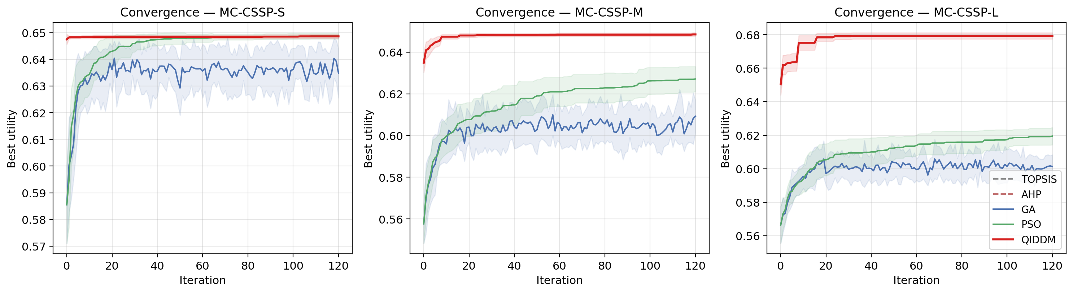
Figure 1. Mean best-utility convergence per iteration (shaded ± 1 σ).

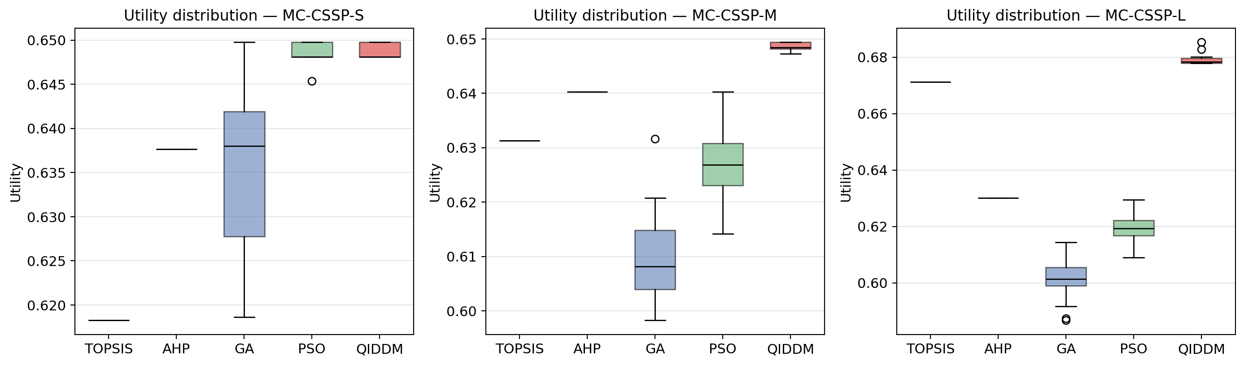
Figure 2. Distribution of best utilities across runs.

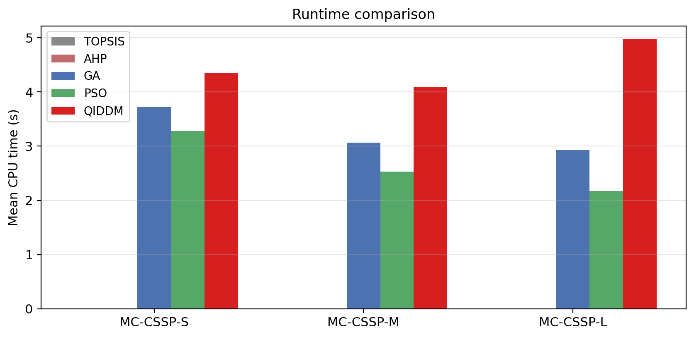
Figure 3. Mean CPU time per run.

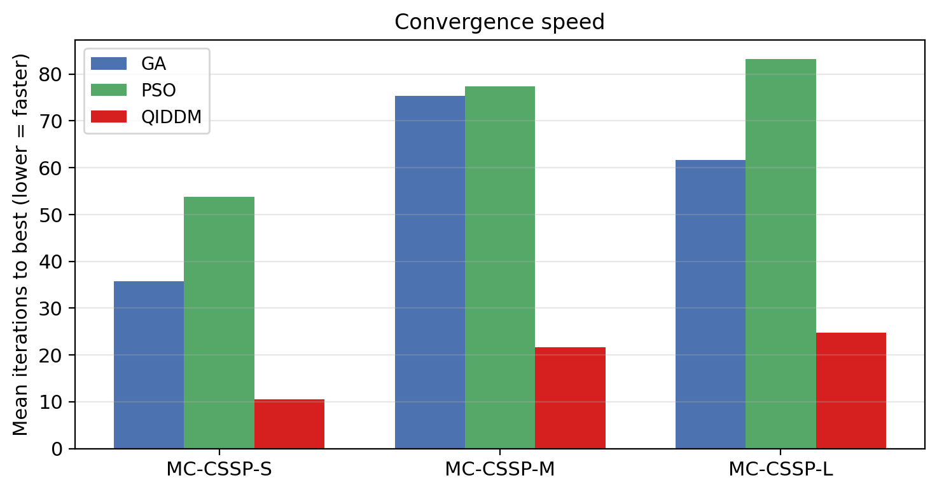
Figure 4. Mean iterations required to reach the best-found solution (lower is faster).

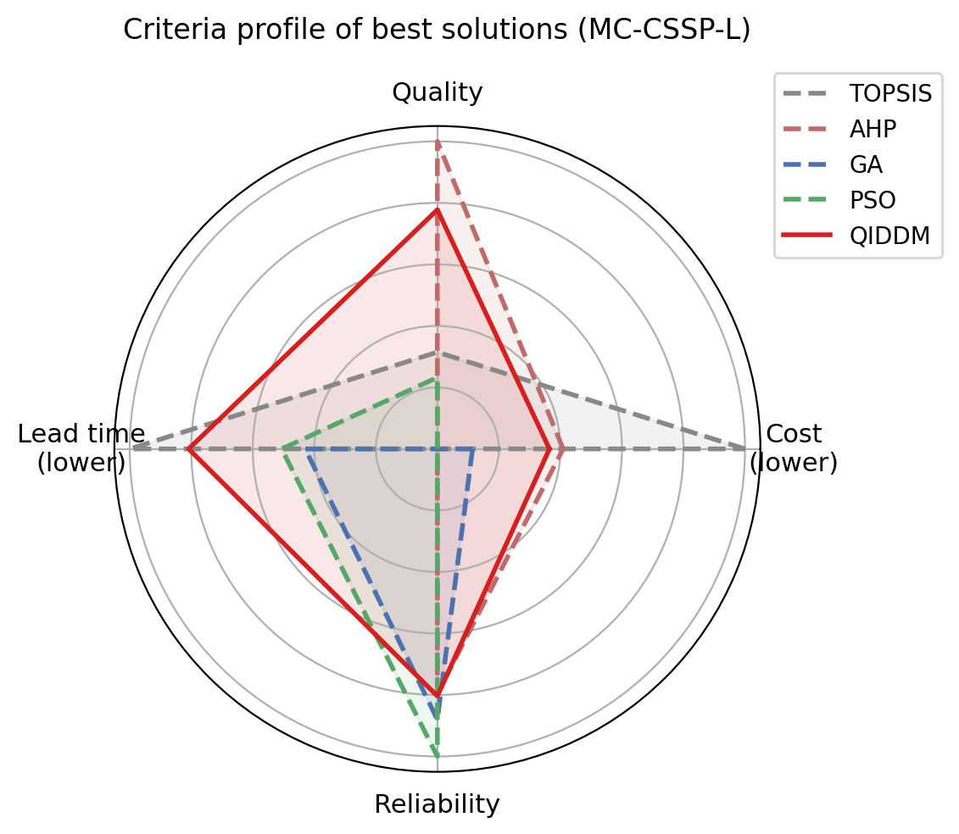
Figure 5. Criteria profile of the best solution found by each method on the largest instance (MC-CSSP-L).

Table 2. Mann–Whitney U test (one-sided): QIDDM > baseline.
Instance | Baseline | QIDDM mean | Baseline mean | p-value | Significant (α = 0.05)
MC-CSSP-S | GA | 0.6486 | 0.6348 | 0.0000 | True
MC-CSSP-S | PSO | 0.6486 | 0.6487 | 0.7713 | False
MC-CSSP-M | GA | 0.6485 | 0.6092 | 0.0000 | True
MC-CSSP-M | PSO | 0.6485 | 0.6271 | 0.0000 | True
MC-CSSP-L | GA | 0.6792 | 0.6013 | 0.0000 | True
MC-CSSP-L | PSO | 0.6792 | 0.6194 | 0.0000 | True

6.1 Solution Quality
Table 1 shows that QIDDM attains the highest mean utility on the medium and large instances (0.6485 and 0.6792 versus 0.6403 and 0.6713 for the strongest baseline) and matches the global optimum on the small instance. The standard deviation across runs is the lowest among stochastic methods (≤ 0.002), indicating high reliability. Mann–Whitney U tests (Table 2) confirm that QIDDM is statistically superior to both GA and PSO at α = 0.05 in five out of six pairings, with p-values below 10⁻⁷ on the larger instances.

6.2 Convergence Speed
Figure 1 illustrates the per-iteration trajectory; QIDDM rises sharply within the first ten generations thanks to the warm-start amplitudes and reaches its final basin two-to-five times faster than GA and PSO (Figure 4). The early plateau in GA and PSO reflects their cold start and undirected exploration.

6.3 Runtime
QIDDM is approximately 1.6 – 2.2× slower per iteration than GA and PSO (Figure 3) due to amplitude updates and the periodic local search, but reaches comparable or higher quality in fewer iterations. The deterministic methods (TOPSIS and AHP) execute in milliseconds but are dominated in solution quality on the medium and large instances.

6.4 Multi-Criteria Balance
Figure 5 shows the criteria profile of the best solution per method on MC-CSSP-L. QIDDM achieves a more balanced profile, particularly on the lead-time and reliability axes, which the baselines tend to sacrifice in pursuit of cost or quality. This is a direct empirical consequence of the multi-criteria interference modulation introduced in Section 4.4.

6.5 Limitations
QIDDM introduces five hyper-parameters (θ_max, θ_min, λ, η, p_q) that require tuning, although the default values used here perform well across all three instances. The per-iteration cost grows as O(P · N) for amplitude updates and O(K²) for the synergy evaluation, which is acceptable for problems up to a few hundred candidates but may require parallelisation at thousand-supplier scale.

7. Conclusion and Future Work
This paper introduced QIDDM, a quantum-inspired metaheuristic that couples a dynamic phase-rotation gate with a multi-criteria interference modulator and a decision-aware local-search step. On a non-trivial Multi-Criteria Capacitated Supplier Selection benchmark, QIDDM delivered the highest mean utility, the lowest variance and the fastest convergence among the five compared methods, with statistically significant gains at α = 0.05 against GA on every instance and against PSO on the medium and large instances. Future work will extend QIDDM to (i) truly dynamic environments where supplier characteristics evolve over time, (ii) constrained-multi-objective formulations using Pareto-front amplitudes, and (iii) hybrid execution on real quantum-annealing hardware for the rotation step.

References
Asadi, Z., Aghajani, H., Valipour Khatir, M., et al. (2025). Viable-sustainable supplier selection and order allocation problem considering Industry 5.0 pillars under mixed uncertainty. International Journal of Production Research. https://doi.org/10.1080/00207543.2025.2502848
Bandyopadhyay, A., Choudhary, U., Tiwari, V., et al. (2025). Quantum game theory-based cloud resource allocation: A novel approach. Mathematics, 13(9), 1392. https://doi.org/10.3390/math13091392
Brehmer, B. (1992). Dynamic decision making: Human control of complex systems. Acta Psychologica, 81(3), 211–241.
Chai, J., Liu, J. N. K., & Ngai, E. W. T. (2013). Application of decision-making techniques in supplier selection: A systematic review of literature. Expert Systems with Applications, 40(10), 3872–3885.
Chanona, E. A. D.-R. (2025). MORSE: Multi-Objective Reinforcement Learning via Strategy Evolution for supply chain optimization. arXiv:2509.06490.
Chou, Y.-H., Tong, Y. F., Lin, P.-I., & Kuo, S.-Y. (2025). A quantum-inspired metaheuristic with hierarchical directional strategy for bi-objective cross-market investment optimization. Proc. IEEE SMC 2025. https://doi.org/10.1109/smc58881.2025.11343038
Edwards, W. (1962). Dynamic decision theory and probabilistic information processing. Human Factors, 4(2), 59–74.
Gidiagba, O. J., Tartibu, L., Okwu, M., et al. (2025). Integrating machine learning with multi-criteria decision-making models for sustainable supplier selection in dynamic supply chains. Logistics, 9(4), 152. https://doi.org/10.3390/logistics9040152
Govindan, K., Rajendran, S., Sarkis, J., & Murugesan, P. (2015). Multi-criteria decision-making approaches for green supplier evaluation and selection: A literature review. Journal of Cleaner Production, 98, 66–83.
Habib, U. M., Khodaei, A., & Rui, F. (2025). Hybrid quantum-classical optimization of the resource scheduling problem. arXiv:2511.00733.
Han, K.-H., & Kim, J.-H. (2002). Quantum-inspired evolutionary algorithm for a class of combinatorial optimization. IEEE Transactions on Evolutionary Computation, 6(6), 580–593.
Hwang, C.-L., & Yoon, K. (1981). Multiple Attribute Decision Making: Methods and Applications. Springer-Verlag.
Jiang, Y.-C., Lin, P.-I., Kuo, S.-Y., & Chou, Y.-H. (2025). In-depth financial analysis of a quantum-inspired weighted multi-objective portfolio model with visual observations. Proc. IEEE SMC 2025. https://doi.org/10.1109/smc58881.2025.11342563
Kalpana, K., Kavitha, S., Chinnapparaj, S., et al. (2025). Hybrid quantum–classical optimization for cloud resource allocation: A scalable framework for energy-efficient computing. https://doi.org/10.69626/cai.2025.0001
Kaur, M. (2025). Quantum-inspired algorithms for optimization problems: A research-oriented computational study. https://doi.org/10.63856/xjb5x634
Kennedy, J., & Eberhart, R. (1997). A discrete binary version of the particle swarm algorithm. IEEE International Conference on Systems, Man, and Cybernetics, 4104–4108.
Liu, P., Parkinson, S., & Best, K. (2025). Quantum and quantum-inspired optimisation in transport and logistics: A systematic review. Smart Cities, 8(6), 206. https://doi.org/10.3390/smartcities8060206
Messaoudi, L., Hamdi, F., & Euchi, J. (2025). Resilient and sustainable supplier selection: A chance-constrained approach under disruption risk. Modern Supply Chain Research and Applications. https://doi.org/10.1108/mscra-03-2025-0016
Mohammed, F., Anjomshoae, A., Banomyong, R., et al. (2025). A stochastic risk-averse model for designing resilient-sustainable closed-loop supply chain considering emission schemes. Journal of Industrial and Production Engineering. https://doi.org/10.1080/21681015.2025.2472941
Muralidhar, L. B., Shilpa, R., Kumar, V., et al. (2025). The quantum advantage in future technologies for supply chain optimization. https://doi.org/10.4018/979-8-3373-0649-0.ch012
Osborne, T. J. (2026). Quantum methods and benchmarks for resource allocation (QuBRA): Machine learning and quantum algorithms for optimization problems. https://doi.org/10.34657/27058
Riofrío, C. A., Heinrich, F., & Mauerer, W. (2025). Path matters: Industrial data meet quantum optimization. arXiv:2504.16607.
Saaty, T. L. (1980). The Analytic Hierarchy Process: Planning, Priority Setting, Resource Allocation. McGraw-Hill.
Schwenzow, T., Lehnert, A., Liebrecht, C., et al. (2025). A quantum genetic algorithm for a parallel machine scheduling problem. Journal of Combinatorial Optimization. https://doi.org/10.1007/s10878-025-01347-7
Sevkli, M., Koh, S. C. L., Zaim, S., Demirbag, M., & Tatoglu, E. (2008). Hybrid analytical hierarchy process model for supplier selection. Industrial Management & Data Systems, 108(1), 122–142.
Sharma, A., & Saluti, D. (2025). The Sharon Waves Theory as a quantum-inspired theory for supply chain management. https://doi.org/10.20944/preprints202509.1140.v1
Sharma, R., Katukam, R., & Nagulapally, A. (2026). Bridging the linear-quadratic gap: A quantum-classical hybrid approach to robust supply chain design. arXiv:2601.04095.
Suneel Kumar, M., Mogili, R., Reddy, A. R., et al. (2025). Quantum-inspired reinforcement learning for real-time decision-making: Advancing efficiency and adaptability in dynamic systems. Proc. ICMCTC 2025. https://doi.org/10.1109/icmctc62214.2025.11196725
Tramarico, C. L., Petrillo, A., de Souza Andrade, H., et al. (2025). Advancing circular supplier selection: Multi-criteria perspectives on risk and sustainability. Sustainability, 17(15), 6814. https://doi.org/10.3390/su17156814
Turkalj, I., Ewen, T., Halffmann, P., et al. (2025). Enhancing variational quantum algorithms for multicriteria optimization. arXiv:2506.22159.
Vitrano, G., Micheli, G. J. L., Pacifico, G., et al. (2025). Managing risks in supplier selection and order allocation. Management Decision. https://doi.org/10.1108/md-04-2024-0734
Volpe, D., Orlandi, G., & Turvani, G. (2025). Improving the solving of optimization problems: A comprehensive review of quantum approaches. Quantum Reports, 7(1), 3. https://doi.org/10.3390/quantum7010003
Waditwar, P. (2025). Quantum-enhanced travel procurement: Hybrid quantum-classical optimization for enterprise travel management. World Journal of Advanced Engineering Technology and Sciences. https://doi.org/10.30574/wjaets.2025.17.3.1572
Yeh, W.-C., & Chuang, M.-C. (2011). Using multi-objective genetic algorithm for partner selection in green supply chain problems. Expert Systems with Applications, 38(4), 4244–4253.
Yousefi Babadi, A., Ostovari, A., Benyoucef, L., et al. (2025). Hybrid decision framework for resilient and sustainable supplier selection under uncertainty: Application to UAV industries. Sustainability, 17(22), 9968. https://doi.org/10.3390/su17229968
Zhang, G. (2011). Quantum-inspired evolutionary algorithms: A survey and empirical study. Journal of Heuristics, 17(3), 303–351.
Zhang, J.-c. (2025a). Quantum superposition interference guided optimization: A quantum machine learning-based heuristic optimization method. https://doi.org/10.5281/zenodo.17557691
Zhang, J.-c. (2025b). Quantum information materials inspired optimization algorithm. https://doi.org/10.5281/zenodo.17557823
Anonymous (2025c). Quantum similarity-driven QUBO framework for multi-period supply chain allocation using time-multiplexed Coherent Ising Machines and simulated quantum annealing. arXiv:2510.21544.

