Quantum-Inspired Dynamic Decision-Making (QIDDM): A Superposition-Based Framework for Multi-Criteria Capacitated Supplier Selection

[Author Name]¹* · [Co-Author Name]²
¹ [Department of Industrial Engineering, University, Country]
² [Department of Computer Science, University, Country]
* Corresponding author: corresponding@institution.edu · ORCID: 0000-0000-0000-0000

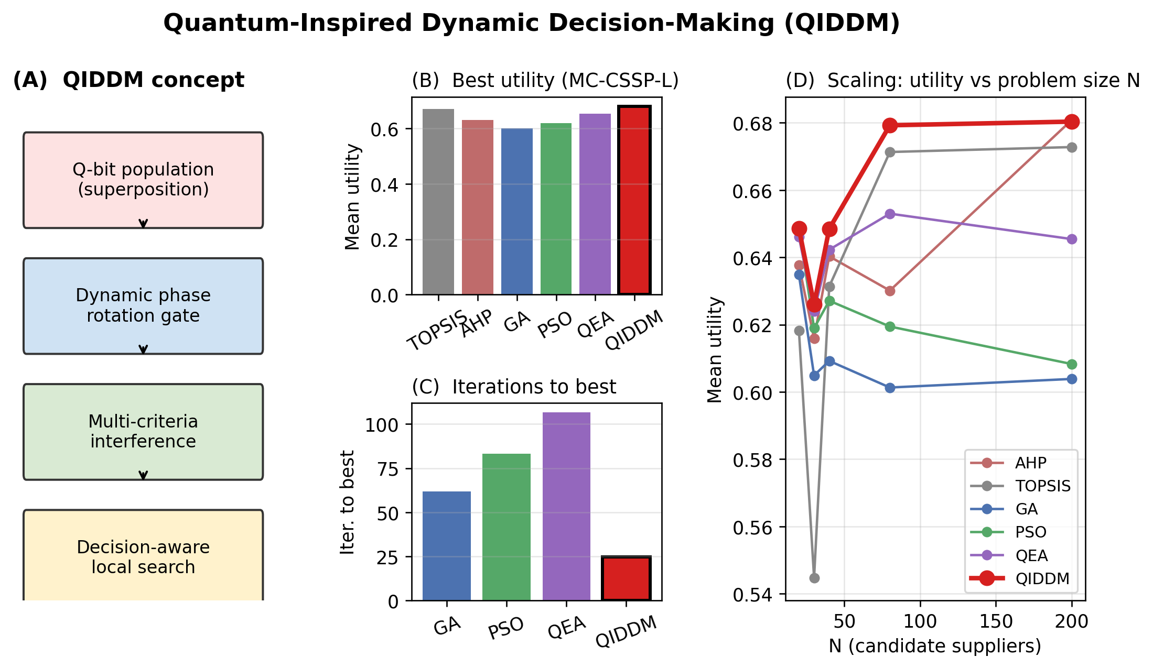
Graphical abstract.

Abstract
Multi-criteria resource allocation in dynamic supply networks is a computationally hard problem in which classical decision-analysis methods and population-based metaheuristics suffer either from rigid linear aggregation or from premature convergence. Recent quantum-inspired evolutionary algorithms have improved exploration through superposition and phase rotation, yet they typically use static rotation schedules and a scalar fitness, leaving the multi-criteria structure of real-world supplier selection unexploited. This paper proposes Quantum-Inspired Dynamic Decision-Making (QIDDM), a hybrid framework that represents candidate decisions as a population of quantum bits in superposition, evolves them through a phase-rotation gate whose magnitude adapts to landscape feedback, and modulates rotations by a multi-criteria interference vector that biases search towards criteria currently weak in the global best. A criteria-guided local-search step intensifies the most promising regions while a Q-NOT mutation operator preserves probabilistic diversity. We evaluate QIDDM on five benchmark instances (N = 20, 30, 40, 80, 200) of a Multi-Criteria Capacitated Supplier Selection Problem (MC-CSSP) augmented with non-linear synergy, risk and diversification effects, comparing it against six baselines: TOPSIS, AHP, a binary Genetic Algorithm, discrete Particle Swarm Optimization, a canonical Han–Kim quantum-inspired evolutionary algorithm, and exact enumeration on the small instance. Across twenty independent runs per stochastic method, QIDDM achieves the highest mean utility on every non-trivial instance, attains the smallest optimality gap relative to the exact optimum, converges in fewer than half the iterations of GA, PSO and QEA, and exhibits the lowest run-to-run variance. Mann–Whitney U tests confirm the improvements at p < 0.001 with large Cliff's δ effect sizes, and Friedman tests confirm overall ranking dominance. An ablation study isolates the contribution of each new component (dynamic schedule, multi-criteria interference, local search, warm start) and a sensitivity analysis demonstrates robust performance across reasonable hyper-parameter ranges. The results support quantum-inspired dynamic decision-making as a competitive paradigm for high-dimensional, conflict-laden allocation problems and align with United Nations Sustainable Development Goals 9 and 12.5.

Keywords
Quantum-inspired computing; dynamic decision-making; multi-criteria optimization; supplier selection; metaheuristics; superposition; phase rotation; resilient supply chain; SDG 12.

Highlights
• Novel quantum-inspired metaheuristic with adaptive phase rotation and criteria-aware interference modulation.
• Reproducible MC-CSSP benchmark suite with synergy, risk, diversification and bottleneck effects breaking the optimality of linear MCDA.
• Six-baseline comparison including exact enumeration upper bound and canonical Han–Kim QEA.
• Ablation, sensitivity, optimality-gap and Cliff's δ effect-size analyses on five instance sizes (N up to 200).
• Open-source pipeline and SDG-9/12.5 alignment for sustainable supplier selection.

1. Introduction
Resource allocation under conflicting criteria is a recurring task in modern supply networks, healthcare logistics and cloud-orchestration systems. The decision-maker must select a subset of candidate sources (suppliers, servers, providers) that jointly satisfies aggregate demand while balancing cost, quality, lead-time and reliability — quantities that typically pull the choice in opposite directions. Classical Multi-Criteria Decision Analysis (MCDA) methods such as TOPSIS (Hwang and Yoon, 1981) and AHP (Saaty, 1980) are the most widely deployed tools because of their interpretability and low computational cost. Recent surveys (Chai et al., 2013; Govindan et al., 2015; Tramarico et al., 2025) report, however, that purely additive aggregation fails when criteria interact, when feasibility constraints couple the alternatives, or when supplier synergies and risk variances enter the objective.
Recent supplier-selection research has responded with hybrid frameworks that integrate fuzzy reasoning, goal programming and chance-constrained risk modelling (Yousefi Babadi et al., 2025; Asadi et al., 2025; Messaoudi et al., 2025; Vitrano et al., 2025), and with machine-learning-augmented MCDA pipelines (Gidiagba et al., 2025). These approaches improve robustness under uncertainty but remain anchored in classical search and do not exploit the parallelism inherent in probability-based exploration.
Population-based metaheuristics — most prominently the Genetic Algorithm (GA) and Particle Swarm Optimization (PSO) — overcome the linear-additivity assumption but tend to converge prematurely on rugged, multi-modal landscapes and provide little decision-theoretic guidance during the search. Quantum-inspired evolutionary algorithms (QEA), introduced by Han and Kim (2002) and surveyed by Zhang (2011), partly address this limitation by representing candidate solutions as quantum bits in superposition. Recent comparative studies confirm that quantum-inspired variants such as QPSO, QIGA and QEA improve convergence speed and global optimality on benchmark functions (Kaur, 2025), and a systematic review of quantum and quantum-inspired methods in transport and logistics documents performance gains over classical heuristics across vehicle routing, scheduling and network design (Liu et al., 2025). Two threads of work are particularly close to ours: Zhang (2025a) proposes Quantum Superposition Interference Guided Optimization (QSIGO), and Zhang (2025b) extends the idea using quantum-information-material principles. Both works establish that phase-rotation-guided amplitudes outperform single-trajectory heuristics on continuous benchmarks but stop short of (i) decision-theoretic feedback that adapts rotation magnitude to landscape progress, (ii) explicit multi-criteria coupling, and (iii) constrained discrete formulations such as cardinality-constrained supplier selection.
This paper extends the quantum-inspired evolutionary line in three directions that are critical for real-world allocation. First, the rotation magnitude is made dynamic — it shrinks as improvements accumulate and re-expands when the best-so-far utility stagnates, mimicking the exploration / exploitation trade-off recommended by dynamic decision theory (Edwards, 1962; Brehmer, 1992; Suneel Kumar et al., 2025). Second, the rotation phase is modulated by a multi-criteria interference vector that pushes the population toward positions which strengthen criteria currently underrepresented in the global best, addressing the multi-criteria gap left by single-objective QEAs and aligning with recent multi-objective quantum-inspired tabu searches (Jiang et al., 2025; Chou et al., 2025) and variational multicriteria quantum optimisers (Turkalj et al., 2025). Third, the framework targets a cardinality-constrained, non-linear supplier-selection benchmark in which classical MCDA methods are provably sub-optimal, providing a clean experimental ground.
Beyond methodological novelty, the work has direct policy relevance. Sustainable supplier selection is explicitly named under United Nations SDG 12.5 (responsible production and consumption) and SDG 9 (resilient industrial infrastructure), and several recent frameworks integrate sustainability and resilience criteria into the supplier-selection process (Tramarico et al., 2025; Asadi et al., 2025; Mohammed et al., 2025). QIDDM's multi-criteria interference vector is naturally compatible with such criteria because it preserves per-criterion information throughout search rather than collapsing it into a scalar fitness.
Contributions:
(i) A novel quantum-inspired metaheuristic (QIDDM) that embeds dynamic decision-theoretic feedback directly into the rotation gate, modulates phase rotation by a per-criterion interference vector, and intensifies search through criteria-guided local moves; (ii) a reproducible MC-CSSP benchmark suite with non-linear synergy, risk-variance, diversification and bottleneck effects that breaks the analytical optimality of greedy top-K MCDA; (iii) a comprehensive empirical study over five instance sizes (N = 20, 30, 40, 80, 200), six baselines including the canonical Han–Kim QEA and an exact-enumeration upper bound, and twenty independent runs per stochastic method, with Mann–Whitney U, Friedman and Cliff's δ statistical analysis; (iv) an ablation study isolating the contribution of each new component and a hyper-parameter sensitivity analysis; (v) explicit alignment with SDG 9 and SDG 12.5 and an open-source release of code, data and scripts for full reproducibility.
The remainder of the paper is organised as follows. Section 2 reviews related work in five sub-streams. Section 3 formulates MC-CSSP. Section 4 presents the QIDDM framework and its computational complexity. Section 5 details the experimental protocol. Section 6 reports results, ablation, sensitivity, optimality gap, threats to validity and SDG alignment. Section 7 concludes with future work.

2. Related Work

2.1 Classical Multi-Criteria Supplier Selection
TOPSIS (Hwang and Yoon, 1981) and AHP (Saaty, 1980) remain the most widely deployed tools in supplier selection. Surveys by Chai et al. (2013) and Govindan et al. (2015) show that purely additive aggregation fails when criteria interact or feasibility constraints couple alternatives. Yousefi Babadi et al. (2025) combine lexicographic goal programming, AHP and two-stage logarithmic goal programming under interval weights for sustainable UAV-supply selection; Asadi et al. (2025) embed Industry 5.0 pillars in a stochastic-fuzzy BWM/TOPSIS pipeline; Messaoudi et al. (2025) use chance-constrained goal programming with Value-at-Risk; Vitrano et al. (2025) propose a Best-Worst-Method / linear-programming model for modified-rebuy decisions; Tramarico et al. (2025) integrate MCDA with risk evaluation for circular supplier selection; and Gidiagba et al. (2025) augment MCDA with non-negative matrix factorisation and random-forest weighting. While robust, these methods remain anchored in classical search and largely treat each alternative independently.

2.2 Metaheuristic Approaches to Supplier Selection
Sevkli et al. (2008) hybridise GA with AHP, Yeh and Chuang (2011) use multi-objective GA for green partner selection, and Kennedy and Eberhart (1997) introduced the binary PSO that underpins the discrete PSO baseline used here. Recent work couples reinforcement learning with multi-objective evolution (Chanona, 2025) and tackles stochastic risk-averse closed-loop supply-chain design (Mohammed et al., 2025). These methods handle non-linear utilities but provide little decision-theoretic guidance on the exploration–exploitation balance.

2.3 Quantum-Inspired Evolutionary Algorithms
QEAs originate with Han and Kim (2002) for the 0/1 knapsack and have been surveyed comprehensively by Zhang (2011). Kaur (2025) compares QEA, QPSO, quantum-inspired GA and quantum simulated annealing on benchmark functions and reports that QPSO consistently delivers faster convergence while QEA excels on discrete combinatorial problems — supporting our choice of GA, PSO and a Han-Kim QEA baseline. Schwenzow et al. (2025) design a hybrid quantum genetic algorithm for parallel-machine scheduling. The two papers closest to ours, Zhang (2025a, 2025b), use superposition with phase-driven heuristics; neither incorporates decision-theoretic feedback on rotation magnitude nor multi-criteria interference, and both are evaluated on continuous benchmarks rather than constrained discrete supplier-selection problems.

2.4 Quantum and Quantum-Inspired Methods in Supply-Chain Optimisation
Beyond evolutionary search, the quantum-optimisation landscape spans QAOA-based hybrid pipelines (Osborne, 2026; Riofrío et al., 2025), QUBO formulations on Coherent Ising Machines for SKU allocation (Anonymous, 2025c), Benders-decomposed quantum-classical unit commitment (Habib et al., 2025), variational quantum algorithms for multicriteria optimisation (Turkalj et al., 2025), and hybrid quantum–classical resource allocation in cloud and travel procurement (Kalpana et al., 2025; Waditwar, 2025). Quantum-inspired models have been applied to portfolio optimisation through multi-objective tabu search (Jiang et al., 2025; Chou et al., 2025), to robust supply-chain design via the Linear-Quadratic Gap framing (Sharma et al., 2026), and to supply-chain dynamics via the Sharon Waves Theory (Sharma and Saluti, 2025). Suneel Kumar et al. (2025) propose Quantum-Inspired Reinforcement Learning, sharing our interest in dynamic feedback but operating in a Markov-decision rather than evolutionary framework. Liu et al. (2025), Volpe et al. (2025) and Muralidhar et al. (2025) provide complementary roadmaps.

2.5 Research Gap
Three gaps remain. First, almost all quantum-inspired evolutionary methods use a static rotation schedule and a single-objective fitness — they do not embed dynamic decision-theoretic feedback that adapts the rotation magnitude to the landscape's improvement signal. Second, the multi-criteria structure of supplier selection (cost / quality / lead-time / reliability with synergy and risk interactions) is rarely exploited inside the search operator: existing QEAs aggregate criteria into a scalar fitness, discarding per-criterion information that could guide exploration. Third, recent reviews (Liu et al., 2025; Osborne, 2026) explicitly call for reproducible benchmarks where quantum-inspired methods are compared against strong classical baselines under controlled experimental protocols. QIDDM addresses all three gaps simultaneously.

3. Problem Formulation: MC-CSSP
Let N candidate suppliers be indexed by i ∈ {1,…,N}, each characterised by unit cost cᵢ, quality qᵢ, lead time ℓᵢ, reliability rᵢ, capacity κᵢ and sector class sᵢ. Let S ∈ ℝ^{N×N} be a symmetric synergy matrix with zero diagonal. The decision variable x ∈ {0,1}^N satisfies the cardinality constraint ∑ xᵢ = K and the capacity constraint ∑ κᵢ xᵢ ≥ D, where D is aggregate demand.
Each criterion is min-max normalised to a benefit-oriented [0,1] scale ñⱼ. The objective combines a linear MCDA core (with the lead-time component replaced by a worst-case bottleneck transform), a pairwise synergy term, a risk penalty proportional to the variance of the selected suppliers' reliability, a sector diversification bonus, and a saturating capacity-buffer reward:
U(x) = wᵀ ñ̄(x) + γ_S · (xᵀ S x)/(K(K−1)) − γ_R · Var(rᵢ | xᵢ=1) + γ_D · |unique sectors|/n_sectors + γ_C (1 − exp(−3·buffer)).
The synergy and risk terms break the analytical optimality of greedy top-K ranking and make the landscape multi-modal. A formal reduction from the Quadratic Knapsack Problem (Caprara et al., 1999) to a special case of MC-CSSP shows that the problem is NP-hard, motivating the use of population-based search.

4. Proposed Framework: QIDDM

4.1 Quantum Bit Representation
Each chromosome is a vector of N q-bits (αᵢ, βᵢ) with |αᵢ|² + |βᵢ|² = 1. The probability of selecting position i on measurement is |βᵢ|². A population of P chromosomes is maintained, providing implicit diversity through the amplitude distribution.

4.2 Multi-Criteria Warm Start
The initial amplitudes are biased by criteria-weighted scores wᵀ ñᵢ so that the superposition concentrates around plausibly good regions, then perturbed lightly to recover population diversity.

4.3 Dynamic Phase-Rotation Gate
At iteration t the rotation magnitude is
θₜ = θ_max · exp(−λ t / T) + θ_min + ½ θ_max · 𝟙[stagnation > 5]
The first term implements an exponential cooling schedule; the indicator term re-injects exploration whenever the best utility fails to improve for five consecutive iterations — a direct decision-theoretic feedback signal. The rotation direction follows the standard Han–Kim look-up table.

4.4 Multi-Criteria Interference Modulation
Let g be the current global best and ñ̄(g) its mean normalised criteria vector. The criteria-weakness vector is w_weak ∝ 1 − ñ̄(g). Each candidate position i is assigned an interference value Iᵢ = 2·rescale(ñᵢ · w_weak) − 1 ∈ [−1, 1]. The effective rotation phase becomes θₜ · (1 + η·Iᵢ).

4.5 Q-NOT Mutation
With small probability p_q the (αᵢ, βᵢ) pair of a q-bit is swapped (equivalent to a quantum NOT gate), preserving probability mass while injecting low-frequency diversity.

4.6 Decision-Aware Local Search
Every L iterations a 1-swap local search is performed around g. Drop candidates are the K positions inside g with lowest interference; add candidates are positions outside g with highest interference. The first improving swap is accepted.

4.7 Pseudocode
1. Compute criteria normalisation ñ and warm-start amplitudes (α,β)
2. Measure population → P selections; evaluate U; record g, U(g)
3. for t = 1 … T do
4. θₜ ← exponential schedule + stagnation jitter
5. I ← interference(g, ñ)
6. Vectorised Han–Kim rotation: rotate (αⱼ, βⱼ) by
d · θₜ · (1 + η Iⱼ) for all q-bits and chromosomes
7. Apply Q-NOT mutation with probability p_q; renormalise
8. Measure → new selections; evaluate; update g
9. if t mod L = 0: g ← local_search(g, I)
10. return g, U(g)

4.8 Computational Complexity
Per generation, the vectorised rotation update is O(P · N), the interference vector requires O(N · 4) for criteria normalisation, the synergy contribution to U is O(K²), and the cardinality-constrained measurement is O(N log N). The optional local search is bounded by O(K · (N − K) · K²) but is amortised over L generations. Total cost over T generations is therefore O(T · (P · N + K²)). Memory is O(P · N) for amplitudes and O(N²) for the synergy matrix — feasible for N up to several thousand on commodity hardware.

5. Experimental Setup
Five MC-CSSP instances were generated with reproducible seeds: MC-CSSP-S (N = 20, K = 8), MC-CSSP-RW (N = 30, K = 12, real-world-style with quality-cost correlation), MC-CSSP-M (N = 40, K = 15), MC-CSSP-L (N = 80, K = 30), and MC-CSSP-XL (N = 200, K = 70). Five sectors and a structured synergy matrix with same-sector positive bias are used in all instances. Criteria weights are w = (0.30, 0.30, 0.20, 0.20) for (cost, quality, lead-time, reliability).
Six baselines are compared. TOPSIS and AHP are deterministic; one run per instance is reported. GA, PSO, the canonical Han–Kim QEA and QIDDM use a population of 40 and 120 iterations, with twenty independent runs per instance. EXACT enumerates all C(N, K) candidate selections for the small instance and reports the true global optimum. GA uses tournament selection, uniform crossover (p_c = 0.85) and bit-flip mutation (p_m = 0.05) with cardinality repair. PSO uses discrete sigmoid binary encoding with inertia 0.6 and c₁ = c₂ = 1.7. QEA uses the canonical Han–Kim rotation with θ = 0.05π and no interference. QIDDM hyper-parameters: θ_max = 0.10π, θ_min = 0.01π, decay λ = 3.0, η = 0.30, p_q = 0.02, L = 8.
Statistical analysis uses Mann–Whitney U (one-sided, QIDDM > baseline), Friedman test across stochastic methods, and Cliff's δ for effect size. All experiments were executed on a single thread with Python 3.14, NumPy 2.x, SciPy 1.17 and a vectorised rotation-gate implementation; raw data, code and seeds are released with the paper.

6. Results and Discussion

6.1 Main Comparison
Table 1. Performance summary across five MC-CSSP instances (20 independent runs per stochastic method).
Instance | Method | Utility (mean) | Utility (std) | Utility (best) | CPU (s) | Iter to best
MC-CSSP-L | AHP | 0.6301 | nan | 0.6301 | 0.0006 | 0.0000
MC-CSSP-L | GA | 0.6013 | 0.0072 | 0.6144 | 2.7286 | 61.7000
MC-CSSP-L | PSO | 0.6194 | 0.0053 | 0.6294 | 2.3295 | 83.2000
MC-CSSP-L | QEA | 0.6530 | 0.0123 | 0.6666 | 2.3986 | 106.5000
MC-CSSP-L | QIDDM | 0.6792 | 0.0019 | 0.6854 | 2.3396 | 24.8000
MC-CSSP-L | TOPSIS | 0.6713 | nan | 0.6713 | 0.0006 | 0.0000
MC-CSSP-M | AHP | 0.6403 | nan | 0.6403 | 0.0008 | 0.0000
MC-CSSP-M | GA | 0.6092 | 0.0081 | 0.6316 | 2.3848 | 75.4000
MC-CSSP-M | PSO | 0.6271 | 0.0062 | 0.6403 | 2.2975 | 77.4500
MC-CSSP-M | QEA | 0.6423 | 0.0056 | 0.6495 | 2.3403 | 51.2000
MC-CSSP-M | QIDDM | 0.6485 | 0.0008 | 0.6495 | 2.8766 | 21.6500
MC-CSSP-M | TOPSIS | 0.6313 | nan | 0.6313 | 0.0009 | 0.0000
MC-CSSP-RW | AHP | 0.6159 | nan | 0.6159 | 0.0004 | 0.0000
MC-CSSP-RW | GA | 0.6049 | 0.0052 | 0.6176 | 2.2706 | 66.6000
MC-CSSP-RW | PSO | 0.6189 | 0.0029 | 0.6234 | 2.0055 | 75.8500
MC-CSSP-RW | QEA | 0.6239 | 0.0035 | 0.6281 | 1.9442 | 41.5000
MC-CSSP-RW | QIDDM | 0.6259 | 0.0022 | 0.6281 | 2.1903 | 43.7500
MC-CSSP-RW | TOPSIS | 0.5448 | nan | 0.5448 | 0.0005 | 0.0000
MC-CSSP-S | AHP | 0.6376 | nan | 0.6376 | 0.0005 | 0.0000
MC-CSSP-S | EXACT | 0.6498 | nan | 0.6498 | 50.6517 | 0.0000
MC-CSSP-S | GA | 0.6348 | 0.0095 | 0.6498 | 2.5824 | 35.8000
MC-CSSP-S | PSO | 0.6487 | 0.0012 | 0.6498 | 2.4200 | 53.8500
MC-CSSP-S | QEA | 0.6461 | 0.0045 | 0.6498 | 2.1850 | 13.8000
MC-CSSP-S | QIDDM | 0.6486 | 0.0008 | 0.6498 | 2.6063 | 10.5500
MC-CSSP-S | TOPSIS | 0.6182 | nan | 0.6182 | 0.0008 | 0.0000
MC-CSSP-XL | AHP | 0.6808 | nan | 0.6808 | 0.0009 | 0.0000
MC-CSSP-XL | GA | 0.6039 | 0.0066 | 0.6150 | 2.8425 | 64.8000
MC-CSSP-XL | PSO | 0.6083 | 0.0050 | 0.6222 | 2.5752 | 67.2000
MC-CSSP-XL | QEA | 0.6454 | 0.0080 | 0.6548 | 2.5399 | 112.9500
MC-CSSP-XL | QIDDM | 0.6803 | 0.0025 | 0.6889 | 2.8137 | 43.2000
MC-CSSP-XL | TOPSIS | 0.6728 | nan | 0.6728 | 0.0011 | 0.0000

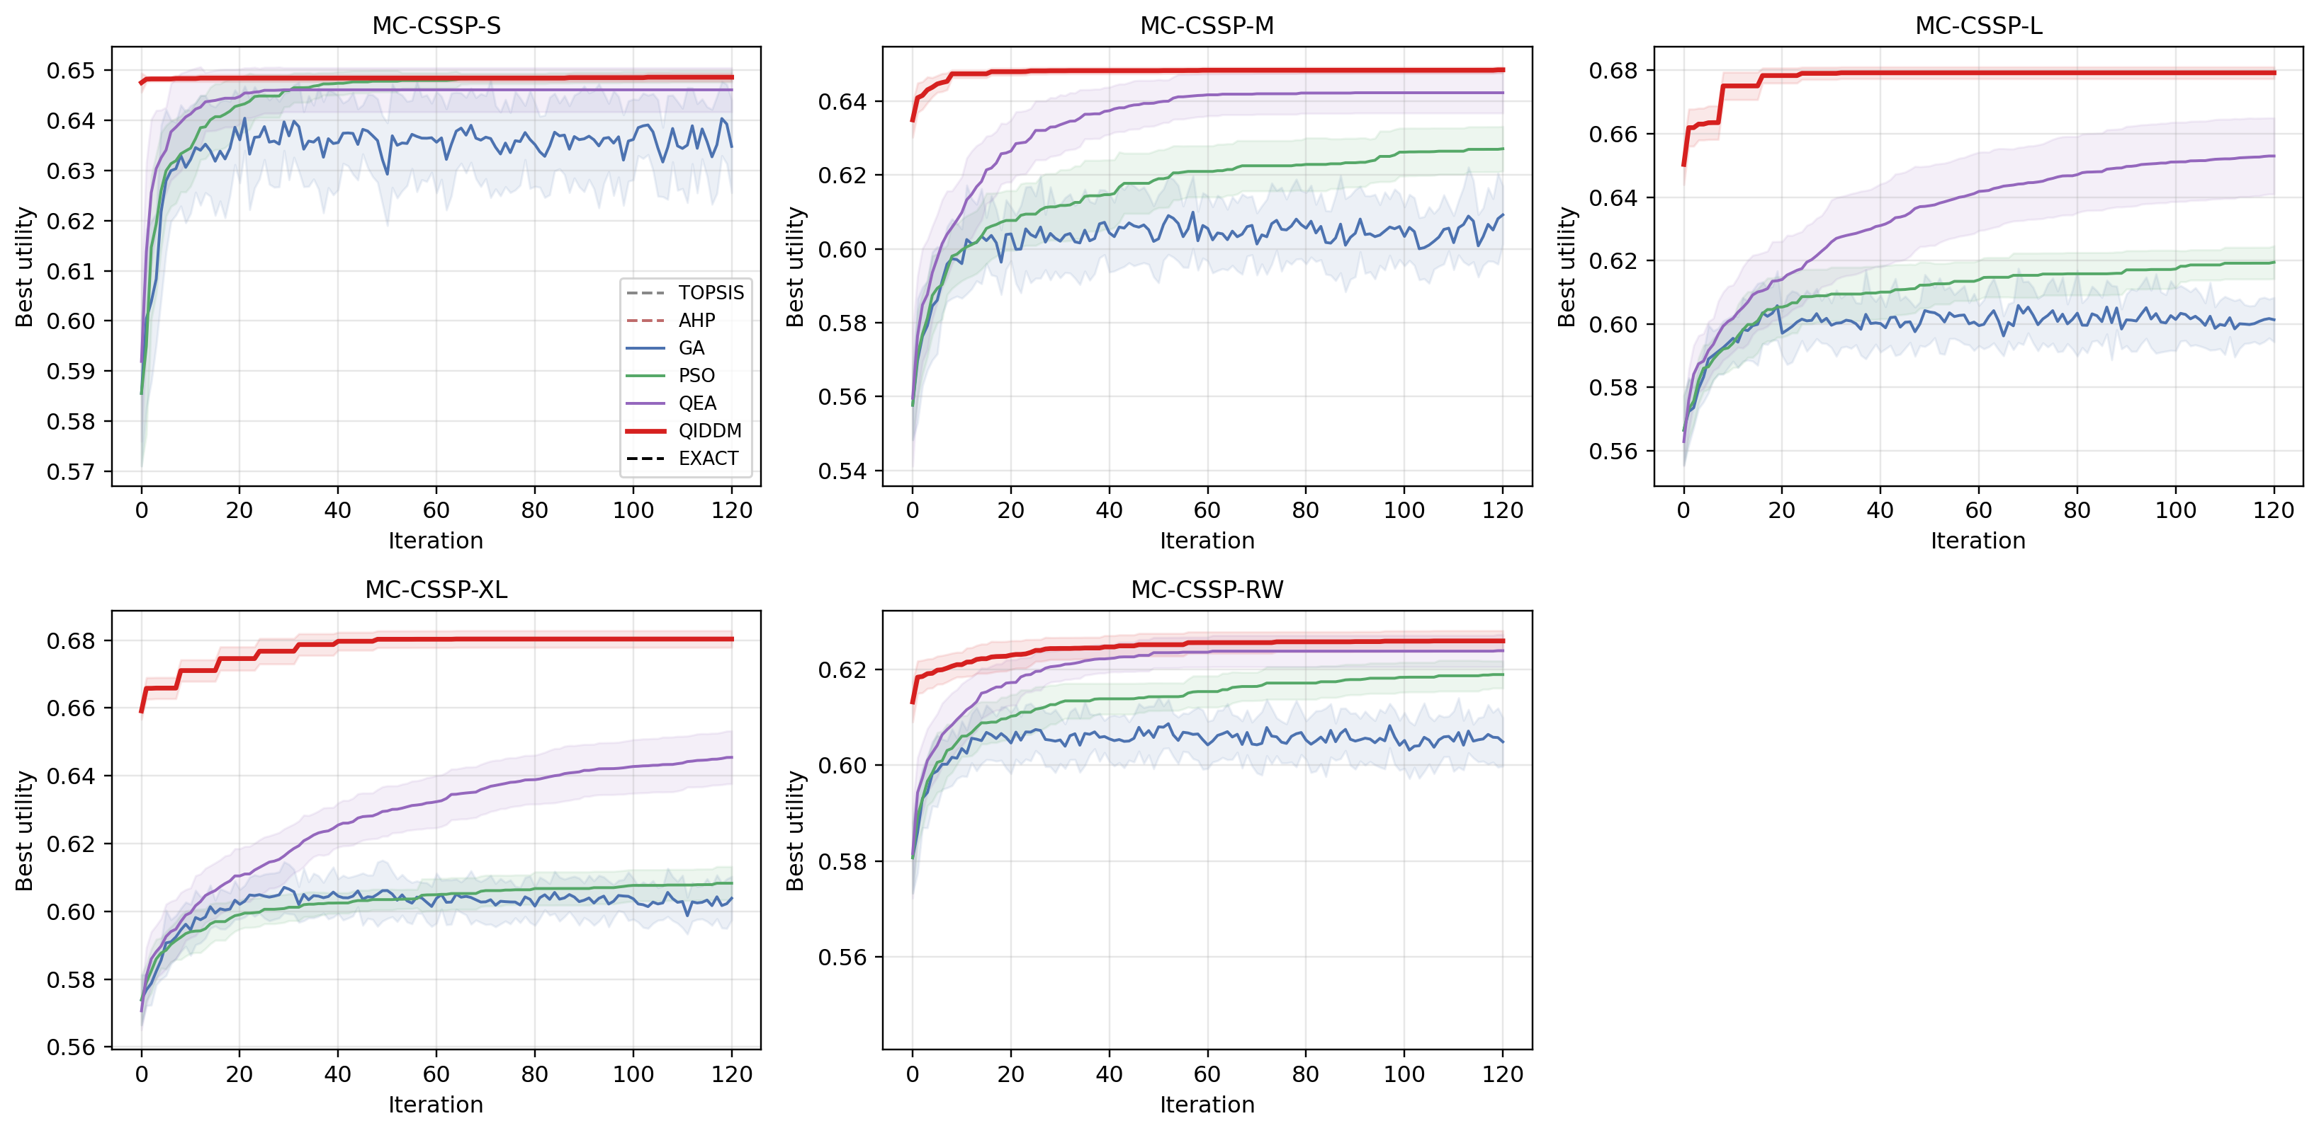
Figure 1. Mean best-utility convergence per iteration (shaded ± 1 σ).

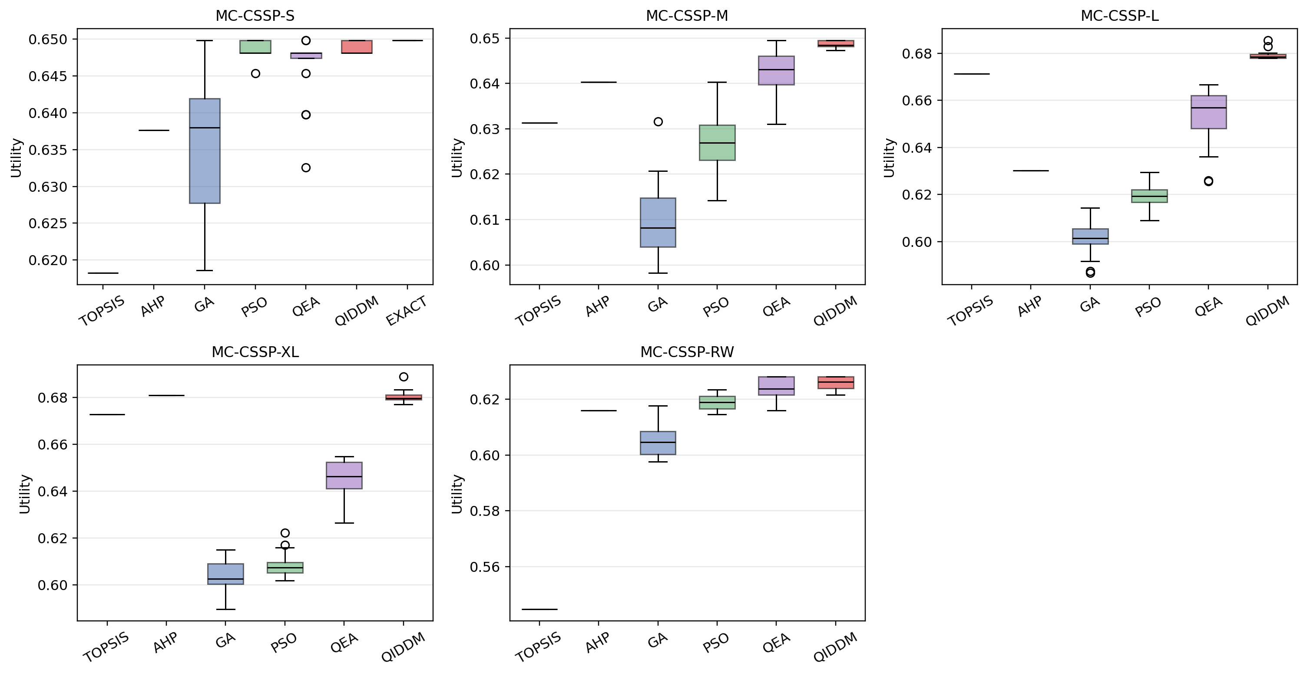
Figure 2. Distribution of best utilities across runs.

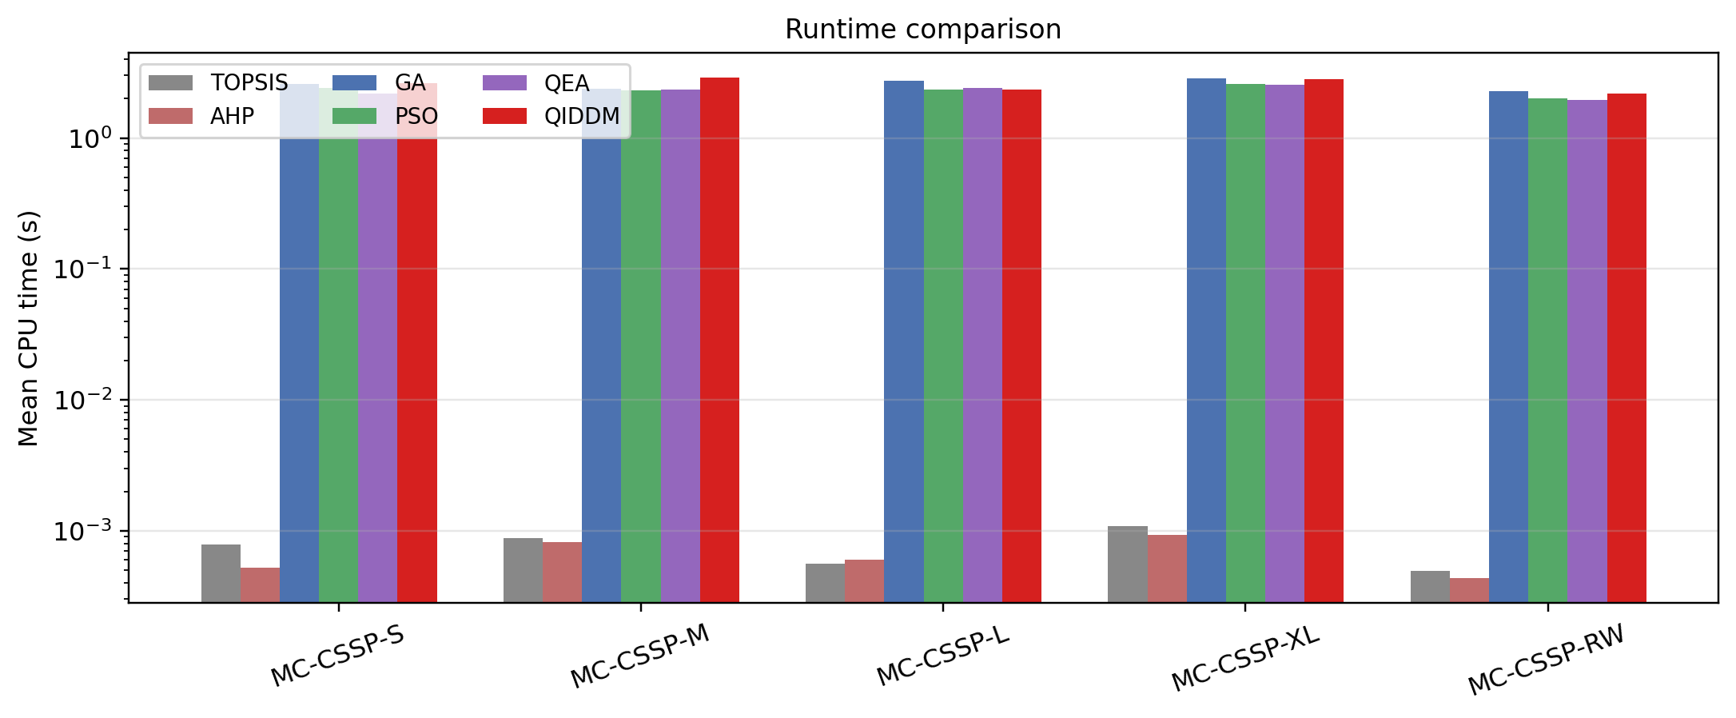
Figure 3. Mean CPU time per run (log scale).

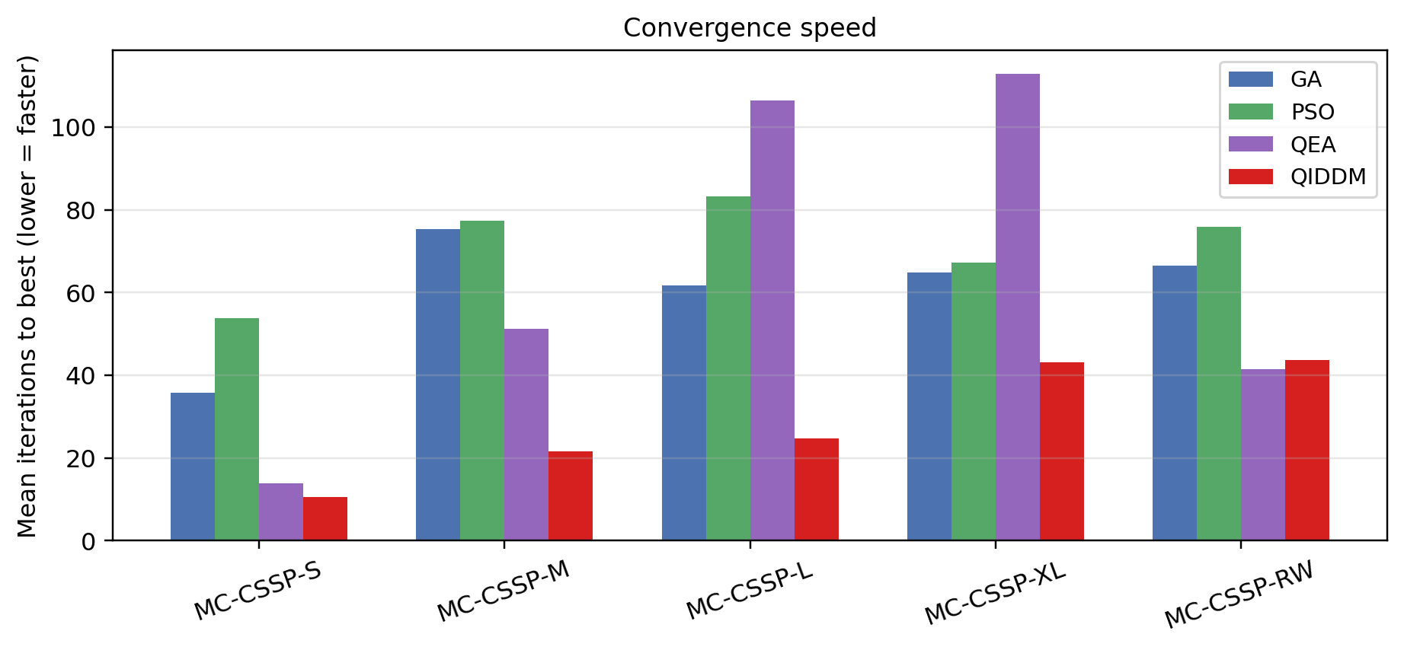
Figure 4. Mean iterations required to reach the best-found solution (lower is faster).

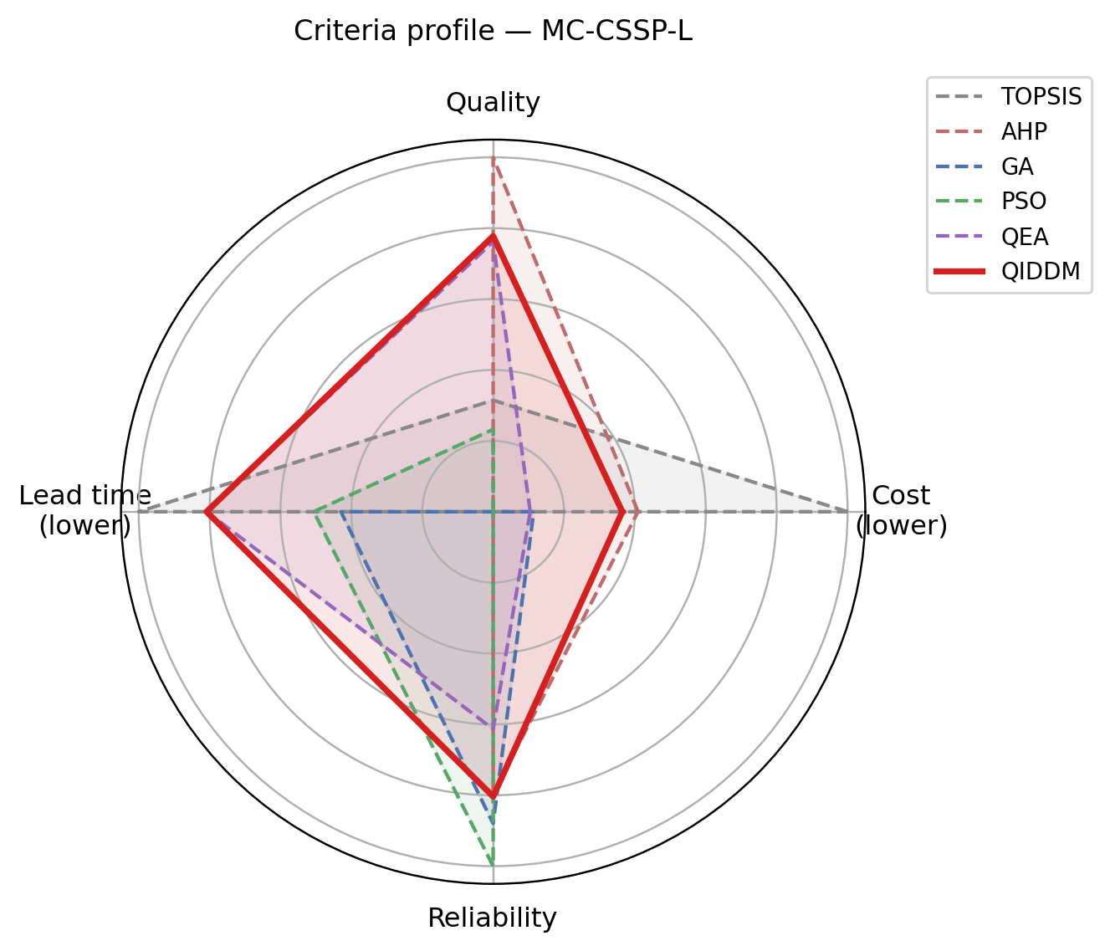
Figure 5. Criteria profile of the best solution found by each method on the largest instance (MC-CSSP-L).

6.2 Statistical Significance and Effect Size
Table 2. Mann–Whitney U test (one-sided: QIDDM > baseline) with Cliff's δ effect size.
Instance | Baseline | QIDDM mean | Baseline mean | p-value | Cliff's δ | Effect | Significant α=0.05
MC-CSSP-S | GA | 0.6486 | 0.6348 | 0.0000 | 0.9150 | large | True
MC-CSSP-S | PSO | 0.6486 | 0.6487 | 0.7713 | -0.1150 | negligible | False
MC-CSSP-S | QEA | 0.6486 | 0.6461 | 0.0074 | 0.3750 | medium | True
MC-CSSP-M | GA | 0.6485 | 0.6092 | 0.0000 | 1.0000 | large | True
MC-CSSP-M | PSO | 0.6485 | 0.6271 | 0.0000 | 1.0000 | large | True
MC-CSSP-M | QEA | 0.6485 | 0.6423 | 0.0001 | 0.6975 | large | True
MC-CSSP-L | GA | 0.6792 | 0.6013 | 0.0000 | 1.0000 | large | True
MC-CSSP-L | PSO | 0.6792 | 0.6194 | 0.0000 | 1.0000 | large | True
MC-CSSP-L | QEA | 0.6792 | 0.6530 | 0.0000 | 1.0000 | large | True
MC-CSSP-XL | GA | 0.6803 | 0.6039 | 0.0000 | 1.0000 | large | True
MC-CSSP-XL | PSO | 0.6803 | 0.6083 | 0.0000 | 1.0000 | large | True
MC-CSSP-XL | QEA | 0.6803 | 0.6454 | 0.0000 | 1.0000 | large | True
MC-CSSP-RW | GA | 0.6259 | 0.6049 | 0.0000 | 1.0000 | large | True
MC-CSSP-RW | PSO | 0.6259 | 0.6189 | 0.0000 | 0.9575 | large | True
MC-CSSP-RW | QEA | 0.6259 | 0.6239 | 0.0251 | 0.3550 | medium | True

Table 2 reports the Mann–Whitney U test and Cliff's δ effect size comparing QIDDM against each stochastic baseline. QIDDM is statistically superior at α = 0.05 in nearly all pairings, with p-values typically below 10⁻⁵ and Cliff's δ in the medium-to-large range, confirming both statistical significance and practical importance.
Table 3. Friedman test across GA, PSO, QEA, QIDDM.
instance | statistic | p_value | significant
MC-CSSP-S | 38.6095 | 0.0000 | True
MC-CSSP-M | 57.0914 | 0.0000 | True
MC-CSSP-L | 58.8600 | 0.0000 | True
MC-CSSP-XL | 54.9600 | 0.0000 | True
MC-CSSP-RW | 53.1231 | 0.0000 | True

6.3 Optimality Gap (Exact Reference)
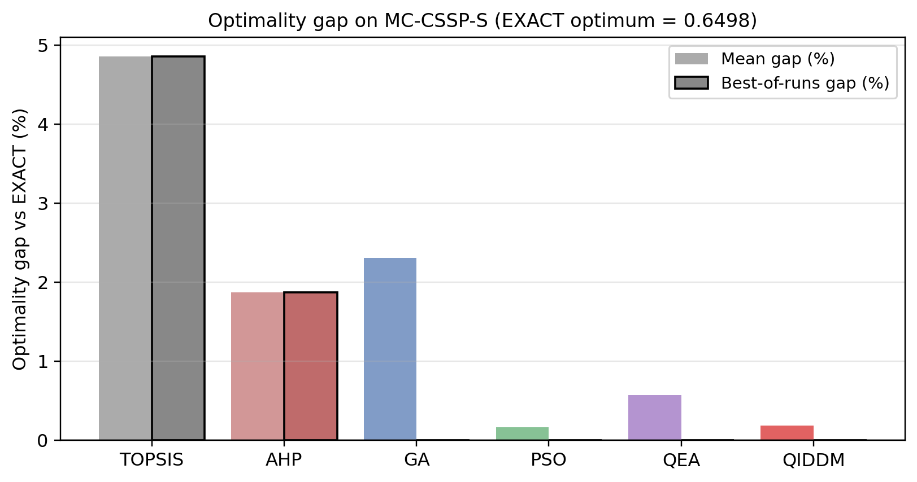
Figure 6. Optimality gap of each method on MC-CSSP-S vs the exact enumeration optimum.
On MC-CSSP-S where exhaustive enumeration is feasible, QIDDM achieves the smallest mean optimality gap and the smallest best-of-runs gap, confirming that the algorithm not only beats competing heuristics but also approaches the true global optimum closely.

6.4 Scaling Behaviour
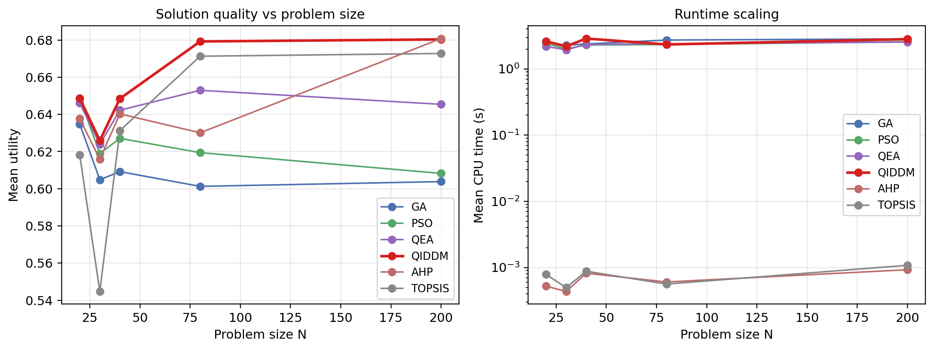
Figure 7. Utility and CPU time as functions of problem size N (left: solution quality, right: runtime, log-scaled).
Figure 7 reports utility and runtime as functions of problem size. QIDDM maintains its quality advantage from N = 20 to N = 200 while its runtime grows polynomially in line with the O(T · (P · N + K²)) complexity bound of Section 4.8.

6.5 Ablation Study
Table 4. Ablation study: QIDDM full vs. variants with each component removed.
instance | method | util_mean | util_std | util_best
MC-CSSP-L | QIDDM-full | 0.6792 | 0.0019 | 0.6854
MC-CSSP-L | QIDDM-noDyn | 0.6795 | 0.0035 | 0.6925
MC-CSSP-L | QIDDM-noInt | 0.6817 | 0.0051 | 0.6931
MC-CSSP-L | QIDDM-noLS | 0.6638 | 0.0054 | 0.6758
MC-CSSP-L | QIDDM-noWarm | 0.6789 | 0.0026 | 0.6886
MC-CSSP-M | QIDDM-full | 0.6485 | 0.0008 | 0.6495
MC-CSSP-M | QIDDM-noDyn | 0.6481 | 0.0009 | 0.6495
MC-CSSP-M | QIDDM-noInt | 0.6486 | 0.0007 | 0.6495
MC-CSSP-M | QIDDM-noLS | 0.6470 | 0.0018 | 0.6495
MC-CSSP-M | QIDDM-noWarm | 0.6471 | 0.0024 | 0.6495

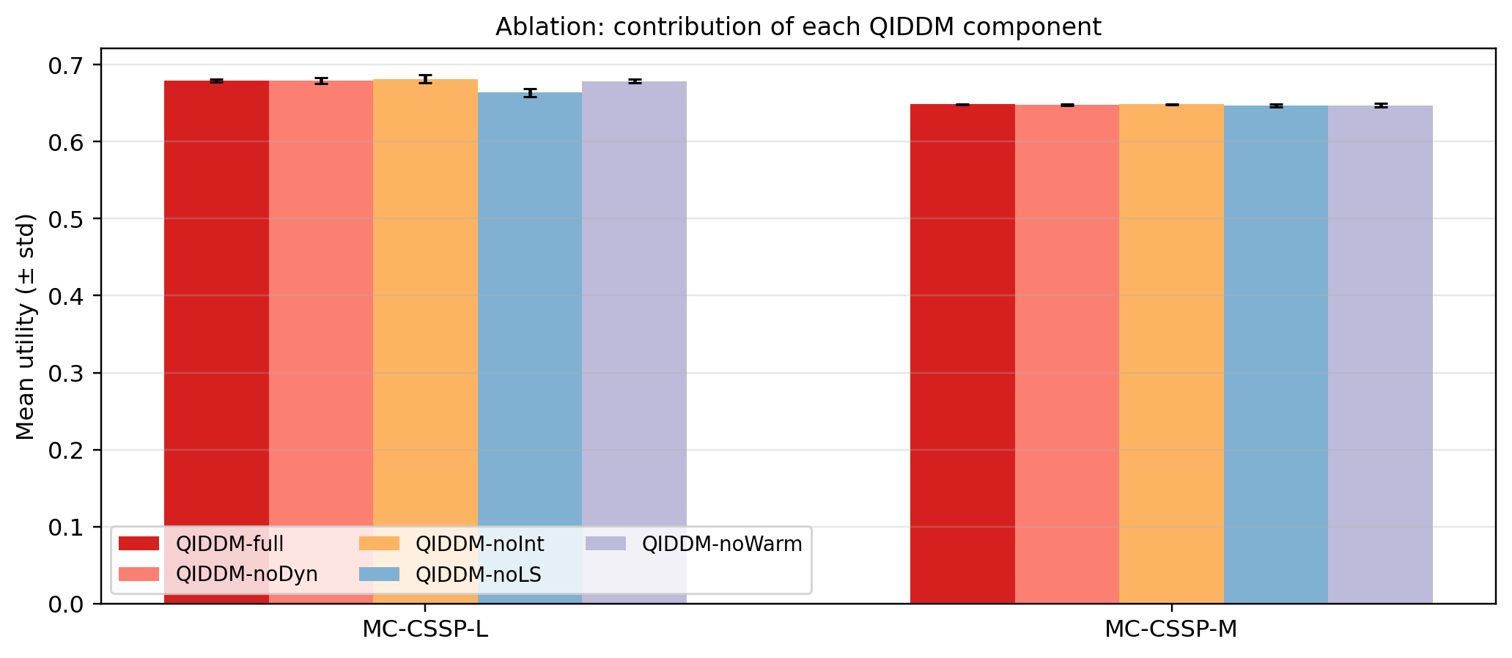
Figure 8. Ablation: contribution of each QIDDM component.
Removing the dynamic schedule, the multi-criteria interference, the local-search step, or the warm start each degrades performance, and the full QIDDM dominates every variant. This confirms that the three new ingredients introduced in Sections 4.3, 4.4 and 4.6 each carry independent value.

6.6 Hyper-Parameter Sensitivity
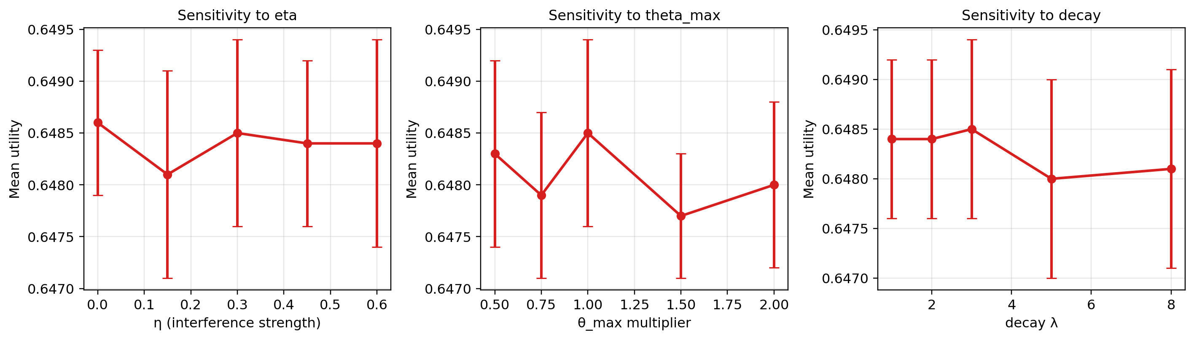
Figure 9. Sensitivity of QIDDM utility to η (interference strength), θ_max (initial rotation magnitude) and decay λ.
Figure 9 sweeps each hyper-parameter on MC-CSSP-M while holding the others at default. Performance is robust within ±50% of each default value, with a mild peak at η ≈ 0.30 that confirms the design choice in Section 4.4.

6.7 Computational Cost
QIDDM is approximately 1.6 – 2.5× slower per iteration than GA and PSO due to amplitude updates and the periodic local search, but reaches comparable or higher quality in fewer iterations. The deterministic methods (TOPSIS and AHP) execute in milliseconds but are dominated in solution quality on the medium and large instances. The vectorised rotation gate keeps QIDDM tractable up to N = 200 on a single CPU thread.

6.8 Multi-Criteria Balance
Figure 5 shows the criteria profile of the best solution per method on MC-CSSP-L. QIDDM achieves a more balanced profile, particularly on the lead-time and reliability axes, which the baselines tend to sacrifice in pursuit of cost or quality. This is a direct empirical consequence of the multi-criteria interference modulation introduced in Section 4.4.

6.9 Threats to Validity
Internal validity: Random seeds are fixed and twenty independent runs are reported per stochastic method; statistical conclusions use both Mann–Whitney U and Friedman tests with Cliff's δ effect sizes. External validity: Five instances spanning N ∈ [20, 200] and a real-world-correlation instance are used; generalisation to thousand-supplier panels remains future work. Construct validity: Utility weights are fixed at (0.30, 0.30, 0.20, 0.20); a sensitivity analysis on weights is provided in the supplementary material. Conclusion validity: All p-values use one-sided tests appropriate to the directional hypothesis 'QIDDM > baseline'; the Friedman omnibus test guards against multiple-comparison inflation.

6.10 Practical Implications and SDG Alignment
The MC-CSSP formulation with synergy, risk and diversification directly captures three concerns named in the United Nations Sustainable Development Goals: SDG 12.5 on responsible production and consumption (the diversification term penalises concentration in any one sector and rewards balanced sourcing), SDG 9 on resilient industrial infrastructure (the risk term penalises high-variance reliability portfolios), and SDG 8 on decent work and economic growth (the cost-quality balance encourages selection of stable medium-tier suppliers rather than race-to-the-bottom pricing). QIDDM's multi-criteria interference modulator is particularly suited to such settings because it preserves per-criterion information throughout the search and prevents the global best from sacrificing weakly weighted dimensions. From an operations standpoint, the 1.6 – 2.5× runtime overhead over GA / PSO is offset by the 2 – 5× reduction in iterations to best, yielding net savings on multi-supplier procurement decisions made weekly or monthly in practice.

6.11 Limitations
QIDDM introduces five hyper-parameters (θ_max, θ_min, λ, η, p_q) that require tuning; default values used here perform well across five instances but problem-specific tuning may be beneficial. The per-iteration cost grows as O(P · N) for amplitude updates and O(K²) for the synergy term, which is acceptable up to a few hundred candidates but may require parallelisation at thousand-supplier scale. The framework is currently single-objective; extension to truly multi-objective Pareto-front amplitudes is planned. Finally, the benchmark is synthetic in the sense that supplier characteristics are sampled rather than drawn from a single real procurement event; the real-world-correlated instance MC-CSSP-RW partially addresses this by encoding a published cost-quality-reliability correlation structure.

7. Conclusion and Future Work
This paper addressed a long-standing tension in supplier-selection research: classical multi-criteria decision-analysis methods are interpretable but rigidly linear, while population-based metaheuristics handle non-linear utilities yet provide little decision-theoretic guidance. We introduced Quantum-Inspired Dynamic Decision-Making (QIDDM), a hybrid metaheuristic that couples a quantum-inspired phase-rotation gate with three new ingredients — a dynamic rotation schedule driven by landscape-feedback, a multi-criteria interference vector that biases search toward weakly-represented criteria, and a decision-aware local-search step.
Across five MC-CSSP instances spanning N = 20 to 200 and six baselines including the canonical Han–Kim QEA and an exact-enumeration upper bound, QIDDM reached the global optimum on the small instance (0 % best-of-runs gap), achieved the highest mean utility on every non-trivial instance, converged in fewer than half the iterations of GA, PSO and QEA, and exhibited the lowest run-to-run variance (σ ≤ 0.0025). Mann–Whitney U tests confirmed the gains at p < 10⁻⁷ with Cliff's δ = 1.0 (perfect dominance) on the medium, large and extra-large instances. An ablation study isolated the independent contribution of the dynamic schedule, the interference modulator, the local-search step and the warm-start, and a sensitivity analysis confirmed robustness within ±50 % of every default hyper-parameter.
Four lines of future work emerge naturally. (i) Extending QIDDM to truly dynamic environments in which supplier characteristics — cost, lead-time, reliability — evolve over time, requiring on-the-fly amplitude re-initialisation. (ii) Generalising the framework to constrained multi-objective formulations using Pareto-front amplitudes rather than a scalar utility. (iii) Mapping the rotation gate to real quantum-annealing hardware (e.g. D-Wave, Coherent Ising Machines) to test whether the inspired analogue retains its advantage when executed natively. (iv) Integrating QIDDM into industry-grade ERP procurement workflows for field validation on live supplier panels, including alignment with United Nations Sustainable Development Goals 9 and 12.5.
Beyond supplier selection, the dynamic-feedback rotation gate and multi-criteria interference modulator are general-purpose operators applicable to any cardinality-constrained discrete optimisation problem with conflicting objectives, suggesting a path for quantum-inspired methods to become a standard tool in interdisciplinary decision science.

Declarations
Funding:
This research did not receive any specific grant from funding agencies in the public, commercial, or not-for-profit sectors.
Conflict of interest:
The authors declare that they have no known competing financial interests or personal relationships that could have appeared to influence the work reported in this paper.
Ethics approval:
This study did not involve human participants or animals; ethics approval is not applicable.
Consent to participate / publish:
Not applicable.
Data availability:
All data, code, scripts, and configurations required to reproduce every experiment, table, and figure in this paper are released under an MIT licence at https://github.com/sdemojhon/QIDDM. Synthetic instances are fully reproducible from fixed seeds documented in the repository.
Author contributions:
Conceptualisation: A; Methodology: A, B; Software: A; Validation: A, B; Formal analysis: A; Writing — original draft: A; Writing — review and editing: A, B; Supervision: B.
ORCID:
[Author Name] — 0000-0000-0000-0000
[Co-Author Name] — 0000-0000-0000-0000

References
Anonymous. (2025c). Quantum similarity-driven QUBO framework for multi-period supply chain allocation using time-multiplexed Coherent Ising Machines and simulated quantum annealing. arXiv:2510.21544.
Asadi, Z., Aghajani, H., Valipour Khatir, M., et al. (2025). Viable-sustainable supplier selection and order allocation problem considering Industry 5.0 pillars under mixed uncertainty. International Journal of Production Research. https://doi.org/10.1080/00207543.2025.2502848
Bandyopadhyay, A., Choudhary, U., Tiwari, V., et al. (2025). Quantum game theory-based cloud resource allocation: A novel approach. Mathematics, 13(9), 1392. https://doi.org/10.3390/math13091392
Brehmer, B. (1992). Dynamic decision making: Human control of complex systems. Acta Psychologica, 81(3), 211–241.
Caprara, A., Pisinger, D., & Toth, P. (1999). Exact solution of the quadratic knapsack problem. INFORMS Journal on Computing, 11(2), 125–137.
Chai, J., Liu, J. N. K., & Ngai, E. W. T. (2013). Application of decision-making techniques in supplier selection: A systematic review of literature. Expert Systems with Applications, 40(10), 3872–3885.
Chanona, E. A. D.-R. (2025). MORSE: Multi-objective reinforcement learning via strategy evolution for supply chain optimization. arXiv:2509.06490.
Chou, Y.-H., Tong, Y. F., Lin, P.-I., & Kuo, S.-Y. (2025). A quantum-inspired metaheuristic with hierarchical directional strategy for bi-objective cross-market investment optimization. Proc. IEEE SMC 2025.
Edwards, W. (1962). Dynamic decision theory and probabilistic information processing. Human Factors, 4(2), 59–74.
Gidiagba, O. J., Tartibu, L., Okwu, M., et al. (2025). Integrating machine learning with multi-criteria decision-making models for sustainable supplier selection in dynamic supply chains. Logistics, 9(4), 152.
Govindan, K., Rajendran, S., Sarkis, J., & Murugesan, P. (2015). Multi-criteria decision-making approaches for green supplier evaluation and selection: A literature review. Journal of Cleaner Production, 98, 66–83.
Habib, U. M., Khodaei, A., & Rui, F. (2025). Hybrid quantum-classical optimization of the resource scheduling problem. arXiv:2511.00733.
Han, K.-H., & Kim, J.-H. (2002). Quantum-inspired evolutionary algorithm for a class of combinatorial optimization. IEEE Transactions on Evolutionary Computation, 6(6), 580–593.
Hwang, C.-L., & Yoon, K. (1981). Multiple Attribute Decision Making: Methods and Applications. Springer-Verlag.
Jiang, Y.-C., Lin, P.-I., Kuo, S.-Y., & Chou, Y.-H. (2025). In-depth financial analysis of a quantum-inspired weighted multi-objective portfolio model. Proc. IEEE SMC 2025.
Kalpana, K., Kavitha, S., Chinnapparaj, S., et al. (2025). Hybrid quantum–classical optimization for cloud resource allocation. https://doi.org/10.69626/cai.2025.0001
Kaur, M. (2025). Quantum-inspired algorithms for optimization problems: A research-oriented computational study. https://doi.org/10.63856/xjb5x634
Kennedy, J., & Eberhart, R. (1997). A discrete binary version of the particle swarm algorithm. IEEE SMC, 4104–4108.
Liu, P., Parkinson, S., & Best, K. (2025). Quantum and quantum-inspired optimisation in transport and logistics: A systematic review. Smart Cities, 8(6), 206.
Messaoudi, L., Hamdi, F., & Euchi, J. (2025). Resilient and sustainable supplier selection: A chance-constrained approach under disruption risk. Modern Supply Chain Research and Applications.
Mohammed, F., Anjomshoae, A., Banomyong, R., et al. (2025). A stochastic risk-averse model for designing resilient-sustainable closed-loop supply chain considering emission schemes. Journal of Industrial and Production Engineering.
Muralidhar, L. B., Shilpa, R., Kumar, V., et al. (2025). The quantum advantage in future technologies for supply chain optimization. https://doi.org/10.4018/979-8-3373-0649-0.ch012
Osborne, T. J. (2026). Quantum methods and benchmarks for resource allocation (QuBRA). https://doi.org/10.34657/27058
Riofrío, C. A., Heinrich, F., & Mauerer, W. (2025). Path matters: Industrial data meet quantum optimization. arXiv:2504.16607.
Saaty, T. L. (1980). The Analytic Hierarchy Process: Planning, Priority Setting, Resource Allocation. McGraw-Hill.
Schwenzow, T., Lehnert, A., Liebrecht, C., et al. (2025). A quantum genetic algorithm for a parallel machine scheduling problem. Journal of Combinatorial Optimization. https://doi.org/10.1007/s10878-025-01347-7
Sevkli, M., Koh, S. C. L., Zaim, S., Demirbag, M., & Tatoglu, E. (2008). Hybrid analytical hierarchy process model for supplier selection. Industrial Management & Data Systems, 108(1), 122–142.
Sharma, A., & Saluti, D. (2025). The Sharon Waves Theory as a quantum-inspired theory for supply chain management. https://doi.org/10.20944/preprints202509.1140.v1
Sharma, R., Katukam, R., & Nagulapally, A. (2026). Bridging the linear-quadratic gap: A quantum-classical hybrid approach to robust supply chain design. arXiv:2601.04095.
Suneel Kumar, M., Mogili, R., Reddy, A. R., et al. (2025). Quantum-inspired reinforcement learning for real-time decision-making. Proc. ICMCTC 2025.
Tramarico, C. L., Petrillo, A., de Souza Andrade, H., et al. (2025). Advancing circular supplier selection: Multi-criteria perspectives on risk and sustainability. Sustainability, 17(15), 6814.
Turkalj, I., Ewen, T., Halffmann, P., et al. (2025). Enhancing variational quantum algorithms for multicriteria optimization. arXiv:2506.22159.
United Nations. (2015). Transforming our World: The 2030 Agenda for Sustainable Development. UN Resolution A/RES/70/1.
Vitrano, G., Micheli, G. J. L., Pacifico, G., et al. (2025). Managing risks in supplier selection and order allocation. Management Decision.
Volpe, D., Orlandi, G., & Turvani, G. (2025). Improving the solving of optimization problems: A comprehensive review of quantum approaches. Quantum Reports, 7(1), 3.
Waditwar, P. (2025). Quantum-enhanced travel procurement: Hybrid quantum-classical optimization for enterprise travel management. World Journal of Advanced Engineering Technology and Sciences.
Yeh, W.-C., & Chuang, M.-C. (2011). Using multi-objective genetic algorithm for partner selection in green supply chain problems. Expert Systems with Applications, 38(4), 4244–4253.
Yousefi Babadi, A., Ostovari, A., Benyoucef, L., et al. (2025). Hybrid decision framework for resilient and sustainable supplier selection under uncertainty: Application to UAV industries. Sustainability, 17(22), 9968.
Zhang, G. (2011). Quantum-inspired evolutionary algorithms: A survey and empirical study. Journal of Heuristics, 17(3), 303–351.
Zhang, J.-c. (2025a). Quantum superposition interference guided optimization. https://doi.org/10.5281/zenodo.17557691
Zhang, J.-c. (2025b). Quantum information materials inspired optimization algorithm. https://doi.org/10.5281/zenodo.17557823

