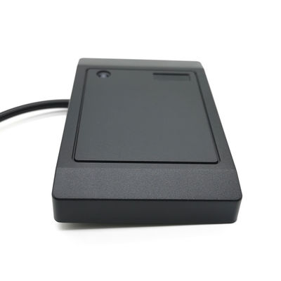 | RFID Scanner  INSTRUCTIONS
WHEN STARTING – RED LED LIGHT



ERROR – NOT CONNECTED Please check installation.

WHEN STARTING – FLASHING LED LIGHT



INITIALIZATION MODE: Please scan to create MASTER CARD

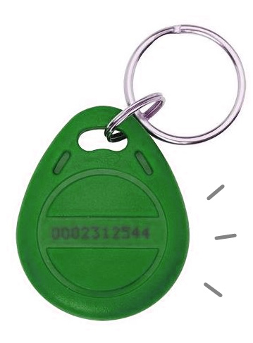  1st TAP BECOMES  MASTER ADD CARD | 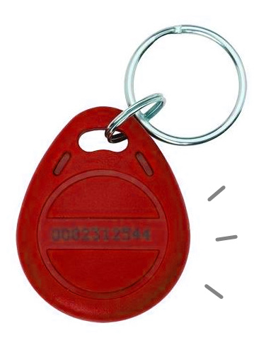  2nd TAP BECOMES  MASTER DELETE CARD | LED GREEN  (NORMAL MODE)

WHEN STARTING – GREEN LED LIGHT

NORMAL MODE: PLEASE SCAN TO ENTER

TO ADD NEW CARD
TAP  MASTER ADD CARD | FLASHING LED  (TAP TO ADD) | 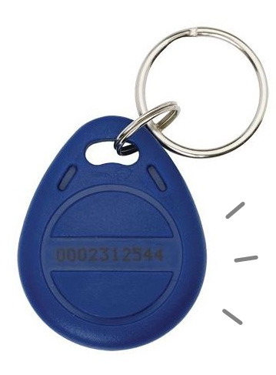  TAP  NEW ID CARD | LED GREEN  (ADDED)

TO REMOVE CARD
TAP  MASTER DELETE CARD | FLASHING LED  (TAP TO REMOVE) | TAP  EXISTING ID CARD | LED GREEN  (REMOVED)

TO REMOVE ALL CARDS (RESET)
TAP  MASTER DELETE CARD | TAP  MASTER DELETE CARD (AGAIN) | FLASHING LED  (WAIT TO STOP FLASHING) | LED GREEN  (RESET)

