Final Homework

1.**a.** 4

**b**. No

c.2

d.0.96375

e.200

f.6000

g. True

2.Conventional Neural Network is a kind of feed forward artificial neural network.It is functioned as a connectivity between its neurons which is inspired by some organization off the animal visual cortex.Some of the neurons are used to inputs of other neurons.All the gradient network are the dot products that performed using theta values that is proportional negative formed by steps.

Linear feed format is the one that doesn’t form a cycle and it also shows difference between dots that is ought to be linear or straight line.

3. 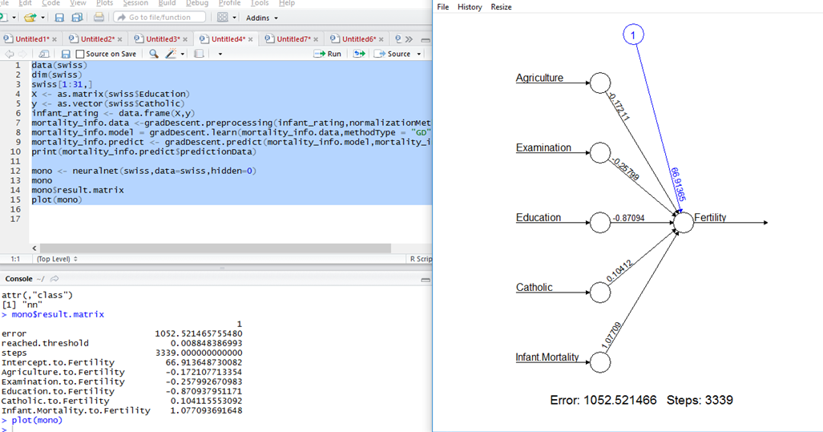

a) 1255.761

b) 2878

c)

4. 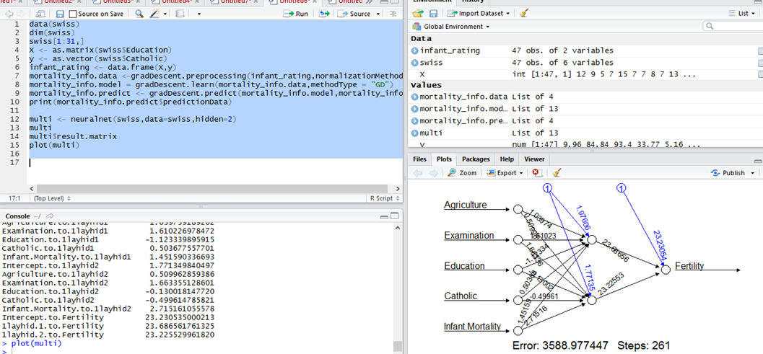

a)3865.902

b) No , “mono” is accurate when it is compared with error values.

5. a) 1254.97

b) 0.602 , 0.508