Homework 2

1.fm <- matrix(2:13,ncol=3) What value is at  fm  matrix location 3rd row 2nd column ?

Ans: 8.

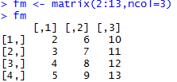

2. result = fm * fm.What value is at result matrix location 3rd row 2nd column ?

Ans : 64

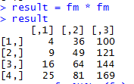

3.ans <- fm %*% t(fm)What value is at matrix location of ans 3rd row 2nd column ?

Ans : 200

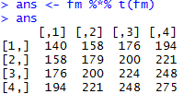

4. what's displayed as a result of mean(result)?

Ans: 68.16667



5. what's displayed as a result sd(result)

Ans:55.1936

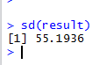

6.  ans2 <- fm + 5

What value is at ans2 matrix location 3rd row 2nd column ?

Ans: 13

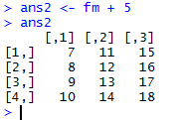

7. > x <- c(1:5)  
 > y <- c(5:1)  
 > z <- x*y

What value is in vector z , row 1, column 3?

Ans: 9

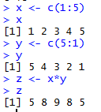

8.  What is the value of zz after this instruction?

**zz <- x%*%y**  
**> zz**

Ans: 35

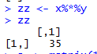

9. a <- matrix(1:9,nrow = 3,ncol=3)

r <- eigen(a) what are the eigenvalues?

Ans: $values

[1] 1.611684e+01 -1.116844e+00 -5.700691e-16

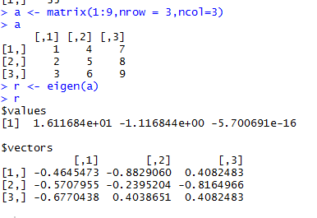

10. What is the eigenvector associated with the first eigenvalue in the instruction result r above?

**Ans:** $vectors

[,1]

[1,] -0.4645473

[2,] -0.5707955

[3,] -0.6770438

11. Execute the sample file in this week's folder and place the graph it displays as an image or pdf as an answer to this problem.

