Objective

The document describes the installation and configuration of mediaWiki.

Solution

The solution is implemented using Terraform (IaC) and Ansible (Configuration management tool). The mediaWiki application is hosted on AWS EC2 instance and configured with the mysql database.

The source code is available in the gitHub repository: <https://github.com/sdey-sag/mediawiki.git> for download

Following are the steps that need to be performed for setting up the mediaWiki

Prequesite

The setup requires a Terraform Controller Node (TCN). The following components need to be installed in the TCN server, before running the terraform scripts.

1. GIT client (sudo yum install git)
2. Terraform binary (Download from the Terraform website and place the binary in the path)
3. Python3 and PIP3 (sudo yum install python3-pip -y)
4. Ansible (pip3 install ansible –user)
5. AWS CLI (pip3 install awscli –user)
6. Boto3 (pip3 install boto3 –user) - For using ansible dynamic inventory plugin for AWS EC2

In this demo the TCN is provisioned as an AWS EC2 t2.micro instance with CentOS 7.

mediaWiki Installation and Setup:

Execute the command **aws configure** on the TCN server to configure the AWS user account access id and secret key and the default region (us-east-1) and output (JSON).

Login to the AWS console and create a custom policy with the below access privileges.

{

"Version": "2012-10-17",

"Statement": [{

"Sid": "CustomPolicyForAWSTerraform",

"Action": [

"ec2:*",

"acm:*",

"elasticloadbalancing:*",

"ssm:Describe*",

"ssm:Get*",

"s3:*"

],

"Effect": "Allow",

"Resource": "*"

}]

}

Create a Role and attach the above policy to the Role and then attach the Role to the TCN EC2 instance.

The terraform commands that will be executed on this TCN instance will make use of the attached privileges to provision AWS resources.

Login to the TCN server. Change to the home directory **/home/centos**

Download the source code from the gitHub by executing <https://github.com/sdey-sag/mediawiki.git>

Generate the SSH key pair locally in the TCN server which will be used for the SSH from the TCN to the mediaWiki node. The same key will be configured in the AWS key pair as **MyKeyPair.** Execute the below command to generate the key pair.

**ssh-keygen -t rsa**

The above command will generate the **id_rsa** and **id_rsa.pub** under **/home/centos/.ssh**

Execute the aws create bucket command to create the S3 bucket where the **terraform state file** will be stored.

**aws s3api create-bucket --bucket <s3-bucket-name> --region us-east-1**

Now open the **backend.tf** file under **/home/centos/mediawiki** and update the S3 bucket name with the above bucket name.

Now the pre configuration steps are done and the scripts are ready for execution.

Go to the directory **~/mediawiki** and execute **terraform init**. This will initialize the Terraform backend with the S3 bucket and download the AWS providr plugins

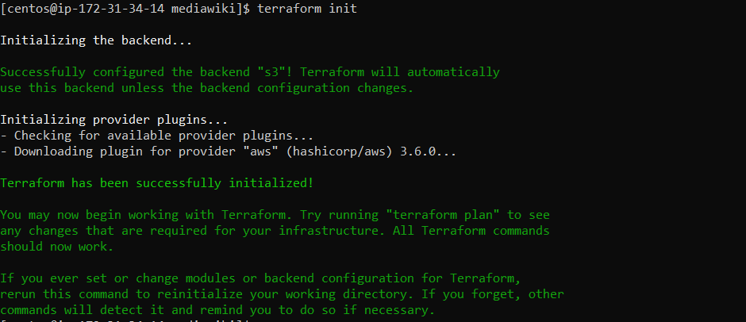

Same directory execute **terraform validate** if you wantto validate the terraform scripts

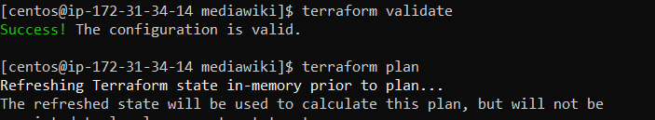

Now execute **terraform plan** that will give the details about of the AWS resources that will be provisioned.

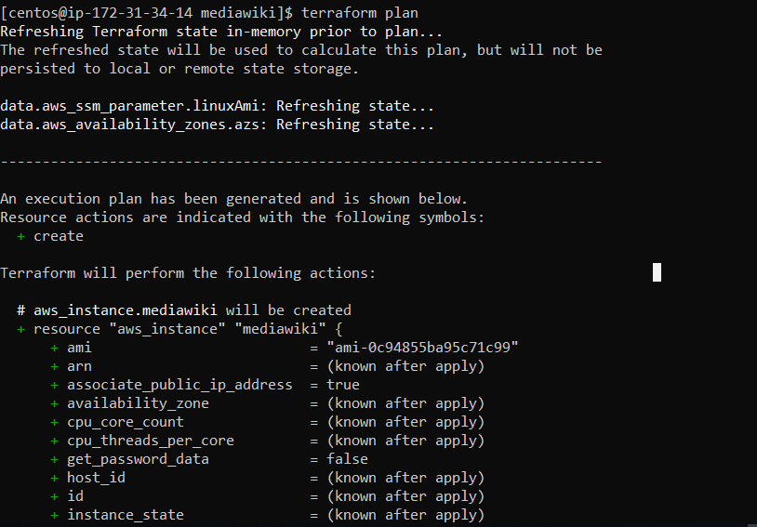

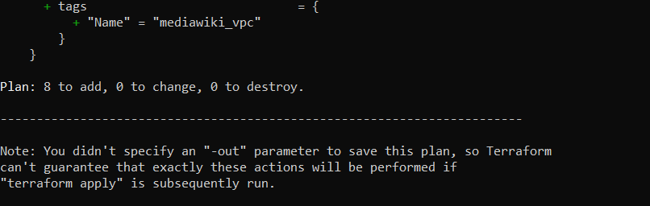

Execute now **time terraform apply --auto-approve** to start provisioning the AWS resources: VPC, Public Subnet, IGW, Route Table, Security Groups, Key Pair and EC2

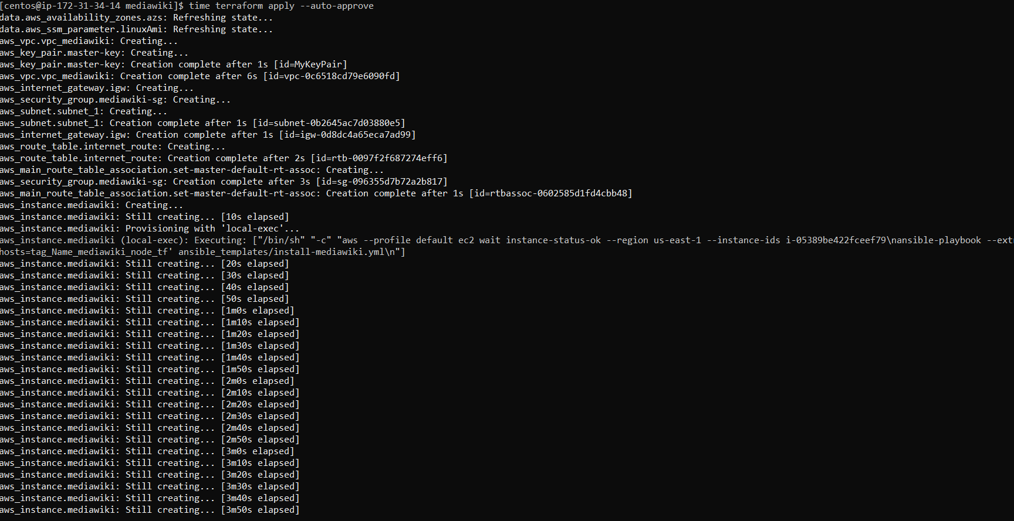

Once the Terraform scripts are executed, it will then trigger the Ansible playbook **install-mediawiki.yml** for the installation and configuration of the mediaWiki node.

The playbook will also configure the mysql database that will be later required later to configure on the mediaWiki page.

**Note:** In the below screen shot the MediaWiki-Host-PublicIP will output the Public IP of the mediaWiki node and the same will be used to access the mediaWiki page on the browser.

http://<MediaWiki-Host-PublicIP>/mediawiki

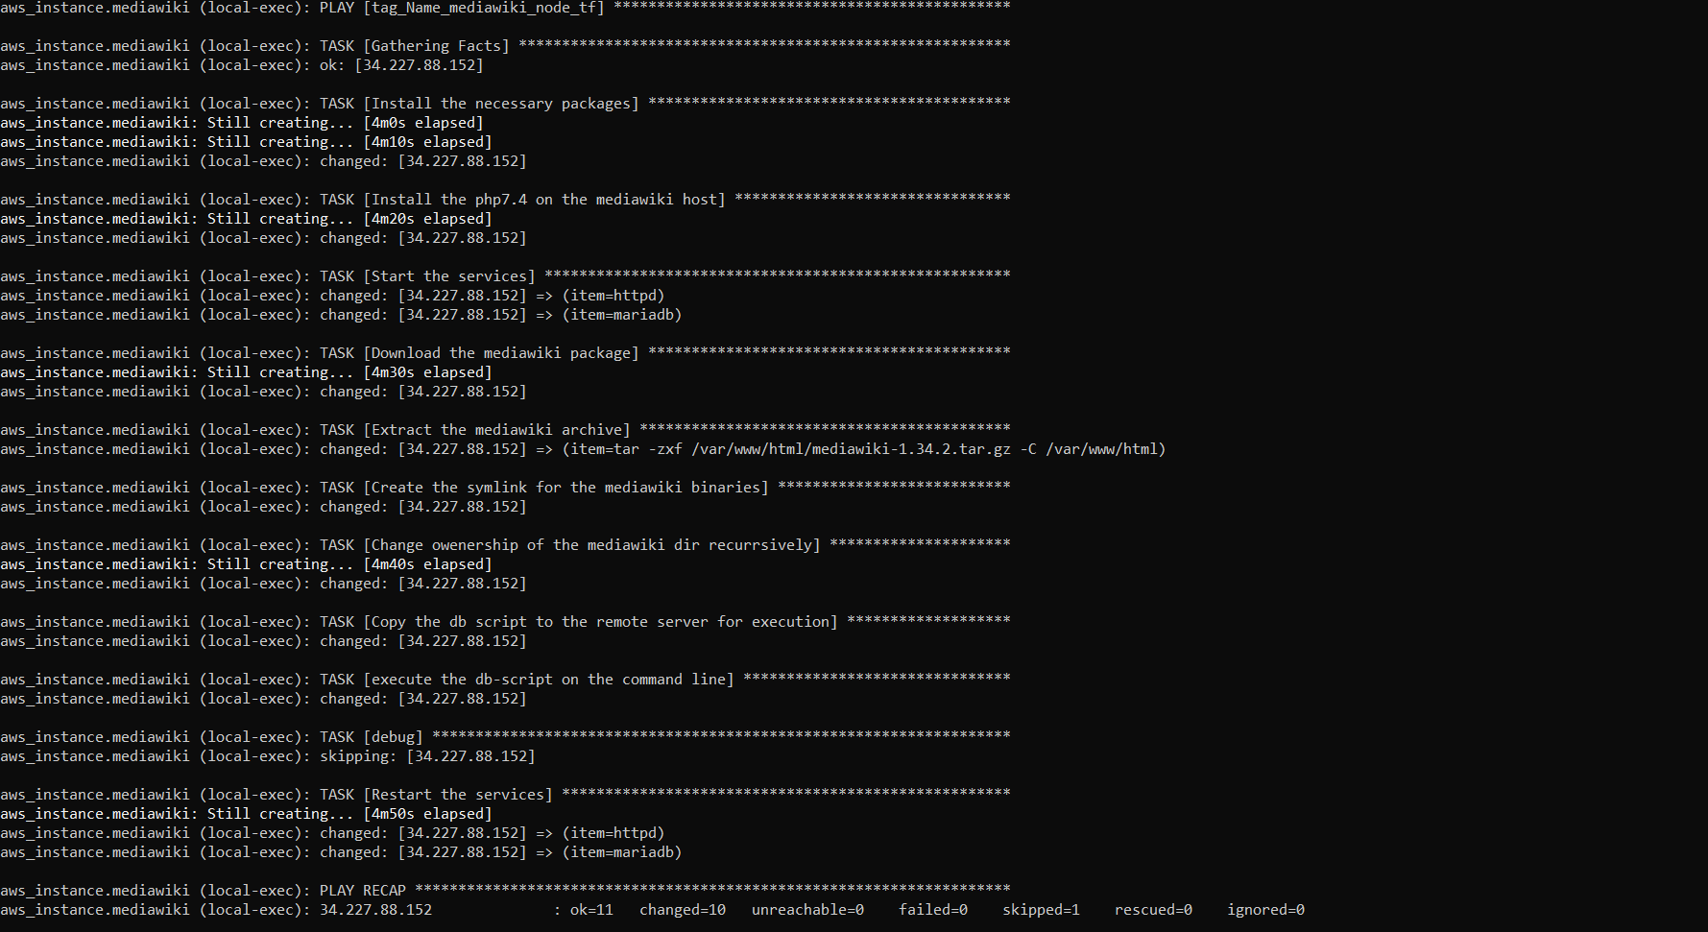

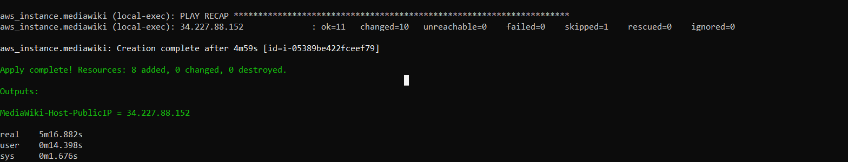

Access the URL: http://<MediaWiki-Host-PublicIP>/mediawiki on the browser. Click on the link to start the mediawiki setup. Click on Continue and proceed

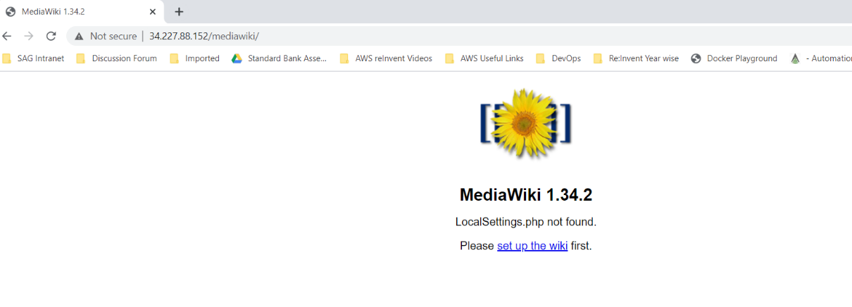

Select the DB as the MySQL

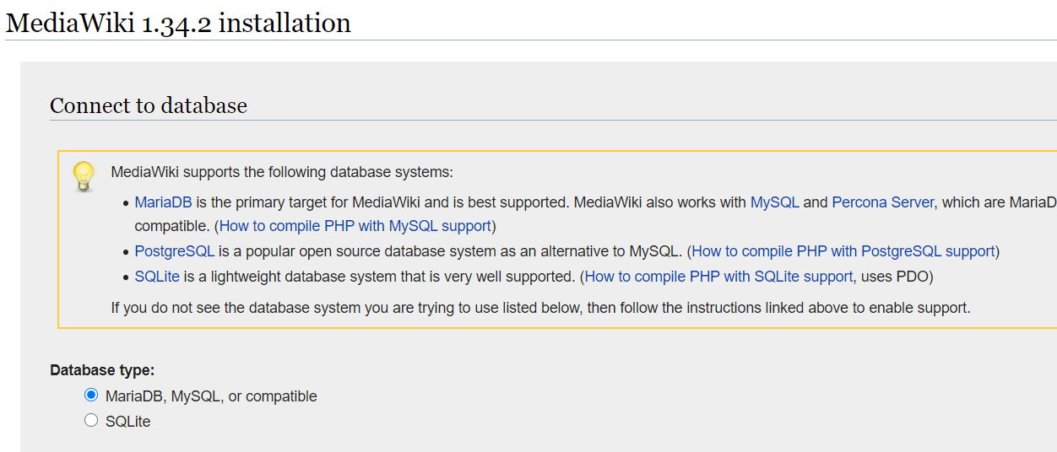

Give the Database details as shown in the screen shot below and Database Password: **manage**

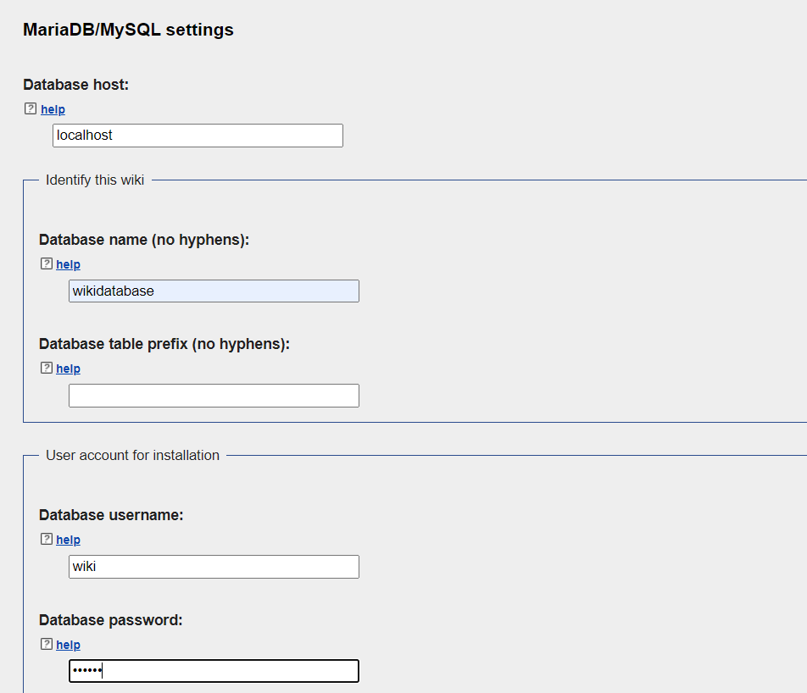

Enter the User name and password. Remember the details as they will be required later to login to your mediawiki page.

Select „I‘ m already bored“ and continue and let the installaiton continue.

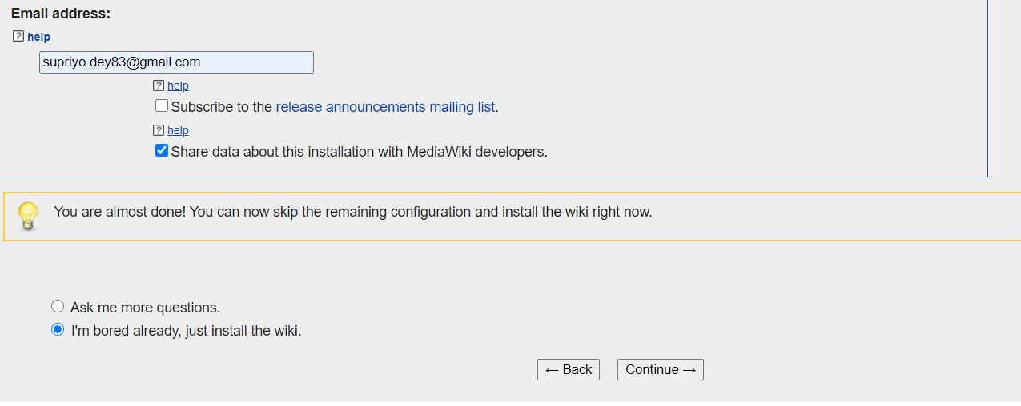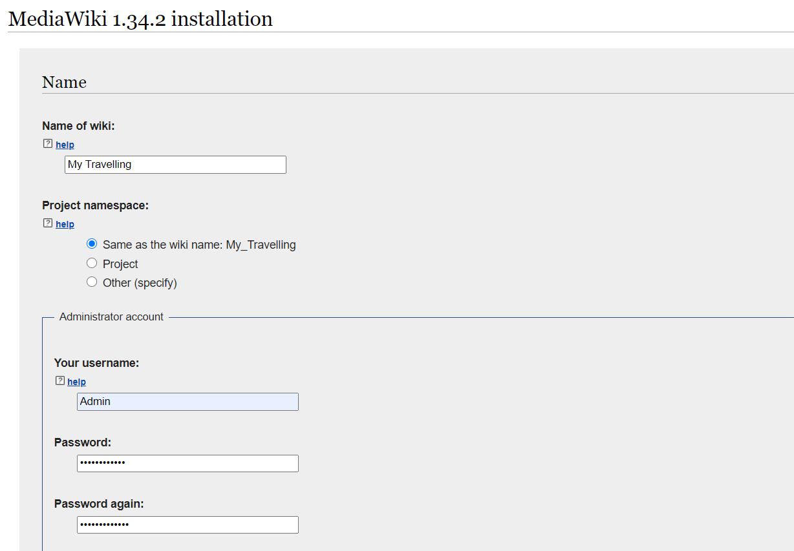

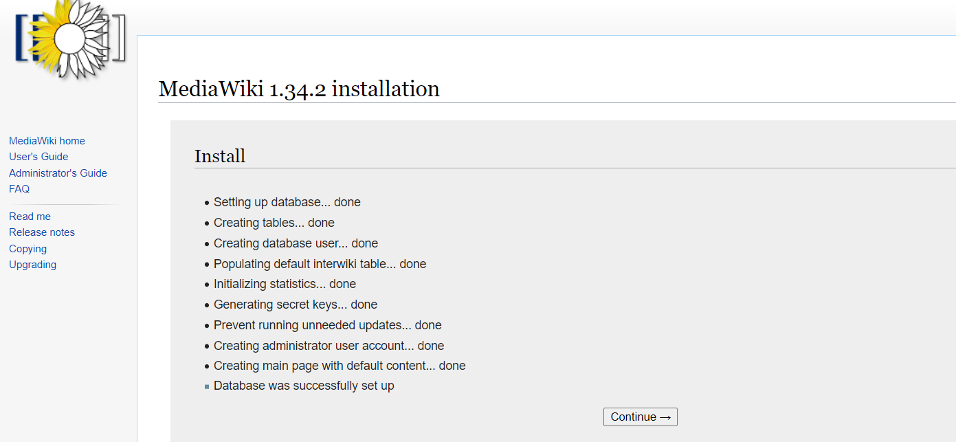

Download the **LocalSettings.php** file and copy it in the **/var/www/html/mediawiki-1.34.2**

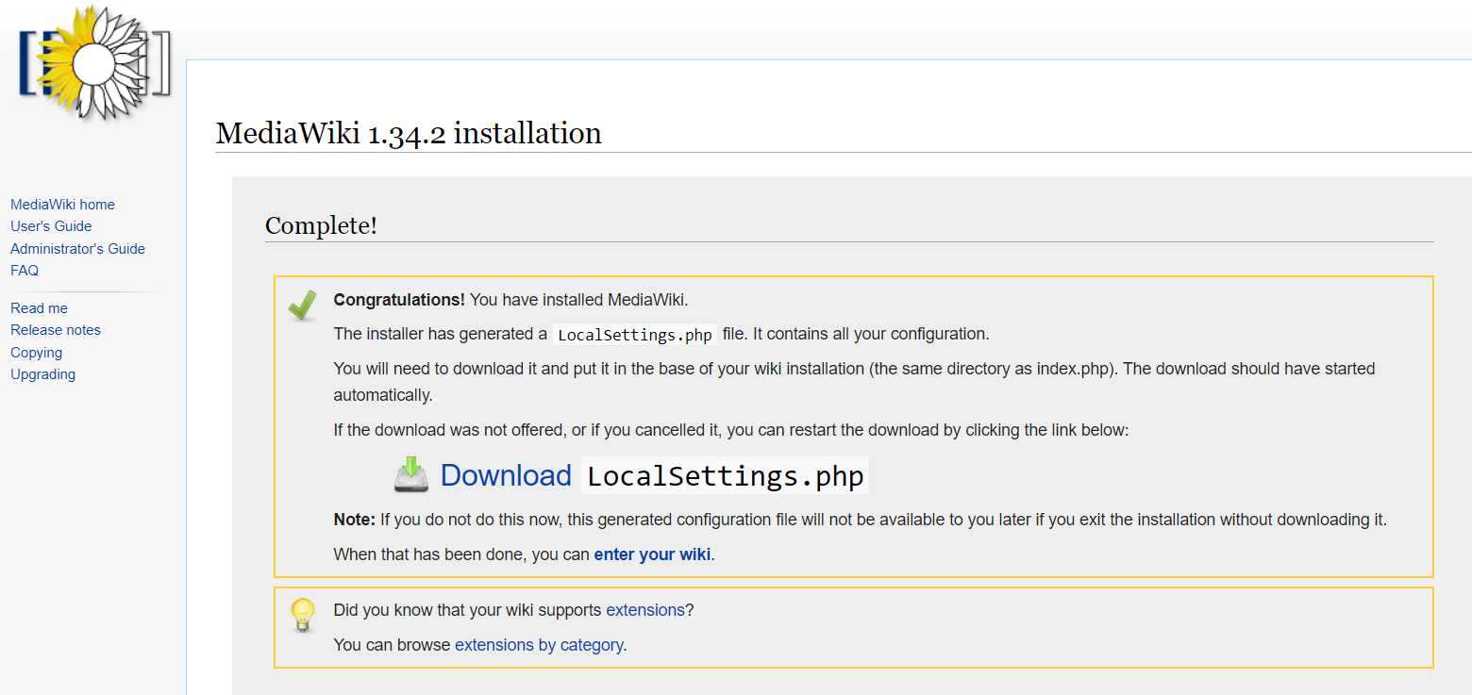

Restart the application (httpd) in the mediawiki node

Access the URL again and Login with the earlier credentials that you have cnfigured.

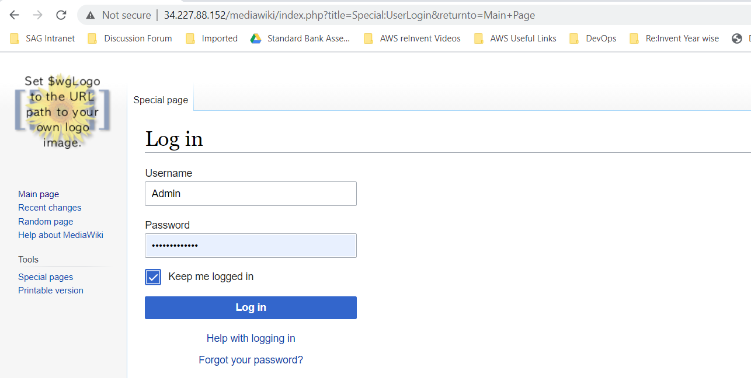

Now the mediaWiki is all set to host your content.

