Evaluation of Deep Learning Architectures for Predicting GPCR-Mediated Neurotoxicity
Souvik Dey^{1,2}, Pinyi Lu^{1,2}, Anders Wallqvist¹*, and Mohamed Diwan M. AbdulHameed^{1,2}*
¹Department of Defense Biotechnology High Performance Computing Software Applications Institute, Defense Health Agency Research & Development, Medical Research and Development Command, Fort Detrick, MD, USA
²The Henry M. Jackson Foundation for the Advancement of Military Medicine, Inc., Bethesda, MD, USA

*Corresponding Authors:
AW - E-mail: sven.a.wallqvist.civ@health.mil; Telephone: (301) 619-1989
MDMA - E-mail: mabdulhameed@bhsai.org; Telephone: (301) 619-1974
DoD Biotechnology High Performance Computing Software Applications Institute
Defense Health Agency Research & Development
Medical Research and Development Command
ATTN: FCMR-TT, 504 Scott Street
Fort Detrick, MD 21702-5012

Supplementary Material

Table S1. Details of the proteins on the unseen proteins test set
Gene names | UniProt ID | Protein names | GPCR family
NTSR2 | O95665 | Neurotensin receptor type 2 | A
LHCGR | P22888 | Lutropin-choriogonadotropic hormone receptor | A
HCRTR1 | O43613 | Orexin/hypocretin receptor type 1 | A
P2RY1 | P47900 | P2Y purinoceptor 1 | A
GRM3 | Q14832 | Metabotropic glutamate receptor 3 | C
HTR1E | P28566 | 5-Hydroxytryptamine receptor 1E | A
OPRD1 | P41143 | Delta-type opioid receptor | A
NTSR1 | P30989 | Neurotensin receptor type 1 | A
CHRM4 | P08173 | Muscarinic acetylcholine receptor M4 | A

Table S2. Performance metrics for the seven models for the off-target profiling task
Model | Accuracy | Sensitivity | Specificity | MCC | AUROC
CosSim | 0.785 ± 0.018 | 0.374 ± 0.025 | 0.912 ± 0.025 | 0.338 ± 0.041 | 0.640 ± 0.012
Transformers | 0.744 ± 0.017 | 0.472 ± 0.053 | 0.827 ± 0.021 | 0.296 ± 0.048 | 0.632 ± 0.013
CA-Base | 0.795 ± 0.010 | 0.494 ± 0.041 | 0.888 ± 0.018 | 0.403 ± 0.029 | 0.714 ± 0.017
CA-Lig | 0.794 ± 0.021 | 0.506 ± 0.037 | 0.882 ± 0.024 | 0.407 ± 0.051 | 0.698 ± 0.014
CA-Prot | 0.670 ± 0.028 | 0.331 ± 0.102 | 0.774 ± 0.064 | 0.103 ± 0.040 | 0.553 ± 0.025
CA-Full | 0.709 ± 0.009 | 0.410 ± 0.044 | 0.802 ± 0.025 | 0.208 ± 0.014 | 0.606 ± 0.010
XGB | 0.754 ± 0.014 | 0.353 ± 0.031 | 0.878 ± 0.013 | 0.257 ± 0.042 | 0.623 ± 0.011
MCC: Matthews correlation coefficient; AUROC: area under the receiver operating characteristic curve; CosSim: dual-projection cosine similarity networks; CA-Base: bidirectional cross-attention with frozen protein and ligand encoders; CA-Lig: fine-tuned ligand encoders; CA-Prot: fine-tuned protein encoders; CA-Full: fine-tuned ligand and protein encoders; XGB: XGBoost.

Table S3. Individual performance metrics for all the proteins in the test set (unseen proteins) during an individual run of the CA-Base model
Protein | No. of ligands | % of active interactions | Ligand similarity | Label difference | Accuracy | Sensitivity | Specificity | MCC | AUROC
NTR2 | 154 | 0.76 | 0.517 | 0.546 | 0.269 | 0.043 | 0.984 | 0.041 | 0.513
LSHR | 49 | 0.20 | 0.374 | 0.380 | 0.800 | 0.020 | 1.000 | 0.057 | 0.510
OX1R | 6153 | 0.46 | 0.658 | 0.483 | 0.547 | 0.350 | 0.716 | 0.073 | 0.533
P2RY1 | 797 | 0.69 | 0.373 | 0.665 | 0.454 | 0.296 | 0.802 | 0.102 | 0.549
GRM3 | 160 | 0.29 | 0.588 | 0.274 | 0.718 | 0.170 | 0.945 | 0.176 | 0.558
5-HT1E | 87 | 0.05 | 0.596 | 0.320 | 0.837 | 0.550 | 0.851 | 0.230 | 0.701
OPRD | 4989 | 0.39 | 0.634 | 0.398 | 0.664 | 0.570 | 0.725 | 0.300 | 0.647
NTR1 | 570 | 0.36 | 0.422 | 0.413 | 0.730 | 0.575 | 0.816 | 0.408 | 0.696
ACM4 | 1417 | 0.28 | 0.567 | 0.300 | 0.800 | 0.460 | 0.931 | 0.465 | 0.695
MCC: Matthews correlation coefficient; AUROC: area under the receiver operating characteristic curve.

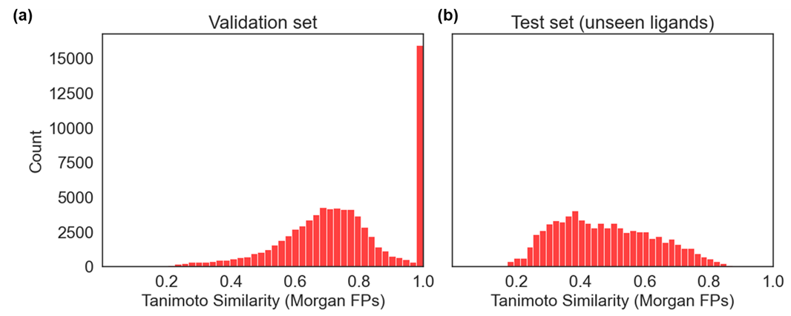Figure S1. Distribution of the Tanimoto similarity calculated using 2,048-bit Morgan fingerprints (FPs) among the compounds in the (a) validation set and (b) test set (unseen ligands) against the five nearest neighbors in the training set.

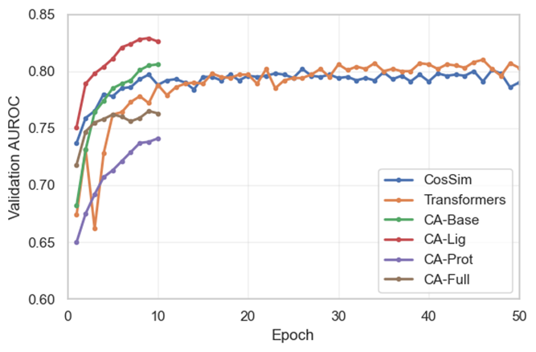
Figure S2. Comparison of validation area under the receiver operating characteristic curve (AUROC) values across multiple epochs for all the models. CosSim: dual-projection cosine similarity networks; CA-Base: bidirectional cross-attention with frozen protein and ligand encoders; CA-Lig: fine-tuned ligand encoders; CA-Prot: fine-tuned protein encoders; CA-Full: fine-tuned ligand and protein encoders.

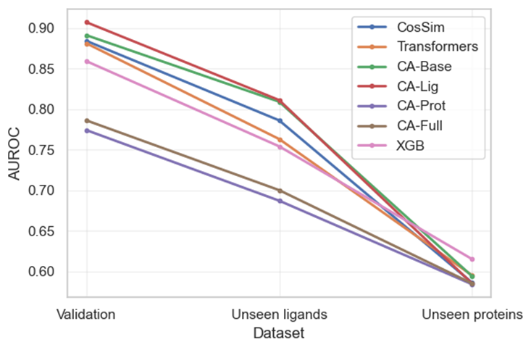
Figure S3. Drop in the area under the receiver operating characteristic curve (AUROC) values for all the models across the different validation protocols. CosSim: dual-projection cosine similarity networks; CA-Base: bidirectional cross-attention with frozen protein and ligand encoders; CA-Lig: fine-tuned ligand encoders; CA-Prot: fine-tuned protein encoders; CA-Full: fine-tuned ligand and protein encoders; XGB: XGBoost.

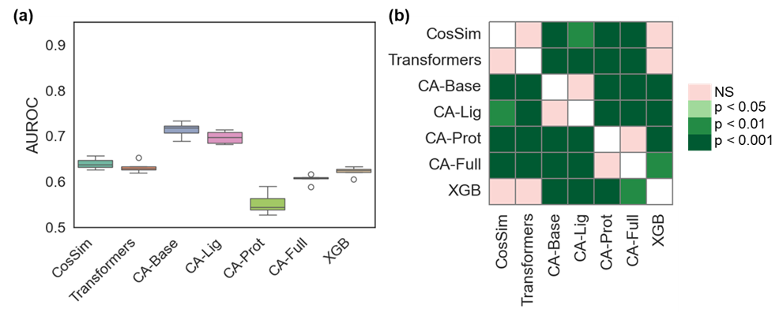
Figure S4. Comparison of model performance for predicting off-target profiling in ligands with at least five G protein-coupled receptor (GPCR) targets. (a) Boxplots comparing the area under the receiver operating characteristic curve (AUROC) for our seven models. (b) Sign plots showing the pairwise significance matrices obtained using the Conover-Friedman test. CosSim: dual-projection cosine similarity networks; CA-Base: bidirectional cross-attention with frozen protein and ligand encoders; CA-Lig: fine-tuned ligand encoders; CA-Prot: fine-tuned protein encoders; CA-Full: fine-tuned ligand and protein encoders; XGB: XGBoost; NS, not significant.

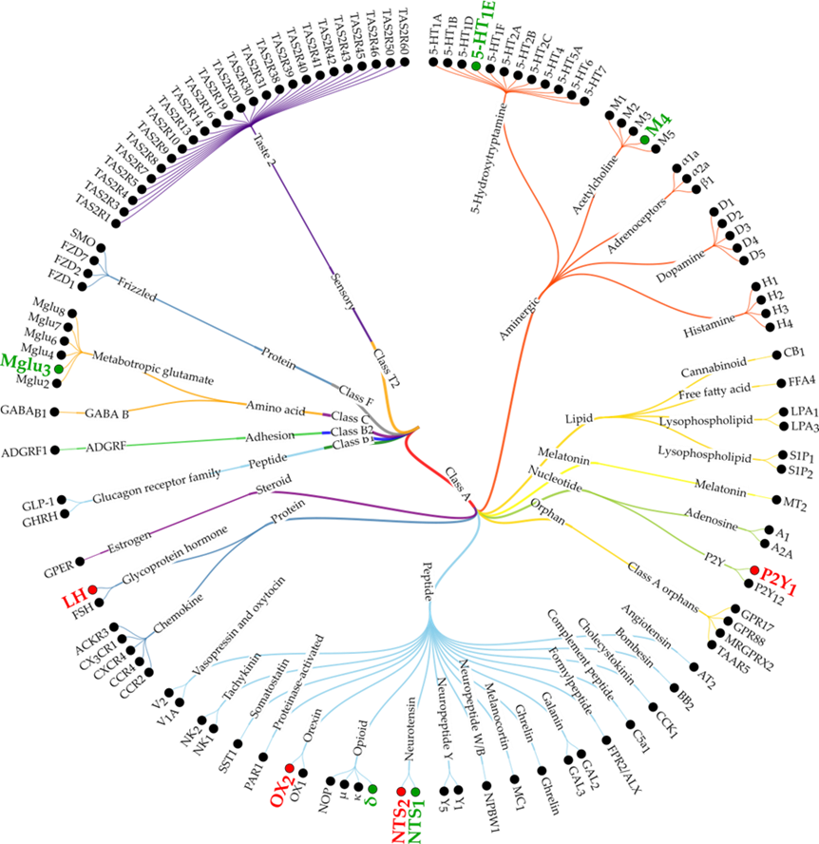
Figure S5. Phylogenetic tree showing the distribution of the 119 G protein-coupled receptors (GPCRs) in our dataset. The GPCRs present in the test set (unseen proteins) are highlighted in green or red based on whether their individual Matthews correlation coefficient (MCC) values were better or worse, respectively, than the average MCC.

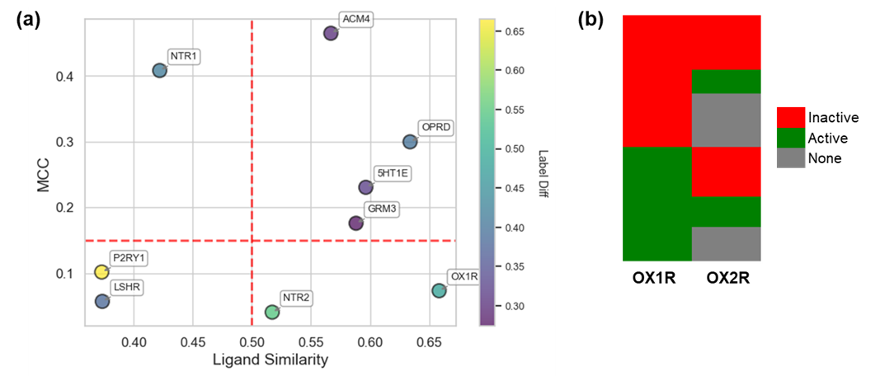
Figure S6. Further insights into model performance on the test set (unseen proteins) during one run of the CA-Base model. (a) Comparison of the Matthews correlation coefficient (MCC) for the nine proteins in the test set against their ligand similarity in the training set, colored by label difference. Dotted red lines separate MCC and ligand similarity values greater than and less than 0.15 and 0.50, respectively. (b) A detailed comparison of the ligand activity of the protein OX1R against its close analogue OX2R present in the training set. Only ligands with activity against OX1R are shown and sorted by activity.

