CYBR8420 – Software Assurance
GotRoot? - BitWarden (CLI)
Robert Ernewein

Basic information

Download: BitWarden – Client Interface (CLI) Windows x64
Link: https://vault.bitwarden.com/download/?app=cli&platform=windows
Format: Zipped executable
File Name: bw.exe
Size: 53.6 MB

New Account created: 20191107@2247

Initial testing

Attempt to determine External Interactors from the Application System using Task Manager, Resources Monitor, & Event Viewer Logs.

Open Command Prompt: cmd

Initial state with command prompt open:

Applications: 4
Processes, Background: 42
Processes, Windows: 95

Command | PID | Commit (KB) | Working (KB) | Shared (KB) | Private (KB)
bw | 22508 | 73,596 | 67,400 | 13,224 | 54,176
bw login | 20336 | 70516 | 80444 | 15004 | 65440
bw login e-mail pw |  | 71184 | 83352 | 16528 | 67004
bw unlock | 20888 | 97908 | 107876 | 14344 | 95532
bw lock | 20348 | 107868 | 118052 | 14592 | 103460

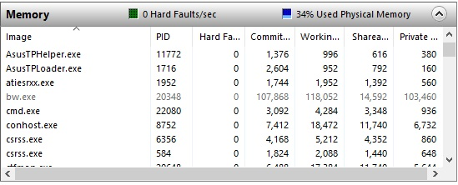
Each of the commands above were executed multiple times as well the following:

bw -v
bw --help
bw sync
bw logout

Initial Findings

Task Manager: No instances, spawned processes, or service changes were indicated. All activity appeared to be contained with the command prompts process space.

Resource Manager: However, BitWarden’s memory footprint was indicated following each command performed (See: Table and Image above).

Note: Resource Manager updates the status of background and system processes once per second, but the Windows Memory Manager maintained the resource allocation for 30 seconds before releasing it as cache/available memory. This allowed me to look at the process space.

Event Viewer: Surprisingly, there were no indications in any of the logs of BitWarden’s interactions.

Conclusion

These findings lead me to believe that all of BitWarden’s functional components are operating within a single process space. I am curious about the contents of the shared memory space and which processes are tied in. I ran about 3 dozen commands and averaged 14.6 MB of shared memory per instance.

The application is only resident while processing a command, but it may be possible to capture the contents of the application space using FTK Imager or logging its execution within a Virtual Machine/Container.

