**Given the provided data, what are three conclusions that we can draw about crowdfunding campaigns?**

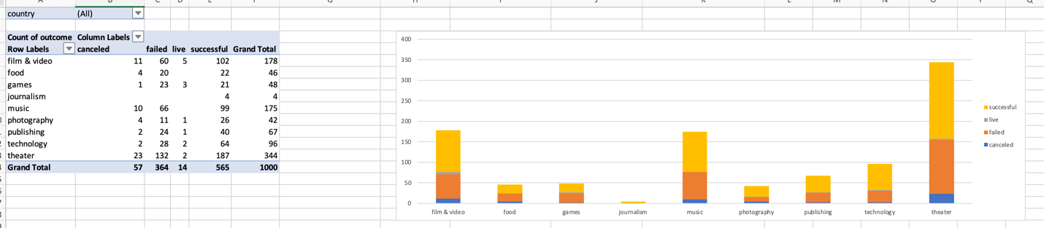

1. Even with such a variety of categories there seems to be a concentration of campaigns in theater, film & video, and music. So, the campaigns are skewed, and unevenly distributed between the categories.
2. Theater campaigns are the most common and have the highest number of successful campaigns – they also have the highest number of failed campaigns.
3. Despite having the fewest campaigns, Journalism has the highest success rate since there have been no failed or canceled campaigns. It is also the only category with no active campaigns, so they seem to be much less frequent than other categories like film & video which currently has the most active campaigns.

**What are some limitations of this dataset?**

Limitations include that the currency needs to be converted prior to comparing since it includes various currencies. There is also no indication if goals were revised at any point, which could impact their success. It is also limited by the fact that it is a static pull of data and could become stale if any of these campaigns are updated, which would results in the need to repull and regenerate this analysis.

**What are some other possible tables and/or graphs that we could create, and what additional value would they provide?**

We could create a graph that shows amount pledged by month to identify if there is a certain month that leads to more money, and this could be added to the outcomes by month to see if those relate.

A table containing information about whether the creator of the campaign already had an existing audience or not would be extremely valuable. It would highlight whether an existing audience to crowdfund from is necessary.

We could also create a graph that displays the goal and the outcome to see if there’s any relation to how much a campaign needs to raise and if they succeed or not. Knowing this would let us set a reasonable goal and would be good to keep in mind when selecting a product. If less expensive campaigns usually get funded then we could choose that route, or vice versa.

We could create a graph that displays the relationship between outcome and if that project was spotlight or not. Depending on the relationship then we could push for being in the spotlight.

A graph displaying average campaign duration and outcome would inform us of any relationship between those features. This would allow us to carefully select a fundraising duration to maximize success.

A graph displaying the relationship between outcome and country would also be informative and valuable since it would show us where campaigns experience the most success.