Create a Web Application

First, you will create a web application that you will use Page Inspector with. In Visual Studio, choose **File** > **New Project**. On the left, expand **Visual C#**, select **Web**, and then select **ASP.NET Web Forms Application**.

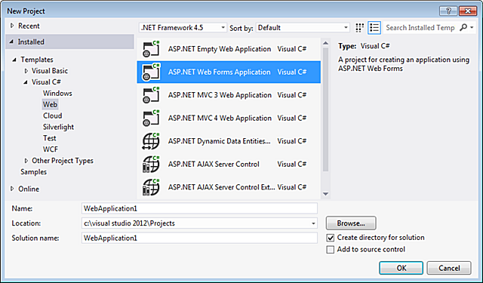

Click **OK**.

The application opens in **Source** view.

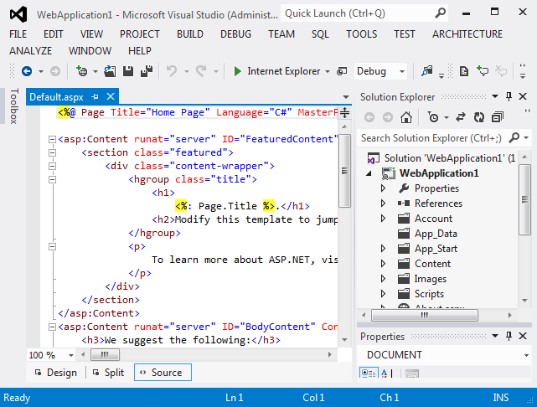

Now that you have an application to work with, you can use Page Inspector to examine and modify it.

Use Page Inspector to View the Application

Next, you will view the application with Page Inspector. In **Solution Explorer**, right click the project, and then choose **View in Page Inspector**.

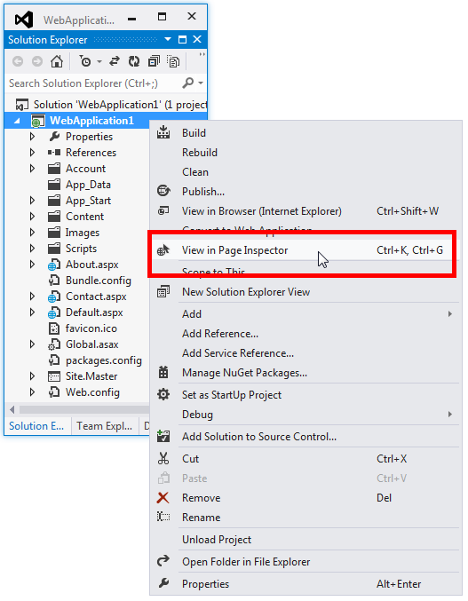

By default, when Page Inspector launches for the first time, it is docked as a narrow window on the left side of the Visual Studio environment. Leave it docked on the left side and set it to a width that is comfortable for you, or dock it in one of the tool areas on the top, bottom, or right:

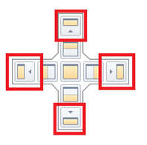

If you undock the Page Inspector window, you can place it outside Visual Studio, or even on a second monitor if you have one. However, in order to ALT+TAB between Page Inspector and Visual Studio when the Page Inspector window is undocked, go to **Tools** > **Options** > **Environment** > **Tabs and Windows**, and under **Tab Well**, clear the check box called **Floating tool windows always stay on top of the main window**:

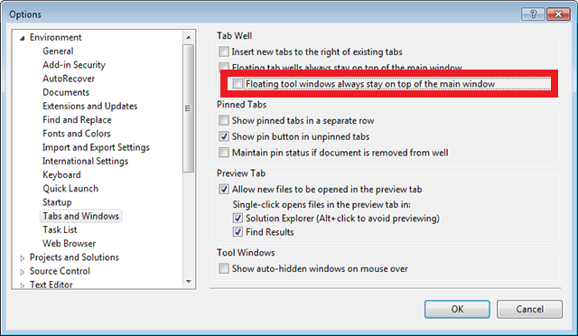

The top pane of the Page Inspector window shows the current page in a browser window. The bottom pane shows the page in HTML markup on the left, and some tabs on the right that let you inspect different aspects of the page. The bottom pane is similar to the [F12 Developer Tools](http://msdn.microsoft.com/en-us/ie/aa740478) in Internet Explorer. (However, unlike the developer tools, you can use Page Inspector right within Visual Studio.)

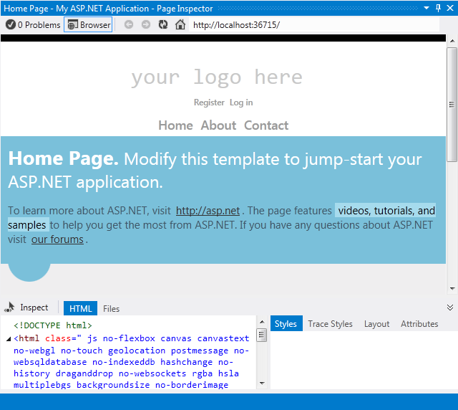

In this tutorial, you will use the Page Inspector browser pane, and the **HTML** and **Styles** tabs to help you rapidly navigate and make changes to the application.

Enable Inspection Mode

Next, you will see how Page Inspector’s Inspection Mode works. In the Page Inspector window, click the **Inspect** button.

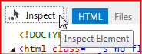

To see inspection mode in action, move your mouse over different parts of the page within the Page Inspector browser window. As you do, the mouse pointer changes to a large plus sign, and the element underneath is highlighted:

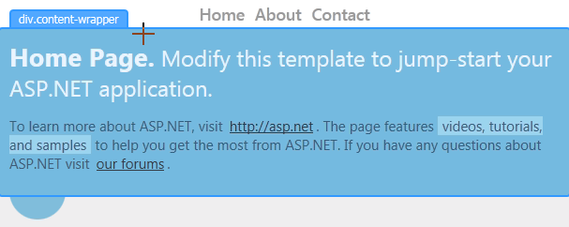

As you move the mouse pointer, note that

* The content in **Source** view changes to show the markup corresponding to the selected element on the page. The relevant markup is highlighted. If the source is in another file, that file is opened in Source view with the relevant markup highlighted.
* The markup displayed in the **HTML** tab in Page Inspector also changes to correspond to the selected element on the page. In the **HTML** tab, the relevant markup is outlined.
* The **Styles** tab shows the CSS rules relevant to the current selection.

Use Page Inspector to Make Changes to Markup

Now you will see how you can use Page Inspector to find and make changes to markup or text whose location might not be immediately obvious.

Put Page Inspector in Inspection Mode and then scroll to the bottom of the home page.

As soon as you enter the footer area, Page Inspector opens the *Site.Master* layout file in **Source** view in a temporary tab to the right of the other tabs and highlights the section of the master page that you have selected. This shows you how Page Inspector can find and display content on a page that might actually come from a different file than the one you originally opened.

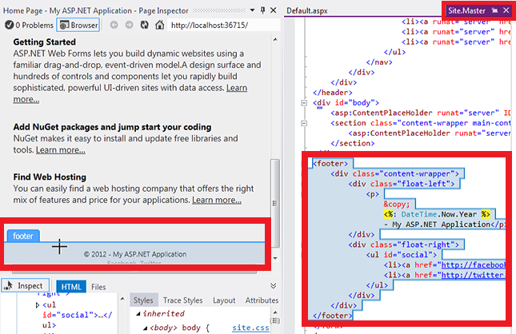

In the Page Inspector browser window, move your mouse pointer over the line with the copyright notice.

In the *Site.Master* page, the corresponding line is highlighted.

Footer copyright line highlighted

Add some text to the end of the line in the *Site.Master* file.

<p>&copy; <%: DateTime.Now.Year %> - My ASP.NET Application Rocks!</p>

Now, press Ctrl+Alt+Enter or click the Update Bar to see the results in the Page Inspector browser window.

My ASP.Net Application Rocks!

You might have thought that the footer was on the *Default.aspx* page, but it turned out to be in the master layout page, and Page Inspector found it for you.

Inspection Mode and the HTML Window

Next, you will have a quick look at the HTML window and how it maps elements for you.

Put Page Inspector in Inspection Mode.



Click the top part of the page that says “your logo here”. You are examining a particular element in more detail, so the display in the browser window no longer changes as you move the mouse pointer.

Now move the mouse pointer to the **HTML** window. As you move the mouse pointer, Page Inspector outlines the element within the **HTML** window and highlights the corresponding element in the browser window.

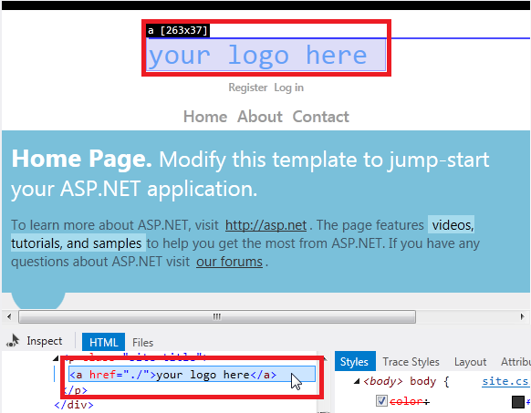

As before, Page Inspector opens the *Site.Master* file for you in a temporary tab. Click the Site.Master tab, and the corresponding markup is highlighted in the <header> section:

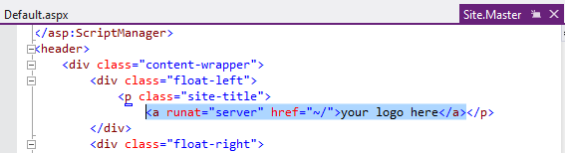

Preview CSS Changes in the Styles Window

Next, you will see how you can use the Page Inspector **Styles** window to preview changes to CSS.

Click the **Inspect** button to put Page Inspector in Inspection Mode.

In the Page Inspector browser window, move the mouse pointer over the “Home Page” section until the **div.content-wrapper** label appears.



Click within the div.content-wrapper section once, and then move the mouse pointer to the **Styles** window. Under the .featured .content-wrapper class selector, clear and select the checkbox for the background-color property.

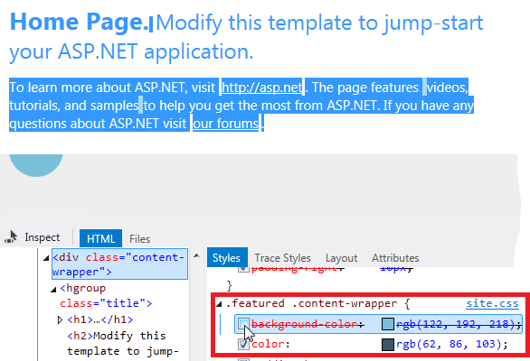

Notice how the change previews instantly in the Page Inspector browser window.

Select the checkbox again, then double-click the property value and change it to red. The change shows immediately:

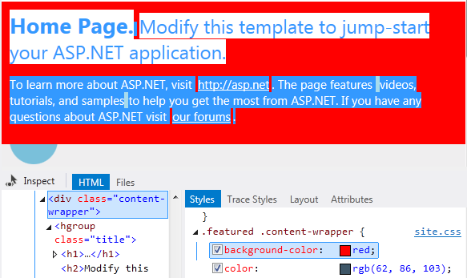

The **Styles** window makes it easy to test and preview CSS changes before you commit the changes to the style sheet itself.