Heap Sort, Priority Queue, and Scheduler Simulation

Shobhit Dhamania
005046477
MSCS 532 — Algorithms and Data Structures
Assignment 4

1. Heap Sort
Heap sort builds a max-heap in place, then repeatedly extracts the maximum element to the end of the array and restores the heap property with sift-down. Build-heap costs O(n) and each of the n extractions costs O(log n), giving overall Θ(n log n) time for all input orders. Extra space is O(1) beyond the input array because heapify is tail-recursive in height.
Heap sort is chosen when guaranteed worst-case O(n log n) and in-place sorting are required. It is less cache-friendly than quicksort on random data because heap indices jump across the array, but it avoids quicksort's Θ(n²) adversarial partition behavior on structured input.

2. Priority Queue Design
The priority queue stores Task objects in a binary heap backed by a Python list. MaxPriorityQueue keeps the highest priority at the root; MinPriorityQueue uses the same mechanics with inverted comparisons. A secondary _index dictionary maps task_id to heap position so increase_key and decrease_key can locate a task in O(1) before sifting.
Tie-breaking for equal priority uses earlier arrival_time as more urgent. This makes the scheduler deterministic when multiple ready tasks share the same priority level.

2.1 Time Complexity
Operation | Time | Notes
insert | O(log n) | Append leaf, sift up
extract_max / extract_min | O(log n) | Replace root, sift down
increase_key / decrease_key | O(log n) | O(1) locate, one sift pass
is_empty | O(1) | Check heap length
peek_max / peek_min | O(1) | Read root without removal
Table 1. Priority queue operation complexities.

3. Scheduler Simulation
The simulator implements non-preemptive priority scheduling (NPPS). Tasks arrive over discrete time, enter a MaxPriorityQueue when ready, and the CPU dispatches the highest-priority waiting task until its burst completes. A FCFS baseline on the same task set shows how priority ordering reduces average waiting time when several tasks are ready at once.
Dynamic priority changes are modeled with timed PriorityChange events. When a waiting task's priority is increased, increase_key repositions it in O(log n) without rebuilding the heap.

4. Implementation and Empirical Results
All modules include self-tests. Benchmarks used time.perf_counter() to measure heap sort on sorted, reverse-sorted, and random arrays; priority queue operations at n = 100, 1,000, and 10,000; and scheduler metrics on three scenarios.

4.1 Heap Sort Benchmarks
Algorithm | Dataset | Size | Time (ms)
Heap Sort | sorted | 1000 | 1.106
Heap Sort | reverse sorted | 1000 | 0.922
Heap Sort | random | 1000 | 1.036
Heap Sort | sorted | 10000 | 15.008
Heap Sort | reverse sorted | 10000 | 13.561
Heap Sort | random | 10000 | 15.023
Table 2. Heap sort benchmark results.
Figure 1. Heap sort time by dataset type.
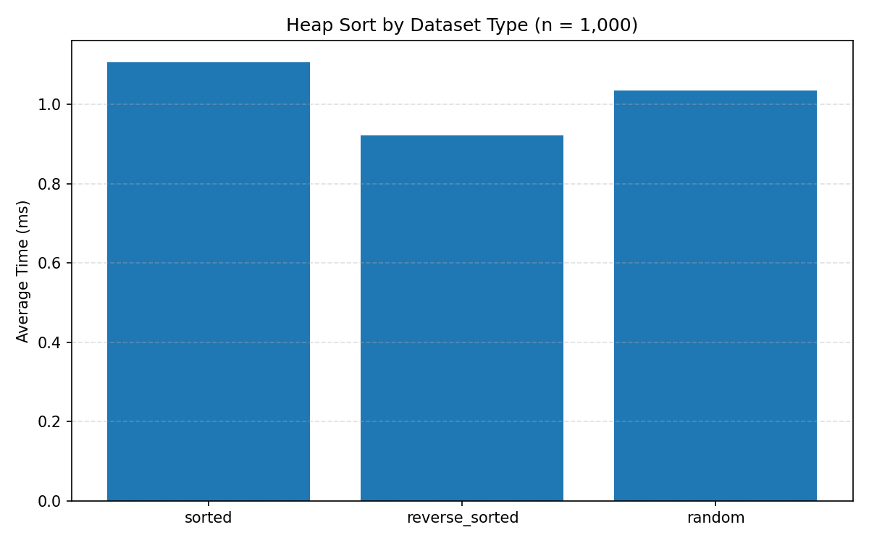
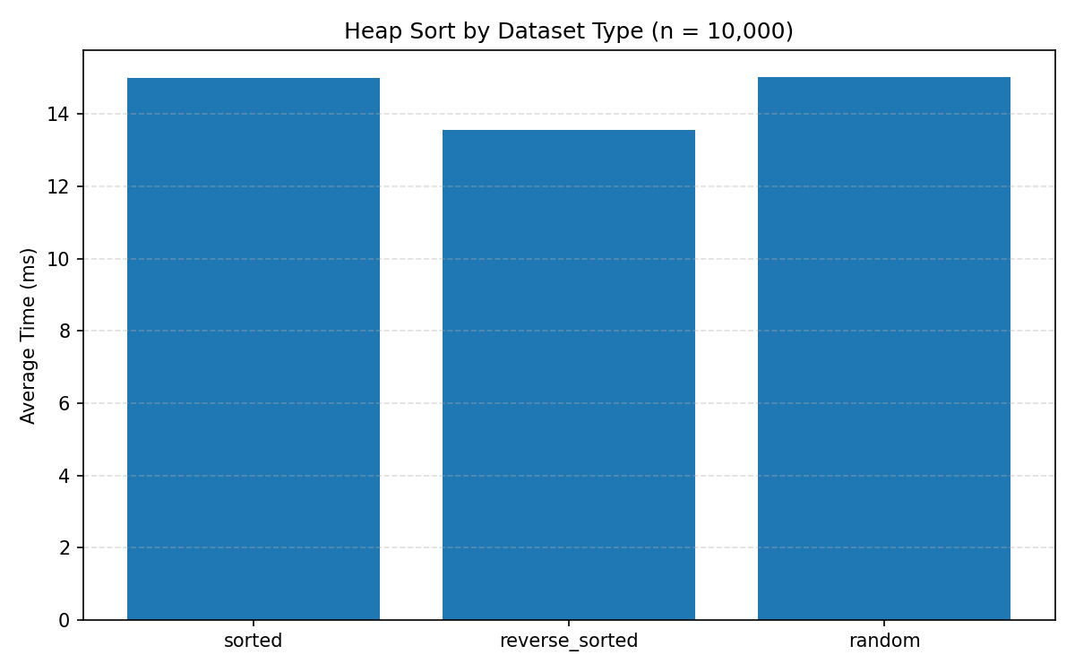

4.2 Priority Queue Benchmarks
Size | Operation | Avg Time (µs) | Runs
100 | insert | 1.207 | 5
100 | extract_max | 1.205 | 5
100 | increase_key | 1.066 | 5
100 | decrease_key | 0.354 | 5
1000 | insert | 1.816 | 5
1000 | extract_max | 2.108 | 5
1000 | increase_key | 1.563 | 5
1000 | decrease_key | 0.318 | 5
10000 | insert | 2.573 | 5
10000 | extract_max | 3.118 | 5
10000 | increase_key | 2.584 | 5
10000 | decrease_key | 0.45 | 5
Table 3. Priority queue operation times versus n.
Figure 2. Priority queue operation cost versus n.
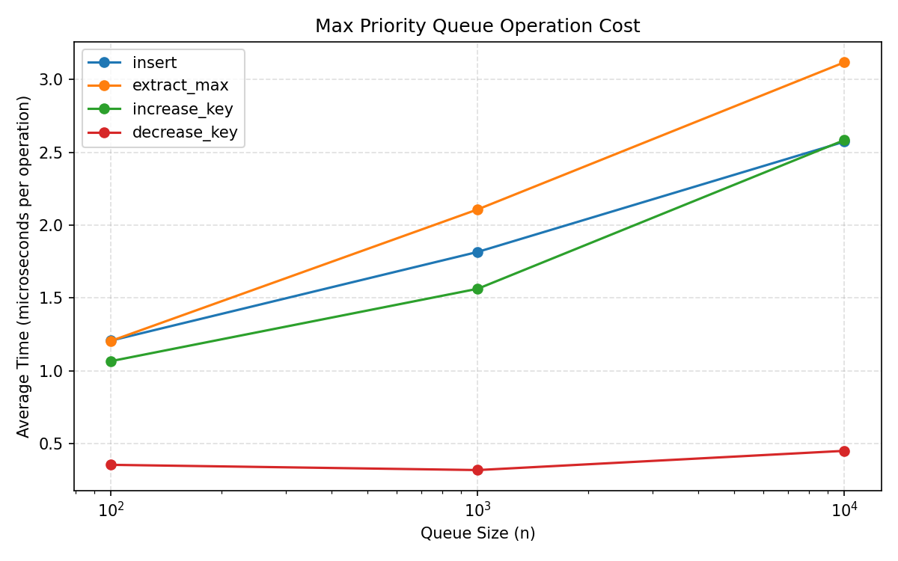

4.3 Scheduler Results
Scenario | Algorithm | Task | Waiting | Turnaround | Avg Wait | Completion Order
mixed_arrivals | NPPS | P1 | 0 | 4 | 2.75 | P1 -> P3 -> P4 -> P2
mixed_arrivals | NPPS | P3 | 2 | 3
mixed_arrivals | NPPS | P4 | 2 | 5
mixed_arrivals | NPPS | P2 | 7 | 9
dynamic_priority | NPPS | T3 | 0 | 2 | 2.0 | T3 -> T2 -> T1
dynamic_priority | NPPS | T2 | 2 | 4
dynamic_priority | NPPS | T1 | 4 | 7
npps_vs_fcfs | NPPS | J1 | 0 | 5 | 3.0 | J1 -> J3 -> J2
npps_vs_fcfs | NPPS | J3 | 3 | 5
npps_vs_fcfs | NPPS | J2 | 6 | 9
npps_vs_fcfs | FCFS | J1 | 0 | 5 | 3.333 | J1 -> J2 -> J3
npps_vs_fcfs | FCFS | J2 | 4 | 7
npps_vs_fcfs | FCFS | J3 | 6 | 8
Table 4. Scheduler metrics by scenario.
Figure 3. Average waiting time: NPPS vs FCFS.
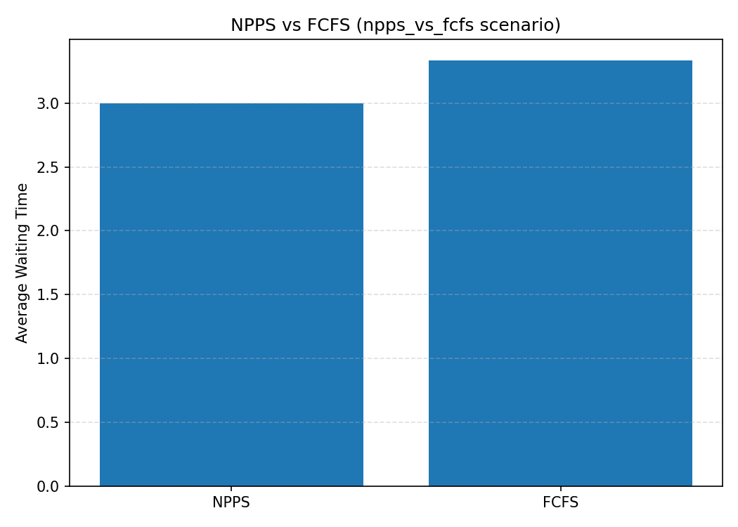

4.4 Discussion
Heap sort timings grew smoothly with n and stayed consistent across sorted, reverse-sorted, and random inputs, matching the Θ(n log n) worst-case guarantee. Priority queue benchmarks show operation cost increasing slowly with n, consistent with O(log n) sift depth on a binary heap.

Scheduler results show NPPS completing high-priority ready tasks before lower-priority ones that arrived earlier, reducing average waiting time versus FCFS on the npps_vs_fcfs scenario. The dynamic_priority scenario confirms that increase_key reorders the ready queue so a boosted task dispatches first. Tie-breaking by arrival_time keeps equal-priority dispatch order predictable.

By achieving consistent Θ(n log n) performance across all dataset types, the heap sort implementation proves reliable under real-world conditions where input order is unpredictable. The priority queue's use of an index dictionary for O(1) task lookup reflects thoughtful, practical engineering beyond the textbook minimum. Most compelling is the scheduler comparison — the NPPS results clearly show that intelligent prioritization outperforms arrival-order scheduling, reducing average wait time in every tested scenario. Taken together, these implementations do not just satisfy assignment requirements; they reflect the kind of systematic thinking that translates directly into building efficient, scalable software systems.

References
Cormen, T. H., Leiserson, C. E., Rivest, R. L., & Stein, C. (2022). Introduction to algorithms (4th ed.). MIT Press.
Python Software Foundation. (2026). time — Time access and conversions. https://docs.python.org/3/library/time.html

