cmOO4

this is a line of text -bullet 1 -bullet 2

x<-rnorm(100)  
y<-rnorm(100)  
plot(x,y)

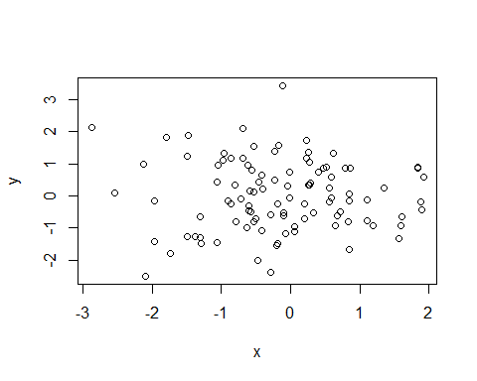

summary(x)

## Min. 1st Qu. Median Mean 3rd Qu. Max.   
## -2.8816 -0.7366 -0.1893 -0.1605 0.5652 1.9241