ARRIS Cloud Platform (ACP) 2.0 ELK User Guide

Table of Contents
Abbreviations and Acronyms 3
Overview 4
INSTALLATION 5
SECURITY 6
OPERATIONS 6
LOGFORWARDING AGENT 6
SERVER-SIDE LOGSTASH 6
ELASTICSEARCH 6
KIBANA 6
USING KIBANA 6
DISCOVER 8
VISUALIZE 8
DASHBOARD 9
SETTINGS 10
Kopf 10
Curator 11

Abbreviations and Acronyms
Acronym | Description
ACP | ARRIS Cloud Platform
ELK | Elasticsearch, Logstash, and Kibana
FQDN | Fully Qualified Domain Name
HA-ACP | Highly Available ACP
LaaS | Logging as a Service
LSC | Logstash Client
LSF | Logstach Forwarder
OSS | Open Source Software
SRDaaS | Service Registration & Discovery as a Service
SVM-ACP | Single VM ACP
VIP | Virtual IP
VM | Virtual Machine

Overview
The ACP 2.0 Logging as a Service (LaaS) provides the centralized, secure, scalable and redundant logging service to collect, store, manage and visualize all levels of system and application log data. It mainly builds upon the open source software Elasticsearch, Logatash and Kibana, so is also referred to as ACP ELK.
The following lists various open source software (OSS) versions that the ACP ELK is built upon. Note that future ACP ELK may choose to upgrade to later OSS versions should the requirements arise.
Open Source Software Component | Version
Elasticsearch | 2.1.1
Logatash | 2.1.1
Kibana | 4.3.1
Curator | 3.4.0
Kopf | 2.1.2

As the following figure shown, ACP ELK consists of the following components:
- Applications’ log-forwarding agent (such as Logstash Forwarder), which connects to ELK cluster securely via SSL to collect and forward logs generated in their specific domains to the ELK cluster. The connection is fully secured using both client and server side authentication.
- Browser client that connects to the ELK cluster securely via SSL to manage and visualize logs being collected. The connection is secured using server side only authentication.
- A redundant pair of load balancer HAProxy as the transport layer proxy for the ELK cluster. All external accesses to ELK cluster are through this proxy using domain agnostic DNS name ‘elk’.
- The 3-node ELK cluster, with each node contains the Logstash, Kibana and Elasticsearch that are running in the same Docker container.
- Etcd cluster that facilitates the dynamic discovery of ELK nodes to form the cluster, and the configuration of the HAProxy backend servers

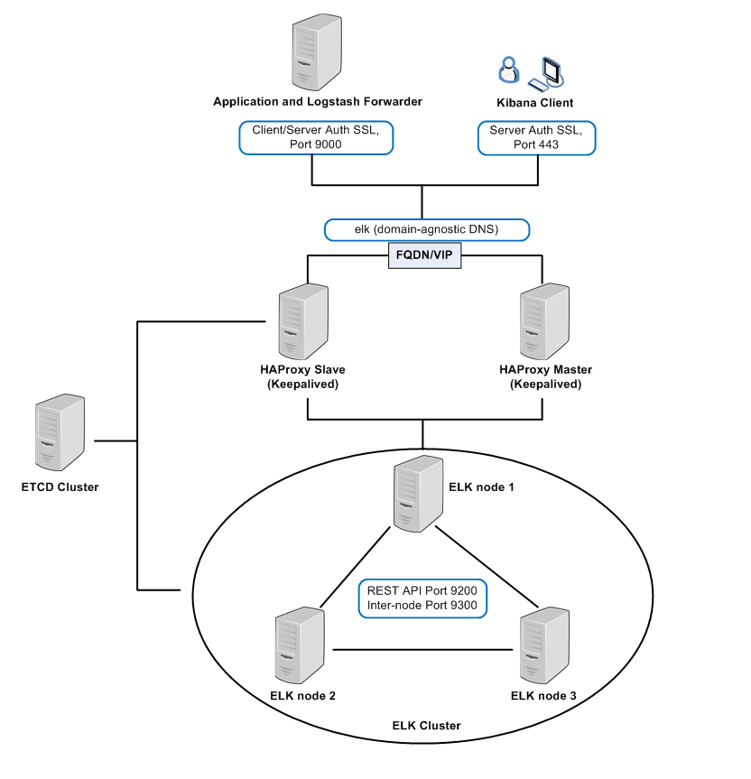
Figure 1 ACP ELK System Components

INSTALLATION
The installation of ELK is part of the ACP install process, backed by Ansible playbooks. Please refer to the ACP Installation Guide for details. A major difference between ACP ELK 2.0 and previous versions is that it now uses the ACP Etcd service to register and discover cluster nodes, so Etcd service must be up and running before installing ELK. This is also true for the HAProxy, although it was already using Etcd service to discover backend ELK nodes even in previous ELK versions.

SECURITY
The security of ACP ELK is managed the same way as outlined in the ACP Installation Guide for production releases, and the ACP Internal Certificates Installation Guide for internal releases.

OPERATIONS

LOGFORWARDING AGENT
There is no change at this point for the log forwarding agent. ACP 2.0 ELK will continue to use Logstash Forwarder to forward application logs to ELK. The configurations including the SSL certificate and target server remain the same.

SERVER-SIDE LOGSTASH
Operation-wise there is no change for the server side Logstash. ACP 2.0 will continue to use the same configuration including the SSL certificate, grok patterns and Lumberjack input settings. The only difference is that the configuration file is no longer mounted on the ELK VM host. It is downloaded from the Docker VM and directly relocated inside the ELK container.

ELASTICSEARCH
Operation-wise there is no change for the Elasticsearch. The main configurations continue to be embedded within the ELK container, and the /data folder that holds all the log indices continues to be mounted on the ELK host for persistency.

KIBANA
There are significant changes in OSS Kibana 4.3.1. It now provides both the frontend UI and NodeJS-powered backend, and a new .kibana index is automatically created in Elasticsearch when Kibana is started first time. This index is used to store user-defined Kibana Searches, Visualizations and Dashboards.

USING KIBANA
The following sections briefly describe the significant changes Kibana UI brings in compared to that of previous ACP ELK versions. For detailed documentation on how use the Kibana UI, please refer to the official Elasticsearch Kibana 4.3 Documentations link at https://www.elastic.co/guide/en/kibana/current/index.html for details.
There are significant changes in Kibana UI Look and Feel and usages. To access Kibana UI, type the following URL in any supported web browser:

https://elk FQDN (or VIP)

When first time starting Kibana, the UI will prompt for configuring the index pattern for Kibana to query on Elasticsearch:

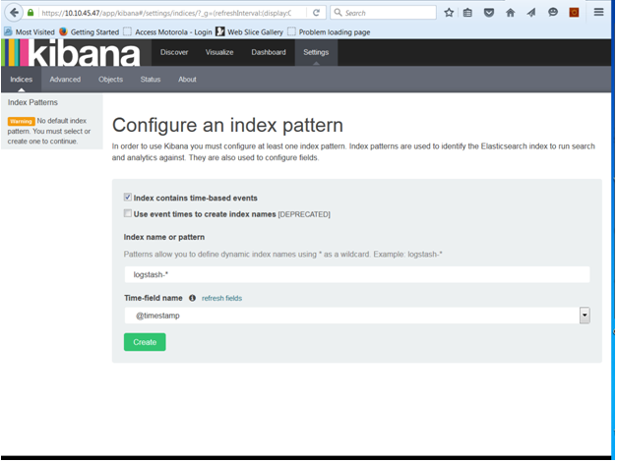
Figure 2 Kibana Configure Index Pattern

The default ‘logstash-*’ index pattern should be accepted by clicking the ‘Create’ button.
Kibana UI is functionally divided by the following main areas:

DISCOVER
This is similar to the previous ACP ELK versions Kibana view that can be opened in front page, except that the look and feel is quite different, as shown in the following figure.

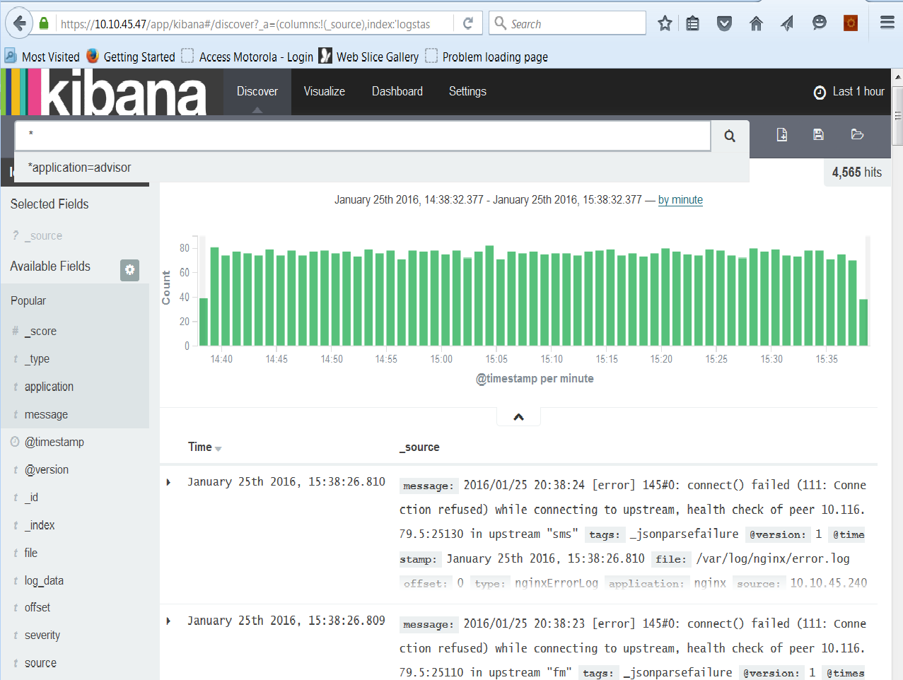
Figure 3 Kibana Discover View

VISUALIZE
This is to create customized graphs, charts, tables, etc. to visualize and compare various data points. The visualization can be saved to the Elasticsearch for persistency.

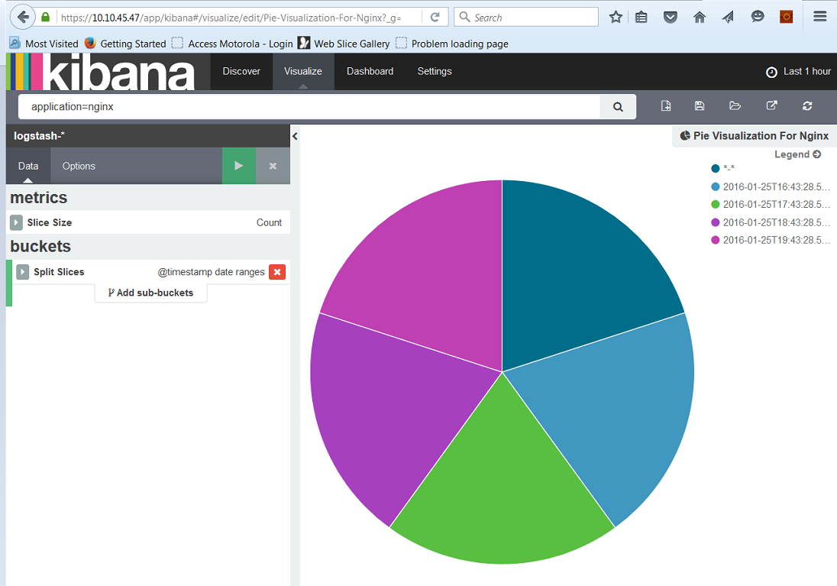
Figure 4 Kibana Visualize View

DASHBOARD
This is to create customized dashboard that combines pre-defined Visualizations so that they can be viewed from a centralized place. The dashboard can be saved to the Elasticsearch for persistency.
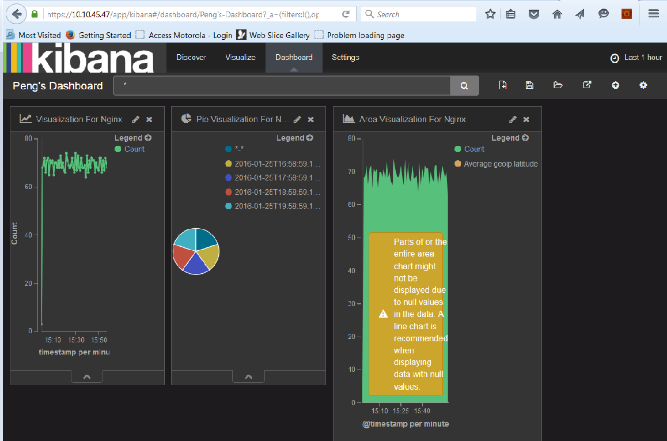
Figure 5 Kibana Dashboard View

SETTINGS
This allows the user to perform administrative operations ranging from monitoring Kibana program running status to exporting or importing saved searches, visualizations and dashboards

Kopf
Kopf is an Elasticsearch plugin that monitors the health of the Elasticesearch cluster. To access Kopf, type the following URL in any supported web browser:

https://elk FQDN (or VIP)/kopf

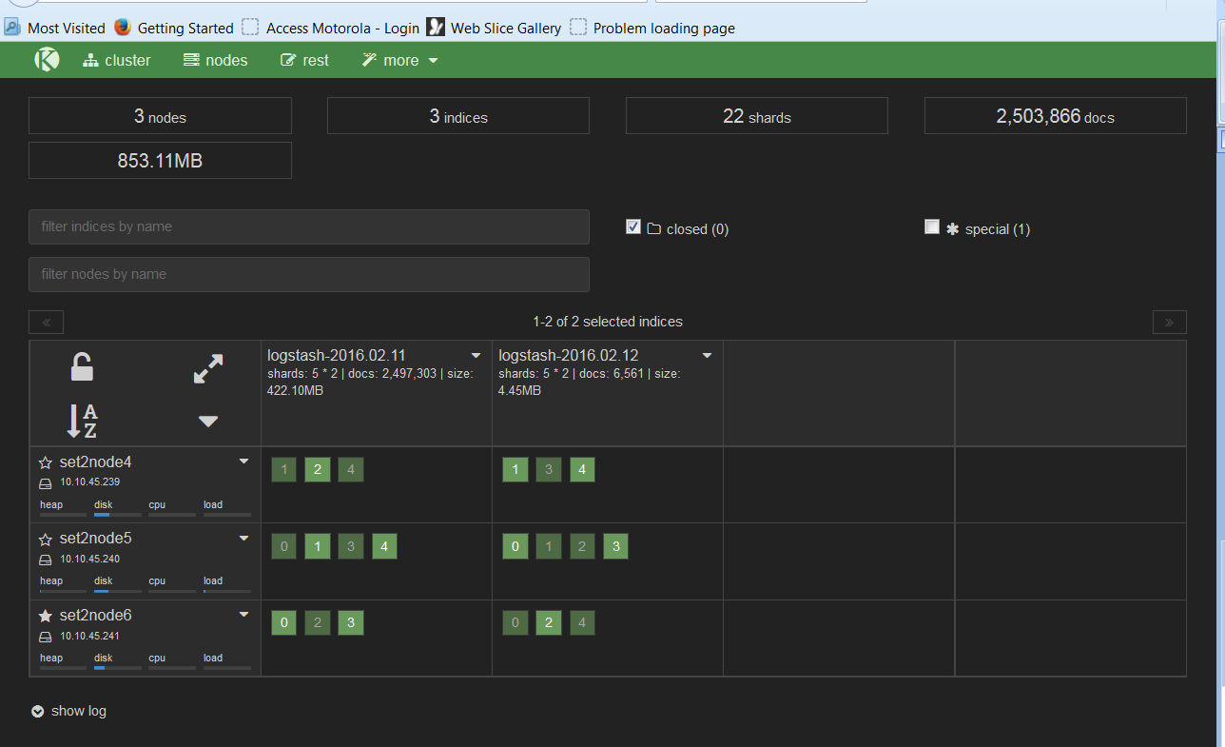

Curator
Curator is a third-party open source software that periodically checks the Elasticsearch disk usage and purge if usage exceeds predefined threshold. The default threshold configuration is as follows:
Start purging Elasticsearch data when disk space usage reaches 75%
Stop purging Elasticsearch data when disk space usage is below 50%
Normally the default settings do not need to be changed. If specific deployment environment requires changes, the user will need to modify the curator.conf on the Docker VM at /home/docker/cloud-service-scripts/certificates/ELK/curator directory.

