**PRACTICAL 2: Creating account, repository on Github s and cloning repository in Github**

**Dharmit Shah 75 FYIT**

**a) Creating account: -**

**Step1:- Search Github on Google and click on the official link of Github.**

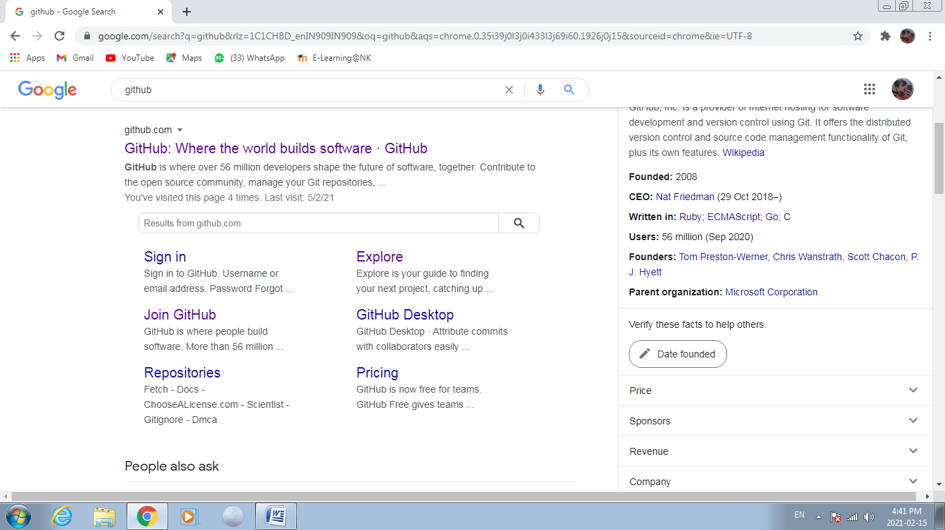

**Step 2: Click on the sign up button to create an account on Github.**

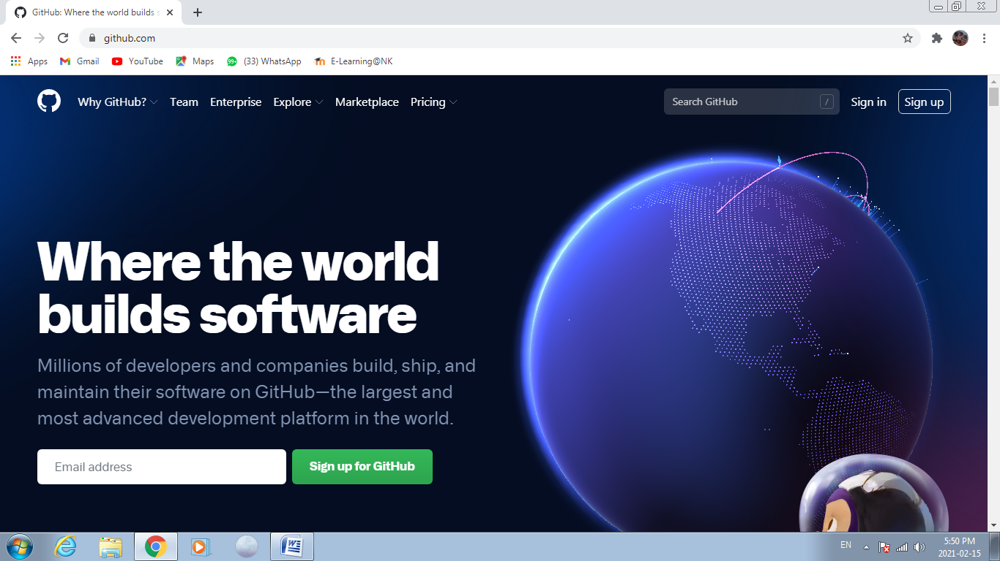

**Step 3: When you click on the signup button you will reach on this page**

**here you have to fill all necessary information which is star marked.**

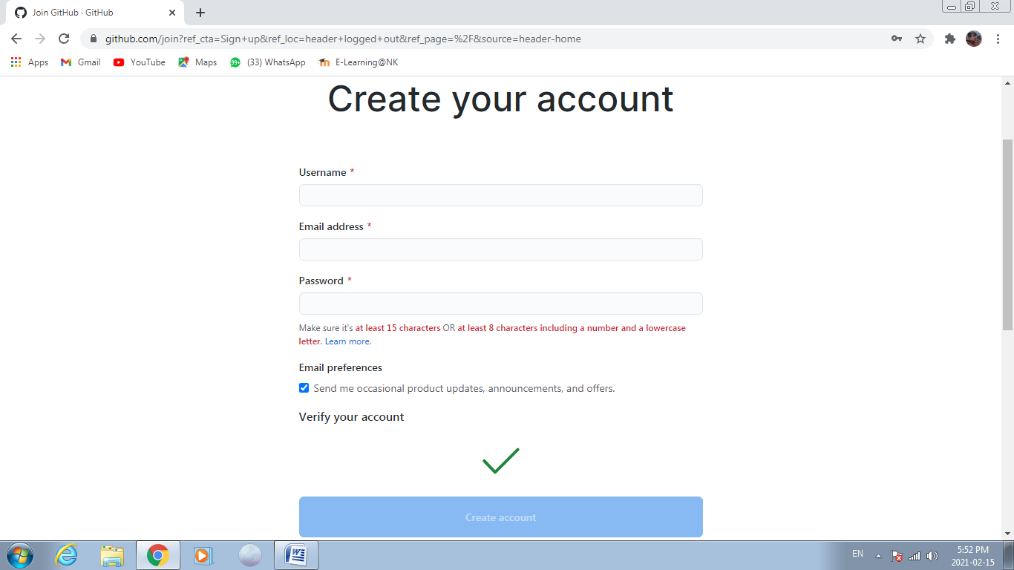

**INSERT YOUR NAME**

**INSERT YOUR EMAIL ID**

**INSERTPASSWORD**

**CLICK ON THE CREATE ACCOUNT**

**VERIFY YOUR ACCOUNT**

**Step 4: After fill all the information verify your account and click on the Create Account button. Now your account is created.**

**b) Creating repository:**

**Step 1: To create repository click on the + button .**

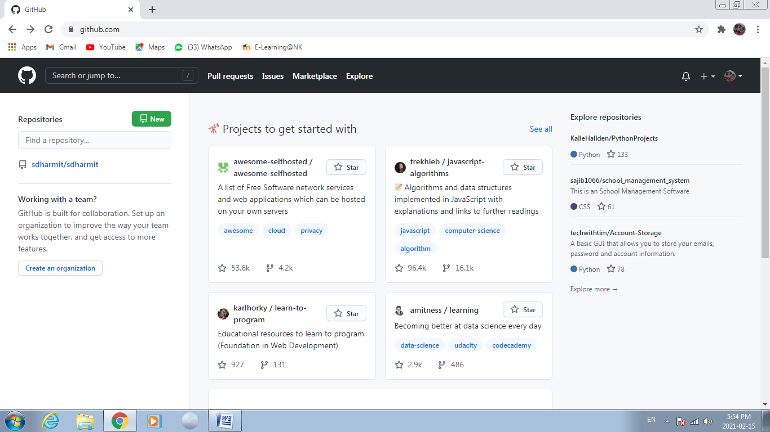

**Step 2: Click on New repository to make your repository.**

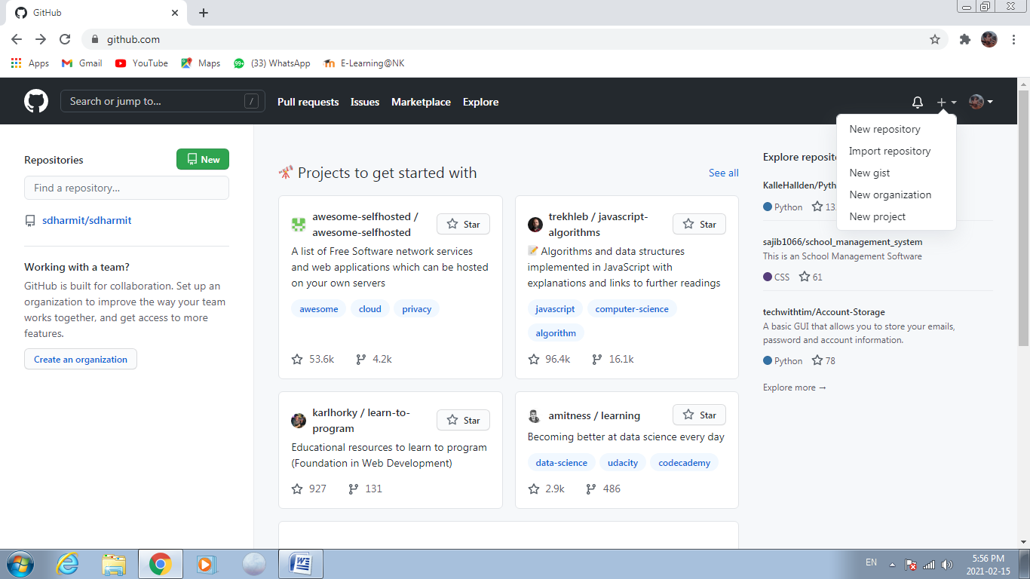

**Step 3: After clicking on the New repository you reach on this page here you have to give your Repository name, click on the private or public button.**

**Description: It is optional, so if you want to describe something about your repository then fill the description field with necessary information**

**1 Private: If you want no one can access your repository then click on private button.**

**2 Public: If you want other people can access your repository then click on public button.**

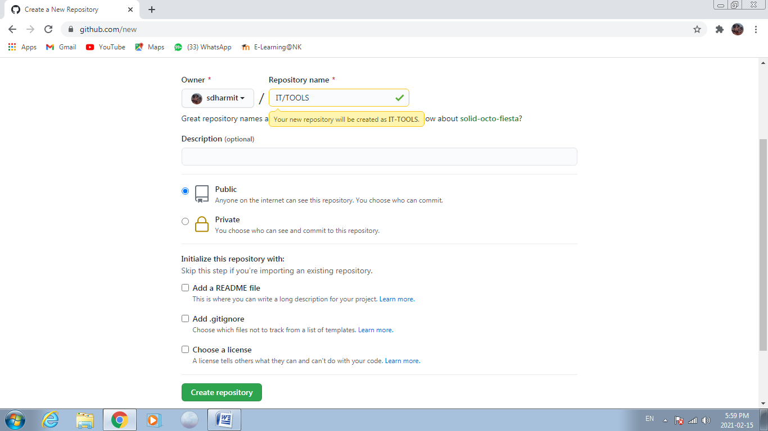

SELECT ONE OF THEM

**DESCRIPTION ABOUT YOUR REPOSITORY**

**NAME OF YOUR REPOSITORY**

**CLICK ON CREATE REPOSITORY BUTTON**

**Step 4: In the last click on the create repository button.**

**c) Cloning repository:**

**After clicking on the create repository button you will reach on this page**

**Step 1: Click on the uploading an existing button .**

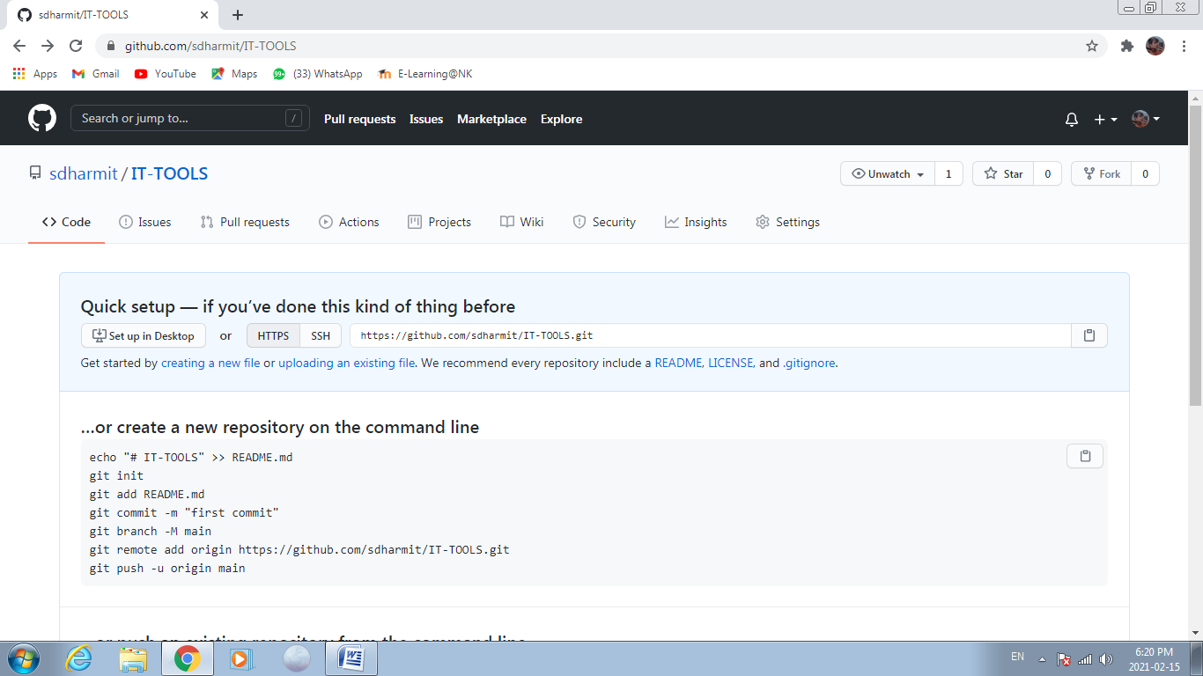

CLICK HERE TO ADD YOUR FILE

**Step 2: Click on choose your files to select your file.**

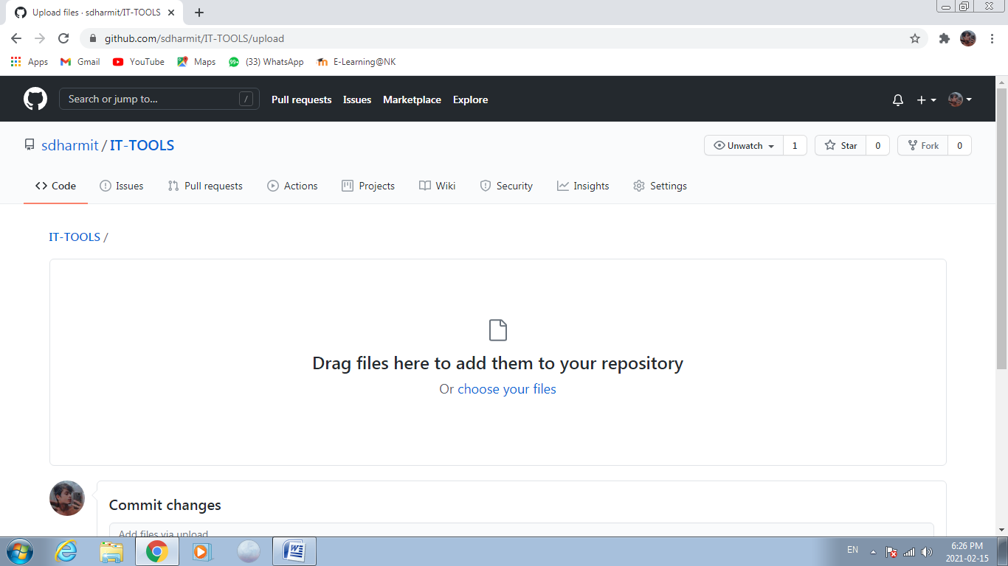

**Step 3: Select the file which you want and click on open button and atlast click on the commit changes button to save the changes.**

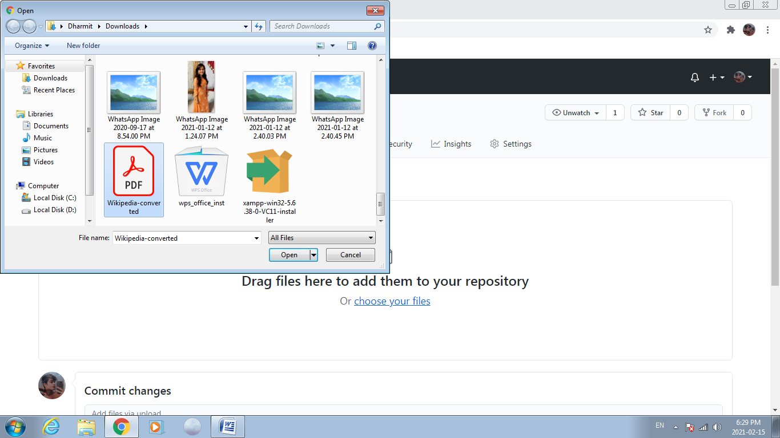

**Step 4: click on the code button to get your repository link and copy the link**

**To share your repository.**

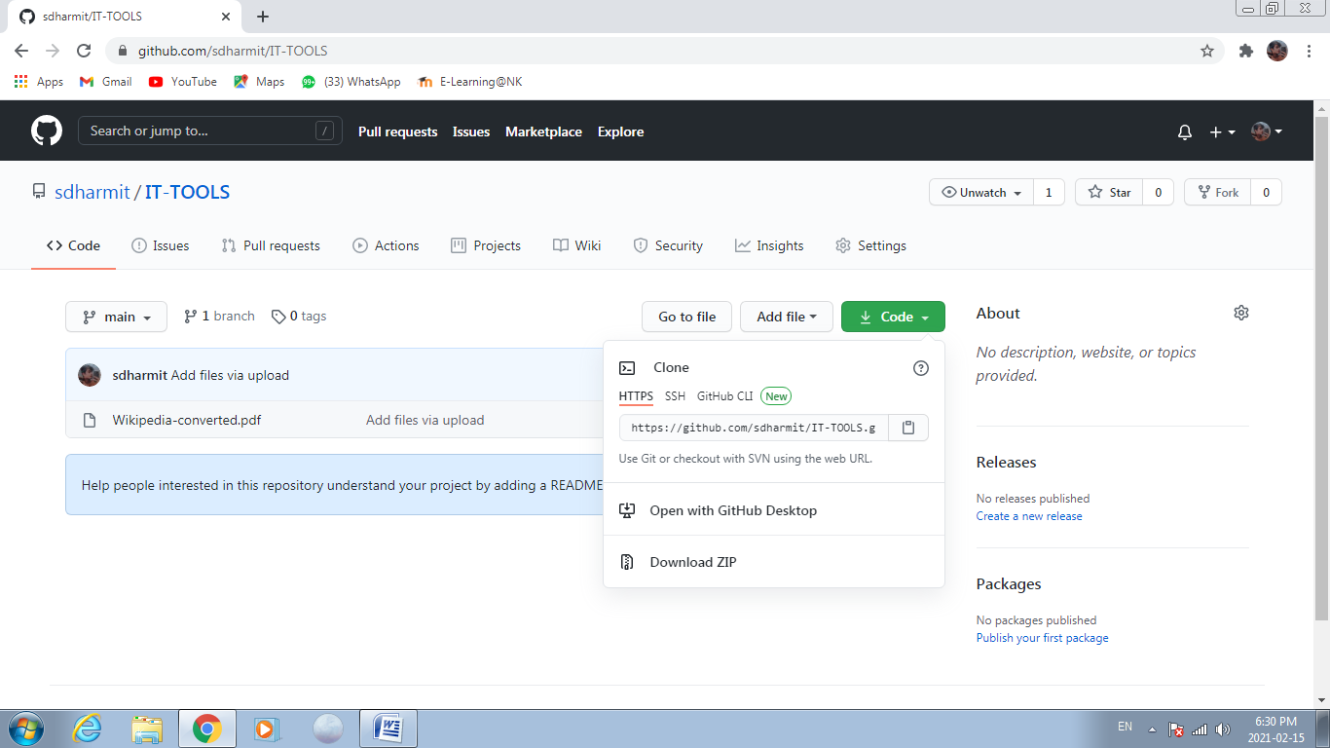

LINK OF THE REPOSITORY

**CLICKON THE CODE BUTTON**