Overall Summary: reports for month of December

Section 1: deciding on an overall negativity metric:

I experimented with three potential metrics for the negativity of a letter. In one metric, I divided the emotional content by the overall letter word count; in the second, I divided emotional content by log-wc. In the third, I scaled sentiment by square root of word count. I found that this metric was best, because it was not biased towards long or short letters. With the log-wc metric, long letters were more likely to have a high emotional score, scoring almost twice as high (on average) as shorter letters. Here, I call a letter “long” if it has more than 500 words, and “short” otherwise. With the raw wc metric, short letters were much more likely to have a relatively high emotional score. Therefore, I felt the best metric was the sqrt-wc method, because this method adjusts for biases in letter length. Curiously, there was a sharp decrease in letter sentiment content for letters of at around 500 words (for both Adams and Washington). This was very unexpected, and no explanation has been found for why this happens.

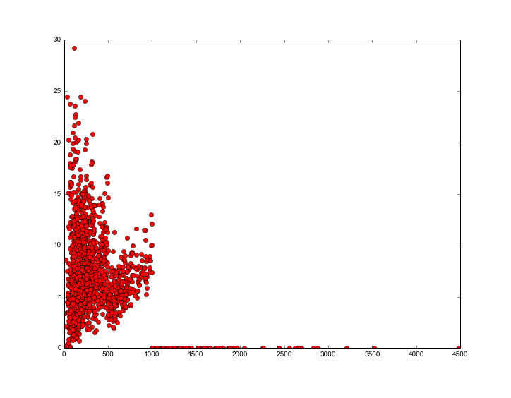
Raw wc metric (Adams):

log-wc metric (Adams):
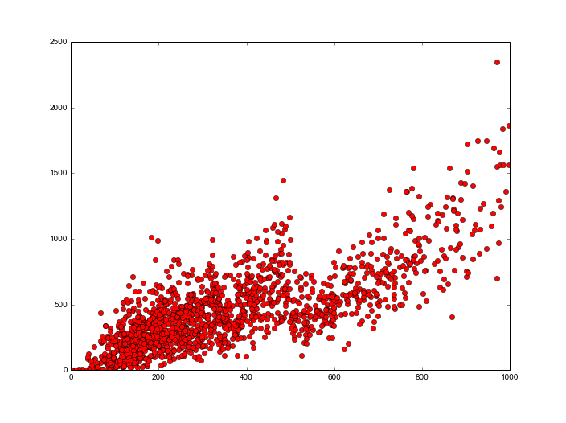
sqrt-wc metric (Adams): As we can see, it is the most balanced of the three metrics in terms of the distribution of sentiment scores assigned to short and long letters.
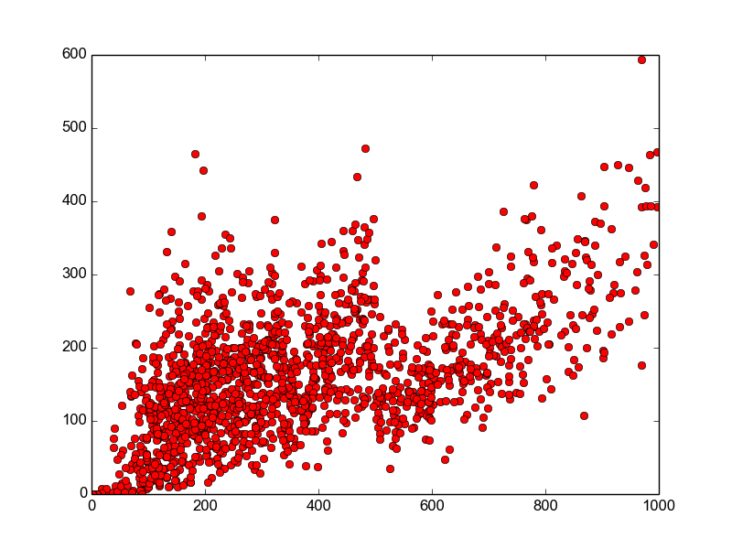

Section 2: creating histograms and scatterplots of negativity:

This is just to examine the overall positive and negative affect of each president. In order to find this, I scored each letter on positive and negative sentiment. This score was computed with a set of the most frequent & sentiment-laden words used by each president. I calculated the sentiment level with sentiwordnet, and I used the raw frequency of the word in all letters for frequency. Multiplying the two gave me an ordered list of words that was appropriately heterogeneous for each president (a discussion of this should be included earlier – this is what I did in November).

I feel that this can be a good metric for a president's overall emotional expressiveness, and it gives an interesting sense of their overall positive and negative outlook on life.

Below is a histogram of the negativity of all of Adams' letters
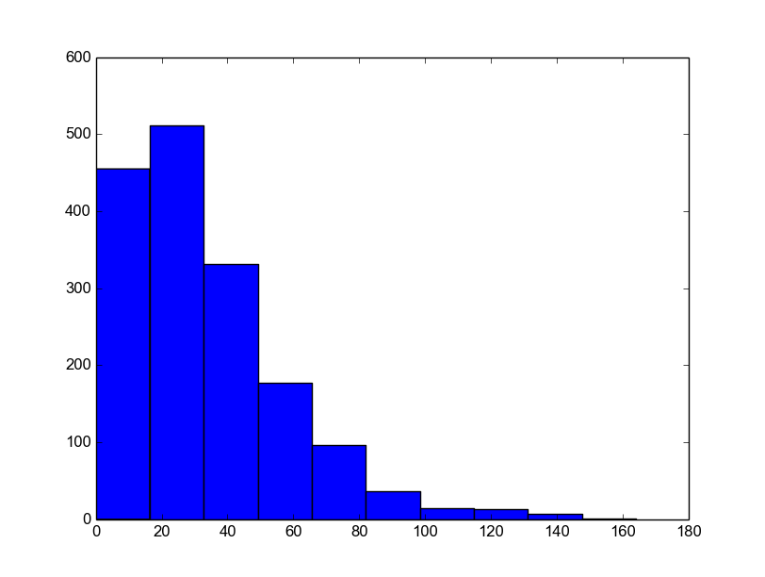

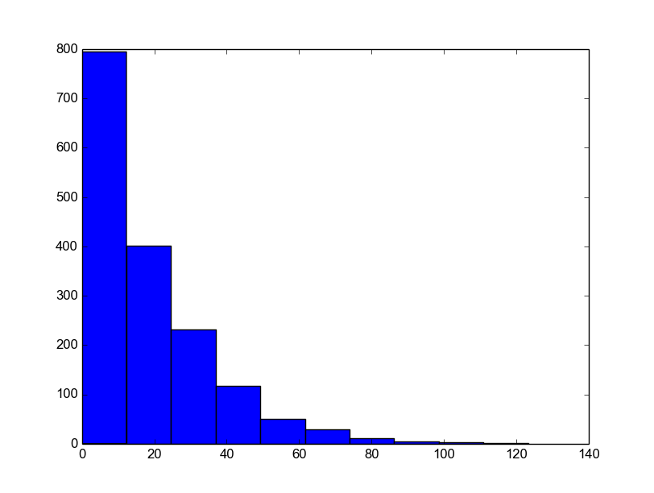
Above is a histogram of the negativity in Washington's letters. As you can see, Washington has a much lower median negativity than Adams – this could be a useful insight regarding his personality.
Section 3: creating a “timeline” of positivity and negativity for Washington and Adams

In order to do this, I computed the date of each letter from its metadata. Then, I averaged the score of all letters occurring in the same month, and plotted the month against the positivity / negativity score of all letters from that month. Below is an example of this kind of graph for Adams.

