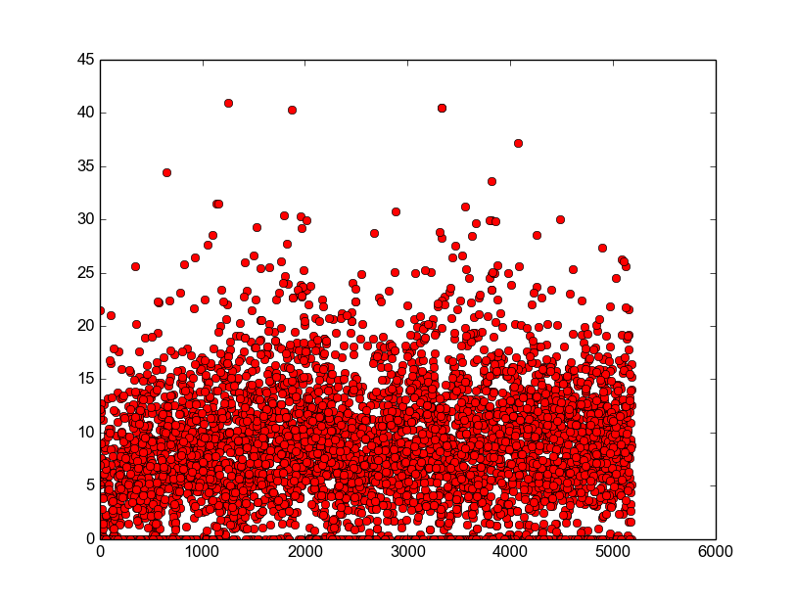
pos+neg, letters #1-5200
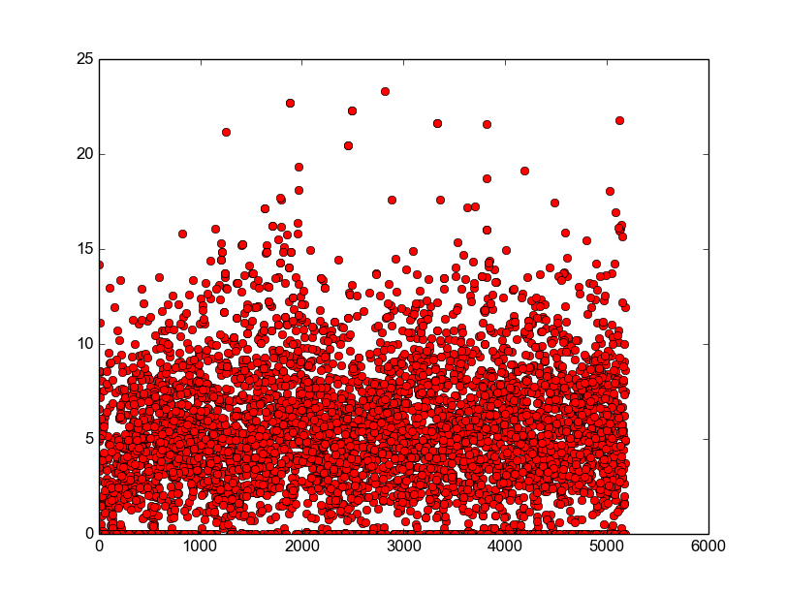

neg, letters # 1-5200

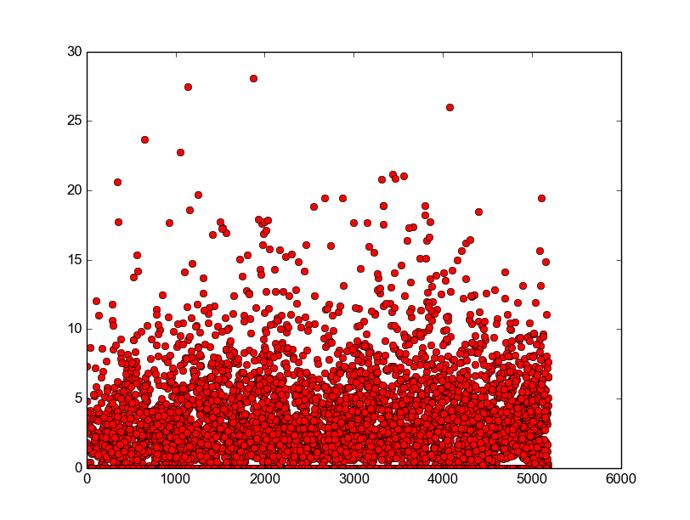
pos, letters # 1-5200
[The above data is all for John Adams]. It shows letter sentiment value (#sentimental words / wordcount) on the y-axis vs. document number on the x axis. The documents in these scatter plots are not always letters written by the president; sometimes they are also letters written to or about him.

Observations:
- There is a spike in negativity around 2000 and 3800.
  - The positive spikes occur largely around these time periods as well.
- peak negativity appears to be roughly between letters # 2000 and 4000 (especially if you include huge outliers)
  - If you look at huge positive outliers, most are between 0 and 2000.
- dates:
  - letter 0 was written in 1755 (John Adams is 20)
  - letter 2000 was written in 1779 (John Adams is 44) [Apr. 1779]
  - letter 3000 was written in 1781 (John Adams is 46) [Jan. 1781]
  - letter 4000 was written in 1782 [June 1782]
  - letter 5000 was written in 1784 (John Adams is 49)
  - letter 0 was written in 1755 (John Adams is 20)
    - this was directly after he graduated college. The French & Indian war had started. He begun teaching & begun his career in law.
    - In 1764 he got married to Abigail Smith.
    - By 1765 Britain was enstating the Stamp Act, and Adams was writing essays in Boston newspapers speaking out against it.
    - From 1774-76, he played a huge part in the revolutionary war. He was in the continental congress. By '77, the war was (effectively) over, and Adams was appointed diplomat to France
  - letter 1000 was written in 1777 (John Adams is 42)
    - in 1778, he left home for the first time. He sailed with his 8-yr old son to Europe and stayed there for six months. The sea voyages were treacherous – there was constant danger due to storms, and they were chased by British frigates at one point.
  - letter 2000 was written in 1779 (John Adams is 44) [Apr. 1779]
    - At this time, Adams had to go back to Europe again; he was charged with creating a peace treaty with Britain.
    - He also wrote the constitution of Massachusetts and participated in the mass. Constitutional convention.
  - letter 3000 was written in 1781 (John Adams is 46) [Jan. 1781]
    - In this time, Adams was an Ambassador to Holland and was working on securing recognition of the US as an independent country
  - letter 4000 was written in 1782 (John Adams is 47) [June 1782]
  - letter 5000 was written in 1784 (John Adams is 49)
    - in 1785, Adams was ambassador to Great Britain.

Comparison of Adams and Washington:
- Note that Washington's negativity is overall significantly less than Adams. Adams has much more letters in the 10-15 range, while Washington is almost always below 6 or 7 (with a few outliers)
- Washington's positivity is overall pretty similar to his negativity, although like Adams, the positivity scores go a lot higher
- Washington's peak positivity seems to be between 3000 and 5000
- His peak negativity seems to be around the 1000 range (near the early part of his letters)
- dates
  - letter 0: 1748 (Washington is 16)
  - letter 1000: 1756 (Washington is 24)
  - letter 2000: 1761 (Washington is 29)
  - letter 3000: 1773 (Washington is 41)
  - letter 4000: 1775
    - the next two time periods were probably the most tumultuous of Washington's life – this is when he was Commander in chief of the continental army that was greatly outmatched by their British opponents in the revolutionary war.
    - Although before this, he did also fight in other wars?
  - letter 5000: 1776

