Notes: data: week of December 3:
Adams (neg, then pos)

– these graphs depict letter sentiment (i.e. count of sentimental words in letter / letter wordcount) versus document number (so an x-value of 0 indicates the earliest document, chronologically). Moreover, the documents in these scatterplots are exclusively written by the president.

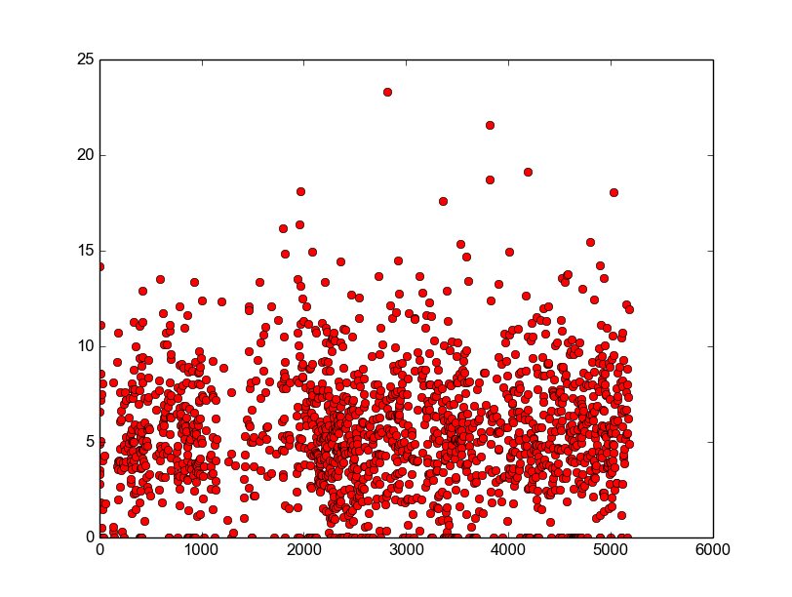
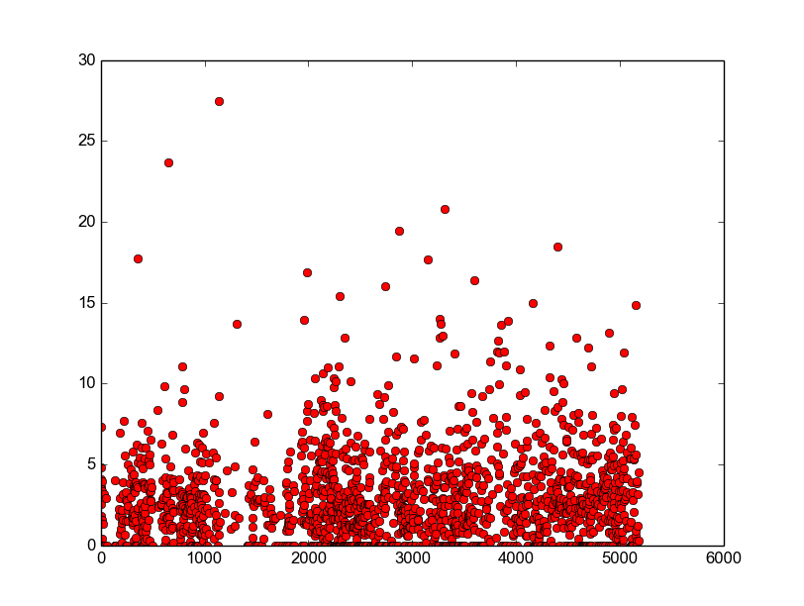
Washington (neg, then pos): note the very linear downward trend in negativity from 0-3000.
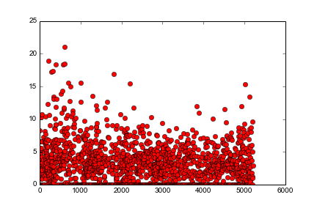
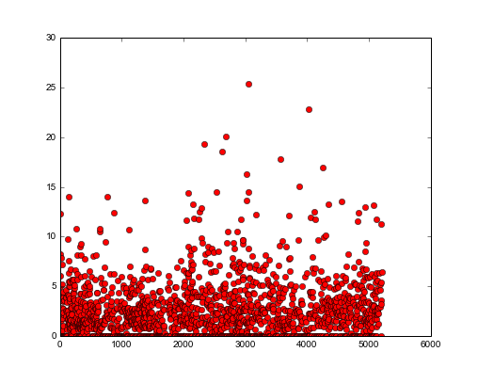
Adams Senti-score Histograms (neg, then pos)
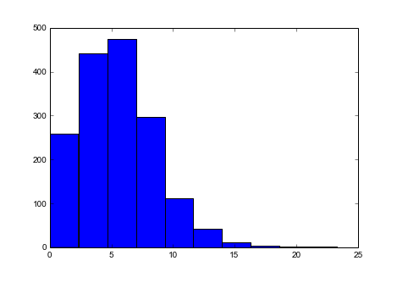
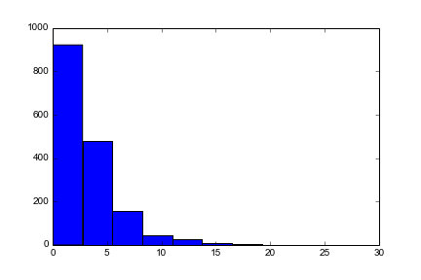
Washington Senti-score histograms (neg, then pos)

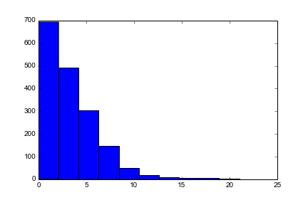
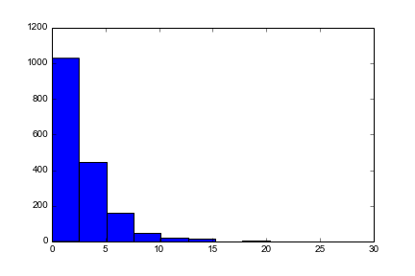

Scatterplot of Sentiment (y) vs. word count (x) [for washington]

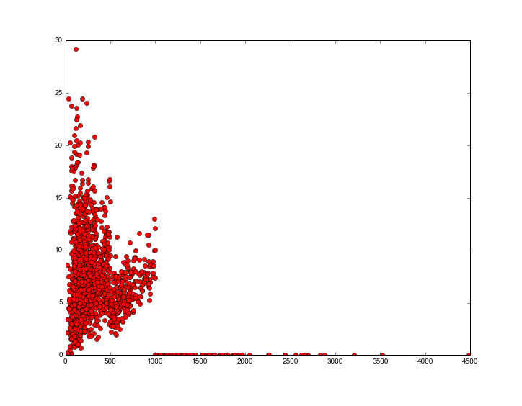
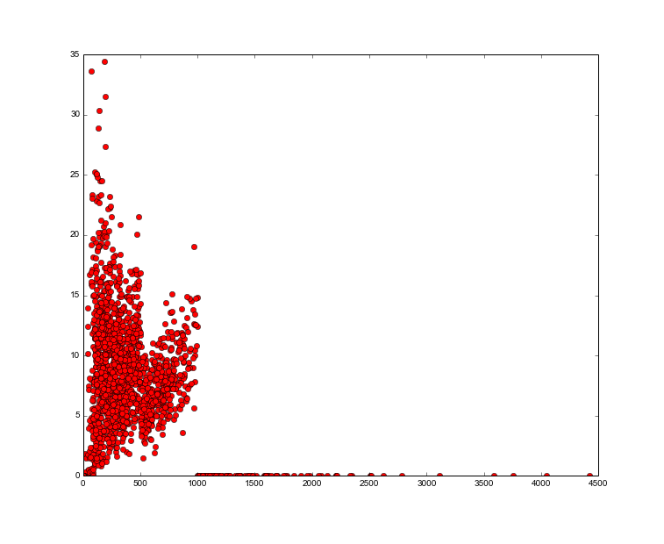

As we can see, the shortest letters generally contain the most sentiment; although there is also a lot more variability with the shorter letters. This is probably because I compute sentiment scores by dividing by length. It may be better to compute by dividing by log of letter length?

As we can also see, there is an uncanny similarity between these two graphs. There is a dip in exactly the same place, meaning that more expression is occurring (relative to length) in letters of between length 900-1000, and letters of between 50-250. Not as many emotions are being expressed at around length 600, and there is a very sharp drop-off on letters greater than length 1000.

Here are the results of (sentiment / log(wc)) vs. wc (for Adams):

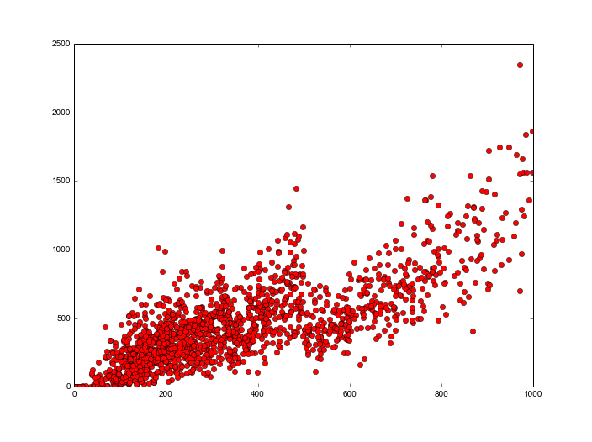

Here are the results of (sentiment / log(wc)) vs. wc (for Washington):
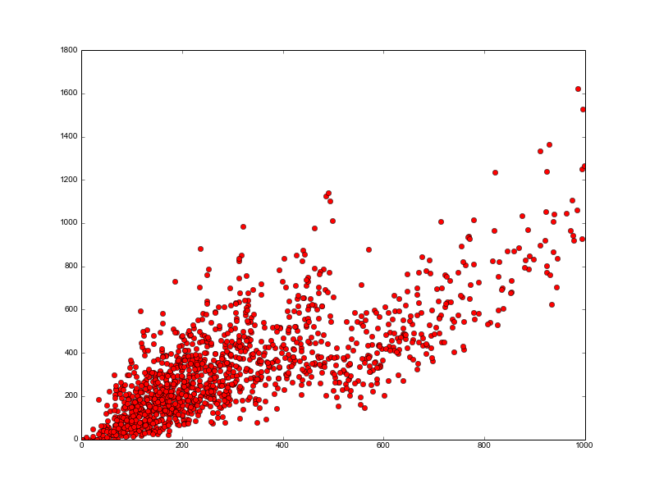
Now, examining the contents of letters.

Adams' most positive letter:

“
Sir
Braintree Feb. 3. 1778

I had Yesterday the Honour of receiving, from the Hand of my worthy Friend General Knox, your kind Letter to me,1 together with five others, which, with Submission to the Fortune of War, shall be conveyed\
and deliverd as you desire. I am happy in this opportunity to convey Intelligence from you to your Friends, and think myself greatly honoured and obliged by your Politeness and Attention to me. A Favour \
which makes me Regret the more my Misfortune in not having had the Honour heretofore of a more particular Acquaintance, with a Nobleman, who has endeared his Name and Character to every honest American, a\
nd every Sensible Friend of Mankind by his Efforts in favour of the Rights of both, as unexampled as they were generous. I thank you, sir for the kind Advice, communicated by General Knox, to which I shal\
l carefully and constantly attend. Shall at all Times be happy to hear of your Welfare, and to have an opportunity of rendering you any Service in my Power. I have the Honour to be with the greatest Respe\
ct and Esteem, sir your most obedient and most obliged humble sert.
”

Adams' most negative letters:

“
Sir
Amsterdam Octr. 15. 1780

I have only, Time, at present to request of you, to let me know whether, the Pamphlet is printed.1 You gave me hopes it would be out last Week but I hear nothing of it. When it is done I should be glad to\
have a dozen or two of them, for which I should be glad to pay, upon the Receipt of them. I am Sir with much respect, your humble servant
”

“
Honourable Sir
Amsterdam the 17 March 1781

May it not displease Yor Excellency; that forwarding the inclosed Letters,1 we repeat again or reqest, that we may be favoured with the rettrn of a few bonds, as to be in the possibility to deliver them w\
hen asked for; we were obliged to promise two of them for Wednesday next; so we begg to receive them before that time and some more as soon as convenient; we have seen by the publicq papers the Broker Yor\
Excellency chose to employ,2 and wish all may do well in time; we have obtained nothing from ors butt good promisses as yett.
May the Vigouros measres, their H. M. declare in their Manifesto to be forced to adopt against England safe and establish the honor of the Republicq, in which the Spirit of the people in generall flatters\
or hopes.
We have the honor to be with the most devoted regard, Honourable Sir Yor Excellencys most Obedient and most humble Servants.
”

Here is a negative letter that was given a negative sentiment score of 8:

“
My Friend2
From my Chamber in Worcester Septr. 1st: 17551

The Favour you granted me on aug. 123 was unluckily packeted with a number of Letters and carried to Leicester, but a certain kind Gentleman has just brought it to hand. I will not lessen the pleasure it \
gave by a Description. But one detestable quality that usually attends your Letters, I find has staind it. I think Phylosophers call it, brevity. But, on second reflection I am not surprizd. I suppose tha\
t agreable Lady you had the happiness of being particularly acquainted with has almost monoppolized your Reflections, and an half hours existence without her in your mind, is little preferable to non exis\
tence. But Ill have you to know, that all the Ladys under heaven, however you esteem them, shant deter me from writing. I have an indisputable, incontestable right to half an hour of your time now and the\
n both to read my Letters, and write me returns. Nevertheless, continually, I felicitate you, upon your newly commenced acquaintance, with this Lady, and pray that the acquaintance may be refined into Con\
nubial Beatitude. May the Charms of her Person exceed those of a Celebrated graecian Beauty, may the strength of her intelect and immagination, be rankd in future times among the brightest Heroines of for\
mer ages, Sappho, Daicier,4 Row,5 may the firmness of her Virtue, equal Lucretias. What can I wish you more? I never was so plagued for thoughts in my life. No wondernot a single Idea has coloured my mind\
this month. At Colledge gay, gorgeous, prospects, dancd before my Eyes, and Hope, sanguine Hope, invigorated my Body, and exhilerated my soul. But now hope has left me, my organs rust and my Facultys dec\
ay. Every Week Day is sacrificed to [...]6 sunday to the Frigid performances [...] Frigid John Calvin. No matter, [...] be patient I have almost done!
Epistolising is what I am very little skilld in, and I never keep Copys of my Letters. So that I cant say, but I tautologize. If you meet [2]with the same in this, that you had in the former, candidly exc\
use it, and set me the example of some regular thinking upon another subject, and Ill <Coppy> follow it if I can. I am obliged to you, for your care Concerning the Book I wrote to you of. All the time I c\
an get is spent, how? No astroleger can tell. Dr. Savel7 says cultivating and pruning the tender sproutings, of such plants as may hereafter be plants of renown.
I can not write to please you in the present state of my mind. Therefore Ill write to please my self, which believe me I cannot do more thoroughly than by subscribing myself your faithfull Friend,

John Adams

P.S. Ill never write you such another Letter. Im almost tempted to throw this to bottomless perdition.
”

In my opinion, this letter should have a much higher negative sentiment score than 8.

