Data Report Week of Dec. 4-11:

- examination of letters identified as positive and negative
  - Here are the letters identified as most negative and my rough classification of them (on a scale of 0-5)
    - where 1 is not at all negative, 5 is extremely negative, 3 is guardedly negative, and the other values are intermediary.
  - Negative Letters: (first, my score. Then, actual score)
    - 1799
      - 3
      - stating that someone has not acknowledged his correspondence. Also describes an unexpected development in Congress which means that he requires assistance.
    - 1957
      - Thanking a leader for honoring his request, and for his country's continued allegiance.
      - Very brief allusion to dangerous times.
      - 2
    - 1971
      - informing someone about the movements of an alliance and a slight time delay, as well as thanking them for sending him something
      - 2
    - 2815
      - Guardedly expressing disappointment about a pamphlet being expected, but not delivered.
      - 3
    - 3356
      - Expressing pessimism about a certain military situation.
      - 5
    - 3525
      - expressing distaste for the attitude of the Dutch; also being pessimistic about the outcome of a battle considered by others to be a highly positive development. Also expresses several other emotions, however.
      - 4
    - 3813
      - Telling someone that he is unable to carry out the course of action they suggested
      - 5
    - 3814
      - Warning someone that the course of action they want him to take is highly unlikely to succeed.
      - 5
    - 4188
      - [Incomplete] Guardedly refuting someone's suggested course of action.
      - 2
    - 4800
      - Dreading undertaking a difficult task, but determined to do so nevertheless.
      - 4
    - 5024
      - discouraging someone from pursuing a course of action
      - 5
  - Positive Letters
    - 359
      - 4
      - rejoices at the winning of an election; but then is wondering whether or not to really be optimistic about the result.
    - 648
    - 1135
    - 1985
    - 2298
    - 2735
    - 2871
    - 3147
    - 3306
    - 3592
    - 4401

Plotting negativity and positivity over time:

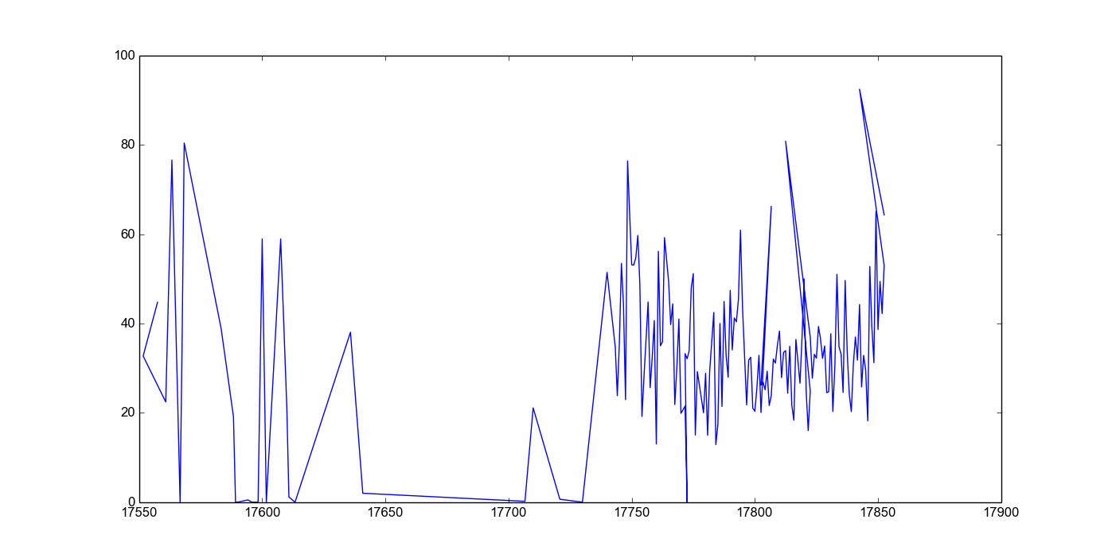
Above is Adams negativity.
- Fairly sparse in the early years
- 1755 - 1764
  - this was directly after he graduated college. The French & Indian war had started. He begun teaching & begun his career in law.
- 1765
  - In 1764 he got married to Abigail Smith.
  - By 1765 Britain was enstating the Stamp Act, and Adams was writing essays in Boston newspapers speaking out against it.
- Very sparse data between 1765 and 1770
- 1775
  - 1774-76: he played a huge part in the revolutionary war. He was in the continental congress. By '77, the war was (effectively) over, and Adams was appointed diplomat to France
    - as we can see, his letters become increasingly more negative over this time period.
  - 1778: he left home for the first time. He sailed with his 8-yr old son to Europe and stayed there for six months. The sea voyages were treacherous – there was constant danger due to storms, and they were chased by British frigates at one point.
    - However, after '77 (perhaps because he is in France?) his letters increase steadily in average positivity
  - 1779: had to go back to Britain to create a peace treaty.
    - Participated in the massachusetts constitutional convention and wrote the constitution of Massachusetts.
    - There is a lot of positivity in these letters
- 1780
  - 1781: Adams was an ambassador in holland, trying to secure independence for the United States
    - There is a lot less positivity in these letters.
- 1785
  - Adams is ambassador to Great Britain.
    - This marks another uptick in his positivity
- Can be hard to tell what Adams is reacting to in this data
  - may be useful to read some letters or to try some kind of topic analysis?

