Results for the “flexible distribution” stockhmm algorithm:

Results of testing with individual tech stocks over 10 years:

The risk-averse model often outperforms the market, and even has the potential to thrive, at times when the stocks are in decline. For example, when we test on “backward stock data” for EA, AAPL, and AT&T, the stockhmm model actually gains money, even though the stock has declined severely in several of these cases.

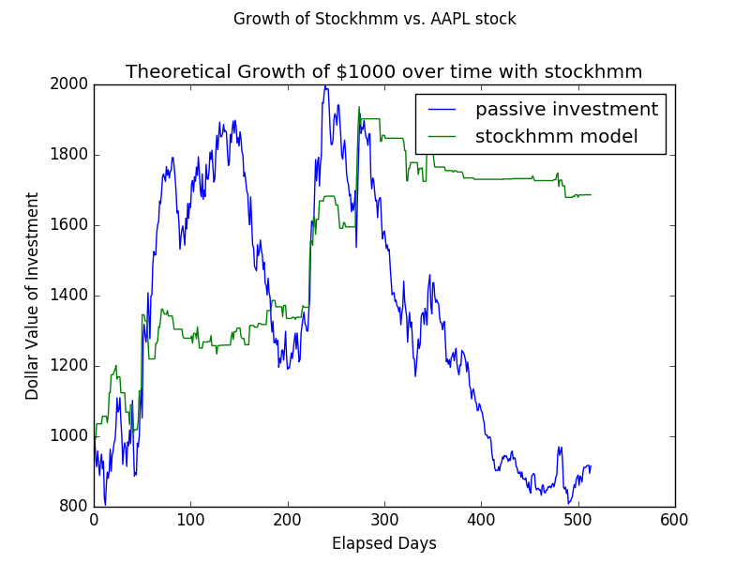

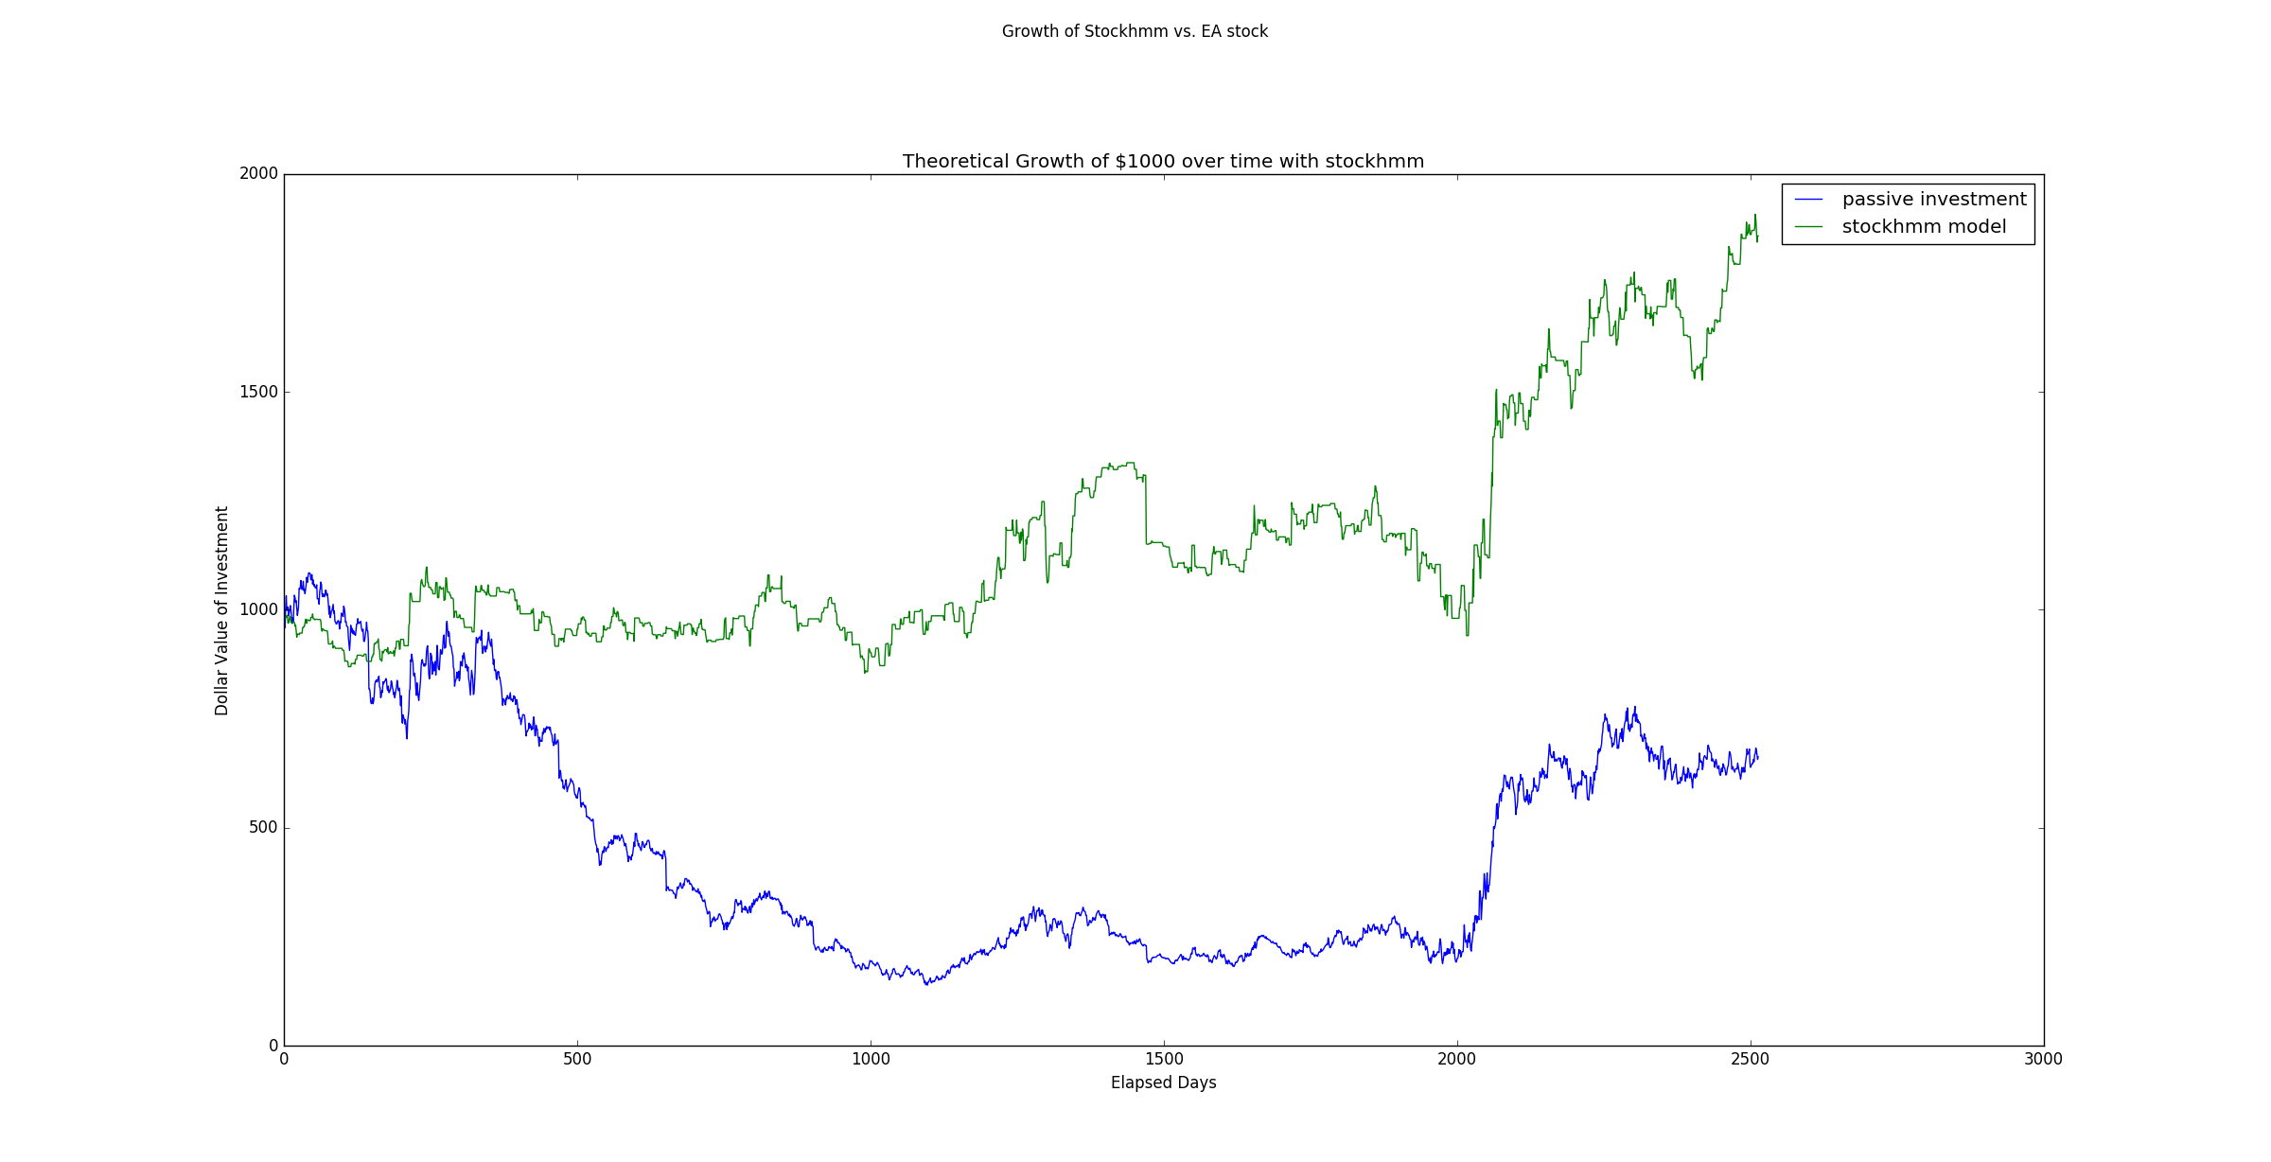

However, there are several other cases where the model underperforms, because it is unwilling to take risks, and therefore misses out on several large growth opportunities. It most especially underperformed the Dow Jones Average over the very long term (i.e. 100 years). Most underperformance happens when the stock market is booming.

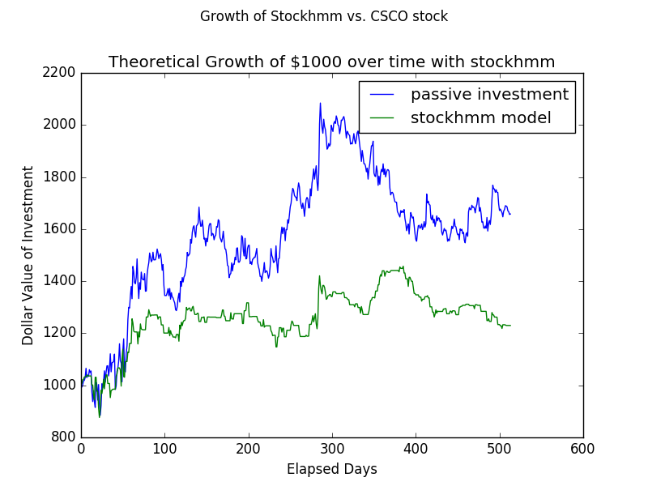

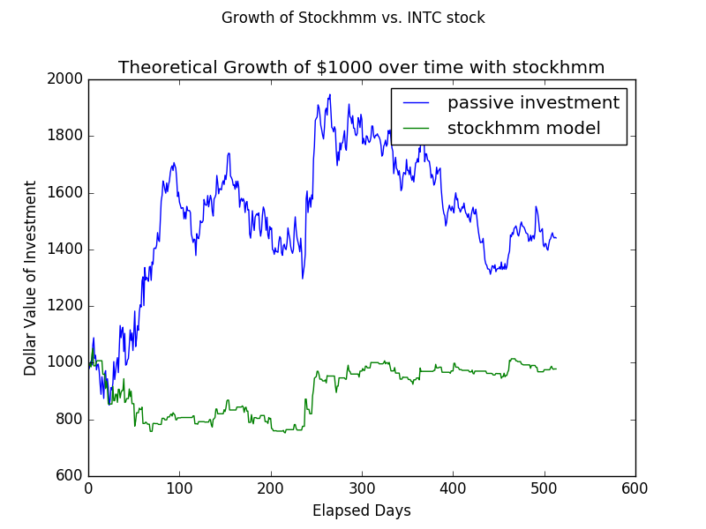

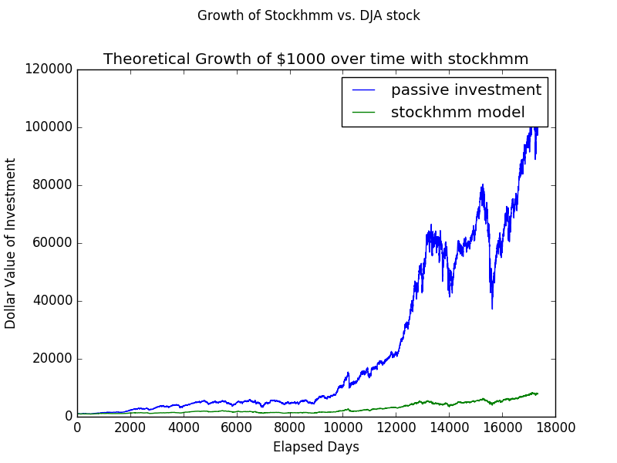

The above is the result of using the model to invest in the Dow Jones industrial average over 100 years. The model sees its total grow six times; this is dwarfed in comparison to the Dow, which has grown to hundreds of times larger than its original value. As we can see, the model performs much better in shorter-term situations, and in conditions in which the market is falling.

The results of k-fold cross validation over the dow jones industrial average are shown below:

#folds Avg. difference ratio of time ahead

5 -$766 0.13

10 -$415 0.23

100 -$35.35 0.37

Keep in mind that the amount initially invested was $1000, so a difference of $766 means that the market is usually about 76% higher than the model at any given moment. As we can see, as the size of the test data decreases, the performance of the model increases with respect to the market.

Note: the results for a cubic util0 model are very similar to the results for the risk-averse model. They are actually even worse against the long-term Dow Jones, but they are better in some short-term situations when the risk-averse model was not doing well. Interestingly, it seems like it chooses to invest at around all the same times, but different amounts. This model actually did much worse than the risk-averse model when it came to long term performance. The risk-averse model grew 6x, where this model only grew 1.3x.

I also tried to use a “risk loving” model – the results of this model are bound to be much more similar to the market, because it is much more likely to go “all in”. This model indeed sticks more closely to the market, but less so than I expected. The risk-averse behavior of the hmm goes away, so it will be more likely to fall alongside a falling stock like AAPL. However the long-term market performance is far better – it increases 12x.

#folds Avg. difference %of time ahead

5 -$743 0.03

10 -$245 0.26

100 -$15.6 0.40

The exprisk model has even less punishment for risk, and rewards the possibility of increasing wealth more highly. However, this model surprisingly did less well than the risk-loving model over the long term. There were many special cases where this model performed better than any of the others, however – such as in the case of EA over the last 10 years, or in the case of the DJA over the last 20 years ([-5000:]).

Last-the linear model, which will always go all or nothing. Let’s see how it does. It is also doing OK. It has its own special cases where it does well. For example, in the last 10 or 20 years of the DJA, it does better than any other model (including exprisk). Over the very long term it is multiplied 8x. The linear model is doing only what the HMM wants – there is no other distortion of the HMM’s training. Below are the crossval results for the linear model

#folds Avg. difference ratio of time ahead

5 -$447 0.37

10 -$336 0.27

100 -$31.1 0.378

Another variation is to allow permutations to be stored as different combinations of states, and/ or to push the visibility and smoothness further back. Here is the result after changing smoothness and visibility both to 3, and allowing permutations to be interpreted differently (risk-loving utility function):

#folds Avg. difference ratio of time ahead

5 -$611.5 0.246

10 -$179 0.468

100 -$24.05 0.377

We can play with this more by making the visibility and smoothness even larger, but I don’t expect a huge increase in results.

Another metric I want to test is how often the model makes the correct decision – this is analogous to a precision/recall test.

* The results of this are very bad; perhaps this is why the model isn’t doing well.
* **The results of this show that the model has almost no predictive power. There are about 53% false positives, 48% false negatives if I set the visibility to five (which gives me the best performance I got so far), and let the prediction model be linear.**
  + **The reason this model is doing well is that future performance in the stock market does not seem to be impacted by past performance.**
  + **Our HMM model had about a 51% probability of correctly predicting the ups and downs of the market, based on the market’s past behavior.**
* **LESSON: THIS IS WHY WE DO EXPLORATORY ANALYSIS BEFORE BUILDING MODELS.**

Interestingly, the algorithm worked better with risk loving and risk hating models than it did with the cubic model. It also did very well with the linear model, which did not filter the findings of the HMM at all.

Another note is that the performance of these models is very hard to measure. The problem with measuring the “amount ahead” is that the price of the stock builds on itself; so once it falls behind it is likely to stay behind.

=🡺 Perhaps a better way to measure performance is through the “ROC” curve, which will measure how accurate the model’s decisions were independently of one another.

Precision: model true positives / (model true positives + model false positives) []

Recall: model true positives / (model true positives + model false negatives)

What are my next steps?

* Clearly, you cannot predict market rises and falls with a HMM
* How else can you train your model to make investment decisions?
  + You can tell it when not to invest?
    - This means predicting when a big drop will happen?
  + You can try to predict the stock market using data from twitter, or data from old newspapers?
  + You can try to predict times when we are in the middle of a recession and times when we are in the middle of a boom.
    - You should only try to predict a total of 5-10% of negative periods.