We are using the MVC (Model View Controller) architectural pattern.

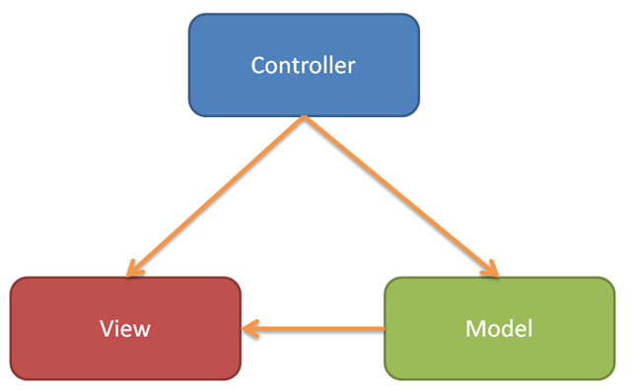

from: <http://www.joshholmes.com/blog/2009/01/27/buildingasimplephotogalleryinaspnetmvcframework/>