写出SQL语句查询在2025年内投递简历的每个岗位，每一个月内收到简历的数量，并且按先按月份降序排序，再按简历数目降序排

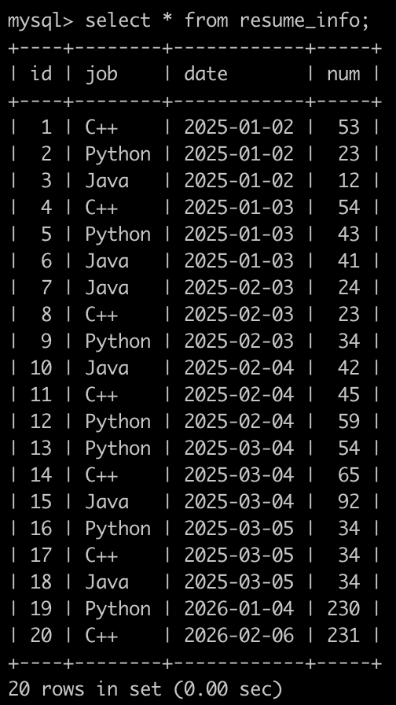

select job,**DATE_FORMAT**(date,"%Y-%m")as mon,sum(num) as cnt

from resume_info

where left(date,4)="2025"

group by job,mon

order by mon desc, cnt desc