605.782.82: Web Application Development with Java

Faculty: Mr. Kiran Chittargi

Term: Fall 2014

Term Project: Preliminary Proposal

Project Name:

Endo Emporium: Because if you got more than two wheels you’re doing it wrong

OR

Motorcycle Rentals 4 U

OR

Another name

Team Members:

Mark Bryant

Stephen Diaz

Eli Medina

**Table of Contents**

MODIFICATION HISOTRY..................................................................................................**3**

1. INTRODUCTION..........................................................................................................**3**
2. GLOSSARY...................................................................................................................**5**
3. SYSTEM ARCHITECTURE.............................................................................................**6**
4. WORK DISTRIBUTION................................................................................................**10**

**MODIFICATION HISTORY**

|  |  |  |  |
| --- | --- | --- | --- |
| **Version Number** | **Description** | **Modified Date** | **Modified By** |
| Draft 1 | Created the preliminary proposal document | 9/28/14 |  |
| Draft 2 | Added System Architecture Screen shots and Work Distribution | 9/29/14 |  |
| Draft 3 |  |  |  |
| Rev R0 | Finalized the document |  |  |

1. **INTRODUCTION**

(*This section of the document briefly describes the need for the system and functions or the system.)*

* 1. **Need for the system:**

This software system is being developed as a project required towards fulfillment of the course 605.782.82:Web application Development with Java in the Fall 2014 term.

* 1. **Project definition:**
     1. Design, Code, Test and implement a motorcycle rental store that enables several users to log on to its website and rent various motorcycles. Each user will have a user ID and can maintain personal information on the web site. The project implementation should follow the best practices mandated by software engineering.
  2. **Project team:**
     1. The team consists of the following team members: Mark Bryant, Stephen Diaz, Eli Medina
     2. The team has chosen the name Endo Emporium, to represent the project.
  3. **Functions of the system:**
     1. The web site is accessible for anyone to browse and rent a motorcycle. However the users will have to register and log on to their account prior to renting a motorcycle.
     2. The web site should allow multiple users to log on simultaneously. Each user should be assigned a unique user ID. The accounts shall be password protected.
     3. The user profile entered should contain details such as:
* Name
* Billing Address
* Home Address
* E-mail Address
* Credit card info (Optional)
  + 1. The web site shall list motorcycles in the following categories:
* Cruisers
* Sport
* Touring
* Supersport
* Off Road
* Scooters
  + 1. Once the customer selects a category to browse, the web site will display the items available for rent. The lists shall include:
* A rental code
* A description of the motorcycle
* A picture of the motorcycle, where available
* Price for rental
* Any special deals that are available for the rental. (Optional)
  + 1. The customer can select one or more rentals from the web page, enter the quantities selected for each rental and chose to add the rental to the cart.
    2. The customer can display/change the contents of the cart anytime.
    3. The customer can continue shopping and add more items to the cart.
    4. Once the customer has finished shopping, the web site shall provide an option to check out the contents of the cart. This shall use SSL for security.
    5. The data maintained in the user profile should be brought in to the check-out form. The customer shall be allowed to change the data.
    6. Once the check-out has been completed an e-mail shall be sent to the customer providing the details of the rental.
    7. The web site shall maintain an inventory of the rentals which get updated at every rental.
    8. An administrator can update the inventory and make the flowing changes: (Optional Feature).
* Update quantities of rentals
* Add a rental
* Delete a rental
* Change the price of the rental

1. **GLOSSARY**

*(This section of the document defines the technical terms used in the document. An effort is made to NOT make any assumptions about the experience or the expertise of the reader)*

|  |  |
| --- | --- |
| Term | Definition |
| HTML | Hypertext markup language is the predominant markup language for web pages. |
| Java | An object oriented programming language |
| Java Script | JavaScript is a scripting language most often used for client-side web development |
| JSP | Java Server Pages – simply put, it adds Java inside HTML pages |
| Servlets | The Java Servlet API allows a software developer to add dynamic content to a Web server using the Java platform. |
| MVC | An acronym for Model-View-Controller. The Model represents the business or database code the View represents the page design code, and the Controller represents the navigational code. |
| My SQL | Open source database system |
| Shopping Cart | A virtual car the holds the motorcycles being considered for rent by the customer. |
| SSL | Secure Sockets Layer: cryptographic protocols which provide secure communications |
| Struts | Struts is an open framework for building Java web applications. The Struts framework is designed to help developers create web applications that utilize a MVC. |

**3.** **System Architecture**

The following sections will break down the system architecture into two subsystems that composite system functionality. These systems are the client and server, which will implement the MVC design paradigm.

3.1 Client-Side Subsystems

3.1.1 Functional Separation

The client side will provide the following screens to provide a user interface and access to functionality by implementing views.

|  |  |
| --- | --- |
| **Screen name** | **Function of the screen** |
| Session GUI | Allows a customer to log on to the web site. |
| Registration GUI | Allows a new customer to enter information or an existing customer to change their information |
| Shopping GUI | Displays the available items in a category. Allows the customer to select one or more items. |
| Shopping Cart GUI | Shows the contents of the cart. Allows modifications or leads to check-out. |
| Check-out GUI | Allows customer to purchase the contents of the cart. Uses SSL for security. |
| Admin GUI | Allows an administrator to manage the inventory.(Optional) |

3.1.2 Technologies:

Client side pages will be served as JSP and HTML pages. DOM/Event handling will be handled using Javascript, and JQuery to simplify development.

3.2 Server-Side Subsystems

3.2.1 Functional Separation

The server subsystems consist of a database, the model/controller constructs of the MVC paradigm. That is the controller constructs will process and validate requests made from client-side screens. While the model construct will provide the web application interface to the DB for storing inventory, customer, and permissions data.

3.2.2 Technology

The server side will use Java servlets to implement controller functionality, as well as SSL technologies to provide secure login, and online purchases.

3.3 Web-app layout.

Store Servlet

Browse Servlet

ProductDetailsPage

CheckoutPage

ShoppingCartPage

CheckoutPage

MotorCyclePage

HelmetsPage

Gloves Page

Jackets Page

3.4 Sitemap

* About Us
* What’s New
* Contact Us

**COMPANY PROFILE**

* How it Works
* Shopping Cart
* Policy

**SHOP ONLINE**

* Registration
* My Profile
* Cancel memb-ership

**MEMBERSHIP**

* Store Location
* Q&A

**CONTACT US**

* Motorcycle Rental
* Helmets
* Gloves
* Jackets

**PRODUCT LINE**

* 1. **Main page (index) screen shot**

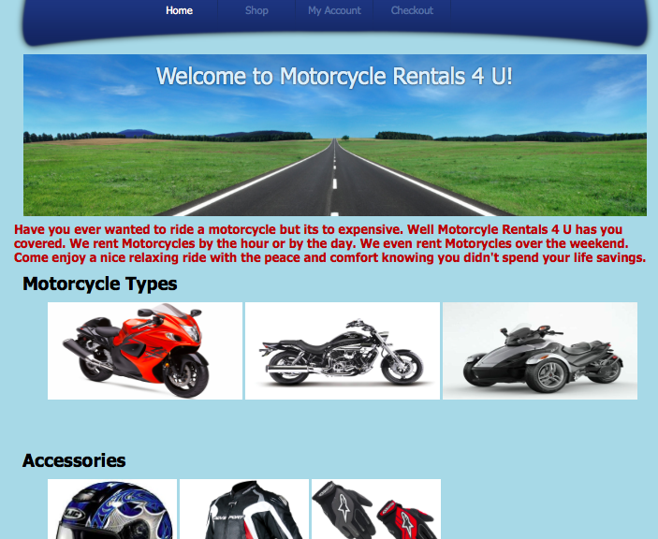

# 4. Work Distribution

4.1 Given below is the division of work between project team members as envisioned at this stage of the project. The team members are free to make changes, if needed during development.

4.1.1 Eli Medina

* + - * Implement MVC architecture using Struts
      * Code Servlet for user maintenance and validation
      * Code Servlet for shopping cart management
      * Code Servlet for check-out using SSL
    1. Stephen Diaz
       - Implement JSP and HTML pages for all the screens
       - Code functionality to send e-mail confirmations
       - Code error screens

4.1.3 Mark Bryant

* + - * Implement Java Script validation for the user interface.
      * Code Servlets for extracting data from the database and passing the data to the product selection JSP pages.
      * Code Servlet for administrator to manage inventory.
      * Implement database and interface with the application.