Steven Di Feo – 1934386

**Open/Close tags\*\*\***

<?php and ?>

**To declare a function:**

Function *name*()

**Call function:**

Functionname();

**Declaring array:**

Array(

Key=>Value

Key=>Value);

**Variables:**

Define(at top of page… declares constatns)

Ex:

define ("ANIMAL_LEG_MAX", #);

$ - then Var name, EX: $var1

$_POST - important

$_GET - important

**String functions:**

Explode(delimiter, str) – split string by string

Implode(str, array) – join array with strings

[Str_replace(search, replace, str)](http://php.net/str_replace) – replace certain character by string

Mb_strlen(str) – get string length

Preg_match(pattern, str) – checks if matches REGEX pattern

**Files:**

Fopen(filename, action)

Fwrite(to which file, write with which file)

Fclose(handle)

Die(kills php)

Json_encode(encodes json to string)

Json_decode(decodes json string)

Filesize(check filesize)

File_exists(checks if file exists)

**Dates**

Date(Y/y,m,d)

Final notes:

* Session_start() – loads “global vars” from the file
  + Place in centralized location
  + Only place once

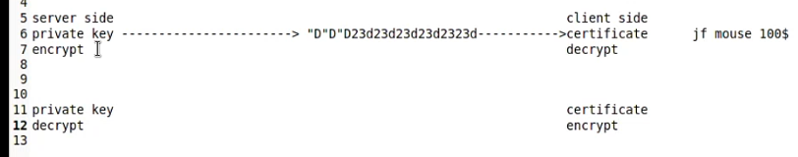

Encryption and decryption on the internet

Back and forth

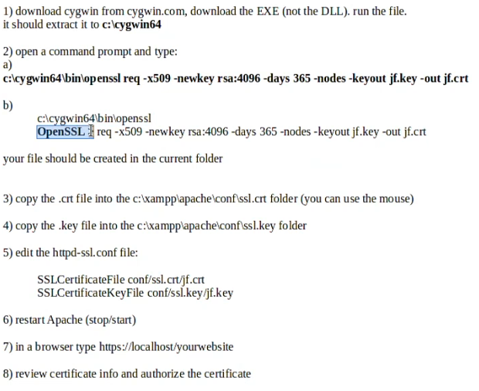

forces user to go into secure connection:

if (!isset($_SERVER["HTTPS"]) || $_SERVER["HTTPS"] != "on")

{

header("Location: https://" . $_SERVER["HTTP_POST"] . $_SERVER["REQUEST_URI"]);

exit();

}

SQL ROOT PASSWORD (JUST IN CASE): lasalle123



**Database:**

Auto-increment: Don’t have full control (if you delete one in the middle of the list)

Use Ticks (` `) for table names

Strings are the slowest for databases, slowest to manage

CHAR = fixed size

* Constraints
* Contacts
* Known length

VARCHAR = Variable size

* Names: VARCHAR
* INPUT/STRING: VARCHAR

Index:

Primary: Primary Key

Unique: Makes data unique, cannot have same value twice

* Seen by the users

Key: Regular index

* In where/join clauses or if it is a FK
* Why? – makes you able to find specific data quicker
* How?
  + PKs are already indexed, FKs are not

Unique: Makes sure it is unique

Views:

* Create views when a table contains sensitive data, don’t want to see all the fields
  + Filtering the fields
* Joins on tables
  + Showing rendez-vous

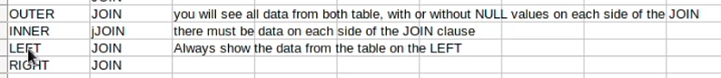

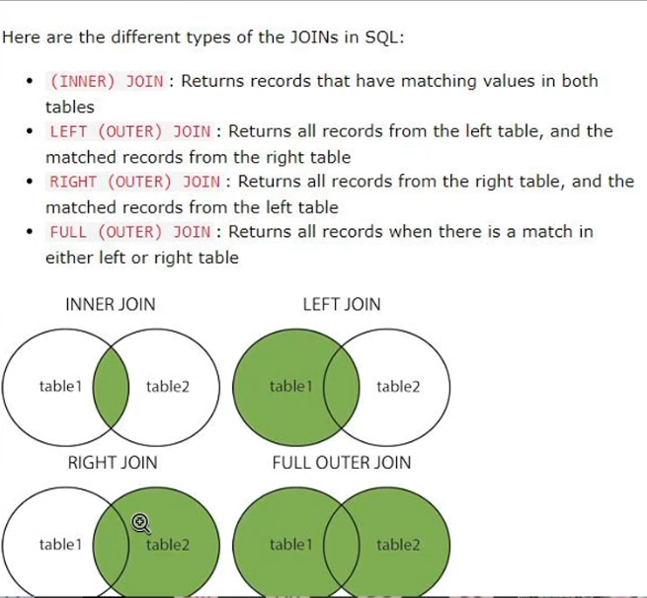

Join:

Inner join: there must be data on each side of the JOIN clause

Outer join: both tables matter, show all data

Left: Sets prio the table to the left

*You can solve most of the problems with left and inner*

Adding a user:

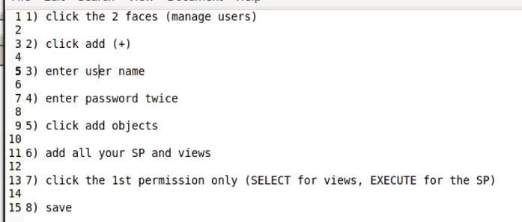

MVC – Model View Controller

Model: classes/objects, business rules, centralized validation

View: show the data received from controller or model (not recommended)

* HTML, CSS, JS

Controller: user input

Object:

Variables: properties

AJAX:

Form of Javascript

XHR = XMLHTTPREQUEST

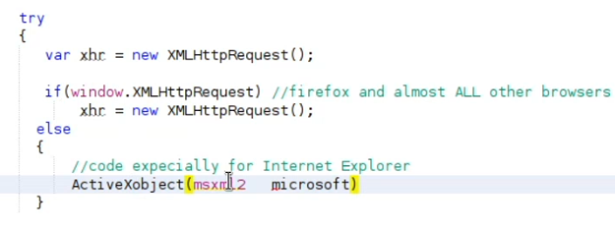

ELSE:

* Handles other browsers (explorer, etc)