|  |
| --- |
| **Free Throws** |

In the *Introduction to Monte Carlo Simulation* course activity, you used a model of a population to randomly generate outcomes for a sample of data. The sample of data was then summarized using a mean, count, proportion, etc. This process was then repeated a number of times and the distribution of the sample’s summaries was then examined to study the variation that would be expected based on the data generating process (DGP). This assignment will give you more practice with using Monte Carlo simulation to study the variation in sample summaries.

**Modeling Free throws**

One real-life situation that can be modeled as a random process is free throw shooting in basketball. As with most real-life situations, it can be hard to envision this as a random process—and in fact not all properties of free throw shooting are random. For example, free throws are practiced and players spend differing amounts of time in practice taking free throws. However, in the long run, you would expect that a pattern would emerge that would describe the variation in players’ made and missed free throw shots (i.e., free throw percentage). However, the individual outcome every time a player goes to the free throw line is uncertain (she might make the shot or she might miss). Because of this, free throw shooting can be modeled as a random process.

In 2016 a typical player in the WNBA attempted 52 free throws and successfully made 79.9% of the free throws. In other words, of the 52 free throws attempted during the 2016 season, the typical WNBA player made 79.9% of the free throw attempts, and missed 20.1% of those attempts. The percentage of free throws that were made is referred to as the player’s “free throw percentage”.

* Use TinkerPlots™ to set up a sampler based on a typical WNBA player—assume this player attempts 52 free throw and has a free throw percentage of 79.9%.

**Explore the Observed Data**

All questions worth 1 point unless otherwise indicated.

1. Copy and paste (or sketch) a picture of your TinkerPlot sampler into your word-processed document. Explain why you chose the sampling device and the values (repeat, percentages, draw, etc) you used to create it. **(2pts)**
2. Run the sampler to generate the outcomes for 52 free throw attempts. Plot the outcomes for this hypothetical WNBA player. Also compute the number (count) of made and missed free throws for this player. Copy and paste (or sketch) this plot into your word-processed document.

**Carry Out Multiple Trials of the Simulation**

1. Using the automation feature, run 50 trials of your simulation. Copy and paste the plot of the results from your 50 trials into your word-processed document.
2. Using the context of basketball, what does a dot in this plot represent?
3. Give and interpret the mean value for your 50 results in context. **(2pts)**
4. By referring to the model you set up in your TinkerPlots sampler, explain how you could have predicted what the value of the mean would be before looking at the plot.
5. Based on the plot of the 50 results, describe the variation in the number of free throws made by giving the endpoints of the range where most counts lie in the plot.
6. Use the *Divider* tool in TinkerPlots to find the percent of the 50 results that fall in the range you provided in Question #7. Report the results.

**Percentiles**

A **percentile** is a measure used in statistics to indicate the value below which a given percentage of observations in a group of observations fall. For example, the 20th percentile is the value (or score) below which 20% of the observations may be found. We can easily find the percentile value using TinkerPlot’sTM Divider tool.

* Highlight the plot of the 50 results by clicking on it. Select the Divider tool from the toolbar. This should add a shaded rectangle to your plot.
* Now click the % (percent) tool in the toolbar. This should add three percentages to your plot. These percentages correspond to the percentage of cases in each of the three areas defined by the divider (the left-side of the shaded area, in the shaded area, and the right-side of the shaded area).
* Drag the left-side of the shaded area all the way to the left-hand side of the plot (the area to the left of the shaded area should have a percentage of zero).
* Drag the right-side of the shaded area so that the percentage in the shaded area is the percentile you want. For example, the figure below shows how to find the 61st-percentile.
* To determine the value that is at the 61st-percentile, add a vertical reference line to the plot by clicking the vertical ref. line button in the toolbar. Move the reference line to the right edge of the shaded area. Below, the value of 215.8 is at the 61st-percentile.

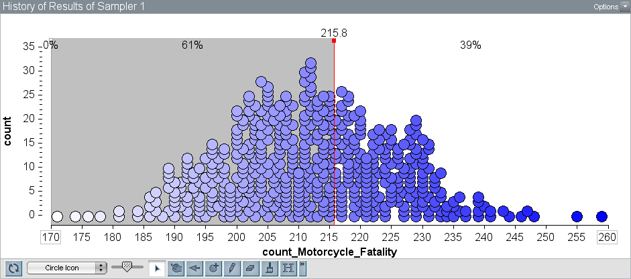

1. In 2016, Seattle Storm player Courtney Paris made 55.6% of her attempted free throws. In our plot, this would be equivalent to a WNBA player making 29 of 52 attempts. Is her free throw percentage likely based on the range you gave in Question #7.
2. ESPN called Courtney Paris’ free throw percentage of 55.6% “embarrassing”. Based on your answer to Question #11, is a WNBA player who makes 55.6% of her free throw attempts “underperforming” by WNBA standards? Explain by referencing your simulation results.