**Make-Up Quiz/Group Exam**

*Each student in your group needs to take the role of writer/recorder for one of the set of questions below. They will be responsible for helping the group come to consensus and also for writing the group’s agreed upon response.*

Writer/Recorder (#1–3): (name)

*Use for Question 1*

Because you have recently completed EPsy 3264, the *Minnesota Daily* has hired you (at an exorbitant fee given your statistics knowledge) as an accuracy auditor to ensure that the headlines for articles are accurate based on the source material.

Read the following summary of a study.

University of Minnesota researchers analyzed the relationship between student stress levels and involvement with University intramural sports. A sample of 580 undergraduate students was recruited via email request and campus postings in spring semester 2015. Students completed a questionnaire assessing self­reported stress levels, academic factors, and extracurricular involvement. It was discovered that students who were currently involved in University intramural sports were significantly less likely to report feeling burned out (*p* < .001).

1. Evaluate each type of validity for the study. (2 points)
   1. How would you rate the level of internal validity evidence based on the study design? Explain.
   2. How would you rate the level of external validity evidence based on the study design? Explain.

*Use for Questions 2–6*

Bernard (Bernie) Maddoff is known around the world as an investment broker whose firm, *Maddoff Investments,* cheated its clients out of billions of dollars. In 2009, Harry Markopolos, an independent financial fraud investigator, testified that the *Securities and Exchange Commission* should have been aware of fraud within *Maddoff Investments* since they had only posted a loss for three of the 87months under investigation, far fewer than other companies during the same time period.

The S&P 500 is a stock market index, maintained by Standard & Poor's, which consists of 500 large American companies. The S&P 500 is a benchmark for the performance of companies such as *Maddoff Investments*. During the 87-month period in which *Maddoff Investments* was suspected of fraud, the S&P 500 posted a loss for 28 of the months.

You have been asked to statistically examine the validity of Harry Markopolos’ statement that *Maddoff Investments* posted losses in far fewer months than other companies during the same time period. To do this, you will carry out a simulation based on what would be expected based on the S&P 500 performance during the 87-month period in question. You will use then use those results to answer the following question:

*Did Maddoff Investments post losses in fewer months than would be expected based on the S&P500 performance during the same time period?*

1. Write the hypothesis for the model you will use to generate outcomes based on the S&P 500 Benchmark performance rate (i.e., the null hypothesis).
2. Sketch the TinkerPlotsTM Sampler you used to simulate data. Be sure to label all pertinent values including the values for Draw and Repeat. Be sure to specify whether the sampling device(s) are sampling with or without replacement.

Writer/Recorder (#4–6): (name)

1. Sketch the plot of the simulation results (History of Results) based on 500 trials. Be sure to label the axes, etc. On the plot displayed previously, also add a vertical line at the observed result.
2. Compute and report the *p*-value. Show your work for full credit.
3. Use the *p*-value you computed in Question #5 to evaluate the compatibility of the observed data with the hypothesized model and answer the research question. Comment on whether this suggests that *Madoff Investments* committed fraud or not.

*Use the following for Questions 7 – 13:*

A research question of interest is whether financial incentives can improve performance. Bernice designed a study to test whether video game players are more likely to win on a certain video game when offered a $5 incentive compared to when simply told to “do your best.” Forty subjects are randomly assigned to one of two groups, with one group being offered $5 for a win and the other group simply being told to “do your best.” She collected the following data from her study.

Do financial incentives improve performance?

|  |  |  |  |
| --- | --- | --- | --- |
|  | $5 incentive | “Do your best” | Total |
| Win | 16 | 8 | *24* |
| Lose | 4 | 12 | *16* |
| Total | *20* | *20* | *40* |

Based on these data, it looks like the $5 incentive is more successful than the encouragement, because the observed difference in “win” proportions is



In order to test whether this apparent difference might be due simply to chance, Bernice does the following:

* She gets 40 index cards. On 24 she writes, "win" and on 16 she writes, "lose".
* She then shuffles the cards and randomly places the cards into two stacks of 20 cards each. One stack represents "$5 incentive" and the other "verbal encouragement".
* For this simulation, she computes the difference in the success rates by subtracting the success rate for the simulation's "verbal encouragement" group from the success rate of the simulation's "$5 incentive" group.
* She repeats the previous two steps 100 times.
* She plots the 100 statistics she observes from these trials.

Below is a plot of the simulated data that Bernice generated from her 100 trials and used to test her research question.

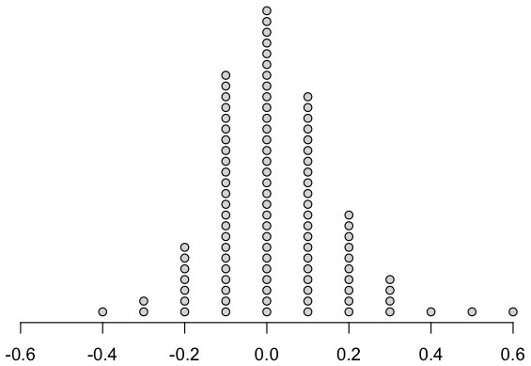

Writer/Recorder (#7–13): (name)

1. What is the explanation for the process Bernice followed? (Circle your answer.)
   1. This process allows her to compare her actual result to what could have happened by chance if the incentive had no effect.
   2. This process allows her to determine the percentage of time the $5 incentive strategy would outperform the “do your best" strategy if the experiment were repeated many times.
   3. This process allows her to determine how many times she needs to replicate the experiment for valid results.
2. Bernice simulated data using which of the following assumptions? (Circle your answer.)
   1. The $5 incentive is more effective than verbal encouragement for improving performance.
   2. The $5 incentive and verbal encouragement are equally effective at improving performance.
   3. Verbal encouragement is more effective than a $5 incentive for improving performance.
3. Compute and report the *p*-value. Show your work for full credit.
4. Use the *p*-value you computed in Question #9 to evaluate the compatibility of the observed data with the hypothesized model and answer the research question.

Use Bernice’s original data and TinkerPlotsTM to create a compatibility interval of the effect of financial incentives.

1. Provide a picture of the sampler you will use. Be sure to indicate values for draw, run, repeat, and whether sampling is conducted with or without replacement.
2. Give the lower and upper endpoints for the compatibility interval, and show how you calculated them.
3. If Bernice’s sample size were ten times as large, how would the uncertainty in the compatibility interval change? (i.e., would there be less uncertainty, more uncertainty, or the same amount of uncertainty?) Explain.

***Please print all group members’ names on the first page of the quiz.***