

**Group Quiz #2**

Each student in your group needs to take the role of writer/recorder for a portion of the quiz (as indicated). They will be responsible for helping the group come to consensus and also for writing the group’s agreed upon response.

Writer/Recorder (#1–4): (name)

**Use for Questions 1–3**

Each of these questions contains a written description of a variable. For each description, (a) sketch a plot of the distribution that you think would result if we plotted that variable; (b) add an appropriate scale to the *x-*axis of each plot to indicate the variation in the variable; and (c) explain, *using the variable’s context*, why the plot you sketched would have the statistical shape you drew and the variation you indicated.

1. Haircut prices for all students who take EPsy 3264.
2. Heights of all University of Minnesota students.
3. Last digit of student ID number for all University of Minnesota students
4. A class of 10 introductory statistics students took a 15-point quiz. The standard deviation for the resulting score distribution was 0. Sketch a dot plot of the score distribution.

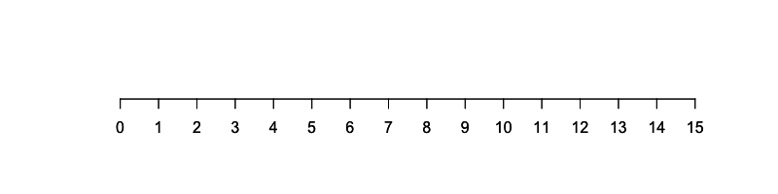

Writer/Recorder (#5–7): (name)

**Use for Questions 5–7**

Author and columnist Leonard Koppett pointed out that the stock market's performance in a given year can be predicted based on the outcome of that year’s Super Bowl. This phenomenon is referred to as the Super Bowl Indicator. The premise is that if a team from the AFC wins, then it will be a down/bear market , but if a team from the NFC wins, it will be an up/bull market. To investigate this, a team of researchers examined the following research question: *Is the Super Bowl Indicator able to predict the performance of the stock market better than chance?* As of January 2020, the indicator has been correct 40 out of 53 times.

1. Write the *null hypothesis* that the research team should base their simulation on in order to investigate the research question.
2. To investigate this research question, one of the researchers, Daphne, intends to perform a simulation using TinkerPlots. She creates the following sampler to explore the just-by-chance model. Correct any problems with Daphne’s sampler by noting your corrections on the image.

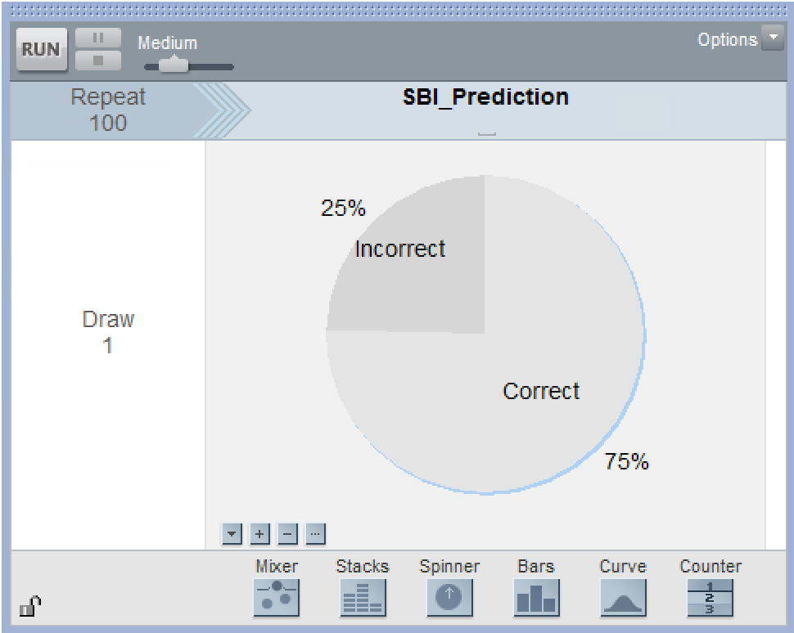

*Daphne’s Sampler.*

1. Another member of the research team, Velma, simulated 500 trials *using the correct model*. The plot below displays the results of Velma’s 500 trials.

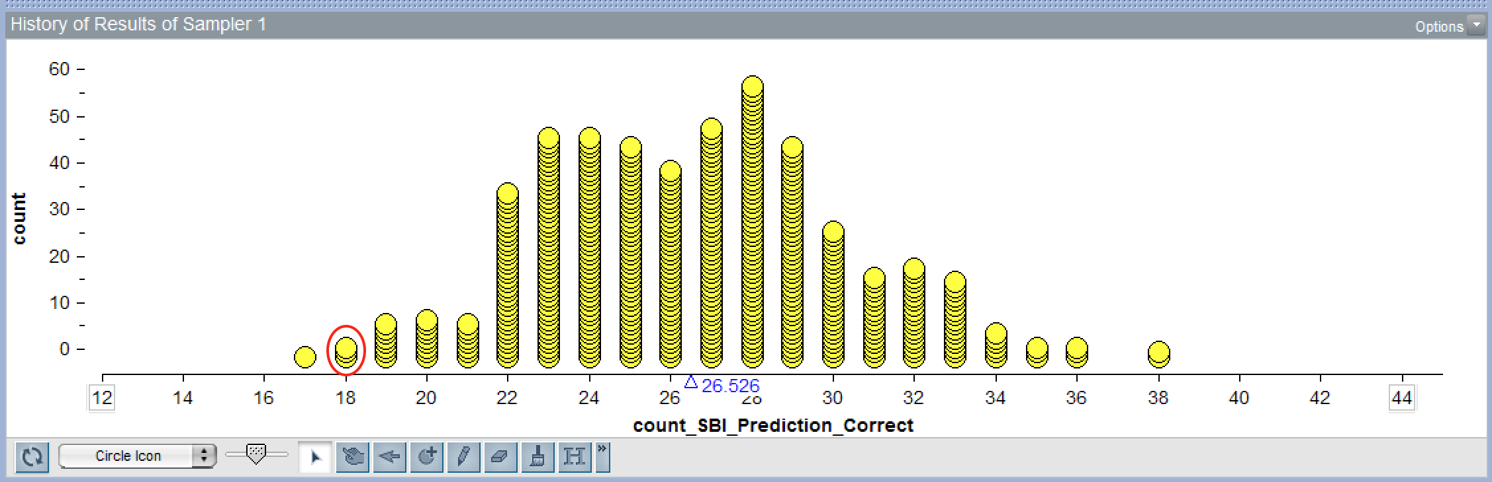

*Velma’s Simulation Results.*

* 1. What was the summary measure that Velma collected in her simulation?
  2. Use the null hypothesis you wrote in Question #5 to explain why Velma should expect that this plot would have a mean value near 26.5.
  3. Describe what the **circled** dots represent in the plot. Use the context of the problem in your description.
  4. Velma also computed the standard deviation, which was 3.65. On the plot displayed previously, shade the area of the plot that indicates results that a statistician would define as likely results. Show how you computed the endpoints for the shaded area.
  5. On the plot displayed previously, also add a vertical line at the result that the research team observed in their actual study. Provide a clear answer to the research question *and* a justification for this answer based on the statistical evidence of the observed result and the variation in the simulated results.

Writer/Recorder (#8–12): (name)

**Use for Questions 8–12**

In 2010, the telecommunications branch of the UK Post Office commissioned a research organization to look at anxieties suffered by cell phone users. The study found that nearly 53 percent of cell phone users in Britain suffer from nomophobia—the fear of losing or not having their cell phone.

1. Assume the true percentage of people in Britain suffering from nomophobia is 53%. Sketch a picture of the TinkerPlots sampler you could use to generate simulated data for a study sampling 35 people from the British population described above. Be sure to label all parts of the sampler.
2. Use TinkerPlots to generate data for 500 simulated trials of the study. For each trial of the study collect the percentage of study participants who suffer from nomophobia. Sketch the plot of these 500 results. Be sure to label the *x-*axis.
3. Compute and report the mean and standard deviation for the 500 results. Also, interpret both values by describing what each of them quantifies.
4. Using the mean and standard deviation you computed in the previous question, provide an *interval estimate* that encapsulates the results one would expect for most of the study replications (i.e., most replication results would be between XX and XX). Show your work so that someone else can understand how you decided on the lower and upper limits of this interval.
5. Another researcher carried out a similar study using 35 participants from the United States. She found that 23 participants, or 66% of the sample, suffered from nomophobia. Based on the interval estimate you provided in the previous question, does it seem like Americans suffer from more, less, or about the same amount of nomophobia as their British peers? Explain.

*Please print all group member’s names on the first page of the quiz.*