

**Group Quiz #4**

Each student in your group needs to take the role of writer/recorder for portion of the quiz (as indicated). They will be responsible for helping the group come to consensus and also for writing the group’s agreed upon response.

Writer/Recorder (#1–6): (name)

**Use for Questions 1–9**

In October 2013, MTV and the Associated Press conducted a survey of digital abuse of young people in the United States. Suppose the study randomly sampled and surveyed 200 teenagers (ages 14–17) and 200 young adults (ages 18–24).

|  |  |  |  |
| --- | --- | --- | --- |
|  | **Perceive cyber-bullying**  **as a problem** | |  |
|  | **Yes** | **No** | **Total** |
| **Teenagers** | 162 | 38 | 200 |
| **Young adults** | 142 | 58 | 200 |
| **Total** | 304 | 96 | 400 |

|  |
| --- |
| **Is the percentage of teenagers who perceive cyber-bullying as a**  **problem different from the percentage of young adults who perceive**  **cyber-bullying as a problem?** |

1. Compute (a) the percentage of teenagers in the sample who perceive cyber-bullying as a problem, (b) the percentage of young adults who perceive cyber-bullying as a problem, and (c) the difference between the two percentages. Show your work so it can be determined how you computed these values.

a)

b)

c)

You will conduct a bootstrap test using TinkerPlotsTM to model the variation in the difference of means, assuming there is no difference between the two groups. Dummy code the responses so that 1 = perceive cyber-bullying as a problem and 0 = do not perceive cyber-bullying as a problem.

1. Create a TinkerPlotsTM sampler so that you can carry out a bootstrap test based on the model you specified in the hypothesis. Sketch the sampler you will use below. Be sure to specify whether the sampling device(s) are sampling with or without replacement.
2. Carry out 500 bootstrap trials. Sketch the plot of the bootstrap differences below. Be sure to label the axes for full credit.
3. Describe the shape of the plot. Also compute and report the mean and standard deviation.
4. On the plot displayed previously, also add a vertical line at the observed result.
5. Compute and report the *p*-value. Show your work for full credit.

Writer/Recorder (#7–9): (name)

1. Use the *p-*value you computed in Question #6 to evaluate the compatibility of the observed data with the hypothesized model.
2. a. How would you rate the level of internal validity evidence based on the study design? Explain.

b. Based on your response to Question #8a, are you willing to draw a causal association between age (teenagers and young adults) and perceptions of cyber-bullying? Explain.

1. a. How would you rate the level of external validity evidence based on the study design? Explain.

b. Based on your response to Question #9a, are you willing to generalize the perceptions of cyber-bullying to all teenagers and young adults in the United States. Explain.

Writer/Recorder (#10–16): (name)

**Use for Questions 10–16**

Three sets of researchers set out to examine the same research question: *Do dog owners spend more money on their pet than cat owners, on average?* To answer this question, the first set of researchers surveyed 20 cat owners and 20 dog owners about how much money they spend (annually) on their pet. The second set of researchers asked the exact same question, but sampled 40 cat owners and 40 dog owners. The third set of researchers again asked the exact same question, but sampled 70 cat owners and 70 dog owners. The null hypothesis that will be modeled by all three sets of researchers is:

*The average amount of money spent annually by dog owners is not more than the average amount of money spent by cat owners.*

1. All three sets of researchers found that dog owners spent $1,641 each year, on average, and cat owners spent $1,291 each year, on average. Compute the observed result that will be used to compute a *p-*value.
2. Each set of researchers carried out 100 trials of the simulation under the null hypothesis. The plots of their results are shown on the next page. For each study, draw a vertical reference line at the observed result *and* shade the area represented by the *p-*value.
3. Circle the study below which has the smallest *p-*value.

Study 1 Study 2 Study 3

1. Which set of results has the *largest standard deviation*? Explain by referring to the variation of the results in each plot.

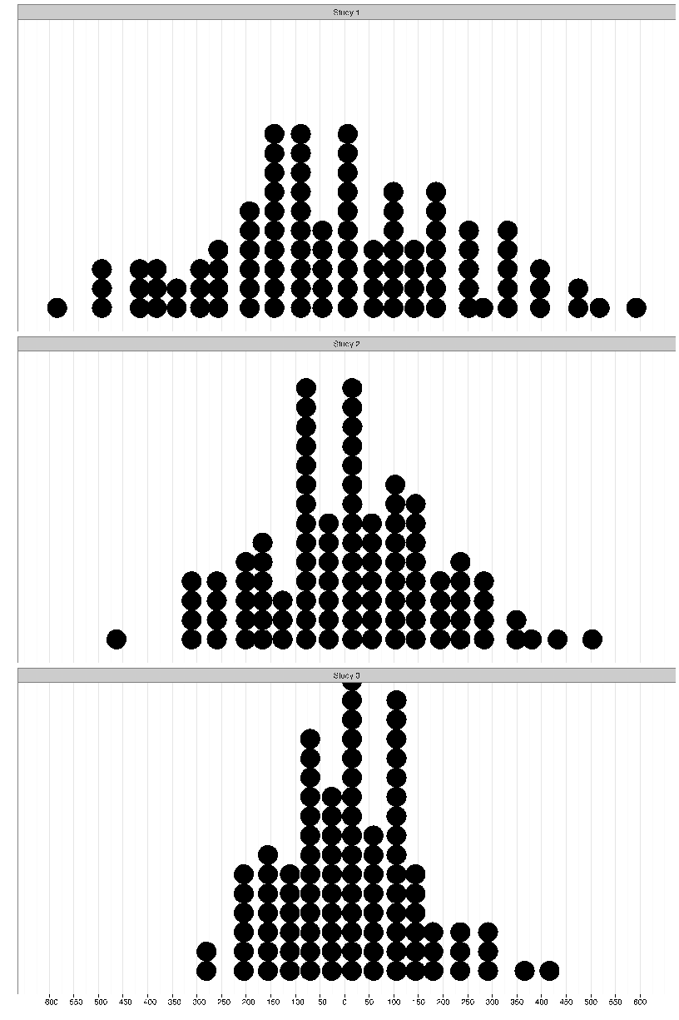

1. Based on your previous answers, describe the relationship between the sample size of a study and the size of the standard deviation of the results.
2. The size of the *p-*value for a particular study is based on the observed result and the variation in the simulated results. Consider a fourth study using the same questions as the previous studies that also found the same observed result. This study, however, sampled 100 cat owners and 100 dog owners.
   1. How would the standard deviation of the results for this fourth study compare to the standard deviation of the results for the other two studies? Explain.
   2. How would the *p-*value of the results for this fourth study compare to the *p-*value of the results for the other three studies? Explain.

***Please print all group members’ names on the first page of the quiz.***