

**Group Quiz #5**

Each student in your group needs to take the role of writer/recorder for portion of the quiz (as indicated). They will be responsible for helping the group come to consensus and also for writing the group’s agreed upon response.

Writer/Recorder (#1–3): (name)

**Use for Questions 1–5**

A study was conducted to investigate the number of days that heroin addicts remained in a clinic for methadone maintenance treatment. The data in *heroin-times.tp* contains the number of days that each of 238 patients stayed in the clinic. You will use these data to answer the following research question:

|  |
| --- |
| **How many days, “typically”, does a patient stay in the clinic?** |

1. Plot the observed data using TinkerPlotsTM. (Do not simulate yet.) Sketch the plot below.
2. The distribution is not symmetric. Which direction is the skew and what does that tell you about the length of time patients stayed in the clinic for methadone maintenance treatment?
3. In skewed distributions, the **median** is often a better indication of a “typical” value than the mean. Use TinkerPlotsTM to find the median of the observed data. (Hint: Look next to the mean button in the TinkerPlotsTM toolbar.) Record this value below.

Writer/Recorder (#4–5): (name)

1. Use TinkerPlotsTM to carry out a bootstrap simulation of 1,000 trials in order to compute a compatibility interval of the **median**. Compute and report the endpoints of the compatibility interval. Show your work for complete credit.
2. Provide an interpretation of your compatibility interval, and use it to answer the research question.

Writer/Recorder (#6–9): (name)

**Use for Questions 6–9**

A researcher is interested in determining if there is an effect of diet on 12-month weight-change. She had 200 people volunteer to be a part of her study. After determining the subjects’ baseline weights, she randomly assigned 100 participants to either follow the Atkins diet or the LEARN diet. After 12 months, the subjects were re-weighed, and their overall weight loss was recorded. The researcher has computed compatibility intervals for the average amount of weight loss for both diets and has come to you for help in interpreting her results.

|  |  |  |  |  |
| --- | --- | --- | --- | --- |
| Table 1  *Means, Standard Errors and Bootstrap Interval Estimates for Weight Loss on the Atkins and LEARN Diet.* | | | | |
|  |  |  | **Compatibility Interval** | |
| **Diet** | **Mean Weight Loss** | **Std. Error** | **Lower Limit** | **Upper Limit** |
| Atkins | 14.48 | 1.93 | 10.62 | 18.34 |
| LEARN | 7.53 | 2.26 | 3.01 | 12.05 |

1. The plot below shows a graphical display of the compatibility interval for the average weight loss for people on the Atkins diet. Use the information in Table 1 to add a graphical display of the compatibility interval for the average weight loss for people on the LEARN diet.

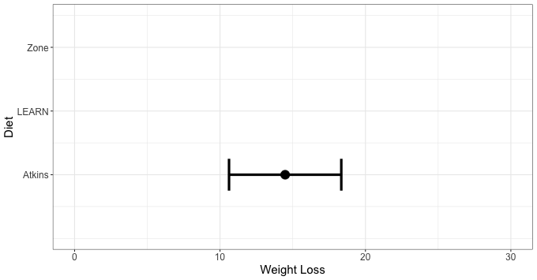

1. One question a researcher may have is whether the Atkins diet is more effective than the LEARN diet ~~(i.e., is the average weight loss for people on the Atkins diet really more than the average weight loss for people on the LEARN diet)~~. Although the average weight loss for people on the Atkins diet appears more effective from the sample data, there is also a great deal of uncertainty in the data. Based on the graphical display of the compatibility intervals, explain how you can tell that there is too much uncertainty to conclude that there was more weight loss on average for Atkins than the LEARN diet.
2. The same researcher also studied a third diet; the Zone diet. Her research showed that the Zone diet was (1) MORE effective than the LEARN diet (after accounting for uncertainty), but (2) was NOT more effective than the Atkins diet (after accounting for uncertainty). Add a graphical display of the compatibility interval for the average weight loss for people on the Zone diet to the plot that meets both criteria. (Note: There are multiple solutions to this problem.)
3. Reconsider the compatibility interval for the mean weight loss of people on the Atkins diet. Explain how the amount of uncertainty in the interval would differ if there had only been 25 participants assigned to this diet.

Writer/Recorder (#10–12): (name)

**Use for Questions 10–12**

Researchers from Harvard Medical School investigated the relationship between incidence of type 2 diabetes and red meat consumption (bacon, hot dogs, etc.). They had a sample of 37,000 women across the United States complete a questionnaire about their eating habits. The women, who were all at least 45 years old, completed this questionnaire yearly for three years. The researchers found that women who consumed more processed red meat had a higher risk of contracting type 2 diabetes (*p* = .004).

1. A newspaper is considering publishing this material with a headline that reads: *Middle-Aged Women Beware: Red Meat Consumption Increases Risk of Type 2 Diabetes.* Explain whether this is an appropriate headline by referring to the study design.
2. Write the null hypothesis that was tested by the researchers.
3. Circle the best interpretation of the second *p*-value provided in the study (*p* = .004).
   1. Assuming there is no difference between treatments, middle-aged women who consume red meat have a 0.4% higher risk of type 2 diabetes than middle-aged women who don’t consume red meat.
   2. Assuming there is no difference between treatments, there is a 0.4% chance of obtaining the observed difference in risk of type 2 diabetes (or more extreme) between middle-aged women who consume red meat and those that don’t.
   3. Assuming there is no difference between treatments, there is a 0.4% chance that there is a meaningful difference in the risk of type 2 diabetes between middle-aged women who consume red meat and those that don’t.

***Please print all group members’ names on the first page of the quiz.***