GAIA//2126

Living Earth Simulation System Design

STATUS  Proposed |  | OWNER  GAIA//2126 Team |  | LAST UPDATED  August 10, 2026

Authors | sdj3261 with Codex
Reviewers | Challenge judges; gameplay and climate-model reviewers
Related docs | README.md; docs/GAME_DESIGN.md; docs/TECHNICAL_ARCHITECTURE.md
Scope | Browser game runtime, 5,000-cell simulation, 3D rendering, saves, and network-ready rankings.

1. Abstract
GAIA//2126 is a browser-first civilization survival tycoon. Policy choices change climate, water, food, housing, cohort migration, and whether cities grow or collapse across a living 3D Earth.
The challenge build runs 5,000 deterministic cells in a Web Worker and renders representative flows in Babylon.js. Release gates are Playability, Originality, Codex Collaboration, Release Potential, and Presentation—in that order. It is a game model, not a literal national forecast.

2. Goals and Non-Goals
Goals | Non-goals
A judge can start, complete turns, and see policy consequences without installation. | Scientifically authoritative city-level forecasting.
Keep 3D interaction responsive while 5,000 cells update off the UI thread. | 100,000-cell GPU compute in the MVP.
Persist runs, cohorts, and deterministic proof data in the browser. | Real-money, identity, or political decision support.
Deploy as static GitHub Pages with WebGPU and WebGL2 fallback. | A live shared ranking when no backend endpoint is configured.

3. Background and Problem Statement
Climate dashboards explain numbers but rarely make delayed consequences playable. A monolithic render loop would also couple frame rate to simulation cost and make future scaling unsafe.
React owns accessible controls, Zustand coordinates state, a Worker owns simulation truth, and Babylon renders transferred snapshots. The invariant is: simulation is numeric; visualization is a faithful, selective illusion.

4. Proposed Architecture

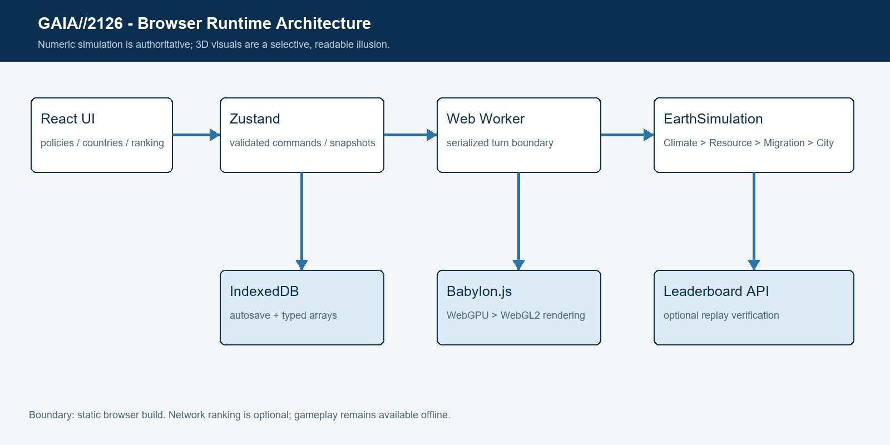
Figure 1. GAIA//2126 browser runtime and data flow.

Core components

Component | Responsibility | Primary storage | Failure behavior
React + Zustand | Collect policy/event input; present metrics, countries, and rankings. | In-memory UI state | Error boundary or reload; durable autosave remains.
EarthSimulation | Advance global state and orchestrate climate, resources, migration, cities. | Versioned policy/event data | Fail closed; reject invalid turn input.
Babylon.js scene | Render 5,000 cells, city states, disasters, and top migration routes. | WebGPU or WebGL2 | WebGPU initialization falls back to WebGL2.
Persistence + proof | Autosave typed arrays and deterministic action log. | IndexedDB; localStorage ranking fallback | Continue play in memory; reject corrupt saves.
Leaderboard service | Fetch and submit ranked runs with replay proof. | Optional REST API + PostgreSQL | Show LOCAL DEMO and never discard a completed run.

5. Request Lifecycle
- The player selects one or two policies plus one event response for the current five-year turn.
- Zustand validates IDs, turn state, policy caps, selection count, and available funds before posting to the Worker.
- The Worker loads the simulation version, seed, global state, policy levels, and authoritative typed-array world.
- EarthSimulation advances policy effects, then Climate, Resource, Migration, and City systems in a fixed deterministic order.
- The Worker retains authoritative arrays; the UI receives detached clones and autosaves the accepted state after each response.
- Rendering is local. Ranking calls use 4s GET and 5s POST timeouts. The run ends at 2126 or when nature or trust reaches zero.
- A transfer-only snapshot, migration summary, final report, and deterministic action entry update all dashboards and the 3D scene.

6. API and Data Contracts

Primary data contract

Field | Type | Required | Description
simulationVersion | number / typed array / object | Yes | Ruleset identifier; server separates incompatible seasons.
seed | number / typed array / object | Yes | Safe integer RNG seed owned by the simulation.
actionLog | number / typed array / object | Yes | Ordered turn, year, policy IDs, and event choice for replay.
world | number / typed array / object | Yes | 5,000 aligned typed-array cells; Worker is source of truth.
migration.routes | number / typed array / object | Yes | Top 12 numeric routes only; no personal data.
entry | number / typed array / object | Yes | Ranked run summary shown to players.
proof | number / typed array / object | Yes | Version, seed, and actions required for server verification.

Contract guarantees

- Only the event for the current turn and known, affordable policies are accepted.
- Action-log entries use contiguous turn numbers and five-year increments.
- Capture simulationVersion, seed, policy IDs, event choice, turn, and year.
- The Worker state is gameplay truth; visual particles and sample rankings are not.
The implementation contract is published in
src/types.ts and src/game/workerProtocol.ts; update both with every save-version change.

7. Consistency, Idempotency, and Replay

One Worker serializes turns. Each accepted turn appends exactly one action entry. Network verification replays from version and seed; duplicate score submissions are deduplicated by run ID.
Scenario | Expected behavior | Reasoning
Repeated score submission | Return the existing run for the same run ID. | Unique database constraint; replay is deterministic.
IndexedDB or ranking API fails | Continue in memory or LOCAL DEMO; preserve the completed entry locally. | Gameplay never depends on network availability.
WebGPU device or REST timeout | Fallback to WebGL2; abort REST within fixed budget. | Engine label and network mode remain visible.
Ruleset changes mid-run | The run's captured simulationVersion remains authoritative. | Server ranks runs only inside the same season/version.

8. Security and Privacy Considerations

- The static game requires no account. A public leaderboard must issue server-owned verified status and rate-limit writes.
- Store callsign, outcome, strategy, and deterministic actions only; never collect location, email, or device identifiers.
- Only a public API URL ships to the client. Database credentials and signing secrets remain server-side.
- Unknown simulation versions are unverified; malformed arrays, IDs, or non-finite values are rejected.
- Define retention before shared launch and support callsign-based deletion through a server-issued run token.

9. Operational Readiness
Signal | SLO or alert | Owner | Launch gate
Playable session completion | >=99% load success in supported browsers | Game team | Required
Turn calculation latency | p95 < 500ms at 5,000 cells | Game team | Required
Worker/save failures | No data loss; visible fallback | Game team | Required
Build/save/schema mismatch | Unknown simulation or save version | Game team | Required
Deterministic replay check | Every release; identical final hash | Game team | Required
Rollout constraint: tests, browser smoke test, static build, then Pages deployment; shared ranking remains opt-in until replay verification passes.

10. Alternatives Considered

Alternative | Why it was considered | Why it was not selected
Three.js-only renderer | Excellent low-level rendering ecosystem. | More game-engine systems would need custom assembly.
Main-thread simulation | Simpler message flow. | Frame stalls during cohort migration and scaling.
Rust/WASM in the MVP | Higher simulation throughput. | Premature toolchain and debugging cost at 5,000 cells.
Mandatory backend | Always-shared ranking and saves. | Breaks offline judging and adds credentials before core fun is proven.

11. Open Questions
- Which leaderboard season length and tie-break order best reward distinct strategies?
- Which regional climate datasets may be used in a public educational release?
- Move diffusion to WebGPU at 20,000 cells or only after profiling target devices?
- Who reviews balance changes that increment simulationVersion?

12. Decision and Next Steps
Ship the 5,000-cell static challenge build first. Validate the full 100-year loop with judges, then add a replay-verifying Go/PostgreSQL ranking service. Scale to 20,000 cells only after measured frame and turn budgets justify it.
Milestone | Deliverable | Exit criteria
M1 | 5,000-cell browser vertical slice | Tests pass; 100-year run completes in browser
M2 | Deterministic proof and visual QA | Seed + action replay reproduces score
M3 | GitHub Pages judging release | No blocker in judging window
M4 | Verified network ranking + 20K cells | Latency, replay, privacy, rollback gates pass

Use footnotes for definitions, assumptions, or terms that need precision without interrupting the main narrative.

