**Design choices for Mood therapy mood badge:**

- what shape do you want it to be? what orientation?

Square with slightly rounded edges so it isn’t sharp; symmetrical; similar to the example shown in the youtube video.

- is it something you would like to wear around your neck or something else?

Yes it would have a string or something so I can wear it around my neck or across my shoulder.

- portable? battery powered? plug into wall or computer via usb?

I would like for it to have a USB port so I can upload code and give it updates whenever I want. I would also like to charge via USB cable and for the badge to have a battery so it can hold charge – hopefully at least all day battery life when its off.

**Sketch of Design:**

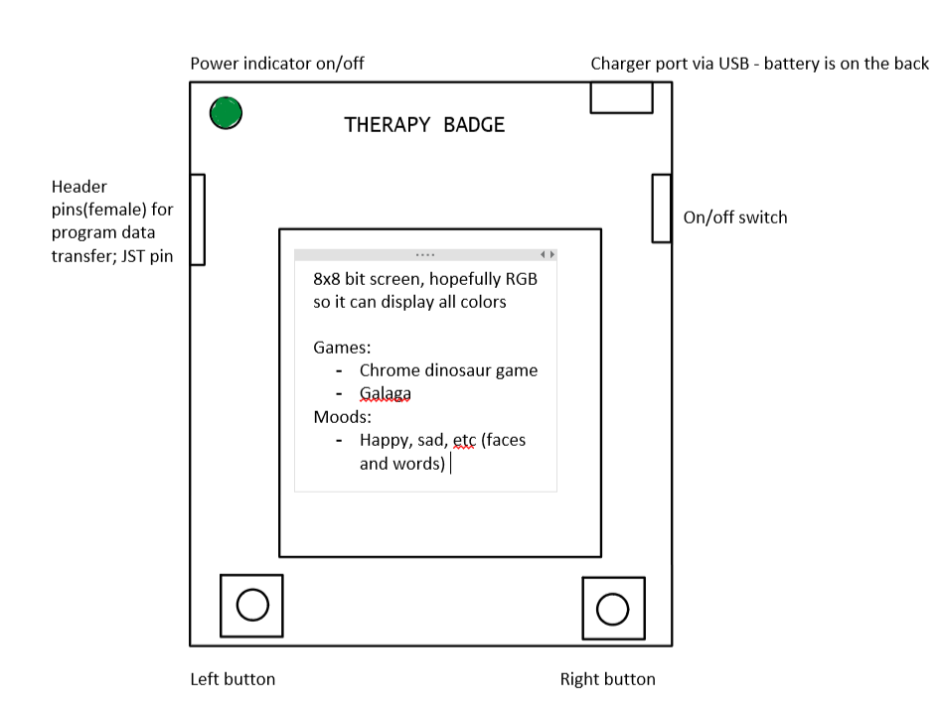

**git notes:**

git status - gives status of files

git add "filename"

git commit -m "message"

git push (refresh on github.com and see the file)

git pull (pulls down from github.com)

git add . (adds all files in directory)

git add -A (adds all files in directory)

git (will show all commands i can use)

if I press git commit without adding a message press esc :wq

tasks:

~~add linnes lab eagle libraries using Git -~~

~~add milestones eagle design blocsk using Git -~~

~~add teaching team as collaborators to my github project~~

~~organize my repository~~

sketch my design and push it to repo on github