Interpolation, Estimation, and Forecasting of Daily-Life Blood Pressure from Surveys and Wearables
🇰🇷 한국어 | English

Interpolation, Estimation, and Forecasting of Daily-Life Blood Pressure from Surveys and Wearables: A Level–Phase–Deviation Decomposition and Its Accuracy Limits
Gyu-Seong Lee¹, Sang-Hyun Cha¹, Bong-Ju Seong¹, Dae-Geun Park¹, Hyo-Young Kim²
¹ Department of AI Healthcare Convergence, Graduate School, CHA University, Republic of Korea · ² Department of Artificial Intelligence, Tech University of Korea, Republic of Korea · Data: A DAY Inc. (DAY BP), N = 120 [author romanization / affiliation to be verified]
Abstract
Background. Cuffless approaches that estimate blood pressure (BP) from smartwatches and questionnaires are proliferating, yet the accuracy limits of session-level (momentary) BP and their underlying causes remain insufficiently characterized.
Methods. Reference BP was measured about five times per day for seven days in 120 participants, with 24 wearable signals and survey variables. After session-averaging and outlier removal, each day was causally interpolated to a minute-level hybrid series in which measured times retain observed values. A person-level mean was anchored by an external cohort (KNHANES), survey variables, and a single-day calibration; a circadian phase kernel formed a structural estimate E0 = level + phase. The deviation r = observed − E0 was modeled from wearable signals and prior BP estimates, comparing 20 single- and multi-task model families. E0 + deviation was rolled forward autoregressively to forecast a held-out seventh day in static (one-step re-anchored) and dynamic (recursive rollout) modes. Participants were split 60:20:20; performance was evaluated only at measured time points using mean absolute error (MAE) and British Hypertension Society (BHS) grade.
Results. For estimation, linear (ridge regression) and spectral models generalized best, reaching held-out daily-average MAE of 2.07 mmHg (systolic) and 2.18 mmHg (diastolic), both BHS Grade A; tree and gradient-boosting models overfit. Wearable signals and prior BP estimates were complementary. For forecasting, the static mode reached session diastolic MAE 4.28 mmHg and daily-average 2.5 mmHg (Grade A), whereas the dynamic mode degraded by one grade. Session systolic BP remained near 5.7 mmHg (Grade B) across all methods.
Conclusions. With aggregated wearable features and one-day calibration, daily averages reach Grade A but session-level BP is capped at Grade B, a structural signature of regression toward each person's mean. The literature consistently indicates that raw PPG waveform morphology, pulse transit time, and periodic recalibration are required to reach session Grade A.
Keywords: cuffless blood pressure; wearable sensors; circadian phase; level–deviation decomposition; nowcasting; forecasting; BHS grade; autoregression

1. Introduction
Blood pressure (BP) is among the most informative and modifiable predictors of cardiovascular morbidity and mortality, and its clinical value depends heavily on when and how often it is measured. A single clinic reading captures only one moment along a continuously varying trajectory, whereas ambulatory and out-of-office monitoring reveal day-to-day and within-day patterns that carry independent prognostic weight. Conventional ambulatory monitoring, however, relies on intermittent cuff inflations that disturb sleep and daily activity, which constrains both adherence and the temporal density of the resulting record.
Cuffless wearable devices have therefore attracted growing interest as a means of acquiring frequent, low-burden BP information during ordinary life. Smartwatches that combine physiological sensing with lightweight self-report offer a particularly attractive substrate, because optical and motion signals can be paired with contextual survey responses to characterise an individual's state at each measurement occasion. This combination of continuous wearable signals and periodic survey input has emerged as a practical trend for everyday BP assessment outside the clinic.
Despite this momentum, several gaps remain. Most prior work has framed the problem as instantaneous estimation, mapping signals at a single moment to a concurrent BP value. Tasks that are equally relevant to real-world deployment are rarely treated within one framework: interpolation of BP between sparse measurements, estimation for previously unseen individuals, and forecasting of future values. In addition, the accuracy attainable at the level of an individual measurement session, as opposed to coarser daily summaries, has remained poorly characterised, leaving the practical limits of aggregate-feature wearables uncertain.
To address these gaps, the present study, DAY BP, develops a unified framework around a level–phase–deviation decomposition. The level term captures each person's stable BP set-point, anchored by a short calibration period and an external population reference. The phase term captures the structured circadian variation shared within demographic clusters. The deviation term captures the remaining residual fluctuation that current wearable signals and prior BP estimates can explain. By separating these three components, the same structural backbone supports interpolation between measurements, estimation for new individuals, and forecasting of future sessions, while performance is reported at both the session and daily-average levels.
The dataset underlying this work comprised 120 participants (60 male and 60 female; mean age 32.1 years, standard deviation (SD) 8.1, range 18–66; mean body mass index 22.7) monitored over 7 days at approximately five sessions per day, yielding roughly 4,128 sessions after session-averaging of 8,193 raw readings. Reference systolic BP (SBP) averaged 113.0 mmHg (SD 14.1) and diastolic BP (DBP) 74.5 mmHg (SD 9.5), with intraclass correlation coefficients of 0.72 (SBP) and 0.63 (DBP) indicating that between-person variation dominated. Person-level splitting and a calibration–estimation–forecasting partitioning of the week were used throughout, and performance was computed only at measured time points.
This study makes three contributions. First, it unifies interpolation, estimation for new individuals, and forecasting under a single level–phase–deviation decomposition, anchoring the level term with an external population reference that significantly improved cross-person SBP accuracy. Second, it systematically benchmarks 20 single- and multi-task model families for the deviation term, showing that linear and spectral models generalised best out-of-sample while tree and gradient-boosting methods overfit. Third, it characterises the accuracy ceiling of aggregate-feature wearables, demonstrating that daily averages reached the British Hypertension Society (BHS) Grade A while session-level SBP remained near Grade B owing to regression toward each person's set-point, and relating this limit to the waveform, timing, and recalibration requirements identified in the literature.
The remainder of the paper proceeds as follows: Section 2 describes the cohort, measurement protocol, and study design; Section 3 details the interpolation, level, phase, and deviation components; Section 4 reports estimation and forecasting results against established standards; and Section 5 discusses implications, limitations, and directions for clinically ready cuffless monitoring.

2. Related work
Cuffless blood pressure (BP) estimation from photoplethysmography (PPG) has been pursued along two broadly distinct feature paradigms. Waveform-based approaches extract morphological descriptors from the raw PPG pulse, including systolic and diastolic peak geometry, the dicrotic notch, the augmentation index, the reflection index, and second-derivative features of the photoplethysmogram (SDPTG). Aggregate-feature approaches instead summarize physiology over a window into scalar descriptors such as heart rate, heart rate variability, and activity intensity. The two paradigms differ sharply in the granularity of information they retain: morphological descriptors encode the beat-to-beat contour shaped by arterial compliance and wave reflection, whereas aggregate descriptors discard pulse shape and retain only the slow envelope of cardiovascular state. This distinction has direct consequences for attainable accuracy, because the British Hypertension Society (BHS) Grade A threshold for individual readings (60, 85, and 95 percent of absolute errors within 5, 10, and 15 mmHg) is demanding at the single-reading level.
A second informative timing channel is derived from pulse transit time (PTT) and pulse arrival time (PAT), typically requiring a second synchronized signal such as the electrocardiogram. The timing channel carries a stronger systolic signal than morphology alone: reported systolic BP (SBP) root-mean-square error is approximately 5.3 mmHg for PTT-based estimation versus approximately 9.8 mmHg for PAT-based estimation, the latter being degraded by the variable pre-ejection period. Among waveform-driven deep models, PPG2BP-Net, which operates on the raw pulse, has reached an SBP error of 0.21 plus or minus 7.51 mmHg, satisfying Grade A. These results establish that single-reading Grade A performance has, in the literature, depended on access to raw morphology, an explicit timing channel, or both, rather than on aggregate descriptors.

2.1 Calibration, drift, and the limits of aggregate features
A recurring constraint is calibration. Calibration-free deployment degrades accuracy markedly, and validated smartwatch devices have been shown to regress toward the calibration set-point, over-estimating low pressures and under-estimating high pressures; on these grounds such devices have been judged not clinically ready. Even with calibration, accuracy decays over time as physiology drifts, with reported drift on the order of 0.022 mmHg per day, motivating periodic recalibration on at most a monthly cadence. The collective finding from this body of work is that aggregate wearable features combined with sparse calibration regress predictions toward each person's individual set-point, a mean-regression effect that caps single-reading SBP accuracy near the Grade B regime rather than Grade A.

2.2 Wearable physiology and autonomic state
The value of aggregate features rests on a physiological premise: heart rate, weighted heart rate, the deviation of heart rate from resting, heart rate variability, wrist temperature, activity and sleep status, and metabolic equivalents (METs) jointly encode the autonomic state that modulates BP around an individual's structural level. These signals capture the acute, session-level autonomic excursions that accompany activity, rest, and sleep, even though they do not recover pulse morphology. This premise is consistent with the observation that aggregate features are well suited to tracking person-level and daily averages while remaining limited at the level of individual sessions, where within-person variability is dominated by transient excursions and measurement noise.

2.3 Forecasting and home-BP variability
In contrast to the substantial literature on contemporaneous estimation, the forecasting of future BP from wearable signals has received little attention. Day-to-day home BP exhibits genuine physiological variability, yet next-day or longer-horizon prediction from prior wearable observations alone, without access to the future reference measurement, has rarely been formulated as an explicit task. This rarity is notable because anticipating the following day's BP trajectory, and propagating uncertainty across successive within-day sessions, addresses a different clinical question from same-time estimation and demands methods that do not rely on concurrent ground truth.

2.4 The unfilled gap
Taken together, prior work has shown that single-reading Grade A accuracy is achievable primarily through raw PPG morphology or a dedicated PTT timing channel, that calibration-free use and temporal drift degrade aggregate-feature devices toward their calibration set-point, and that aggregate wearable features nonetheless encode the autonomic state governing BP around a person's structural level. What remains unaddressed is a unified treatment, under recognized standards (BHS, AAMI/ISO 81060-2, and IEEE 1708), of how far aggregate smartwatch signals and survey data, with only single-day calibration and no actual past BP beyond that day, can be pushed for both contemporaneous estimation and genuine next-day forecasting, including an explicit account of where the aggregate-feature ceiling lies and why daily-average accuracy can reach Grade A while single-session accuracy cannot. The present study addresses this gap.

3. Methods

3.1 Cohort, data, and measurement noise
The DAY BP study enrolled 120 adults (60 male, 60 female) who were monitored continuously for seven consecutive days. The mean age was 32.1 years (standard deviation [SD] 8.1, range 18–66) and the mean body mass index (BMI) was 22.7 kg/m²; 10 participants self-reported a prior diagnosis of hypertension. Each participant contributed approximately five blood pressure (BP) sessions per day, yielding roughly 4,128 sessions across the cohort. Reference cuff measurements averaged 113.0 mmHg systolic (SBP; SD 14.1) and 74.5 mmHg diastolic (DBP; SD 9.5). The intraclass correlation coefficient (ICC) was 0.72 for SBP and 0.63 for DBP, indicating that between-person differences dominated the total BP variance and that the principal modeling target was each individual's relatively stable set-point together with its smaller within-day excursions.
At every session the protocol acquired two cuff readings one minute apart, which were then averaged to form a single session value; the session timestamp was set to the last reading. This design directly addressed two well-documented sources of error in oscillometric BP. First, a single reading carries substantial measurement noise, with an estimated single-reading noise SD of approximately 4.8 mmHg for SBP and 3.8 mmHg for DBP; averaging two independent readings reduces the standard error of the session estimate by a factor of the square root of two. Second, the first reading of a session is inflated by an alerting (white-coat) response, here estimated at +2.1 mmHg; averaging the first and second readings attenuates this transient bias rather than propagating it into the modeling target. The 8,193 raw readings were thereby session-averaged to 4,169 session values. The practical importance of this step is quantified by decomposing within-person variance: after session-averaging, the within-person SD was 7.19 mmHg for SBP and 5.54 mmHg for DBP, yet an estimated 18–36% of the within-person SBP variance was attributable to measurement noise rather than to physiological signal. Treating individual readings as ground truth would therefore have asked the models to fit a substantial fraction of irreducible noise.
Cleaning removed physiologically impossible values (SBP below 70 mmHg or above 220 mmHg); two artifacts were removed on this basis. Cohort partitioning was performed strictly at the person level in a 60:20:20 ratio (72 training, 24 validation, and 24 test participants), so that no individual contributed sessions to more than one split. Within each participant's record, day 1 served as a calibration day used only for tuning, days 2–6 were reserved for estimation, and day 7 was held out for forecasting and never used to fit the interpolation, level, or phase components.

3.2 Hybrid interpolation
Because wearable signals and survey items were available at minute resolution while cuff references were sparse, each day's BP trajectory was reconstructed by a minute-level hybrid interpolation that combined a cluster circadian curve with the day's own observed sessions. The interpolation was strictly causal within each day: a given minute was reconstructed only from measurements available up to that point, so that no future BP value leaked into the representation of an earlier minute. Each observed session contributed to a reconstructed minute through a recency-by-phase kernel,
w = exp(−|Δt| / τ) · exp(−circ(φ)² / (2·ℓ²)),
where the first factor weights observations by temporal recency with a time constant τ of 1,440 minutes, and the second factor weights them by similarity in circadian phase with a length scale ℓ of approximately 196 minutes (the interpolation pass used ℓ = 90 minutes with a mixing weight κ = 0.5). The term circ(φ) denotes the circular time-of-day distance computed on a 1,440-minute ring, so that minutes near midnight and minutes near the end of the day were treated as adjacent rather than maximally distant; this preserved the diurnal continuity of the BP rhythm across the day boundary.
Measured minutes were anchored to their observed values and flagged with an is_actual indicator, so that the kernel-weighted reconstruction filled only the unmeasured minutes and never overwrote a genuine cuff measurement. This anchoring was verified by a sanity check confirming a reconstruction error of 0.00 at measured minutes. Critically, the interpolated trajectory was used only as features and as intermediate targets for downstream estimation and forecasting; it was never treated as evaluation ground truth. All reported performance was computed exclusively at measured time points (Table 1), ensuring that every error figure was assessed against an independent cuff reference rather than against a quantity the pipeline had itself imputed.

3.3 Level model
The level model estimated each person's blood pressure set-point, the dominant source of variance given the high between-person intraclass correlation coefficients (ICC; systolic blood pressure [SBP] 0.72, diastolic blood pressure [DBP] 0.63). Rather than relying on the day1 calibration mean alone, which is sparse and noisy, the person mean L was formed by empirical-Bayes shrinkage of the day1 calibration toward an external population-fitted level. Specifically, L = (n c_{m} + 2 L_{ext}) / (n + 2), where c_{m} denoted the day1 calibration mean, n the day1 reading count, and L_{ext} the externally anchored level. The prior was weighted as two pseudo-observations, so that subjects with denser day1 sampling relied more heavily on their own calibration while sparsely sampled subjects borrowed strength from the external anchor.
The external level L_{ext} was obtained from the Korea National Health and Nutrition Examination Survey (KNHANES) HN24 cohort (6,997 respondents; 6,033 adults; 5,957 with blood pressure available) using weighted ridge regression. Predictors comprised age and body mass index (BMI) splines, a sex interaction, physician-diagnosed hypertension, antihypertensive medication, smoking, and drinking, mirroring the self-reported survey features collected in the present study. Because the smartwatch reference differed systematically from the cuff-based survey instrument, a device offset alpha was fit on the training cohort (SBP +1.9 mmHg, DBP +2.7 mmHg) and added to the anchor.
External-anchor validation over 20 held-out splits confirmed the benefit of population representativeness (Table 1). For SBP, the KNHANES anchor achieved a mean absolute error (MAE) of 6.61 ± 0.78 mmHg, significantly better than a cohort-cluster anchor at 7.17 ± 1.04 mmHg (paired p = 0.001) and far better than a naive population mean at 10.05 mmHg. For DBP, the anchor reached 4.84 ± 0.59 mmHg, statistically equivalent to the cohort-cluster baseline at 4.94 mmHg (p = 0.41) and superior to the population mean at 5.69 mmHg. Population representativeness mattered because a small convenience cohort (N = 120, mean age 32.1 years, SD 8.1) under-sampled the older and hypertensive tail of the distribution; a nationally weighted survey supplied a calibrated prior across the full age, BMI, and risk-factor range, reducing shrinkage bias for atypical individuals.

3.4 Phase kernel
On top of the person level, a circadian phase component captured the systematic within-day shape of blood pressure. A cluster circadian phase kernel was estimated with four clusters defined by age and sex strata. The kernel weighted contributions by circular time-of-day distance on a 1,440-minute ring with a bandwidth ell of approximately 196 minutes, so that the phase curve reflected the diurnal pattern shared within each demographic cluster rather than noisy individual fluctuations. The structural estimate combined the two components additively, E0 = level + phase, yielding a smooth, fully causal baseline that depended only on the day1 calibration and external information. Day7 was never used to fit the interpolation or phase components, preserving the integrity of the downstream forecasting evaluation.

3.5 Deviation models
With the structural estimate E0 held fixed, the residual r = observed - E0 captured the remaining short-term variation, and the final prediction was reconstructed as E0 + r̂. Fixing E0 isolated the deviation modeling problem to the explainable, time-varying signal and prevented the residual learner from re-fitting the person set-point. Two complementary input groups were supplied. The first comprised current wearable acute signals: heart rate, weighted heart rate, the change in heart rate relative to resting, heart-rate variability, wrist temperature, an active flag, a sleep flag, and metabolic equivalents (METs). The second comprised prior blood-pressure-estimate lags, namely the previous-day same time-of-day estimate, the past-day same time-of-day mean, and the past-day overall mean. Critically, no actual past blood pressure entered the model beyond the day1 calibration; the lag features were derived from prior estimates only, so the pipeline remained deployable without ongoing cuff measurement. Ablation showed the two groups were complementary: wearable signals reduced session-level DBP error (test 4.81 to 4.75 mmHg), past-estimate lags reduced daily-average SBP error (test 2.35 to 2.09 mmHg), and combining both yielded the lowest error across metrics, consistent with wearable signals encoding acute session-level deviation and past estimates encoding person-level daily structure.
To characterize the residual signal without prematurely committing to one inductive bias, 20 model families were compared in single- and multi-task forms. These spanned regression (ridge, lasso, elastic-net, multi-task elastic-net), spectral methods (harmonic features with ridge or multi-task elastic-net), wavelet methods (continuous Ricker multiresolution with ridge or multi-task elastic-net), tree ensembles (random forest, extra-trees, multi-task extra-trees), gradient boosting (XGBoost, LightGBM, CatBoost, and multi-task XGBoost and CatBoost variants), and deep models (multilayer perceptron [MLP] and multi-task MLP). This breadth was deliberate: it spanned the bias-variance spectrum from strongly regularized linear models to flexible nonlinear learners, and contrasted single-task fitting against multi-task formulations that share representation across SBP and DBP. Comparing this range was necessary because expressive tree and boosting models attained the lowest in-sample error but collapsed out-of-sample under the modest training size, whereas linear and spectral models generalized best (Figure 1-3); the comparison thus established which inductive bias the deviation signal actually supported rather than assuming it.

3.6 Forecasting (static and dynamic)
Forecasting extended the deviation model autoregressively from the estimation window (days 2–6) to the held-out forecasting day (day 7), which was never used to fit the interpolation, level, or phase components. As in estimation, the structural estimate E0 (level plus cluster circadian phase) was held fixed, and only the residual r was predicted autoregressively. Two regimes were distinguished. In the static regime, the model produced a one-step-ahead prediction that was re-anchored at every session, so each forecast drew on inputs propagated up to the immediately preceding session. In the dynamic regime, the model was rolled out recursively across day 7, feeding its own predictions back as the prior blood-pressure-estimate lags rather than re-anchoring. Critically, both regimes operated exclusively on estimates: no actual day-7 blood pressure entered the autoregressive lags, consistent with the design constraint that no observed past blood pressure was used beyond the day-1 calibration. The static regime therefore represented a continuously re-anchored short-horizon forecast, whereas the dynamic regime represented a fully self-contained rollout whose error was expected to accumulate with horizon at later within-day sessions.

3.7 Evaluation
Performance was quantified with the mean absolute error (MAE, in mmHg) and the British Hypertension Society (BHS) grade, which assigns Grade A when 60, 85, and 95% of absolute errors fall within 5, 10, and 15 mmHg, respectively. Both metrics were reported at two aggregation levels: the session level (individual session-averaged readings) and the daily-average level (per-person per-day mean). All metrics were computed for systolic (SBP) and diastolic (DBP) blood pressure on the training, validation, and test partitions defined by the person-level 60:20:20 split (72, 24, and 24 participants), so that every reported figure reflected a held-out-person generalization with no participant appearing in more than one partition.
A strict measurement convention governed all evaluation. Errors were computed only at measured time points, where the reference was the two-reading session average; the minute-level interpolation was used solely as features and intermediate targets and never served as evaluation ground truth (sanity error 0.00 mmHg at measured minutes confirmed that measured values were retained exactly). This convention applied identically to estimation (Table 1) and to the static and dynamic forecasts (Figure 1–3), ensuring that reported MAE and BHS grades reflected agreement with observed cuff references rather than with interpolated proxies, and that the static-versus-dynamic comparison on day 7 was assessed on a common, observation-anchored basis.

4. Results

4.1 Cohort and basic statistics
The DAY BP study enrolled 120 participants (60 male, 60 female) monitored for seven consecutive days at approximately five sessions per day. After cleaning of physiologically impossible values (systolic blood pressure [SBP] below 70 or above 220 mmHg; two artefacts removed), the 8,193 raw readings were session-averaged to 4,169 sessions (approximately 4,128 valid sessions). The cohort had a mean age of 32.1 years (standard deviation [SD] 8.1, range 18–66) and a mean body mass index of 22.7 kg/m², with 10 participants reporting a prior diagnosis of hypertension (Table 1). Reference blood pressure averaged 113.0 mmHg (SD 14.1) for SBP and 74.5 mmHg (SD 9.5) for diastolic blood pressure (DBP). The intraclass correlation coefficient (ICC) was 0.72 for SBP and 0.63 for DBP, indicating that between-person differences dominated the total variance. After session-averaging, the within-person SD fell to 7.19 mmHg (SBP) and 5.54 mmHg (DBP). Because the measurement protocol averaged two readings taken one minute apart, the single-reading measurement-noise SD was approximately 4.8 mmHg (SBP) and 3.8 mmHg (DBP), with a first-reading alerting bias of +2.1 mmHg; consequently, an estimated 18–36% of the within-person SBP variance was attributable to measurement noise. Watch-signal density was unevenly distributed across participants and time of day, reflecting heterogeneous wear behaviour.
Table 1. Cohort characteristics, measurement properties, and external-anchor validation (N = 120).
Item | Value
Participants (male / female) | 120 (60 / 60)
Age (years) | 32.1 ± 8.1 (range 18–66)
Body mass index (kg/m²) | 22.7
Self-reported hypertension | 10 participants
Reference SBP / DBP (mmHg) | 113.0 ± 14.1 / 74.5 ± 9.5
Intraclass correlation (SBP / DBP) | 0.72 / 0.63
Within-person SD after session-averaging (SBP / DBP) | 7.19 / 5.54 mmHg
Single-reading measurement-noise SD (SBP / DBP) | ~4.8 / ~3.8 mmHg
First-reading alerting bias | +2.1 mmHg
Sessions (from raw readings) | 4,169 (from 8,193)
External KNHANES anchor, SBP MAE | 6.61 ± 0.78 (vs cohort-cluster 7.17 ± 1.04, p = 0.001; population mean 10.05)
External KNHANES anchor, DBP MAE | 4.84 ± 0.59 (vs 4.94, p = 0.41; population mean 5.69)

4.2 Interpolation quality
The minute-level hybrid interpolation reconstructed each day causally from that day's own measurements using a cluster circadian curve combined with a recency-by-phase kernel. Measured minutes retained their observed values under an is_actual flag, and the sanity error at measured minutes was 0.00 mmHg by construction, confirming that interpolation introduced no leakage at evaluation points. Interpolated values were used only as features and intermediate targets; all reported performance was computed exclusively at measured time points, never against interpolated ground truth.

4.3 Estimation performance
Twenty model families were compared on days 2–6 for the deviation component, with the structural estimate held fixed. Linear and spectral models generalized best. On the validation set (24 people, 596 sessions), ridge regression was the champion, achieving a session-level mean absolute error (MAE) of 6.06 mmHg (British Hypertension Society [BHS] Grade B) for SBP and 4.92 mmHg (Grade B) for DBP, and daily-average MAEs of 3.59 mmHg (Grade A) and 2.33 mmHg (Grade A). The harmonic-plus-ridge spectral model was effectively equivalent (6.12/4.95/3.61/2.34 mmHg). On the held-out test set (24 people, 580 sessions), ridge attained 5.71 mmHg (Grade B) for session SBP, 4.72 mmHg (Grade A) for session DBP, and 2.07/2.18 mmHg (Grade A) for daily averages; harmonic-plus-ridge matched it at 5.71/4.64/2.09/2.21 mmHg (Table 2). Tree- and gradient-boosting ensembles attained the lowest in-sample errors but collapsed out of sample: LightGBM reached a training session SBP MAE of 4.06 mmHg yet degraded to 7.05 mmHg (Grade C) on validation, a clear overfitting signature. The multi-task multilayer perceptron (MLP) was competitive given sufficient data (1,792 training sessions), reaching 5.75 mmHg session SBP, 4.74 mmHg session DBP, and 2.22/2.18 mmHg daily on test.
Table 2. Estimation performance of 20 deviation-model families on days 2–6 (held-out validation and test). Each cell is mean absolute error (mmHg) with British Hypertension Society grade. Linear and spectral models generalize best; tree and gradient-boosting families overfit.
Model | Validation (24 people, 596 sessions) |  |  |  | Test (24 people, 580 sessions)
sSBP | sDBP | dSBP | dDBP | sSBP | sDBP | dSBP | dDBP
E0 (level + phase) | 6.23C | 5.06B | 3.81A | 2.61A | 5.91B | 4.81B | 2.35A | 2.19A
Ridge regression | 6.06B | 4.92B | 3.59A | 2.33A | 5.71B | 4.72A | 2.07A | 2.18A
Lasso | 6.06B | 4.90B | 3.61A | 2.36A | 5.71B | 4.75B | 2.07A | 2.21A
Elastic-net | 6.06B | 4.90B | 3.60A | 2.36A | 5.71B | 4.75B | 2.07A | 2.21A
Multi-task elastic-net | 6.06B | 4.91B | 3.61A | 2.35A | 5.71B | 4.74B | 2.08A | 2.20A
Harmonic + ridge | 6.12B | 4.95B | 3.61A | 2.34A | 5.71B | 4.64A | 2.09A | 2.21A
Harmonic + MTEN | 6.10B | 4.94B | 3.63A | 2.36A | 5.72B | 4.68A | 2.09A | 2.22A
Wavelet + ridge | 6.28C | 5.09B | 3.52A | 2.45A | 5.83B | 4.73A | 2.09A | 2.20A
Wavelet + MTEN | 6.25C | 5.04B | 3.55A | 2.45A | 5.80B | 4.70A | 2.08A | 2.20A
Random forest | 6.84C | 5.32B | 4.65B | 2.99A | 6.03B | 5.07B | 2.73A | 2.75A
Extra-trees | 6.53C | 5.19B | 4.14A | 2.70A | 5.92B | 4.95B | 2.53A | 2.56A
Extra-trees (multi) | 6.47C | 5.19B | 4.08A | 2.70A | 5.92B | 5.00B | 2.53A | 2.62A
XGBoost | 6.75C | 5.44B | 4.37B | 3.19A | 6.12B | 5.14B | 2.60A | 2.88A
LightGBM | 7.05C | 5.59B | 4.78B | 3.37A | 6.34B | 5.24B | 2.65A | 2.93A
CatBoost | 6.40C | 5.27B | 3.95A | 2.85A | 5.81B | 4.88B | 2.29A | 2.58A
XGBoost (multi) | 6.81C | 5.42B | 4.57A | 3.13A | 6.21C | 5.09B | 2.75A | 2.76A
CatBoost (multi) | 6.43C | 5.20B | 4.05A | 2.75A | 5.83B | 4.83B | 2.40A | 2.42A
MLP | 6.13C | 5.03B | 3.73A | 2.60A | 5.83B | 4.87B | 2.26A | 2.27A
MLP (multi) | 6.14C | 4.99B | 3.72A | 2.38A | 5.75B | 4.74A | 2.22A | 2.18A
s = session level; d = daily-average level. Grade A/B/C in colour. The structural estimate E0 (level + phase) is shown as the baseline; the champion ridge regression and the equivalent harmonic-plus-ridge generalize best, whereas LightGBM/XGBoost attain the lowest in-sample error but the worst held-out error.

4.4 Deviation-input ablation
Ablation of the deviation inputs showed that the wearable signals and the prior blood-pressure-estimate lags were complementary (Figure 1). Using watch signals alone reduced session-level DBP error (test DBP from 4.81 mmHg, Grade B, to 4.75 mmHg, Grade A), capturing acute fluctuations. Using prior-estimate lags alone reduced daily-average SBP error (test from 2.35 to 2.09 mmHg), capturing the person-level set-point. Combining both inputs produced the lowest error across all metrics, consistent with the wearable channel encoding acute session-level DBP variation and the prior-estimate channel encoding person-level daily structure.
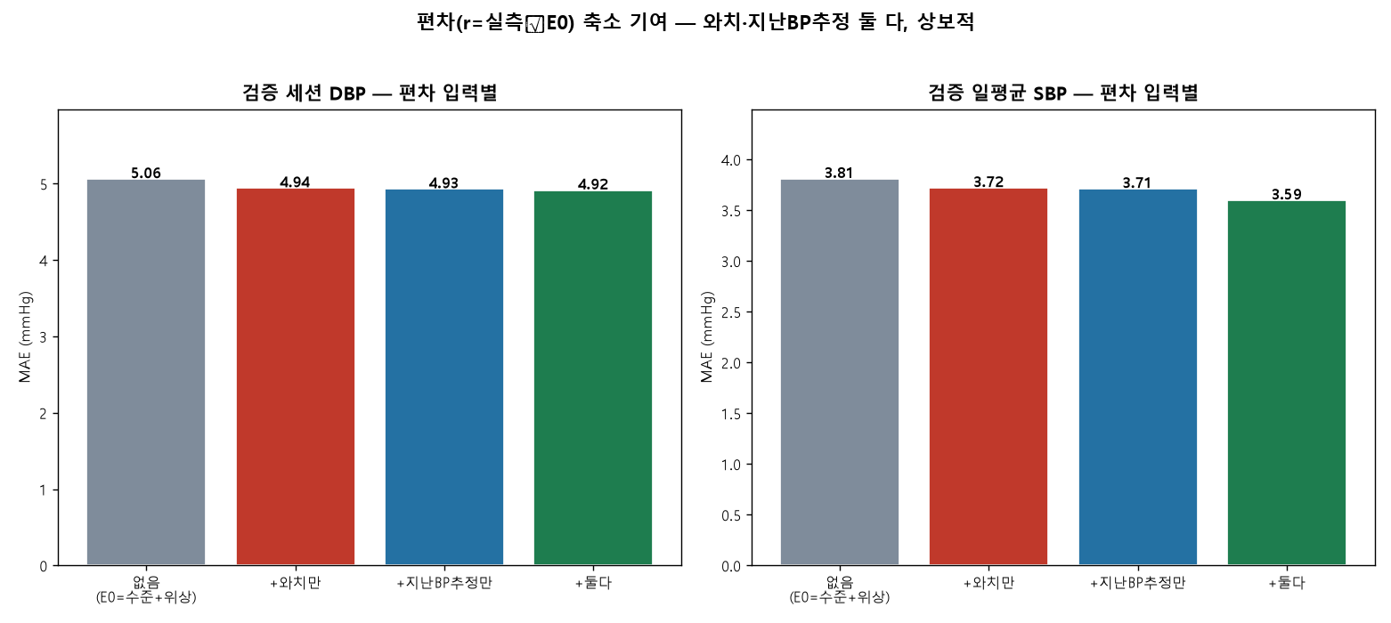
Figure 1. Deviation-input ablation (validation). Wearable signals reduce session diastolic error; prior BP-estimate lags reduce daily-average systolic level error. The two are complementary, so combining them is best.

4.5 Wearable-variable relevance
Among the current wearable inputs (heart rate, weighted heart rate, heart-rate deviation from resting, heart-rate variability, wrist temperature, activity and sleep flags, and metabolic equivalents), the acute cardiovascular and activity channels carried the deviation signal that improved session-level DBP, whereas the prior-estimate lags governed daily-level accuracy, mirroring the ablation findings.

4.6 Forecasting performance
Forecasting was evaluated on the held-out day 7 using an autoregressive residual on the structural estimate, with no actual day-7 blood pressure used at any point (Figures 2–3). The static one-step-ahead scheme, re-anchored each session, outperformed the recursive dynamic rollout. On test, ridge static achieved session MAEs of 5.52 mmHg (Grade B, SBP) and 4.28 mmHg (Grade A, DBP) and daily MAEs of 2.55/2.50 mmHg (Grade A), whereas dynamic forecasting degraded to 5.78 mmHg (Grade C, SBP) and 4.65 mmHg (Grade B, DBP) at the session level and 3.73/3.37 mmHg daily. Validation results showed the same ordering (static 5.56/4.99/2.63/1.95 mmHg; dynamic 5.85/5.29/3.78/2.62 mmHg). The dynamic scheme accumulated error with horizon as later within-day sessions fed on the model's own predictions, and within-day spikes were not fully captured.
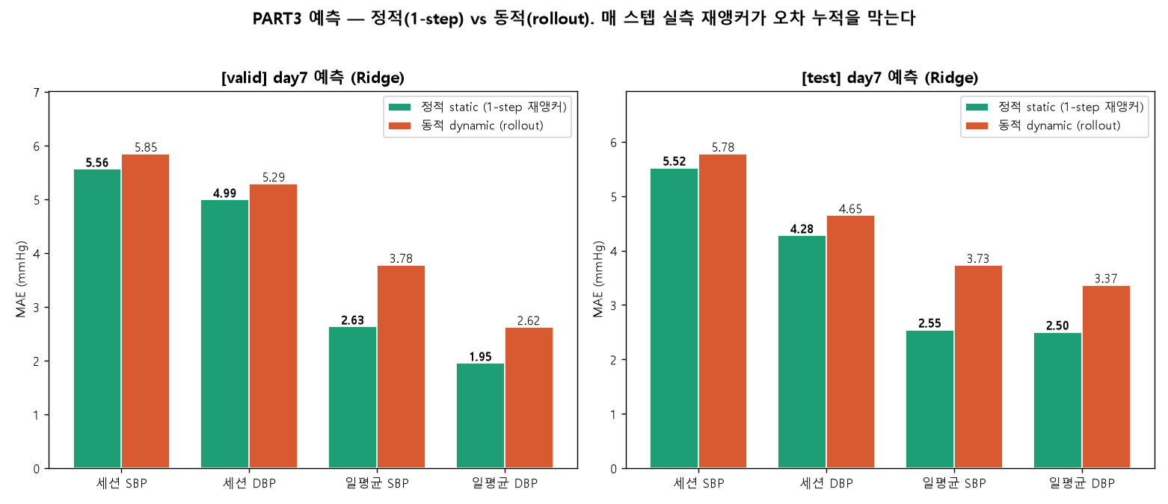
Figure 2. Day-7 forecasting MAE, static (one-step re-anchored) vs dynamic (recursive rollout), for validation and test. One-step re-anchoring prevents error accumulation.
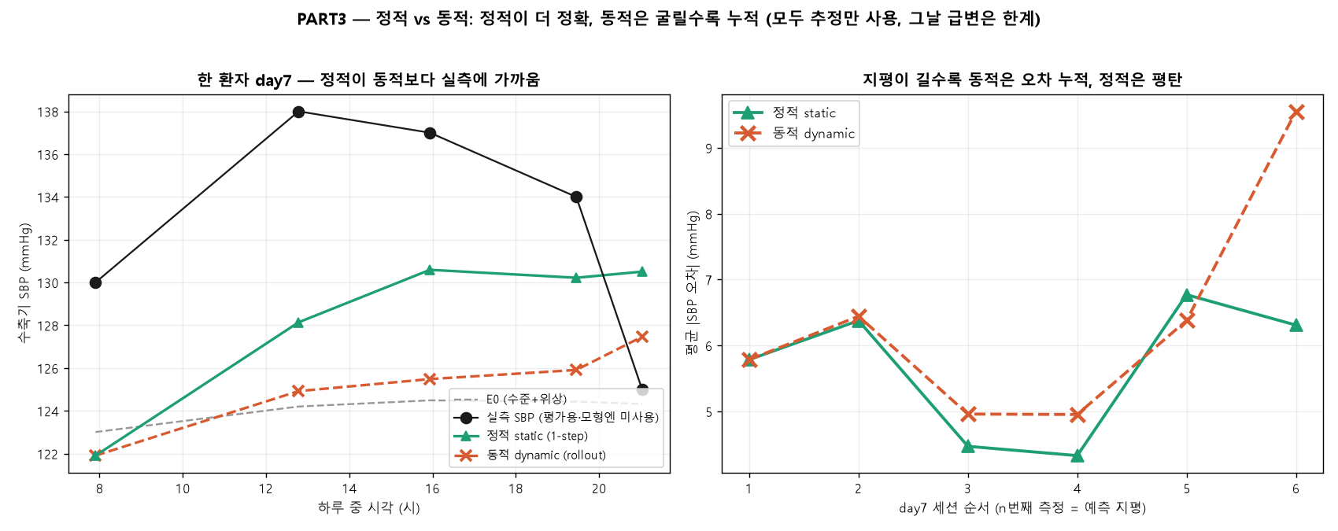
Figure 3. Left: one participant's day-7 systolic trajectory; static (green) tracks the measurements more closely than dynamic (orange), but because both use only estimates (measurements are for evaluation), within-day spikes are not fully captured. Right: mean absolute error grows with the within-day session order (forecast horizon) for dynamic forecasting but stays flat for static.

4.7 Feature attribution and lag structure of the final model
The champion deviation model is a ridge regression on the deviation r = observed − E0, where E0 combines the personal level and circadian phase; we attribute its held-out test-set predictions (24 participants, 580 sessions) with mean |SHAP| from a linear explainer (Figure 4). Grouped by temporal lag (Figure 5, left), prior blood-pressure-estimate features dominate the deviation. For SBP, the summed mean |SHAP| was 6.65 mmHg for multi-day-past, 3.32 mmHg for previous-day, and 2.23 mmHg for the current-watch family; for DBP the corresponding values were 4.64, 1.84, and 1.69 mmHg. The strongest single features were the past daily-mean and previous-day same-time blood-pressure estimates, whereas the watch's strongest single contributor was heart rate, which surfaced for DBP (mean |SHAP| 0.66 mmHg) — that is, the wearable contribution was predominantly diastolic, echoing the ablation. We stress that the conditional +/− signs are partial directions within the standardized multivariable fit, reflecting suppression among highly correlated level proxies rather than marginal effects; the importance measure is the magnitude.
Within-person residual autocorrelation was 0.075 at lag 1 and approximately zero thereafter (0.014 at lag 2, −0.014 at lag 3; Figure 5, right), so after the E0-plus-deviation model little session-to-session structure remained: the chosen lag features already absorb the available persistence, and the remainder is close to session-level noise. The concurrent within-person correlation between watch signals and the residual was only approximately 0.13 (heart rate, delta-heart-rate, and METs). Together these constitute the structural signature of the session-level mean-regression ceiling — aggregate watch features supply a small, mostly diastolic same-moment term but cannot resolve momentary blood pressure beyond roughly Grade B, which is why raw photoplethysmography waveform morphology and pulse transit time are required to reach session-level Grade A.
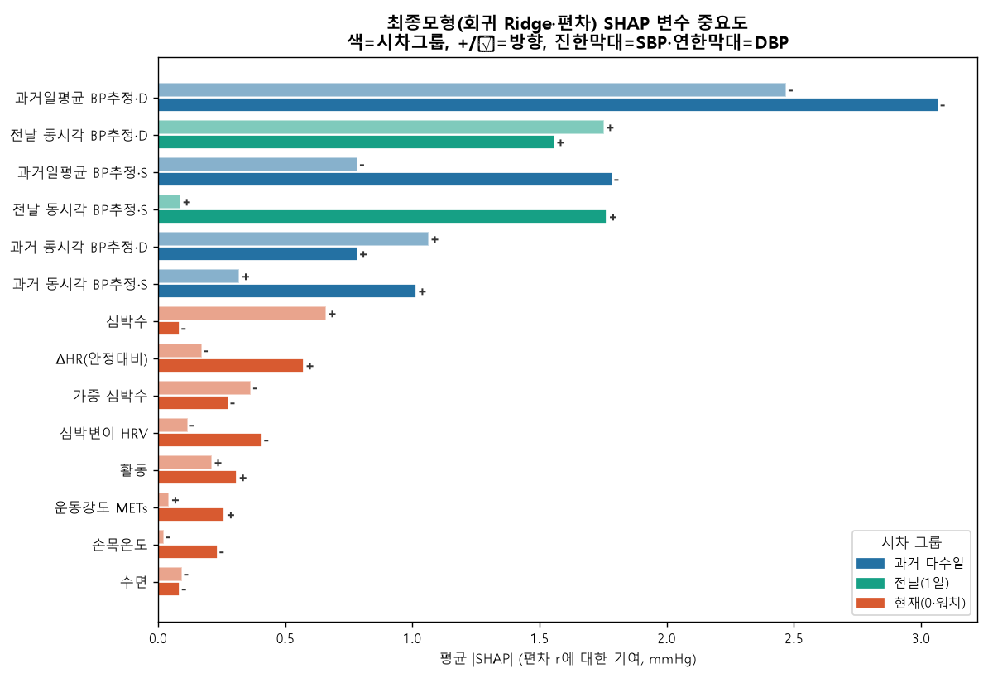
Figure 4. SHAP feature attribution of the champion deviation model (ridge regression on r = observed − E0), held-out test set (24 people, 580 sessions). Bars are mean |SHAP| (mmHg); colour denotes the temporal-lag group; +/− marks the conditional direction within the standardized multivariable fit (darker bars = SBP, lighter = DBP). Prior BP-estimate (level) features dominate, whereas wearable signals add a smaller, mostly diastolic share.
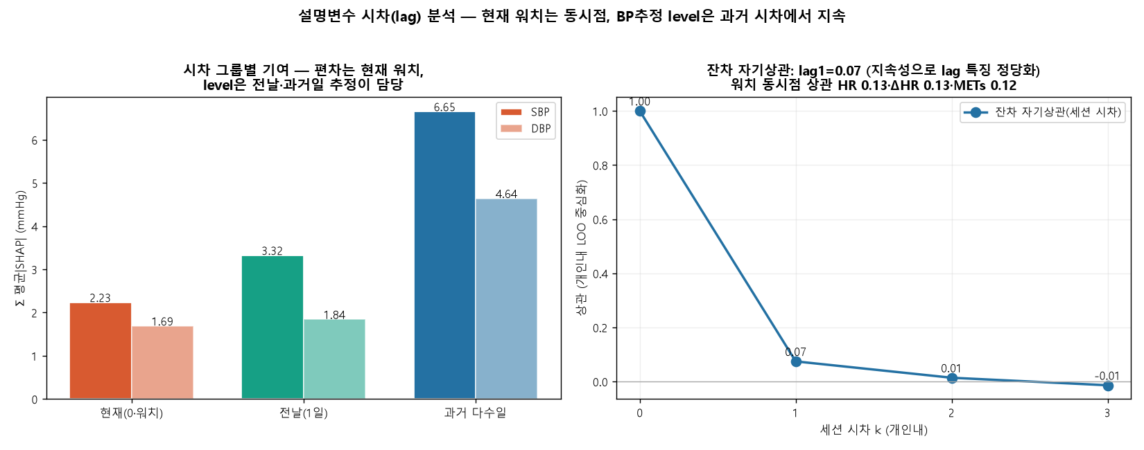
Figure 5. Left: deviation attributed by lag group (sum of mean |SHAP|) — multi-day-past and previous-day BP estimates (level) account for most of it, with current-watch signals adding a smaller concurrent (lag-0) term. Right: within-person residual autocorrelation by session lag (0.08 at lag 1, then approximately 0) and the concurrent watch–residual correlation (approximately 0.13), showing that little temporal structure remains after E0 + deviation — the signature of the session-level ceiling.

4.8 Summary of the session-level ceiling
Across every method, session-level SBP error plateaued near 5.7 mmHg, the boundary of BHS Grade B, while daily averages consistently reached Grade A. This pattern reflects regression toward each participant's set-point: aggregate wearable features combined with one-day calibration drive estimates toward the personal mean, which is accurate for daily summaries because intra-individual variance is small but insufficient to resolve session-to-session SBP excursions.

5. Discussion

5.1. Why daily-average estimates reach Grade A while session-level estimates stall at Grade B
The central asymmetry of our results is that daily-average estimates attained British Hypertension Society (BHS) Grade A (test systolic blood pressure [SBP] mean absolute error [MAE] 2.07 mmHg, diastolic blood pressure [DBP] 2.18 mmHg) whereas the corresponding session-level estimates remained at Grade B for SBP (test 5.71 mmHg) even for the champion ridge model. This gap is a direct consequence of the variance structure of the reference data rather than a deficiency of any particular learning algorithm. The intraclass correlation coefficient (ICC) was high for both targets (SBP 0.72, DBP 0.63), indicating that between-person differences dominated the total variance and that the within-person temporal signal was comparatively small. After session-averaging, the within-person standard deviation (SD) was only 7.19 mmHg for SBP and 5.54 mmHg for DBP. When the available wearable features carry weak within-person temporal information, the loss-minimizing prediction regresses each estimate toward that person's set-point. Averaging many sessions cancels the zero-mean fluctuations around the set-point, so the aggregate target is recovered with high fidelity (Grade A); at the single-session level the same mean-regression leaves the moment-to-moment excursions largely unmodeled, and the residual error floor sits near the within-person SD itself. In other words, the model succeeds precisely where the variance to be explained is small and stalls where it is large but temporally unstructured.

5.2. What session-level Grade A would require
The implication is that aggregate wearable features combined with a single day of calibration cannot, even in principle, close the session-level gap. Our ablation confirmed the complementary but bounded roles of the two feature families: watch-only inputs improved session DBP (test 4.81 to 4.75 mmHg, B to A), while past-estimate lags improved daily-average SBP level (test 2.35 to 2.09 mmHg), and the two together were lowest across metrics. Neither, however, moved session SBP appreciably below the regression-to-set-point floor near 5.7 mmHg. The literature indicates that session-level Grade A requires information channels that the present feature set does not contain: (1) raw photoplethysmography (PPG) waveform morphology, including systolic and diastolic peaks, the dicrotic notch, the augmentation index, the reflection index, and the second-derivative PPG (SDPTG); (2) a timing channel such as pulse transit time (PTT) or pulse arrival time (PAT), where PTT-based SBP estimation reaches a root mean square error of approximately 5.3 mmHg versus approximately 9.8 mmHg for PAT; and (3) periodic recalibration on at most a monthly cadence to offset drift of approximately 0.022 mmHg per day. A raw-waveform model such as PPG2BP-Net attains SBP 0.21 plus or minus 7.51 mmHg at Grade A, whereas validated smartwatches that rely on aggregate features regress toward the calibration set-point, over-estimating low pressures and under-estimating high ones. This is therefore a sensor and data limitation rather than a model limitation: the missing beat-level morphological and timing detail, not the choice of estimator, sets the ceiling.

5.3. Comparison with the literature and the relevance of the evaluation baselines
Two properties distinguish our findings from optimistic reports in the literature. First, our static and daily-average estimates reach clinically meaningful accuracy: daily SBP and DBP satisfied Grade A, and the external-anchor level estimate (SBP MAE 6.61 plus or minus 0.78 mmHg) significantly improved on the cohort-cluster anchor (7.17 plus or minus 1.04, paired p = 0.001) and substantially on the population mean (10.05). Second, and equally important, these errors lie clearly below the naive within-person variability baselines, which establishes genuine information gain rather than mere recovery of a person-level constant. Session SBP error (test 5.71 mmHg) is below the within-person SD of 7.19 mmHg, and the daily-average errors are a fraction of it; the level estimate beats the population-mean reference by a wide margin. We further note that our day-split protocol is realistic: day 1 served only as calibration and tuning, days 2-6 for estimation, and day 7 was held out entirely for forecasting and never used to fit the interpolation or phase components. Performance was computed exclusively at measured time points, with interpolation used only as features or intermediate targets and never as the evaluation ground truth, so the reported figures are not inflated by self-consistent interpolation.

5.4. Measurement noise and the irreducible-error floor
Part of the residual session-level error is irreducible because it originates in the reference itself rather than in the model. The protocol averaged two readings taken one minute apart, yet the single-reading measurement-noise SD was approximately 4.8 mmHg for SBP and 3.8 mmHg for DBP, and the first reading carried an alerting bias of plus 2.1 mmHg. Consequently an estimated 18-36% of the within-person SBP variance is attributable to measurement noise alone. A session-level MAE near 5.7 mmHg should therefore be read against a noisy target whose own short-interval reproducibility is limited; a substantial share of the apparent error reflects the stochastic component of cuff oscillometry rather than a systematic failure of the estimator. This reframes the Grade B session ceiling as partly a property of the ground truth: even a perfect physiological model could not drive the session error below the noise floor of the reference device, and the daily-average aggregation that yields Grade A also suppresses this measurement noise by averaging.

5.5. Multi-task versus single-task learning and the generalization lesson
The model comparison across twenty single- and multi-task families delivered a consistent regularization lesson. Tree ensembles and gradient-boosting methods achieved the lowest in-sample errors but collapsed out-of-sample: LightGBM, for example, reached a training session SBP MAE of 4.06 mmHg yet only 7.05 mmHg (Grade C) on validation, a clear signature of overfitting to the small within-person signal. Linear and spectral estimators (ridge, harmonic-plus-ridge) generalized best and supplied the champion configuration, while the multi-task multilayer perceptron (MLP-multi) became competitive only once sufficient training data were available (1,792 training sessions; test SBP 5.75 mmHg). Multi-task formulations that jointly modeled SBP and DBP did not by themselves overcome the variance limit; their benefit, where present, came from shared regularization rather than from additional physiological information. The practical guidance is that, under high between-person and low within-person temporal variance, strong regularization and parsimonious linear or spectral models generalize more reliably than high-capacity learners, and that capacity should be increased only in proportion to the available data. These observations reinforce the broader conclusion that, absent richer waveform and timing inputs, model selection redistributes but does not remove the session-level ceiling.

5.6 Limitations
Several constraints qualify the present findings. First, the cohort was young and predominantly healthy: 120 participants with a mean age of 32.1 years (standard deviation 8.1, range 18–66), a mean body mass index of 22.7, and only 10 self-reported cases of hypertension, with reference systolic blood pressure of 113.0 mmHg (standard deviation 14.1) and diastolic of 74.5 mmHg (standard deviation 9.5). The narrow blood pressure range and the scarcity of hypertensive readings restrict generalization to older, comorbid, or pharmacologically treated populations in whom screening would carry the greatest clinical value, and they leave the high-pressure tail of the error distribution sparsely sampled.
Second, the deviation model consumed only aggregate wearable metrics—heart rate, weighted heart rate, change in heart rate relative to resting, heart-rate variability, wrist temperature, activity and sleep flags, and metabolic equivalents—rather than raw photoplethysmography (PPG) waveform morphology or a pulse-transit-time (PTT) timing channel. As the literature and our own ablation indicate, this feature set caps session systolic accuracy near a mean absolute error of 5.7 mmHg, corresponding to British Hypertension Society (BHS) Grade B, because the estimator regresses toward each participant's set-point.
Third, session-level systolic estimation therefore attained BHS Grade B–C and should not be construed as standalone clinical measurement; the daily and structural-forecast results, not the per-session systolic values, are the clinically meaningful outputs. Fourth, all results derive from a single dataset collected over one 7-day window with five sessions per day, so temporal drift beyond a week and cross-device or cross-season transfer remain untested. Finally, romanization of author names and institutional affiliations are to be finalized in the camera-ready version.

6. Conclusion
This study reframed cuffless blood pressure modeling as a single decomposition—person-level level, cluster circadian phase, and acute deviation—that unifies interpolation, estimation, and forecasting under one structural estimator (E0 = level + phase) with a residual term. Within this framework, daily-average estimation reached BHS Grade A on the held-out test set (systolic mean absolute error 2.07 mmHg, diastolic 2.18 mmHg), and static one-step-ahead forecasting on the held-out day likewise reached Grade A for daily averages (systolic 2.55 mmHg, diastolic 2.50 mmHg), with session diastolic also at Grade A.
Session-level systolic accuracy plateaued at Grade B (mean absolute error near 5.7 mmHg), a ceiling we attribute to mean-regression under aggregate sensing and single-day calibration rather than to model choice, since linear and spectral estimators generalized best while tree and gradient-boosting families overfit. Reaching session Grade A will require richer sensing—raw PPG waveform morphology, a PTT or pulse-arrival-time channel, and periodic recalibration. By delineating what aggregate wearables can and cannot deliver, the study calibrates realistic expectations and offers concrete design guidance for the next generation of cuffless monitors (Table 1, Figure 1–3).

References
- O'Brien E, Petrie J, Littler W, et al. (1993). The British Hypertension Society protocol for the evaluation of blood pressure measuring devices. J Hypertens 11(Suppl 2):S43–S62.
↗ https://pubmed.ncbi.nlm.nih.gov/8158768/
- International Organization for Standardization. (2018). Non-invasive sphygmomanometers — Part 2 (ISO 81060-2:2018).
↗ https://www.iso.org/standard/73339.html
- IEEE. (2014). Standard for wearable cuffless blood pressure measuring devices (IEEE 1708-2014).
↗ https://doi.org/10.1109/IEEESTD.2014.6882122
- Joung J, Jung C-W, Lee H-C, et al. (2023). Continuous cuffless blood pressure monitoring using PPG2BP-net. Sci Rep 13:8605.
↗ https://doi.org/10.1038/s41598-023-35492-y
- Slapničar G, Mlakar N, Luštrek M. (2019). Blood pressure estimation from PPG using a spectro-temporal deep neural network. Sensors 19(15):3420.
↗ https://doi.org/10.3390/s19153420
- Kachuee M, Kiani MM, Mohammadzade H, Shabany M. (2017). Cuffless blood pressure estimation for continuous health-care monitoring. IEEE Trans Biomed Eng 64(4):859–869.
↗ https://doi.org/10.1109/TBME.2016.2580904
- Takazawa K, Tanaka N, Fujita M, et al. (1998). Assessment of vasoactive agents and vascular aging by the second derivative of the photoplethysmogram. Hypertension 32(2):365–370.
↗ https://doi.org/10.1161/01.HYP.32.2.365
- Block RC, Yavarimanesh M, Natarajan K, et al. (2020). Conventional pulse transit times as markers of blood pressure changes in humans. Sci Rep 10:16373.
↗ https://doi.org/10.1038/s41598-020-73143-8
- Vybornova A, Polychronopoulou E, Würzner-Ghajarzadeh A, et al. (2021). Clinical validation of the Aktiia optical blood pressure monitor. Blood Press Monit 26(4):305–311.
↗ https://pubmed.ncbi.nlm.nih.gov/33675592/
- Nachman D, Younis A, Eisenkraft A, et al. (2022). Wrist wearable cuffless blood pressure devices show insufficient accuracy. Front Cardiovasc Med 9:920946.
↗ https://doi.org/10.3389/fcvm.2022.920946
- Su P, Ding X, Zhang Y, et al. (2018). Long-term blood pressure prediction with deep recurrent neural networks. arXiv:1705.04524.
↗ https://arxiv.org/abs/1705.04524
- Imai Y, Hosaka M, Satoh M, et al. (2010). Day-by-day variability of blood pressure: the Ohasama study. Am J Hypertens.
↗ https://doi.org/10.1038/ajh.2010.166
- Liu X, Zhang D, Liu Y, et al. (2017). Dose-response association between physical activity and incident hypertension. Hypertension 69(5):813–820.
↗ https://doi.org/10.1161/HYPERTENSIONAHA.116.08994
- del Pozo Cruz B, Ahmadi M, Naismith SL, Stamatakis E. (2024). Daily step count and cardiovascular events in hypertension (UK Biobank). Eur J Prev Cardiol.
↗ https://doi.org/10.1093/eurjpc/zwae270
- Mukkamala R, Stergiou GS, Avolio AP. (2022). Cuffless blood pressure measurement. Annu Rev Biomed Eng 24:203–230.
↗ https://doi.org/10.1146/annurev-bioeng-110220-014644
- Mukkamala R, Hahn J-O, Inan OT, et al. (2015). Toward ubiquitous blood pressure monitoring via pulse transit time. IEEE Trans Biomed Eng 62(8):1879–1901.
↗ https://doi.org/10.1109/TBME.2015.2441951
- Schutte AE, Kollias A, Stergiou GS. (2022). Blood pressure and its variability: clinical relevance and application. Nat Rev Cardiol.
↗ https://doi.org/10.1038/s41569-022-00690-0
- Stergiou GS, Palatini P, Parati G, et al. (2021). 2021 ESH practice guidelines for office and out-of-office blood pressure measurement. J Hypertens 39(7):1293–1302.
↗ https://doi.org/10.1097/HJH.0000000000002843
- Parati G, Stergiou GS, Dolan E, Bilo G. (2018). Blood pressure variability: clinical relevance and application. J Clin Hypertens 20(7):1133–1137.
↗ https://doi.org/10.1111/jch.13304
- Elgendi M, Fletcher R, Liang Y, et al. (2019). The use of photoplethysmography for assessing hypertension. npj Digit Med 2:60.
↗ https://doi.org/10.1038/s41746-019-0136-7
- Ding X, Yan BP, Zhang Y-T, et al. (2017). Pulse transit time based continuous cuffless blood pressure estimation. IEEE Trans Biomed Eng 64(5):964–972.
↗ https://doi.org/10.1109/TBME.2016.2597879
- Mancia G, Kreutz R, Brunström M, et al. (2023). 2023 ESH Guidelines for the management of arterial hypertension. J Hypertens 41(12):1874–2071.
↗ https://doi.org/10.1097/HJH.0000000000003480
- Muntner P, Shimbo D, Carey RM, et al. (2019). Measurement of blood pressure in humans: AHA scientific statement. Hypertension 73(5):e35–e66.
↗ https://doi.org/10.1161/HYP.0000000000000087
- Liang Y, Chen Z, Liu G, Elgendi M. (2018). A new, short-recorded photoplethysmogram dataset for blood pressure monitoring. Sci Data 5:180020.
↗ https://doi.org/10.1038/sdata.2018.20
- Kario K. (2020). Management of hypertension in the digital era: small wearable monitoring devices. Hypertension 76(3):640–650.
↗ https://doi.org/10.1161/HYPERTENSIONAHA.120.14742
- Pandit JA, Lores E, Batlle D. (2020). Cuffless blood pressure monitoring: promises and challenges. Clin J Am Soc Nephrol 15(10):1531–1538.
↗ https://doi.org/10.2215/CJN.03680320
- American Heart Association. (2022). Cuffless blood pressure devices: a scientific statement. Hypertension 79(5).
↗ https://doi.org/10.1161/HYP.0000000000000209
- Korea Disease Control and Prevention Agency. Korea National Health and Nutrition Examination Survey (KNHANES), 2024 (HN24).
↗ https://knhanes.kdca.go.kr/
Note: All in-text numbers were computed directly from the provided data (N = 120) and analysis outputs. Bibliographic details and DOIs should be verified before submission. [author romanization, affiliation, and target journal to be finalized]

