**Deliverable 2**: Upload a text file or screen shot to show the input and output of running the program and demonstrating that your program has been adequately tested.

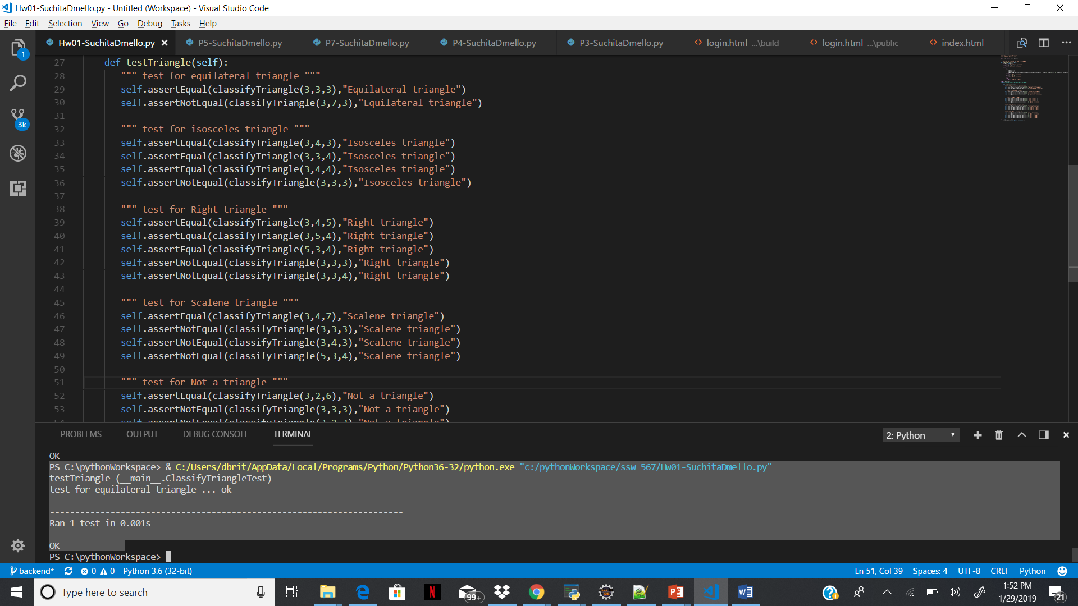

**Deliverable 3**: Describe your experience with this assignment, specifically:

* What challenges did you encounter with this assignment, if any?
  + The implementation for classifying the type of triangle was complex
* What did you think about the requirements specification for this assignment?
  + Requirements should be more specific regarding as its not clear for example a triangle can be isosceles and right angle and scalene at same time. In such scenario which value to be written is not specified in the requirement.
* What challenges did you encounter with the tools?
  + I used visual studio for the implement and there were no challenges.
* Describe the criteria you used to determine that you had sufficient test cases, i.e. how did you know you were done?
  + For each type of triangles, I wrote the positive and negative test cases with different input. I also wrote test cases with same input in different sequence to test my implementation.