9-th November 2019

**2. assignment/6. Task**

**Sadi Mamedov**

LHXOTB

sadimamedov7@gmail.com

Group 2

# Task

**Four game**

This a two-player game is played on a board consists of *n* x *n* fields, where each field contains a value between 0 and 4. Initially, all the fields contain the value of 0. If a player chooses a field, then the value of the field and its neighbors incremented by one (if the value is less than 4). The player’s score represents how many fields did he make to have the value of 4. If a value of a field reaches 4, then the field is colorized with the color of the actual player (red or blue). The game ends, when all fields have the value of 4. The player having the higher score wins.

Implement this game, and let the board size be selectable (3x3, 5x5, 7x7). The game should recognize if it is ended, and it has to show in a message box which player won. After this, a new game should be started automatically.

# UML Diagram

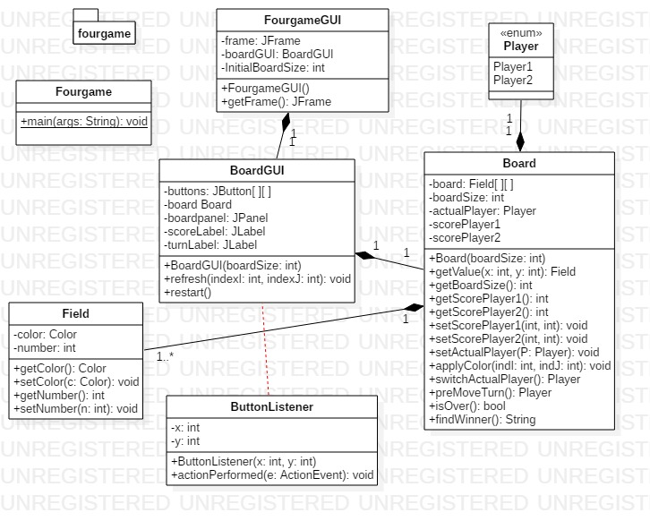

Connection between events and event handlers:

#1. Event: sizeMenuItem

Event Handler: ActionListener()

____________________________________________________________________________________

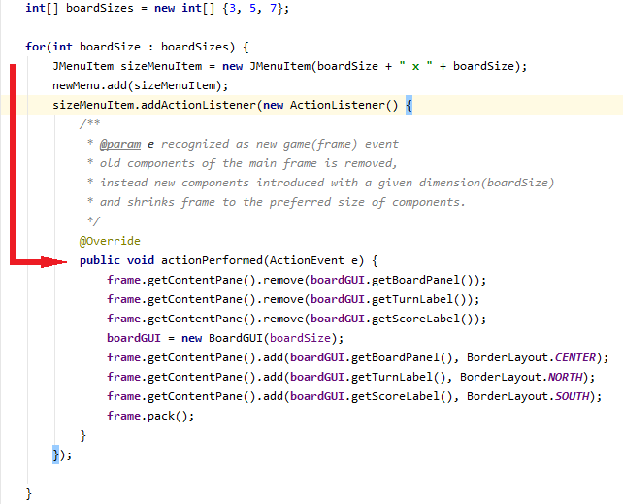

#2 Event: exitMenuItem

Event Handler: ActionListener()

_____________________________________________________________________________________

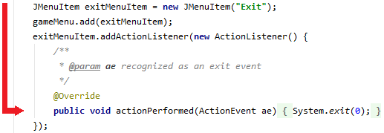

#3 Event: boardGUI Initialization/ button creation

Event Handler: ButtonListener (ActionListener())

_____________________________________________________________________________________



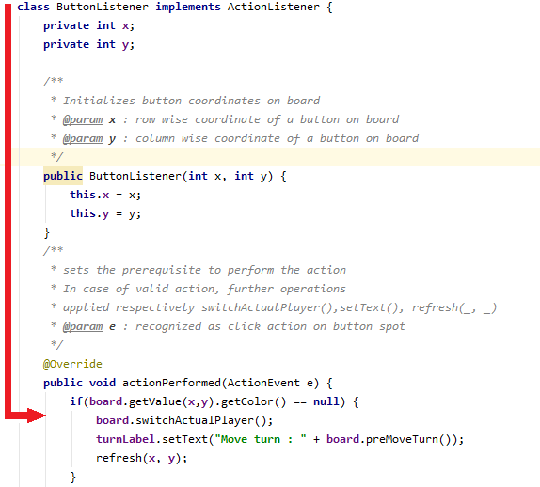

Testing:

**#1 Case:** The game environment is set to 3x3 dimension table. Player2 targets the same buttons likewise Player1. Expected output: **Player2 wins to the nil**.

**#2 Case:** The game environment is 5x5 by default. Player1 avoids targeting the buttons which have value equals 2 or higher. Expected output: **Player1 wins by huge difference.**

**#3 Case:** The game environment is set to largest ,7x7 dimension, table. After successful strategy,

Both players managed to reach to the last round with the tie. Player2 has the last attempt left and targets it. Expected output: **Player2 wins by one**.

**#4 Case:** The game environment is 5x5 by default. After successful strategy,

Both players managed to reach to the last round with the tie. Player1 has the last attempt left and targets it. Expected output: **Player1 wins by one**.

**#5 Case:** The game environment is set to 3x3 by dimension table. After successful strategy by player Player1, it wins against the only single point scored of by the opponent, as it’s not possible for Player1 to win on every spot of the 3x3 board. Expected output: **Player1 wins to the one.**