24-th November 2019

**3. assignment/2. Task**

**Sadi Mamedov**

LHXOTB

sadimamedov7@gmail.com

Group 2

# Task

**2. Snake**

We have a rattlesnake in a desert, and our snake is initially two units long (head and rattler). We have to collect with our snake the foods on the level, that appears randomly. Only one food piece is placed randomly at a time on the level (on a field, where there is no snake). The snake starts off from the center of the level in a random direction. The player can control the movement of the snake’s head with keyboard buttons. If the snake eats a food piece, then its length grows by one unit.

It makes the game harder that there are rocks in the desert. If the snake collides with a rock, then the game ends. We also lose the game, if the snake goes into itself, or into the boundary of the game level.

In these situations, show a popup messagebox, where the player can type his name and save it together with the amount of food eaten to the database. Create a menu item, which displays a highscore table of the players for the 10 best scores. Also, create a menu item which restarts the game.

# 

# UML Diagram

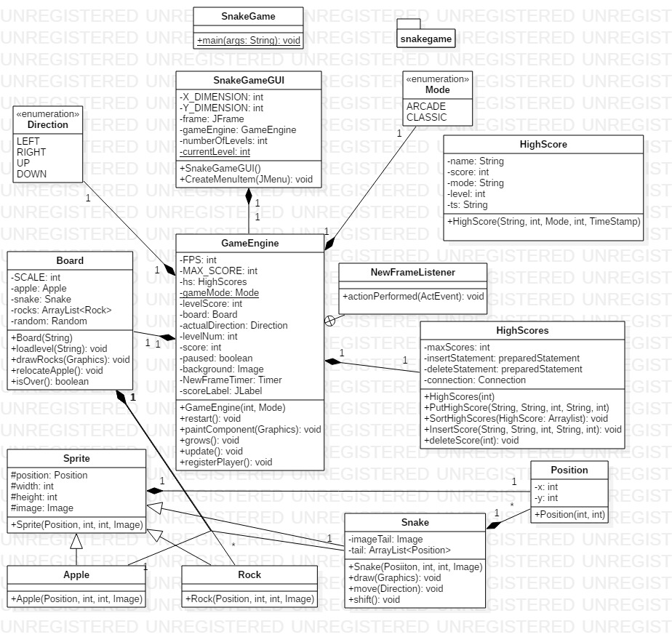

Testing:

**#1 Case:** The game difficulty is set to 2nd level in Classic mode. Player successfully reaches the predefined victory number 50 by default. Expected output: **Player is registered atop as a winner.**

**Automatic restart is triggered from the same level.**

**#2 Case:** The game difficulty is set to Arcade mode. Player collides with the rock in 4th level by having score equals to 17. Expected output: **Game is over. Player is registered on the table.**

**Automatic restart is triggered from the first level.**

**#3 Case:** The game difficulty is set to 7th level in Classic mode. Player collides with the part of snake. Expected output: **Game is over. Automatic restart is triggered from the same level.**

**#4 Case:** The game difficulty is set to Arcade mode. Five players launch the game separately and reaches different results, which of those are registered on the table. Expected output: **Correct order based on corresponding player’s score on the database table.**

**#5 Case:** The game difficulty is set to nth level in Classic mode. Pressing multiple arrow keys for various directions in a single frame is tested, disabled by default due to particular condition. Pressing traversal keys is tested, disabled by default. Pressing space key is tested to activate /pause, paused by default. Expected output: **All test cases regarding key pressing pass successfully.**