**Problem 1**

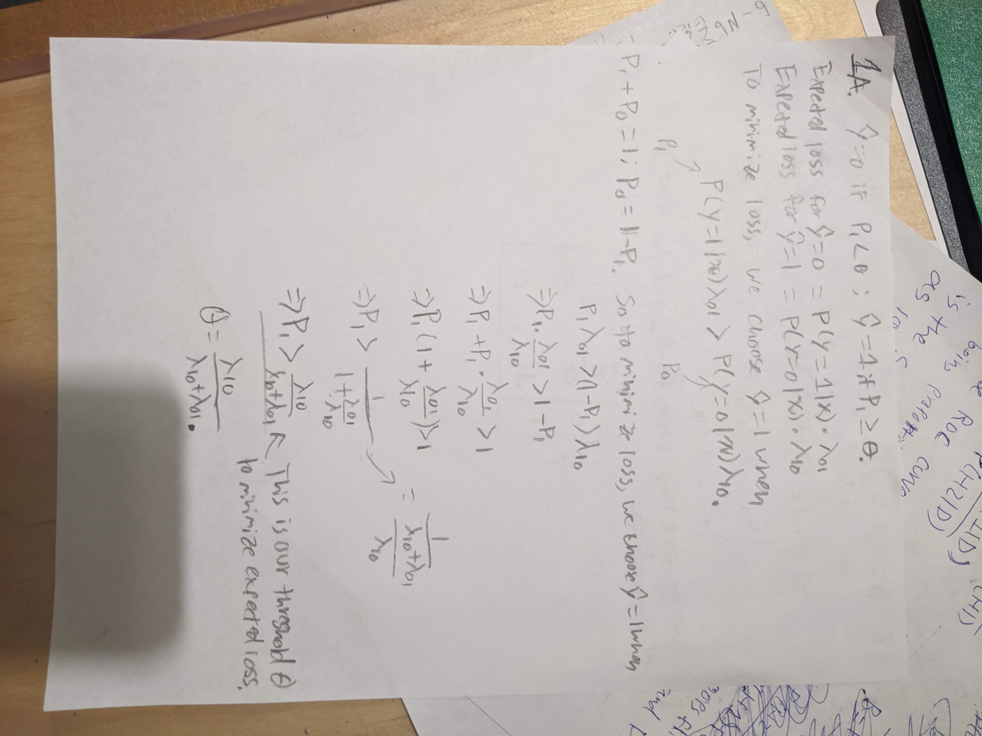

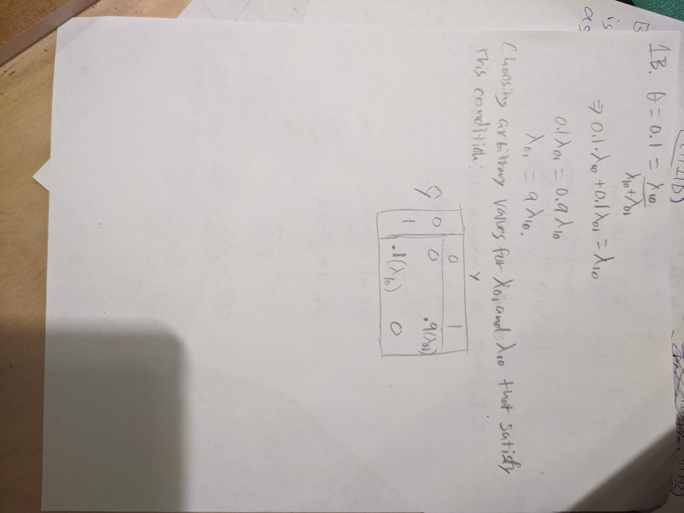

**Problem 2**

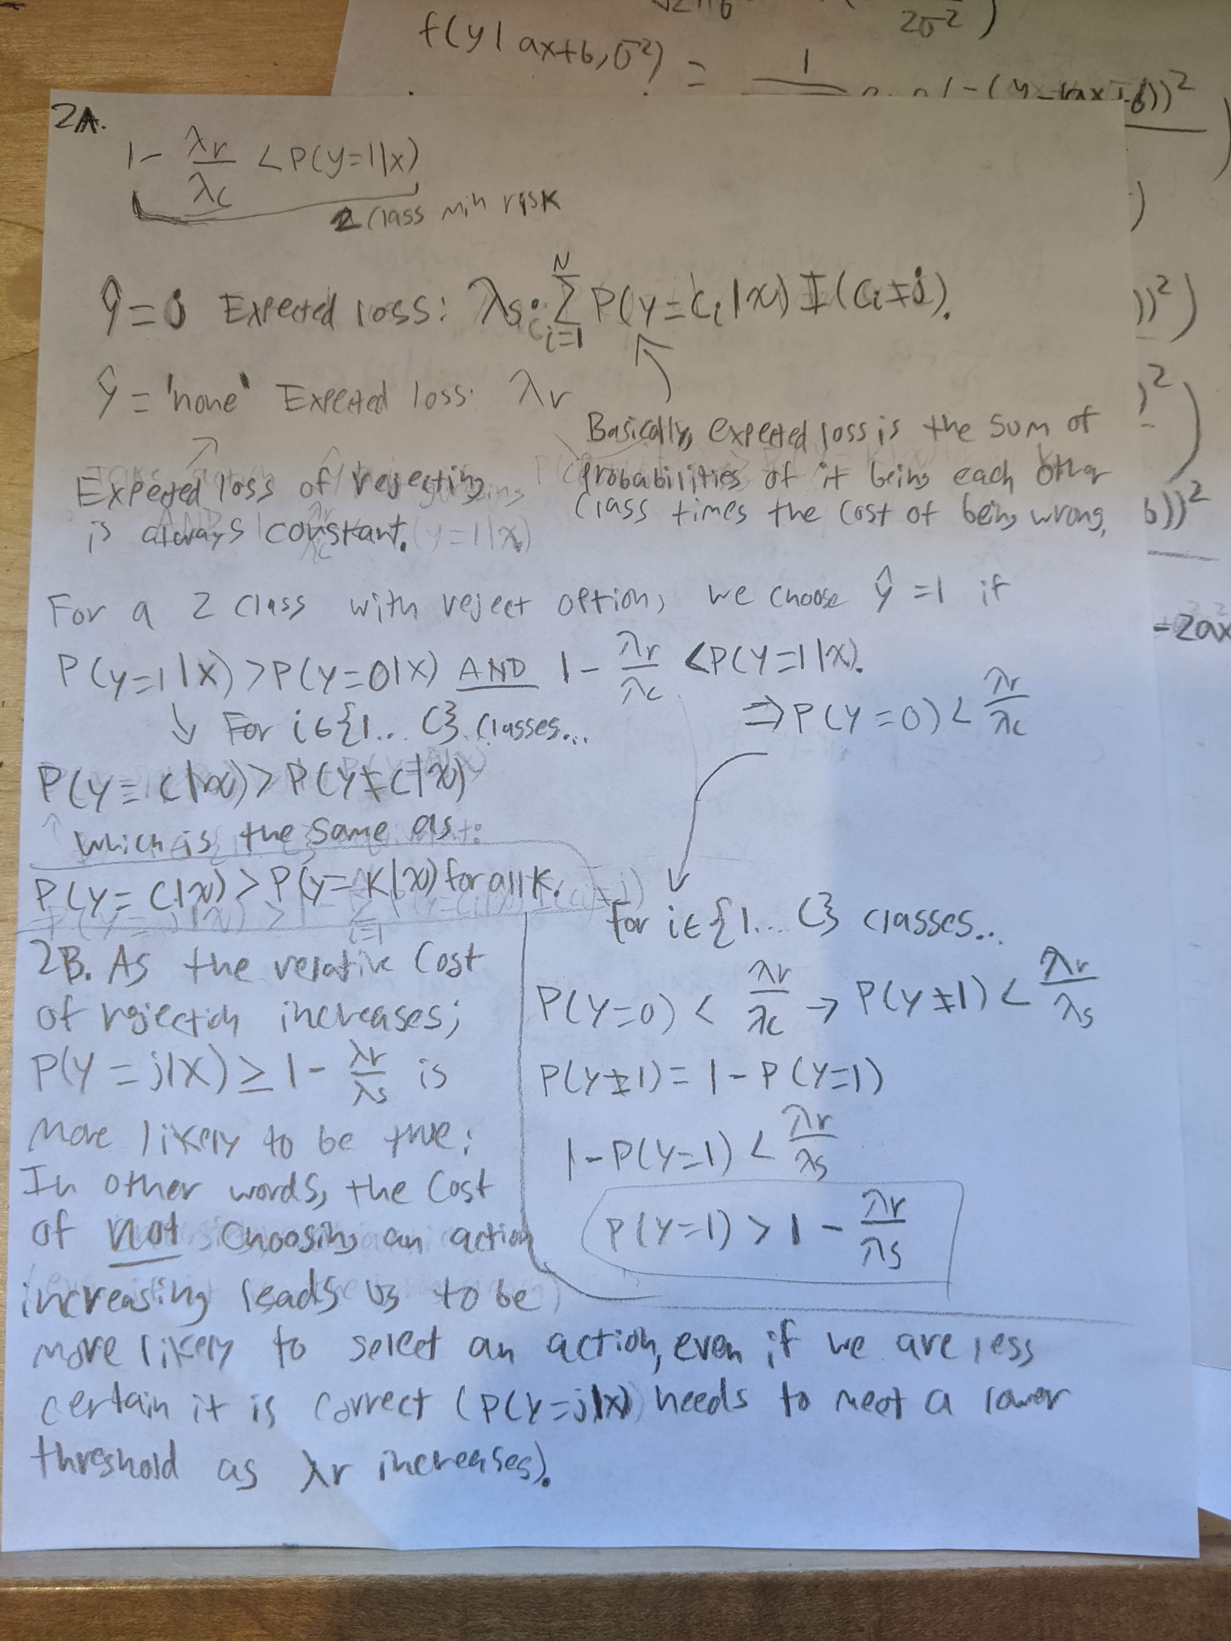

**Problem 2 continued**

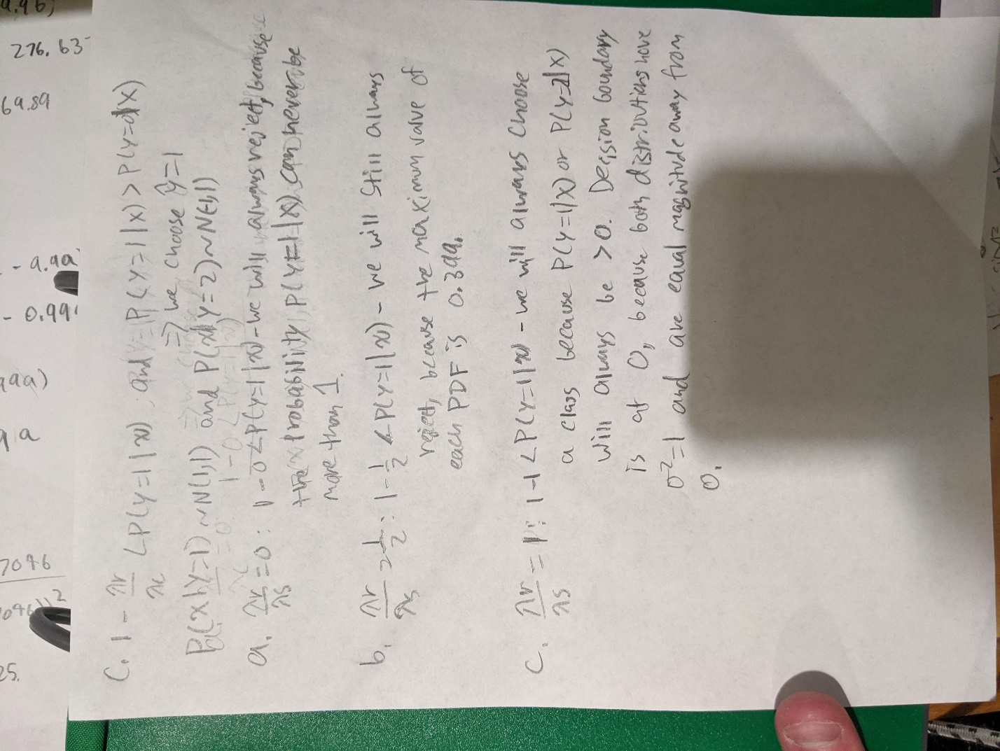

**Problem 3**



**Problem 4**

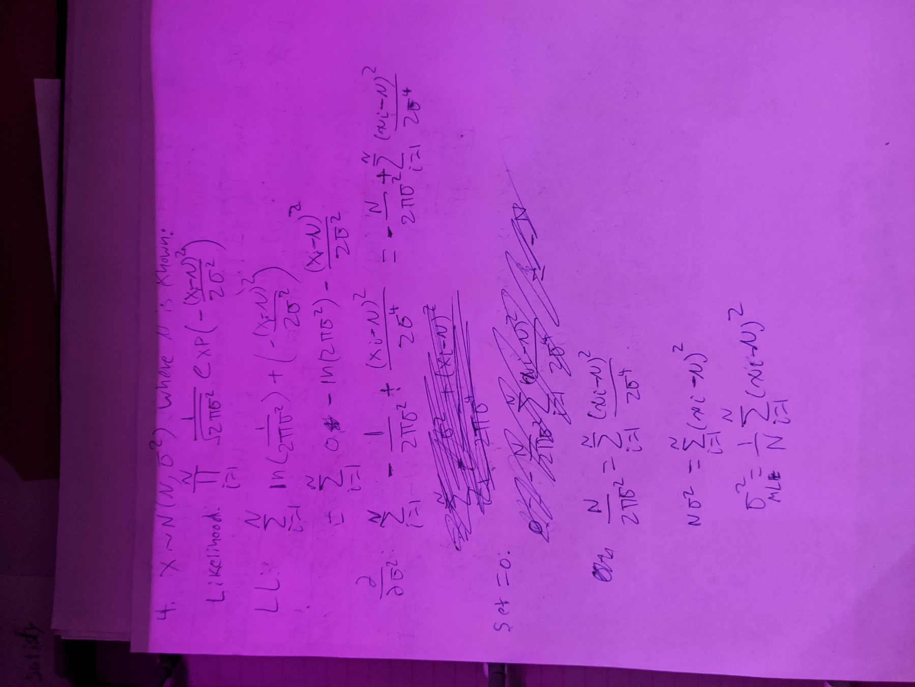

We know from class (2nd lecture) that the MLE of the variance of a normal distribution is a biased estimator because its expected value is not equal to the actual variance of the distribution. σmle = (1-1/n) * σ2 whereas the variance is just σ2