**Problem 1A**

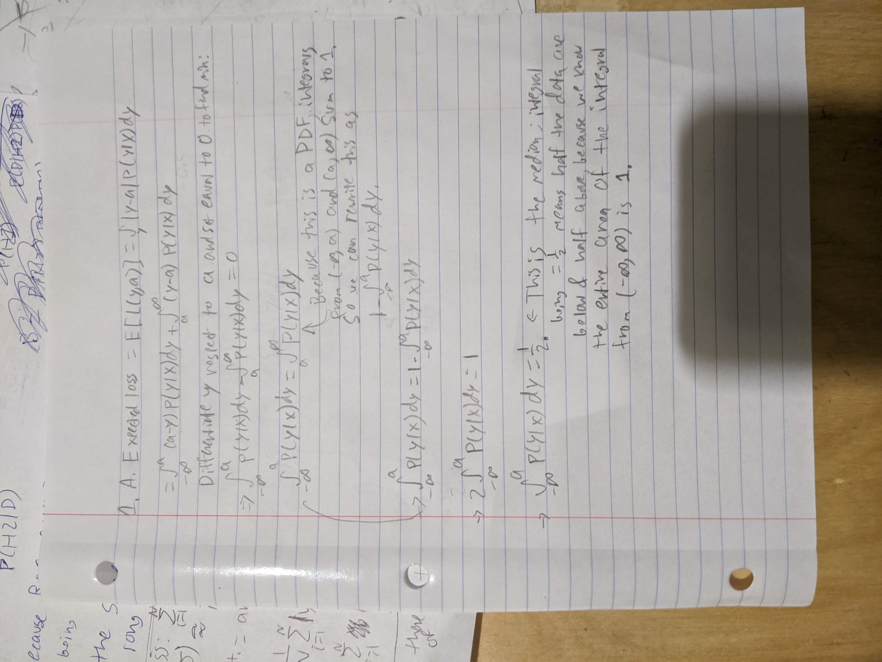

**Problem 1B and C**

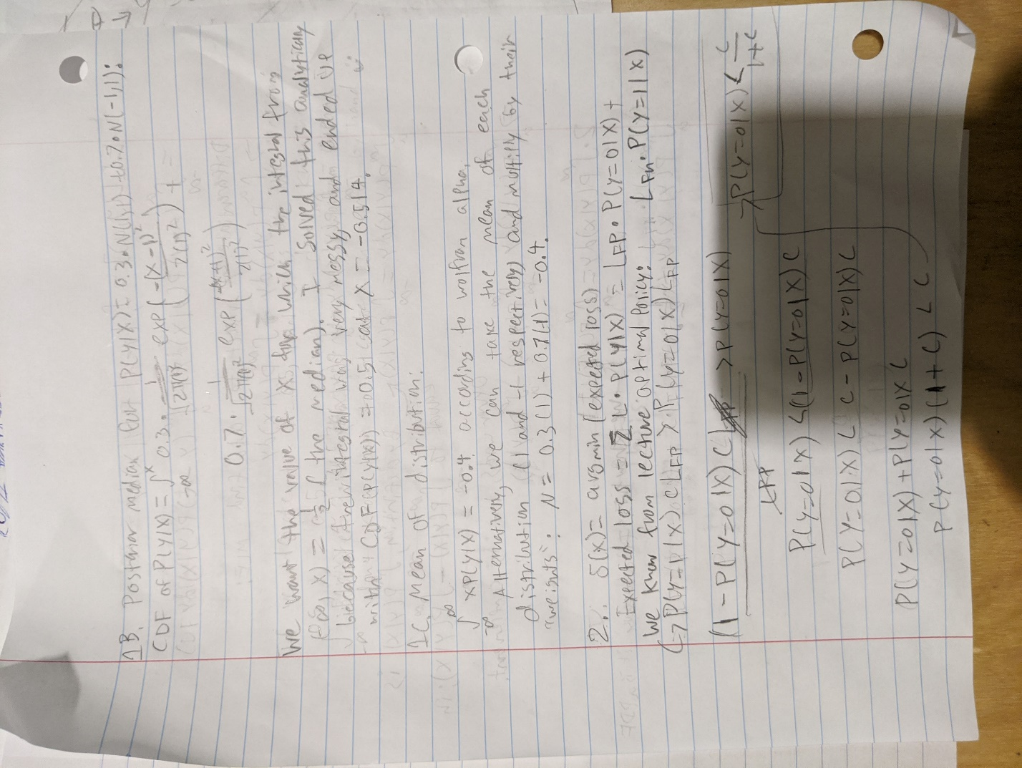

Part C discussion: The mean here, -0.4, is simply the mean of each normal distribution that P(X) is composed of, multiplied by their respective “weights”.

**Problem 1D**

The difference between the posterior median and the mean is that the median is an indication of the “center” of the data; half of the probability distribution’s density falls on each side of the median. On the other hand, the mean represents the value we expect to get every time we sample from the distribution. The median simply tells us where the middlepoint of the data is, but the median tells us what value to expect when sampling. These are different values because the data in this case are in two vague clusters, around the mean of each normal distribution that makes up P(X); however, the overall distribution is not symmetrical because the component distributions have “weights” of 0.3 and 0.7 respectively, which means that the most likely value is not at the midpoint of the distribution in terms of density. Because the distribution with a mean at -1 has a higher “weight”, the P(X) distribution has more of its density near -1, which is why the mean and median are both negative.

**Problem 2**

