SDMX STANDARDS: SECTION 6

SDMX
TECHNICAL NOTES

Version 2.1

April 2011

© SDMX 2011
http://www.sdmx.org/
Contents

1 Purpose and Structure 1
1.1 Purpose 1
1.2 Structure 1
2 General Notes on This Document 1
3 Guide for SDMX Format Standards 2
3.1 Introduction 2
3.2 SDMX Information Model for Format Implementers 2
3.2.1 Introduction 2
3.3 SDMX-ML and SDMX-EDI: Comparison of Expressive Capabilities and Function 3
3.3.1 Format Optimizations and Differences 3
3.3.2 Data Types 4
3.4 SDMX-ML and SDMX-EDI Best Practices 6
3.4.1 Reporting and Dissemination Guidelines 6
3.4.2 Best Practices for Batch Data Exchange 10
4 General Notes for Implementers 12
4.1 Representations 12
4.2 Time and Time Format 14
4.2.1 Introduction 14
4.2.2 Observational Time Period 14
4.2.3 Standard Time Period 15
4.2.4 Gregorian Time Period 15
4.2.5 Date Time 15
4.2.6 Standard Reporting Period 15
4.2.7 Distinct Range 19
4.2.8 Time Format 19
4.2.9 Transformation between SDMX-ML and SDMX-EDI 20
4.2.10 Time Zones 20
4.2.11 Representing Time Spans Elsewhere 21
4.2.12 Notes on Formats 21
4.2.13 Effect on Time Ranges 21
4.2.14 Time in Query Messages 21
4.3 Structural Metadata Querying Best Practices 24
4.4 Versioning and External Referencing 24
5 Metadata Structure Definition (MSD) 25
5.1 Scope 25
5.2 Identification of the Object Type to which the Metadata is to be Attached 25
5.3 Report Structure 27
5.4 Metadata Set 28
6 Maintenance Agencies 29
7 Concept Roles 31
7.1 Overview 31
7.2 Information Model 31
7.3 Technical Mechanism 31
7.4 SDMX-ML Examples in a DSD 32
7.5 SDMX Cross Domain Concept Scheme 33
8 Constraints 34
8.1 Introduction 34
8.2 Types of Constraint 34
8.3 Rules for a Content Constraint 35
8.3.1 Scope of a Content Constraint 35
8.3.2 Multiple Content Constraints 36
8.3.3 Inheritance of a Content Constraint 37
8.3.4 Constraints Examples 38
9 Annex I: How to eliminate extra element in the .NET SDMX Web Service 44
9.1 Problem statement 44
9.2 Solution 45
9.3 Applying the solution 48

Purpose and Structure

Purpose
The intention of this document is to document certain aspects of SDMX that are important to understand and will aid implementation decisions. The explanations here supplement the information documented in the SDMX XML schema and the Information Model.

Structure
This document is organized into the following major parts:

A guide to the SDMX Information Model relating to Data Structure Definitions and Data Sets, statement of differences in functionality supported by the different formats and syntaxes for Data Structure Definitions and Data Sets, and best practices for use of SDMX formats, including the representation for time period
A guide to the SDMX Information Model relating to Metadata Structure Definitions, and Metadata Sets
Other structural artefacts of interest: agencies, concept role. constraint, partial code list

General Notes on This Document
At this version of the standards, the term “Key family” is replaced by Data Structure Definition (also known and referred to as DSD) both in the XML schemas and the Information Model. The term “Key family” is not familiar to many people and its name was taken from the model of SDMX-EDI (previously known as GESMES/TS). The more familiar name “Data Structure Definition” which was used in many documents is now also the technical artefact in the SDMX-ML and Information Model technical specifications. The term “Key family” is still used in the SDMX-EDI specification.

There has been much work within the SDMX community on the creation of user guides, tutorials, and other aides to implementation and understanding of the standard. This document is not intended to duplicate the function of these documents, but instead represents a short set of technical notes not generally covered elsewhere.

Guide for SDMX Format Standards

Introduction
This guide exists to provide information to implementers of the SDMX format standards – SDMX-ML and SDMX-EDI – that are concerned with data, i.e. Data Structure Definitions and Data Sets. This section is intended to provide information which will help users of SDMX understand and implement the standards. It is not normative, and it does not provide any rules for the use of the standards, such as those found in SDMX-ML: Schema and Documentation and SDMX-EDI: Syntax and Documentation.

SDMX Information Model for Format Implementers

Introduction
The purpose of this sub-section is to provide an introduction to the SDMX-IM relating to Data Structure Definitions and Data Sets for those whose primary interest is in the use of the XML or EDI formats. For those wishing to have a deeper understanding of the Information Model, the full SDMX-IM document, and other sections in this guide provide a more in-depth view, along with UML diagrams and supporting explanation. For those who are unfamiliar with DSDs, an appendix to the SDMX-IM provides a tutorial which may serve as a useful introduction.

The SDMX-IM is used to describe the basic data and metadata structures used in all of the SDMX data formats. The Information Model concerns itself with statistical data and its structural metadata, and that is what is described here. Both structural metadata and data have some additional metadata in common, related to their management and administration. These aspects of the data model are not addressed in this section and covered elsewhere in this guide or in the full SDMX-IM document.

The Data Structure Definition and Data Set parts of the information model are consistent with the GESMES/TS version 3.0 Data Model (called SDMX-EDI in the SDMX standard), with these exceptions:

the “sibling group” construct has been generalized to permit any dimension or dimensions to be wildcarded, and not just frequency, as in GESMES/TS. It has been renamed a “group” to distinguish it from the “sibling group” where only frequency is wildcarded. The set of allowable partial “group” keys must be declared in the DSD, and attributes may be attached to any of these group keys;
furthermore, whilst the “group” has been retained for compatibility with version 2.0 and with SDMX-EDI, it has, at version 2.1, been replaced by the “Attribute Relationship” definition which is explained later
the section on data representation is now a convention, to support interoperability with EDIFACT-syntax implementations ( see section 3.3.2);
DSD-specific data formats are derived from the model, and some supporting features for declaring multiple measures have been added to the structural metadata descriptions
Clearly, this is not a coincidence. The GESMES/TS Data Model provides the foundation for the EDIFACT messages in SDMX-EDI, and also is the starting point for the development of SDMX-ML.

Note that in the descriptions below, text in courier and italicised are the names used in the information model (e.g. DataSet).

SDMX-ML and SDMX-EDI: Comparison of Expressive Capabilities and Function
SDMX offers several equivalent formats for describing data and structural metadata, optimized for use in different applications. Although all of these formats are derived directly from the SDM-IM, and are thus equivalent, the syntaxes used to express the model place some restrictions on their use. Also, different optimizations provide different capabilities. This section describes these differences, and provides some rules for applications which may need to support more than one SDMX format or syntax. This section is constrained to the Data Structure Definitionand the Date Set.

Format Optimizations and Differences
The following section provides a brief overview of the differences between the various SDMX formats.

Version 2.0 was characterised by 4 data messages, each with a distinct format: Generic, Compact, Cross-Sectional and Utility. Because of the design, data in some formats could not always be related to another format. In version 2.1, this issue has been addressed by merging some formats and eliminating others. As a result, in SDMX 2.1 there are just two types of data formats: GenericData and StructureSpecificData (i.e. specific to one Data Structure Definition).

Both of these formats are now flexible enough to allow for data to be oriented in series with any dimension used to disambiguate the observations (as opposed to only time or a cross sectional measure in version 2.0). The formats have also been expanded to allow for ungrouped observations.

To allow for applications which only understand time series data, variations of these formats have been introduced in the form of two data messages; GenericTimeSeriesData and StructureSpecificTimeSeriesData. It is important to note that these variations are built on the same root structure and can be processed in the same manner as the base format so that they do NOT introduce additional processing requirements.

Structure Definition
The SDMX-ML Structure Message supports the use of annotations to the structure, which is not supported by the SDMX-EDI syntax.
The SDMX-ML Structure Message allows for the structures on which a Data Structure Definition depends – that is, codelists and concepts – to be either included in the message or to be referenced by the message containing the data structure definition. XML syntax is designed to leverage URIs and other Internet-based referencing mechanisms, and these are used in the SDMX-ML message. This option is not available to those using the SDMX-EDI structure message.
Validation
SDMX-EDI – as is typical of EDIFACT syntax messages – leaves validation to dedicated applications (“validation” being the checking of syntax, data typing, and adherence of the data message to the structure as described in the structural definition.)
The SDMX-ML Generic Data Message also leaves validation above the XML syntax level to the application.
The SDMX-ML DSD-specific messages will allow validation of XML syntax and datatyping to be performed with a generic XML parser, and enforce agreement between the structural definition and the data to a moderate degree with the same tool.
Update and Delete Messages and Documentation Messages
All SDMX data messages allow for both delete messages and messages consisting of only data or only documentation.

Character Encodings
All SDMX-ML messages use the UTF-8 encoding, while SDMX-EDI uses the ISO 8879-1 character encoding. There is a greater capacity with UTF-8 to express some character sets (see the “APPENDIX: MAP OF ISO 8859-1 (UNOC) CHARACTER SET (LATIN 1 OR “WESTERN”) in the document “SYNTAX AND DOCUMENTATION VERSION 2.0”.) Many transformation tools are available which allow XML instances with UTF-8 encodings to be expressed as ISO 8879-1-encoded characters, and to transform UTF-8 into ISO 8879-1. Such tools should be used when transforming SDMX-ML messages into SDMX-EDI messages and vice-versa.

Data Typing
The XML syntax and EDIFACT syntax have different data-typing mechanisms. The section below provides a set of conventions to be observed when support for messages in both syntaxes is required. For more information on the SDMX-ML representations of data, see below.

Data Types
The XML syntax has a very different mechanism for data-typing than the EDIFACT syntax, and this difference may create some difficulties for applications which support both EDIFACT-based and XML-based SDMX data formats. This section provides a set of conventions for the expression in data in all formats, to allow for clean interoperability between them.

It should be noted that this section does not address character encodings – it is assumed that conversion software will include the use of transformations which will map between the ISO 8879-1 encoding of the SDMX-EDI format and the UTF-8 encoding of the SDMX-ML formats.

Note that the following conventions may be followed for ease of interoperation between EDIFACT and XML representations of the data and metadata. For implementations in which no transformation between EDIFACT and XML syntaxes is foreseen, the restrictions below need not apply.

- Identifiers are:
- Maximum 18 characters;
- Any of A..Z (upper case alphabetic), 0..9 (numeric), _ (underscore);
- The first character is alphabetic.
- Names are:

- Maximum 70 characters.
- From ISO 8859-1 character set (including accented characters)
- Descriptions are:

- Maximum 350 characters;
- From ISO 8859-1 character set.
- Code values are:

- Maximum 18 characters;
- Any of A..Z (upper case alphabetic), 0..9 (numeric), _ (underscore), / (solidus, slash), = (equal sign), - (hyphen);
However, code values providing values to a dimension must use only the following characters:

A..Z (upper case alphabetic), 0..9 (numeric), _ (underscore)

- Observation values are:

- Decimal numerics (signed only if they are negative);
- The maximum number of significant figures is:
- 15 for a positive number

- 14 for a positive decimal or a negative integer

- 13 for a negative decimal

- Scientific notation may be used.
- Uncoded statistical concept text values are:

- Maximum 1050 characters;
- From ISO 8859-1 character set.
- Time series keys:

In principle, the maximum permissible length of time series keys used in a data exchange does not need to be restricted. However, for working purposes, an effort is made to limit the maximum length to 35 characters; in this length, also (for SDMX-EDI) one (separator) position is included between all successive dimension values; this means that the maximum length allowed for a pure series key (concatenation of dimension values) can be less than 35 characters. The separator character is a colon (“:”) by conventional usage.

SDMX-ML and SDMX-EDI Best Practices

Reporting and Dissemination Guidelines

Central Institutions and Their Role in Statistical Data Exchanges
Central institutions are the organisations to which other partner institutions "report" statistics. These statistics are used by central institutions either to compile aggregates and/or they are put together and made available in a uniform manner (e.g. on-line or on a CD-ROM or through file transfers). Therefore, central institutions receive data from other institutions and, usually, they also "disseminate" data to individual and/or institutions for end-use. Within a country, a NSI or a national central bank (NCB) plays, of course, a central institution role as it collects data from other entities and it disseminates statistical information to end users. In SDMX the role of central institution is very important: every statistical message is based on underlying structural definitions (statistical concepts, code lists, DSDs) which have been devised by a particular agency, usually a central institution. Such an institution plays the role of the reference "structural definitions maintenance agency" for the corresponding messages which are exchanged. Of course, two institutions could exchange data using/referring to structural information devised by a third institution.

Central institutions can play a double role:

- collecting and further disseminating statistics;
- devising structural definitions for use in data exchanges.

Defining Data Structure Definitions (DSDs)
The following guidelines are suggested for building a DSD. However, it is expected that these guidelines will be considered by central institutions when devising new DSDs.

Dimensions, Attributes and Code Lists

Avoid dimensions that are not appropriate for all the series in the data structure definition. If some dimensions are not applicable (this is evident from the need to have a code in a code list which is marked as “not applicable”, “not relevant” or “total”) for some series then consider moving these series to a new data structure definition in which these dimensions are dropped from the key structure. This is a judgement call as it is sometimes difficult to achieve this without increasing considerably the number of DSDs.
Devise DSDs with a small number of Dimensions for public viewing of data. A DSD with the number dimensions in excess 6 or 7 is often difficult for non specialist users to understand. In these cases it is better to have a larger number of DSDs with smaller “cubes” of data, or to eliminate dimensions and aggregate the data at a higher level. Dissemination of data on the web is a growing use case for the SDMX standards: the differentiation of observations by dimensionality which are necessary for statisticians and economists are often obscure to public consumers who may not always understand the semantic of the differentiation.
Avoid composite dimensions. Each dimension should correspond to a single characteristic of the data, not to a combination of characteristics.
Consider the inclusion of the following attributes. Once the key structure of a data structure definition has been decided, then the set of (preferably mandatory) attributes of this data structure definition has to be defined. In general, some statistical concepts are deemed necessary across all Data Structure Definitions to qualify the contained information. Examples of these are:
- A descriptive title for the series (this is most useful for dissemination of data for viewing e.g. on the web)

- Collection (e.g. end of period, averaged or summed over period)

- Unit (e.g. currency of denomination)

- Unit multiplier (e.g. expressed in millions)

- Availability (which institutions can a series become available to)

- Decimals (i.e. number of decimal digits used in numerical observations)

- Observation Status (e.g. estimate, provisional, normal)

Moreover, additional attributes may be considered as mandatory when a specific data structure definition is defined.

Avoid creating a new code list where one already exists. It is highly recommended that structural definitions and code lists be consistent with internationally agreed standard methodologies, wherever they exist, e.g., System of National Accounts 1993; Balance of Payments Manual, Fifth Edition; Monetary and Financial Statistics Manual; Government Finance Statistics Manual, etc. When setting-up a new data exchange, the following order of priority is suggested when considering the use of code lists:
- international standard code lists;
- international code lists supplemented by other international and/or regional institutions;
- standardised lists used already by international institutions;
- new code lists agreed between two international or regional institutions;
- new specific code lists.
The same code list can be used for several statistical concepts, within a data structure definition or across DSDs. Note that SDMX has recognised that these classifications are often quite large and the usage of codes in any one DSD is only a small extract of the full code list. In this version of the standard it is possible to exchange and disseminate a partial code list which is extracted from the full code list and which supports the dimension values valid for a particular DSD.

Data Structure Definition Structure
The following items have to be specified by a structural definitions maintenance agency when defining a new data structure definition:
Data structure definition (DSD) identification:
- DSD identifier
- DSD name
A list of metadata concepts assigned as dimensions of the data structure definition. For each:
- (statistical) concept identifier
- ordinal number of the dimension in the key structure (SDMX-EDI only)
- code list identifier (Id, version, maintenance agency) if the representation is coded
A list of (statistical) concepts assigned as attributes for the data structure definition. For each:
- (statistical) concept identifier
- code list identifier if the concept is coded
- assignment status: mandatory or conditional
- attachment level
- maximum text length for the uncoded concepts
- maximum code length for the coded concepts
A list of the code lists used in the data structure definition. For each:
- code list identifier
- code list name
- code values and descriptions
Definition of data flow definitions. Two (or more) partners performing data exchanges in a certain context need to agree on:
- the list of data set identifiers they will be using;

- for each data flow:
- its content and description
- the relevant DSD that defines the structure of the data reported or disseminated according the the dataflow definition

Exchanging Attributes

Attributes on series, sibling and data set level
Static properties.
- Upon creation of a series the sender has to provide to the receiver values for all mandatory attributes. In case they are available, values for conditional attributes should also be provided. Whereas initially this information may be provided by means other than SDMX-ML or SDMX-EDI messages (e.g. paper, telephone) it is expected that partner institutions will be in a position to provide this information in SDMX-ML or SDMX-EDI format over time.

- A centre may agree with its data exchange partners special procedures for authorising the setting of attributes' initial values.

- Attribute values at a data set level are set and maintained exclusively by the centre administrating the exchanged data set.

Communication of changes to the centre.
- Following the creation of a series, the attribute values do not have to be reported again by senders, as long as they do not change.

- Whenever changes in attribute values for a series (or sibling group) occur, the reporting institutions should report either all attribute values again (this is the recommended option) or only the attribute values which have changed. This applies both to the mandatory and the conditional attributes. For example, if a previously reported value for a conditional attribute is no longer valid, this has to be reported to the centre.

- A centre may agree with its data exchange partners special procedures for authorising modifications in the attribute values.

Communication of observation level attributes “observation status”, "observation confidentiality", "observation pre-break".
- In SDMX-EDI, the observation level attribute “observation status” is part of the fixed syntax of the ARR segment used for observation reporting. Whenever an observation is exchanged, the corresponding observation status must also be exchanged attached to the observation, regardless of whether it has changed or not since the previous data exchange. This rule also applies to the use of the SDMX-ML formats, although the syntax does not necessarily require this.

- If the “observation status” changes and the observation remains unchanged, both components would have to be reported.

- For Data Structure Definitions having also the observation level attributes “observation confidentiality” and "observation pre-break" defined, this rule applies to these attribute as well: if an institution receives from another institution an observation with an observation status attribute only attached, this means that the associated observation confidentiality and pre-break observation attributes either never existed or from now they do not have a value for this observation.

Best Practices for Batch Data Exchange

Introduction
Batch data exchange is the exchange and maintenance of entire databases between counterparties. It is an activity that often employs SDMX-EDI formats, and might also use the SDMX-ML DSD-specific data set. The following points apply equally to both formats.

Positioning of the Dimension "Frequency"
The position of the “frequency” dimension is unambiguously identified in the data structure definition. Moreover, most central institutions devising structural definitions have decided to assign to this dimension the first position in the key structure. This facilitates the easy identification of this dimension, something that it is necessary to frequency's crucial role in several database systems and in attaching attributes at the “sibling” group level.

Identification of Data Structure Definitions (DSDs)
In order to facilitate the easy and immediate recognition of the structural definition maintenance agency that defined a data structure definition, most central institutions devising structural definitions use the first characters of the data structure definition identifiers to identify their institution: e.g. BIS_EER, EUROSTAT_BOP_01, ECB_BOP1, etc.

Identification of the Data Flows
In order to facilitate the easy and immediate recognition of the institution administrating a data flow definitions, many central institutions prefer to use the first characters of the data flow definition identifiers to identify their institution: e.g. BIS_EER, ECB_BOP1, ECB_BOP1, etc. Note that in GESMES/TS the Data Set plays the role of the data flow definition (see DataSet in the SDMX-IM).

The statistical information in SDMX is broken down into two fundamental parts - structural metadata (comprising the Data Structure Definition, and associated Concepts and Code Lists) - see Framework for Standards -, and observational data (the DataSet). This is an important distinction, with specific terminology associated with each part. Data - which is typically a set of numeric observations at specific points in time - is organized into data sets (DataSet) These data sets are structured according to a specific Data Structure Definition (DataStructureDefinition) and are described in the data flow definition (DataflowDefinition) The Data Structure Definition describes the metadata that allows an understanding of what is expressed in the data set, whilst the data flow definition provides the identifier and other important information (such as the periodicity of reporting) that is common to all of its component data sets.

Note that the role of the Data Flow (called DataflowDefintion in the model) and Data Set is very specific in the model, and the terminology used may not be the same as used in all organisations, and specifically the term Data Set is used differently in SDMX than in GESMES/TS. Essentially the GESMES/TS term "Data Set" is, in SDMX, the "Dataflow Definition" whist the term "Data Set" in SDMX is used to describe the "container" for an instance of the data.

Special Issues

"Frequency" related issues
Special frequencies. The issue of data collected at special (regular or irregular) intervals at a lower than daily frequency (e.g. 24 or 36 or 48 observations per year, on irregular days during the year) is not extensively discussed here. However, for data exchange purposes:
- such data can be mapped into a series with daily frequency; this daily series will only hold observations for those days on which the measured event takes place;

- if the collection intervals are regular, additional values to the existing frequency code list(s) could be added in the future.

Tick data. The issue of data collected at irregular intervals at a higher than daily frequency (e.g. tick-by-tick data) is not discussed here either. However, for data exchange purposes, such series can already be exchanged in the SDMX-EDI format by using the option to send observations with the associated time stamp.

General Notes for Implementers
This section discusses a number of topics other than the exchange of data sets in SDMX-ML and SDMX-EDI. Supported only in SDMX-ML, these topics include the use of the reference metadata mechanism in SDMX, the use of Structure Sets and Reporting Taxonomies, the use of Processes, a discussion of time and data-typing, and some of the conventional mechanisms within the SDMX-ML Structure message regarding versioning and external referencing.

This section does not go into great detail on these topics, but provides a useful overview of these features to assist implementors in further use of the parts of the specification which are relevant to them.

Representations
There are several different representations in SDMX-ML, taken from XML Schemas and common programming languages. The table below describes the various representations which are found in SDMX-ML, and their equivalents.

SDMX-ML Data Type | XML Schema Data Type | .NET Framework Type | Java Data Type
String | xsd:string | System.String | java.lang.String
Big Integer | xsd:integer | System.Decimal | java.math.BigInteger
Integer | xsd:int | System.Int32 | int
Long | xsd.long | System.Int64 | long
Short | xsd:short | System.Int16 | short
Decimal | xsd:decimal | System.Decimal | java.math.BigDecimal
Float | xsd:float | System.Single | float
Double | xsd:double | System.Double | double
Boolean | xsd:boolean | System.Boolean | boolean
URI | xsd:anyURI | System.Uri | Java.net.URI or java.lang.String
DateTime | xsd:dateTime | System.DateTime | javax.xml.datatype.XMLGregorianCalendar
Time | xsd:time | System.DateTime | javax.xml.datatype.XMLGregorianCalendar
GregorianYear | xsd:gYear | System.DateTime | javax.xml.datatype.XMLGregorianCalendar
GregorianMonth | xsd:gYearMonth | System.DateTime | javax.xml.datatype.XMLGregorianCalendar
GregorianDay | xsd:date | System.DateTime | javax.xml.datatype.XMLGregorianCalendar
Day, MonthDay, Month | xsd:g* | System.DateTime | javax.xml.datatype.XMLGregorianCalendar
Duration | xsd:duration | System.TimeSpan | javax.xml.datatype.Duration

There are also a number of SDMX-ML data types which do not have these direct correspondences, often because they are composite representations or restrictions of a broader data type. For most of these, there are simple types which can be referenced from the SDMX schemas, for others a derived simple type will be necessary:

- AlphaNumeric (common:AlphaNumericType, string which only allows A-z and 0-9)
- Alpha (common:AlphaType, string which only allows A-z)
- Numeric (common:NumericType, string which only allows 0-9, but is not numeric so that is can having leading zeros)
- Count (xs:integer, a sequence with an interval of “1”)
- InclusiveValueRange (xs:decimal with the minValue and maxValue facets supplying the bounds)
- ExclusiveValueRange (xs:decimal with the minValue and maxValue facets supplying the bounds)
- Incremental (xs:decimal with a specified interval; the interval is typically enforced outside of the XML validation)
- TimeRange (common:TimeRangeType, start DateTime + Duration,)
- ObservationalTimePeriod (common: ObservationalTimePeriodType, a union of StandardTimePeriod and TimeRange).
- StandardTimePeriod (common: StandardTimePeriodType, a union of BasicTimePeriod and TimeRange).
- BasicTimePeriod (common: BasicTimePeriodType, a union of GregorianTimePeriod and DateTime)
- GregorianTimePeriod (common:GregorianTimePeriodType, a union of GregorianYear, GregorianMonth, and GregorianDay)
- ReportingTimePeriod (common:ReportingTimePeriodType, a union of ReportingYear, ReportingSemester, ReportingTrimester, ReportingQuarter, ReportingMonth, ReportingWeek, and ReportingDay).
- ReportingYear (common:ReportingYearType)
- ReportingSemester (common:ReportingSemesterType)
- ReportingTrimester (common:ReportingTrimesterType)
- ReportingQuarter (common:ReportingQuarterType)
- ReportingMonth (common:ReportingMonthType)
- ReportingWeek (common:ReportingWeekType)
- ReportingDay (common:ReportingDayType)
- XHTML (common:StructuredText, allows for multi-lingual text content that has XHTML markup)
- KeyValues (common:DataKeyType)
- IdentifiableReference (types for each identifiable object)
- DataSetReference (common:DataSetReferenceType)
- AttachmentConstraintReference (common:AttachmentConstraintReferenceType)

Data types also have a set of facets:

- isSequence = true | false (indicates a sequentially increasing value)
- minLength = positive integer (# of characters/digits)
- maxLength = positive integer (# of characters/digits)
- startValue = decimal (for numeric sequence)
- endValue = decimal (for numeric sequence)
- interval = decimal (for numeric sequence)
- timeInterval = duration
- startTime = BasicTimePeriod (for time range)
- endTime = BasicTimePeriod (for time range)
- minValue = decimal (for numeric range)
- maxValue = decimal (for numeric range)
- decimal = Integer (# of digits to right of decimal point)
- pattern = (a regular expression, as per W3C XML Schema)
- isMultiLingual = boolean (for specifying text can occur in more than one language)

Note that code lists may also have textual representations assigned to them, in addition to their enumeration of codes.s

Time and Time Format

Introduction
First, it is important to recognize that most observation times are a period. SDMX specifies precisely how Time is handled.

The representation of time is broken into a hierarchical collection of representations. A data structure definition can use of any of the representations in the hierarchy as the representation of time. This allows for the time dimension of a particular data structure definition allow for only a subset of the default representation.

The hierarchy of time formats is as follows (bold indicates a category which is made up of multiple formats, italic indicates a distinct format):

- Observational Time Period
  - Standard Time Period
    - Basic Time Period
      - Gregorian Time Period
      - Date Time
    - Reporting Time Period
  - Time Range

The details of these time period categories and of the distinct formats which make them up are detailed in the sections to follow.

Observational Time Period
This is the superset of all time representations in SDMX. This allows for time to be expressed as any of the allowable formats.

Standard Time Period
This is the superset of any predefined time period or a distinct point in time. A time period consists of a distinct start and end point. If the start and end of a period are expressed as date instead of a complete date time, then it is implied that the start of the period is the beginning of the start day (i.e. 00:00:00) and the end of the period is the end of the end day (i.e. 23:59:59).

Gregorian Time Period
A Gregorian time period is always represented by a Gregorian year, year-month, or day. These are all based on ISO 8601 dates. The representation in SDMX-ML messages and the period covered by each of the Gregorian time periods are as follows:

Gregorian Year:
Representation: xs:gYear (YYYY)
Period: the start of January 1 to the end of December 31
Gregorian Year Month:
Representation: xs:gYearMonth (YYYY-MM)
Period: the start of the first day of the month to end of the last day of the month
Gregorian Day:
Representation: xs:date (YYYY-MM-DD)
Period: the start of the day (00:00:00) to the end of the day (23:59:59)

Date Time
This is used to unambiguously state that a date-time represents an observation at a single point in time. Therefore, if one wants to use SDMX for data which is measured at a distinct point in time rather than being reported over a period, the date-time representation can be used.
Representation: xs:dateTime (YYYY-MM-DDThh:mm:ss)

Standard Reporting Period
Standard reporting periods are periods of time in relation to a reporting year. Each of these standard reporting periods has a duration (based on the ISO 8601 definition) associated with it. The general format of a reporting period is as follows:

[REPORTING_YEAR]-[PERIOD_INDICATOR][PERIOD_VALUE]

Where:
REPORTING_YEAR represents the reporting year as four digits (YYYY)
PERIOD_INDICATOR identifies the type of period which determines the duration of the period
PERIOD_VALUE indicates the actual period within the year

The following section details each of the standard reporting periods defined in SDMX:

Reporting Year:
Period Indicator: A
Period Duration: P1Y (one year)
Limit per year: 1
Representation: common:ReportingYearType (YYYY-A1, e.g. 2000-A1)
Reporting Semester:
Period Indicator: S
Period Duration: P6M (six months)
Limit per year: 2
Representation: common:ReportingSemesterType (YYYY-Ss, e.g. 2000-S2)
Reporting Trimester:
Period Indicator: T
Period Duration: P4M (four months)
Limit per year: 3
Representation: common:ReportingTrimesterType (YYYY-Tt, e.g. 2000-T3)
Reporting Quarter:
Period Indicator: Q
Period Duration: P3M (three months)
Limit per year: 4
Representation: common:ReportingQuarterType (YYYY-Qq, e.g. 2000-Q4)
Reporting Month:
Period Indicator: M
Period Duration: P1M (one month)
Limit per year: 1
Representation: common:ReportingMonthType (YYYY-Mmm, e.g. 2000-M12)
Notes: The reporting month is always represented as two digits, therefore 1-9 are 0 padded (e.g. 01). This allows the values to be sorted chronologically using textual sorting methods.
Reporting Week:
Period Indicator: W
Period Duration: P7D (seven days)
Limit per year: 53
Representation: common:ReportingWeekType (YYYY-Www, e.g. 2000-W53)
Notes: There are either 52 or 53 weeks in a reporting year. This is based on the ISO 8601 definition of a week (Monday - Saturday), where the first week of a reporting year is defined as the week with the first Thursday on or after the reporting year start day. The reporting week is always represented as two digits, therefore 1-9 are 0 padded (e.g. 01). This allows the values to be sorted chronologically using textual sorting methods.
Reporting Day:
Period Indicator: D
Period Duration: P1D (one day)
Limit per year: 366
Representation: common:ReportingDayType (YYYY-Dddd, e.g. 2000-D366)
Notes: There are either 365 or 366 days in a reporting year, depending on whether the reporting year includes leap day (February 29). The reporting day is always represented as three digits, therefore 1-99 are 0 padded (e.g. 001). This allows the values to be sorted chronologically using textual sorting methods.

The meaning of a reporting year is always based on the start day of the year and requires that the reporting year is expressed as the year at the start of the period. This start day is always the same for a reporting year, and is expressed as a day and a month (e.g. July 1). Therefore, the reporting year 2000 with a start day of July 1 begins on July 1, 2000.

A specialized attribute (reporting year start day) exists for the purpose of communicating the reporting year start day. This attribute has a fixed identifier (REPORTING_YEAR_START_DAY) and a fixed representation (xs:gMonthDay) so that it can always be easily identified and processed in a data message. Although this attribute exists in specialized sub-class, it functions the same as any other attribute outside of its identification and representation. It must takes its identity from a concept and state its relationship with other components of the data structure definition. The ability to state this relationship allows this reporting year start day attribute to exist at the appropriate levels of a data message. In the absence of this attribute, the reporting year start date is assumed to be January 1; therefore if the reporting year coincides with the calendar year, this Attribute is not necessary.

Since the duration and the reporting year start day are known for any reporting period, it is possible to relate any reporting period to a distinct calendar period. The actual Gregorian calendar period covered by the reporting period can be computed as follows (based on the standard format of [REPROTING_YEAR]-[PERIOD_INDICATOR][PERIOD_VALUE] and the reporting year start day as [REPORTING_YEAR_START_DAY]):

- Determine [REPORTING_YEAR_BASE]:
Combine [REPORTING_YEAR] of the reporting period value (YYYY) with [REPORTING_YEAR_START_DAY] (MM-DD) to get a date (YYYY-MM-DD). This is the [REPORTING_YEAR_START_DATE]
  - If the [PERIOD_INDICATOR] is W:
    - If [REPORTING_YEAR_START_DATE] is a Friday, Saturday, or Sunday:
AddError: Reference source not found (P3D, P2D, or P1D respectively) to the [REPORTING_YEAR_START_DATE]. The result is the [REPORTING_YEAR_BASE].
    - If [REPORTING_YEAR_START_DATE] is a Monday, Tuesday, Wednesday, or Thursday:
AddError: Reference source not found (P0D, -P1D, -P2D, or -P3D respectively) to the [REPORTING_YEAR_START_DATE]. The result is the [REPORTING_YEAR_BASE].
  - Else:
The [REPORTING_YEAR_START_DATE] is the [REPORTING_YEAR_BASE].
- Determine [PERIOD_DURATION]:
  - If the [PERIOD_INDICATOR] is A, the [PERIOD_DURATION] is P1Y.
  - If the [PERIOD_INDICATOR] is S, the [PERIOD_DURATION] is P6M.
  - If the [PERIOD_INDICATOR] is T, the [PERIOD_DURATION] is P4M.
  - If the [PERIOD_INDICATOR] is Q, the [PERIOD_DURATION] is P3M.
  - If the [PERIOD_INDICATOR] is M, the [PERIOD_DURATION] is P1M.
  - If the [PERIOD_INDICATOR] is W, the [PERIOD_DURATION] is P7D.
  - If the [PERIOD_INDICATOR] is D, the [PERIOD_DURATION] is P1D.
- Determine [PERIOD_START]:
Subtract one from the [PERIOD_VALUE] and multiply this by the [PERIOD_DURATION]. Add this to the [REPORTING_YEAR_BASE]. The result is the [PERIOD_START].
- Determine the [PERIOD_END]:
Multiply the [PERIOD_VALUE] by the [PERIOD_DURATION]. AddError: Reference source not found this to the [REPORTING_YEAR_BASE] addError: Reference source not found -P1D. The result is the [PERIOD_END].

For all of these ranges, the bounds include the beginning of the [PERIOD_START] (i.e. 00:00:00) and the end of the [PERIOD_END] (i.e. 23:59:59).

Examples:

2010-Q2, REPORTING_YEAR_START_DAY = --07-01 (July 1)
- [REPORTING_YEAR_START_DATE] = 2010-07-01
- [REPORTING_YEAR_BASE] = 2010-07-01
- [PERIOD_DURATION] = P3M
- (2-1) * P3M = P3M
2010-07-01 + P3M = 2010-10-01
[PERIOD_START] = 2010-10-01
- 2 * P3M = P6M
2010-07-01 + P6M = 2010-13-01 = 2011-01-01
2011-01-01 + -P1D = 2010-12-31
[PERIOD_END] = 2011-12-31

The actual calendar range covered by 2010-Q2 (assuming the reporting year begins July 1) is 2010-10-01T00:00:00/2010-12-31T23:59:59

2011-W36, REPORTING_YEAR_START_DAY = --07-01 (July 1)
- [REPORTING_YEAR_START_DATE] = 2010-07-01
- 2011-07-01 = Friday
2011-07-01 + P3D = 2011-07-04
[REPORTING_YEAR_BASE] = 2011-07-04
- [PERIOD_DURATION] = P7D
- (36-1) * P7D = P245D
2011-07-04 + P245D = 2012-03-05
[PERIOD_START] = 2012-03-05
- 36 * P7D = P252D
2011-07-04 + P252D =2012-03-12
2012-03-12 + -P1D = 2012-03-11
[PERIOD_END] = 2012-03-11

The actual calendar range covered by 2011-W36 (assuming the reporting year begins July 1) is 2012-03-05T00:00:00/2012-03-11T23:59:59

Distinct Range
In the case that the reporting period does not fit into one of the prescribe periods above, a distinct time range can be used. The value of these ranges is based on the ISO 8601 time interval format of start/duration. Start can be expressed as either an ISO 8601 date or a date-time, and duration is expressed as an ISO 8601 duration. However, the duration can only be postive.

Time Format
In version 2.0 of SDMX there is a recommendation to use the time format attribute to gives additional information on the way time is represented in the message. Following an appraisal of its usefulness this is no longer required. However, it is still possible, if required , to include the time format attribute in SDMX-ML.

Code | Format
OTP | Observational Time Period: Superset of all SDMX time formats (Gregorian Time Period, Reporting Time Period, and Time Range)
STP | Standard Time Period: Superset of Gregorian and Reporting Time Periods
GTP | Superset of all Gregorian Time Periods and date-time
RTP | Superset of all Reporting Time Periods
TR | Time Range: Start time and duration (YYYY-MM-DD(Thh:mm:ss)?/<duration>)
GY | Gregorian Year (YYYY)
GTM | Gregorian Year Month (YYYY-MM)
GD | Gregorian Day (YYYY-MM-DD)
DT | Distinct Point: date-time (YYYY-MM-DDThh:mm:ss)
RY | Reporting Year (YYYY-A1)
RS | Reporting Semester (YYYY-Ss)
RT | Reporting Trimester (YYYY-Tt)
RQ | Reporting Quarter (YYYY-Qq)
RM | Reporting Month (YYYY-Mmm)
RW | Reporting Week (YYYY-Www)
RD | Reporting Day (YYYY-Dddd)
- Table 1: SDMX-ML Time Format Codes

Transformation between SDMX-ML and SDMX-EDI
When converting SDMX-ML data structure definitions to SDMX-EDI data structure definitions, only the identifier of the time format attribute will be retained. The representation of the attribute will be converted from the SDMX-ML format to the fixed SDMX-EDI code list. If the SDMX-ML data structure definition does not define a time format attribute, then one will be automatically created with the identifier "TIME_FORMAT".

When converting SDMX-ML data to SDMX-EDI, the source time format attribute will be irrelevant. Since the SDMX-ML time representation types are not ambiguous, the target time format can be determined from the source time value directly. For example, if the SDMX-ML time is 2000-Q2 the SDMX-EDI format will always be 608/708 (depending on whether the target series contains one observation or a range of observations)

When converting a data structure definition originating in SDMX-EDI, the time format attribute should be ignored, as it serves no purpose in SDMX-ML.
When converting data from SDMX-EDI to SDMX-ML, the source time format is only necessary to determine the format of the target time value. For example, a source time format of 604 will result in a target time in the format YYYY-Ss whereas a source format of 608 will result in a target time value in the format YYYY-Qq.

Time Zones
In alignment with ISO 8601, SDMX allows the specification of a time zone on all time periods and on the reporting year start day. If a time zone is provided on a reporting year start day, then the same time zone (or none) should be reported for each reporting time period. If the reporting year start day and the reporting period time zone differ, the time zone of the reporting period will take precedence. Examples of each format with time zones are as follows (time zone indicated in bold):

- Time Range (start date): 2006-06-05-05:00/P5D
- Time Range (start date-time): 2006-06-05T00:00:00-05:00/P5D
- Gregorian Year: 2006-05:00
- Gregorian Month: 2006-06-05:00
- Gregorian Day: 2006-06-05-05:00
- Distinct Point: 2006-06-05T00:00:00-05:00
- Reporting Year: 2006-A1-05:00
- Reporting Semester: 2006-S2-05:00
- Reporting Trimester: 2006-T2-05:00
- Reporting Quarter: 2006-Q3-05:00
- Reporting Month: 2006-M06-05:00
- Reporting Week: 2006-W23-05:00
- Reporting Day: 2006-D156-05:00
- Reporting Year Start Day: --07-01-05:00
According to ISO 8601, a date without a time-zone is considered "local time". SDMX assumes that local time is that of the sender of the message. In this version of SDMX, an optional field is added to the sender definition in the header for specifying a time zone. This field has a default value of 'Z' (UTC). This determination of local time applies for all dates in a message.

Representing Time Spans Elsewhere
It has been possible since SDMX 2.0 for a Component to specify a representation of a time span. Depending on the format of the data message, this resulted in either an element with 2 XML attributes for holding the start time and the duration or two separate XML attributes based on the underlying Component identifier. For example if REF_PERIOD were given a representation of time span, then in the Compact data format, it would be represented by two XML attributes; REF_PERIODStartTime (holding the start) and REF_PERIOD (holding the duration). If a new simple type is introduced in the SDMX schemas that can hold ISO 8601 time intervals, then this will no longer be necessary. What was represented as this:

<Series REF_PERIODStartTime="2000-01-01T00:00:00" REF_PERIOD="P2M"/>

can now be represented with this:

<Series REF_PERIOD="2000-01-01T00:00:00/P2M"/>

Notes on Formats
There is no ambiguity in these formats so that for any given value of time, the category of the period (and thus the intended time period range) is always clear. It should also be noted that by utilizing the ISO 8601 format, and a format loosely based on it for the report periods, the values of time can easily be sorted chronologically without additional parsing.

Effect on Time Ranges
All SDMX-ML data messages are capable of functioning in a manner similar to SDMX-EDI if the Dimension at the observation level is time: the time period for the first observation can be stated and the rest of the observations can omit the time value as it can be derived from the start time and the frequency. Since the frequency can be determined based on the actual format of the time value for everything but distinct points in time and time ranges, this makes is even simpler to process as the interval between time ranges is known directly from the time value.

Time in Query Messages
When querying for time values, the value of a time parameter can be provided as any of the Observational Time Period formats and must be paired with an operator. In addition, an explicit value for the reporting year start day can be provided, or this can be set to "Any". This section will detail how systems processing query messages should interpret these parameters.

Fundamental to processing a time value parameter in a query message is understanding that all time periods should be handled as a distinct range of time. Since the time parameter in the query is paired with an operator, this is also effectively represents a distinct range of time. Therefore, a system processing the query must simply match the data where the time period for requested parameter is encompassed by the time period resulting from value of the query parameter. The following table details how the operators should be interpreted for any time period provided as a parameter.

Operator | Rule
Greater Than | Any data after the last moment of the  period
Less Than | Any data before the first moment of the  period
Greater Than or Equal To | Any data on or after the first moment of  the period
Less Than or Equal To | Any data on or before the last moment of  the period
Equal To | Any data which falls on or after the first  moment of the period and before or on  the last moment of the period

Reporting Time Periods as query parameters are handled based on whether the value of the reportingYearStartDay XML attribute is an explicit month and day or "Any":

If the time parameter provides an explicit month and day value for the reportingYearStartDay XML attribute, then the parameter value is converted to a distinct range and processed as any other time period would be processed.

If the reportingYeartStartDay XML attribute has a value of "Any", then any data within the bounds of the reporting period for the year is matched, regardless of the actual start day of the reporting year. In addition, data reported against a normal calendar period is matched if it falls within the bounds of the time parameter based on a reporting year start day of January 1. When determining whether another reporting period falls within the bounds of a report period query parameter, one will have to take into account the actual time period to compare weeks and days to higher order report periods. This will be demonstrated in the examples to follow.

Note that the reportingYearStartDay XML attribute on the time value parameter is only used to qualify a reporting period value for the given time value parameter. The usage of this is different than using the attribute value parameter for the actual reporting year start day attribute. In the case that the attribute value parameters is used for the reporting year start day data structure attribute, it will be treated as any other attribute value parameter; data will be filtered to that which matches the values specified for the given attribute. For example, if the attribute value parameter references the reporting year start day attribute and specifies a value of "--07-01", then only data which has this attribute with the value "--07-01" will be returned. In terms of processing any time value parameters, the value supplied in the attribute value parameter will be irrelevant.

Examples:

Gregorian Period
Query Parameter: Greater than 2010
Literal Interpretation: Any data where the start period occurs after 2010-12-31T23:59:59.
Example Matches:
- 2011 or later
- 2011-01 or later
- 2011-01-01 or later
- 2011-01-01/P[Any Duration] or any later start date
- 2011-[Any reporting period] (any reporting year start day)
- 2010-S2 (reporting year start day --07-01 or later)
- 2010-T3 (reporting year start day --07-01 or later)
- 2010-Q3 or later (reporting year start day --07-01 or later)
- 2010-M07 or later (reporting year start day --07-01 or later)
- 2010-W28 or later (reporting year start day --07-01 or later)
- 2010-D185 or later (reporting year start day --07-01 or later)

Reporting Period with explicit start day
Query Parameter: Greater than or equal to 2009-Q3, reporting year start day = "--07-01"
Literal Interpretation: Any data where the start period occurs on after 2010-01-01T00:00:00 (Note that in this case 2009-Q3 is converted to the explicit date range of 2010-01-01/2010-03-31 because of the reporting year start day value).
Example Matches: Same as previous example

Reporting Period with "Any" start day
Query Parameter: Greater than or equal to 2010-Q3, reporting year start day = "Any"
Literal Interpretation: Any data with a reporting period where the start period is on or after the start period of 2010-Q3 for the same reporting year start day, or and data where the start period is on or after 2010-07-01.
Example Matches:
- 2011 or later
- 2010-07 or later
- 2010-07-01 or later
- 2010-07-01/P[Any Duration] or any later start date
- 2011-[Any reporting period] (any reporting year start day)
- 2010-S2 (any reporting year start day)
- 2010-T3 (any reporting year start day)
- 2010-Q3 or later (any reporting year start day)
- 2010-M07 or later (any reporting year start day)
- 2010-W27 or later (reporting year start day --01-01)
- 2010-D182 or later (reporting year start day --01-01)
- 2010-W28 or later (reporting year start day --07-01)
- 2010-D185 or later (reporting year start day --07-01)

Structural Metadata Querying Best Practices
When querying for structural metadata, the ability to state how references should be resolved is quite powerful. However, this mechanism is not always necessary and can create an undue burden on the systems processing the queries if it is not used properly.

Any structural metadata object which contains a reference to an object can be queried based on that reference. For example, a categorisation references both a category and the object is it categorising. As this is the case, one can query for categorisations which categorise a particular object or which categorise against a particular category or category scheme. This mechanism should be used when the referenced object is known.

When the referenced object is not know, then the reference resolution mechanism could be used. For example, suppose one wanted to find all category schemes and the related categorisations for a given maintenance agency. In this case, one could query for the category scheme by the maintenance agency and specify that parent and sibling references should be resolved. This would result in the categorisations which reference the categories in the matched schemes to be returned, as well as the object which they categorise.

Versioning and External Referencing
Within the SDMX-ML Structure Message, there is a pattern for versioning and external referencing which should be pointed out. The identifiers are qualified by their version numbers – that is, an object with an Agency of “A”, and ID of “X” and a version of “1.0” is a different object than one with an Agency of “A’, an ID of “X”, and a version of “1.1”.

The production versions of identifiable objects/resources are assumed to be static – that is, they have their isFinal attribute set to ‘true”. Once in production, and object cannot change in any way, or it must be versioned. For cases where an object is not static, the isFinal attribute must have a value of “false”, but non-final objects should not be used outside of a specific system designed to accommodate them. For most purposes, all objects should be declared final before use in production.

This mechanism is an “early binding” one – everything with a versioned identity is a known quantity, and will not change. It is worth pointing out that in some cases relationships are essentially one-way references: an illustrative case is that of Categories. While a Category may be referenced by many dataflows and metadata flows, the addition of more references from flow objects does not version the Category. This is because the flows are not properties of the Categories – they merely make references to it. If the name of a Category changed, or its sub-Categories changed, then versioning would be necessary.

Versioning operates at the level of versionable and maintainable objects in the SDMX information model. If any of the children of objects at these levels change, then the objects themselves are versioned.

One area which is much impacted by this versioning scheme is the ability to reference external objects. With the many dependencies within the various structural objects in SDMX, it is useful to have a scheme for external referencing. This is done at the level of maintainable objects (DSDs, code lists, concept schemes, etc.) In an SDMX-ML Structure Message, whenever an “isExternalReference” attribute is set to true, then the application must resolve the address provided in the associated “uri” attribute and use the SDMX-ML Structure Message stored at that location for the full definition of the object in question. Alternately, if a registry “urn” attribute has been provided, the registry can be used to supply the full details of the object.

Because the version number is part of the identifier for an object, versions are a necessary part of determining that a given resource is the one which was called for. It should be noted that whenever a version number is not supplied, it is assumed to be “1.0”. (The “x.x” versioning notation is conventional in practice with SDMX, but not required.)

Metadata Structure Definition (MSD)

Scope
The scope of the MSD is enhanced in this version to better support the types of construct to which metadata can be attached. In particular it is possible to specify an attachment to any key or partial key of a data set. This is particularly useful for web dissemination where metadata may be present for the data, but is not stored with the data but is related to it. For this use case to be supported it is necessary to be able to specify in the MSD that metadata is attached to a key or partial key, and the actual key or partial key to be identified in the Metadata Set.

In addition to the increase in the scope of objects that can be included in an MSD, the way the identifier mechanism works in this version, and the terminology used, is much simpler.

Identification of the Object Type to which the Metadata is to be Attached
The following example shows the structure and naming of the MSD components for the use case of defining full and partial keys.

The schematic structure of an MSD is shown below.

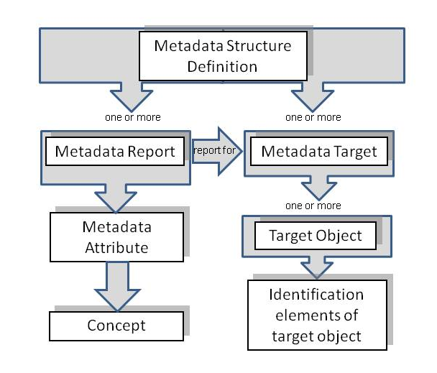

- Figure 1: Schematic of the Metadata Structure Definition
The MSD comprises the specification of the object types to which metadata can be reported in a Metadata Set (Metadata Target(s)), and the Report Structure(s) comprising the Metadata Attributes that identify the Concept for which metadata may be reported in the Metadata Set. Importantly, one Report Structure references the Metadata Target for which it is relevant. One Report Structure can reference many Metadata Target i.e. the same Report Structure can be used for different target objects.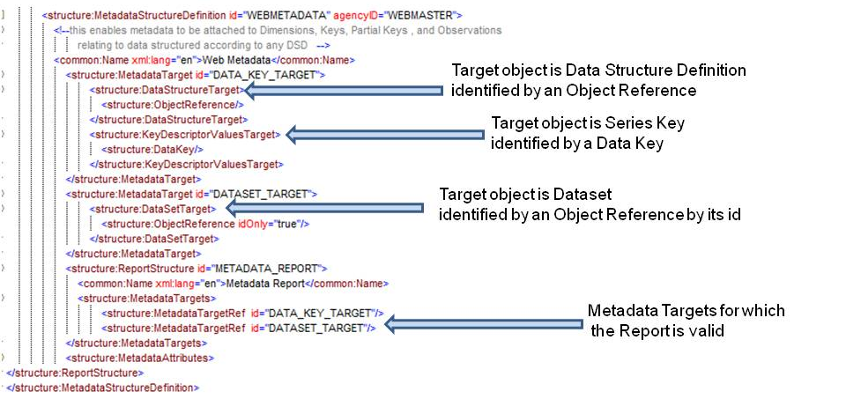
- Figure 2: Example MSD showing Metadata Targets
Note that the SDMX-ML schemas have explicit XML elements for each identifiable object type because identifying, for instance, a Maintainable Object has different properties from an Identifiable Object which must also include the agencyId, version, and id of the Maintainable Object in which it resides.

Report Structure
An example is shown below.
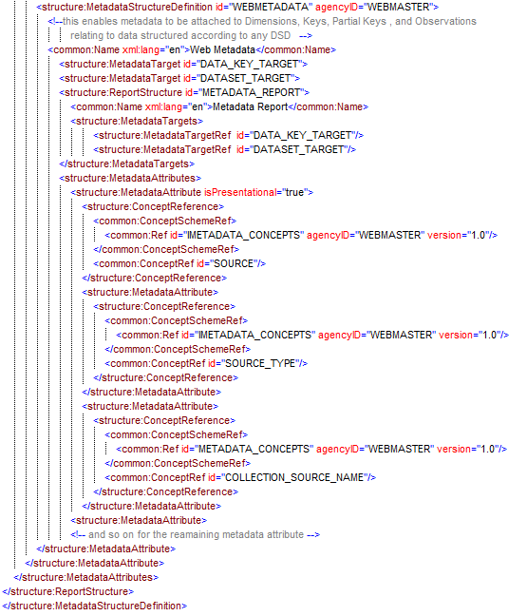
Figure 3: Example MSD showing specification of three Metadata Attributes
This example shows the following hierarchy of Metadata Attributes:
Source – this is presentational and no metadata is expected to be reported at this level
  - Source Type
  - Collection Source Name

Metadata Set
An example of reporting metadata according to the MSD described above, is shown below.

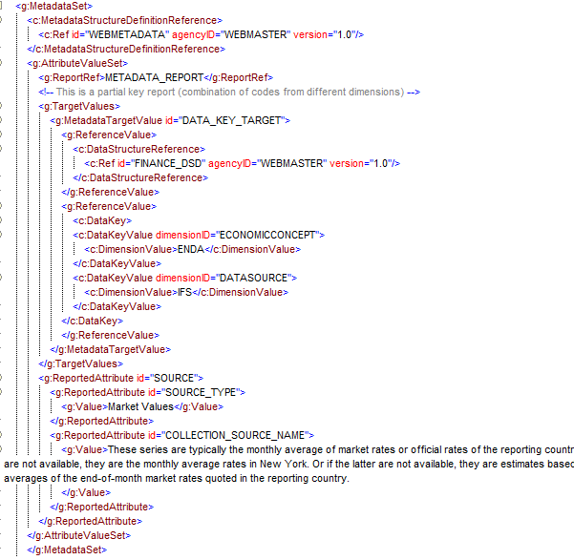
- Figure 4: Example Metadata Set
This example shows:
- The reference to the MSD, Metadata Report, and Metadata Target (MetadataTargetValue)
- The reported metadata attributes (AttributeValueSet)

Maintenance Agencies
All structural metadata in SDMX is owned and maintained by a maintenance agency (Agency identified by agencyID in the schemas). It is vital to the integrity of the structural metadata that there are no conflicts in agencyID. In order to achieve this SDMX adopts the following rules:

- Agencies are maintained in an Agency Scheme (which is a sub class of Organisation Scheme)
- The maintenance agency of the Agency Scheme must also be declared in a (different) Agency Scheme.
- The “top-level” agency is SDMX and this agency scheme is maintained by SDMX.
- Agencies registered in the top-level scheme can themselves maintain a single Agency Scheme. SDMX is an agency in the SDMX agency scheme. Agencies in this scheme can themselves maintain a single Agency Scheme and so on.
- The AgencyScheme cannot be versioned and so take a default version number of 1.0 and cannot be made “final”.
- There can be only one AgencyScheme maintained by any one Agency. It has a fixed Id of AgencyScheme.
- The format of the agency identifier is agencyId.agencyID etc. The top-level agency in this identification mechanism is the agency registered in the SDMX agency scheme. In other words, SDMX is not a part of the hierarchical ID structure for agencies. SDMX is, itself, a maintenance agency.

This supports a hierarchical structure of agencyID.

An example is shown below.

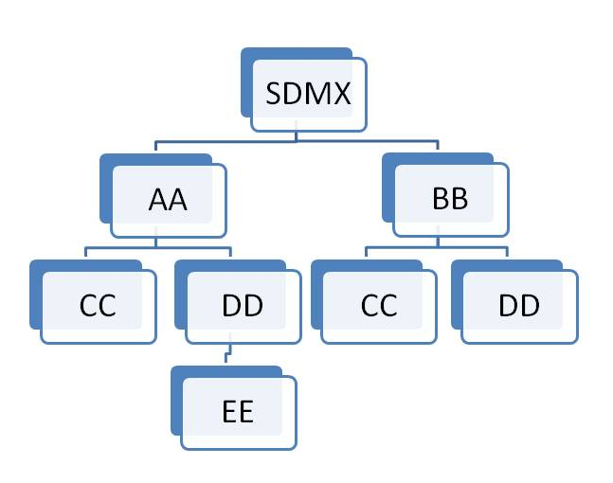
- Figure 5: Example of Hierarchic Structure of Agencies
Each agency is identified by its full hierarchy excluding SDMX.

The XML representing this structure is shown below.

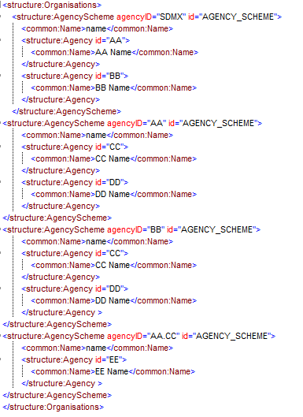
- Figure 6: Example Agency Schemes Showing a Hierarchy
Example of Structure Definitions:

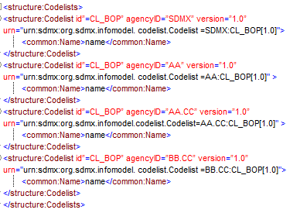
- Figure 7: Example Showing Use of Agency Identifiers

Each of these maintenance agencies has an identical Codelist with the Id CL_BOP. However, each is uniquely identified by means of the hierarchic agency structure.

Concept Roles

Overview
The DSD Components of Dimension and Attribute can play a specific role in the DSD and it is important to some applications that this role is specified. For instance, the following roles are some examples:

Frequency – in a data set the content of this Component contains information on the frequency of the observation values
Geography - in a data set the content of this Component contains information on the geographic location of the observation values
Unit of Measure - in a data set the content of this Component contains information on the unit of measure of the observation values

In order for these roles to be extensible and also to enable user communities to maintain community-specific roles, the roles are maintained in a controlled vocabulary which is implemented in SDMX as Concepts in a Concept Scheme. The Component optionally references this Concept if it is required to declare the role explicitly. Note that a Component can play more than one role and therefore multiple “role” concepts can be referenced.

Information Model
The Information Model for this is shown below:

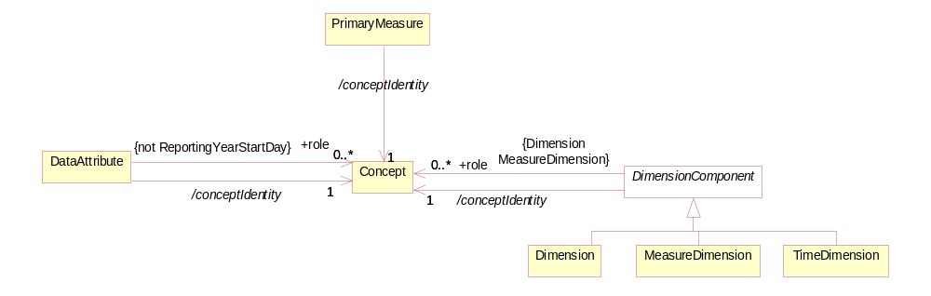
- Figure 8: Information Model Extract for Concept Role
It is possible to specify zero or more concept roles for a Dimension, Measure Dimension and Data Attribute (but not the ReportingYearStartDay). The Time Dimension, Primary Measure, and the Attribute ReportingYearStartDay have explicitly defined roles and cannot be further specified with additional concept roles.

Technical Mechanism
The mechanism for maintain and using concept roles is as follows:

- Any recognized Agency can have a concept scheme that contains concepts that identify concept roles. Indeed, from a technical perspective any agency can have more than one of these schemes, though this is not recommended.

- The concept scheme that contains the “role” concepts can contain concepts that do not play a role.

- There is no explicit indication on the Concept whether it is a ‘role” concept.

- Therefore, any concept in any concept scheme is capable of being a “role” concept.

- It is the responsibility of Agencies to ensure their community knows which concepts in which concept schemes play a “role” and the significance and interpretation of this role. In other words, such concepts must be known by applications, there is no technical mechanism that can inform an application on how to process such a “role”.

- If the concept referenced in the Concept Identity in a DSD component (Dimension, Measure Dimension, Attribute) is contained in the concept scheme containing concept roles then the DSD component could play the role implied by the concept, if this is understood by the processing application.

- If the concept referenced in the Concept Identity in a DSD component (Dimension, Measure Dimension, Attribute) is not contained in the concept scheme containing concept roles, and the DSD component is playing a role, then the concept role is identified by the Concept Role in the schema.

SDMX-ML Examples in a DSD

The Cross-Domain Concept Scheme maintained by SDMX contains concept role concepts (FREQ chosen as an example).
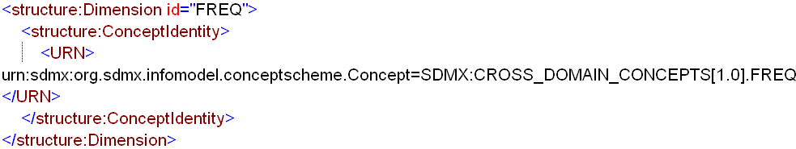

Whether this is a role or not depends upon the application understanding that FREQ in the Cross-Domain Concept Scheme is a role of Frequency.
Using a Concept Scheme that is not the Cross-Domain Concept Scheme where it is required to assign a role using the Cross-Domain Concept Scheme. Again FREQ is chosen as the example.
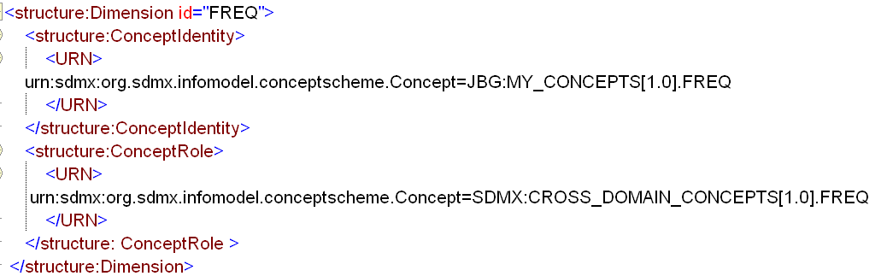
This explicitly states that this Dimension is playing a role identified by the FREQ concept in the Cross-Domain Concept Scheme. Again the application needs to understand what FREQ in the Cross-Domain Concept Scheme implies in terms of a role.
This is all that is required for interoperability within a community. The important point is that a community must recognise a specific Agency as having the authority to define concept roles and to maintain these “role” concepts in a concept scheme together with documentation on the meaning of the role and any relevant processing implications. This will then ensure there is interoperability between systems that understand the use of these concepts.

Note that each of the Components (Data Attribute, Primary Measure, Dimension, Measure Dimension, Time Dimension) has a mandatory identity association (Concept Identity) and if this Concept also identifies the role then it is possible to state this by

SDMX Cross Domain Concept Scheme
All concepts in the SDMX Cross Domain Concept Scheme are capable of playing a role and this scheme will contain all of the roles that were allowed at version 2.0 and will be maintained with new roles that are agreed at the level of the community using the Cross Domain Concept Scheme.

The table below lists the Concepts that need to be in this scheme either for compatibility with version 2.0 or because of requests for additional roles at version 2.1 which have been accepted.

Note that each of the Components (Data Attribute, Primary Measure, Dimension, Measure Dimension, Time Dimension) has a mandatory identity association (Concept Identity) and if this Concept also identifies the role then it is possible to state this by means of the isRole attribute (isRole=true) Additional roles can still be specified by means of the +role association to additional Concepts that identify the role.

Constraints

Introduction
In this version of SDMX the Constraints is a Maintainable Artefact can be associated to one or more of:

- Data Structure Definition
- Metadata Structure Definition
- Dataflow
- Metadataflow
- Provision Agreement
- Data Provider (this is restricted to a Release Calendar Constraint)
- Simple or Queryable Datasources

Note that regardless of the artifact to which the Constraint is associated, it is constraining the contents of code lists in the DSD to which the constrained object is related. This does not apply, of course, to a Data Provider as the Data Provider can be associated, via the Provision Agreement, to many DSDs. Hence the reason for the restriction on the type of Constraint that can be attached to a Data Provider.

Types of Constraint
The Constraint can be of one of two types:

- Content constraint
- Attachable constraint

The attachable constraint is used to define “cube slices” which identify sub sets of data in terms of series keys or dimension values. The purpose of this is to enable metadata to be attached to the constraint, and thereby to the cube slices defined in the Constraint. The metadata can be attached via the “reference metadata” mechanism – MSD and Metadata Set – or via a Group in the DSD. Below is snippet of the schema for a DSD that shows the constructs that enable the Constraint to referenced from a Group in a DSD.

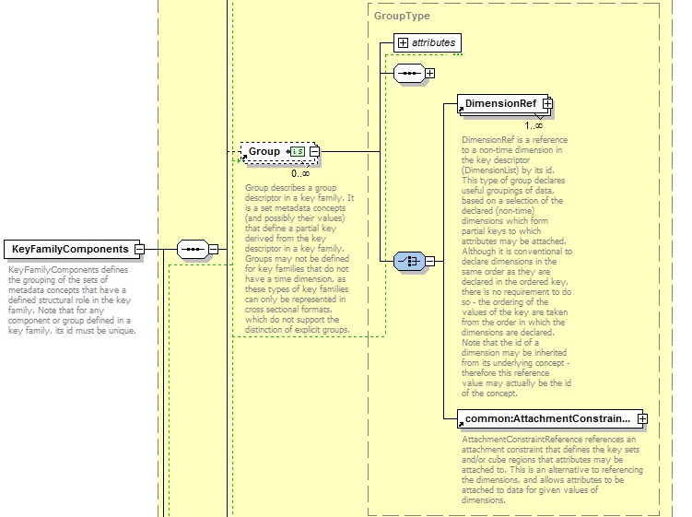

Figure 9: Extract from the SDMX-ML Schema showing reference to Attachment Constraint
For the Content Constraint specific “inheritance” rules apply and these are detailed below.

Rules for a Content Constraint

Scope of a Content Constraint
A Content Constraint is used specify the content of a data or metadata source in terms of the component values or the keys.

In terms of data the components are:

- Dimension
- Measure Dimension
- Time Dimension
- Data Attribute
- Primary Measure

And the keys are the content of the KeyDescriptor – i.e. the series keys composed, for each key, by a value for each Dimension and Measure Dimension

In terms of reference metadata the components are:

- Target Object which is one of:
  - Key Descriptor Values
  - Data Set
  - Report Period
  - IdentifiableObject

- Metadata Attribute

The “key” is therefore the combination of the Target Objects that are defined for the Metadata Target.

For a Constraint based on a DSD the Content Constraint can reference one or more of:

- Data Structure Definition
- Dataflow
- Provision Agreement

For a Constraint based on an MSD the Content Constraint can reference one or more of:

- Metadata Structure Definition
- Metadataflow
- Provision Agreement

Furthermore, there can be more than one Content Constraint specified for a specific object e.g. more than one Constraint for a specific DSD.

In view of the flexibility of constraints attachment, clear rules on their usage are required. These are elaborated below.

Multiple Content Constraints
There can be many Content Constraints for any Constrainable Artefact (e.g. DSD), subject to the following restrictions:

Cube Region
- The constraint can contain multiple Member Selections (e.g. Dimension) but:
- A specific Member Selection (e.g. Dimension FREQ) can only be contained in one Content Constraint for any one attached object (e.g. a specific DSD or specific Dataflow)

Key Set
Key Sets will be processed in the order they appear in the Constraint and wildcards can be used (e.g. any key position not reference explicitly is deemed to be “all values”). As the Key Sets can be “included” or “excluded” it is recommended that Key Sets with wildcards are declared before KeySets with specific series keys. This will minimize the risk that keys are inadvertently included or excluded.

Inheritance of a Content Constraint

Attachment levels of a Content Constraint
There are three levels of constraint attachment for which these inheritance rules apply:
- DSD/MSD – top level
  - Dataflow/Metadataflow – second level
    - Provision Agreement – third level

Note that these rules do not apply to the Simple Datasoucre or Queryable Datasource: the Content Constraint(s) attached to these artefacts are resolved for this artefact only and do not take into account Constraints attached to other artefacts (e.g. Provision Agreement. Dataflow, DSD).
It is not necessary for a Content Constraint to be attached to higher level artifact. e.g. it is valid to have a Content Constraint for a Provision Agreement where there are no constraints attached the relevant dataflow or DSD.

Cascade rules for processing Constraints
The processing of the constraints on either Dataflow/Metadataflow or Provision Agreement must take into account the constraints declared at higher levels. The rules for the lower level constraints (attached to Dataflow/ Metadataflow and Provision Agreement) are detailed below.
Note that there can be a situation where a constraint is specified at a lower level before a constraint is specified at a higher level. Therefore, it is possible that a higher level constraint makes a lower level constraint invalid. SDMX makes no rules on how such a conflict should be handled when processing the constraint for attachment. However, the cascade rules on evaluating constraints for usage are clear - the higher level constraint takes precedence in any conflicts that result in a less restrictive specification at the lower level.

Cube Region
- It is not necessary to have a constraint on the higher level artifact (e.g. DSD referenced by the Dataflow) but if there is such a constraint at the higher level(s) then:
  - The lower level constraint cannot be less restrictive than the constraint specified for the same Member Selection (e.g. Dimension) at the next higher level which constraints that Member Selection (e.g. if the Dimension FREQ is constrained to A, Q in a DSD then the constraint at the Dataflow or Provision Agreement cannot be A, Q, M or even just M – it can only further constrain A,Q).
  - The constraint at the lower level for any one Member Selection further constrains the content for the same Member Selection at the higher level(s).
- Any Member Selection which is not referenced in a Content Constraint is deemed to be constrained according to the Content Constraint specified at the next higher level which constraints that Member Selection.
- If there is a conflict when resolving the constraint in terms of a lower-level constraint being less restrictive than a higher-level constraint then the constraint at the higher-level is used.

Note that it is possible for a Content Constraint at a higher level to constrain, say, four Dimensions in a single constraint, and a Content Constraint at a lower level to constrain the same four in two, three, or four Content Constraints.

Key Set
- It is not necessary to have a constraint on the higher level artefact (e.g. DSD referenced by the Dataflow) but if there is such a constraint at the higher level(s) then:

  - The lower level constraint cannot be less restrictive than the constraint specified at the higher level.
  - The constraint at the lower level for any one Member Selection further constrains the keys specified at the higher level(s).
- Any Member Selection which is not referenced in a Content Constraint is deemed to be constrained according to the Content Constraint specified at the next higher level which constraints that Member Selection.
- If there is a conflict when resolving the keys in the constraint at two levels, in terms of a lower-level constraint being less restrictive than a higher-level constraint, then the offending keys specified at the lower level are not deemed part of the constraint.

Note that a Key in a Key Set can have wildcarded Components. For instance the constraint may simply constrain the Dimension FREQ to “A”, and all keys where the FREQ=A are therefore valid.

The following logic explains how the inheritance mechanism works. Note that this is conceptual logic and actual systems may differ in the way this is implemented.

- Determine all possible keys that are valid at the higher level.
- These keys are deemed to be inherited by the lower level constrained object, subject to the constraints specified at the lower level.
- Determine all possible keys that are possible using the constraints specified at the lower level.
- At the lower level inherit all keys that match with the higher level constraint.
- If there are keys in the lower level constraint that are not inherited then the key is invalid (i.e. it is less restrictive).

Constraints Examples
The following scenario is used.
DSD
This contains the following Dimensions:
- GEO – Geography
- SEX – Sex
- AGE – Age
- CAS – Current Activity Status
In the DSD common code lists are used and the requirement is to restrict these at various levels to specify the actual code that are valid for the object to which the Content Constraint is attached.
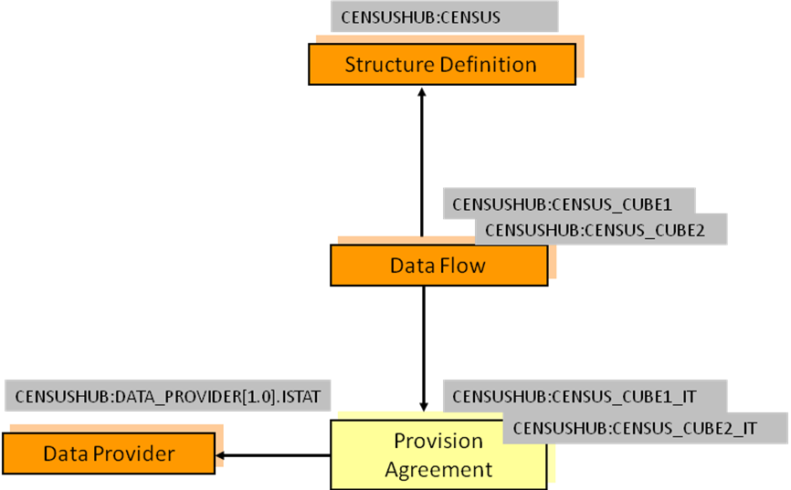
- Figure 10: Example Scenario for Constraints
Constraints are declared as follows:
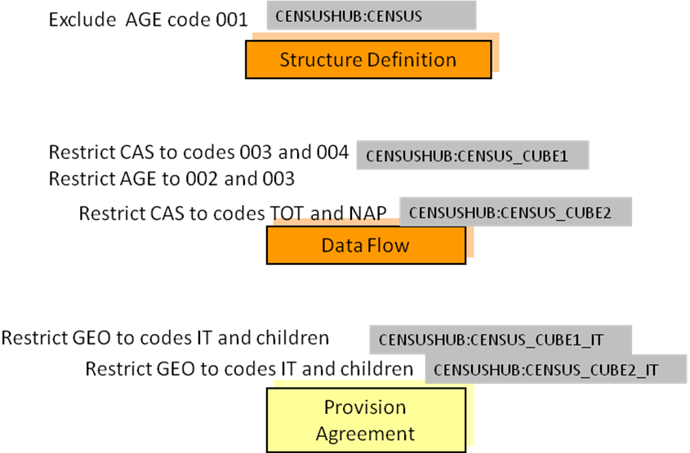
- Figure 11: Example Content Constraints
Notes:
- AGE is constrained for the DSD and is further restricted for the Dataflow CENSUS_CUBE1.
- The same Constraint applies to both Provision Agreements.

The cascade rules elaborated above result as follows:
DSD
- Constrained by eliminating code 001 from the code list for the AGE Dimension.

Dataflow CENSUS_CUBE1
- Constrained by restricting the code list for the AGE Dimension to codes 002 and 003(note that this is a more restrictive constraint than that declared for the DSD which specifies all codes except code 001).
- Restricts the CAS codes to 003 and 004.

Dataflow CENSUS_CUBE2
- Restricts the code list for the CAS Dimension to codes TOT and NAP.
- Inherits the AGE constraint applied at the level of the DSD.

Provision Agreements CENSUS_CUBE1_IT
- Restricts the codes for the GEO Dimension to IT and its children.
- Inherits the constraints from Dataflow CENSUS_CUBE1 for the AGE and CAS Dimensions.

Provision Agreements CENSUS_CUBE2_IT
- Restricts the codes for the GEO Dimension to IT and its children.
- Inherits the constraints from Dataflow CENSUS_CUBE2 for the CAS Dimension.
- Inherits the AGE constraint applied at the level of the DSD.

The constraints are defined as follows:
DSD Constraint
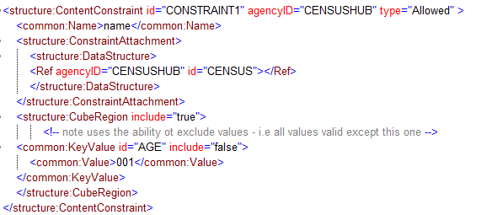

Dataflow Constraints
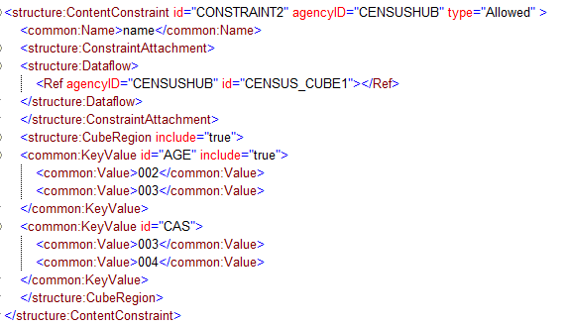
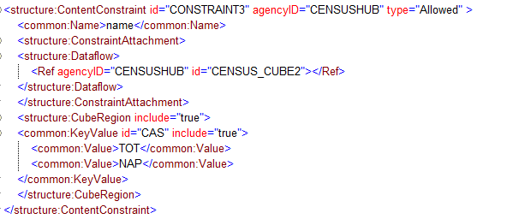
Provision Agreement Constraint
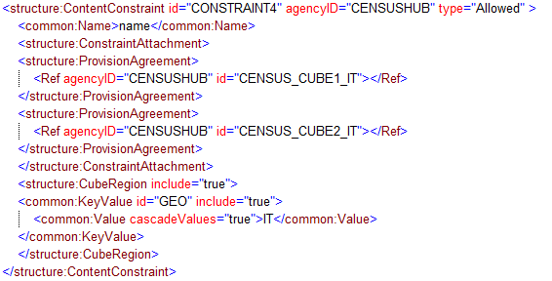

Annex I: How to eliminate extra element in the .NET SDMX Web Service

Problem statement
For implementing an SDMX compliant Web Service the standardised WSDL file should be used that describes the expected request/response structure. The request message of the operation contains a wrapper element (e.g. “GetGenericData”) that wraps a tag called “GenericDataQuery”, which is the actual SDMX query XML message that contains the query to be processed by the Web Service. In the same way the response is formulated in a wrapper element “GetGenericDataResponse”.
As defined in the SOAP specification, the root element of a SOAP message is the Envelope, which contains an optional Header and a mandatory Body. These are illustrated below along with the Body contents according to the WSDL:
XML
<SOAP-ENV:Envelope
<SOAP-ENV:Body>
<GetGenericData>
<sdmx:GenericDataQuery>
...
</sdmx:GenericDataQuery>
</GetGenericData>
</SOAP-ENV:Body>
</SOAP-ENV:Envelope>

The problem that initiated the present analysis refers to the difference in the way SOAP requests are when trying to implement the aforementioned Web Service in .NET framework.
Building such a Web Service using the .NET framework is done by exposing a method (i.e. the getGenericData in the example) with an XML document argument (lets name it “Query”). The difference that appears in Microsoft .Net implementations is that there is a need for an extra XML container around the SDMX GenericDataQuery. This is the expected behavior since the framework is let to publish automatically the Web Service as a remote procedure call, thus wraps each parameter into an extra element. The .NET request is illustrated below:
XML
<SOAP-ENV:Envelope
<SOAP-ENV:Body>
<GetGenericData>
<Query> <!-- MS .Net implementation -->
<GenericDataQuery>
...
</GenericDataQuery>
</Query> <!-- MS .Net implementation -->
</GetGenericData>
</SOAP-ENV:Body>
</SOAP-ENV:Envelope>

Furthermore this extra element is also inserted in the automatically generated WSDL from the framework. Therefore this particularity requires custom clients for the .NET Web Services that is not an interoperable solution.

Solution

The solution proposed for conforming the .NET implementation to the envisioned SOAP requests has to do with the manual intervention to the serialisation and deserialisation of the XML payloads. Since it is a Web Service of already prepared XML messages requests/responses this is the indicate way so as to have full control on the XML messages. This is the way the Java implementation (using Apache Axis) of the SDMX Web Service has adopted.
As regards the .NET platform this is related with the usage of XmlAnyElement parameter for the .NET web methods.
Web methods use XmlSerializer in the .NET Framework to invoke methods and build the response.
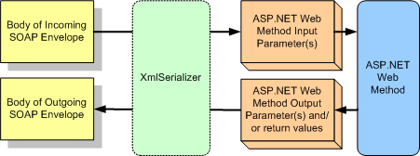

The XML is passed to the XmlSerializer to de-serialize it into the instances of classes in managed code that map to the input parameters for the Web method. Likewise, the output parameters and return values of the Web method are serialized into XML in order to create the body of the SOAP response message.
In case the developer wants more control over the serialization and de-serialization process a solution is represented by the usage of XmlElement parameters. This offers the opportunity of validating the XML against a schema before de-serializing it, avoiding de-serialization in the first place, analyzing the XML to determine how you want to de-serialize it, or using the many powerful XML APIs that are available to deal with the XML directly. This also gives the developer the control to handle errors in a particular way instead of using the faults that the XmlSerializer might generate under the covers.
In order to control the de-serialization process of the XmlSerializer for a Web method, XmlAnyElement is a simple solution to use.
To understand how the XmlAnyElement attribute works we present the following two web methods:
C#
// Simple Web method using XmlElement parameter
[WebMethod]
public void SubmitXml(XmlElement input)
{ return; }

In this method the input parameter is decorated with the XmlAnyElement parameter. This is a hint that this parameter will be de-serialized from an xsd:any element. Since the attribute is not passed any parameters, it means that the entire XML element for this parameter in the SOAP message will be in the Infoset that is represented by this XmlElement parameter.

C#
// Simple Web method...using the XmlAnyElement attribute
[WebMethod]
public void SubmitXmlAny([XmlAnyElement] XmlElement input)
{ return; }

The difference between the two is that for the first method, SubmitXml, the XmlSerializer will expect an element named input to be an immediate child of the SubmitXml element in the SOAP body. The second method, SubmitXmlAny, will not care what the name of the child of the SubmitXmlAny element is. It will plug whatever XML is included into the input parameter. The message style from ASP.NET Help for the two methods is shown below. First we look at the message for the method without the XmlAnyElement attribute.

XML
<?xml version="1.0" encoding="utf-8"?>
<soap:Envelope
xmlns:xsi="http://www.w3.org/2001/XMLSchema-instance"
xmlns:xsd="http://www.w3.org/2001/XMLSchema"
xmlns:soap="http://schemas.xmlsoap.org/soap/envelope/">
<soap:Body>
<SubmitXml xmlns="http://msdn.microsoft.com/AYS/XEService">
<input>xml</input>
</SubmitXml>
</soap:Body>
</soap:Envelope>
Now we look at the message for the method that uses the XmlAnyElement attribute.
XML
<?xml version="1.0" encoding="utf-8"?>
<!-- SOAP message for method using XmlAnyElement -->
<soap:Envelope
xmlns:xsi="http://www.w3.org/2001/XMLSchema-instance"
xmlns:xsd="http://www.w3.org/2001/XMLSchema"
xmlns:soap="http://schemas.xmlsoap.org/soap/envelope/">
<soap:Body>
<SubmitXmlAny xmlns="http://msdn.microsoft.com/AYS/XEService">
Xml
</SubmitXmlAny>
</soap:Body>
</soap:Envelope>
The method decorated with the XmlAnyElement attribute has one fewer wrapping elements. Only an element with the name of the method wraps what is passed to the input parameter.
For more information please consult:
http://msdn.microsoft.com/en-us/library/aa480498.aspx
Furthermore at this point the problem with the different requests has been solved. However there is still the difference in the produced WSDL that has to be taken care. The automatic generated WSDL now doesn’t insert the extra element, but defines the content of the operation wrapper element as “xsd:any” type.
XML
<xs:element name="GetGenericData">
<xs:complexType>
<xs:sequence>
<xs:any minOccurs="0" maxOccurs="1" />
</xs:sequence>
</xs:complexType>
</xs:element>
Without a common WSDL still the solution doesn’t enforce interoperability. In order to “fix” the WSDL, there two approaches. The first is to intervene in the generation process. This is a complicated approach, compared to the second approach, which overrides the generation process and returns the envisioned WSDL for the SDMX Web Service.
This is done by redirecting the request to the “/Service?WSDL” to the envisioned WSDL stored locally into the application. To do this, from the project add a “Global Application Class” item (.asax file) and override the request in the “Application_BeginRequest” method. This is demonstrated in detail in the next section.
This approach has the disadvantage that for each deployment the WSDL end point has to be changed to reflect the current URL. However this inconvenience can be easily eliminated if a developer implements a simple rewriting module for changing the end point to the one of the current deployment.

Applying the solution
In the context of the SDMX Web Service, applying the above solution translates into the following:
C#
[return: XmlAnyElement]
public XmlDocument GetGenericData([XmlAnyElement]XmlDocument Query)
{ return; }
The SOAP request/response will then be as follows:
GenericData Request

XML
<?xml version="1.0" encoding="utf-8"?>
<soap:Envelope xmlns:xsi="http://www.w3.org/2001/XMLSchema-instance" xmlns:xsd="http://www.w3.org/2001/XMLSchema" xmlns:soap="http://schemas.xmlsoap.org/soap/envelope/">
<soap:Body>
<GetGenericData xmlns="http://www.sdmx.org/resources/webservices">
Xml
</GetGenericData>
</soap:Body>
</soap:Envelope>

GenericData Response

XML
<?xml version="1.0" encoding="utf-8"?>
<soap:Envelope xmlns:xsi="http://www.w3.org/2001/XMLSchema-instance" xmlns:xsd="http://www.w3.org/2001/XMLSchema" xmlns:soap="http://schemas.xmlsoap.org/soap/envelope/">
<soap:Body>
<GetGenericDataResponse xmlns="http://www.sdmx.org/resources/webservices">
Xml
</GetGEnericDataResponse>
</soap:Body>
</soap:Envelope>
For overriding the automatically produced WSDL, in the solution explorer right click the project and select “Add” -> “New item…”. Then select the “Global Application Class”. This will create “.asax” class file in which the following code should replace the existing empty method:
C#
protected void Application_BeginRequest(object sender, EventArgs e)
{
System.Web.HttpApplication app = (System.Web.HttpApplication)sender;
if (Request.RawUrl.EndsWith("/Service1.asmx?WSDL"))
{
app.Context.RewritePath("/SDMX_WSDL.wsdl", false);
}
}

The SDMX_WSDL.wsdl should reside in the in the root directory of the application. After applying this solution the returned WSDL is the envisioned. Thus in the request message definition contains:
XML
<xs:element name="GetGenericData">
<xs:complexType>
<xs:sequence>
<xs:element ref="sdmx:GenericQueryData"/>
</xs:sequence>
</xs:complexType>
</xs:element>

The seconds can be reported fractionally
ISO 8601 defines alternative definitions for the first week, all of which produce equivalent results. Any of these definitions could be substituted so long as they are in relation to the reporting year start day.
The rules for adding durations to a date time are described in the W3C XML Schema specification. See http://www.w3.org/TR/xmlschema-2/#adding-durations-to-dateTimes for further details.
2010-Q3 (with a reporting year start day of --01-01) starts on 2010-07-01. This is day 4 of week 26, therefore the first week matched is week 27.
2010-Q3 (with a reporting year start day of --07-01) starts on 2011-01-01. This is day 6 of week 27, therefore the first week matched is week 28.

