SDMX STANDARDS: SECTION 2

INFORMATION MODEL:
UML CONCEPTUAL DESIGN

Version 2.1

April 2011

© SDMX 2011
http://www.sdmx.org/

Contents
1 Introduction 1
1.1 Related Documents 1
1.2 Modelling Technique and Diagrammatic Notes 1
1.3 Overall Functionality 2
1.3.1 Information Model Packages 2
1.3.2 Version 1.0 3
1.3.3 Version 2.0/2.1 3
2 Actors and Use Cases 5
2.1 Introduction 5
2.2 Use Case Diagrams 6
2.2.1 Maintenance of Structural and Provisioning Definitions 6
2.2.2 Publishing and Using Data and Reference Metadata 10
3 SDMX Base Package 13
3.1 Introduction 13
3.2 Base Structures - Identification, Versioning, and Maintenance 14
3.2.1 Class Diagram 14
3.2.2 Explanation of the Diagram 14
3.3 Basic Inheritance 18
3.3.1 Class Diagram– Basic Inheritance from the Base Inheritance Classes 18
3.3.2 Explanation of the Diagram 19
3.4 Data Types 19
3.4.1 Class Diagram 19
3.4.2 Explanation of the Diagram 20
3.5 The Item Scheme Pattern 21
3.5.1 Context 21
3.5.2 Class Diagram 21
3.5.3 Explanation of the Diagram 22
3.6 The Structure Pattern 23
3.6.1 Context 23
3.6.2 Class Diagrams 24
3.6.3 Explanation of the Diagrams 26
4 Specific Item Schemes 31
4.1 Introduction 31
4.2 Inheritance View 32
4.3 Codelist 33
4.3.1 Class Diagram 33
4.3.2 Explanation of the Diagram 34
4.4 Concept Scheme and Concepts 36
4.4.1 Class Diagram - Inheritance 36
4.4.2 Explanation of the Diagram 37
4.4.3 Class Diagram - Relationship 38
4.4.4 Explanation of the diagram 38
4.5 Category Scheme 40
4.5.1 Context 40
4.5.2 Class diagram - Inheritance 40
4.5.3 Explanation of the Diagram 41
4.5.4 Class diagram - Relationship 42
4.6 Organisation Scheme 44
4.6.1 Class Diagram 44
4.6.2 Explanation of the Diagram 44
4.7 Reporting Taxonomy 48
4.7.1 Class Diagram 48
4.7.2 Explanation of the Diagram 48
5 Data Structure Definition and Dataset 51
5.1 Introduction 51
5.2 Inheritance View 52
5.2.1 Class Diagram 52
5.2.2 Explanation of the Diagram 53
5.3 Data Structure Definition – Relationship View 55
5.3.1 Class Diagram 55
5.3.2 Explanation of the Diagrams 55
5.4 Data Set – Relationship View 65
5.4.1 Context 65
5.4.2 Class Diagram 65
5.4.3 Explanation of the Diagram 66
6 Cube 74
6.1 Context 74
6.2 Support for the Cube in the Information Model 74
7 Metadata Structure Definition and Metadata Set 75
7.1 Context 75
7.2 Inheritance 75
7.2.1 Introduction 75
7.2.2 Class Diagram - Inheritance 76
7.2.3 Explanation of the Diagram 77
7.3 Metadata Structure Definition 77
7.3.1 Introduction 77
7.3.2 Structures Already Described 77
7.3.3 Class Diagram – Relationship 78
7.3.4 Explanation of the Diagram 78
7.4 Metadata Set 84
7.4.1 Class Diagram 84
7.4.2 Explanation of the Diagram 85
8 Hierarchical Code List 92
8.1 Scope 92
8.2 Inheritance 93
8.2.1 Class Diagram 93
8.2.2 Explanation of the Diagram 93
8.3 Relationship 94
8.3.1 Class Diagram 94
8.3.2 Explanation of the Diagram 94
9 Structure Set and Mappings 98
9.1 Scope 98
9.2 Structure Set 99
9.2.1 Class Diagram – Inheritance 99
9.2.2 Class Diagram – Relationship 100
9.2.3 Explanation of the Diagram 100
9.3 Structure Map 102
9.3.1 Class Diagram 102
9.3.2 Explanation of the Diagram 102
9.4 Item Scheme Map 104
9.4.1 Context 104
9.4.2 Class Diagram 105
9.4.3 Explanation of the Diagram 105
9.5 Hybrid Codelist Map 108
9.5.1 Class Diagram 108
9.5.2 Explanation of the Diagram 108
10 Constraints 111
10.1 Scope 111
10.2 Inheritance 111
10.2.1 Class Diagram of Constrainable Artefacts - Inheritance 111
10.2.2 Explanation of the Diagram 111
10.3 Constraints 112
10.3.1 Relationship Class Diagram – high level view 112
10.3.2 Explanation of the Diagram 113
10.3.3 Relationship Class Diagram – Detail 114
11 Data Provisioning 124
11.1 Class Diagram 124
11.2 Explanation of the Diagram 125
11.2.1 Narrative 125
11.2.2 Definitions 126
12 Process 128
12.1 Introduction 128
12.2 Model – Inheritance and Relationship view 129
12.2.1 Class Diagram 129
12.2.2 Explanation of the Diagram 129
13 Transformations and Expressions 132
13.1 Scope 132
13.2 Model - Inheritance View 133
13.2.1 Class Diagram 133
13.2.2 Explanation of the Diagram 133
14 Appendix 1: A Short Guide To UML in the SDMX Information Model 137
14.1 Scope 137
14.2 Use Cases 137
14.3 Classes and Attributes 138
14.3.1 General 138
14.3.2 Abstract Class 139
14.4 Associations 139
14.4.1 General 139
14.4.2 Simple Association 139
14.4.3 Aggregation 140
14.4.4 Association Names and Association-end (role) Names 141
14.4.5 Navigability 141
14.4.6 Inheritance 142
14.4.7 Derived association 142

Change History
Version 1.0 – initial release September 2004.

Version 2.0 – release November 2005

Major functional enhancements by addition of new packages:

- Metadata Structure Definition
- Metadata Set
- Hierarchical Code Scheme
- Data and Metadata Provisioning
- Structure Set and Mappings
- Transformations and Expressions
- Process and Transitions
Re-engineering of some SDMX Base structures to give more functionality:

- Item Scheme and Item can have properties – this gives support for complex hierarchical code schemes (where the property can be used to sequence codes in scheme), and Item Scheme mapping tables (where the property can give additional information about the map between the two schemes and the between two Items)
- revised Organisation pattern to support maintained schemes of organisations, such as a data provider
- modified Component Structure pattern to support identification of roles played by components and the attachment of attributes
- change to inheritance to enable more artefacts to be identifiable and versionable
Introduction of new types of Item Scheme:

- Object Type Scheme to specify object types in support of the Metadata Structure Definition (principally the object types (classes) in this Information Model)
- Type Scheme to specify types other than object type
- A generic Item Scheme Association to specify the association between Items in two or more Item Schemes, where such associations cannot be described in the Structure Set and Transformation.
The Data Structure Definition is introduced as a synonym for Key Family though the term Key Family is retained and used in this specification.

Modification to Data Structure Definition (DSD) to

- align the cross sectional structures with the functionality of the schema
- support Data Structure Definition extension (i.e. to derive and extend a Data Structure Definition from another Data Structure Definition), thus supporting the definition of a related “set” of key families
- distinguish between data attributes (which are described in a Data Structure Definition) from metadata attributes (which are described in a metadata structure definition)
- attach data attributes to specific identifiable artefacts (formally this was supported by attachable artefact)
Domain Category Scheme re-named Category Scheme to better reflect the multiple usage of this type of scheme (e.g. subject matter domain, reporting taxonomy).

Concept Scheme enhanced to allow specification of the representation of the Concept. This specification is the default (or core) representation and can be overridden by a construct that uses it (such as a Dimension in a Data Structure Definition).

Revision of cross sectional data set to reflect the functionality of the version 1.0 schema.

Revision of Actors and Use Cases to reflect better the functionality supported.

Version 2.1 – release April 2011

The purpose of this revision is threefold:

- To introduce requested changes to functionality
- To align the model and syntax implementations more closely (note, however, that the model remains syntax neutral)
- To correct errors in version 2.0

SDMX Base
Basic inheritance and patterns

- The following attributes are added to Maintainable:

i) isExternalReference
ii) structure URL
iii) serviceURL

- Added Nameable Artefact and moved the Name and Description associations from Identifiable Artefact to Nameable Artefact. This allows an artefact to be identified (with id and urn) without the need to specify a Name.

- Removed any inheritance from Versionable Artefact with the exception of Maintainable Artefact – this means that only Maintainable objects can be versioned, and objects contained in a maintainable object cannot be independently versioned.

- Renamed MaintenanceAgency to Agency 0 this is its name in the schema and the URN.

- Removed abstract class Association as a subclass of Item (as these association types are not maintained in Item Schemes). Specific associations are modelled explicitly (e.g. Categorisation, ItemScheme, Item).

- Added ActionType to data types.

- Removed Coded Artefact and Uncoded Artefact and all subclasses (e.g. Coded Data Attribute and Uncoded Data Attribute) as the “Representation” is more complex than just a distinction between coded and uncoded.

- Added Representation to the Component. Removed association to Type.

- Removed concept role association (to Item) as roles are identified by a relationship to a Concept.

- Removed abstract class Attribute as both Data Attribute and Metadata Attribute have different properties. Data Attribute and Metadata Attribute inherit directly from Component.

- isPartial attribute added to Item Scheme to support partial Item Schemes (e.g. partial Code list).

Representation

- Removed interval and enumeration from Facet.
- added facetValueType to Facet.
- Re-named DataType to facetValueType.
- Added observationalTimePeriod, inclusiveValueRange and exclusiveValueRange to facetValueType.
- Added ExtendedFacetType as a sub class of FacetType. This includes Xhtml as a facet type to support this as an allowed representation for a Metadata Attribute

Organisations
- Organisation Role is removed and replaced with specific Organisation Schemes of Agency, Data Provider, Data Consumer, Organisation Unit.

Mapping (Structure Maps)

Updated Item Scheme Association as follows:

- Renamed to Item Scheme Map to reflect better the sub classes and relate better to the naming in the schema.

- Removed inheritance of Item Scheme Map from Item Scheme, and inherited directly from Nameable Artefact.

- Item Association inherits from Identifiable Artefact.

- Removed Property from the model as this is not supported in the schema.

- Removed association type between Item Scheme Map and Item, and Association and Item.

- Removed Association from the model.

- Made Item Association a sub class of Identifiable, was a sub class Item.

- Removed association to Property from both Item Scheme Map and Item.

- Added attribute alias to both Item Scheme Association and Item Association.

- Made Item Scheme Map and Item Association abstract.

- Added sub-classes to Item Scheme Map – there is a subclass for each type of Item Scheme Association (e.g. Code list Map).

- Added mapping between Reporting Taxonomy as this is an Item Scheme and can be mapped in the same way as other Item Schemes.

- Added Hybrid Code list Map and Hybrid Code Map to support code mappings between a Code list and a Hierarchical Code list.

Mapping: Structure Map

- This is a new diagram. Essentially removed inherited /hierarchy association between the various maps, as these no longer inherit from Item, and replaced the associations to the abstract Maintainable and Versionable Artefact classes with the actual concrete classes.

- Removed associations between Code list Map, Category Scheme Map, and Concept Scheme Map and made this association to Item Scheme Map.

- Removed hierarchy of Structure Map.

Concept

- Added association to Representation.

Data Structure Definition

- Added Measure Dimension to support structure-specific renderings of the DSD. The Measure Dimension is associated to a Concept Scheme that specifies the individual measures that are valid.

- The three types of “Dimension”, - Dimension, Measure Dimension, Time Dimension – have a super class – Dimension Component

- Added association to a Concept that defines the role that the component (Dimension, Data Attribute, Measure Dimension) plays in the DSD. This replaces the Boolean attributes on the components.

- Added Primary Measure and removed this as role of Measure.

- Deleted the derived Data Structure Definition association from Data Structure Definition to itself as this is not supported directly in DSD.

- Deleted attribute GroupKeyDescriptor.isAttachmentConstraint and replaced with an association to an Attachment Constraint.

- Replaced association from Data Attribute to Attachable Artefact with association to Attribute Relationship.

- Added a set of classes to support Attribute Relationship.

- Renamed KeyDescriptor to DimensionDescriptor to better reflect its purpose.

- Renamed GroupKeyDescriptor to GroupDimensionDescriptor to better reflect its purpose.

Code list

- CodeList classname changed to Codelist.

- Removed codevalueLength from Codelist as this is supported by Facet.

- Removed hierarchyView association between Code and Hierarchy as this association is not implemented.

Metadata Structure Definition(MSD)

- Full Target Identifier, Partial Target Identifier, and Identifier Component are replaced by Metadata Target and Target Object. Essentially this eliminates one level of specification and reference in the MSD, and so makes the MSD more intuitive and easier to specify and to understand.

- Re-named Identifiable Object Type to Identifiable Object Target and moved to the MSD package.

- Added sub classes to Target Object as these are the actual types of object to which metadata can be attached. These are Identifiable Object Target (allows reporting of metadata to any identifiable object), Key Descriptor Values Target (allows reporting of metadata for a data series key, Data Set Target (allows reporting of metadata to a data set), and Reporting Period Target (allows the metadata set to specify a reporting period).

- Allowed Target Object can have any type of Representation, this was restricted in version 2.0 to an enumerated representation in the model (but not in the schemas).

- Removed Object Type Scheme (as users cannot maintain their own list of object types), and replaced with an enumeration of Identifiable Objects.

- Removed association between Metadata Attribute and Identifiable Artefact and replaced this with an association between Report Structure and Metadata Target, and allowed one Report Structure to reference more than on Metadata Target. This allowing a single Report Structure to be defined for many object types.

- Added the ability to specify that a Metadata Attribute can be repeated in a Metadata Set and that a Metadata Attribute can be specified as “presentational” meaning that it is present for structural and presentational purposes, and will not have content in a Metadata Set.

- The Representation of a Metadata Attribute uses Extended Facet (to support Xhtml).

Metadata Set

- Added link to Data Provider - 0..1 but note that for metadata set registration this will be 1.

- Removed Attribute Property as the underlying Property class has been removed.

- One Metadata Set is restricted to reporting metadata for a single Report Structure.

- The Metadata Report classes are re-structured and re-named to be consistent with the renaming and restructuring of the MSD.

- Metadata Attribute Value is renamed Reported Attribute to be consistent with the schemas.

- Deleted XML attribute and Contact Details from the inheritance diagram.

Category Scheme
- Added Categorisation. Category no longer has a direct association to Dataflow and Metadataflow.

- Changed Reporting Taxonomy inheritance from Category Scheme to Maintainable Artefact.

- Added Reporting Category and associated this to Structure Usage.

Data Set

- Removed the association to Provision Agreement from the diagram.

- Added association to Data Structure Definition. This association was implied via the dataflow but this is optional in the implementation whereas the association to the Data Structure Definition is mandatory.

- Added attributes to Data Set.

- There is a single, unified, model of the Data Set which supports four types of data set:

  - Generic Data Set – for reporting any type of data series, including time series and what is sometimes known as “cross sectional data”. In this data set, the value of any one dimension (including the Time Dimension) can be reported with the observation (this must be for the same dimension for the entire data set)

  - Structure-specific Data Set – for reporting a data series that is specific to a DSD

  - Generic Time Series Data Set – this is identical to the Generic Data Set except it must contain only time series, which means that a value for the Time Dimension is reported with the Observation

  - Structure-specific Time Series Data Set - this is identical to the Structure-specific Data Set except it must contain only time series, which means that a value for the Time Dimension is reported with the Observation.

- Removed Data Set as a sub class of Identifiable – but note that Data Set has a “setId” attribute.

- Added coded and uncoded variants of Key Value, Observation, and Attribute Value in order to show the relationship between the coded values in the data set and the Codelist in the Data Structure Definition.

- Made Key Value abstract with sub classes for coded, uncoded, measure (MeasureKeyValue) ads time(TimeKeyValue) The Measure Key Value is associated to a Concept as it must take its identify from a Concept.

XSDataSet
- This is removed and replaced with the single, unified data set model.

Constraint

- Constraint is made Maintainable (was Identifiable).

- Added artefacts that better support and distinguish (from data) the constraints for metadata.

- Added Constraint Role to specify the purpose of the Constraint. The values are allowable content (for validation of sub set code code lists), and actual content (to specify the content of a data or metadata source).

Process
- Removed inheritance from Item Scheme and Item: Process inherits directly from Maintainable and Process Step from Identifiable.

- Removed specialisation association between Transition and Association.

- Removed Transition Scheme - transitions are explicitly specified and not maintained as Items in a Item Scheme.

- Removed Expression and replaced with Computation.

- Transition is associated to Process Step and not Process itself. Therefore the source association to Process Step is removed.

- Removed Expressions as these are not implemented in the schemas. But note that the Transformations and Expressions model is retained, though it is not implemented in the schemas.

Hierarchical Codelist

- Renamed HierarchicalCodeList to HierarchicalCodelist.
- This is re-modelled to reflect more accurately the way this is implemented: this is as an actual hierarchy rather than a set of relational associations from which the hierarchy can be derived.

- Code Association is re-named Hierarchical Code and the association type association to Code is removed (as these association types are not maintained in an Item Scheme).

- Hierarchical Code is made an aggregate of Hierarchy, and not of Hierarchical Codelist.

- Removed root node in the Hierarchy – there can be many top-level codes in Hierarchical Code.

- Added reference association between Hierarchical Code and Level to indicate the Level if the Hierarchy is a level based hierarchy.

Provisioning and Registration
- Data Provider and Provision Agreement have an association to Datasource (was Query Datasource), as the association is to any of Query Datasource and Simple Datasource.

- Provision Agreement is made Maintainable and indexing attributes moved to Registration

- Registration has a registry assigned Id and indexing attributes.

Introduction
This document is not normative, but provides a detailed view of the information model on which the normative SDMX specifications are based. Those new to the UML notation or to the concept of Data Structure Definitions may wish to read the appendixes in this document as an introductory exercise.

Related Documents
This document is one of two documents concerned with the SDMX Information Model. The complete set of documents is:

SDMX SECTION 02 INFORMATION MODEL: UML CONCEPTUAL DESIGN (this document)

This document comprises the complete definition of the information model, with the exception of the registry interfaces. It is intended for technicians wishing to understand the complete scope of the SDMX technical standards in a syntax neutral form.

SDMX SECTION 05 REGISTRY SPECIFICATION: LOGICAL INTERFACES

This document provides the logical specification for the registry interfaces, including subscription/notification, registration/submission of data and metadata, and querying.

Modelling Technique and Diagrammatic Notes
The modelling technique used for the SDMX Information Model (SDMX-IM) is the Unified Modelling Language (UML). An overview of the constructs of UML that are used in the SDMX-IM can be found in the Appendix “A Short Guide to UML in the SDMX Information Model”

UML diagramming allows a class to be shown with or without the compartments for one or both of attributes and operations (sometimes called methods). In this document the operations compartment is not shown as there are no operations.

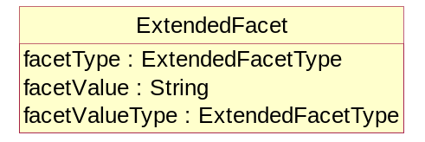
Figure 1 Class with operations suppressed

In some diagrams for some classes the attribute compartment is suppressed even though there may be some attributes. This is deliberate and is done to aid clarity of the diagram. The method used is:

- The attributes will always be present on the class diagram where the class is defined and its attributes and associations are defined.
- On other diagrams, such as inheritance diagrams, the attributes may be suppressed from the class for clarity.

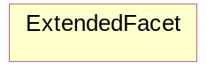
Figure 2 Class with attributes also suppressed

Note that, in any case, attributes inherited from a super class are not shown in the sub class.

The following table structure is used in the definition of the classes, attributes, and associations.

Class | Feature | Description
ClassName
 | attributeName | .
 | associationName
 | +roleName

The content in the “Feature” column comprises or explains one of the following structural features of the class:

- Whether it is an abstract class. Abstract classes are shown in italic Courier font
- The superclass this class inherits from, if any
- The sub classes of this class, if any
- Attribute – the attributeName is shown in Courier font
- Association – the associationName is shown in Courier font. If the association is derived from the association between super classes then the format is /associationName
- Role – the +roleName is shown in Courier font
The Description column provides a short definition or explanation of the Class or Feature. UML class names may be used in the description and if so, they are presented in normal font with spaces between words. For example the class ConceptScheme will be written as Concept Scheme.

Overall Functionality

Information Model Packages
The SDMX Information Model (SDMX-IM) is a conceptual metamodel from which syntax specific implementations are developed. The model is constructed as a set of functional packages which assist in the understanding, re-use and maintenance of the model.

In addition to this, in order to aid understanding each package can be considered to be in one of three conceptual layers:

- the SDMX Base layer comprises fundamental building blocks which are used by the Structural Definitions layer and the Reporting and Dissemination layer
- the Structural Definitions layer comprises the definition of the structural artefacts needed to support data and metadata reporting and dissemination
- the Reporting and Dissemination layer comprises the definition of the data and metadata containers used for reporting and dissemination
In reality the layers have no implicit or explicit structural function as any package can make use of any construct in another package.

Version 1.0
In version 1.0 the metamodel supported the requirements for:

- Data Structure Definition definition including (domain) category scheme, (metadata) concept scheme, and code list

- Data and related metadata reporting and dissemination
The SDMX-IM comprises a number of packages. These packages act as convenient compartments for the various sub models in the SDMX-IM. The diagram below shows the sub models of the SDMX-IM that were included in the version 1.0 specification.
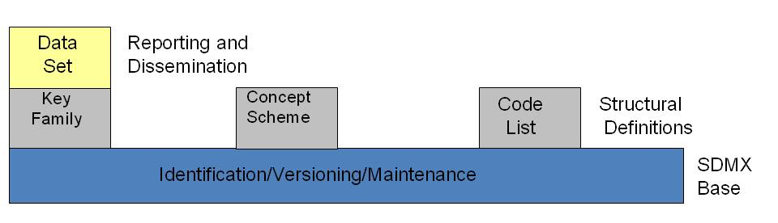
Figure 3: SDMX Information Model Version 1.0 package structure

Version 2.0/2.1
The version 2.0/2.1 model extends the functionality of version 1.0. principally in the area of metadata, but also in various ways to define structures to support data analysis by systems with knowledge of cube type structures such as OLAP systems. The following major constructs have been added at version 2.0/2.1

- Metadata structure definition
- Metadata set
- Hierarchical Codelist
- Data and Metadata Provisioning
- Process
- Mapping
- Constraints
- Constructs supporting the Registry
Furthermore, the term Data Structure Definition replaces the term Key Family: as both of these terms are used in various communities they are synonymous. The term Data Structure Definition is used in the model and this document.
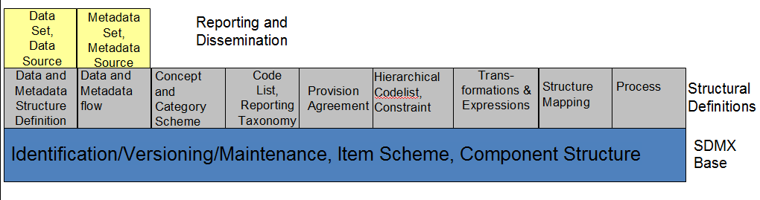
Figure 4 SDMX Information Model Version 2.0/2.1 package structure
Additional constructs that are specific to a registry based scenario can be found in the Specification of Registry Interfaces. For information these are shown on the diagram below and comprise:

- Subscription and Notification
- Registration
- Discovery
Note that the data and metadata required for registry functions are not confined to the registry, and the registry also makes use of the other packages in the Information Model.
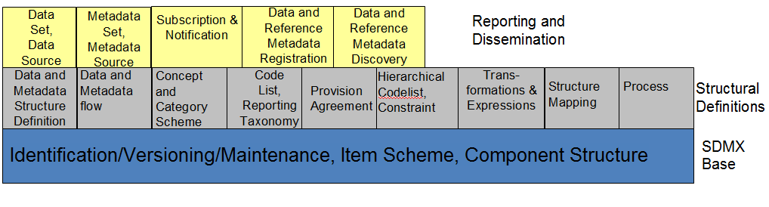
Figure 5: SDMX Information Model Version 2.0/2.1 package structure including the registry

Actors and Use Cases

Introduction
In order to develop the data models it is necessary to understand the functions to be supported resulting from the requirements definition. These are defined in a use case model. The use case model comprises actors and use cases and these are defined below.

Actor
“An actor defines a coherent set of roles that users of the system can play when interacting with it. An actor instance can be played by either an individual or an external system”

Use case
“A use case defines a set of use-case instances, where each instance is a sequence of actions a system performs that yields an observable result of value to a particular actor”

The overall intent of the model is to support data and metadata reporting, dissemination, and exchange in the field of aggregated statistical data and related metadata. In order to achieve this, the model needs to support three fundamental aspects of this process:

- Maintenance of structural and provisioning definitions
- Data and reference metadata publishing (reporting), and consuming (using)
- Access to data, reference metadata, and structural and provisioning definitions
This document covers the first two aspects, whilst the document on the Registry logical model covers the last aspect.

Use Case Diagrams

Maintenance of Structural and Provisioning Definitions

Use cases

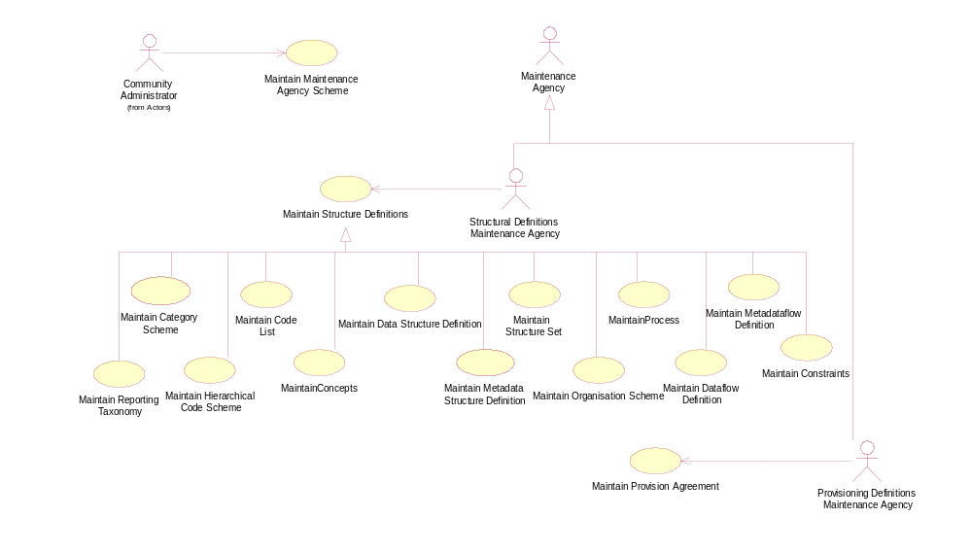
Figure 6 Use cases for maintaining data and metadata structural and provisioning definitions

Explanation of the Diagram
In order for applications to publish and consume data and reference metadata it is necessary for the structure and permitted content of the data and reference metadata to be defined and made available to the applications, as well as definitions that support the actual process of publishing and consuming. This is the responsibility of a Maintenance Agency.

All maintained artefacts are maintained by a Maintenance Agency. For convenience the Maintenance Agency actor is sub divided into two actor roles:

- maintaining structural definitions
- maintaining provisioning definitions
Whilst both these functions may be carried out by the same person, or at least by the same maintaining organization, the purpose of the definitions is different and so the roles have been differentiated: structural definitions define the format and permitted content of data and reference metadata when reported or disseminated, whilst provisioning definitions support the process of reporting and dissemination (who reports what to whom, and when).

In a community based scenario where at least the structural definitions may be shared, it is important that the scheme of maintenance agencies is maintained by a responsible organization (called here the Community Administrator), as it is important that the Id of the Maintenance Agency is unique.

Definitions
Actor | Use Case | Description
 |  | Responsible organisation that administers structural definitions common to the community as a whole.
 | 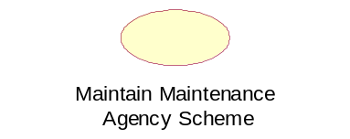 | Creation and maintenance of the top-level scheme of maintenance agencies for the Community.
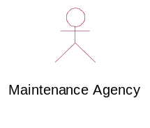 |  | Responsible agency for maintaining structural artefacts such as code lists, concept schemes, Data Structure Definition structural definitions, metadata structure definitions, data and metadata provisioning artefacts such as provision agreement, and sub-maintenance agencies.  sub roles are:  Structural Definitions Maintenance Agency  Provisioning Definitions Maintenance Agency
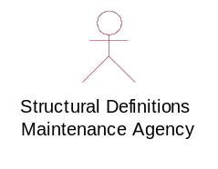 |  | Responsible for maintaining structural definitions.
 | 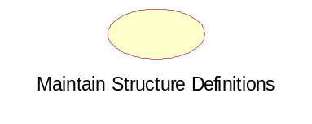 | The maintenance of structural definitions. This use case has sub class use cases for each of the structural artefacts that are maintained.
 | 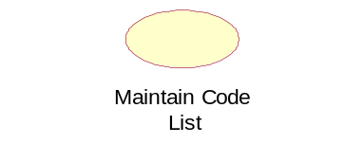  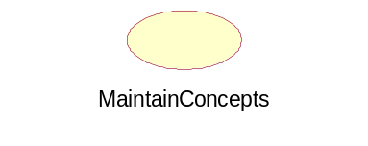  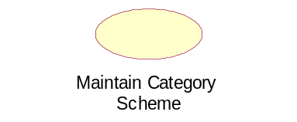  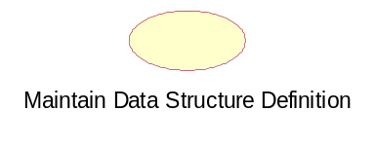  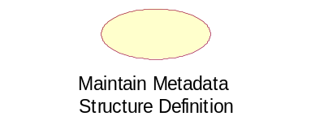  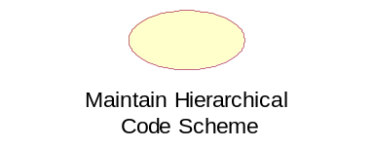  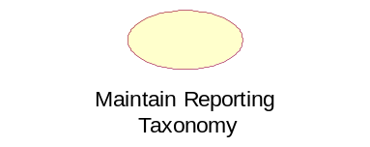  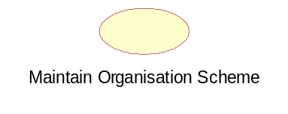  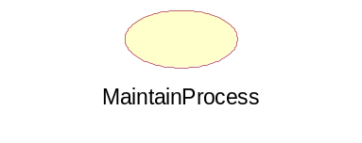  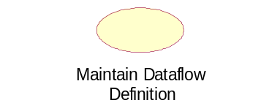  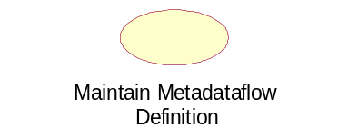 | Creation and maintenance of the Data Structure Definition, Metadata Structure Definition, and the supporting artefacts that they use, such as code list and concepts  This includes Agency, Data Provider, Data Consumer, and Organisation Unit Scheme
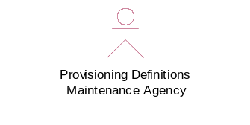 |  | Responsible for maintaining data and metadata provisioning definitions.
 | 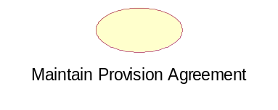 | The maintenance of provisioning definitions.
Figure 7: Table of Actors and Use Cases for Maintenance of Structural and Provisioning Definitions

Publishing and Using Data and Reference Metadata

Use Cases
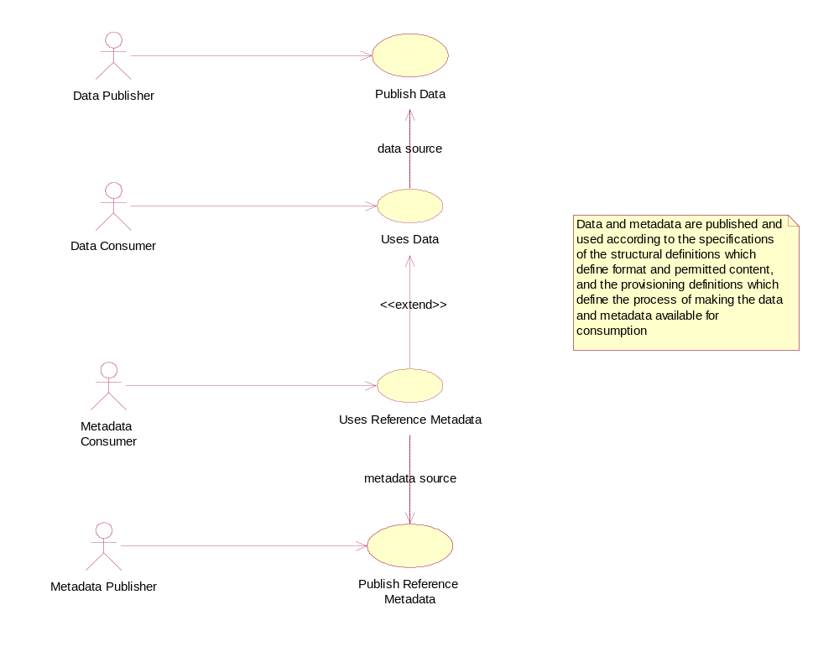
Figure 8: Actors and use cases for data and metadata publishing and consuming

Explanation of the Diagram
Note that in this diagram “publishing” data and reference metadata is deemed to be the same as “reporting” data and reference metadata. In some cases the act of making the data available fulfils both functions. Aggregated data is published and in order for the Data Publisher to do this and in order for consuming applications to process the data and reference metadata its structure must be known. Furthermore, consuming applications may also require access to reference metadata in order to present this to the Data Consumer so that the data is better understood. As with the data, the reference metadata also needs to be formatted in accordance with a maintained structure. The Data Consumer and Metadata Consumer cannot use the data or reference metadata unless it is “published” and so there is a “data source” or “metadata source” dependency between the “uses” and “publish” use cases.

In any data and reference metadata publishing and consuming scenario both the publishing and the consuming applications will need access to maintained Provisioning Definitions. These definitions may be as simple as who provides what data and reference metadata to whom, and when, or it can be more complex with constraints on the data and metadata that can be provided by a particular publisher, and, in a data sharing scenario where data and metadata are “pulled” from data sources, details of the source.

Definitions
Actor | Use Case | Description
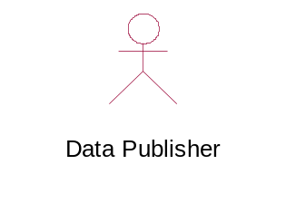 |  | Responsible for publishing data according to a specified Data Structure Definition (data structure) definition, and relevant provisioning definitions.
 | 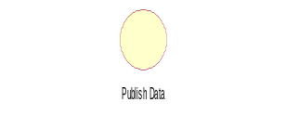 | Publish a data set. This could mean a physical data set or it could mean to make the data available for access at a data source such as a database that can process a query.
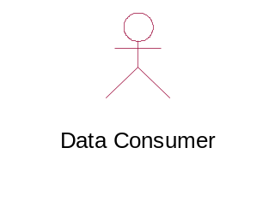 |  | The user of the data. It may be a human consumer accessing via a user interface, or it could be an application such as a statistical production system.
 | 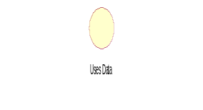 | Use data that is formatted according to the structural definitions and made available according to the provisioning definitions.  Data are often linked to metadata that may reside in a different location and be published and maintained independently.
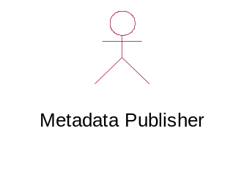 |  | Responsible for publishing reference metadata according to a specified metadata structure definition, and relevant provisioning definitions.
 |  | Publish a reference metadata set. This could mean a physical metadata set or it could mean to make the reference metadata available for access at a metadata source such as a metadata repository that can process a query.
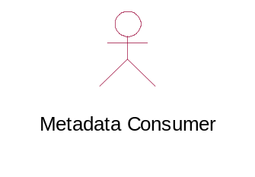 |  | The user of the reference metadata. It may be a human consumer accessing via a user interface, or it could be an application such as a statistical production or dissemination system.
 | 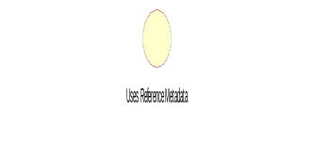 | Use reference metadata that is formatted according to the structural definitions and made available according to the provisioning definitions.

SDMX Base Package

Introduction
The constructs in the SDMX Base package comprise the fundamental building blocks that support many of the other structures in the model. For this reason, many of the classes in this package are abstract (i.e. only derived sub-classes can exist in an implementation).

The motivation for establishing the SDMX Base package is as follows:

- it is accepted “Best Practise” to identify fundamental archetypes occurring in a model
- identification of commonly found structures or “patterns” leads to easier understanding
- identification of patterns encourages re-use
Each of the class diagrams in this section views classes from the SDMX Base package from a different perspective. There are detailed views of specific patterns, plus overviews showing inheritance between classes, and relationships amongst classes.

Base Structures - Identification, Versioning, and Maintenance

Class Diagram

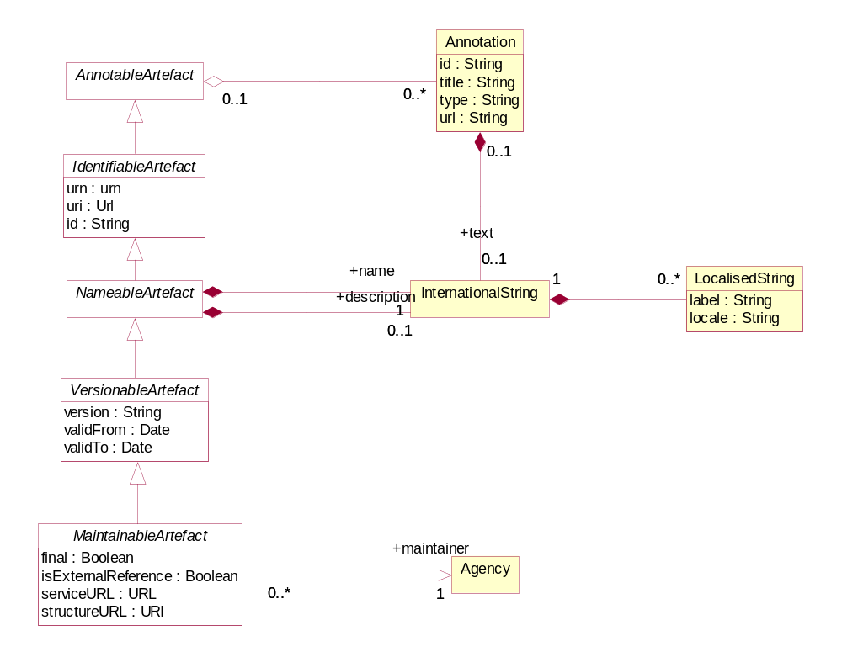
Figure 9: SDMX Identification, Maintenance and Versioning

Explanation of the Diagram

Narrative
This group of classes forms the nucleus of the administration facets of SDMX objects. They provide features which are reusable by derived classes to support horizontal functionality such as identity, versioning etc.

All classes derived from the abstract class AnnotableArtefact may have Annotations (or notes): this supports the need to add notes to all SDMX-ML elements. The Annotation is used to convey extra information to describe any SDMX construct. This information may be in the form of a URL reference and/or a multilingual text (represented by the association to InternationalString).

The IdentifiableArtefact is an abstract class that comprises the basic attributes needed for identification. Concrete classes based on IdentifiableArtefact all inherit the ability to be uniquely identified.

The NamableArtefact is an abstract class that inherits from IdentifiableArtefact and in addition the +description and +name roles support multilingual descriptions and names for all objects based on NameableArtefact. The InternationalString supports the representation of a description in multiple locales (locale is similar to language but includes geographic variations such as Canadian French, US English etc.). The LocalisedString supports the representation of a description in one locale.

VersionableArtefact is an abstract class which inherits from NameableArtefact and adds versioning ability to all classes derived from it.

MaintainableArtefact further adds the ability for derived classes to be maintained via its association to Agency, and adds locational information (i.e. from where the object can be retrieved). It is possible to define whether the artefact is draft or final with the final attribute.

The inheritance chain from AnnotableArtefact through to MaintainableArtefact allows SDMX classes to inherit the features they need, from simple annotation, through identity, naming, to versioning and maintenance.

Definitions
Class | Feature | Description
AnnotableArtefact | Base inheritance sub classes are:  IdentifiableArtefact | Objects of classes derived from this can have attached annotations.
Annotation |  | Additional descriptive information attached to an object.
 | id | Identifier for the Annotation. It can be used to disambiguate one Annotation from another where there are several Annotations for the same annotated object.
 | title | A title used to identify an annotation.
 | type | Specifies how the annotation is to be processed.
 | url | A link to external descriptive text.
 | +text | An International String provides the multilingual text content of the annotation via this role.
IdentifiableArtefact | Superclass is AnnotableArtefact  Base inheritance sub classes are:  NameableArtefact | Provides identity to all derived classes. It also provides annotations to derived classes because it is a subclass of Annotable Artefact.
 | id | The unique identifier of the object.
 | uri | Universal resource identifier that may or may not be resolvable.
 | urn | Universal resource name – this is for use in registries: all registered objects have a urn.
NameableArtefact | Superclass is IdentifiableArtefact  Base inheritance sub classes are:  VersionableArtefact | Provides a Name and Description to all derived classes in addition to identification and annotations.
 | +description | A multi-lingual description is provided by this role via the International String class.
 | +name | A multi-lingual name is provided by this role via the International String class
InternationalString |  | The International String is a collection of Localised Strings and supports the representation of text in multiple locales.
LocalisedString |  | The Localised String supports the representation of text in one locale (locale is similar to language but includes geographic variations such as Canadian French, US English etc.).
 | label | Label of the string.
 | locale | The geographic locale of the string e.g French, Canadian French.
VersionableArtefact | Superclass is NameableArtefact  Base inheritance sub classes are:  MaintainableArtefact | Provides versioning information for all derived objects.
 | version | A version string following an agreed convention
 | validFrom | Date from which the version is valid
 | validTo | Date from which version is superceded
MaintainableArtefact | Inherits from  VersionableArtefact | An abstract class to group together primary structural metadata artefacts that are maintained by an Agency.
 | final | Defines whether a maintained artefact is draft or final.
 | isExternalReference | If set to “true” it indicates that the content of the object is held externally.
 | structureURL | The URL of an SDMX-ML document containing the external object.
 | serviceURL | The URL of an SDMX-compliant web service from which the external object can be retrieved.
 | +maintainer | Association to the Maintenance Agency responsible for maintaining the artefact.
Agency |  | See section on “Organisations”

Basic Inheritance

Class Diagram– Basic Inheritance from the Base Inheritance Classes
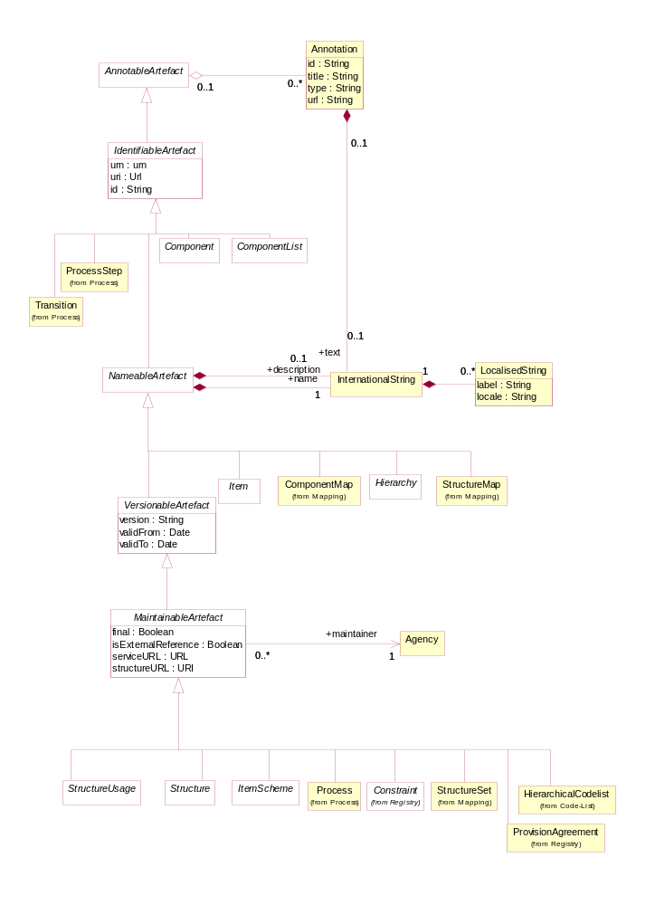
Figure 10: Basic Inheritance from the Base Structures

Explanation of the Diagram

Narrative
The diagram above shows the inheritance within the base structures. The concrete classes are introduced and defined in the specific package to which they relate.

Data Types

Class Diagram

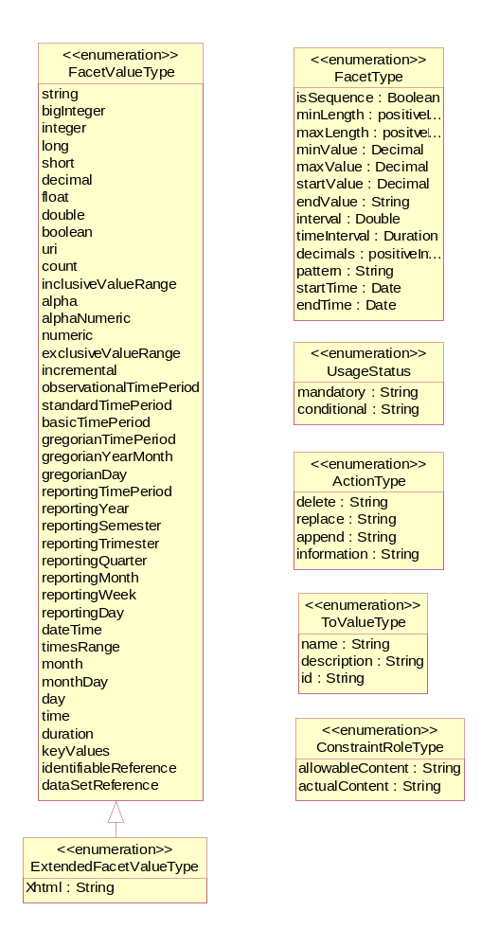
Figure 11: Class Diagram of Basic Data Types

Explanation of the Diagram

Narrative
The UsageStatus enumeration is used as a data type on a DataAttribute where the value of the attribute in an instance of the class must take one of the values in the UsageStatus (i.e. mandatory, conditional).

The FacetType and FacetValueType enumerations are used to specify the valid format of the content of a non enumerated Concept or the usage of a Concept when specified for use on a Component on a Structure (such as a Dimension in a DataStructureDefinition). The description of the various types can be found in the section on ConceptScheme (section 4.4).

The ActionType enumeration is used to specify the action that a receiving system should take when processing the content that is the object of the action. It is enumerated as follows:

- Append

Data or metadata is an incremental update for an existing data/metadata set or the provision of new data or documentation (attribute values) formerly absent. If any of the supplied data or metadata is already present, it will not replace that data or metadata. This corresponds to the "Update" value found in version 1.0 of the SDMX Technical Standards

- Replace

Data/metadata is to be replaced, and may also include additional data/metadata to be appended.

- Delete

Data/Metadata is to be deleted.

- Information

Data and metadata are for information purposes.

The IdentifiableObjectType enumeration is used to specify an object type whose class is a sub class of IdentifiableArtefact either directly of via NameableArtefact, VersionableArtefact or MaintainableArtefact.

The ToValueType data type contains the attributes to support transformations defined in the StructureMap (see Section 9).

The ConstraintRoleType data type contains the attributes that identify the purpose of a Constraint (allowableContent, actualContent).

The Item Scheme Pattern

Context
The Item Scheme is a basic architectural pattern that allows the creation of list schemes for use in simple taxonomies, for example.

The ItemScheme is the basis for CategoryScheme, Codelist, ConceptScheme, ReportingTaxonomy, and OrganisationScheme.

Class Diagram
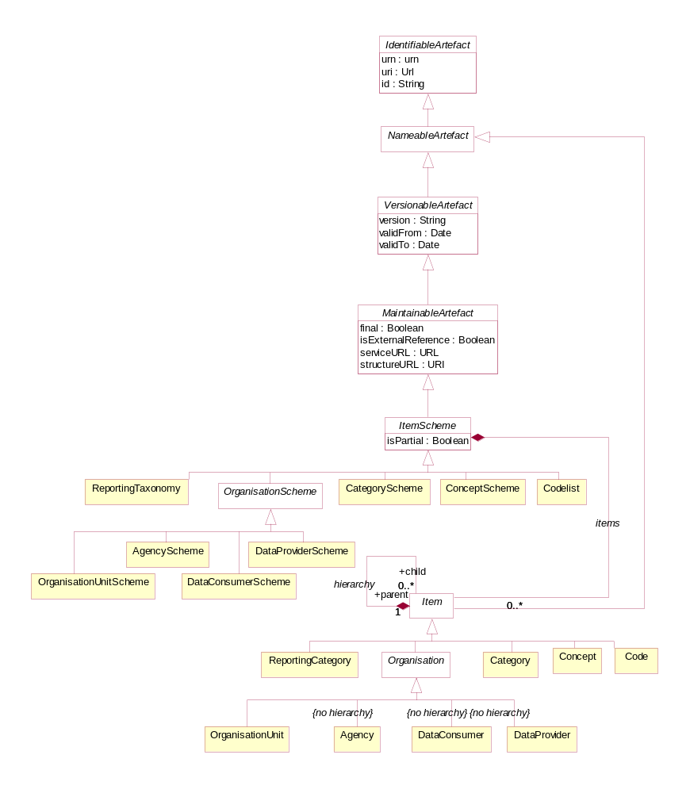
Figure 12 The Item Scheme pattern

Explanation of the Diagram

Narratve
The ItemScheme is an abstract class which defines a set of Item (this class is also abstract). Its main purpose is to define a mechanism which can be used to create taxonomies which can classify other parts of the SDMX Information Model. It is derived from MaintainableArtefact which gives it the ability to be annotated, have identity, naming, versioning and be associated with an Agency. An example of a concrete class is a CategoryScheme. The associated Category are Items.

In an exchange environment an ItemScheme is allowed to contain a sub-set of the Items in the maintained ItemScheme. If such an ItemScheme is disseminated with a sub-set of the Items then the fact that this is a sub-set is denoted by setting the isPartial attribute to “true”.

A “partial” ItemScheme cannot be maintained independently in its partial form i.e. it cannot contain Items that are not present in the full ItemScheme and the content of any one Item (e.g. names and descriptions) cannot deviate from the content in the full ItemScheme. Furthermore, the Id of the ItemScheme where isPartial is set to “true” is the same as the Id of the full ItemScheme (maintenance agency, id, version). This is important as this is the Id that that is referenced in other structures (e.g. a Codelist referenced in a DSD) and this Id is always the same, regardless of whether the disseminated ItemScheme is the full ItemScheme or a partial ItemScheme.

The purpose of a partial ItemScheme is to support the exchange and dissemination of a sub-set ItemScheme without the need to maintain multiple ItemSchemes which contain the same Items. For instance when a Codelist is used in a DataStructureDefinition it is sometimes the case that only a sub-set of the Codes in a Codelist are relevant. In this case a partial Codelist can be constructed using the Constraint mechanism explained later in this document.

Item inherits from NameableArtefact which gives it the ability to be annotated and have identity, and therefore has id, uri and urn attributes, a name and a description in the form of an InternationalString. Unlike the parent ItemScheme, the Item itself is not a MaintainableArtefact and therefore cannot have an independent Agency (i.e. it implicitly has the same agency as the ItemScheme).

The Item can be hierarchic and so one Item can have child Items. The restriction of the hierarchic association is that a child Item can have only parent Item.

Definitions
Class | Feature | Description
ItemScheme | Inherits from:  MaintainableArtefact  Direct sub classes are:  CategoryScheme  ConceptScheme  Codelist  ReportingTaxonomy  OrganisationScheme | The descriptive information for an arrangement or division of objects into groups based on characteristics, which the objects have in common.
 | isPartial | Denotes whether the Item Scheme contains a sub set of the full set of Items in the maintained scheme.
 | items | Association to the Items in the scheme.
Item | Inherits from:  NameableArtefact  Direct sub classes are  Category  Concept  Code  ReportingCategory  Organisation | The Item is an item of content in an Item Scheme. This may be a node in a taxonomy or ontology, a code in a code list etc.  Node that at the conceptual level the Organisation is not hierarchic
 | hierarchy | This allows an Item optionally to have one or more child Items.

The Structure Pattern

Context
The Structure Pattern is a basic architectural pattern which allows the specification of complex tabular structures which are often found in statistical data (such as Data Structure Definition, and Metadata Structure Definition). A Structure is a set of ordered lists. A pattern to underpin this tabular structure has been developed, so that commonalities between these structure definitions can be supported by common software and common syntax structures.

Class Diagrams
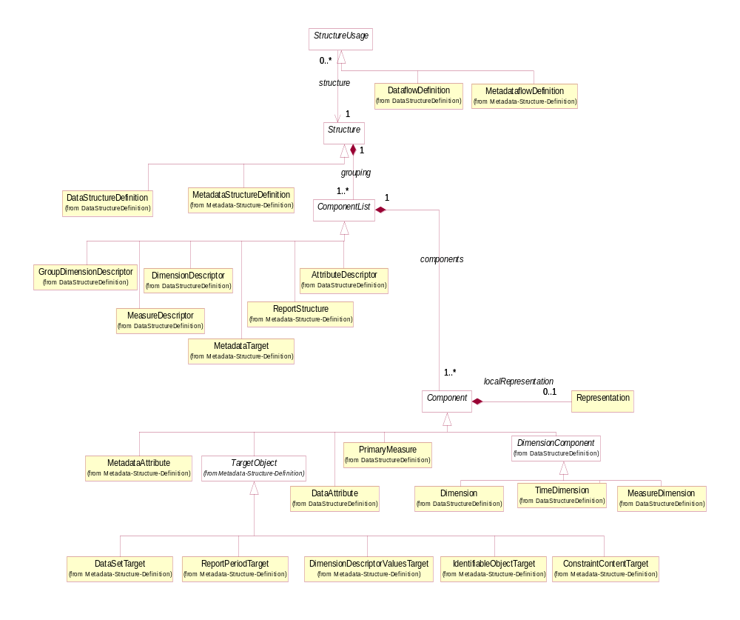
Figure 13: The Structure Pattern

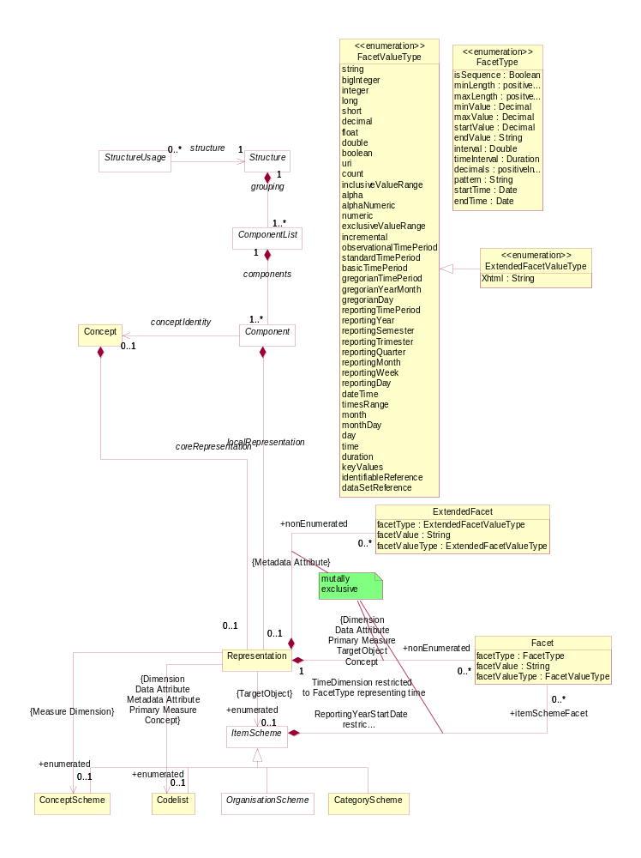
Figure 14: Representation within the Structure Pattern

Explanation of the Diagrams

Narrative
The Structure is an abstract class which contains a set of one or more ComponentList(s) (this class is also abstract). An example of a concrete Structure is DataStructureDefinition.

The ComponentList is a list of one or more Component(s). The ComponentList has several concrete descriptor classes based on it: DimensionDescriptor, GroupDimensionDescriptor, MeasureDescriptor, and AttributeDescriptor of the DataStructureDefinition and MetadataTarget, and ReportStructure of the MetaDataStructureDefinition.

The Component is contained in a ComponentList. The type of Component in a ComponentList is dependent on the concrete class of the ComponentList as follows:

DimensionDescriptor: Dimension, Measure Dimension, Time Dimension
GroupDimensionDescriptor: Dimension, Measure Dimension, Time Dimension
MeasureDescriptor: PrimaryMeasure
AttributeDescriptor: Data Attribute
MetadataTarget: TargetObject and its sub classes
ReportStructure: MetadataAttribute

Each Component takes its semantic (and possibly also its representation) from a Concept in a ConceptScheme. This is represented by the conceptIdentity association to Concept.

The Component may also have a localRepresentation, This allows a concrete class, such as Dimension, to specify its representation which is local to the Structure in which it is contained (for Dimension this will be DataStructureDefinition), and thus overrides any coreRepresentation specified for the Concept.

The Representation can be enumerated or non-enumerated. The valid content of an enumerated representation is specified either in an ItemScheme which can be one of ConceptScheme, Codelist, OrganisationScheme, CategoryScheme, and ReportingTaxonomy. The valid content of a non-enumerated representation is specified as one or more Facet (for example these may specify minimum and maximum values). For a MetadataAttribute this is achieved by one of more Extended Facet which allows the additional representation of XHTML.

The types of representation that are valid for specific components is expressed in the model as a constraint on the association viz:

- The MeasureDimension must be enumerated and use a ConceptScheme
- The Dimension (but not MeasureDimension), DataAttribute, PrimaryMeasure, MetadataAttribute may be enumerated and, if so, use a Codelist
- The TargetObject may be enumerated and, if so, can use any ItemScheme (Codelist, ConceptScheme, OrganisationScheme, CategoryScheme, ReportingTaxonomy)
- The Dimension (but not MeasureDimension), Data Attribute, PrimaryMeasure, TargetObject may be non-enumerated and, if so, use one of more Facet, note that the FacetValueType applicable to the TimeDimension is restricted to those that represent time
- The MetadataAttribute may be non-enumerated and, if so, uses one or more ExtendedFacet

The Structure may be used by one or more StructureUsage. An example of this in terms of concrete classes is that a DataflowDefinition (sub class of StructureUsage) may use a particular DataStructureDefinition (sub class of Structure), and similar constructs apply for the MetadataflowDefinition (link to MetadataStructureDefinition).

Definitions
Class | Feature | Description
StructureUsage | Inherits from:  MaintainableArtefact  Sub classes are:  DataflowDefinition  MetadataflowDefinition | An artefact whose components are described by a Structure. In concrete terms (sub-classes) an example would be a Dataflow Definition which is linked to a given structure – in this case the Data Structure Definition.
 | structure | An association to a Structure specifying the structure of the artefact.
Structure | Inherits from:  MaintainableArtefact  Sub classes are:  DataStructure  Definition  MetadataStructure Definition | Abstract specification of a list of lists to define a complex tabular structure. A concrete example of this would be statistical concepts, code lists, and their organisation in a data or metadata structure definition, defined by a centre institution, usually for the exchange of statistical information with its partners.
 | grouping | A composite association to one or more component lists.
ComponentList | Inherits from:  IdentifiableArtefact  Sub classes are:  DimensionDescriptor  GroupDimension  Descriptor  MeasureDescriptor  AttributeDescriptor  MetadataTarget  ReportStructure | An abstract definition of a list of components. A concrete example is a Dimension Descriptor which defines the list of Dimensions in a Data Structure Definition.
 | components | An aggregate association to one or more components which make up the list.
Component | Inherits from:  IdentifiableArtefact  Sub classes are:  PrimaryMeasure  DataAttribute  DimensionComponent  TargetObject  MetadataAttribute | A component is an abstract super class used to define qualitative and quantitative data and metadata items that belong to a Component List and hence a Structure. Component is refined through its sub-classes.
 | conceptIdentity | Association to a Concept in a Concept Scheme that identifies and defines the semantic of the Component
 | localRepresentation | Association to the Representation of the Component if this is different from the coreRepresentation of the Concept which the Component uses (ConceptUsage)
Representation |  | The allowable value or format for Component or Concept
 | +enumerated | Association to an enumerated list that contains the allowable content for the Component when reported in a data or metadata set. The type of enumerated list that is allowed for any concrete Component is shown in the constraints on the association (e.g. Identifier Component can have any of the sub classes of Item Scheme, whereas Measure Dimension must have a Concept Scheme).
 | +nonEnumerated | Association to a set of Facets that define the allowable format for the content of the Component when reported in a data or metadata set.
Facet |  | Defines the format for the content of the Component when reported in a data or metadata set.
 | facetType | A specific content type which is constrained by the FacetType enumeration
 | facetValueType | The format of the value of a Component when reported in a data or metadata set. This is contrained by the FacetValueType enumeration.
 | +itemSchemeFacet | Defines the format of the identifiers in an Item Scheme used by a Component. Typically this would define the number of characters (length) of the identifier.
ExtendedFacet |  | This has the same function as Facet but allows additionally an XHTML representation. This is constrained for use with a Metadata Attribute

The specification of the content and use of the sub classes to ComponentList and Component can be found in the section in which they are used (DataStructureDefinition and MetadataStructureDefinition)

Representation Constructs
The majority of SDMX FacetValueTypes are compatible with those found in XML Schema, and have equivalents in most current implementation platforms:

SDMX Facet Value Type | XML Schema Data Type | .NET Framework Type | Java Data Type
String | xsd:string | System.String | java.lang.String
Big Integer | xsd:integer | System.Decimal | java.math.BigInteger
Integer | xsd:int | System.Int32 | int
Long | xsd.long | System.Int64 | long
Short | xsd:short | System.Int16 | short
Decimal | xsd:decimal | System.Decimal | java.math.BigDecimal
Float | xsd:float | System.Single | float
Double | xsd:double | System.Double | double
Boolean | xsd:boolean | System.Boolean | boolean
URI | xsd:anyURI | System.Uri | Java.net.URI or java.lang.String
DateTime | xsd:dateTime | System.DateTime | javax.xml.datatype.XMLGregorianCalendar
Time | xsd:time | System.DateTime | javax.xml.datatype.XMLGregorianCalendar
GregorianYear | xsd:gYear | System.DateTime | javax.xml.datatype.XMLGregorianCalendar
GregorianMonth | xsd:gYearMonth | System.DateTime | javax.xml.datatype.XMLGregorianCalendar
GregorianDay | xsd:date | System.DateTime | javax.xml.datatype.XMLGregorianCalendar
Day, MonthDay, Month | xsd:g* | System.DateTime | javax.xml.datatype.XMLGregorianCalendar
Duration | xsd:duration | System.TimeSpan | javax.xml.datatype.Duration

There are also a number of SDMX data types which do not have these direct correspondences, often because they are composite representations or restrictions of a broader data type. These are detailed in Section 6 of the standards.

The Representation is composed of Facets, each of which conveys characteristic information related to the definition of a value domain. Often a set of Facets are needed to convey the required semantic. For example, a sequence is defined by a minimum of two Facets: one to define the start value, and one to define the interval.

Facet Type | Explanation
isSequence | The isSequence facet indicates whether the values are intended to be ordered, and it may work in combination with the interval, startValue, and endValue facet or the timeInterval, startTime, and endTime, facets. If this attribute holds a value of true, a start value or time and a numeric or time interval must supplied. If an end value is not given, then the sequence continues indefinitely.
interval | The interval attribute specifies the permitted interval (increment) in a sequence. In order for this to be used, the isSequence attribute must have a value of true.
startValue | The startValue facet is used in conjunction with the isSequence and interval facets (which must be set in order to use this facet). This facet is used for a numeric sequence, and indicates the starting point of the sequence. This value is mandatory for a numeric sequence to be expressed.
endValue | The endValue facet is used in conjunction with the isSequence and interval facets (which must be set in order to use this facet). This facet is used for a numeric sequence, and indicates that ending point (if any) of the sequence.
timeInterval | The timeInterval facet indicates the permitted duration in a time sequence. In order for this to be used, the isSequence facet must have a value of true.
startTime | The startTime facet is used in conjunction with the isSequence and timeInterval facets (which must be set in order to use this facet). This attribute is used for a time sequence, and indicates the start time of the sequence. This value is mandatory for a time sequence to be expressed.
endTime | The endTime facet is used in conjunction with the isSequence and timeInterval facets (which must be set in order to use this facet). This facet is used for a time sequence, and indicates that ending point (if any) of the sequence.
minLength | The minLength facet specifies the minimum and length of the value in characters.
maxLength | The maxLength facet specifies the maximum length of the value in characters.
minValue | The minValue facet is used for inclusive and exclusive ranges, indicating what the lower bound of the range is. If this is used with an inclusive range, a valid value will be greater than or equal to the value specified here. If the inclusive and exclusive data type is not specified (e.g. this facet is used with an integer data type), the value is assumed to be inclusive.
maxValue | The maxValue facet is used for inclusive and exclusive ranges, indicating what the upper bound of the range is. If this is used with an inclusive range, a valid value will be less than or equal to the value specified here. If the inclusive and exclusive data type is not specified (e.g. this facet is used with an integer data type), the value is assumed to be inclusive.
decimals | The decimals facet indicates the number of characters allowed after the decimal separator.
pattern | The pattern attribute holds any regular expression permitted in the implementation syntax (e.g. W3C XML Schema).

Specific Item Schemes

Introduction
The structures that are an arrangement of objects into hierarchies or lists based on characteristics, and which are maintained as a group inherit from ItemScheme. These concrete classes are:

- Codelist
- ConceptScheme
- CategoryScheme
- AgencyScheme, DataProviderScheme, DataConsumerScheme, OrganisationUnitScheme which all inherit from the abstract class OrganisationScheme
- Reporting Taxonomy

Inheritance View
The inheritance and relationship views are shown together in each of the diagrams in the specific sections below.

Codelist

Class Diagram

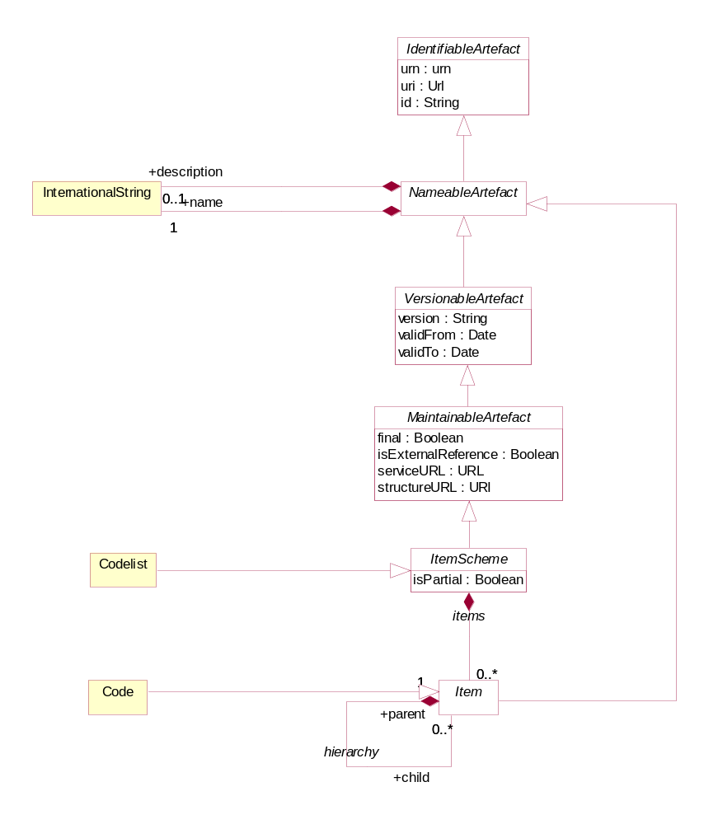
Figure 15 Class diagram of the Codelist

Explanation of the Diagram

Narrative
The Codelist inherits from the ItemScheme and therefore has the following attributes:

- id
- uri
- urn
- version
- validFrom
- validTo
- isExternalReference
- serviceURL
- structureURL
- final
- isPartial
The Code inherits from Item and has the following attributes:

- id
- uri
- urn
Both Codelist and Code have the association to InternationalString to support a multi-lingual name, an optional multi-lingual description, and an association to Annotation to support notes (not shown).

Through the inheritance the Codelist comprise one or more Codes, and the Code itself can have one or more child Codes in the (inherited) hierarchy association. Note that a child Code can have only one parent Code in this association. A more complex HierachicalCodelist which allow multiple parents and multiple hierarchies is described later.

A partial Codelist (where isPartial is set to “true”) is identical to a Codelist and contains the Code and associated names and descriptions, just as in a normal code list. However, its content is a sub set of the full Codelist. The way this works is described in section 3.5.3.1 on ItemScheme.

Definitions
Class | Feature | Description
Codelist | Inherits from  ItemScheme | A list from which some statistical concepts (coded concepts) take their values.
Code | Inherits from  Item | A language independent set of letters, numbers or symbols that represent a concept whose meaning is described in a natural language.
 | /hierarchy | Associates the parent and the child codes.

Concept Scheme and Concepts

Class Diagram - Inheritance

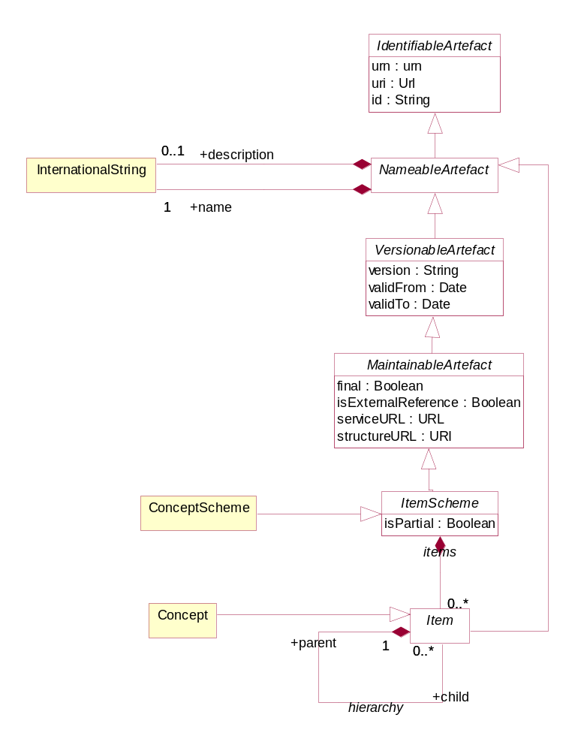
Figure 16 Class diagram of the Concept Scheme

Explanation of the Diagram
The ConceptScheme inherits from the ItemScheme and therefore has the following attributes:

- id
- uri
- urn
- version
- validFrom
- validTo
- isExternalReference
- registryURL
- structureURL
- repositoryURL
- final
- isPartial
Concept inherits from Item and has the following attributes:

- id
- uri
- urn
Through the inheritance from NameableArtefact both ConceptScheme and Concept have the association to InternationalString to support a multi-lingual name, an optional multi-lingual description, and an association to Annotation to support notes (not shown).

Through the inheritance from ItemScheme the ConceptScheme comprise one or more Concepts, and the Concept itself can have one or more child Concepts in the (inherited) hierarchy association. Note that a child Concept can have only one parent Concept in this association.

A partial ConceptScheme (where isPartial is set to “true”) is identical to a ConceptScheme and contains the Concept and associated names and descriptions, just as in a normal ConceptScheme. However, its content is a sub set of the full ConceptScheme. The way this works is described in section 3.5.3.1 on ItemScheme.

Class Diagram - Relationship
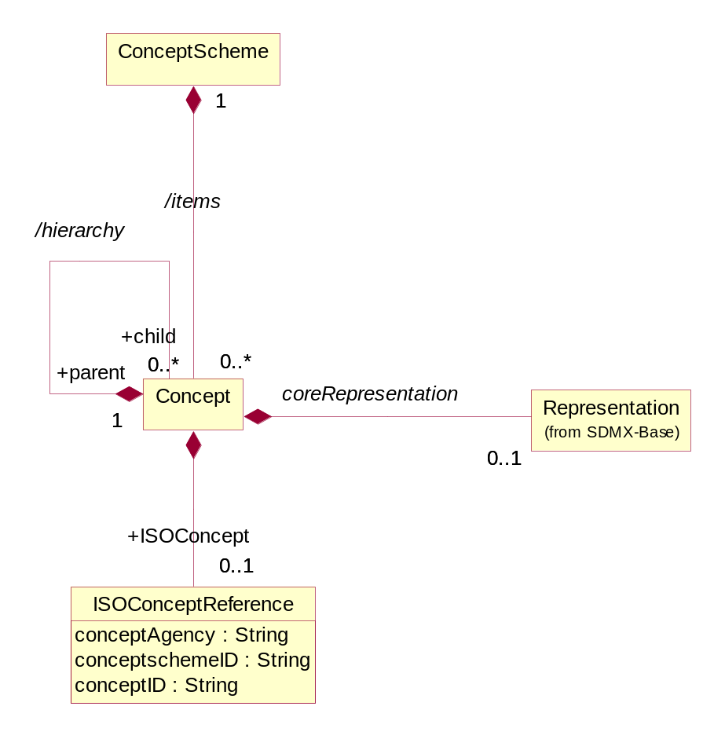
Figure 17: Relationship class diagram of the Concept Scheme

Explanation of the diagram

Narrative
The ConceptScheme can have one or more Concepts. A Concept can have zero or more child Concepts, thus supporting a hierarchy of Concepts. Note that a child Concept can have only one parent Concept in this association. The purpose of the hierarchy is to relate concepts that have a semantic relationship: for example a Reporting_Country and Vis_a_Vis_Country may both have Country as a parent concept, or a CONTACT may have a PRIMARY_CONTACT as a child concept. It is not the purpose of such schemes to define reporting structures: these reporting structures are defined in the MetadataStructureDefinition.

The Concept can be associated with a coreRepresentation. The coreRepresentation is the specification of the format and value domain of the Concept when used on a structure like a DataStructureDefinition or a MetadataStructureDefinition, unless the specification of the Representation is overridden in the relevant structure definition. In a hierarchical ConceptScheme the Representation is inherited from the parent Concept unless overridden at the level of the child Concept.

Note that the ConceptScheme is used as the Representation of the MeasureDimension in a DataStructureDefinition (see 5.3.2). Each Concept in this ConceptScheme is a specific measure, each of which can be given a coreRepresentation. Thus the valid format of the observation for each measure when reported in a data set for the MeasureDimension is specified in the Concept. This allows a different format for each measure. This is covered in more detail in 5.3.

The Representation is documented in more detail in the section on the SDMX Base.

The Concept may be related to a concept described in terms of the ISO/IEC 11179 standard. The ISOConceptReference identifies this concept and concept scheme in which it is contained.

Definitions
Class | Feature | Description
ConceptScheme | Inherits from  ItemScheme | The descriptive information for an arrangement or division of concepts into groups based on characteristics, which the objects have in common.
Concept | Inherits from  Item | A concept is a unit of knowledge created by a unique combination of characteristics.
 | /hierarchy | Associates the parent and the child concept.
 | coreRepresentation | Associates a Representation.
 | +ISOConcept | Association to an ISO concept reference.
ISOConceptReference |  | The identity of an ISO concept definition.
 | conceptAgency | The maintenance agency of the concept scheme containing the concept.
 | conceptSchemeID | The identifier of the concept scheme.
 | conceptID | The identifier of the concept.

Category Scheme

Context
This package defines the structure that supports the definition of and relationships between categories in a category scheme. It is similar to the package for concept scheme. An example of a category scheme is one which categorises data – sometimes known as a subject matter domain scheme or a data category scheme. Importantly, as will be seen later, the individual nodes in the scheme (the “categories”) can be associated to any set of IdentiableArtefacts in a Categorisation.

Class diagram - Inheritance
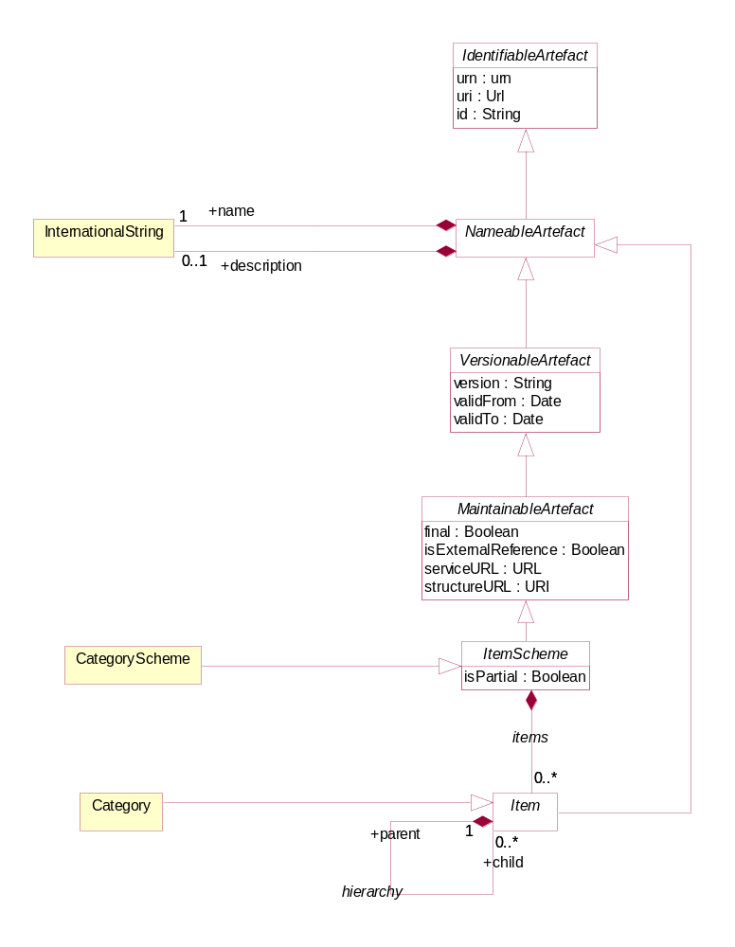
Figure 18 Inheritance Class diagram of the Category Scheme

Explanation of the Diagram

Narrative
The categories are modelled as a hierarchical ItemScheme. The CategoryScheme inherits from the ItemScheme and has the following attributes:

- id
- uri
- urn
- version
- validFrom
- validTo
- isExternalReference
- structureURL
- serviceURL
- final
- isPartial
Category inherits from Item and has the following attributes:

- id
- uri
- urn
Both CategoryScheme and Category have the association to InternationalString to support a multi-lingual name, an optional multi-lingual description, and an association to Annotation to support notes (not shown on the model).

Through the inheritance the CategoryScheme comprise one or more Categorys, and the Category itself can have one or more child Category in the (inherited) hierarchy association. Note that a child Category can have only one parent Category in this association.

A partial CategoryScheme (where isPartial is set to “true”) is identical to a CategoryScheme and contains the Category and associated names and descriptions, just as in a normal CategoryScheme. However, its content is a sub set of the full CategoryScheme. The way this works is described in section 3.5.3.1 on ItemScheme.

Class diagram - Relationship
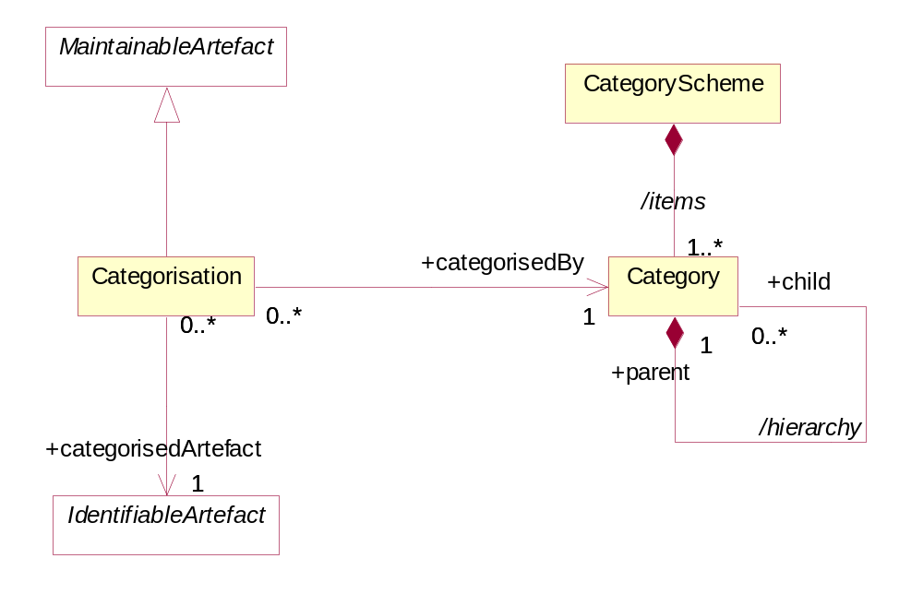
Figure 19: Relationship Class diagram of the Category Scheme
The CategoryScheme can have one or more Categorys. The Category is Identifiable and has identity information. A Category can have zero or more child Categorys, thus supporting a hierarchy of Categorys. Any IdentifiableArtefact can be +categorisedBy a Category. This is achieved by means of a Categorisation. Each Categorisation can associate one IdentifiableArtefact with one Category. Multiple Categorisations can be used to build a set of IdentifiableArtefacts that are +categorisedBy the same Category. Note that there is no navigation (i.e. no embedded reference) to the Categorisation from the Category. From an implementation perspective this is necessary as Categorisation has no affect on the versioning of either the Category or the IdentifiableArtefact.

Definitions
Class | Feature | Description
CategoryScheme | Inherits from  ItemScheme | The descriptive information for an arrangement or division of categories into groups based on characteristics, which the objects have in common.
 | /items | Associates the categories.
Category | Inherits from  Item | An item at any level within a classification, typically tabulation categories, sections, subsections, divisions, subdivisions, groups, subgroups, classes and subclasses.
 | /hierarchy | Associates the parent and the child Category.
Categorisation | Inherits from  MaintainableArtefact | Associates an IdentifableArtefact with a Category.
 | +categorisedArtefact | Associates the IdentifableArtefact.
 | +categorisedBy | Associates the Category.

Organisation Scheme

Class Diagram

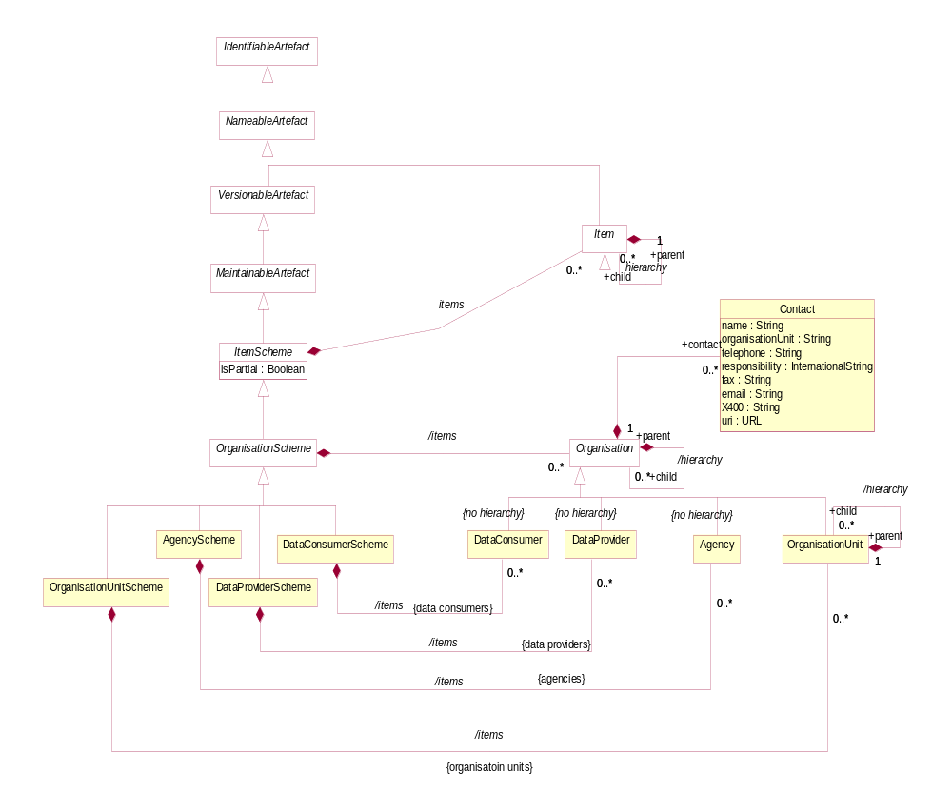
Figure 20 The Organisation Scheme class diagram

Explanation of the Diagram

Narrative
The OrganisationScheme is abstract. It contains Organisation which is also abstract. The Organisation can have child Organisation.

The OrganisationScheme can be one of four types:

- AgencyScheme – contains Agency which is restricted to a flat list of agencies (i.e. there is no hierarchy). Note that the SDMX system of (Maintenance) Agency can be hierarchic and this is explained in more detail in the separate document “Technical Notes”.
- DataProviderScheme – contains DataProvider which is restricted to a flat list of agencies (i.e. there is no hierarchy).
- DataConsumerScheme – contains DataConsumer which is restricted to a flat list of agencies (i.e. there is no hierarchy).
- OrganisationUnitScheme – contains OrganisationUnit which does inherit the /hierarchy association from Organisation.

Reference metadata can be attached to the Organisation by means of the metadata attachment mechanism. This mechanism is explained in the Reference Metadata section of this document (see section 7). This means that the model does not specify the specific reference metadata that can be attached to a DataProvider, DataConsumer,OrganisationUnit or Agency, except for limited Contact information.

A partial OrganisationScheme (where isPartial is set to “true”) is identical to a OrganisationScheme and contains the Organisation and associated names and descriptions, just as in a normal OrganisationScheme However, its content is a sub set of the full OrganisationScheme. The way this works is described in section 3.5.3.1 on ItemScheme.

Definitions
Class | Feature | Description
OrganisationScheme | Abstract Class  Inherits from  ItemScheme  Sub classes are:  AgencyScheme  DataProviderScheme  DataConsumerScheme  OrganisationUnitScheme | A maintained collection of Organisations.
 | /items | Association to the Organisations in the scheme.
Organisation | Inherits from  Item  Sub classes are:  Agency  DataProvider  DataConsumer  OrganisationUnit | An organisation is a unique framework of authority within which a person or persons act, or are designated to act, towards some purpose.
 | +contact | Association to the Contact information.
 | /hierarchy | Association to child Organisations.
Contact |  | An instance of a role of an individual or an organization (or organization part or organization person) to whom an information item(s), a material object(s) and/or person(s) can be sent to or from in a specified context.
 | name | The designation of the Contact person by a linguistic expression.
 | organisationUnit | The designation of the organisational structure by a linguistic expression, within which Contact person works.
 | responsibility | The function of the contact person with respect to the organisation role for which this person is the Contact.
 | telephone | The telephone number of the Contact.
 | fax | The fax number of the Contact.
 | email | The Internet e-mail address of the Contact.
 | X400 | The X400 address of the Contact.
 | uri | The URL address of the Contact.
AgencyScheme |  | A maintained collection of Maintenace Agencies.
 | /items | Association to the Maintenance Agency in the scheme.
DataProviderScheme |  | A maintained collection of Data Providers.
 | /items | Association to the Data Providers in the scheme.
DataConsumerScheme |  | A maintained collection of Data Consumers.
 | /items | Association to the Data Consumers in the scheme.
OrganisationUnitScheme |  | A maintained collection of Organisation Units.
 | /items | Association to the Organisation Units in the scheme.
Agency | Inherits from  Organisation | Responsible agency for maintaining artefacts such as statistical classifications, glossaries, structural metadata such as Data and Metadata Structure Definitions, Concepts and Code lists.
DataProvider | Inherits from  Organisation | An organisation that produces data or reference metadata.
DataConsumer | Inherits from  Organisation | An organisation using data as input for further processing.
OrganisationUnit | Inherits from  Organisation | A designation in the organisational structure.
 | /hierarchy | Association to child Organisation Units

Reporting Taxonomy

Class Diagram
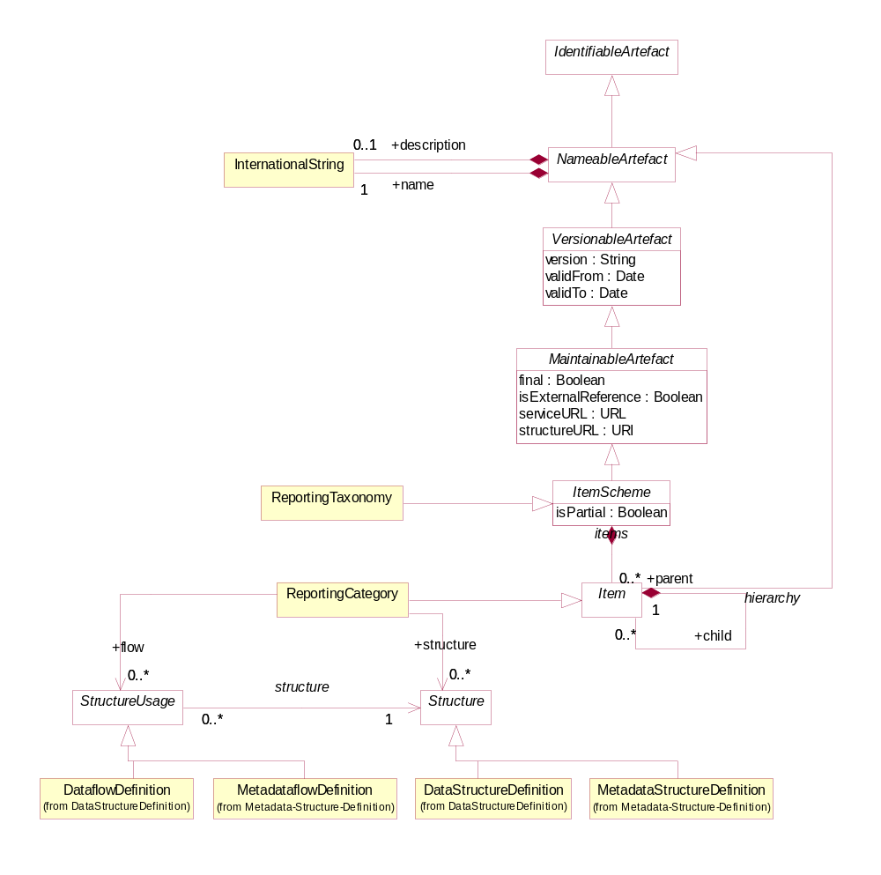
Figure 21: Class diagram of the Reporting Taxonomy

Explanation of the Diagram

Narrative
In some data reporting environments, and in particular those in primary reporting, a report may comprise a variety of heterogeneous data, each described by a different Structure. Equally, a specific disseminated or published report may also comprise a variety of heterogeneous data. The definition of the set of linked sub reports is supported by the ReportingTaxonomy.

The ReportingTaxonomy is a specialised form of ItemScheme. Each ReportingCategory of the ReportingTaxonomy can link to one or more StructureUsage which itself can be one of DataflowDefinition, or MetadataflowDefinition, and one or more Structure, which itself can be one of DataStructureDefinition or MetadataStructureDefinition. It is expected that within a specific ReportingTaxonomy each Category that is linked in this way will be linked to the same class (e.g. all Category in the scheme will link to a DataflowDefinition). Note that a ReportingCategory can have child ReportingCategory and in this way it is possible to define a hierarchical ReportingTaxonomy. It is possible in this taxonomy that some ReportingCategory are defined just to give a reporting structure. For instance:

Section 1
1. linked to DatafowDefinition_1
2 linked to DatafowDefinition_2
Section 2
1 linked toDatafowDefinition_3
2 linked to DatafowDefinition_4

Here, the nodes of Section 1 and Section 2 would not be linked to DataflowDefinition but the other would be linked to a DataflowDefinition (and hence the DataStructureDefinition).

A partial ReportingTaxonomy (where isPartial is set to “true”) is identical to a ReportingTaxonomy and contains the ReportingCategory and associated names and descriptions, just as in a normal ReportingTaxonomy However, its content is a sub set of the full ReportingTaxonomy The way this works is described in section 3.5.3.1 on ItemScheme.

Definitions
Class | Feature | Description
ReportingTaxonomy | Inherits from  ItemScheme | A scheme which defines the composition structure of a data report where each component can be described by an independent Dataflow Definition or Metdataflow Definition.
 | items | Associates the Reporting Category
ReportingCategory | Inherits from  Item | A component that gives structure to the report and links to data and metadata.
 | hierarchy | Associates child Reporting Category.
 | +flow | Association to the data and metadata flows that link to metadata about the provisioning and related data and metadata sets, and the structures that define them.
 | +structure | Association to the Data Structure Definition and Metadata Structure Definitions which define the structural metadata describing the data and metadata that are contained at this part of the report.

Data Structure Definition and Dataset

Introduction
The DataStructureDefiniton is the class name for a structure definition for data. Some organisations know this type of definition as a “Key Family” and so the two names are synonymous. The term Data Structure Definition (also referred to as DSD) is used in this specification.

Many of the constructs in this layer of the model inherit from the SDMX Base Layer. Therefore, it is necessary to study both the inheritance and the relationship diagrams to understand the functionality of individual packages. In simple sub models these are shown in the same diagram, but are omitted from the more complex sub models for the sake of clarity. In these cases, the inheritance diagram below shows the full inheritance tree for the classes concerned with data structure definitions.

There are very few additional classes in this sub model other than those shown in the inheritance diagram below. In other words, the SDMX Base gives most of the structure of this sub model both in terms of associations and in terms of attributes. The relationship diagrams shown in this section show clearly when these associations are inherited from the SDMX Base (see the Appendix “A Short Guide to UML in the SDMX Information Model” to see the diagrammatic notation used to depict this).

The actual SDMX Base construct from which the concrete classes inherit depends upon the requirements of the class for:

- Annotation - AnnotableArtefact
- Identification - IdentifiableArtefact
- Naming - NameableArtefact
- Versioning – VersionableArtefact
- Maintenance - MaintainableArtefact

Inheritance View

Class Diagram

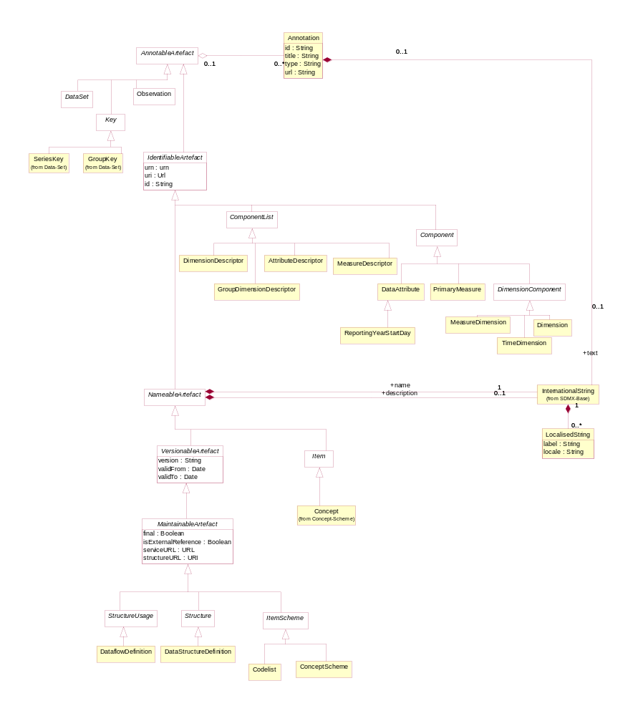
Figure 22 Class inheritance in the Data Structure Definition and Data Set Packages

Explanation of the Diagram

Narrative
Those classes in the SDMX metamodel which require annotations inherit from AnnotableArtefact . These are:

- IdentifiableArtefact
- DataSet (and therefore StructureSpecificDataSet, GenericDataSet, GenericTimeSeriesDataSet StructureSpecificTimeSeriesDataSet)
- Key (and therefore SeriesKey and GroupKey)
Those classes in the SDMX metamodel which require annotations and global identity are derived from IdentifiableArtefact . These are:

- NameableArtefact
- ComponentList
- Component
Those classes in the SDMX metamodel which require annotations, global identity, multilingual name and multilingual description are derived from NameableArtefact . These are:

- VersionableArtefact
- Item
The classes in the SDMX metamodel which require annotations, global identity, multilingual name and multilingual description, and versioning are derived from VersionableArtefact . These are:

- MaintainableArtefact
Abstract classes which represent information that is maintained by Maintenance Agencies all inherit from MaintainableArtefact, they also inherit all the features of a VersionableArtefact, and are:

- StructureUsage
- Structure
- ItemScheme
All the above classes are abstract. The key to understanding the class diagrams presented in this section are the concrete classes that inherit from these abstract classes.

Those concrete classes in the SDMX Data Structure Definition and Dataset packages of the metamodel which require to be maintained by Agencies all inherit (via other abstract classes) from MaintainableArtefact, these are:

- DataflowDefinition
- DataStructureDefinition
The component structures that are lists of lists, inherit directly from Structure. A Structure contains several lists of components. The concrete class that inherits from Structure is:
- DataStructureDefinition
A DataStructureDefinition contains a list of dimensions, a list of measures and a list of attributes.

The concrete classes which inherit from ComponentList and are sub components of the DataStructureDefinition are:

- DimensionDescriptor – content is Dimension, MeasureDimension and Time Dimension
- DimensionGroupDescriptor – content is an association to Dimension, MeasureDimension, TimeDimension
- MeasureDescriptor – content is PrimaryMeasure
- AttributeDescriptor – content is DataAttribute
The classes that inherit from Component are:

- PrimaryMeasure
- DimensionComponent and thereby its sub classes of Dimension, MeasureDimension, and TimeDimension

- DataAttribute
The class that inherit from DataAttribute is:

- ReportingYearStartDay

The concrete classes identified above are the majority of the classes required to define the metamodel for the DataStructureDefinition. The diagrams and explanations in the rest of this section show how these concrete classes are related in order to support the functionality required.

Data Structure Definition – Relationship View

Class Diagram
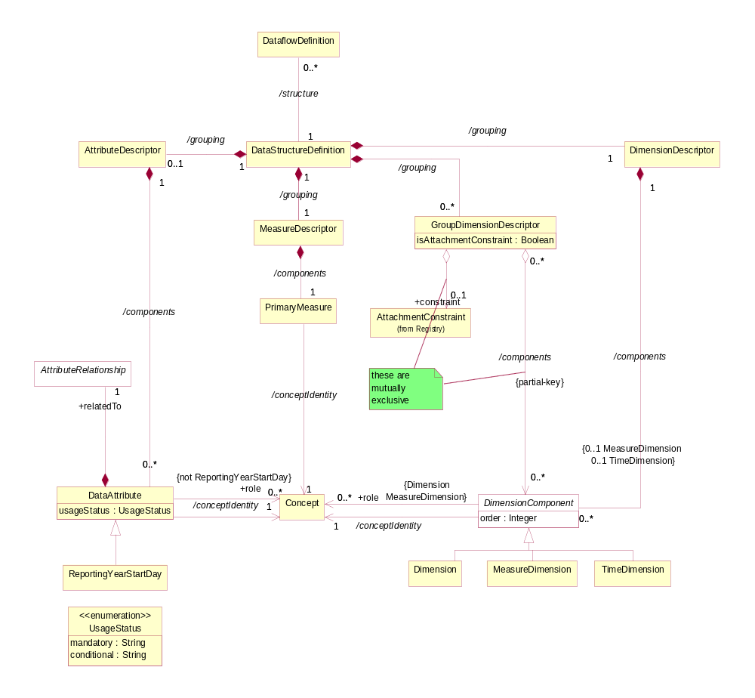

Figure 23 Relationship class diagram of the Data Structure Definition excluding representation

Explanation of the Diagrams

Narrative
A DataStructureDefinition defines the Dimensions, MeasureDimension, TimeDimension, DataAttributes, and PrimaryMeasure, and associated Representation that comprise the valid structure of data and related attributes that are contained in a DataSet, which is defined by a DataflowDefinition.

The DataflowDefinition may also have additional metadata attached that defines qualitative information and Constraints on the use of the DataStructureDefinition such as the sub set of Codes used in a Dimension (this is covered later in this document – see “Data Constraints and Provisioning” section 9). Each DataflowDefinition has a maximum of one DataStructureDefinition specified which defines the structure of any DataSets to be reported/disseminated.

There are three types of dimension each having a common association to Concept:

- Dimension
- MeasureDimension
- TimeDimension

Note that In the description here DimensionComponent can be oany or all of its sub classes i.e. Dimension, MeasureDimension, TimeDimension., and the term “DataAttribute” refers to both DataAttribute and its sub class ReportingYearStartDate.

The DimensionComponent, DataAttribute, and PrimaryMeasure link to the Concept that defines its name and semantic (/conceptIdentity association to Concept). The DataAttribute, Dimension, and MeasureDimension (but not TimeDimension) can optionally have a +conceptRole association with a Concept that identifies its role in the DataStructureDefinition. Therefore, the allowable roles of a Concept are maintained in a ConceptScheme. Examples of roles are: geography, entity, count, unit of measure. The use of these roles is to enable applications to process the data in a meaningful way (e.g. relating a dimension value to a mapping vector). It is expected that communities (such as the official statistics community) will harmonise these roles with their community so that data can be exchanged and shared in a meaningful way in the community.

The valid values for a DimensionComponent, PrimaryMeasure, or DataAttribute, when used in this DataStructureDefinition, are defined by the Representation. This Representation is taken from the Concept definition (coreRepresentation) unless it is overridden in this DataStructureDefinition (localRepresentation) – see Figure 23. Note that for the MeasureDimension the Representation must be a ConceptScheme and this must always be referenced from the MeasureDimension and cannot therefore be defaulted to the Representation of the Concept associated by the/conceptIdentity. Note also that TimeDimension and ReportingYearStartDate are constrained to specific FacetValueTypes

There will always be a DimensionDescriptor grouping that identifies all of the Dimension comprising the full key. Together the Dimensions specify the key of an Observation.

The DimensionComponent can optionally be grouped by multiple GroupDimensionDescriptors each of which identifies the group of Dimensions that can form a partial key. The GroupDimensionDescriptor must be identified (GroupDimensionDescriptor.id) and this is used in the GroupKey of the DataSet to declare which DataAttributes are reported at this group level in the DataSet.

There may be a maximum of one MeasureDimension specified in the DimensionDescriptor. The purpose of a MeasureDimension is to specify formally the meaning of the measures (because the PrimaryMeasure typically has a generic meaning e.g. observation value) and to enable multiple measures to be defined and reported in a StructureSpecificDataSet. Note that the MeasureDimension references a ConceptScheme as its Representation (see later) whereas a Dimension can have either an enumerated (Codelist) or non-enumerated (Facet) representation. For a MeasureDimension the Concepts in the ConceptScheme comprise the list of allowable measures. This enables the representation for each individual measure (Concept) to be declared as the coreRepresentation of the Concept, thus overriding the Representation specified for the PrimaryMeasure for the observation value of this MeasureDimension Concept.

There can be a maximum of one TimeDimension specified in the DimensionDescriptor. The TimeDimension is used to specify the Concept used to convey the time period of the observation in a data set. The TimeDimension must contain a valid representation of time and cannot be coded

The PrimaryMeasure is the observable phenomenon, and, although there can be only one PrimaryMeasure, for consistency with the ComponentList/Component pattern it is grouped by a MeasureDescriptor.

The DataAttribute defines a characteristic of data that are collected or disseminated and is grouped in the DataStructureDefinition by a single AttributeDescriptor. The DataAttribute can be specified as being mandatory, or conditional, as defined in usageStatus. The DataAttribute may play a specific role in the structure and this is specified by the +role association to the Concept that identifies its role.

A DataAttribute is specified as being +relatedTo an AttributeRelationship which defines the constructs to which the DataAttribute is to be reported present in a DataSet. The DataAttribute can be specified as being related to one of the following artefacts:

- DataSet (NoSpecifiedRelationship)
- Dimension or set of Dimensions (DimensionRelationship)
- Set of Dimensions specified by a GroupKey (GroupRelationship – this is retained for compatibility reasons – or +groupKey of the DimensionRelationship)
- Observation (PrimaryMeasureRelationship)
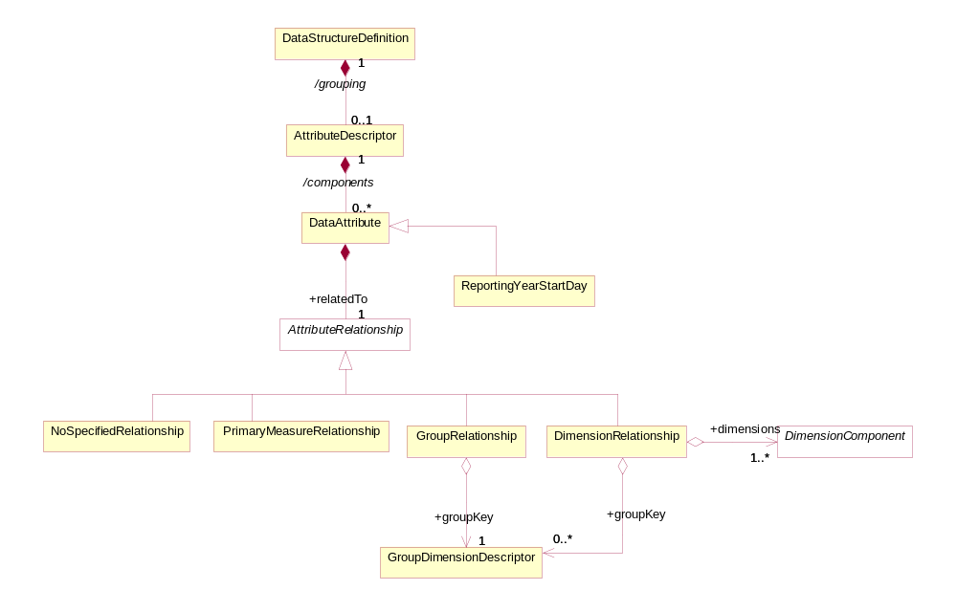
Figure 24: Attribute Attachment Defined in the Data Structure Definition
The following table details the possible relationships a DataAttribute may specify. Note that these relationships are mutually exclusive, and therefore only one of the following is possible.
Relationship | Meaning | Location in Data Set at which the Attribute is reported
None | The value of the attribute does not vary with the values of any other Component. | The attribute is reported at the level of the Dataset Attribute.
Dimension (1..n) | The value of the attribute will vary with the value(s) of the referenced Dimension(s). In this case, Group(s) to which the attribute should be attached may optionally be specified. | The attribute is reported at the lowest level of the Dimension to which the Attribute is related, otherwise at the level of the Group if Attachment Group(s) is specified.
Group | The value of the Attribute varies with combination of values for all of the Dimensions contained in the Group. This is added as a convenience to listing all Dimensions and the attachment Group, but should only be used when the Attribute value varies based on all Group Dimension values. | The attribute is reported at the level of Group.
Primary Measure | The value of the Attribute varies with the observed value. | The attribute is reported at the level of Observation.

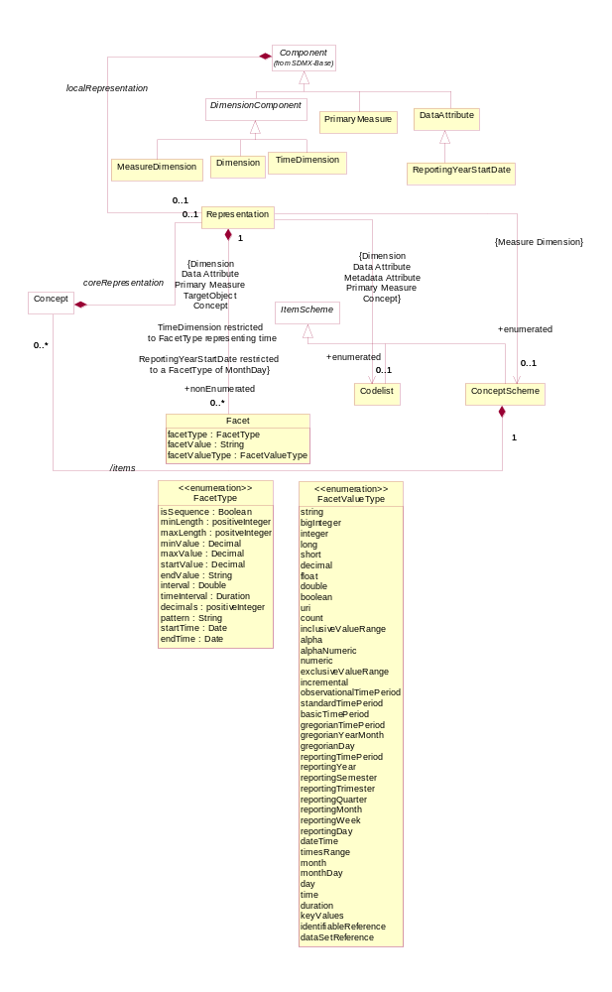
Figure 25: Representation of DSD Components
Each of Dimension, MeasureDimension, TimeDimension, PrimaryMeasure, and DataAttribute can have a Representation specified (using the localRepresentation association). If this is not specified in the DataStructureDefinition then the representation specified for Concept (coreRepresentation) is used. For the MeasureDimension the representation for the individual measures is specified for the Concept in the ConceptScheme referenced by the MeasureDimension.

A DataStructureDefinition can be extended to form a derived DataStructureDefinition. This is supported in the StructureMap.

Definitions
Class | Feature |  | Description
StructureUsage |  |  | See “SDMX Base”.
DataflowDefinition | Inherits from  StructureUsage |  | Abstract concept (i.e. the structure without any data) of a flow of data that providers will provide for different reference periods.
 | /structure |  | Associates a Dataflow Definition to the Data Structure Definition.
DataStructureDefinition |  |  | A collection of metadata concepts, their structure and usage when used to collect or disseminate data.
 | /grouping |  | An association to a set of metadata concepts that have an identified structural role in a Data Structure Definition.
Group  DimensionDescriptor | Inherits from  ComponentList |  | A set metadata concepts that define a partial key derived from the Dimension Descriptor in a Data Structure Definition.
 | +constraint |  | Identifies an Attachment Constraint that specifies the sub set of Dimension, Measure, or Attribute values to which an Attribute can be attached.
 | /components |  | An association to the Dimension and Measure Dimension components that comprise the group.
DimensionDescriptor | Inherits from  ComponentList |  | An ordered set of metadata concepts that, combined, classify a statistical series, and whose values, when combined (the key) in an instance such as a data set, uniquely identify a specific observation.
 | /components |  | An association to the Dimension, Measure Dimension, and Time Dimension comprising the Key Descriptor.
AttributeDescriptor | Inherits from  ComponentList |  | A set metadata concepts that define the attributes of a Data Structure Definition.
 | /components |  | An association to a Data Attribute component.
MeasureDescriptor | Inherits from  ComponentList |  | A metadata concept that defines the measure of a Data Structure Definition.
 | /components |  | An association to a measure component.
Dimension | Inherits from  Component | A metadata concept used (most probably together with other metadata concepts) to classify a statistical series, e.g. a statistical concept indicating a certain economic activity or a geographical reference area.
 | /role | Association to the Concept that specifies the role that that the Dimension plays in the Data Structure Definition.
 | /conceptIdentity | An association to the metadata concept which defines the semantic of the Dimension.
MeasureDimension | Inherits from  Dimension | A statistical concept that identifies the component in the key structure that has an enumerated list of measures. This dimension has, as its representation the Concept Scheme that enumerates the measure concepts.
TimeDimension | Inherits from  Dimension | A metadata concept that identifies the component in the key structure that has the role of “time”.
DataAttribute | Inherits from  Component  Sub class  ReportingYear  StartDay | A characteristic of an object or entity.
 | /role | Association to the Concept that specifies the role that that the Data Attribute plays in the Data Structure Definition.
 | usageStatus | Defines the usage status which is constrained by the data type Usage Status.
 | +relatedTo | Association to a Attribute Relationship.
 | /conceptIdentity | An association to the Concept which defines the semantic of the component.
ReportingYearStartDay | Inherits from DataAttribute | A specialised Data Attribute whose value is used in conjunction with the predefined reporting periods in the Time Dimension. If this is not present, then by default all reporting period values for the Time Dimension will be assumed to be based on a reporting year start day of January 1.
PrimaryMeasure | Inherits from  Component | The metadata concept that is the phenomenon to be measured in a data set. In a data set the instance of the measure is often called the observation.
 | /conceptIdentity | An association to the Concept which carries the values of the measures.
AttributeRelationship | Abstract Class  Sub classes  NoSpecified  Relationship  PrimaryMeasure  Relationship  GroupRelationship  Dimension  Relationship | Specifies the type of artefact to which a Data Attribute can be attached in a Data Set.
NoSpecifiedRelationship |  | The Data Attribute is not related to any specific construct.
PrimaryMeasure  Relationship |  | The Data Attribute is related to the Primary Measure construct.
GroupRelationship |  | The Data Attribute is related to a Group Dimension Descriptor construct.
 | +groupKey | An association to the Group Dimension Descriptor
DimensionRelationship |  | The Data Attribute is related to a set of Dimensions.
 | +dimensions | Association to the set of Dimensions to which the Data Attribute is related.
 | +groupKey | Association to the Group Dimension Descriptor which specifies the set of Dimensions to which the Data Attribute is attached.

The explanation of the classes, attributes, and associations comprising the Representation is described in the section on the SDMX Base.

Data Set – Relationship View

Context
A data set comprises the collection of data values and associated metadata that are collected or disseminated according to a known DataStructureDefinition.

Class Diagram
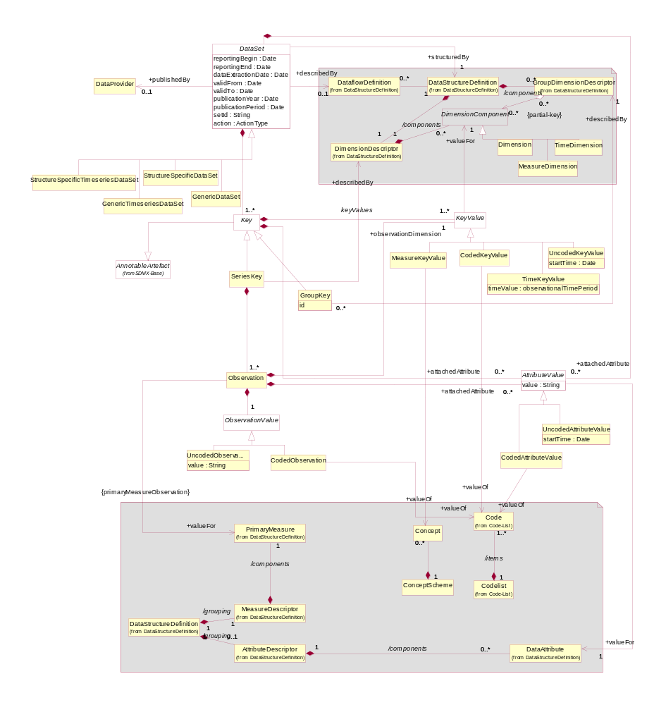
Figure 26 Class Diagram of the Data Set

Explanation of the Diagram

Narrative – Data Set
Note that the DataSet must conform to the DataStructureDefinition associated to the DataflowDefinition for which this DataSet is an “instance of data”. Whilst the model shows the association to the classes of the DataStructureDefinition, this is for conceptual purposes to show the link to the DataStructureDefinition. In the actual DataSet as exchanged there must, of course, be a reference to the DataStructureDefinition and optionally a DataflowDefinition, but the DataStructureDefinition is not necessarily exchanged with the data. Therefore, the DataStructureDefinition classes are shown in the grey areas, as these are not a part of the DataSet when the DataSet is exchanged. However, the structural metadata in the DataStructureDefinition can be used by an application to validate the contents of the DataSet in terms of the valid content of a KeyValue as defined by the Representation in the DataStructureDefinition.

An organisation playing the role of DataProvider can be responsible for one or more DataSet.

A DataSet can be formatted either as a generic data set (GenericDataSet, GenericTimeseriesDataSet) or a DataStructureDefinition specific data set (StructureSpecificDataSet, StructureSpecificTimeseriesDataSet). The generic data set is structured in exactly the same way no matter which DataStructureDefinition the DataSet expresses. The structured data set is structured according to one specific DataStructureDefinition. Depending on the syntax chosen for the implementation the structured data set should support better validation at the syntax level.

A DataSet is a collection of a set of Observations that share the same dimensionality, which is specified by a set of unique components (Dimension, MeasureDimension, TimeDimension) defined in the DimensionDescriptor of the DataStructureDefinition, together with associated AttributeValues that define specific characteristics about the artefact to which it is attached. - DataSet, Observation, set of Dimensions. It is structured in terms of a SeriesKey to which Observations are reported.

The Observation can be the value of the variable being measured for the Concept associated to the PrimaryMeasure in the MeasureDescriptor of the DataStructureDefinition. This is true when there is no MeasureDimension that specifies the precise meaning of each Observation. Each Observation associates an ObservationValue with a KeyValue (+observationDimension) which is the value for the “Dimension at the Observation Level”. Any dimension can be specified as being the “Dimension at the Observation Level”, and this specification is made at the level of the DataSet (i.e. it must be the same dimension for the entire DataSet).

If the “Dimension at the Observation Level” is the MeasureDimension it is possible (but not mandatory) that an Observation can be reported with an explicit identification of one or more Concept in the ConceptScheme referenced by the MeasureDimension as its Representation. In other words, the actual Concepts are explicitly stated in the Observation.

If it is required to specify explicitly that the DataSet is time series then one of GenericTimeSeriesDataSet or StructureSpecificTimeSeriesDataSet is used and the KeyValue for the +observationDimension must be a TimeKeyValue. In a GenericDataSet and a StructureSpecificDataSet it is permissible to have any dimension as the +observationDimension including the TimeDimension.

The KeyValue is a value for one of MeasureDimension, TimeDimension, or Dimension specified in the DataStructureDefinition. If it is a Dimension it can be coded (CodedKeyValue) or uncoded (UncodedKeyValue). If it is a MeasureDimension then it is MeasureKeyValue. If it is TimeDimension then it is a TimeKeyValue. The actual value that the CodedDimensionValue can take must be one of the Codes in the Codelist specified as the Representation of the Dimension in the DataStructureDefinition. The actual value that the MeasureDimensionValue can take must be a valid representation specified for the Concept in the ConceptScheme to which this MeasureDimensionValue is related (+valueFor).

The ObservationValue can be coded - this is the CodedObservation – or it can be uncoded – this is the UncodedObservation.

The GroupKey is a sub unit of the Key that has the same dimensionality as the SeriesKey, but defines a subset of the KeyValues of the SeriesKey. Its sub dimension structure is defined in the GroupDimensionDescriptor of the DataStructureDefinition identified by the same id as the GroupKey. The id identifies a “type” of group and the purpose of the GroupKey is to report one or more AttributeValue that are contained at this group level. The GroupKey is present when the GroupDimensionDescriptor is related to the GroupRelationship in the DataStructureDefinition. There can be many types of groups in a DataSet. If the Group is related to the DimensionRelationship in the DataStructureDefinition then the AttributeValue will be reported with the appropriate dimension in the SeriesKey or Observation.

In this way each of DataSet, SeriesKey, GroupKey, and Observation can have zero or more AttributeValue that defines some metadata about the object to which it is associated. The allowable Concepts and the objects to which these metadata can be associated (attached) are defined in the DataStructureDefinition.

The AttributeValue links to the object type (DataSet, SeriesKey, GroupKey, Observation,) to which it is associated.

Definitions
Class | Feature |  | Description
DataSet | Abstract Class  Sub classes  GenericDataSet  StructureSpecificDataSet  GenericTime  SeriesDataSet  StructureSpecificTime  SeriesDataSet |  | An organised collection of data.
 | reportingBegin |  | A specific time period in a known system of time periods that identifies the start period of a report.
 | reportingEnd |  | A specific time period in a known system of time periods that identifies the end period of a report.
 | dataExtractionDate |  | A specific time period that identifies the date and time that the data are extracted from a data source.
 | validFrom |  | Indicates the inclusive start time indicating the validity of the information in the data set.
 | validTo |  | Indicates the inclusive end time indicating the validity of the information in the data set.
 | publicationYear |  | Specifies the year of publication of the data or metadata in terms of whatever provisioning agreements might be in force.
 | publicationPeriod |  | Specifies the period of publication of the data or metadata in terms of whatever provisioning agreements might be in force.
 | setId |  | Provides an identification of the data set.
 | action |  | Defines the action to be taken by the recipient system (update, append, delete)
 | describedBy |  | Associates a data flow definition and thereby a Data Structure Definition to the data set.
 | +structuredBy |  | Associates the Data Structure Definition that defines the structure of the Data Set. Note that the Data Structure Definition is the same as that associated (non-mandatory) to the Dataflow Definition.
 | +publishedBy |  | Associates the Data Provider that reports/publishes the data.
 | +attachedAttribute |  | Association to the Attribute Values relating to the Data Set
GenericDataSet |  |  | A data format structure that is able to contain data corresponding to any Data Structure Definition.
StructureSpecific  DataSet |  |  | A data format structure that contains data corresponding to one specific Data Structure Definition.
GenericTimeseries  DataSet |  |  | A data format structure that is able to contain timeseries data corresponding to any Data Structure Definition.
StructureSpecific  TimeseriesDataSet |  |  | A data format structure that contains timeseries data corresponding to one specific Data Structure Definition.
Key | Abstract class  Sub classes  SeriesKey  GroupKey |  | Comprises the cross product of values of dimensions that identify uniquely an Observation.
 |  | keyValues | Association to the individual Key Values that comprise the Key.
 |  | +attachedAttribute | Association to the Attribute Values relating to the Series Key or Group Key.
KeyValue |  | Abstract class  Sub classes  MeasureKeyValue  TimeKeyValue  CodedKeyValue  UncodedKeyValue | The value of a component of a key such as the value of the instance a Dimension in a Dimension Descriptor of a Data Structure Definition.
 |  | +valueFor | Association to the key component in the Data Structure Definition for which this Key Value is a valid representation.  Note that this is conceptual association as the key component is identified explicitly in the data set.
MeasureKeyValue |  | Inherits from  KeyValue | The value of the Measure Dimension component of the key. The value is the Concept to which this class is associated.
 |  | +value | Association to the Concept.  Note that this is a conceptual association showing that the Concept must exist in the Concept Scheme associated with the Measure Dimension in the Data Structure Definition. In the actual Data Set the value of the Concept is placed in the Key Value.
TimeKeyValue |  | Inherits from  KeyValue | The value of the Time Dimension component of the key.
CodedKeyValue |  | Inherits from  KeyValue | The value of a coded component of the key. The value is the Code to which this class is associated.
 |  | +value | Association to the Code.  Note that this is a conceptual association showing that the Code must exist in the Code list associated with the Dimension in the Data Structure Definition. In the actual Data Set the value of the Code is placed in the Key Value.
UnCodedKeyValue |  | Inherits from  KeyValue | The value of an uncoded component of the key.
 |  | value | The value of the key component.
 |  | startTime | This attribute is only used if the textFormat of the attribute is of the Timespan type in the Data Structure Definition (in which case the value field takes a duration).
 |  | +valueFor | Associates Dimension, Measure Dimension, or Time Dimension to the Key Value, and thereby to the Concept that is the semantic of the Dimension, or Time Dimension.
GroupKey |  | Inherits from  Key | A set of Key Values that comprise a partial key, of the same dimensionality as the Time Series Key for the purpose of attaching Data Attributes.
 |  | +describedBy | Associates the Group Dimension Descriptor defined in the Data Structure Definition.
SeriesKey |  | Inherits from  Key | Comprises the cross product of values of all the Key Values that, together with the Key Value of the +observation Dimension identify uniquely an Observation.
 |  | +describedBy | Associates the Dimension Descriptor defined in the Data Structure Definition.
Observation |  |  | The value of the observed phenomenon in the context of the Key Values comprising the key.
 |  | +valueFor | Associates the Primary Measure defined in the Data Structure Definition.
 |  | +attachedAttribute | Association to the Attribute Values relating to the Observation.
 |  | +observationDimension | Association to the Key Value that holds the value of the “Dimension at the Observation Level”.
ObservationValue |  | Abstract class  Sub classes  UncodedObservation  CodedObservation
UncodedObservation |  | Inherits from  ObservationValue | An observation that has a text value.
 |  | value | The value of the Uncoded Observation.
CodedObservation |  | Inherits from  ObservationValue | An Observation that takes its value from a code in a Code list.
 |  | +value | Association to the Code that is the value of the Observation.  Note that this is a conceptual association showing that the Code must exist in the Code list associated with the Primary Measure or the Concept of the Measure Dimension in the Data Structure Definition. In the actual Data Set the value of the Code is placed in the Observation.
AttributeValue |  | Abstract class  Sub classes  UncodedAttributeValue  CodedAttributeValue | The value of an attribute, such as the instance of a Coded Attribute or of an Uncoded Attribute in a structure such as a Data Structure Definition.
 |  | value | The value of the attribute.
 |  | +valueFor | Association to the Data Attribute defined in the Data Structure Definition. Note that this is conceptual association as the Concept is identified explicitly in the data set.
UncodedAttribute  Value |  | Inherits from  AttributeValue | An attribute value that has a text value.
 |  | startTime | This attribute is only used if the textFormat of the attribute is of the Timespan type in the Data Structure Definition (in which case the value field takes a duration).
CodedAttribute  Value |  | Inherits from  AttributeValue | An attribute that takes it value from a Code in Code list.
 |  | +value | Association to the Code that is the value of the Attribute Value.  Note that this is a conceptual association showing that the Code must exist in the Code list associated with the Data Attribute in the Data Structure Definition. In the actual Data Set the value of the Code is placed in the Attribute Value.

Cube

Context
Some statistical systems create views of data based on a “cube” structure. In essence, a cube is an n-dimensional object where the value of each dimension can be derived from a hierarchical code list. The utility of such cube systems is that it is possible to “roll up” or “drill down” each of the hierarchy levels for each of the dimensions to specify the level of granularity required to give a “view” of the data – some dimensions may be rolled up, others may be drilled down. Such systems give a dynamic view of the data, with aggregated values for rolled up dimension positions. For example, the individual countries may be rolled up into an economic region such as the EU, or a geographical region such as Europe, whilst another dimension, such as “type of road” may be drilled down to its lower level. The resulting measure (such as “number of accidents”) would then be an aggregation of the value for each individual country for the specific type of road.

Such cube systems rely, not on simple code lists, but on hierarchical code sets (see section 8).

Support for the Cube in the Information Model
Data reported using a Data Structure Definition structure (where each dimension value, if coded, is taken from a flat code list) can be described by a cube definition and can be processed by cube aware systems. The SDMX-IM supports the definition of such cubes in the following way:

- The HierachicalCodelist defines the (often complex) hierarchies of codes
- If required, the StructureSet can
  - group DataStructureDefinition that describe the cube
  - provide a mapping mechanism between the codes in the flat code lists used by the DataStructureDefinition and a HierarchicalCodelist where the HierarchicalCodelist uses code lists that are not used in the DataStructureDefinition

Metadata Structure Definition and Metadata Set

Context
The SDMX metamodel allows metadata:

- To be exchanged without the need to embed it within the object that it is describing.

- To be stored separately from the object that it describes, yet be linked to it (for example, an organisation has a metadata repository which supports the dissemination of metadata resulting from metadata requests generated by systems or services that have access to the object for which the metadata pertains. This is common in web dissemination where additional metadata is available for viewing (and eventually downloading) by clicking on an “information” icon next to the object to which the metadata is attached).

- To be indexed to aid searching (example: a registry service can process a metadata report and extract structural information that allows it to catalogue the metadata in a way that will enable users to query for it).

- To be reported according to a defined structure.

In order to achieve this, the following structures are modelled:

- metadata structure definition which has the following components:
  - the object types to which the metadata are to be associated (attached)
  - the components that, together, comprise a unique key of the object type to which the metadata are to be associated
  - the reporting structure comprising the metadata attributes that can be attached to the various object types (these attributes can be structured in a hierarchy), together with any constraints that may apply (e.g. association to a code list that contains valid values for the attribute when reported in a metadata set)
- the metadata set, which contains reported metadata

Inheritance

Introduction
As with the Data Structure Definition Structure, many of the constructs in this layer of the model inherit from the SDMX Base layer. Therefore, it is necessary to study both the inheritance and the relationship diagrams to understand the functionality of individual packages. The diagram below shows the full inheritance tree for the classes concerned with the MetadataStructureDefinition and the MetadataSet.

There are very few additional classes in the MetadataStructureDefinition package that do not themselves inherit from classes in the SDMX Base. In other words, the SDMX Base gives most of the structure of this sub model both in terms of associations and in terms of attributes. The relationship diagrams shown in this section show clearly when these associations are inherited from the SDMX Base (see the Appendix “A Short Guide to UML in the SDMX Information Model” to see the diagrammatic notation used to depict this). It is important to note that SDMX base structures used for the MetadataStructureDefinition are the same as those used for the DataStructureDefinition and so, even though the usage is slightly different, the underlying way of defining a MetadataStructureDefinition is similar to that used for defining a DataStructureDefinition.

Class Diagram - Inheritance
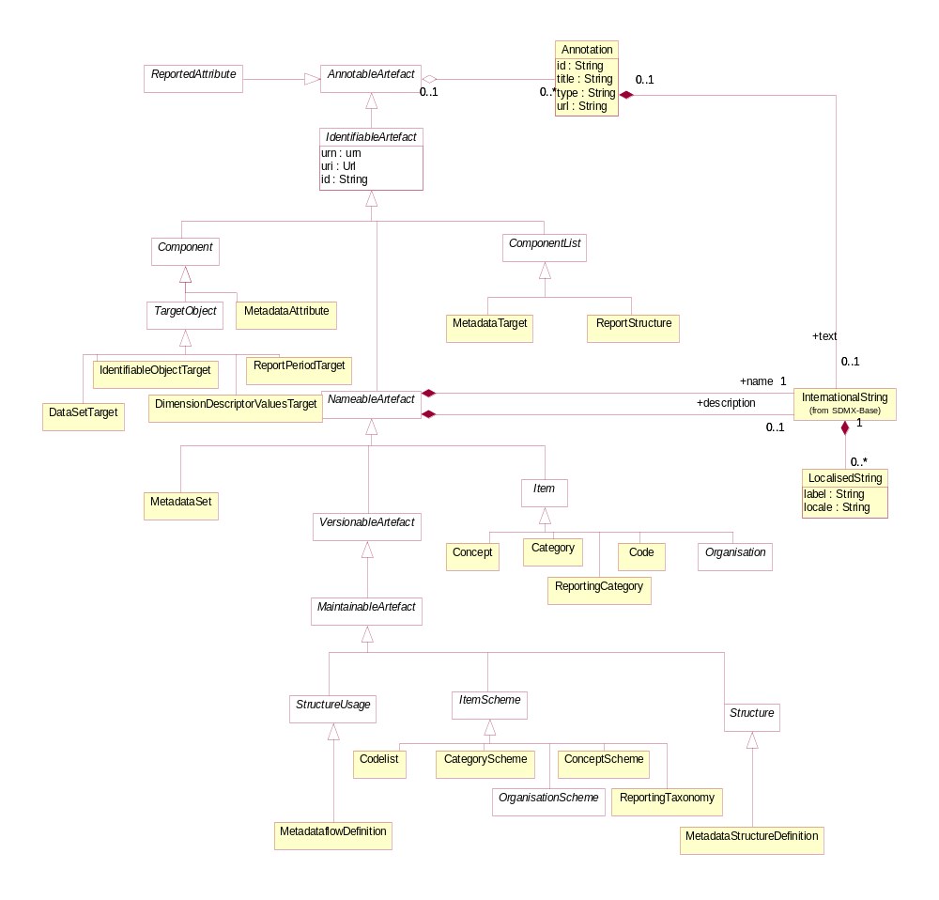
Figure 27: Inheritance class diagram of the Metadata Structure Definition

Explanation of the Diagram

Narrative
It is important to the understanding of the relationship class diagrams presented in this section to identify the concrete classes that inherit from the abstract classes.

The concrete classes in this part of the SDMX metamodel which require to be maintained by Maintenance Agencies all inherit from MaintainableArtefact. These are:

- StructureUsage (concrete class is MetadataflowDefinition)
- Structure (concrete class is MetadataStructureDefinition)
These classes also inherit the identity and versioning facets of IdentifiableArtefact, NameableArtefact, and VersionableArtefact.

A Structure contains several lists of components. The concrete classes which inherit from ComponentList and in themselves are sub components of the MetadataStructureDefinition are:

- MetadataTarget
- ReportStructure
ComponentList contains Components. The classes that inherit from Component are:

- Sub Classes of TargetObject
- MetadataAttribute

Metadata Structure Definition

Introduction
The diagrams and explanations in the rest of this section show how these concrete classes are related so as to support the functionality required.

Structures Already Described
The MetadataStructureDefinition makes use of the following ItemScheme structures either as explicit concrete classes in the model, or as possible lists which comprise the value domain of a TargetObject.

- CategoryScheme
- ConceptScheme
- Codelist
- OrganisationScheme
- Reporting Taxonomy

Class Diagram – Relationship
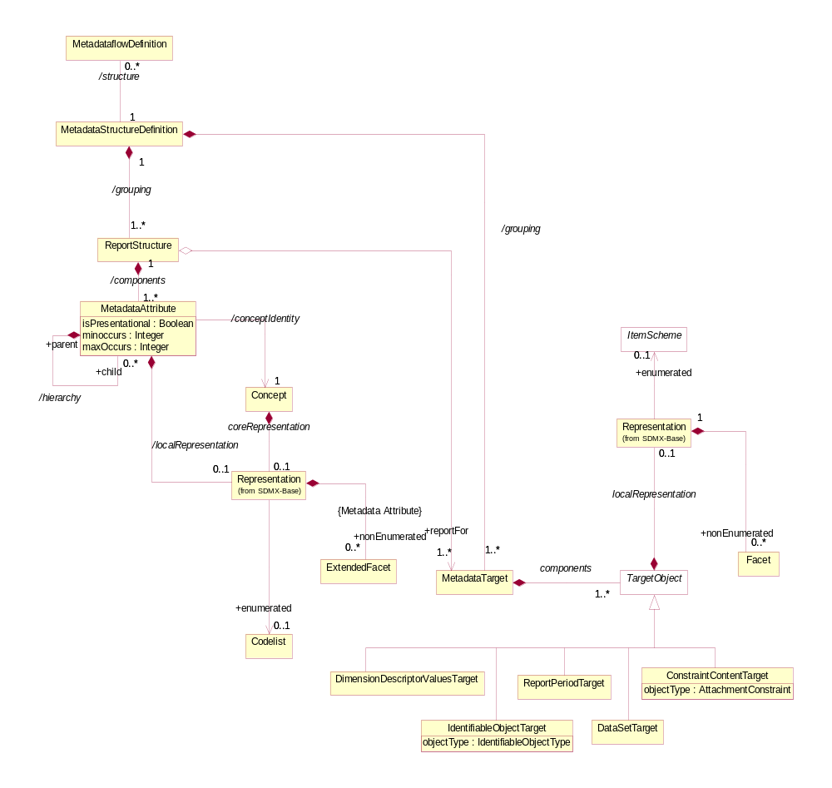
Figure 28: Relationship class diagram of the Metadata Structure Definition

Explanation of the Diagram

Narrative
In brief a MetadataStructureDefinition (MSD) defines:

- The MetadataTarget which defines the components (TargetObject) and their Representation which are valid for this MetadataStructureDefinition, and which are the metadata target object of one or more ReportStructure
- The ReportStructures comprising the MetadataAttributes that can be associated with the object type identified in the referenced MetadataTargets, and hierarchical structure of the attributes
The MetadataTarget comprises one or more TargetObjects. The combination of TargetObjects identifies a specific object type to which metadata can be attached in a MetadataSet.

The TargetObject is one of the following:

- DimensionDescriptorValuesTarget - this allows the specification of a full or partial key (as used in a dataset) to be specified in a MetadataSet as the target object
- IdentifiableObjectTarget – this defines a specific object type, which can be any IdentifiableArtefact
- DataSetTarget – this specifies that the target object is a DataSet
- ReportPeriodTarget - this specifies that the report period must be present in the MetadataSet
- ConstraintContentTarget – this specifies that target object is the content of an AttachmentConstraint i.e. the part of the data set or metadata set identified by the content of an AttachmentConstraint
The valid content of a TargetObject when reported in a MetadataSet is defined in the Representation. This can be an enumerated representation (i.e. a reference to one of the sub clases of ItemScheme – these are Codelist, ConceptScheme, OrganisationScheme, CategoryScheme, or ReportingTaxonomy) or non-enumerated.

Thus a single MetadataStructureDefinition can be defined for a discrete set of related object types. For example, a single definition can be constructed to define the metadata that can be attached to any part of a Data Structure Definition, or that can be attached to any artefact concerned with the reporting of quality metadata (such as data provider and (data) category). The MetadataTarget specifies the identification properties of a specific object type to which metadata can be attached in a MetadataSet. For example, in a DataStructureDefinition the MetadataTarget might be a Dimension, and therefore the TargetObjects are those that uniquely identify a Dimension. This will include both the DataStructureDefinition and the Dimension (both of these are an IdentifiableArtefact and will use the IdentitifableObjectTarget) as both TargetObjects are required in order to identify uniquely a Dimension).

The ReportStructure comprises a set of MetadataAttributes - these can be defined as a hierarchy. Each MetadataAttribute identifies a Concept that is reported or disseminated in a MetadataSet (/conceptIdentity) that uses this MetadataStructureDefinition. Different MetadataAttributes in the same ReportStructure can use Concepts from different ConceptSchemes. Note that a MetadataAttribute does not link to a Concept that defines its role in this MetadataStructureDefinition (i.e. the MetadataAttribute does not play a role).

The MetadataAttribute can be specified as having multiple occurrences and/or specified as being mandatory (minOccurs=1 or more) or conditional (minOccurs=0). A hierarchical ReportStructure can be defined by specifying a hierarchy for a MetadataAttribute.

The ReportStructure is associated to one or more of the MetadataTargets which specify to which object the MetadataAttributes specified in the ReportStructure are attached when reported in a MetadataSet.

It can be seen from this that the specification of the object types to which a MetadataAttribute can be attached is indirect: the MetadataAttributes are defined in a ReportStructure which itself is attached to one or more MetadataTarget and the actual object is identified by the TargetObjects comprising the MetadataTarget. This gives a flexible mechanism by which the actual object types need not be defined in concrete terms in the model, but are defined dynamically in the MetadataStructureDefinition, in much the same way as the keys to which data observation are “attached” in a DataStructureDefinition. In this way the MetadataStructureDefinition can be used to define any set of MetadataAttributes and any set of object types to which they can be attached.

Each MetadataAttribute can have a Representation specified (using the /localRepresentation association). If this is not specified in the MetadataStructureDefinition then the Representation is taken from that defined for the Concept (the coreRepresentation association).

The definition of the various types of Representation can be found in the specification of the Base constructs. Note that if the Representation is non-enumerated then the association is to the ExtendedFacet (which allows for xhtml as a FacetValueType). If the Representation is enumerated then is must use a Codelist.

The MetadataStructureDefinition is linked to a MetadataflowDefinition. The MetadataflowDefinition does not have any attributes in addition to those inherited from the Base classes.

Definitions
Class | Feature | Description
StructureUsage |  | See “SDMX Base”.
Metadataflow Definition | Inherits from:  StructureUsage | Abstract concept (i.e. the structure without any metadata) of a flow of metadata that providers will provide for different reference periods.
 | /structure | Associates a Metadata Structure Definition.
MetadataStructure Definition |  | A collection of metadata concepts, their structure and usage when used to collect or disseminate reference metadata.
 | /grouping | An association to a Metadata Target or Report Structure.
MetadataTarget | Inherits from  ComponentList | A set of components that define a key of an object type to which metadata may be attached.
 | /components | Associates the Target Object components that define the key of the Metadata Target.
TargetObject | Abstract Class  Sub Classes  DimensionDescriptorValuesTarget IdentifiableObjectTarget  DataSetTarget  ReportPeriodTarget
 | /localRepresentation | Associates a Representation to the Target Object that must be respected when the object is identified in a Metadata Set. This may be enumerated or non-enumerated.
DimensionDescriptorValuesTarget | Inherits from  TargetObject | The target object is the key of a data series.
IdentifiableObject Target | Inherits from  TargetObject | The target object is a specified object type.
 | objectType | Identifies the object type.
DataSetTarget | Inherits from  TargetObject | The target object is a Data Set.
ReportPeriodTarget | Inherits from  TargetObject | The target is a report period. Note that this does not describe the use of an object, but rather serves as a unique metadata key for metadata reports. Metadata reports attached to a particular object may vary over time, and this time identifier component can be used to disambiguate the reports, much like the time dimension disambiguates observations in a data series.
ConstraintTarget | Inherits from  TargetObject | The target object is the data or reference metadata that is identified in the content of an Attachment Constraint.
ReportStructure | Inherits from:  ComponentList | Defines a set of concepts that comprises the Metadata Attributes to be reported.
 | /components | An association to the Metadata Attributes relevant to the Report Structure.
 | +reportFor | Associates the Metadata Targets for which this Report Structure is used.
MetadataAttribute |  | Identifies a Concept for which a value may be reported in a Metadata Set.
 | /hierarchy | Association to one or more child Metadata Attribute.
 | /conceptIdentity | An association to the concept which defines the semantic of the attribute.
 | isPresentational | Indication that the Metadata Attribute is present for structural purposes (i.e. it has child attributes) and that no value for this attribute is expected to be reported in a Metadata Set using this Report Structure.
 | minOccurs  maxOccurs | Specifies how many occurrences of the Metadata Attribute may be reported at this point in the Metadata Report.
ConceptUsage |  | The use of a Concept as Metadata Attribute.
 | concept | Association to a Concept in a ConceptScheme.
 | /localRepresentation | Associates a Representation that overrides any core representation specified for the Concept itself.
Representation |  | The representation of the Metadata Attribute.

Metadata Set

Class Diagram
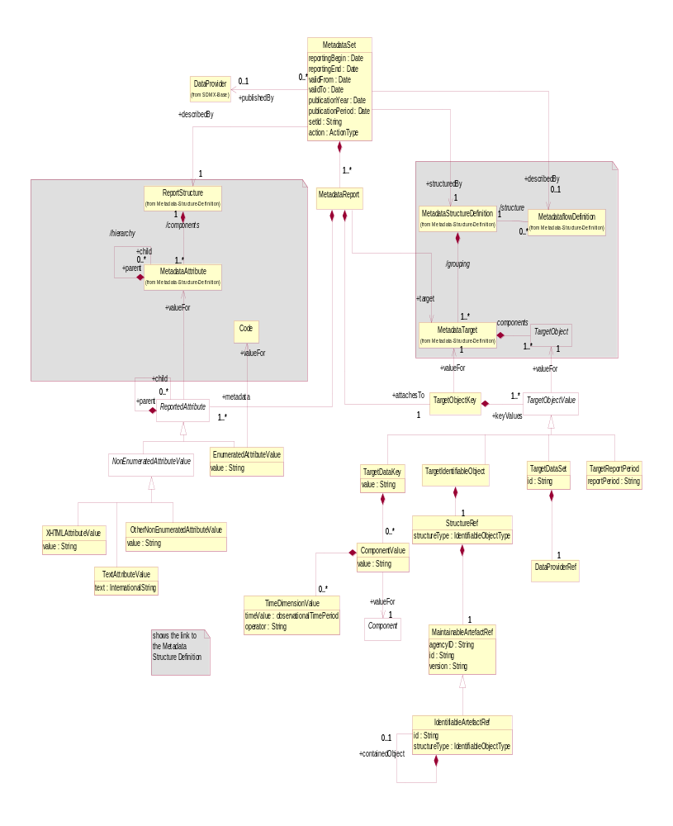
Figure 29: Relationship Class Diagram of the Metadata Set

Explanation of the Diagram

Narrative
Note that the MetadataSet must conform to the MetadataStructureDefinition associated to the MetadataflowDefinition for which this MetadataSet is an “instance of metadata”. Whilst the model shows the association to the classes of the MetadataStructureDefinition, this is for conceptual purposes to show the link to the MetadataStructureDefinition. In the actual MetadataSet as exchanged there must, of course, be a reference to the MetadataStructureDefinition and the ReportStructure, and optionally a MetadataflowDefinition, but the MetadataStructureDefinition is not necessarily exchanged with the metadata. Therefore, the MetadataStructureDefinition classes are shown in the grey areas, as these are not a part of the MetadataSet itself.

An organisation playing the role of DataProvider can be responsible for one or more MetadataSet.

A MetadataSet comprises one or more MetadataReport, each of which must be for the same ReportStructure. It references both a MetadataTarget, defined in the MetadataStructureDefinition, and contains a TargetObjectKey and ReportedAttributes.

The identified ReportStructure specifies which MetadataAttributes are expected as ReportedAttributes. The identified MetadataTarget specifies the expected content of the TargetObjectKey i.e. it specifies the information required to identify the object for which the ReportedAttributes are reported.

The TargetObjectValue can be one of:

- TargetDataKey – this can contain:
  - a SeriesKey (set of dimension values)
  - a SeriesKey plus a value or values (giving time range) for the TimeDimension (TimeDimensionValue)
  - a value of values for the TimeDimension
- TargetIdentifiableObject -this identifies any identifiable object (which includes both Maintainable and Identifiable objects
- TargetDataSet – this identifies a DataSet
- TargetReportPeriod – this specifies the report period for the Report

A simple text value for the ReportedAttribute uses the NonEnumeratedAttributeValue sub class of ReportedAttribute whilst a coded value uses the EnumeratedAttributeValue sub class.

The NonEnumeratedAttributeValue can be one of:

- XHTMLAttributeValue – the content is XHTML
- TextAttributeValue – the content is textual and may contain the text in multiple languages
- OtherNonEnumeratedAttributeValue – the content is a string value that must conform to the Representation specified for the MetadataAttribute in the MetadataStructureDefinition for the relevant ReportStructure

The EnumeratedAttributeValue contains a value for a Code specified as the Representation for the MetadataAttribute in the MetadataStructureDefinition for the relevant ReportStructure.

Definitions
Class | Feature | Description
MetadataSet |  | Any organised collection of metadata.
 | reportingBegin | A specific time period in a known system of time periods that identifies the start period of a report.
 | reportingEnd | A specific time period in a known system of time periods that identifies the ebd period of a report.
 | dataExtractionDate | A specific time period that identifies the date and time that the data are extracted from a data source.
 | validFrom | Indicates the inclusive start time indicating the validity of the information in the data set.
 | validTo | Indicates the inclusive end time indicating the validity of the information in the metadata set.
 | publicationYear | Specifies the year of publication of the data or metadata in terms of whatever provisioning agreements might be in force.
 | publicationPeriod | Specifies the period of publication of the data or metadata in terms of whatever provisioning agreements might be in force.
 | setId | Provides an identification of the metadata set.
 | action | Defines the action to be taken by the recipient system (update, replace, delete)
 | +describedBy | Associates a Metadataflow Definition to the Metadata Set.
 | +structuredBy | Associates the Metadata Structure Definition that defines the structure of the Metadata Set. Note that the Metadata Structure Definition  is the same as that associated (non-mandatory) to the Metadataflow Definition.
 | +publishedBy | Associates the Data Provider that reports/publishes the metadata.
 | +describedBy | Reference to the Report Structure.
MetadataReport |  | A set of values for Metadata Attributes defined in a Report Structure of a Metadata Structure Definition.
 | +attachesTo | Associates the object key to which metadata is to be attached.
 | +target | Associates the Metadata Target that defines the target object to which the metadata are to be associated.
 | +metadata | Associates the Reported Attribute values which are to be associated with the object or objects identified by the Target Object Key.
TargetObjectKey |  | Identifies the key of the object to which the metadata are to be attached.
 | +valueFor | Associates the Metadata Target that identifies the object type and the component structure of the Target Object Key.  Note that this is a conceptual association showing the link to the MSD construct.
 | +keyValues | Associates the Target Object Values of the Target Object Key.
TargetObjectValue | Abstract class  Sub classes are  TargetDataKey  TargetIdentifiableObject  TargetDataSet  TargetReportPeriod | The key of an individual object of the type specified in the Metadata Target of the Metadata Structure Definition.
 | +valueFor | Associates the Target Object for which this value is provided.  Note that this is a conceptual association showing the link to the MSD construct.
TargetDataKey | Inherits from  TargetObjectValue | The identification of the components and the values that form the data or metadata key.
ComponentValue |  | Collectively contain the identification of the components and the values that form the data key.
value |  | The key value.
 | +valueFor | Associates the Component for which the value is declared.
TimeDimensionValue |  | Contains identification of the Time Dimension and the value.
TargetIdentifiable  Object | Inherits from  TargetObjectValue | Specifies the identification of an Identifiable object.
StructureRef |  | Contains the identification of an Identifiable object.
 | structureType | The object type of the target object.
Maintainable  ArtefactRef  Identifiable  ArtefactRef |  | Identification of the target object by means of its identifier constructs i.e agency ID, id, version for Maintainable Object plus, for Identifiable Object, the id.
 | +containedObject | Association to a contained object in a hierarchy of Identifiable Objects such as a Transition in a Process Step.
TargetDataSet | Inherits from  TargetObjectValue | Contains the identification of a Data Set
TargetReportPeriod | Inherits from  TargetObjectValue | Contains the period covered by the Metadata Report.
ReportedAttribute | Abstract class  Sub classes are:  NonEnumeratedAttributeValue  EnumeratedAttributeValue | The value for a Metadata Attribute.
 | +valueFor | Association to the Metadata Attribute in the Metadata Structure Definition that identifies the Concept and allowed Representation for the Reported Attribute.  Note that this is a conceptual association showing the link to the MSD construct. The syntax for the Reported Attribute will state, in some form, the id of the Metadata Attribute.
 | +child | Association to a child Reported Attribute consistent with the hierarchy defined in the Report Structure for the Metadata Attribute for which this child is a Reported Attribute.
NonEnumerated AttributeValue | Inherits from  ReportedAttribute  Sub class:  XHTMLAttributeValue  TextAttributeValue  OtherNonEnumerated  AttributeValue | The content of a Reported Attribute where this is textual.
XHTMLAttributeValue |  | This contains XHTML.
 | value | The string value of the XHTML.
TextAttributeValue |  | This value of a Reported Attribute where the content is human-readable text.
 | text | The string value is text. This can be present in multiple language versions.
OtherNonEnumerated AttributeValue |  | The value of a Reported Attribute where the content is not of human-readable text.
 | value | A text string that is consistent in format to that defined in the Representation of the Metadata Attribute for which this is a Reported Attribute.
EnumeratedAttributeValue | Inherits from  MetadataAttributeValue | The content of a Reported Attribute that is taken from a Code in a Code list.
 | value | The Code value of the Reported Attribute.
 | +value | Association to a Code in the Code list specified in the Representation of the Metadata Attribute for which this Reported Attribute is the value  Note that this shows the conceptual link to the Item that is the value. In reality, the value itself will be contained in the Enumerated Attribute Value.

Hierarchical Code List

Scope
The Codelist described in the section on structural definitions supports a simple hierarchy of Codes, and restricts any child Code to having just one parent Code. Whilst this structure is useful for supporting the needs of the DataStructureDefinition and the MetadataStructureDefinition, it may not sufficient for supporting the more complex associations between codes that are often found in coding schemes such as a classification scheme. Often, the Codelist used in a DataStructureDefinition is derived from a more complex coding scheme. Access to such a coding scheme can aid applications, such as OLAP applications or data visualisation systems, to give more views of the data than would be possible with the simple Codelist used in the DataStructureDefinition.

Note that a hierarchical code list is not necessarily a balanced tree. A balanced tree is where levels are pre-defined and fixed, (i.e. a level always has the same set of codes, and any code has a fixed parent and child relationship to other codes). A statistical classification is an example of a balanced tree, and the support for a balanced hierarchy is a sub set, and special case, of the hierarchical code list.

The principal features of the Hierarchical Codelist are:

- A child code can have more than one parent.

- There can be more than one code that has no parent (i.e. more than one “root node”).

- There may be many hierarchies (or “views”) defined, in terms of the associations between the codes. Each hierarchy serves a particular purpose in the reporting, analysis, or dissemination of data.

- The levels in a hierarchy can be explicitly defined or they can be implicit: (i.e. they exist only as parent/child relationships in the coding structure).

Inheritance

Class Diagram
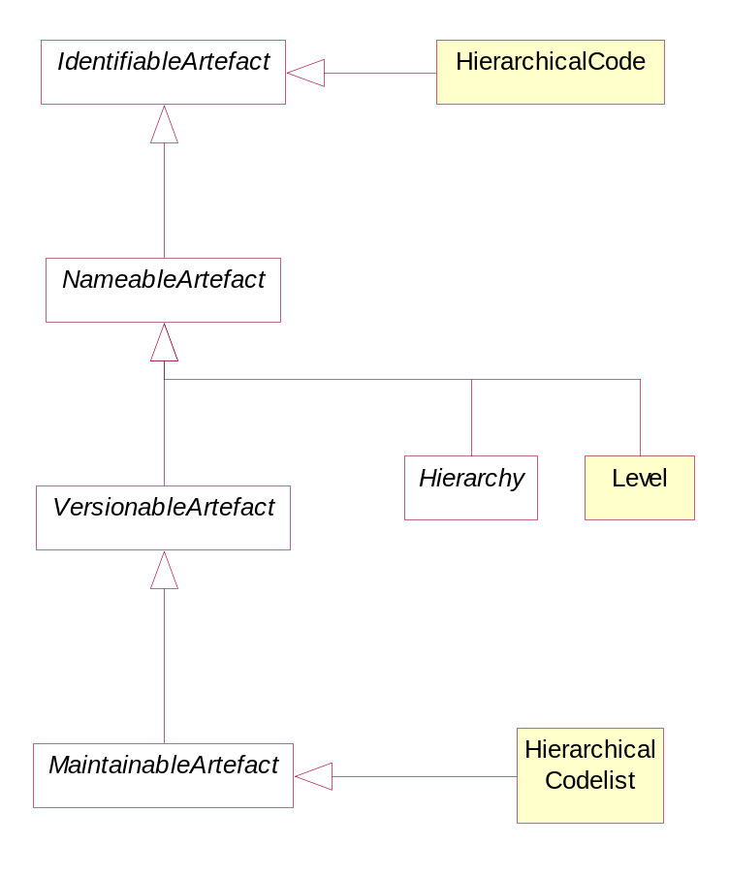
Figure 30: Inheritance class diagram for the Hierarchical Codelist

Explanation of the Diagram

Narrative

The HierarchicalCodelist inherits from MaintainableArtefact and thus has identification, naming, versioning and a maintenance agency. Both Hierarchy and Level are a NameableArtefact and therefore have an Id, multi-lingual name and multi-lingual description. A HierachicalCode is an IdentifiableArtefact.

It is important to understand that the Codes participating in a HierarchicalCodelist are not themselves contained in the list – they are referenced from the list and are maintained in one or more Codelists. This is explained in the narrative of the relationship class diagram below..

Definitions
The definitions of the various classes, attributes, and associations are shown in the relationship section below.

Relationship

Class Diagram
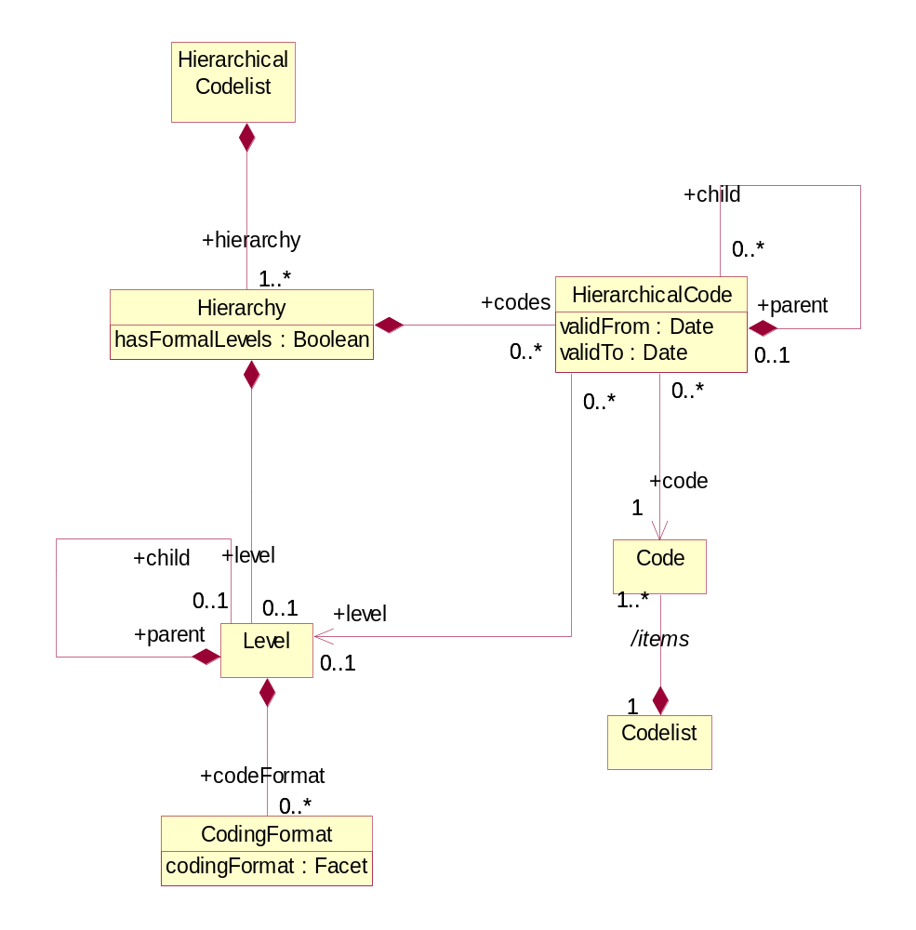
Figure 31: Relationship class diagram of the Hierarchical Code Scheme

Explanation of the Diagram

Narrative
The basic principles of the HierarchicalCodelist are:

- The HierarchicalCodelist is a specification of the Codes comprising the scheme and the specification of the structure of the Codes in the scheme in terms of one or more Hierarchy.

- The Codes in the HierarchicalCodelist are not themselves a part of the scheme, rather they are references to Codes in one or more external Codelists.

- Any individual Code may participate in many Hierarchys, in order to give structure to the HierarchicalCodelist.

- The Hierarchy of Codes is specified in HierarchicalCode. This references the Code and its immediate child HierarchicalCodes.

A Hierarchy can have formal levels (hasFormalLevels=”true”). However, even if hasFormalLevels=”false” the Hierarchy can still have one or more Levels associated in order to document information about the HierarchicalCodes.

If hasFormalLevels=”false the Hierarchy is “value based” comprising a hierarchy of codes with no formal Levels. If hasFormalLevels=”true” then the hierarchy is “level based” where each Level is a formal Level in the HierarchicalCodeList, such as those present in statistical classifications. In a “level based” hierarchy each HierarchicalCode is linked to the Level in which it resides (which must be in the same Hierarchy as the HierarchicalCode). It is expected that all HierarchicalCodes at the same hierarchic level defined by the +parent/+child association will be linked to the same Level. Note that the +level association need only be specified if the HierarchicalCode is at a different hierarchical level ((implied by the HierarchicalCode parent/child association) than the actual Level in the level hierarchy (implied by the Level parent/child association).

[Note that organisations wishing to be compliant with accepted models for statistical classifications should ensure that the Id is the number associated with the Level, where Levels are numbered consecutively starting with level 1 at the highest Level].

The Level may have CodingFormat information defined (e.g. coding type at that level).

Definitions

Class | Feature | Description
HierarchicalCode  list | Inherits from:  MaintainableArtefact | An organised collection of codes that may participate in many parent/child relationships with other Codes in the scheme, as defined by one or more Hierarchy of the scheme.
 | +hierarchy | Association to Hierarchies of Codes.
Hierarchy | Inherits from:  NameableArtefact | A classification structure arranged in levels of detail from the broadest to the most detailed level.
 | hasFormalLevels | If “true” this indicates a hierarchy where the structure is arranged in levels of detail from the broadest to the most detailed level.  If “false” this indicates a hierarchy structure where the items in the hierarchy have no formal level structure.
 | +codes | Association to the top-level Hierarchical Codes in the Hierarchy.
 | +level | Association to the top Level in the Hierarchy.
Level | Inherits from  NameableArtefact | In a “level based” hierarchy this describes a group of Codes which are characterised by homogeneous coding, and where the parent of each Code in the group is at the same higher level of the Hierarchy.  In a “value based’ hierarchy this describes information about the HierarchicalCodes at the specified nesting level.
 | +codeFormat | Association to the Coding Format.
 | +child | Association to a child Level of Level.
CodingFormat |  | Specifies format information for the codes at this level in the hierarchy such as whether the codes at the level are alphabetic, numeric or alphanumeric and the code length.
HierarchicalCode |  | A hierarchic structure of code references.
 | validFrom | Date from which the construct is valid
 | validTo | Date from which construct is superseded.
 | +code | Association to the Code that is used at the specific point in the hierarchy.
 | +child | Association to a child Code in the hierarchy.
 | +level | Association to a Level where levels have been defined for the Hierarchy.
Code |  | The Code to be used at this point in the hierarchy.
 | /items | Association to the Code list containing the Code.
Codelist |  | The Code list containing the Code.

Structure Set and Mappings

Scope
A StructureSet allows components in one structure to be mapped to components in another structure of the same type. In this context the term “structure” is used loosely to include types of ItemScheme, types of Structure, and types of StructureUsage. The allowable structures that can be mapped, and the components that can be mapped within these structures are:

Structure Type | Component type
Codelist | Code
Category Scheme | Category
Concept Scheme | Concept
Organisation Scheme | Organisation – this allows mapping any type of Organisation to any type of Organisation (e.g. a Data Provider to an Organisation Unit)
Hierarchical Codelist | Hierachical Code to Code or vice-versa
Data Structure Definition | Dimension, Measure Dimension, Time Dimension. Data Attribute, Primary Measure
Metadata Structure Definition | Target Object, Metadata Attribute
Dataflow Definition | None
Metadataflow Definition | None

The StructureSet can contain one or more “maps” and can define related structures (via the association +relatedStructure) which group related DataStructureDefinitions, MetadataStructureDefinitions, DataflowDefinintions, MetadataflowDefinintions.

Structure Set

Class Diagram – Inheritance
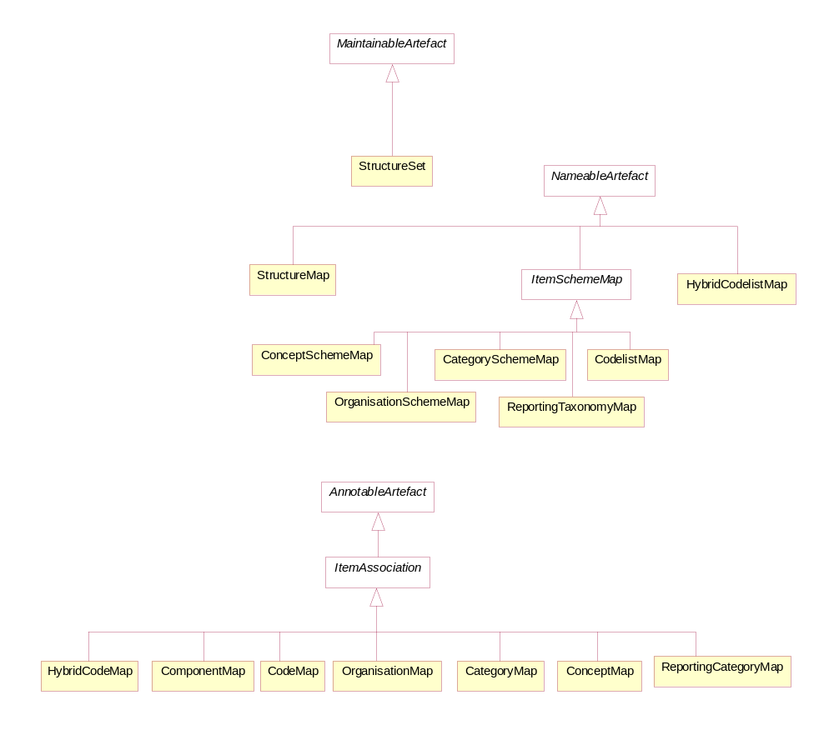
Figure 32: Inheritance Class Diagram of the Structure Set

Class Diagram – Relationship

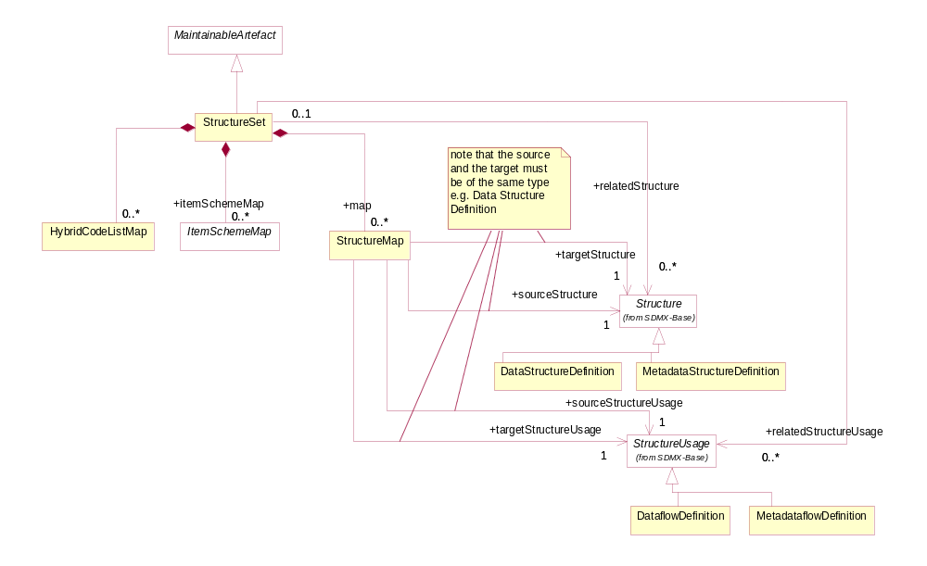
Figure 33: Relationship Class diagram of the Structure Set

Explanation of the Diagram

Narrative
The StructureSet is a MaintainableArtefact. It can contain:

- A set of references to concrete sub-classes of Structure and StructureUsage (DataStructureDefinition, MetadataStructureDefinition, DataflowDefinition or MetadataflowDefinition) to indicate that a relationship exists between them. For example there may be a group of DataStructureDefinition which, together, form the definition of a cube, each DataStructureDefinition defining a part of the cube.
- A set of StructureMaps which define which components of one structure are equivalent to those in another in a ComponentMap.
- A set of ItemSchemeMaps which define the mapping between two concrete classes of ItemScheme, and the mapping of the Items in these schemes, such as the mapping of Codes in two Codelists..
- A set of HybridCodelistMaps which define the mapping between a Codelist and a HierachicalCodelist.

The StructureMap references two Structures or StructureUsages. In concrete terms these references will be to DataStructureDefinitions, MetadataStructureDefinitions, DataflowDefinitions or MetadataflowDefinitions.

Definitions
Class | Feature | Description
StructureSet | Inherits from  MaintainableArtefact | A maintainable collection of structural maps that link components together in a source/target relationship where there is a semantic equivalence between the source and the target components.
 | +relatedStructure | Association to a set of Data Structure Definitions and Metadata Structure Definitions.
 | +relatedStructureUsage | Association to a set of Dataflow Definition and Metadataflow Definition.
 | +map | Association to Structure Map.
 | +itemSchemeMap | Association to Item Scheme Map
StructureMap | Inherits from  NameableArtefact | Links a source and target structure where there is a semantic equivalence between the source and the target structures.
 | sourceStructure | Association to the source Structure.
 | targetStructure | Association to the target Structure which must be of the same type as the source Structure.
 | sourceStructureUsage | Association to the source Structure Usage.
 | targetStructureUsage | Association to the target Structure Usage which must be of the same type as the source Structure Usage.

Structure Map

Class Diagram
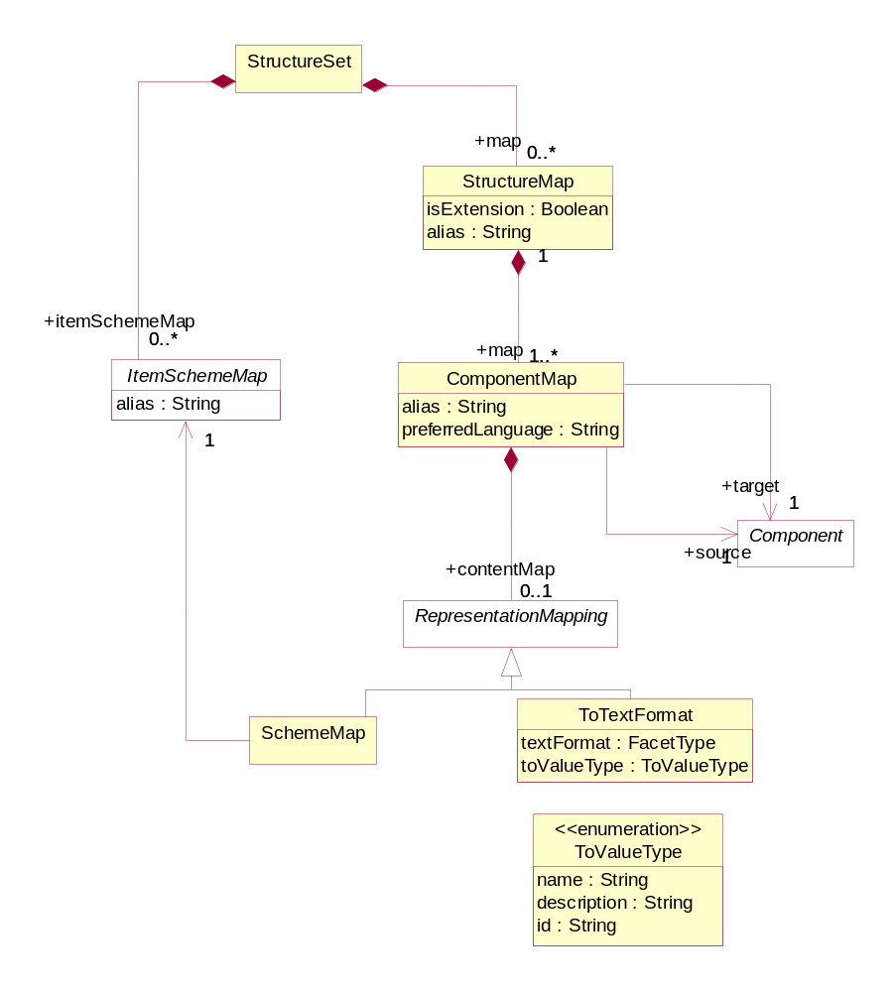
Figure 34: Class diagram of the Structure Map

Explanation of the Diagram

Narrative
The StructureMap contains a set of ComponentMaps, each one indicating equivalence between Components of the referenced Structure. ComponentMap has a RepresentationMapping which can be one of the concete classes of ItemSchemeMap (e.g. for a Dimension this would be a CodelistMap) or ToTextFormat which takes values: id, name, description. This instructs mapping tools to use the id, name or description of a coded component to determine equivalence with an uncoded component's value.

An example of a ComponentMap is linking the source Component that is a Dimension in the source DataStructureDefinition (identified in the StructureMap) to the equivalent target Component that is a Dimension in the target DataStructureDefinition).

Definitions
Class | Feature | Description
StructureMap | Inherits from  NameableArtefact | Links a source and target structure where there is a semantic equivalence between the source and the target structures.
 | alias | An alternate identification of the map, that allows the relation of multiple maps to be expressed by the sharing of this value.
 | +map | Association to the Component Map.
ComponentMap | Inherits from  AnnotableArtefact | Links a source and target Component where there is a semantic equivalence between the source and the target Components.
 | alias | An alternate identification of the map, that allows the relation of multiple maps to be expressed by the sharing of this value.
 | preferredLanguage | Specifies the language to use for the content of the To Text Format option of RepresentationMap
 | +source | Association to the source Component.
 | +target | Association to the target Component.
 | +contentMap | Association to the constructs that map the content of the Components – this will be either one of sub classes of Item Scheme or a mapping to text.
Representation Mapping | AbstractClass  Sub classes:  SchemeMap  ToTextFormat | Defines the mapping of the content of the source Component to the content of the target Component.
SchemeMap | Inherits from  RepresentationMapping | Associates an Item Scheme Map
ToTextFormat | Inherits from  RepresentationMapping | Defines the text format
 | textFormat | Text format type.
 | toValueType | Identifies the construct to be taken from the Item of the source Component when mapping the content of the source Component to the content of the target Component.
ToValueType |  | Enumeration of the construct in the Item.

Item Scheme Map

Context
The ItemSchemeMap is used to associate the Items in two different ItemSchemes. This is a generic mechanism that can be used to map Items. Specific models exist for mapping schemes where there is a semantic equivalence between Items in the ItemScheme. The model supports the mapping of any two ItemSchemes of the same type. These are:

- ConceptScheme
- CategoryScheme
- OrganisationScheme
- Codelist
- ReportingTaxonomy

Class Diagram
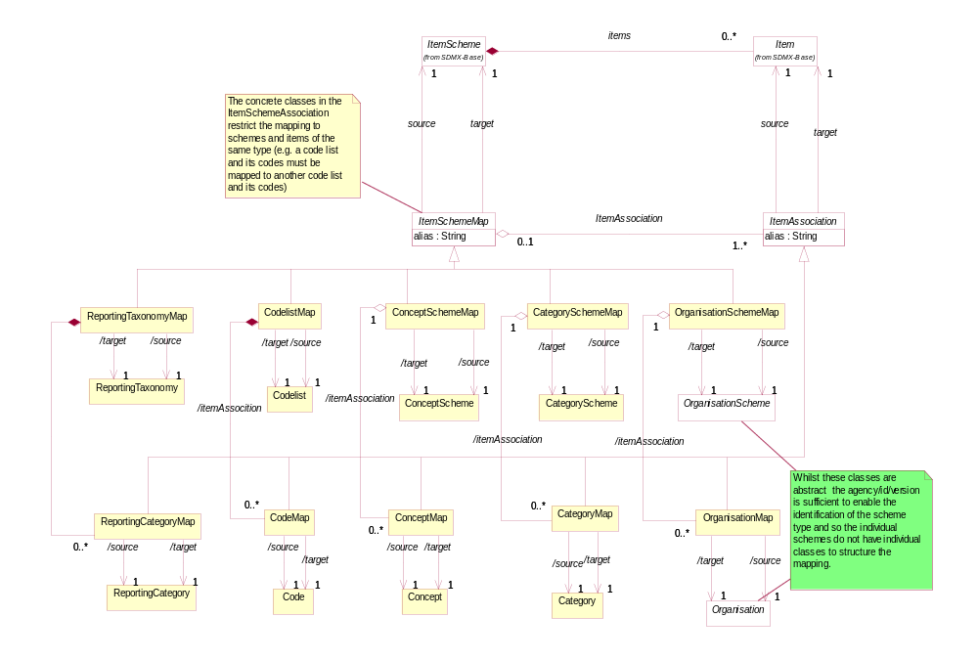
Figure 35: Class diagram of the Item Scheme Map

Explanation of the Diagram

Narrative
Both the ItemSchemeMap and the ItemAssociation inherit from NameableArtefact.

Each of ConceptSchemeMap, CategorySchemeMap, CodelistMap and OrganisationSchemeMap, ReportingTaxonomyMap provides a mechanism for specifying semantic equivalence between the items (Concept, Category,Code, Organisation, ReportingCategory) in the scheme. Note that any type of OrganisationScheme and Organisation can be mapped (e.g. an Agency in an AgencyScheme can be mapped to an OrganisationUnit in an OrganisationUnitScheme).

Each scheme map identifies a +source and +target scheme whose content is to be mapped. Note that many schemes can be joined together via a set of pair-wise mappings. The ConceptMap, CategoryMap, CodelistMap, OrganisationMap, and ReportingTaxonomyMap denotes which Concepts, Categorys, Codes, Organisations, and ReportingCategorys are semantically equivalent and a shared alias can be specified to refer to a set of mapped concepts to facilitate querying.

Definitions
Class | Feature | Description
ItemSchemeMap | Inherits from  NameableArtefact  Sub Classes  ConceptSchemeMap  CategorySchemeMap  CodelistMap  OrganisationSchemeMap  ReportingTaxonomySchemeMap | Associates two Item Schemes
 | alias | An alternate identification of the map, that allows the relation of multiple maps to be expressed by the sharing of this value.
 | source | Association to the source Item Scheme.
 | target | Association to the target Item Scheme.
 | ItemAssociation | Association to the Item Association.
ItemAssociation | Inherits from  AnnotableArtefact  Sub Classes  ConceptMap  CategoryMap  CodeMap  OrganisationMap  ReportingCategoryMap
 | source | Association to the source Item.
 | target | Association to the target Item.
ConceptSchemeMap | Inherits from  ItemSchemeMap | Associates a source and target Concept Scheme
 | /source | Association to the source Concept Scheme.
 | /target | Association to the target Concept Scheme.
ConceptMap | Inherits from  ItemAssociation | Associates a source and target Concept.
 | /source | Association to the source Concept.
 | /target | Association to the target Concept.
CodelistMap | Inherits from  ItemSchemeMap | Associates a source and target Code list.
 | /source | Association to the source Code list.
 | /target | Association to the target Code list.
CodeMap | Inherits from  ItemAssociation | Associates a source and target Code.
 | /source | Association to the source Code.
 | /target | Association to the target Code.
CategorySchemeMap | Inherits from  ItemSchemeMap | Associates a source and target Category Scheme.
 | /source | Association to the source Category Scheme.
 | /target | Association to the target Category Scheme.
CategoryMap | Inherits from  ItemAssociation | Associates a source and target Category.
 | /source | Association to the source Category.
 | /target | Association to the target Category.
OrganisationSchemeMap | Inherits from  ItemSchemeMap | Associates a source and target Organisation Scheme.
 | /source | Association to the source Organisation Scheme.
 | /target | Association to the target Organisation Scheme.
OrganisationMap | Inherits from  ItemAssociation | Associates a source and target Organisation.
 | /source | Association to the source Organisation.
 | /target | Association to the target Organisation.
ReportingTaxonomyMap | Inherits from  ItemSchemeMap | Associates a source and target Reporting Taxonomy.
 | /source | Association to the source Reporting Taxonomy.
 | /target | Association to the target Reporting Taxonomy.
ReportingCategoryMap | Inherits from  ItemAssociation | Associates a source and target Reporting Category.
 | /source | Association to the source Reporting Category.
 | /target | Association to the target Reporting Category.

Hybrid Codelist Map

Class Diagram
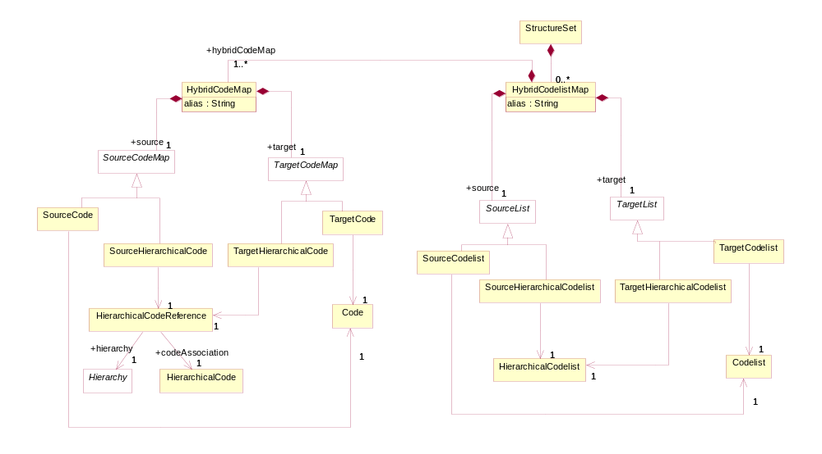
Figure 36: Class diagram of the Hybrid Codelist Map

Explanation of the Diagram

Narrative
The HybridCodelistMap maps the content of a Codelist and a HierachicalCodelist. It contains a mapping of the codes in the two schemes (HybridCodeMap). The HybridCodeMap maps either a Code or HierachicalCode to a Code or HierarchicalCode. The HierarchicalCode is identified by a combination of the Hierarchy and the HierarchicalCode.

Definitions
Class | Feature | Description
HybridCodelist  Map | Inherits from  NameableArtefact | Associates a Codelist and a Hierarchical Codelist.
 | alias | An alternate identification of the map, that allows the relation of multiple maps to be expressed by the sharing of this value.
 | +source | Association to the source List.
 | +target | Association to the target List.
 | +hybridCodeMap | Association to the set of Hybrid Code Maps in the Hybrid Codelist Map.
SourceList | Abstract Class  Sub classes  SourceCodelist  SourceHierarchical  Codelist
TargetList | Abstract Class  Sub classes  TargetCodelist  TargetHierarchical  Codelist
SourceCodelist |  | Identifies the Codelist where this is the source of the map.
TargetCodelist |  | Identifies the Codelist where this is the target of the map.
SourceHierarchical  Codelist |  | Identifies the Hierarchical Codelist where this is the source of the map.
TargetHierarchical  Codelist |  | Identifies the Hierarchical Codelist where this is the target of the map.
HybridCodeMap | Inherits from  AnnotableArtefact | Associates the source and target codes in Hybrid Codelist Map.
 | +source | Associates the Source Code Map.
 | +target | Associates the Target Code Map.
SourceCodeMap | Abstract Class  Sub classes  SourceCode  SourceHierarchical  Code
TargetCodeMap | Abstract Class  Sub classes  TargetCode  TargetHierarchical  Code
SourceCode |  | Identifies the Code where this is the source of the map.
TargetCode |  | Identifies the Code where this is the target of the map.
SourceHierarchical  Code |  | Identifies the Hierarchical Code where this is the source of the map
TargetHierarchical  Code |  | Identifies the Hierarchical Code where this is the target of the map.
HierarchicalCode Reference |  | References both the Hierarchy and the Hierarchical Code in a Hierarchical Codelist.
 | +hierarchy  +codeAssociation | Associates the Hierarchical Code in the Hierarchy of the Hierarchical Codelist.

Constraints

Scope
The scope of this section is to describe the support in the metamodel for specifying both the access to and the content of a data source. The information may be stored in a resource such as a registry for use by applications wishing to locate data and metadata which is available via the Internet. The Constraint is also used to specify a sub set of a Codelist which may used as a partial code list which is relevant in the context of the artefact to which the Constraint is attached e.g. Data Structure Definition, Dataflow, Provision Agreement.

Note that in this metamodel the term data source refers to both data and metadata sources, and data provider refers to both data and metadata providers.

A data source may be a simple file of data or metadata (in SDMX-ML format), or a database or metadata repository. A data source may contain data for many data or metadataflows (called DataflowDefinition, and MetadataflowDefinition in the model), and the mechanisms described in this section allow an organisation to specify precisely the scope of the content of the data source where this data source is registered (SimpleDataSource, QueryDataSource).

The DataflowDefinition and MetadataflowDefinition, themselves may be specified as containing only a sub set of all the possible keys that could be derived from a DataStructureDefinition or MetadataStructureDefinition.

These specifications are called Constraint in this model.

Inheritance

Class Diagram of Constrainable Artefacts - Inheritance
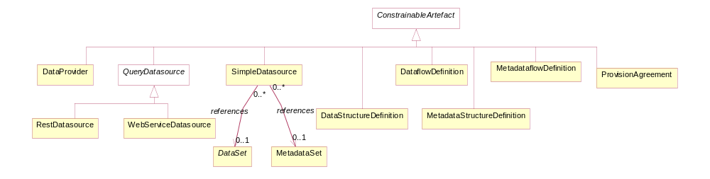
Figure 37: Inheritance class diagram of constrainable and provisioning artefacts

Explanation of the Diagram

Narrative
Any artefact that is derived from ConstrainableArtefact can have constraints defined. The artefacts that can have constraint metadata attached are:

- DataflowDefinition
- ProvisionAgreement
- DataProvider – this is restricted to release calendar
- MetadataflowDefinition
- DataStructureDefinition
- MetadataStructureDefinition
- DataSet
- SimpleDataSource – this is a registered data source where the registration references the actual DataSet or MetadataSet
- QueryDataSource
Note that, because the Constraint can specify a sub set of the component values implied by a specific Structure (such a specific DataStructureDefinition or specific MetadataStructureDefinition), the ConstrainableArtefacts must be associated with a specific Structure. Therefore, whilst the Constraint itself may not be linked directly to a DataStructureDefinition or MetadataStructureDefinition, the artefact that it is constraining will be linked to a DataStructureDefinition or MetadataStructureDefinition. As a Data Provider does not link to any one specific DSD or MSD the type of information that can be contained in a Constraint linked to a DataProvider is restricted to Release Calendar.

Constraints

Relationship Class Diagram – high level view
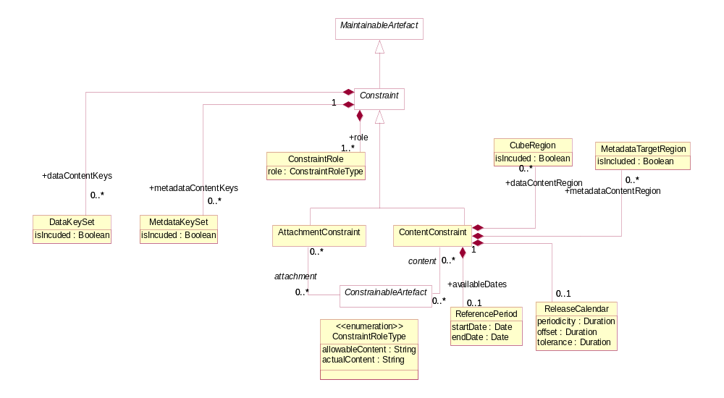
Figure 38: Relationship class diagram showing constraint metadata

Explanation of the Diagram

Narrative
The constraint mechanism allows specific constraints to be attached to a ConstrainableArtefact. With the exception of ReferencePeriod, and ReleaseCalendar these constraints specify a sub set of the total set of values or keys that may be present in any of the ConstrainableArtefacts.

For instance a DataStructureDefinition specifies, for each Dimension, the list of allowable code values. However, a specific DataflowDefinition that uses the DataStructureDefinition may contain only a sub set of the possible range of keys that is theoretically possible from the DataStructureDefinition definition (the total range of possibilities is sometimes called the Cartesian product of the dimension values). In addition to this, a DataProvider that is capable of supplying data according to the DataflowDefinition has a ProvisionAgreement, and the DataProvider may also wish to supply constraint information which may further constrain the range of possibilities in order to describe the data that the provider can supply. It may also be useful to describe the content of a datasource in terms of the KeySets or CubeRegions contained within it.

A ConstrainableArtefact can have two types of Constraint:

- ContentConstraint – is used solely as a mechanism to specify either the available set of keys (DataKeySet, MetadataKeySet) or set of component values (CubeRegion, MetadatTargetRegion) in a DataSource such as a DataSet or a database (QueryDatasource), or the allowable keys that can be constructed from a DataStructureDefinition. Multiple such constraints may be present for a ConstrainableArtefact. For instance, there may be a ContentConstraint that specifies the values allowed for the ConstrainableArtefact (role is allowableContent) which can be used for validation or for constructing a partial code list, whilst another constraint can specify the actual content of a data or metadata source (role is actualContent).
- AttachmentConstraint – is used as a mechanism to define slices of the full set of data and to which metadata can be attached in a Data Set or MetadataSet. These slices can be defined either as a set of keys (KeySet) or a set of component values (CubeRegion). There can be many AttachmentConstraints specified for a specific AttachableArtefact.

In addition to (DataKeySet, MetadataKeySet, CubeRegion, MetadataTargetRegion, a Constraint can have a ReferencePeriod defining one of more date ranges (ValidityPeriod) specifying the time period for which data or metadata are available in the ConstrainableArtefact and a ReleaseCalendar specifying when data are released for publication or reporting.

Relationship Class Diagram – Detail
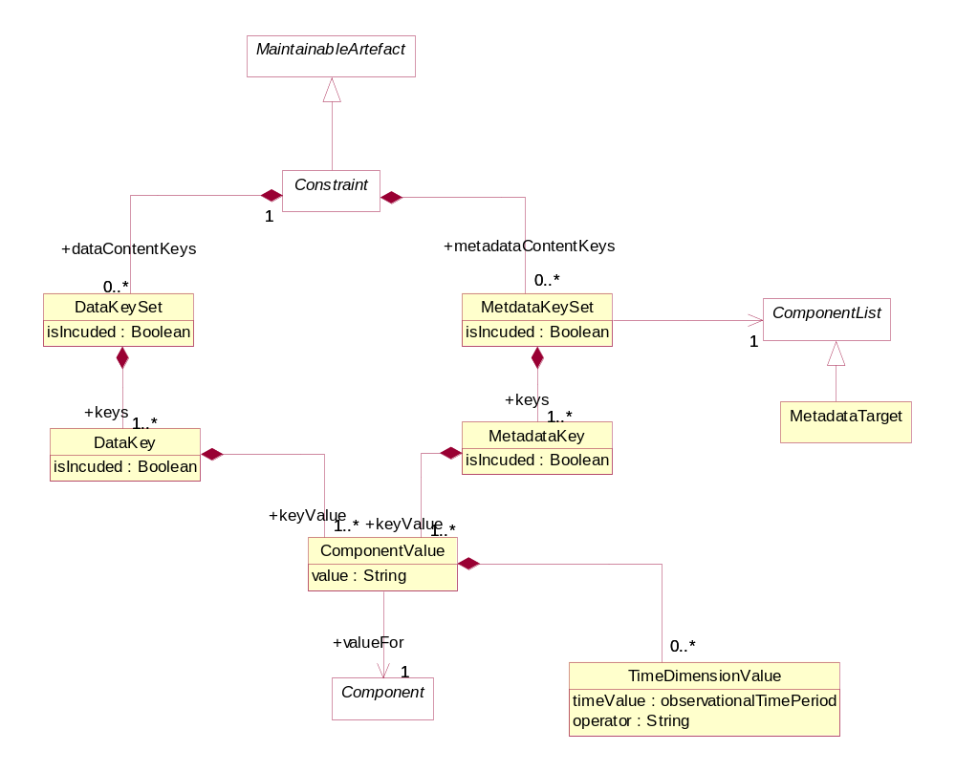
Figure 39: Constraints - Key Set Constraints
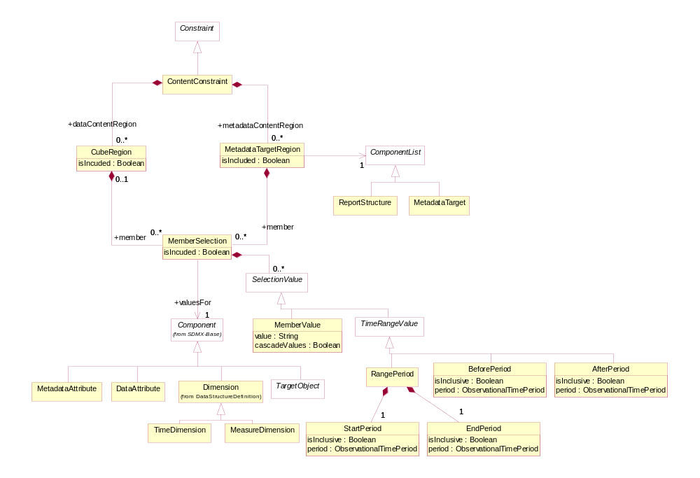
Figure 40: Constraints - Cube Region and Metadata Target Region Constraints

Explanation of the Diagram
A Constraint is a MaintainableArtefact.

A Constraint has a choice of two ways of specifying value sub sets:

- As a set of keys that can be present in the DataSet (DataKeySet) or MetadataSet (MetadataKeySet). Each DataKey or MetadataKey specifies a number of ComponentValues each of which reference a Component (e.g. Dimension, TargetObject). Each ComponentValue is a value that may be present for a Component of a structure when contained in a DataSet or MetadataSet. The MetadataKeySet must also identify the MetadataTarget as there can be many of each of these in a MetadataStructureDefinition. For the DataKeySet the equivalent identification is not necessary as there is only one DimensionDescriptor and one AttributeDescriptor.
- As a set of CubeRegions or MetadataTaregetRegions each of which defines a “slice” of the total structure (MemberSelection) in terms of one or more MemberValues that may be present for a Component of a structure when contained in a DataSet or MetadataSet.
The difference between (1) and (2) above is that in (1) a complete key is defined whereas in (2) above the “slice” defines a list of possible values for each of the Components but does not specify specific key combinations. In addition, in (1) the association between Component and DataKeyValue or MetadataKeyValue is constrained to the components that comprise the key or identifier, whereas in (2) it can contain other component types (such as attributes). The value in ComponentValue.value and MemberValue.value must be consistent with the Representation declared for the Component in the DataStructureDefinition or MetadataStructureDefinition. Note that in all cases the “operator” on the value is deemed to be “equals”. Furthermore, it is possible in a MemberValue to specify that child values (e.g. child codes) are included in the constraint by means of the cascadeValues attribute.

It is possible to define for the DataKeySet, DataKey, MetadataKeySet, MetadataKey, CubeRegion, MetadataTargetRegion, and MemberSelection whether the set is included (isIncluded = “true”) or excluded (isIncluded = ”false”) from the constraint definition. This attribute is useful if, for example, only a small sub-set of the possible values are not included in the set, then this smaller sub-set can be defined and excluded from the constraint. Note that if the child construct is “included: and the parent construct is “excluded” then the child construct is included in the list of constructs that are “excluded”.

Definitions
Class | Feature | Description
Constrainable Artefact | Abstract Class  Sub classes are:  DataflowDefinition  Metadataflow  Definition  ProvisionAgreement  DataProvider  QueryDatasource  SimpleDatasource  DataStructure  Definition  MetadataStructure Definition | An artefact that can have Constraints specified.
 | content | Associates the metadata that constrains the content to be found in a data or metadata source linked to the Constrainable Artefact.
 | attachment | Associates the metadata that constrains the valid content of a Constrainable Artefact to which metadata may be attached.
Constraint | Inherits from  MaintainableArtefact  Abstract class. Sub classes are:  AttachmentConstraint  ContentConstraint | Specifies a sub set of the definition of the allowable or actual content of a data or metadata source that can be derived from the Structure that defines code lists and other valid content.
 | +availableDates | Association to the time period that identifies the time range for which data or metadata are available in the data source.
 | +dataContentKeys | Association to a sub set of Data Key Sets (i.e. value combinations) that can be derived from the definition of the structure to which the Constrainable Artefact is linked.
 | +metadataContentKeys | Association to a sub set of Metdata Key Sets (i.e. value combinations) that can be derived from the definition of the Structure to which the Constrainable Artefact is linke
 | +dataContentRegion | Association to a sub set of component values that can be derived from the Data Structure Definition to which the Constrainable Artefact is linked.
 | +metadataContentRegion | Association to a sub set of component values that can be derived from the Metadata Structure Definition to which the Constrainable Artefact is linked.
ContentConstraint | Inherits from  Constraint | Defines a Constraint in terms of the content that can be found in data or metadata sources linked to the Constrainable Artefact to which this constraint is associated.
 | +role | Association to the role that the Constraint plays
ConstraintRole |  | Specifies the way the type of content of a Constraint in terms of its purpose.
 | allowableContent | The Constraint contains a specification of the valid sub set of the Component values or keys.
 | actualContent | The Constraint contains a specification of the actual content of a data or metadata source in terms of the Component values or keys in the source.
Attachment  Constraint | Inherits from  Constraint | Defines a Constraint in terms of the combination of component values that may be found in a data source, and to which a Constrainable Artefact may be associated in a structure definition.
DataKeySet |  | A set of data keys.
 | isIncluded | Indicates whether the Data Key Set is included in the constraint definition or excluded from the constraint definition.
 | +keys | Association to the Data Keys in the set.
MetadataKeySet |  | A set of metadata keys.
 | isIncluded | Indicates whether the Metadata Key Set is included in the constraint definition or excluded from the constraint definition.
 | +keys | Association to the Metadata Keys in the set.
DataKey |  | The values of a key in a data set.
 | isIncluded | Indicates whether the Data Key is included in the constraint definition or excluded from the constraint definition.
 | +keyValue | Associates the Component Values that comprise the key.
MetadataKey |  | The values of a key in a metadata set.
 | isIncluded | Indicates whether the Metdadata Key is included in the constraint definition or excluded from the constraint definition.
 | +keyValue | Associates the Component Values that comprise the key.
ComponentValue |  | The identification of and value of a Component of the key (e.g. Dimension)
 | value | The value of Component
 | +valueFor | Association to the Component (e.g. Dimension) in the Structure to which the Constrainable Artefact is linked.
TimeDimensionValue |  | The value of the Time Dimension component.
 | timeValue | The value of the time period.
 | operator | Indicates whether the specified value represents and exact time or time period, or whether the value should be handled as a range.  A value of greaterThan or greaterThanOrEqual indicates that the value is the beginning of a range (exclusive or inclusive, respectively).  A value of lessThan or lessThanOrEqual indicates that the value is the end or a range (exclusive or inclusive, respectively).  In the absence of the opposite bound being specified for the range, this bound is to be treated as infinite (e.g. any time period after the beginning of the provided time period for greaterThanOrEqual)
CubeRegion |  | A set of Components and their values that defines a sub set or “slice” of the total range of possible content of a data structure to which the Constrainable Artefact is linked.
 | isIncluded | Indicates whether the Cube Region is included in the constraint definition or excluded from the constraint definition.
 | +member | Associates the set of Components that define the sub set of values.
MetadataTargetRegion |  | A set of Components and their values that defines a sub set or “slice” of the total range of possible content of a metadata structure to which the Constrainable Artefact is linked.
 | isIncluded | Indicates whether the Metadata Target Region is included in the constraint definition or excluded from the constraint definition.
 | +member | Associates the set of Components that define the sub set of values.
MemberSelection |  | A set of permissible values for one component of the axis.
 | isIncluded | Indicates whether the Member Selection is included in the constraint definition or excluded from the constraint definition.
 | +valuesFor | Association to the Component in the Structure to which the Constrainable Artefact is linked, which defines the valid Representation for the Member Values.
MemberValue |  | A single value of the set of values for the Member Selection.
 | value | A value of the member.
 | cascadeValues | Indicates that the child nodes of the member are included in the Member Selection (e.g. child codes)
TimeRangeValue | Abstract Class  Concrete Classes  BeforePeriod  AfterPeriod  RangePeriod | A time value or values that specifies the date or dates for which the constrained selection is valid.
BeforePeriod | Inherits from  TimeRangeValue | The period before which the constrained selection is valid.
 | isInclusive | Indication of whether the date is inclusive in the period.
AfterPeriod | Inherits from  TimeRangeValue | The period after which the constrained selection is valid.
 | isInclusive | Indication of whether the date is inclusive in the period.
RangePeriod |  | The start and end periods in a date range.
 | +start | Association to the Start Period.
 | +end | Association to the End Period.
StartPeriod | Inherits from  TimeRangeValue | The period from which the constrained selection is valid.
 | isInclusive | Indication of whether the date is inclusive in the period.
EndPeriod | Inherits from  TimeRangeValue | The period to which the constrained selection is valid.
 | isInclusive | Indication of whether the date is inclusive in the period.
ReferencePeriod |  | A set of dates that constrain the content that may be found in a data or metadata set.
 | startDate | The start date of the period.
 | endDate | The end date of the period.
ReleaseCalendar |  | The schedule of publication or reporting of the data or metadata
 | periodicity | The time period between the releases of the data or metadata
 | offset | Interval between January 1st and the first release of the data
 | tolerance | Period after which the data or metadata may be deemed late.

Data Provisioning

Class Diagram
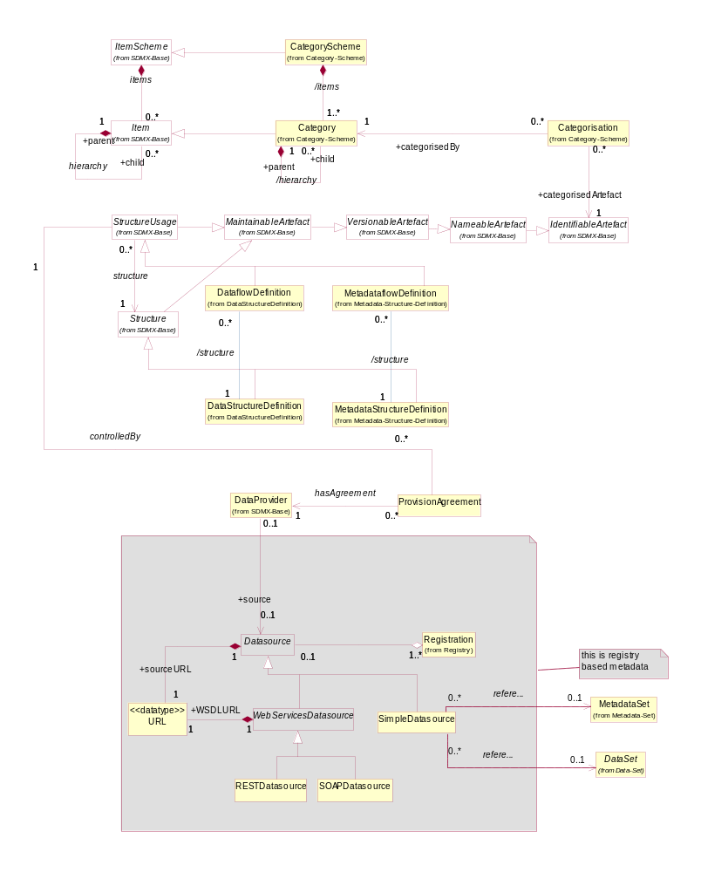
Figure 41: Relationship and inheritance class diagram of data provisioning

Explanation of the Diagram

Narrative
This sub model links many artefacts in the SDMX-IM and is pivotal to an SDMX metadata registry, as all of the artefacts in this sub model must be accessible to an application that is responsible for data and metadata registration or for an application that requires access to the data or metadata.

Whilst a registry contains all of the metadata depicted on the diagram above, the classes in the grey shaded area are specific to a registry based scenario where data sources (either physical data and metadata sets or databases and metadata repositories) are registered. More details on how these classes are used in a registry scenario can be found in the SDMX Registry Interface document. (Section 5 of the SDMX Standards).

A ProvisionAgreement links the artefact that defines how data and metadata are structured and classified (StructureUsage) to the DataProvider, and, by means of a data or metadata registration, it references the Datasource (this can be data or metadata), whether this be an SDMX conformant file on a website (SimpleDatasource) or a database service capable of supporting an SDMX query and responding with an SDMX conformant document (QueryDatasource).

The StructureUsage, which has concrete classes of DataflowDefinition and MetadataflowDefinition identifies the corresponding DataStructureDefinition or MetadataStructureDefinition, and, via Categorisation, can link to one or more Category in a CategoryScheme such as a subject matter domain scheme, by which the StructureUsage can be classified. This can assist in drilling down from subject matter domains to find the data or metadata that may be relevant.

The SimpleDatasource links to the actual DataSet or MetadataSet on a website (this is shown on the diagram as a dependency called “references”). The sourceURL is obtained during the registration process of the DataSet or the MetadataSet. Additional information about the content of the SimpleDatasource is stored in the registry in terms of a ContentConstraint (see 10.3) for the Registration.

The QueryDatasource is an abstract class that represents a data source which can understand an SDMX-ML query (SOAPDatasource) or RESTful query (RESTDatasource) and respond appropriately. Each of these different Datasources inherit the dataURL from Datasource, and the QueryDatasource has an additional URL to locate a WSDL or WADL document to describe how to access it. All other supported protocols are assumed to use the SimpleDatasource URL.

The diagram below shows in schematic way the essential navigation through the SDMX structural artefacts that eventually link to a data or metadata registration.

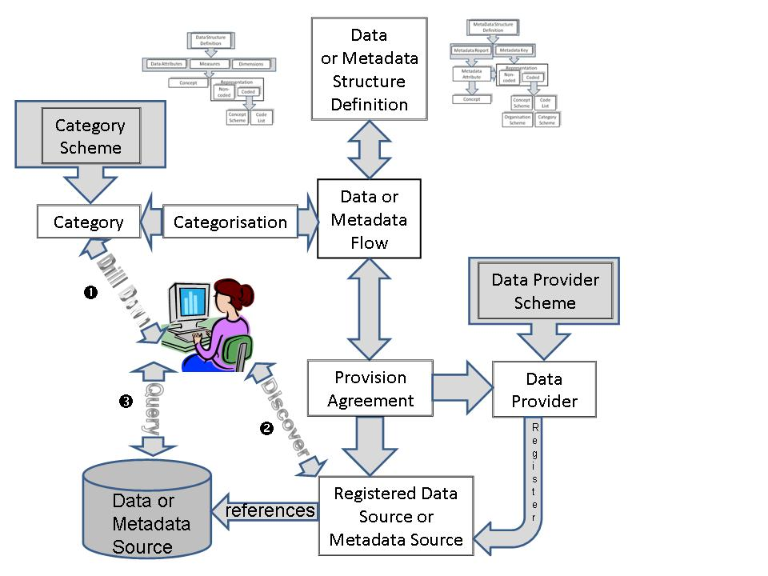
Figure 42: Schematic of the linking of structural metadata to data and metadata registration

Definitions

Class | Feature | Description
StructureUsage | Abstract class:  Sub classes are:  DataflowDefinition  MetadataflowDefinition | This is described in the Base.
 | controlledBy | Association to the Provision Agreements that comprise the metadata related to the provision of data.
DataProvider |  | See Organisation Scheme.
 | hasAgreement | Association to the Provision Agreements for which the provider supplies data or metadata.
 | +source | Association to a data or metadata source which can process a data or metadata query.
ProvisionAgreement |  | Links the Data Provider to the relevant Structure Usage (e.g. Dataflow Definition or Metadataflow Definition) for which the provider supplies data or metadata The agreement may constrain the scope of the data or metadata that can be provided, by means of a Constraint.
 | +source | Association to a data or reference metadata source which can process a data or metadata query.
Datasource | Abstract class:  Sub classes are:  SimpleDatasource  WebServices  Datasource | Identification of the location or service from where data or reference metadata can be obtained.
 | +sourceURL | The URL of the data or reference metadata source (a file or a web service).
SimpleDatasource |  | An SDMX-ML data set accessible as a file at a URL.
WebServices  Datasource | Abstract class:  Inherits from:  Datasource  Sub classes are:  RESTDatasource  SOAPDatasource | A data or reference metadata source which can process a data or metadata query.
RESTDatasource |  | A data or reference metadata source that is accessible via a RESTful web services interface.
SOAPDatasource |  | A data or reference metadata source that conforms to a SOAP web service interface.
 | +WSDLURL | Association to the URL of the Web Service Definition Language (SOAP) or Web Service Application Language (REST) profile of the web service.
Registration |  | This is not detailed here but is shown as the link between the SDMX-IM and the Registry Service API. It denotes a data or metadata registration document.

Process

Introduction
In any system that processes data and reference metadata the system itself is a series of processes and in each of these processes the data or reference metadata may undergo a series of transitions. This is particularly true of its path from raw data to published data and reference metadata. The process model presented here is a generic model that can capture key information about these stages in both a textual way and also in a more formalised way by linking to specific identifiable objects, and by identifying software components that are used.

Model – Inheritance and Relationship view

Class Diagram
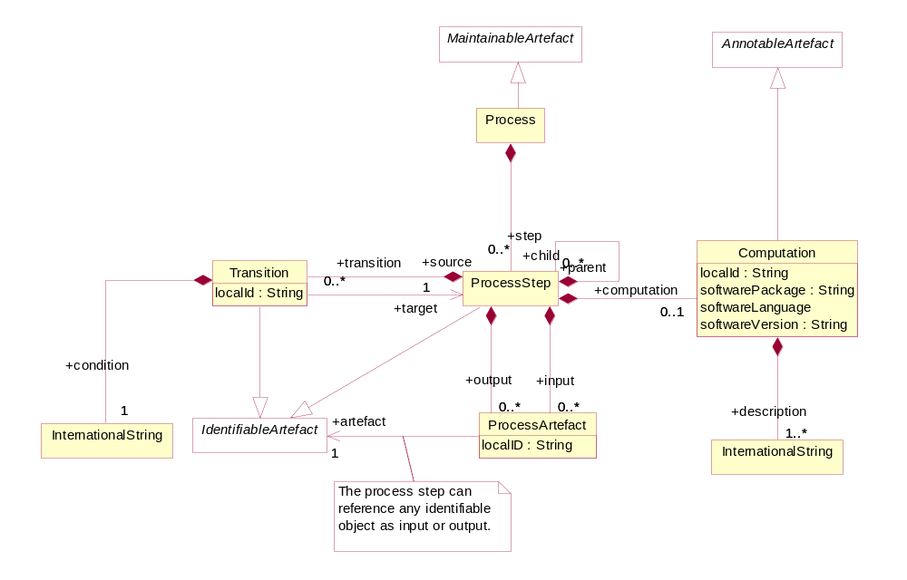
Figure 43: Inheritance and Relationship class diagram of Process and Transitions

Explanation of the Diagram

Narrative
The Process is a set of hierarchical ProcessSteps. Each ProcessStep can take zero or more IdentifiableArtefacts as input and output. Each of the associations to the input and output IdentifiableArtefacts (ProcessArtefact) can be assigned a localID.

The computation performed by a ProcessStep is optionally described by a Computation, which can identify the software used by the ProcessStep and can also be described in textual form (+description) in multiple language variants. The Transition describes the execution of ProcessSteps from +source ProcessStep to +target ProcessStep based on the outcome of a +condition that can be described in multiple language variants.

Definitions
Class | Feature | Description
Process | Inherits from  Maintainable | A scheme which defines or documents the operations performed on data or metadata in order to validate data or metadata to derive new information according to a given set of rules.
 | +step | Associates the Process Steps.
ProcessStep | Inherits from  IdentifiableArtefact | A specific operation, performed on data or metadata in order to validate or to derive new information according to a given set of rules.
 | +input | Association to the Process Artefact that identifies the objects which are input to the Process Step.
 | +output | Association to the Process Artefact that identifies the objects which are output from the Process Step.
 | +child | Association to child Processes that combine to form a part of this Process.
 | +computation | Association to one or more Computations.
 | +transition | Association to one or more Transitions.
Computation |  | Describes in textual form the computations involved in the process.
 | localId | Distinguishes between Computations in the same Process.
 | softwarePackage  softwareLanguage  softwareVersion | Information about the software that is used to perform the computation.
 | +description | Text describing or giving additional information about the computation. This can be in multiple language variants.
Transition | Inherits from  IdentifiableArtefact | An expression in a textual or formalised way of the transformation of data between two specific operations (Processes) performed on the data.
 | +target | Associates the Process Step that is the target of the Transition.
 | +condition | Associates a textual description of the Transition.
ProcessArtefact |  | Identification of an object that is an input to or an output from a Process Step.
 | +artefact | Association to an Identifiable Artefact that is the input to or the output from the Process Step.

Transformations and Expressions

Scope
The purpose of this package in the model is to be able to track the derivation of data. It is similar in concept to lineage in data warehousing – i.e. how data are derived.

The functionality of this part of the model allows the identification and documentation of the calculations performed (these will normally be automated, program calculations), as well as defining structures that support a syntax neutral expression “grammar” that can specify the operations at a granular level such that a program can “read” the metadata and compose the expression required in whatever computer language is appropriate.

This part of the model also allows specifying and documenting the coherence rules among different data, expressing them as calculations (for example, the coherence rule “a + b = c” can be written as “a + b - c = 0” and checked through the calculation “if((a + b – c) = 0, then …, else …)”).

It should be noted that the model represented below is similar in scope and content to the Expression metamodel in the Common Warehouse Metamodel (CWM) developed by the Object Management Group (OMG). This specification can be found at:

http://www.omg.org/cwm

The Expression metamodel is described in Section 8.5 of Part 1 of the CWM specification. The class diagram shown below is an interpretation of the CWM Expression metamodel expressed in the base classes of the SDMX-IM.

Model - Inheritance View

Class Diagram
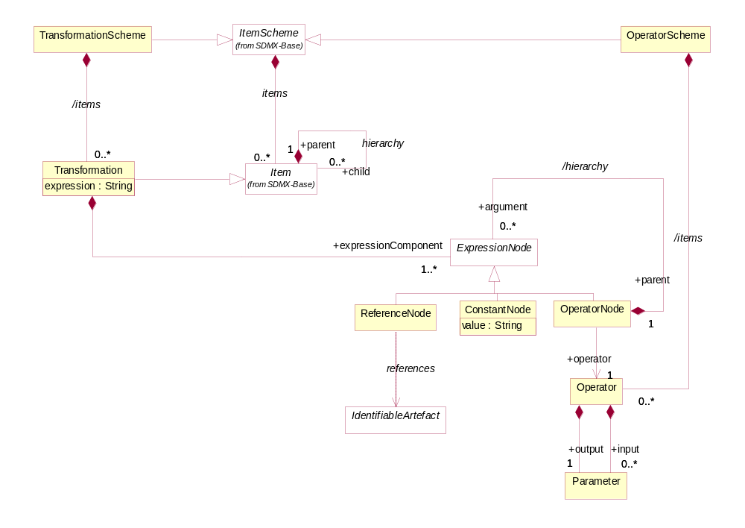
Figure 44: Inheritance and relationship class diagram of transformation classes

Explanation of the Diagram

Narrative
There are three type of ItemScheme relevant to this model.

- A TransformationScheme which comprises one or more Transformations.
- An OperatorScheme which comprises one or more Operators.
- An ExpressionNodeScheme scheme which contains one or more ExpressionNodes..

The model presented here is a basic framework which can be used for expressions and transformations, but requires more work on elaborating its integration into the model and its actual use within the model. This elaboration will be in a future release of the standard.

The expression concept in the SDMX-IM takes a functional view of expression trees, resulting in the ability of relatively few expression node types to represent a broad range of expressions. Every function or traditional mathematical operator that appears in an expression hierarchy is represented by the +operator role on the association to Operator which in turn comprises input and output Parameter. For example, the arithmetic plus operation “a + b” can be thought of as the function “sum(a, b).” The “sum” is the Operator, and “a” and “b” are its Parameters. A parameter is a generic possible input and output of an operator (e.g. base and exponent are the parameters of the power operator), while an argument is the specific value that a parameter takes in a specific calculation (e.g. in the Einstein equation “E = MC²”. the arguments of the “power” operation are “C” (the base) and “2” (the exponent)).The actual semantics of a particular function or operation are left to specific tool implementations and are not captured by the SDMX-IM.

The hierarchical nature of the SDMX-IM representation of expressions is achieved by the recursive nature of the OperatorNode association. This association allows the sub-hierarchies within an expression to be treated as actual arguments of their parent nodes.

The model can be used equally to define data derivations and to define integrity checks (e.g. the Sum of A+B must equal C).

Although the model defines the data structures that are used to contain a syntax neutral expression, the model itself does not specify a syntax neutral expression grammar. Alternatively, the function can be described in a text form either as an unstructured explanation of the function, or as a more formal language like BNF.

The data structures work as follows:

The actual basic mathematical functions that need to be performed (e.g. sum, multiply, divide, assign (=), <, > etc.) are defined as Operators an OperatorScheme. For each Operator the input and output Parameters, are defined in the Parameter class.

The calculations are defined as Transformations in a TransformationScheme. A Transformation is a specific calculation and is specified by means of an expression, which is obtained by applying one or more Operators in the desired order (for example, in the textual form, using parenthesis) and specifying the actual arguments for the Operators’ Parameters; the result of the whole expression is assigned (=) to the model item that is the result of the Transformation (that is “E” in the Einstein equation). A Transformation operates on existing IdentifiableArtefacts and its result is another IdentifiableArtefact. A calculated IdentifiableArtefact may be in its turn be an operand of other Transformations.

The expression of a Transformation (for example, for the Einstein equation calculus, “E = M*(C**2)”) may be decomposed in a hierarchy of ExpressionNodes (in the example, “M”, “C”, “2”, *, **). The ExpressionNode can be a ReferenceNode, a ConstantNode or an OperatorNode. The ReferenceNode references an identifiable model artefact (in the example, “M” and “C”). The ConstantNode is by definition a constant value (in the example “2”). The OperatorNode references an Operator in the OperatorScheme (in the example *, **). The Transformation has an association to its component ExpressionNodes.

The hierarchy of the ExpressionNodes conveys the order in which the operators are applied in the expression and is obtained by means of the /hierarchy association of the OperatorNode class, in which the child ExpressionNodes are the arguments of the parent OperatorNode. The child ExpressionNodes must correspond to the formal parameters of the Operator referenced by the parent OperatorNode in the correct sequence. The (child) ExpressionNode can be the result of another operation (that is another OperatorNode) or can be a Constant or can be a reference to an IdentifiableArtefact (ReferenceNode). All IdentifiableArtefacts in the SDMX-IM have a unique urn comprising the values of the individual objects that identify it. The structure of this urn is defined in the Registry Specification. An example would be the urn of a code which comprises the agency:code-list-id.code-id – an actual example is "urn:sdmx:org.sdmx.infomodel.codelist.Code=TFFS:CL_AREA(1.0).1A".

Definitions
Class | Feature | Description
Transformation  Scheme | Inherits from  ItemScheme | A scheme which defines or documents the transformations required in order to derive or validate data from other data.
Transformation | Inherits from  Item | An individual Transformation.
 | +expressionComponent | Association to an Expression Node.
ExpressionNode | Abstract class  Sub Classes  ReferenceNode  ConstantNode  OperatorNode | A node in a possible hierarchy of nodes that together define or document an expression.
 | /hierarchy | Association to child Expression Nodes
ReferenceNode | Inherits from  ExpressionNode | A specific type of Expression Node that references a specific object.
 | references | Association to the Identifiable Artefact that is the referenced object.
ConstantNode | Inherits from  ExpressionNode | A specific type of Expression Node that contains a constant value.
 | value | The value of the Constant
OperatorNode | Inherits from  ExpressionNode | A specific type of Expression Node that references an Operator
 | +operator | Association to an Operator that defines the mathematical operator of the Operator Node.
 | +arguments | Association to mathematical arguments of an Operator Node.
OperatorScheme | Inherits from  ItemScheme | A scheme which defines mathematical operators.
Operator | Inherits from  Item | The mathematical operator in an Operator Scheme.
 | +input | Association to the input Parameters of the Operator
 | +output | Association to the output Parameter of the Operator.
Parameter |  | The input or output of an Operator.

Appendix 1: A Short Guide To UML in the SDMX Information Model

Scope
The scope of this document is to give a brief overview of the diagram notation used in UML. The examples used in this document have been taken from the SDMX UML model.

Use Cases
In order to develop the data models it is necessary to understand the functions that require to be supported. These are defined in a use case model. The use case model comprises actors and use cases and these are defined below.

The actor can be defined as follows:
“An actor defines a coherent set of roles that users of the system can play when interacting with it. An actor instance can be played by either an individual or an external system”

The actor is depicted as a stick man as shown below.

Figure 45 Actor

The use case can be defined as follows:
“A use case defines a set of use-case instances, where each instance is a sequence of actions a system performs that yields an observable result of value to a particular actor”


Figure 46 Use case

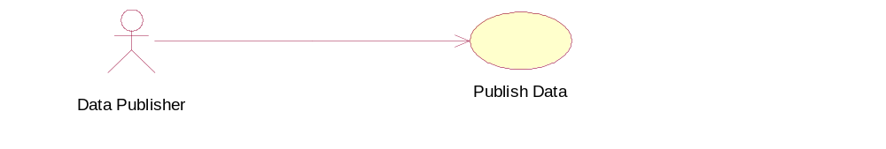
Figure 47 Actor and use case

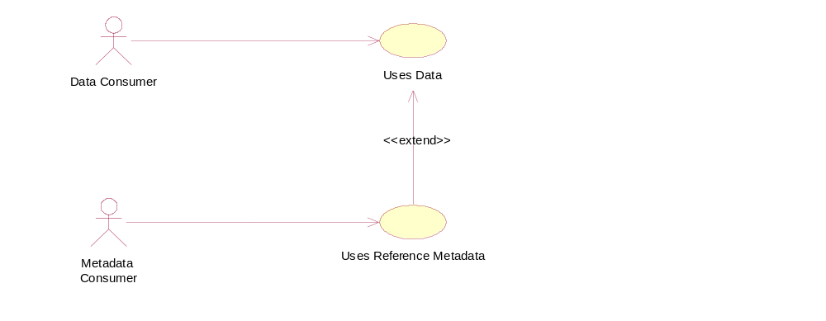
Figure 48 Extend use cases
An extend use case is where a use case may be optionally extended by a use case that is independent of the using use case. The arrow in the association points to he owning use case of the extension. In the example above the Uses Data use case is optionally extended by the Uses Metadata use case.

Classes and Attributes

General
A class is something of interest to the user. The equivalent name in an entity-relationship model (E-R model) is the entity and the attribute. In fact, if the UML is used purely as a means of modelling data, then there is little difference between a class and an entity.

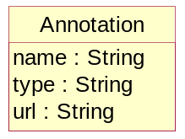
Figure 49 Class and its attributes

Figure 49 shows that a class is represented by a rectangle split into three compartments. The top compartment is for the class name, the second is for attributes and the last is for operations. Only the first compartment is mandatory. The name of the class is Annotation, and it belongs to the package SDMX-Base. It is common to group related artefacts (classes, use-cases, etc.) together in packages. . Annotation has three “String” attributes – name, type, and url. The full identity of the attribute includes its class e.g. the name attribute is Annotation.name.

Note that by convention the class names use UpperCamelCase – the words are concatenated and the first letter of each word is capitalized. An attribute uses lowerCamelCase - the first letter of the first (or only) word is not capitalized, the remaining words have capitalized first letters.

Abstract Class
An abstract class is drawn because it is a useful way of grouping classes, and avoids drawing a complex diagram with lots of association lines, but where it is not foreseen that the class serves any other purpose (i.e. it is always implemented as one of its sub classes). In the diagram in this document an abstract class is depicted with its name in italics, and coloured white.

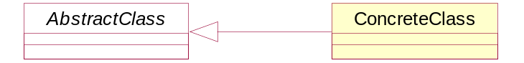
Figure 50 Abstract and concrete classes

Associations

General
In an E-R model these are known as relationships. A UML model can give more meaning to the associations than can be given in an E-R relationship. Furthermore, the UML notation is fixed (i.e. there is no variation in the way associations are drawn). In an E-R diagram, there are many diagramming techniques, and it is the relationship in an E-R diagram that has many forms, depending on the particular E-R notation used.

Simple Association
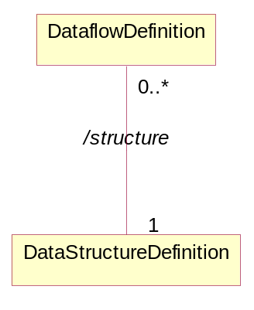
Figure 51 A simple association

Here the DataflowDefinition class has an association with the DataStructureDefinition class. The diagram shows that a DataflowDefinition can have an association with only one DataStructureDefinition (1) and that a DataStructureDefinition can be linked to many DataflowDefinitions (0..*). The association is sometimes named to give more semantics.

In UML it is possible to specify a variety of “multiplicity” rules. The most common ones are:

- Zero or one (0..1)
- Zero or many (0..*)
- One or many (1..*)
- Many (*)
- Unspecified (blank)

Aggregation
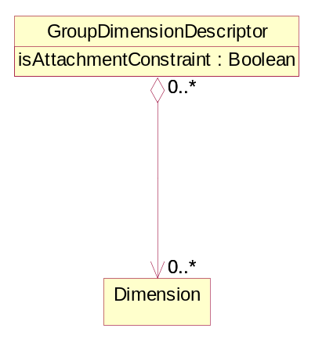
Figure 52: A simple aggregate association

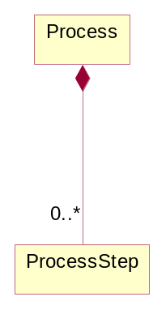
Figure 53 A composition aggregate association

An association with an aggregation relationship indicates that one class is a subordinate class (or a part) of another class. In an aggregation relationship. There are two types of aggregation, a simple aggregation where the child class instance can outlive its parent class, and a composition aggregation where
the child class's instance lifecycle is dependent on the parent class's instance lifecycle. In the simple aggregation it is usual, in the SDMX Information model, for this association to also be a reference to the associated class.

Association Names and Association-end (role) Names
It can be useful to name associations as this gives some more semantic meaning to the model i.e. the purpose of the association. It is possible for two classes to be joined by two (or more) associations, and in this case it is extremely useful to name the purpose of the association. Figure 54 shows a simple aggregation between CategoryScheme and Category called /items (this means it is derived from the association between the super classes – in this case between the ItemScheme and the Item, and another between Category called /hierarchy.

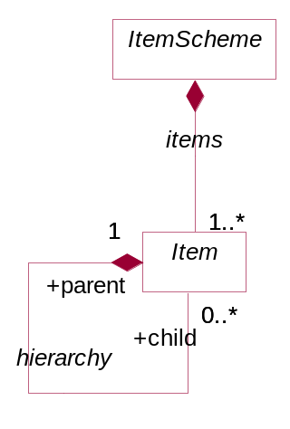
Figure 54 Association names and end names
Furthermore, it is possible to give role names to the association-ends to give more semantic meaning – such as parent and child in a tree structure association. The role is shown with “+” preceding the role name (e.g. in the diagram above the semantic of the association is that a Item can have zero or one parent Items and zero or many child Item).

In this model the preference has been to use role names for associations between concrete classes and association names for associations between abstract classes. The reason for using an association name is often useful to show a physical association between two sub classes that inherit the actual association between the super class from which they inherit. This is possible to show in the UML with association names, but not with role names. This is covered later in “Derived Association”.

Note that in general the role name is given at just one end of the association.

Navigability
Associations are, in general, navigable in both directions. For a conceptual data model it is not necessary to give any more semantic than this.

However, UML allows a notation to express navigability in one direction only. In this model this “navigability” feature has been used to represent referencing. In other words, the class at the navigable end of the association is referenced from the class at the non-navigable end. This is aligned, in general, with the way this is implemented in the XML schemas.
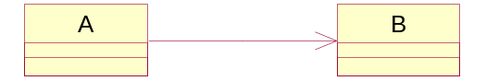
Figure 55 One way association
Here it is possible to navigate from A to B, but there is no implementation support for navigatation from B to A using this association.

Inheritance
Sometimes it is useful to group common attributes and associations together in a super class. This is useful if many classes share the same associations with other classes, and have many (but not necessarily all) attributes in common. Inheritance is shown as a triangle at the super class.

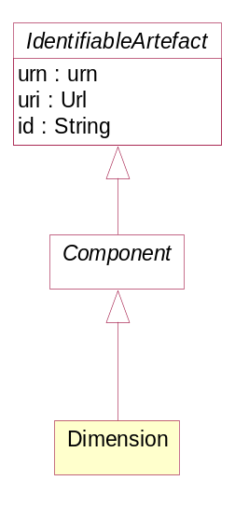
Figure 56 Inheritance
Here the Dimension is derived from Component which itself is derived from IdentifiableArtefact. Both Component and IdentifiableArtefact are abstract superclasses. The Dimension inherits the attributes and associations of all of the the super classes in the inheritance tree. Note that a super class can be a concrete class (i.e. it exists in its own right as well as in the context of one of its sub classes), or an abstract class.

Derived association
It is often useful in a relationship diagram to show associations between sub classes that are derived from the associations of the super classes from which the sub classes inherit. A derived association is shown by “/” preceding the association name e.g. /name.

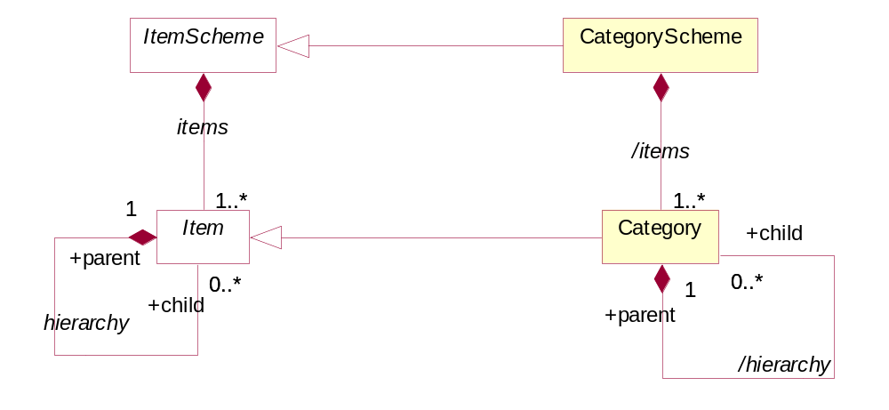
Figure 57 Derived associations

OLAP: On line analytical processing
BNF: Backus Naur Form

