Volume

1

schedule forward

Forward Intelligence Systems, LLC

Administrative User Guide

Forward Intelligence Systems, LLC

Schedule Forward Administrative User’s Guide

© Forward Intelligence Systems, LLC

5120 South Julian Drive • Suite 148

Tucson, AZ 85629

Phone 520.477.1349

Table of Contents

* Intro to Schedule Forward 1
* Logging into Schedule Forward 1
* Resetting a lost password 2

The reset page 2

* Administrative Dashboard 2

Who’s Currently Working 2

Latest Timeoff Requests 3

Providers and Staff 4

Alerts and Notification 5

* Providers 5

Searching for Providers 6

Edit a Provider 6

Edit Provider Preferences 6

Edit Provider Timeoff Requests 7

Delete a Provider 9

Add a New Provider 9

Export Provider List 9

* Shifts 9

Searching for Shifts 10

Edit a Shift 10

Delete a Shift 11

Add a New Shift 11

Export Shift List 12

* Traded Shifts 12

Searching for trade requests 13

* Messages 14
* Groups and Roles Management 15
* Configurations 16

Chapter

1

Intro to Schedule Forward

Schedule Forward is a physician scheduling application designed to make schedule creation quick, easy, and worry-free.

S

chedule Forward is a web-based application that is designed to significantly reduce the time it takes to schedule physicians within hospitals of all sizes. It includes features such as **auto-scheduling**, **weekend normalization**, **shift trading**, **time off requests,** and a wide array of **customizations** built to enable virtually any hospital to tailor Schedule Forward to seamlessly fit into its workflow.

No installation is required to run Schedule Forward. Simply open any web browser available on any internet-connected computer or mobile device and gain access to the entire application.

# Logging into Schedule Forward

Logging into Schedule Forward is as simple as pointing your browser to the application’s web address and supplying your login credentials that you established during the signup process.

Steps to login to Schedule Forward:

1. Browse to **http://www.schedulefwd.com**
2. Supply input your **username** and **password.** Then select **hospital**
3. Click the ‘Login’ button

The application will authenticate your credentials and redirect you to your administrative dashboard after successfully logging in. If you forgot your password, click the ‘Forgot your password’ link.

# Resetting a lost password

In the event that a password has been lost or forgotten, point your browser to the Schedule Forward login page and select the ‘Forgot your password?’ link. This process will enable users to reset their passwords and login.

passwords can only be reset, not retrieved.

Steps to reset your password:

1. Browse to **http://www.schedulefwd.com**
2. Click the red ‘Forgot your password?’ link
3. On the new form, supply your **email** and **hospital**
4. Click the ‘Recover Password’ button

The system will authenticate your email and hospital and will send an email to the address that was supplied. The email will contain instructions on resetting the password, including a clickable link that brings the user to the reset page.

## The reset page

From the reset page, simply supply a new password (twice) and click the ‘Reset Password’ button to save the password. Then, navigate back to the main login form at http://www.schedulefwd.com and supply the new password. Click the ‘Login’ button.

# Administrative Dashboard

The administrative dashboard is the first page that administrators see after logging into Schedule Forward. It provides a quick look at common information that is important to the hospital-working environment.

The dashboard contains several links down the left hand side that provide admin users with quick access to schedule information, statistics, providers, alerts and notifications generated by Schedule Forward.

The administrative dashboard should be the administrator’s most frequently accessed page throughout the month to monitor their hospital’s scheduling data. The dashboard gives admin users a read only ability to monitor trade and time off requests, view charts that visually depict providers and their working schedules as well as a view current system-wide alerts and notifications. By default, the dashboard will display the ‘Who’s Currently Working’ view.

## Who’s Currently Working

This page contains two different tables of information. The first table, titled ‘*Who’s Currently Working*’ displays the entire day’s listing of shifts, times and the providers that are assigned to them. If there are multiple providers within a single shift, the provider’s names are separated by a comma. This table is static ordered by the earliest shift.

#### Figure: ‘Who’s Currently Working’ table

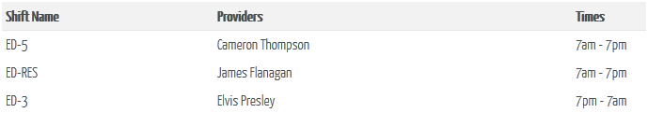

The second table, titled ‘*Three Day Schedule Forecast’,* gives the administrator the next three days of working schedules without requiring a view of the full schedule. This view will also highlight any open (unfilled) shifts in red, making it apparent that administrative action may be necessary. The shift name, along with only its start time, is displayed within the day’s column. Underneath the shift name, the shift’s providers are listed and separated by a line break (see ‘ED-5’ on October 31st in the below figure).

#### Figure: ‘Three Day Schedule Forecast’ table

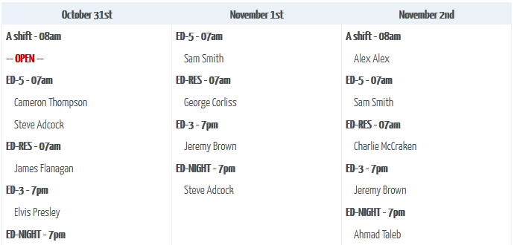

## Latest Time off Requests

This view displays a “heat map” of the time off requests for the next month to be scheduled (typically two months out). The darker the blue, the more time off requests for that particular shift. Shifts with white background colors indicate no time off requests have been received by the system. Once a shift gets more than 10 time off requests before schedule generation, a dark blue color will be used to denote the increase in time off activity. Administrators should take note of darker blue shifts to ensure the proper number of providers covers the shift.

In the figure below, note the darker blue shifts listed on December 8th. This indicates that several shifts on the 8th have ten or more time off requests. Also, note there are no time off requests for December 4th and 5th and all shifts appear with a plain white background color.

#### Figure: ‘Timeoff Requests Heat Map’

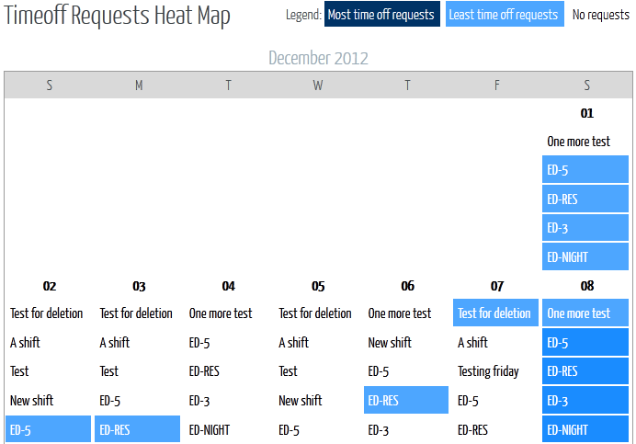

## Providers and Staff

This view provides a visual interface to the hospital’s providers and displays a variety of graphs and tables that can be used to easily identify scheduling strengths and weaknesses month-to-month. By default, the ‘# of users by group’ pie chart is displayed, visually depicting a summation of the number of providers that are assigned to every group in your hospital.

For every graph or chart, a table of raw data is displayed that provides a tabled look of the same data without charts or colors. The table is sortable by any column with a simple click on the column name.

The report type and date range restrictions can be selected at the top of the page via the ‘Select Report Type’ and ‘Reporting Period’ drop down menus.

To select another type of chart, click the ‘Select Report Type’ drop down box on the top left of the screen. The available selections are displayed. Simply selecting one will automatically change the graph and associated data table below the chart or graph. The ‘Reporting Period’ drop down menu on the right will restrict the month that the data will be returned for.

For example, to switch the graph to display the total number of hours for each user within the given reporting period, select the ‘Select Report Type’ drop down and click on the ‘Total Hours By Users’ choice. The figure below demonstrates what the line graph might look like. Hours are broken out along the Y-axis and provider last names are labeled along the X-axis.

#### Figure: Example graph from the ‘Providers and Staff’ view

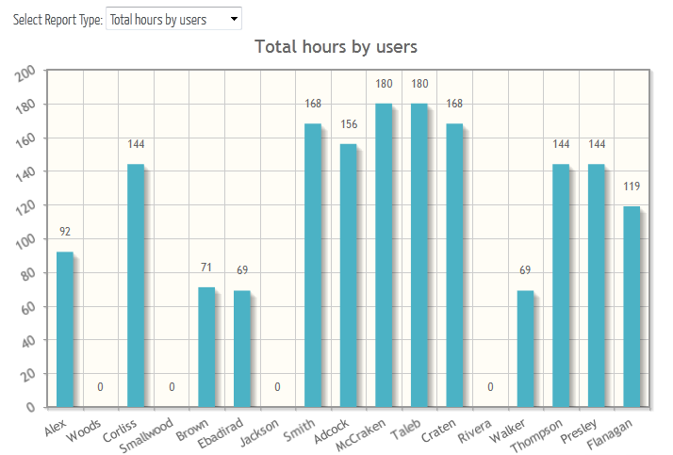

## Alerts and Notification

Periodically, the system will generate messages that are necessary or helpful for the administrator to look at. For example, these messages might tell the administrator that the next month’s schedule has just been generated or that a trade shift request has been issued and needs approval.

This view provides the administrator with the ability to view each message and mark them as read on a per-message basis. Messages that are not marked as read will remain on this view indefinitely. It is generally good practice to clear messages once the message’s content is no longer relevant.

# Providers

Filter providers by clicking on one of the ‘Filter by’ options in the gray box towards the top

The Providers page gives the administrator access to every (including external providers), saved within the system. Through this page, providers can be viewed, added, edited and removed by clicking on the appropriate icon on the right hand side of each provider’s table row. The page also provides links to allow administers to edit provider preferences and timeoff requests.

To **switch between providers and external providers**, simply select one of the “Filter by” links at the top of the page. The table of providers will automatically refresh without a page reload and display the filtered set of providers.

## Searching for Providers

Providers can be searched on the provider’s page in a couple ways. First, the table of providers can be sorted by column, easily allowing administrators to scan through the providers list to more easily pick out desired information. Second, administrators can type any word or phrase in the search box on the top right of the provider’s table. With each character typed, the table will automatically modify its viewable content so it conforms to what the user has typed.

For example, if the provider’s table contained a user named Tiger Woods, searching for “woo” will display all users with the characters “woo”, including Tiger Woods. No other users without that search string somewhere in their provider’s row of information will be displayed.

## user_edit Edit a Provider

When clicked, the ‘Edit Provider’ capability allows the administrator to change properties associated with a user, including overriding the user’s minimum and maximum hours worked according to that provider’s assigned group. The figure below depicts the ‘Edit Provider’ screen with the Monthly Hours override active.

#### Figure: ‘Edit Provider’ screen with Monthly hours active

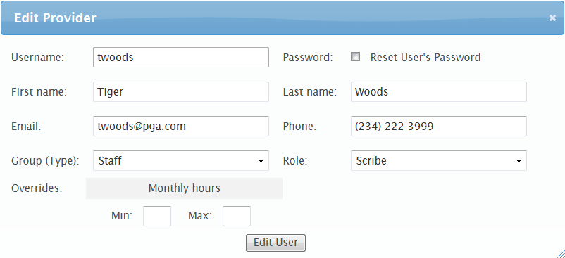

All fields are editable. Here, the user belongs to the ‘Scribe’ role and the ‘Staff’ group and does not have minimum and maximum override values set. The ‘Reset User’s Password’ checkbox, when clicked, will reset the provider’s password to a randomly generated string of characters and dispatch an email to the provider’s email address with the new password automatically.

## wrench Edit Provider Preferences

Administrators have the ability to edit the preferences for each provider. To edit a provider’s preferences, simply click on the preferences icon in the provider’s table. The next page, pictured below, displays a view that is identical to the view that the provider would see when editing his or her own preference information.

**On the left**, shifts are ranked in the order of priority. The top shift is the shift that the provider prefers to work the most, while the bottom shift is the shift that the provider prefers the least.

To edit the shift rankings, simply click and hold over a shift and drag your mouse up or down to move that shift to the appropriate place within the shift hierarchy. To place a shift in a new location, simply release the mouse button and the shift will be dropped in place.

Note that preferences are not saved until the ‘Save scheduling preferences’ button at the bottom of the screen is clicked.

C:\Users\42six\Documents\GitHub\ScheduleForward\schedulefwd\Admin Guide\save.scheduling.preferences.jpg

**On the right**, providers and administrators specify fine-grained working preferences by interacting with a series of radio buttons, checkboxes and drop down boxes on a simple form. To change a preference, simply click the form element that corresponds to the desired value. All changes made to a provider’s preferences will take effect during the next scheduling period.

#### Figure: Administrator view of provider preferences page

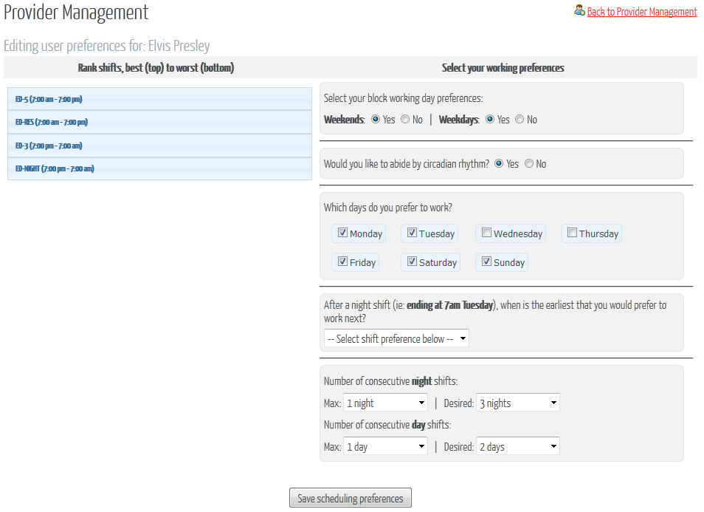

## calendar_view_day Edit Provider Timeoff Requests

Administrators have the ability to add timeoff requests on behalf of each provider. To add a timeoff request, select the timeoff icon from the provider’s table. The next page displays a monthly calendar interface for the next unscheduled month. Each shift is organized into their assigned days and ordered by start time. Shift names that are bold have been requested off by the provider being edited.

Notice the ‘Icon Legend’ display at the top right. The legend indicates the shifts that the provider has deemed *mandatory* to take off and those that are nice to have. This status can be toggled by simply clicking on the icon itself next to the particular shift to be edited. Clicking on the mandatory icon will change the timeoff request for that shift over to a “nice to have”, and visa-versa.

**To request an entire day off**, simply click on the day number. Each shift will then turn bold, indicating the shift has been requested off for the provider. By default, timeoff requests are labeled “Nice to have” unless otherwise changed. Click the day number again to remove the timeoff requests.

**To request an individual shift off**, simply click on the shift. By default, timeoff requests are labeled “Nice to have” unless otherwise changed. Click the shift again to remove the timeoff request.

Timeoff requests are automatically recorded with each click. No additional submit button click is required to save each request.

#### Figure: Administrator view of provider timeoff request

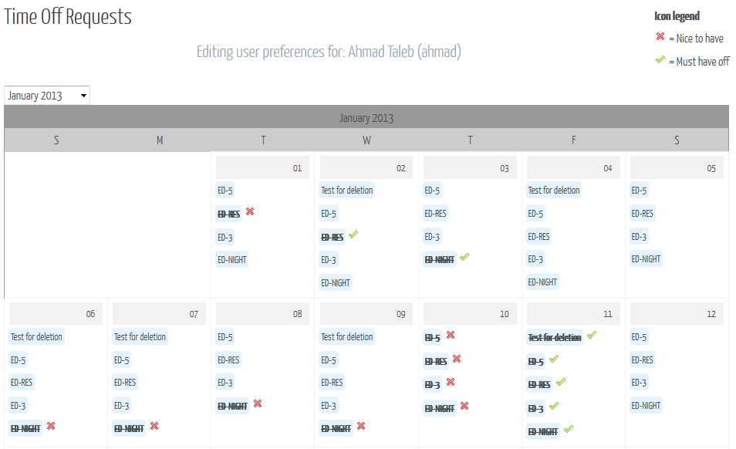

The Figure above displays a timeoff page for a provider. Notice the “mandatory” and “nice to have” icons next to each shift. In this example, the user has indicated that Friday, January 11th needs to be a required day off, while the day before (Thursday, January 10th) is a nice to have.

## C:\Users\42six\Documents\GitHub\ScheduleForward\Web\images\user_delete.png Delete a Provider

Deleting a provider is as easy as clicking on the delete icon from the provider’s table. The application will confirm the deletion with a confirmation popup box. Once confirmed, the provider will be removed from the system.

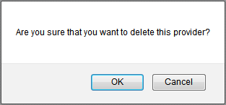

## C:\Users\42six\Documents\GitHub\ScheduleForward\Web\images\user_add.png Add a New Provider

Adding a new provider to the system is performed by clicking on the ‘Add New Provider’ link at the top right of the provider’s page. A popup window will display and allow the administrator to specify the properties of the new provider.

#### Figure: Add a New Provider screen

## C:\Users\42six\Documents\GitHub\ScheduleForward\schedulefwd\Admin Guide\admin.new.provider.jpg

## Export Provider List

C:\Users\42six\Documents\GitHub\ScheduleForward\schedulefwd\Admin Guide\export.options.jpgUsers can easily be exported into CSV (Comma-Separated Values), Excel or PDF files by clicking on the appropriate link at the top right of the providers table. The system will prompt for a location to download the file on the administrator’s local file system. Once downloaded, the file can be viewable through any application capable of viewing the document time (i.e.: Notepad, Microsoft Excel, Adobe Acrobat Reader, etc.).

# Shifts

Schedule Forward supports the ability for administrators to define custom shifts that conform to the constraints of the hospital. Shifts are setup as logical containers that hold scheduled providers and are assigned to run a span a set of hours on the user-defined days of the month. Shifts are assigned to particular groups of providers.

**To view a list of shifts**, click on the ‘Shifts’ link towards the top of the page. The ‘Shift Management’ page will display a table of shifts for the hospital along with the ability to edit and delete each shift. The table will also quickly indicate to the administrator the times that the shifts run and the frequency (days of the week) via a green background color. For example, in the figure below, ‘A shift’ only runs on Monday, Wednesday, Friday and Sunday, while all other shifts run every day.

#### Figure: Shift Management page

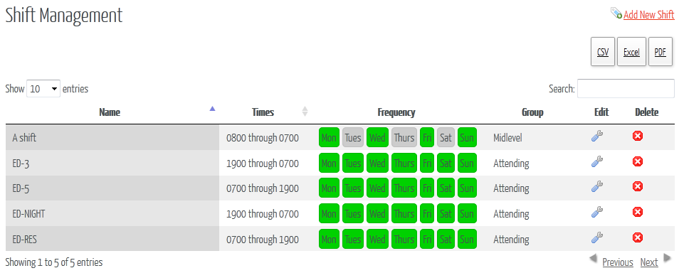

## Searching for Shifts

Shifts can be searched on the shifts page in a couple ways. First, the table of shifts can be sorted by column, easily allowing administrators to scan through the shifts list to more easily pick out desired information. Second, administrators can type any word or phrase in the search box on the top right of the shifts table. With each character typed, the table will automatically modify its viewable content so it conforms to what the user has typed.

For example, if the shifts table contained a shift with “Night” anywhere in it, searching for “igh” will display all shifts with the characters “igh”, including the “Night” shift. No other shifts without that search string somewhere in the shift’s row of information will be displayed.

## C:\Users\42six\Documents\GitHub\ScheduleForward\Web\images\wrench.png Edit a Shift

To edit a shift, simply click the edit icon on the right of the shift table that corresponds to the desired shift to edit. A popup window will display with a form that allows the administrator to alter the properties of a shift.

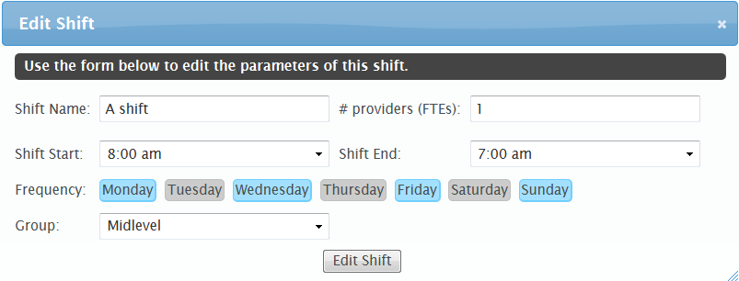

To edit the ‘Frequency’ of the shift, simply click on the day of the week. The blue-highlighted shifts are considered selected. To un-select, simply click on a blue day and it will switch over to gray, indicating that the day is no longer selected. To save the edits to a shift, click the ‘Edit Shift’ button below the table.

## C:\Users\42six\Documents\GitHub\ScheduleForward\schedulefwd\Web\images\cancel.png Delete a Shift

Deleting a shift is as easy as clicking on the delete icon from the shifts table. The application will confirm the deletion with a confirmation popup box. Once confirmed, the shift will be removed from the system.

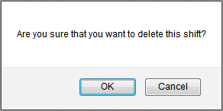

## C:\Users\42six\Documents\GitHub\ScheduleForward\Web\images\tag_blue_add.png Add a New Shift

Adding a new shift to the system is performed by clicking on the ‘Add New Shift’ link at the top right of the shifts page. A popup window will display and allow the administrator to specify the properties of the new provider.

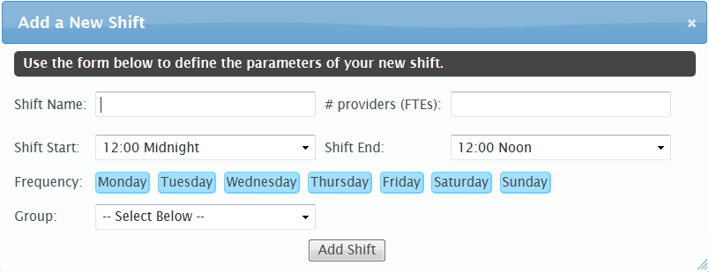

By default, all days are selected for the Frequency field. Simply click on the day of the week to unselect it, and re-click again to select it. Use the drop down menus to select the start and end time of the shift and specify a group of providers for this shift via the ‘Group’ drop down list.

## Export Shift List

C:\Users\42six\Documents\GitHub\ScheduleForward\schedulefwd\Admin Guide\export.options.jpgShifts can easily be exported into CSV (Comma-Separated Values), Excel or PDF files by clicking on the appropriate link at the top right of the shifts table. The system will prompt for a location to download the file on the administrator’s local file system. Once downloaded, the file can be viewable through any application capable of viewing the document time (i.e.: Notepad, Microsoft Excel, Adobe Acrobat Reader, etc.).

# Traded Shifts

Administrators have the ability to view a historical log of all trade requests in the system. If the hospital has been setup to require administrative approval of all trade requests, the traded shifts page also offers the ability to approve or deny requests. This functionality is broken out into two separate tables on the page.

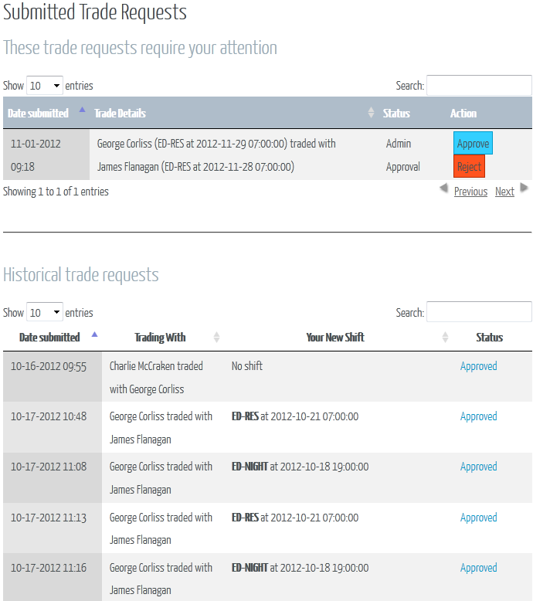

The above table illustrates a scenario where at least 5 historical trades have been recorded and one trade that still needs to be approved by the administrator. The ‘Trade Details’ table cell indicates who initiated the trade request and to whom it was traded to. A status of ‘Admin Approval’ means the shift trade request has already been approved by both users and only requires the administrator to approve the request before it becomes available for the next schedule generation process.

**To approve a trade request**, simply click the blue ‘Approve’ button on the right hand side of the ‘These trade requests require your attention’ table. The system will confirm with a popup window that the trade request should be approved.

**To reject a trade request**, select the red ‘Reject’ button on the right hand side of the ‘These trade requests require your attention table. The system will confirm with a popup window that the trade request should be rejected.

## Searching for trade requests

Trade requests can be searched on the Traded Shifts page in a couple ways. First, the table of trade requests can be sorted by column, easily allowing administrators to scan through the trade requests list to more easily pick out desired information. Second, administrators can type any word or phrase in the search box on the top right of the trade requests table. With each character typed, the table will automatically modify its viewable content so it conforms to what the user has typed.

For example, if the trade requests table contained a request with “George” anywhere in it, searching for “ge” will display all shifts with the characters “ge”, including all requests to or from “George”. No other trade requests without that search string somewhere in the trade requests row of information will be displayed.

# Messages

# Macintosh SSD:Users:tomwildcat:Desktop:Screen Shot 2012-11-07 at 8.06.59 PM.png

Every user has the ability to send and receive messages from all users of the department. The above illustration shows what the message service looks like. There four types of directories. The first is a standard inbox where all incoming messages come in. Messages are automatically marked as read when opened. Users do have the ability to manually mark as read as well as unread. From any directory as user can move any message they select to the “Archives” directory. Users can also easily delete messages as well. To perform any of the previous actions to multiple messages a user only needs to select the checkbox to the right of each message it intends to perform the action on.

Once a message is opened a user can then “reply” to the sender of the message, “reply all” to reply to all senders of the message, or “forward” the message to a user or multiple users.

# Groups and Roles Management

# Macintosh SSD:Users:tomwildcat:Desktop:Screen Shot 2012-11-07 at 8.26.13 PM.png

The “groups and roles management” section (as seen in the illustration above) is where an admin will go and set some general preferences for each user group (ie. Attending, Midlevel, Resident, etc..). These general preferences are maximum hours and minimum hours a user can work. Also, the number of users for each group is displayed here. This is also where an admin can add new user groups. The bottom section of the view also displays the total number of each type of user (admin or users).

If an admin needs the above data archived out, there are three output types, CSV, Excel, and PDF.

There are two other features in the groups and roles section, which is located under the PDF Print heading. Both create a PDF to physically give it to a user to fill out by hand. The first one is for basic shift preferences. The other is for manually requesting days off.

# Configurations

# Macintosh SSD:Users:tomwildcat:Desktop:Screen Shot 2012-11-07 at 9.06.28 PM.png

Note that configurations are not saved until the ‘Save Configurations’ button at the bottom or top of the screen is clicked.

Macintosh SSD:Users:tomwildcat:Desktop:Screen Shot 2012-11-07 at 9.18.26 PM.png

The configurations page is made up of two sections. The first is “system rules and behaviors”. This section will be rules and behaviors that will affect users department wide.

The next section pertains strictly to the scheduling configurations. This section can be changed on a monthly basis if needed. The schedule creation will base its configurations on the most current configurations saved at the given time of execution.

# Schedule

## Schedule navigation

Basic navigation of the schedule is easy. At the top of the schedule in the center is where the month and year are displayed for the month of the schedule that is in view.

Macintosh SSD:Users:tomwildcat:Desktop:Screen Shot 2012-11-08 at 9.19.54 PM.png

You can navigate from month to month by click on the arrows at the top left of the schedule. To return to the current month, just click on the “today” button.

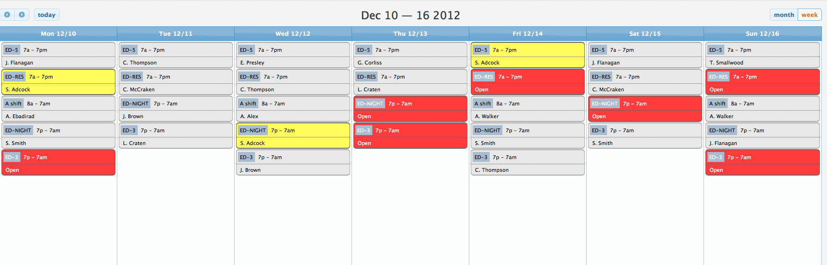

Macintosh SSD:Users:tomwildcat:Desktop:Screen Shot 2012-11-08 at 9.20.03 PM.png

To view the schedule by week instead of month, just click on the week view. To navigate to a different week just click on the arrow keys on the top left of the schedule view.

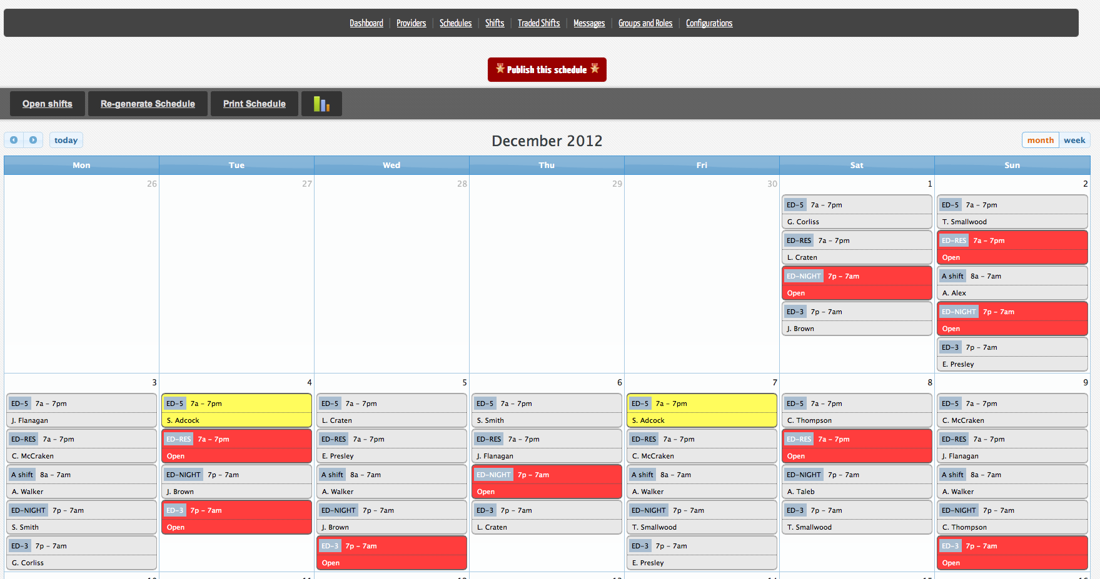

Both admins and standard users view the schedule in the same way. Only admins can alter the schedule directly. Standard users access the schedule in read only manner.

## Adding Physicians to Shifts

An admin can easily add a physician to a shift by clicking anywhere on a shift in the schedule view.

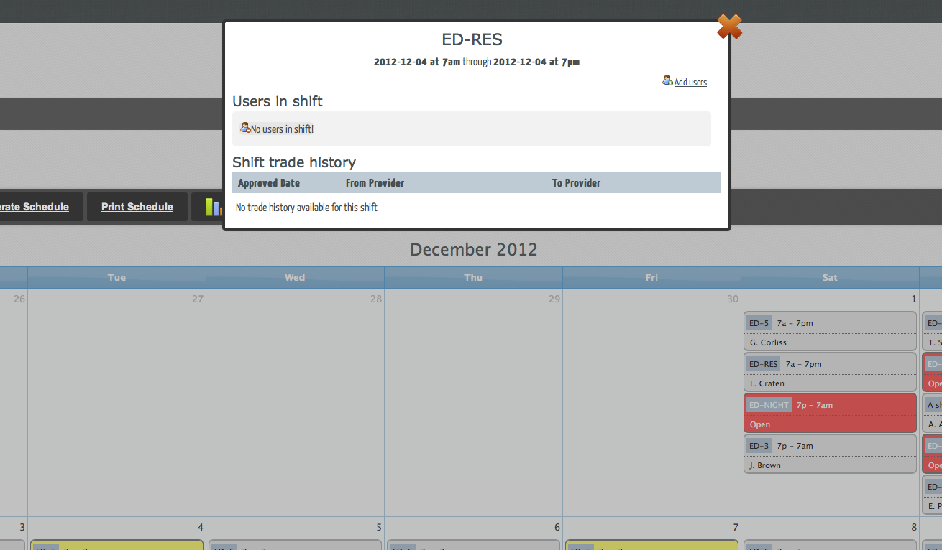

The admin will then see above view. The shift name, date, and time will be displayed at the top of the view.

Under the “Users in shift” section is where you will see current users that are occupying the shift.

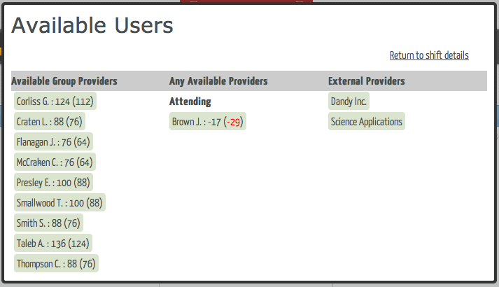

Clicking the “Add users” button will bring up the list of available users that you can easily add to the shift.

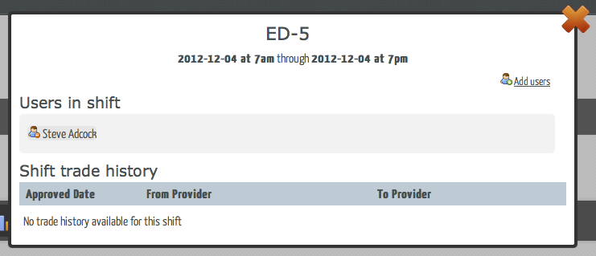

Clicking on the “Return to shift details” will bring you back.

The section at the bottom is “Shift trade history”, all shift trades can easily be viewed here.

## Publication of Schedule

Macintosh SSD:Users:tomwildcat:Desktop:Screen Shot 2012-11-08 at 9.19.33 PM.png

When the admin has looked over the schedule and made any necessary adjustments, the admin will click on the “Publish this schedule” button, which will make the schedule active and viewable for all users in the department.

# Support

## Contacting support

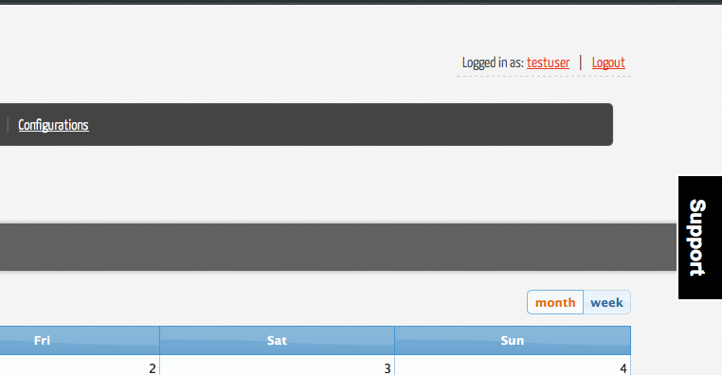

Support is easily available throughout the site. Just click on the support button on the right side of the screen.

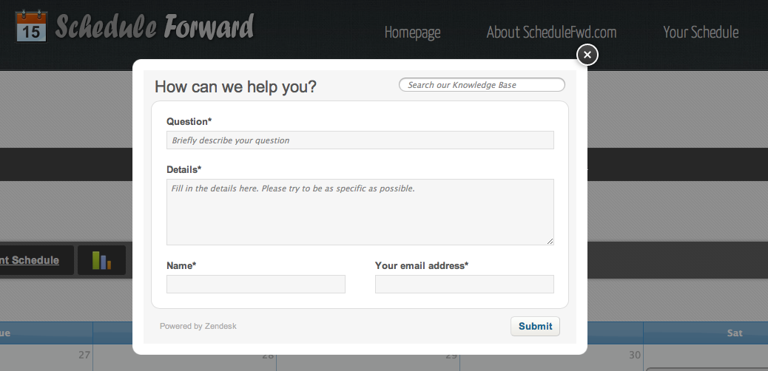

The support box is then displayed on the top center of the screen. Briefly in one sentence describe your problem (don’t include everything, this is similar to the subject line an email). Then list all the details you encountered. Make sure to also include where on the site you where when you encountered the issue as well as how to reproduce the issue. Make sure to include your name and email address.

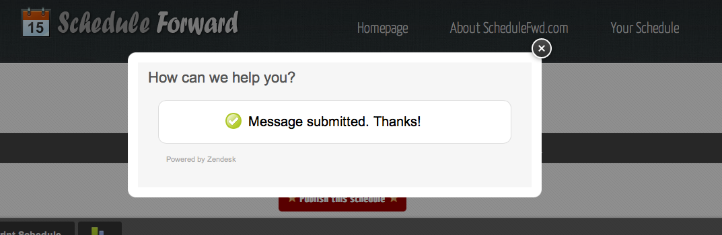

You will then be presented with the “Message submitted” screen. You will receive a response within 24 hours. You are a valued customer and we will do our best to accommodate you.