**HYPOTHESIS formulation**

**Form 10 hypothesis on given dataset**

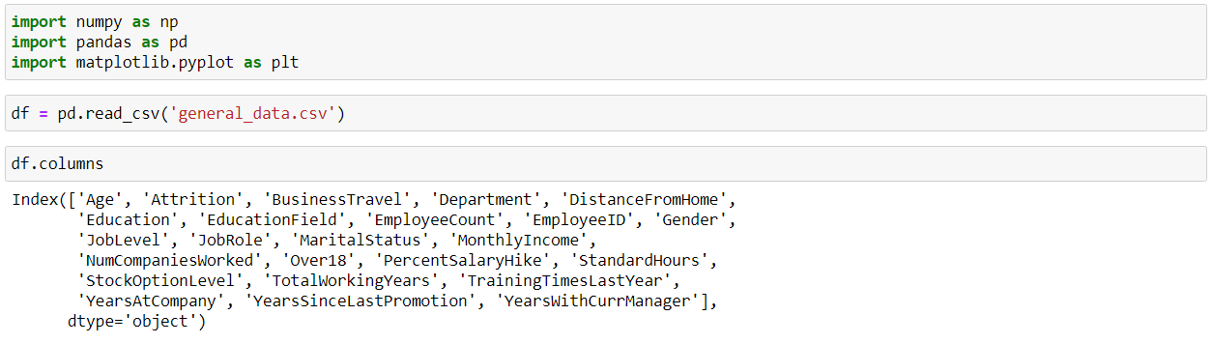

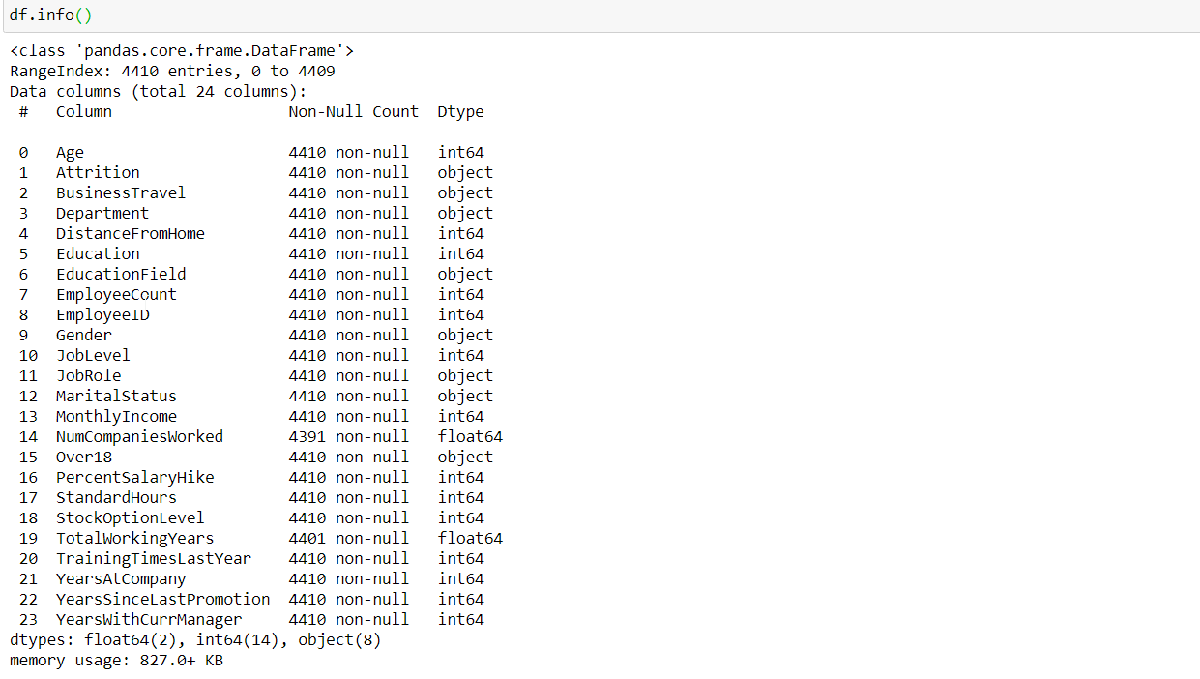

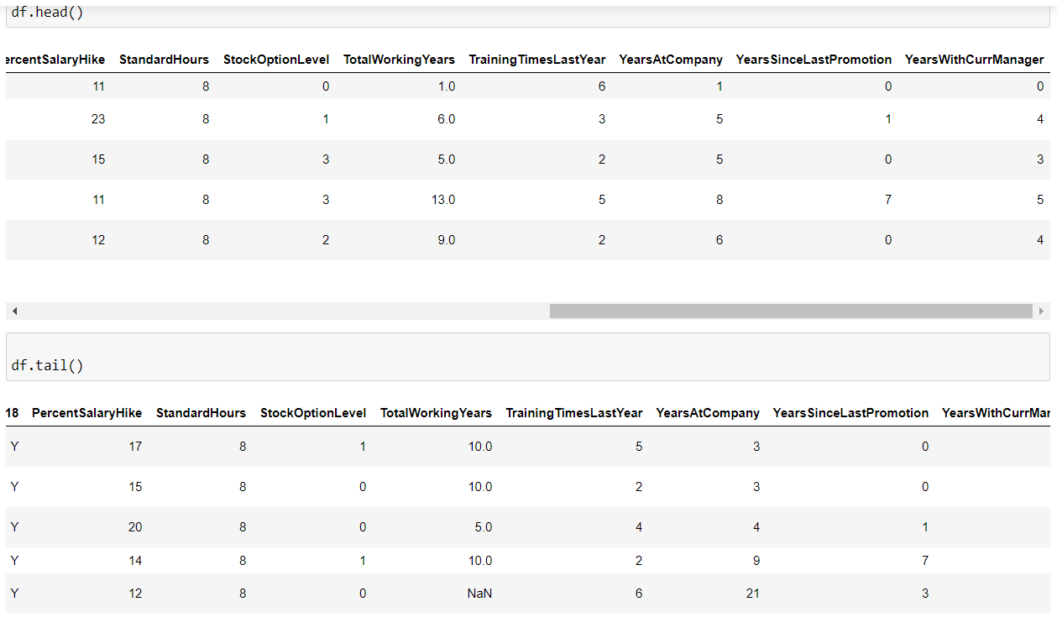

**HYPOTHESIS 1**

H0 Average age of employee with attrition is equal to 33

H1 Average age of employee with attrition is not equal to 33

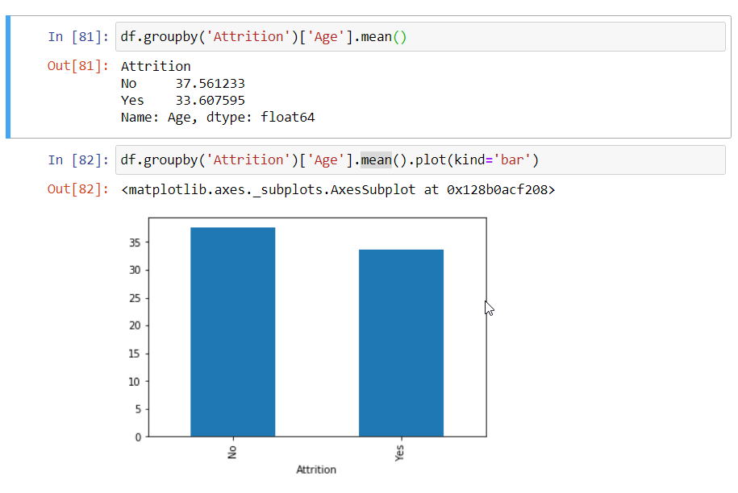

# HYPOTHESIS 2

H0 employees who travel rarely are attributed more

H1 employees who travel rarely are not attributed more

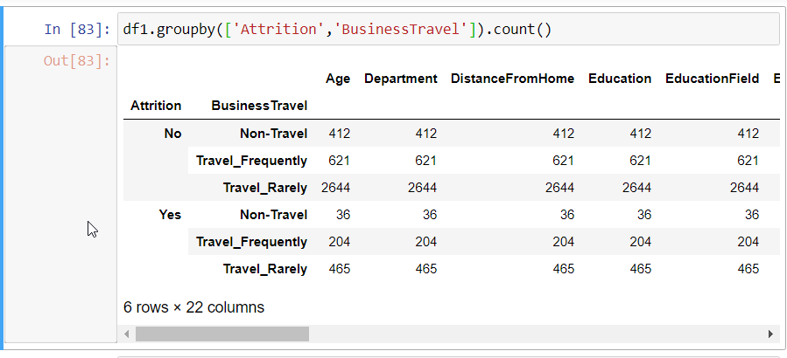

# HYPOTHESIS 3

# H0 employees with average distance from home equal to 9 do not undergo attrition

# H1 employees with average distance from home equal to 9 do undergo attrition

# 

# HYPOTHESIS 4

H0 female experience attrition more than male

H1 female do not experience attrition more than male

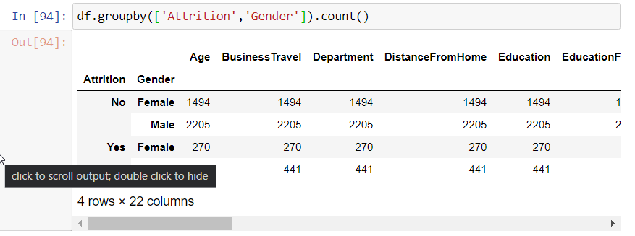

# HYPOTHESIS 5

# H0 Mean age of employee is less than 35

# H1 Mean age of employee is greater than or equal to 35

# 

# HYPOTHESIS 6

# H0 Mean monthly income of employee is less than 67000

# H1 Mean monthly income employee is greater than or equal to 67000

# 

# HYPOTHESIS 7

# H0 Mean Years At Company of employee is less than 67000

# H1 Mean Years At Company employee is greater than or equal to 67000

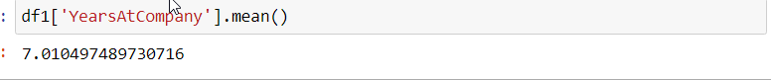

# HYPOTHESIS 8

# H0 employees with average training last year of greater than 3 are attributed more

# H1 employees with average training last year of greater than 3 are attributed less

# 

# HYPOTHESIS 9

# H0 Mean Years with Current Manager of employee is less than 4

H1 Mean Years with Current Manager is greater than or equal to 4

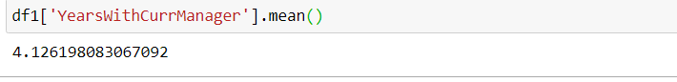

# HYPOTHESIS 10

H0 Mean Total Working Years of employee is less than 4

H1 Mean Total Working Years is greater than or equal to 4

