Trade Volume Trends in Ports Across Different Geographies During the COVID-19 Pandemic and the Russia-Ukraine War (2018–2024)

Introduction
This report examines the impact of major global crises — namely the COVID-19 pandemic and the Russia-Ukraine War occurring between 2018 and 2024 — on the trade volumes of selected ports in different regions. Port performance during crisis periods is compared on the basis of container throughput (TEU).
Ports were selected from different continents and trade routes. Shanghai Port in China serves as the center of production and exports in Asia, while the Rotterdam and Hamburg ports in Europe are among the continent's main logistics hubs. The Port of Los Angeles in the United States is a focal point for foreign trade carried out across the Pacific.
In addition, ports located at transit points in the Eastern Mediterranean — such as Mersin (Turkey), Alexandria (Egypt), and Beirut (Lebanon) — were included in the study. These ports are situated on the Europe-Asia-Africa trade corridor and are directly exposed to the economic and logistical influence of major players such as Russia, Ukraine, and China. By incorporating not only large ports but also strategic transit nodes in different regions, the aim was to achieve a more balanced assessment.

Countries and their largest ports analyzed in this report:

Country | Port
China | Shanghai
Netherlands | Rotterdam
Germany | Hamburg
Turkey | Mersin
Egypt | Alexandria
Lebanon | Beirut
Poland | Gdańsk
Russia | Novorossiysk (NUTEP)
Ukraine | Odessa
United States | Los Angeles

Trade Density Distribution
Since the annual trade volume data of ports span different value ranges, direct use in comparative analyses can be misleading. For example, mega-ports such as Shanghai handle millions of TEUs, while ports such as Odessa or Beirut have considerably lower figures.
For this reason, the Z-score method was preferred, calculated by taking into account each port's own mean and standard deviation. The Z-score shows how many standard deviations a given value is from that port's mean. In this way, all ports are reduced to the same scale and fluctuations over time become comparable on a relative basis.

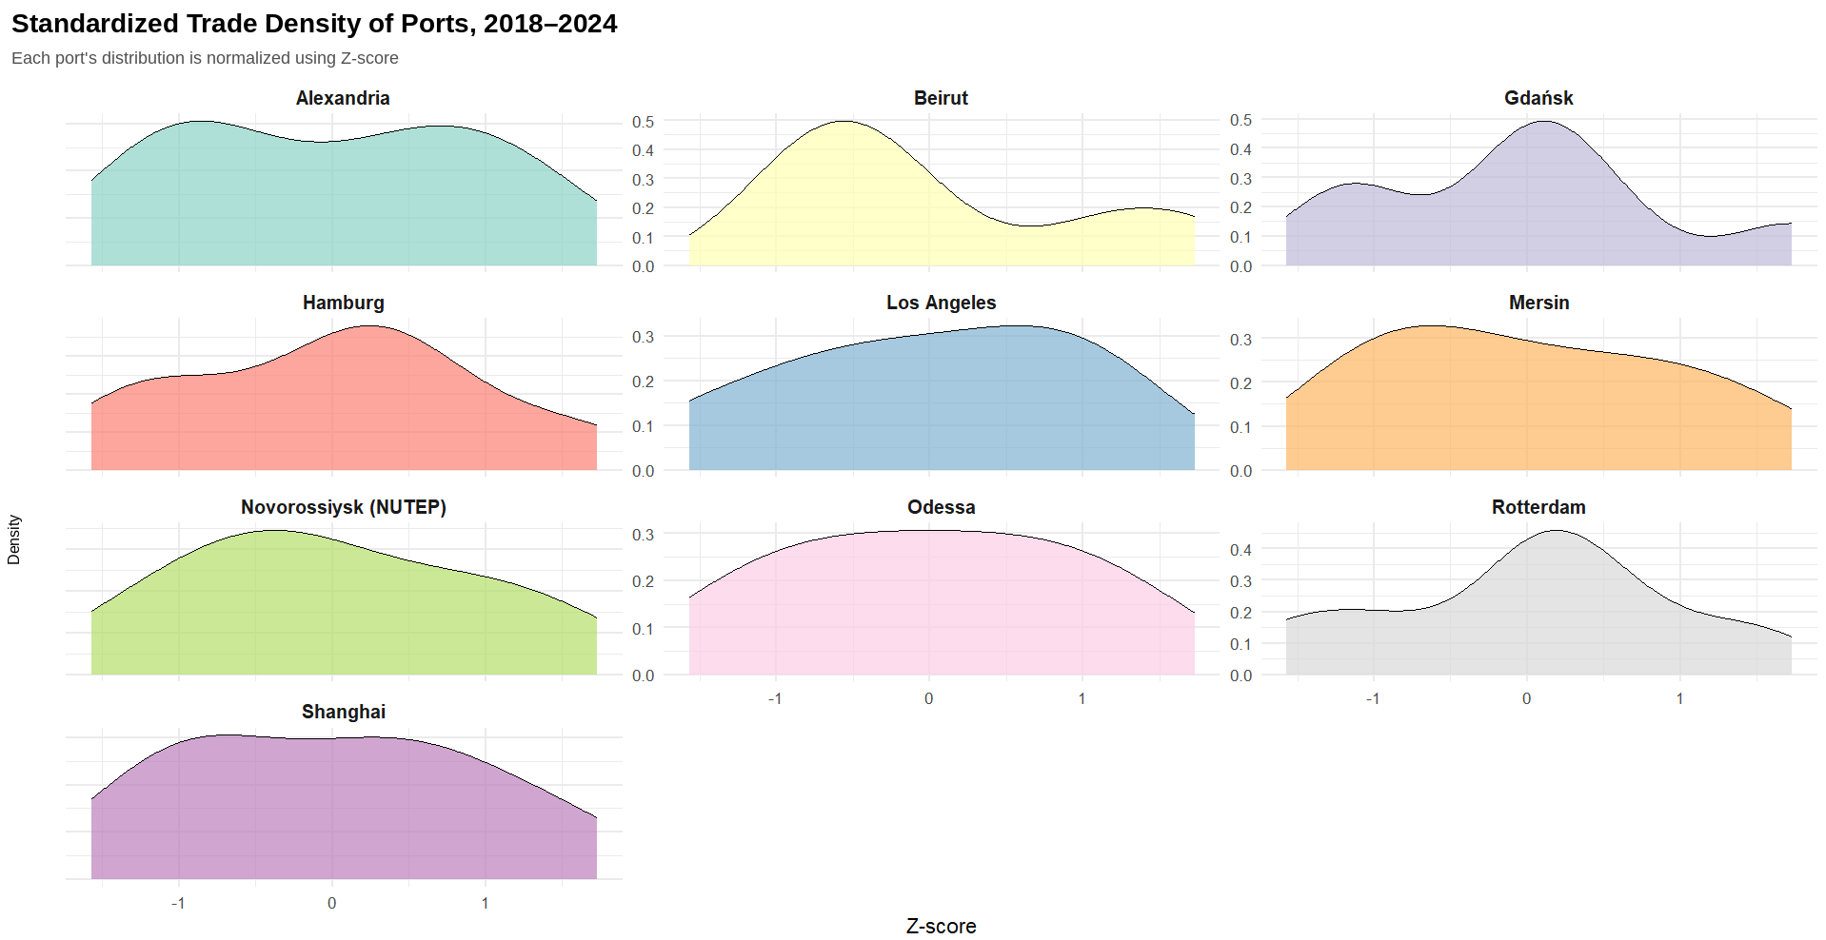
Figure 1. Standardized Trade Density of Ports, 2018–2024 (Z-score normalized)

Port-Level Density Trends
1. Alexandria (Egypt), Beirut (Lebanon), Odessa (Ukraine)
These three ports show a relatively flat and wide distribution, indicating that trade volume was more stable across years with fewer deviations. The density curve for Odessa in particular is symmetric and narrow, implying limited growth or decline.
2. Gdańsk (Poland), Rotterdam (Netherlands)
The density curve forms a distinct peak and appears more concentrated, indicating that volume was clearly centered around the mean in certain years. Rotterdam in particular shows data tightly clustered around the average.
3. Beirut (Lebanon)
Beirut's curve is more right-skewed with a sharper peak, suggesting notably high performance in certain years. Overall, trade volume fluctuation follows a more irregular pattern.
4. Mersin (Turkey), Novorossiysk (Russia), Los Angeles (USA)
The distribution is somewhat wider, indicating higher year-to-year trade volume fluctuation. This may reflect the impact of global and regional shocks (the pandemic, the war, supply chain disruptions) on these ports.
5. Shanghai (China)
Despite high absolute trade volumes, Shanghai's distribution following Z-score normalization shows a balanced structure centered around the mean, pointing to consistent year-on-year performance.
Assessment
The Kernel Density Plot effectively conveys the shape, symmetry, and concentration trends of the distributions.

Total Trade Share of Ports, 2018–2024
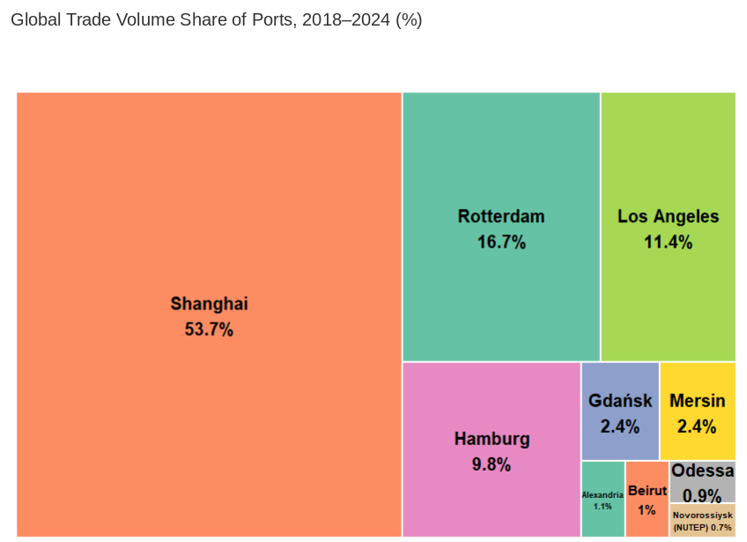
Figure 2. Global Trade Volume Share of Ports, 2018–2024 (%)
This treemap visualizes the percentage share of 10 major ports in total global foreign trade volume between 2018 and 2024.

Shanghai Port (53.7%)
- Alone accounts for more than half of total trade volume.
- This reflects China's absolute dominance in global maritime trade.
- Shanghai's container terminal capacity and its central role in Asia-Pacific supply chains explains this figure.
Rotterdam Port (16.7%)
- Europe's largest port, serving as a gateway between the North Sea and Europe's interior.
- Rotterdam's high share stems from its transshipment function for countries such as Germany, Belgium, and France.
Los Angeles Port (11.4%)
- As the largest port on the US West Coast, it plays a strategic role in Asia-America trade.
- Reflects the dense container traffic with China and South Korea.
Mid-Sized Ports
- Hamburg (9.8%): Plays an important role in Germany's foreign trade; one of the gateways to Eastern Europe.
- Gdańsk and Mersin (2.4% each): Major logistics centers for Poland and Turkey.
- Alexandria (1.1%) and Beirut (1.0%): Balancing ports on the Middle East–North Africa corridor.
Low-Share Ports
- Odessa (0.9%) and Novorossiysk (0.7%): Black Sea ports with a relatively small share of international corridors, primarily serving regional distribution.
General Observation
- The top 3 ports (Shanghai, Rotterdam, Los Angeles) account for approximately 82% of total volume.
- This demonstrates the high degree of concentration in global maritime trade.
- Asian and European coastal ports dominate; Middle Eastern and Black Sea ports have comparatively low volumes.
Assessment
The Treemap is highly effective in highlighting the global asymmetry in trade volume and the dominant position of major logistics hubs. This analysis clearly reveals the concentration and inequality embedded in global trade structure.

Volume Change, 2018–2024
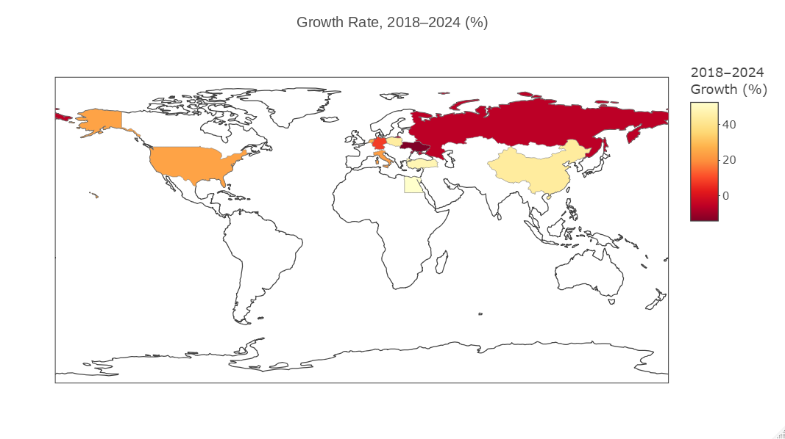
Figure 3. Growth Rate, 2018–2024 (%)
This choropleth map visualizes the growth rates (%) in foreign trade volumes across countries between 2018 and 2024.

Countries with Negative Growth (Dark Red)
- Russia and its surroundings (ports such as Novorossiysk, Odessa): A decline in trade volume is observed, explained by geopolitical risks after 2022 (the Ukraine war, sanctions).
- China: The light red tone suggests that growth has either stalled or declined — likely due to saturation at ports like Shanghai, post-pandemic capacity limits, and shifts in global supply chains.
Moderately Growing Countries
- USA: Approximately 20% growth at its ports (especially Los Angeles), consistent with rebounding import demand after the pandemic.
- Netherlands (Rotterdam): Stable and controlled growth as Europe's main freight transfer hub.
Countries with Mild Growth
- Turkey, Poland, Egypt: Growth in the 10–15% range, benefiting from their positions as alternative transit corridors.
Key Findings from the Map
- Geopolitical tensions are redirecting trade: while Russia and Ukraine show negative growth, alternative corridor countries like Turkey and Poland are gaining.
- Saturation in China, demand recovery in the USA: growth at Chinese ports remains limited while US ports show a trade rebound.
- Major hubs such as Rotterdam and Mersin are progressing at a moderate pace.
Assessment
The Choropleth Map is highly effective in illustrating the geographical redistribution of trade flows and the impact of geopolitical developments on trade corridors.

Statistical Comparison and Distribution Analysis of Port Trade Volumes, 2018–2024

Normality Test: Shapiro-Wilk
Based on the Shapiro-Wilk test applied to Z-score normalized values:
- W = 0.95802
- p-value = 0.01949

This result is statistically significant (p < 0.05), meaning the distribution deviates from normality. Non-parametric test methods should therefore be preferred.

Variance Homogeneity Test: Levene's Test
Based on the Levene test results:
- F(9, 60) = 10.189
- p < 0.001

This result indicates that group variances are not homogeneous, further confirming that parametric test assumptions have been violated.

Between-Group Differences: Kruskal-Wallis Test
When the trade volumes of 10 ports were compared using the Kruskal-Wallis test, the H statistic was found to be significant. Based on this result, the median of at least one group differs significantly from the others.

→ Effect Size (Eta-squared)
Eta-squared value: 0.9517 — a very high effect size, indicating that differences in trade volume across ports are statistically significant to a very large degree.

Pairwise Comparisons: Bonferroni-Corrected Wilcoxon Test
Among the statistically significant pairs according to the Bonferroni-corrected Wilcoxon test:
- Shanghai is significantly different from almost all other ports (p = 0.026).
- Rotterdam, Gdańsk, Mersin differ from some smaller ports.
- Beirut, Alexandria, Odessa — differences among these smaller-volume ports are mostly not significant.

This test reveals clear volume differences across different port segments.

Descriptive Statistics

Port | n | Mean | Median | Std Dev | IQR
Shanghai | 7 | 46,259,000 | 47,030,000 | 3,465,808 | 4,828,500
Rotterdam | 7 | 14,373,714 | 14,455,000 | 624,944 | 581,500
Los Angeles | 7 | 9,842,857 | 9,900,000 | 791,322 | 1,150,000
Hamburg | 7 | 8,428,571 | 8,500,000 | 555,921 | 650,000
Mersin | 7 | 2,042,857 | 2,000,000 | 373,529 | 550,000
Gdańsk | 7 | 2,062,286 | 2,072,000 | 108,518 | 96,000
Alexandria | 7 | 906,429 | 914,000 | 70,325 | 121,000
Beirut | 7 | 903,714 | 828,000 | 257,598 | 288,000
Odessa | 7 | 750,000 | 750,000 | 108,012 | 150,000
Novorossiysk (NUTEP) | 7 | 619,000 | 600,000 | 86,854 | 108,500

- Shanghai and Rotterdam means are far above all other ports.
- Novorossiysk, Odessa, Alexandria show relatively low volume and low variance.

Bootstrap Median Confidence Intervals (95%)

Port | Median | Lower Bound | Upper Bound
Shanghai | 47,030,000 | 43,303,000 | 49,160,000
Rotterdam | 14,455,000 | 13,800,000 | 14,800,000
Los Angeles | 9,900,000 | 9,200,000 | 10,700,000
Hamburg | 8,500,000 | 7,800,000 | 8,700,000
Mersin | 2,000,000 | 1,700,000 | 2,400,000
Gdańsk | 2,072,000 | 1,949,000 | 2,118,000
Alexandria | 914,000 | 839,000 | 974,000
Beirut | 828,000 | 700,000 | 1,200,000
Odessa | 750,000 | 650,000 | 850,000
Novorossiysk (NUTEP) | 600,000 | 550,000 | 700,000

- Shanghai and Rotterdam demonstrate not only high values but also narrow confidence intervals, signaling stability.
- Beirut shows a wide confidence interval, indicating high volatility and uncertainty.

Overall Conclusions
- Since normality and variance homogeneity assumptions were not met, non-parametric methods were appropriately applied.
- The Kruskal-Wallis and Wilcoxon tests clearly reveal significant differences between ports.
- Shanghai stands out statistically and economically, representing over 50% of global trade.
- Bootstrap confidence intervals reinforce the reliability of median values and show which ports are more volatile versus stable.
- The high eta-squared value indicates that trade volumes of the analyzed ports are largely determined by port-level effects.

