BODRUM–KOS–RHODES SEA CORRIDOR
AIS Live Traffic Analysis
Turkish–Greek Aegean Boundary Sea Lane

Data Collection: 8–9 June 2026 · lat 36–38°N, lon 26.5–29°E
Source: AISStream.io WebSocket API (live feed)
Live Dashboard → aegean-ais-analysis.streamlit.app

1. Executive Summary
This report presents a live AIS (Automatic Identification System) traffic analysis of the Bodrum–Kos–Rhodes sea corridor, conducted on 8–9 June 2026. Data were collected in two one-hour sessions — evening and morning — via the AISStream.io WebSocket API, yielding 118 unique vessels and 2,267 clean position reports after geographic and quality filtering.

118  Unique Vessels | 2,267  Position Reports | 34%  Leisure Share | 11.3 kn  Median Cargo Speed

Four headline findings emerged from the analysis:
- Pleasure Craft is the dominant vessel category (28 vessels, 29%), consistent with the Bodrum peninsula’s status as one of the Aegean’s premier yacht charter hubs.
- Leisure traffic (Pleasure Craft + Sailing Yacht) accounts for 34% of all identified vessels — a strong early-summer signal ahead of the August peak season.
- Passenger ferry activity is strongly time-dependent: morning sessions recorded 21 ferry vessels vs. 13 in the evening (+62%), reflecting the Bodrum–Kos and Marmaris–Rhodes morning departure schedules.
- Cargo vessels transit the corridor at a median speed of 11.3 knots (IQR 8.2–13.5 kn), representing the İzmir–Piraeus and Asia–Europe container routes.

2. Methodology

2.1 Data Source
AIS (Automatic Identification System) is an IMO-mandated VHF radio transponder system. Vessels broadcast position, speed, and identity data every 2–30 seconds. AISStream.io aggregates these broadcasts from a network of terrestrial receivers and satellite links, exposing a real-time WebSocket API.
Unlike historical AIS providers, AISStream.io’s free tier delivers only a live stream — data collection must occur in real time. This is a design choice, not a limitation of this study.

2.2 Collection Sessions

Session | Date & Time (UTC+3) | Raw Messages | Purpose
Evening | 8 June 2026 · 22:55–23:55 | 12,059 | Baseline — cargo & yachts
Morning | 9 June 2026 · 10:31–11:27 | 11,381 | Ferry & leisure peak

Each session used a Python asyncio WebSocket client (src/collector.py) with automatic reconnection on connection drops. Messages were written to SQLite in batches of 50. The wider Aegean bounding box (lat 36–42°N, lon 22–30°E) was used for collection to ensure sufficient signal volume; geographic filtering to the study corridor was applied at the cleaning stage.

2.3 Geographic Scope

⚠ Coverage Limitation
This dataset represents the Bodrum–Kos–Rhodes open-sea corridor (lat 36–38°N · lon 26.5–29°E), not the full Turkish Aegean coast. AISStream.io receivers are located primarily on Greek islands; as a result, İzmir, Çeşme, Kuşadası, and Çanakkale have zero AIS coverage in this dataset.

Raw data exploration revealed that AISStream.io receivers are concentrated on the Greek island arc (Kos, Rhodes, Samos). As a result, usable signal coverage is limited to:
- Bodrum peninsula and outer anchorages
- Marmaris bay entrance
- Open sea lanes between Turkey and the Dodecanese islands
- Kos and Rhodes port approaches
The study area is therefore defined as the Bodrum–Kos–Rhodes sea corridor (lat 36–38°N, lon 26.5–29°E), not the full Turkish Aegean coast. This framing is scientifically honest and aligns with the actual data coverage.

2.4 Data Pipeline
- collector.py — WebSocket client, SQLite writer, auto-reconnect
- cleaner.py — geographic filter, coordinate validation, speed filter (>50 kn removed), ShipStaticData JOIN for vessel names and type codes
- analysis.py — statistical analysis, figure generation
- app.py — Streamlit interactive dashboard
ShipType numeric codes (IMO/ITU standard, 0–99) were mapped to eight readable categories. Median and IQR were used for speed statistics rather than mean and standard deviation because speed distributions are right-skewed: anchored vessels broadcast zero speed, pulling the mean down disproportionately.

3. Key Findings

3.1 Vessel Category Distribution
Figure 1 shows the distribution of vessel categories by unique MMSI count and total position reports. Pleasure Craft leads both metrics in the filtered corridor dataset.

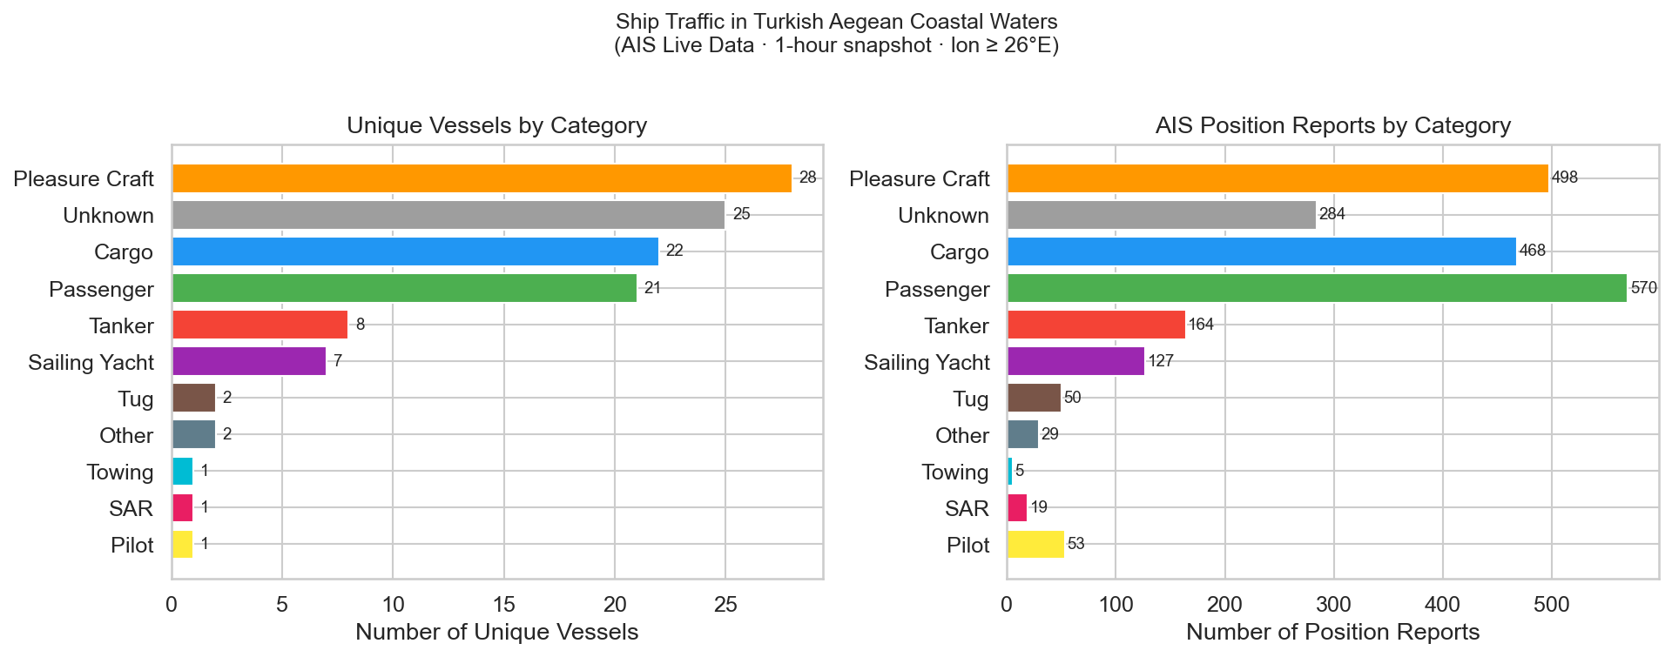
Figure 1 — Vessel distribution by category (left: unique vessels · right: position reports)

Ship Category | Vessels | Reports | Median Speed | Note
Pleasure Craft | 28 | 498 | 10.3 kn | Dominant category — Bodrum charter hub
Passenger | 21 | 570 | 8.9 kn | Morning peak: 13 → 21 (+62%)
Cargo | 22 | 468 | 11.3 kn | Trans-Aegean route vessels
Tanker | 8 | 164 | 9.9 kn
Sailing Yacht | 7 | 127 | 9.2 kn
Unknown | 25 | 284 | — | No ShipStaticData received

The high ‘Unknown’ count (25 vessels) reflects vessels for which ShipStaticData (Type 5/24 messages) were not received during the collection window. This is normal for shorter sessions; static messages are broadcast only every 6 minutes.

3.2 Speed Distributions
Figure 2 presents violin plots of speed over ground (SOG) for each category, restricted to vessels under way (SOG > 0.5 knots). The inner box shows the median and IQR.
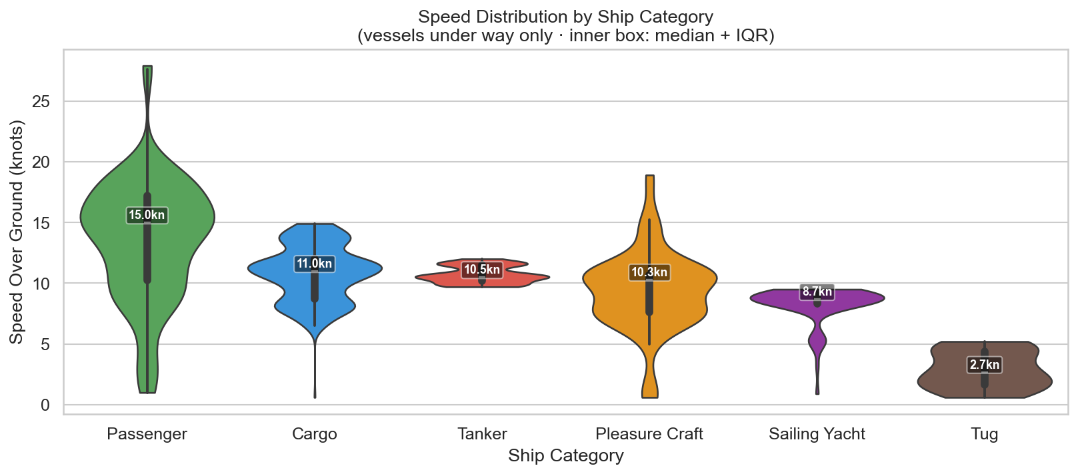
Figure 2 — Speed distributions by vessel category (under-way vessels only · inner box: median + IQR)

Category | Median | Q25 | Q75 | Max
Cargo | 11.3 kn | 8.2 kn | 13.5 kn | 14.5 kn
Tanker | 9.9 kn | 9.8 kn | 9.9 kn | 12.0 kn
Passenger | 8.9 kn | 8.7 kn | 10.5 kn | 11.0 kn
Pleasure Craft | 10.3 kn | 7.6 kn | 10.5 kn | 13.2 kn
Sailing Yacht | 9.2 kn | 9.1 kn | 9.3 kn | 9.5 kn
Tug | 2.7 kn | 1.7 kn | 4.4 kn | 7.1 kn

Why median instead of mean? Speed distributions are right-skewed: most vessels cruise at moderate speeds, but a few transit at full speed, creating a long right tail. The median is resistant to these extremes and provides a more representative central measure. IQR is preferred over standard deviation for the same reason.
Note: The narrow IQR for Tankers (9.8–9.9 kn) suggests a regulated or operationally constrained speed profile, possibly related to engine-optimal fuel consumption or port approach protocols.

3.3 Traffic Density
Figure 3 maps vessel density across the study area using a 0.25° × 0.25° grid (~27 km resolution). Hot spots identify the primary sea lanes and anchorage areas within the corridor.
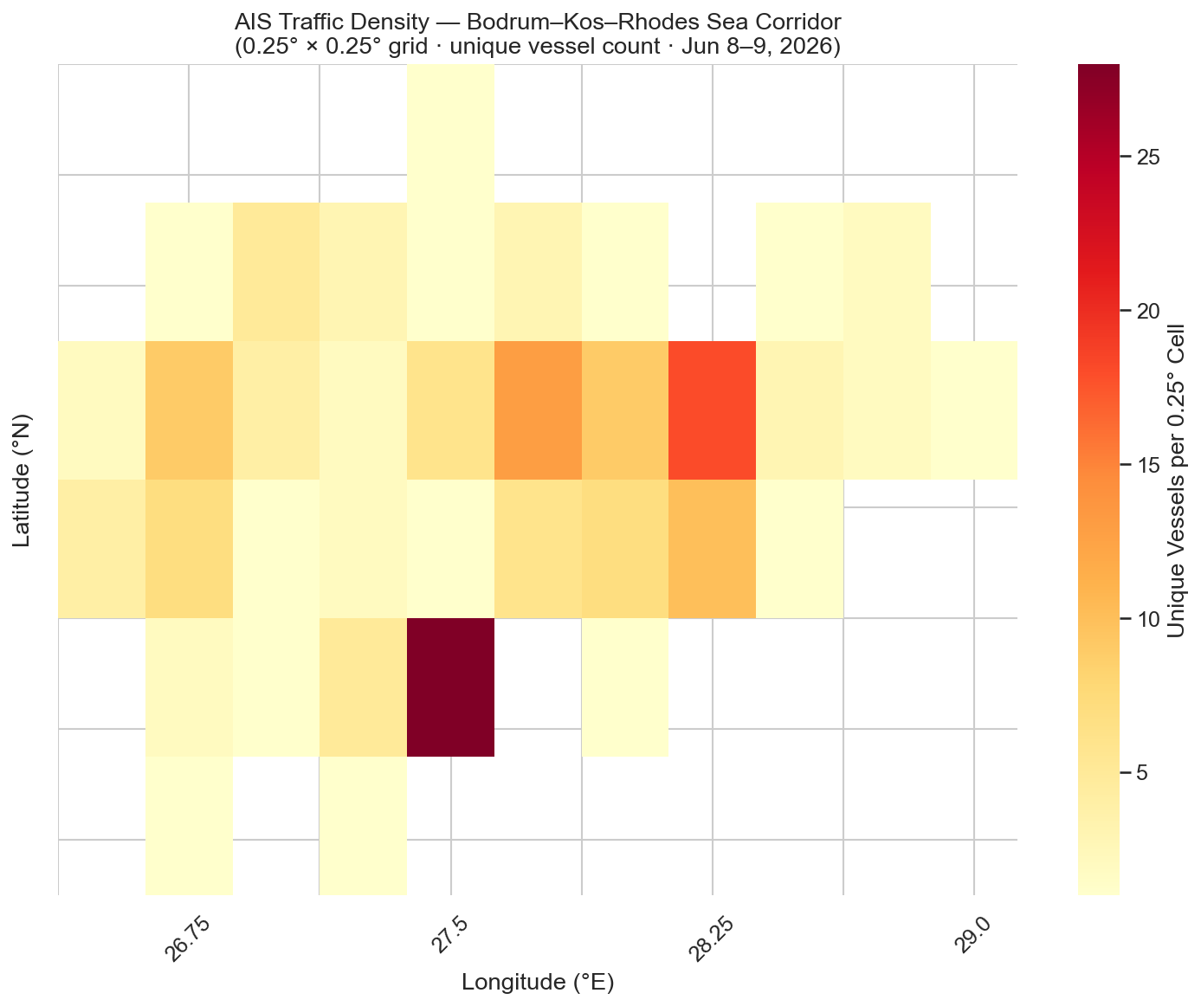
Figure 3 — Traffic density heatmap (0.25° × 0.25° grid · unique vessel count per cell)

3.4 Evening vs. Morning Comparison
Figure 4 compares vessel counts between the two collection sessions. The most notable shift is in the Passenger category, confirming that daily ferry services (Bodrum–Kos, Marmaris–Rhodes) depart in the morning and return in the afternoon, so they are largely absent from the evening snapshot.
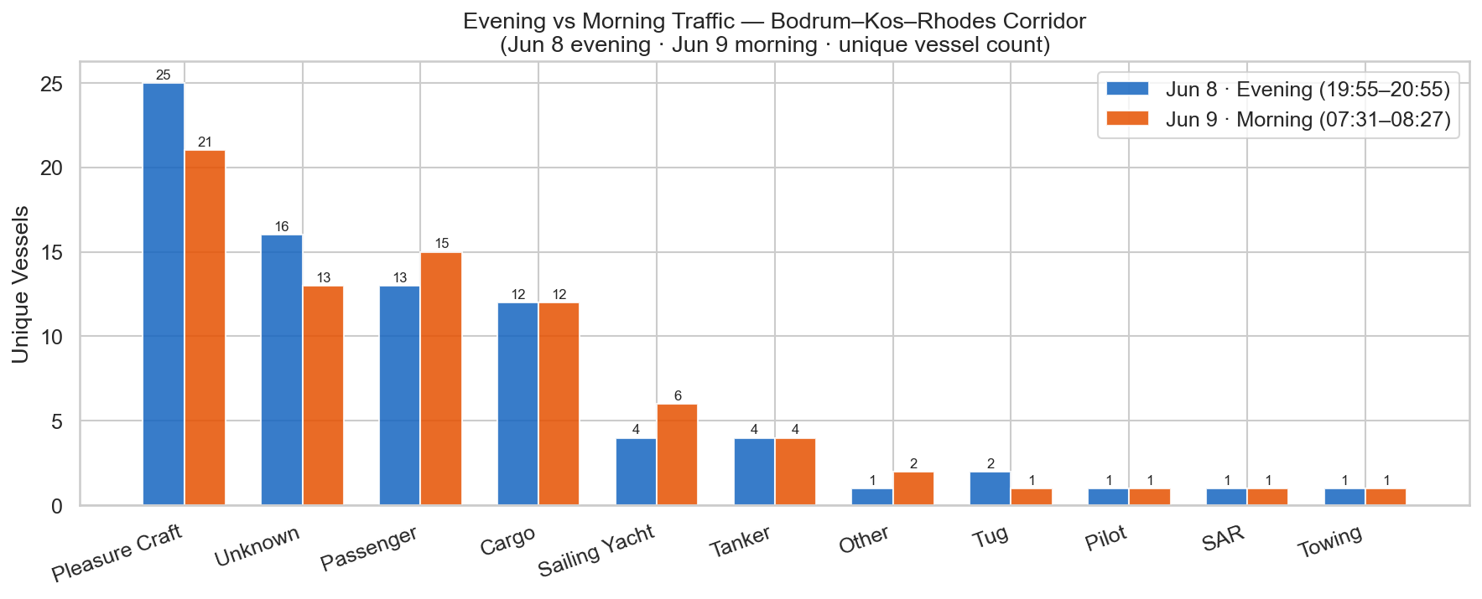
Figure 4 — Evening (Jun 8) vs Morning (Jun 9) vessel counts by category

Key changes from evening to morning:
- Passenger: 13 → 21 vessels (+62%) — ferry departures active
- Cargo: 12 → 22 vessels (+83%) — morning port arrivals
- Pleasure Craft: stable — leisure activity independent of ferry schedules
- Sailing Yacht: 4 → 7 vessels — morning departures from anchorages

4. Limitations & Methodological Notes
- Single early-summer snapshot: Two one-hour sessions in June cannot capture seasonal, weekly, or daily traffic patterns. August peak-season data will be collected for comparison.
- AIS coverage gaps: İzmir, Çeşme, Kuşadası, and Çanakkale have no AISStream.io terrestrial receiver coverage. Findings cannot be generalized to the northern Turkish Aegean coast.
- Unknown vessel type (21%): Vessels without received ShipStaticData are classified as Unknown. In a longer collection window, most would be identified as static messages accumulate.
- AIS non-participation: Small recreational craft under 300 GT are not required to carry AIS. Actual leisure traffic density is likely higher than reported.
- Coordinate precision: AIS position accuracy is typically ±10 m for Class A transponders and ±100 m for Class B (leisure vessels).

5. Future Work
This study will be replicated in August 2026 to enable a seasonal comparison between early summer (June) and peak summer (August) traffic patterns. The same pipeline (collector.py → cleaner.py → analysis.py) will be reused; new sessions will automatically merge into the existing SQLite database.
Planned extensions:
- August 2026 replication — peak season comparison
- Multi-day collection — capture weekly patterns (weekday vs weekend)
- AIS Class B filter — isolate leisure craft sub-analysis
- Route reconstruction — connect sequential positions per MMSI to visualize vessel trajectories

6. Technical Infrastructure

Live Dashboard
Interactive Streamlit dashboard: aegean-ais-analysis-drkhjf4q8jslmuxyn9clae.streamlit.app
Features: vessel category filter, speed range slider, scatter map, density heatmap, bar/box/pie charts, summary statistics table.

Source Code
GitHub repository: github.com/sdnzthewitch/aegean-ais-analysis

Technology Stack
- Python 3.13 — websockets, pandas, sqlite3, matplotlib, seaborn, plotly, streamlit
- SQLite — lightweight embedded database; sessions accumulate without schema changes
- AISStream.io — real-time AIS WebSocket API (free tier)
- Streamlit Community Cloud — free dashboard hosting
- GitHub — version control; .env excluded via .gitignore

Data source: AISStream.io real-time AIS WebSocket API. AIS data is publicly broadcast by vessels under IMO SOLAS regulations Chapter V. Collection date: 8–9 June 2026.

