BODRUM–KOS–RHODES SEA CORRIDOR
AIS Live Traffic Analysis
Turkish–Greek Aegean Boundary Sea Lane

Data Collection: 8–9 June 2026 · lat 36–38°N, lon 26.5–29°E
Source: AISStream.io WebSocket API (live feed)
Live Dashboard → aegean-ais-analysis.streamlit.app
Pilot Study · Version 1.0 · June 2026

1. Executive Summary
This report presents a live AIS (Automatic Identification System) traffic analysis of the Bodrum–Kos–Rhodes sea corridor, conducted on 8–9 June 2026. Data were collected in two one-hour sessions — evening and morning — via the AISStream.io WebSocket API, yielding 118 unique vessels and 2,267 clean position reports after geographic and quality filtering.

118  Unique Vessels | 2,267  Position Reports | 29.7%  Leisure Share* | 11.0 kn  Median Cargo Speed

Four headline findings emerged from the analysis:
- Pleasure Craft is the dominant vessel category (28 vessels, 24%), consistent with the Bodrum peninsula’s status as one of the Aegean’s premier yacht charter hubs.
- Leisure traffic (Pleasure Craft + Sailing Yacht) accounts for 29.7% of all observed vessels — or 37.6% of vessels with an identified type — a strong early-summer signal ahead of the August peak season.
- Passenger ferry activity is time-dependent: morning session recorded 15 ferry vessels vs. 13 in the evening (+15%), consistent with Bodrum–Kos and Marmaris–Rhodes morning departure schedules.
- Cargo vessels transit the corridor at a median speed of 11.0 knots (IQR 8.7–12.0 kn); passenger vessels lead all categories at 15.0 kn median, reflecting high-speed catamaran services.

2. Methodology

2.1 Data Source
AIS (Automatic Identification System) is an IMO-mandated VHF radio transponder system. Class A transponders (commercial vessels) broadcast position reports every 2–10 seconds underway and every 3 minutes at anchor; static data (Type 5) is broadcast every 6 minutes. AISStream.io aggregates these broadcasts from a network of terrestrial receivers, exposing a real-time WebSocket API.
Unlike historical AIS providers, AISStream.io’s free tier delivers only a live stream — data collection must occur in real time. This is a design choice, not a limitation of this study.

2.2 Collection Sessions

Session | Date & Time (UTC+3) | Raw Messages | Purpose
Evening | 8 June 2026 · 22:55–23:55 | 12,059 | Baseline — cargo & yachts
Morning | 9 June 2026 · 10:31–11:27 | 11,381 | Ferry & leisure peak

Each session used a Python asyncio WebSocket client (src/collector.py) with automatic reconnection on connection drops. Messages were written to SQLite in batches of 50. The wider Aegean bounding box (lat 36–42°N, lon 22–30°E) was used for collection to ensure sufficient signal volume; geographic filtering to the study corridor was applied at the cleaning stage.

2.3 Geographic Scope

⚠ Coverage Limitation
This dataset represents the Bodrum–Kos–Rhodes open-sea corridor (lat 36–38°N · lon 26.5–29°E), not the full Turkish Aegean coast. AISStream.io receivers are located primarily on Greek islands; as a result, İzmir, Çeşme, Kuşadası, and Çanakkale have zero AIS coverage in this dataset.

Raw data exploration revealed that AISStream.io receivers are concentrated on the Greek island arc (Kos, Rhodes, Samos). As a result, usable signal coverage is limited to:
- Bodrum peninsula and outer anchorages
- Marmaris bay entrance
- Open sea lanes between Turkey and the Dodecanese islands
- Kos and Rhodes port approaches
The study area is therefore defined as the Bodrum–Kos–Rhodes sea corridor (lat 36–38°N, lon 26.5–29°E), not the full Turkish Aegean coast. This framing is scientifically honest and aligns with the actual data coverage.

2.4 Data Pipeline
- collector.py — WebSocket client, SQLite writer, auto-reconnect
- cleaner.py — geographic filter, coordinate validation, speed filter (>50 kn removed), ShipStaticData JOIN for vessel names and type codes
- analysis.py — statistical analysis, figure generation
- app.py — Streamlit interactive dashboard
ShipType numeric codes (IMO/ITU standard, 0–99) were mapped to eight readable categories. Median and IQR were used for speed statistics rather than mean and standard deviation because speed distributions are right-skewed: anchored vessels broadcast zero speed, pulling the mean down disproportionately.

3. Key Findings

3.1 Vessel Category Distribution
Figure 1 shows the distribution of vessel categories by unique MMSI count and total position reports. Pleasure Craft leads both metrics in the filtered corridor dataset.

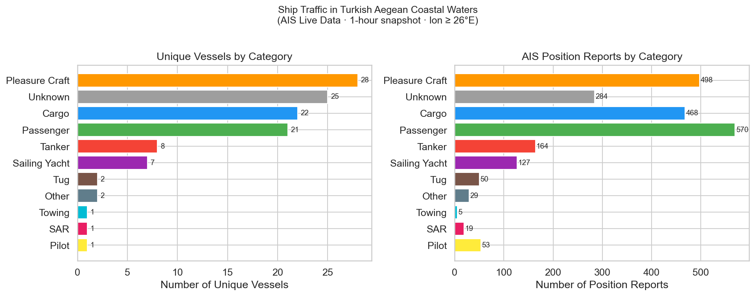
Figure 1 — Vessel distribution by category (left: unique vessels · right: position reports)

Ship Category | Vessels | Reports | Median Speed | Note
Pleasure Craft | 28 | 498 | 10.3 kn | Dominant category — Bodrum charter hub
Passenger | 21 | 570 | 15.0 kn | Morning 13→15 (+15%); high-speed ferries
Cargo | 22 | 468 | 11.0 kn | Consistent across sessions (12→12)
Tanker | 8 | 164 | 10.5 kn
Sailing Yacht | 7 | 127 | 8.7 kn | Evening 4 → Morning 6
Unknown | 25 | 284 | — | 21% — no ShipStaticData received

The ‘Unknown’ count (25 vessels, 21%) reflects vessels for which ShipStaticData (Type 5/24 messages) were not received during the collection window. This is expected for one-hour sessions; static messages are broadcast only every 6 minutes, so some vessels will not have broadcast a static message during the collection period.

3.2 Speed Distributions
Figure 2 presents violin plots of speed over ground (SOG) for each category, restricted to vessels under way (SOG > 0.5 knots). The inner box shows the median and IQR.
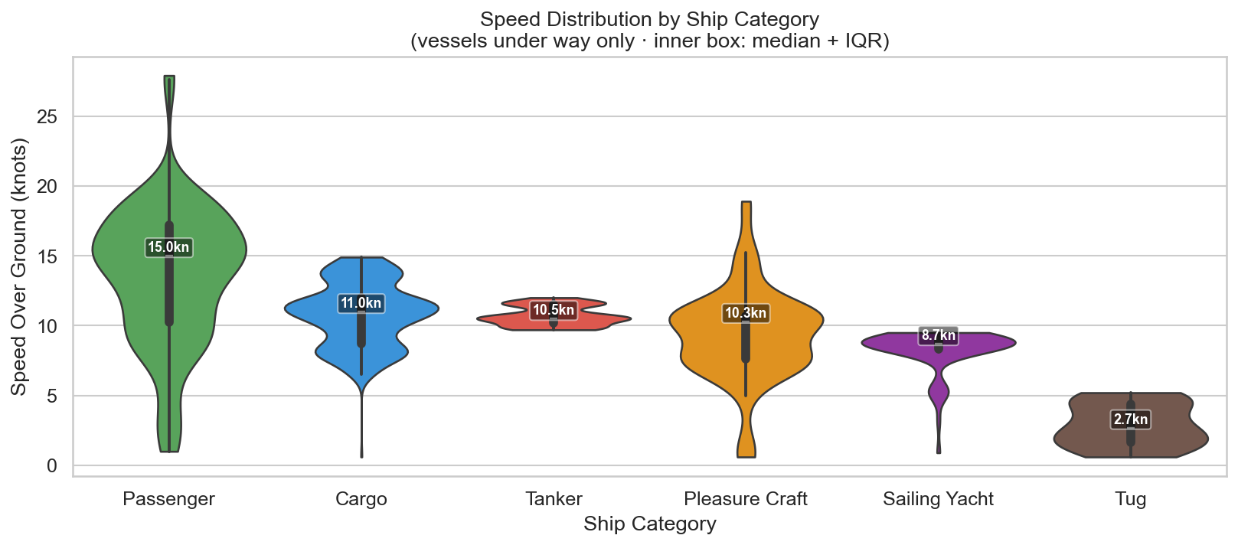
Figure 2 — Speed distributions by vessel category (under-way vessels only · inner box: median + IQR)

Category | Median | Q25 | Q75 | Max
Cargo | 11.0 kn | 8.7 kn | 12.0 kn | 14.9 kn
Tanker | 10.5 kn | 10.2 kn | 11.5 kn | 12.0 kn
Passenger | 15.0 kn | 10.2 kn | 17.2 kn | 27.9 kn
Pleasure Craft | 10.3 kn | 7.6 kn | 10.7 kn | 18.9 kn
Sailing Yacht | 8.7 kn | 8.3 kn | 9.0 kn | 9.5 kn
Tug | 2.7 kn | 1.7 kn | 4.4 kn | 7.1 kn

Why median instead of mean? Speed distributions are right-skewed: most vessels cruise at moderate speeds, but a few transit at full speed, creating a long right tail. The median is resistant to these extremes and provides a more representative central measure. IQR is preferred over standard deviation for the same reason.
Note: The relatively narrow IQR for Tankers (10.2–11.5 kn) and Sailing Yachts (8.3–9.0 kn) suggests operationally constrained speed profiles — tankers may follow fuel-optimal engine settings, while sailing yachts are wind-limited. Passenger vessels show the widest range (10.2–17.2 kn), consistent with a mix of slow car ferries and fast catamaran services.

3.3 Traffic Density
Figure 3 maps vessel density across the study area using a 0.25° × 0.25° grid (~27 km resolution). Hot spots identify the primary sea lanes and anchorage areas within the corridor.
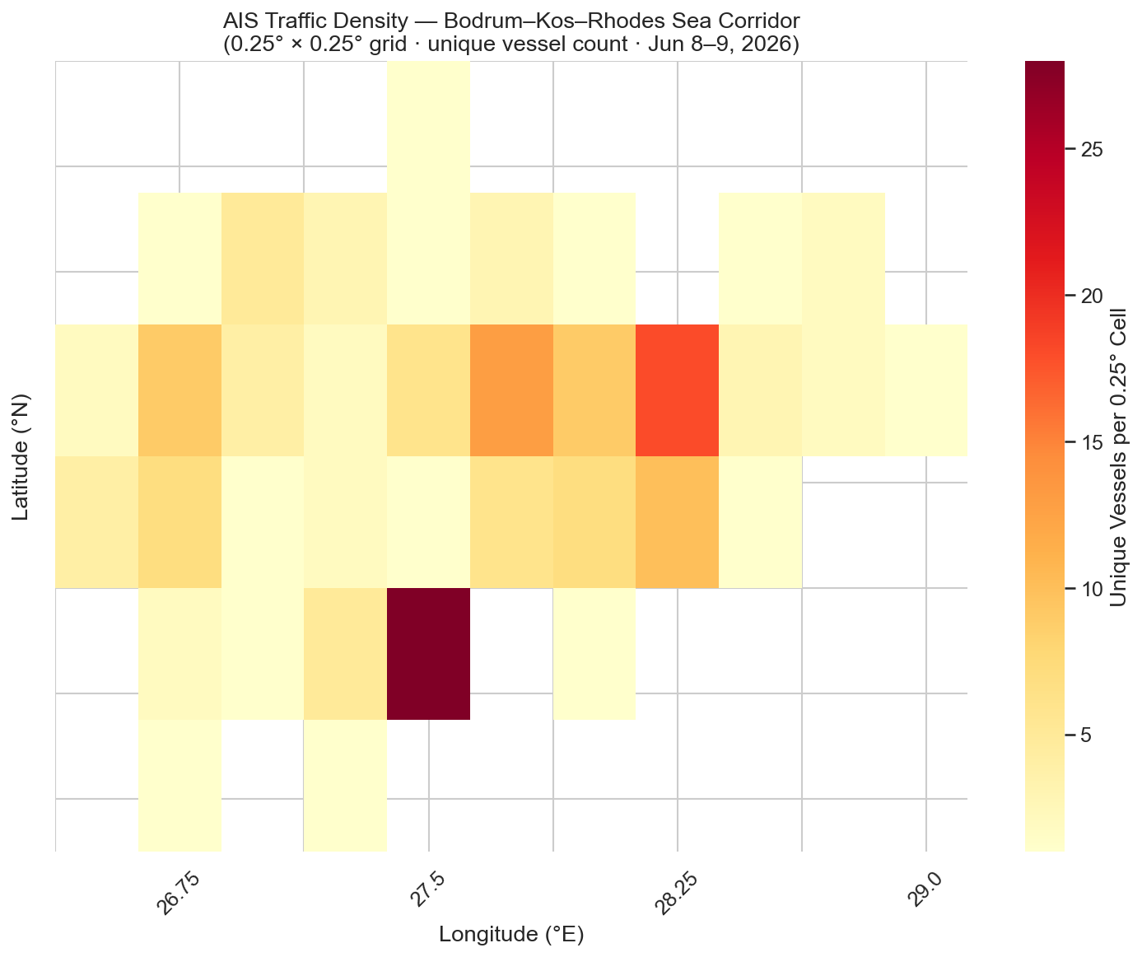
Figure 3 — Traffic density heatmap (0.25° × 0.25° grid · unique vessel count per cell)

3.4 Evening vs. Morning Comparison
Figure 4 compares vessel counts between the two collection sessions. The most notable shift is in the Passenger category. The modest increase (13→15, +15%) is consistent with scheduled morning departures on routes such as Bodrum–Kos and Marmaris–Rhodes, though the two-session sample is insufficient to confirm causal attribution.
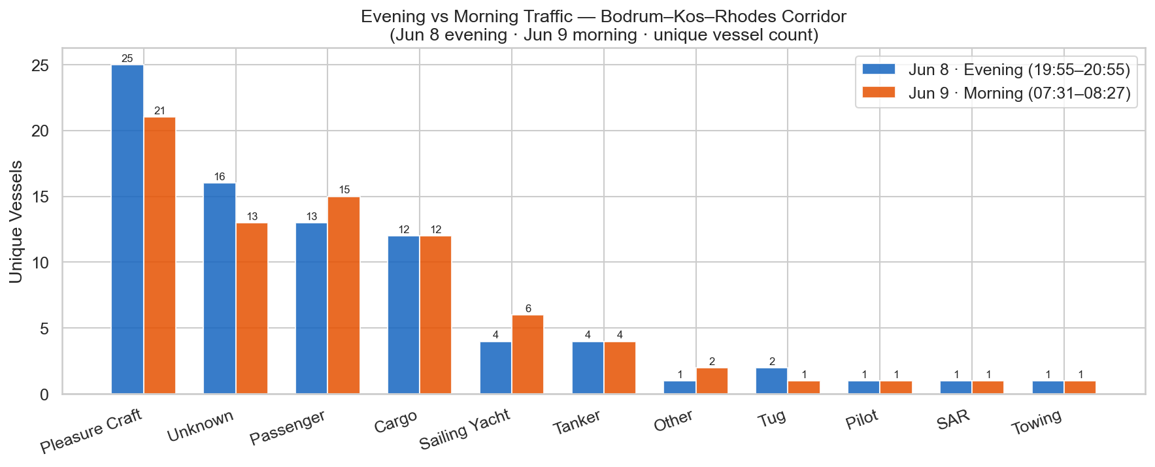
Figure 4 — Evening (Jun 8) vs Morning (Jun 9) vessel counts by category

Key changes from evening to morning:
- Passenger: 13 → 15 vessels (+15%) — morning ferry departures on Bodrum–Kos and Marmaris–Rhodes routes
- Cargo: 12 → 12 vessels (no change) — consistent transit traffic through the corridor
- Pleasure Craft: 25 → 21 vessels (−16%) — slightly less leisure activity in the morning session
- Sailing Yacht: 4 → 6 vessels — morning departures from anchorages

4. Limitations & Methodological Notes
- Single early-summer snapshot: Two one-hour sessions in June cannot capture seasonal, weekly, or daily traffic patterns. August peak-season data will be collected for comparison.
- AIS coverage gaps: İzmir, Çeşme, Kuşadası, and Çanakkale have no AISStream.io terrestrial receiver coverage. Findings cannot be generalized to the northern Turkish Aegean coast.
- Unknown vessel type (21%): Vessels without received ShipStaticData are classified as Unknown. In a longer collection window, most would be identified as static messages accumulate.
- AIS non-participation: Small recreational craft under 300 GT are not required to carry AIS. Actual leisure traffic density is likely higher than reported.
- Position accuracy: AIS messages include a position accuracy flag (0 = >10 m, 1 = <10 m GNSS). Positional error is not analyzed in this study.

5. Future Work
This study will be replicated in August 2026 to enable a seasonal comparison between early summer (June) and peak summer (August) traffic patterns. The same pipeline (collector.py → cleaner.py → analysis.py) will be reused; new sessions will automatically merge into the existing SQLite database.
Planned extensions:
- August 2026 replication — peak season comparison
- Multi-day collection — capture weekly patterns (weekday vs weekend)
- AIS Class B filter — isolate leisure craft sub-analysis
- Route reconstruction — connect sequential positions per MMSI to visualize vessel trajectories

6. Technical Infrastructure

Live Dashboard
Interactive Streamlit dashboard: aegean-ais-analysis-drkhjf4q8jslmuxyn9clae.streamlit.app
Features: vessel category filter, speed range slider, scatter map, density heatmap, bar/box/pie charts, summary statistics table.

Source Code
GitHub repository: github.com/sdnzthewitch/aegean-ais-analysis

Technology Stack
- Python 3.13 — websockets, pandas, sqlite3, matplotlib, seaborn, plotly, streamlit
- SQLite — lightweight embedded database; sessions accumulate without schema changes
- AISStream.io — real-time AIS WebSocket API (free tier)
- Streamlit Community Cloud — free dashboard hosting
- GitHub — version control; .env excluded via .gitignore

Data source: AISStream.io real-time AIS WebSocket API. AIS data is publicly broadcast by vessels under IMO SOLAS regulations Chapter V. Collection date: 8–9 June 2026.

