**Docker Training Tasks**

**> Basic Command task**

* Start 4 containers from an image that does not automatically exit, such as Nginx, detached.
* Stop 2 of the containers leaving 2 up.

**→ Command:-**

docker run -d --name nginx nginx

docker run -d --name nginx01 nginx

docker run -d --name nginx02 nginx

docker run -d --name nginx03 nginx

docker stop <container-id> <container-id>

**→ Screenshot:-**

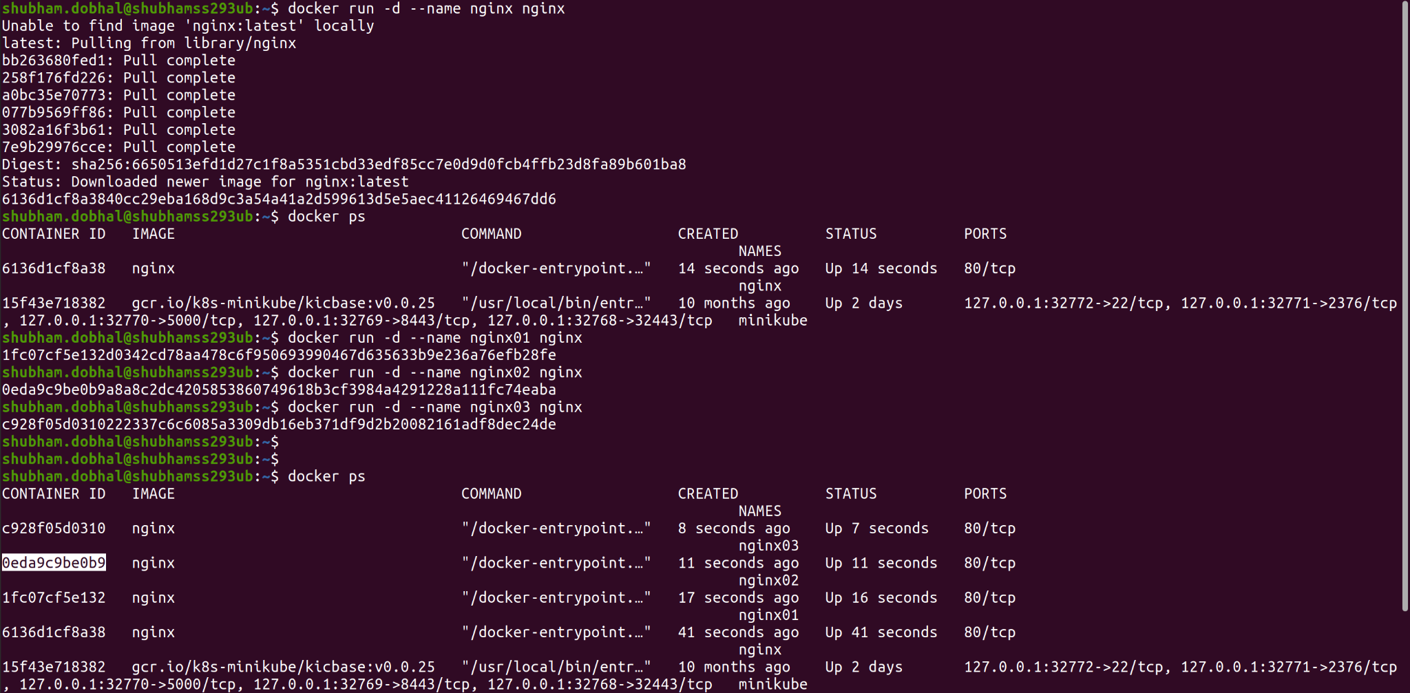

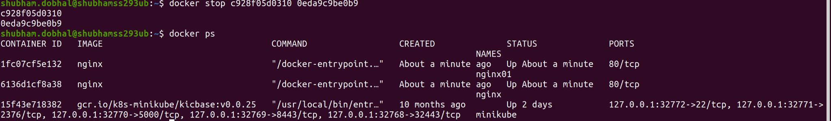

* Check the usage of docker containers and clean the spaces taken by stopped containers/images.

**→ Command:-**

docker ps -as

docker stats --no-stream

docker rm <container-id> <container-id>

**→ Screenshot:-**

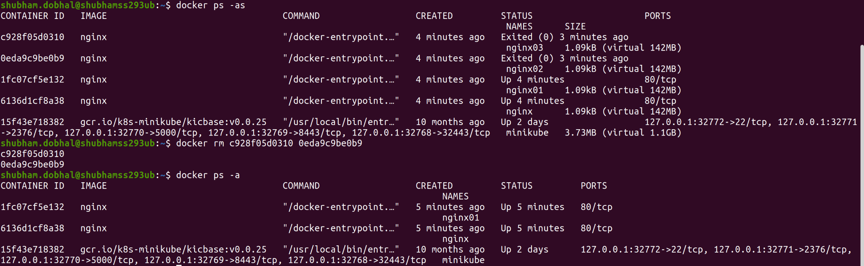



* Start image devopsdockeruh/exec_bash_exercise, it will start a container with clock-like features and create a log. Go inside the container and use tail -f ./logs.txt to follow the logs. Every 15 seconds the clock will send you a “secret message”.

**→ Command:-**

docker run -d --name devops devopsdockeruh/exec_bash_exercise

docker logs <container-id>

docker exec -it <container-id> /bin/bash

**Secret message:- Docker is easy**

**→ Screenshot:-**

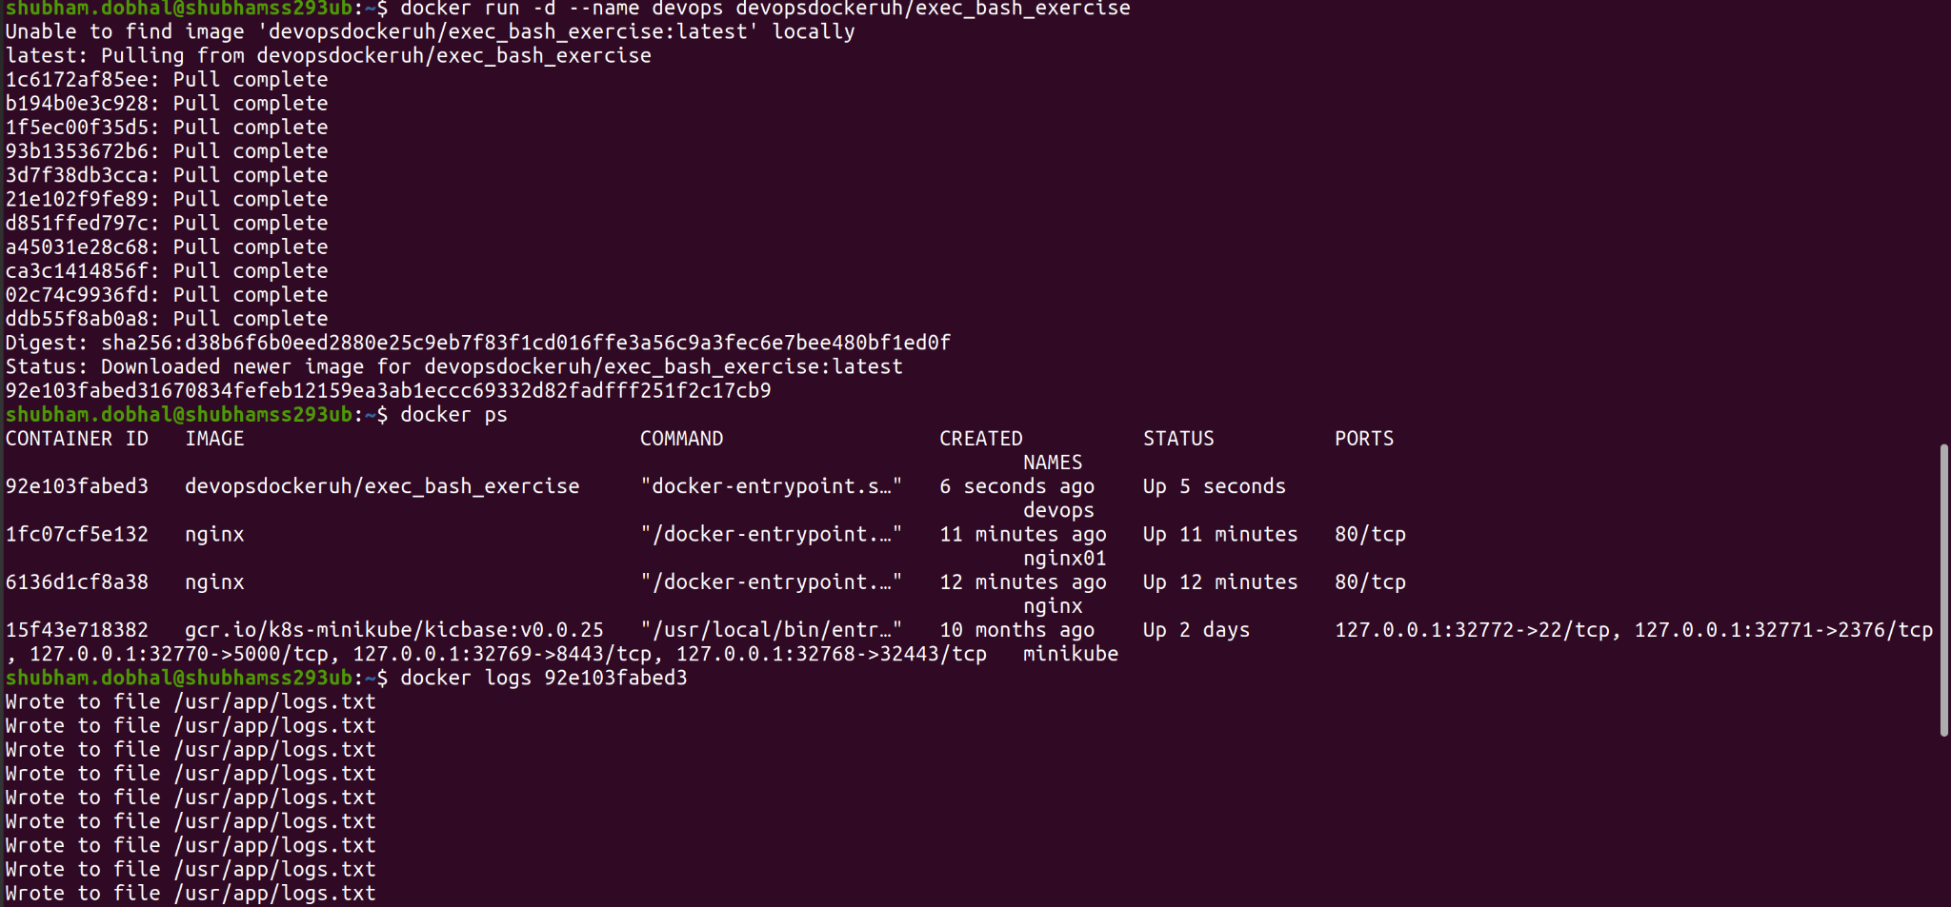

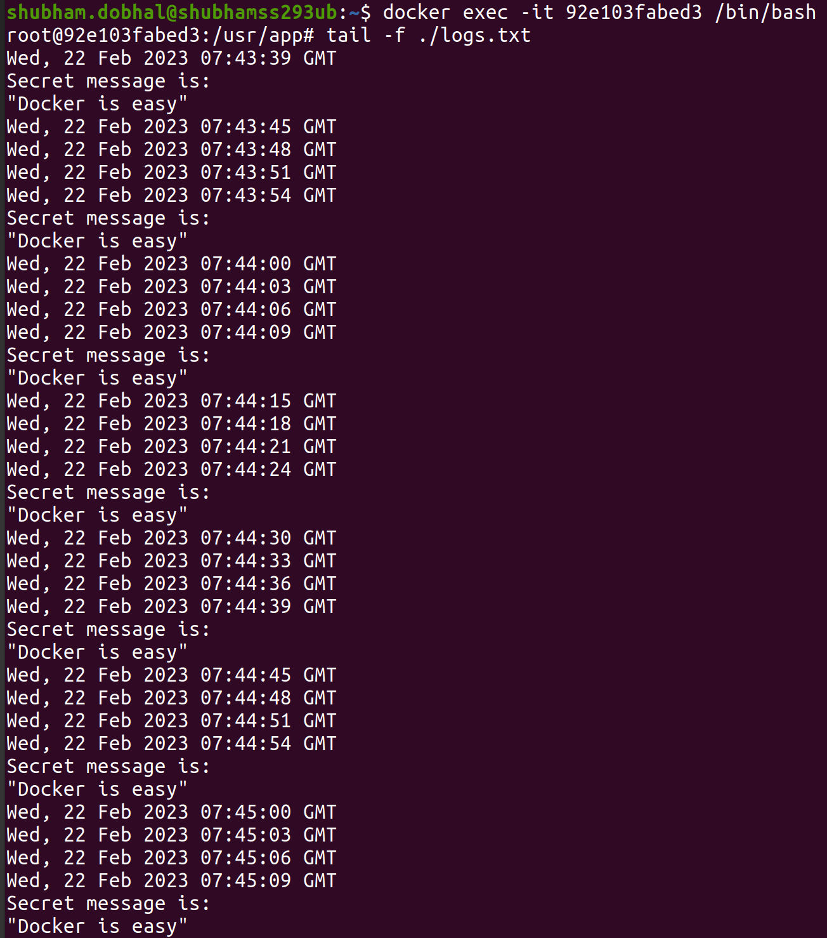

**> Dockerfile task**

* Create a dockerfile using Ubuntu 16.04 as a base image and install ping utilities, also provide some target as default to showcase at the time of running the container after building the image.

**→ Command:-**

docker build -t shubham:v1 .

docker run -d --name image shubham:v1

docker ps

docker logs <container-id>

**→ Screenshot:-**

