**K8s Training Tasks**

**> For DevOps**

* Create a deployment.yaml file for your application which is being accessed using the nodeport service and also adds a few environment variables with the help of secrets and configmap and the pods should only be scheduled on the node which has the label country=India(use the concept of Node Affinity).

**→ Command:-**

kubectl create ns training

kubectl get nodes

kubectl label nodes minikube-m02 country=India

kubectl describe nodes minikube-m02

kubectl apply -f config.yaml

kubectl apply -f secret.yaml

kubectl apply -f deploy.yaml

kubectl apply -f service.yaml

kubectl get secret -n training

kubectl get cm -n training

kubectl get all -n training -o wide

kubectl describe pod deploy-68849d6fcf-5xj6s -n training

minikube service service -n training

**→ Screenshot:-**

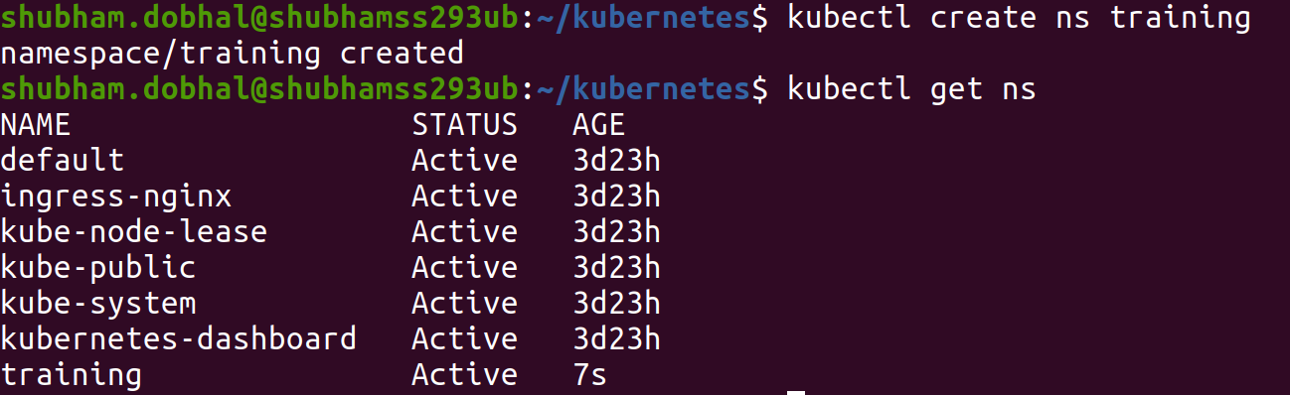

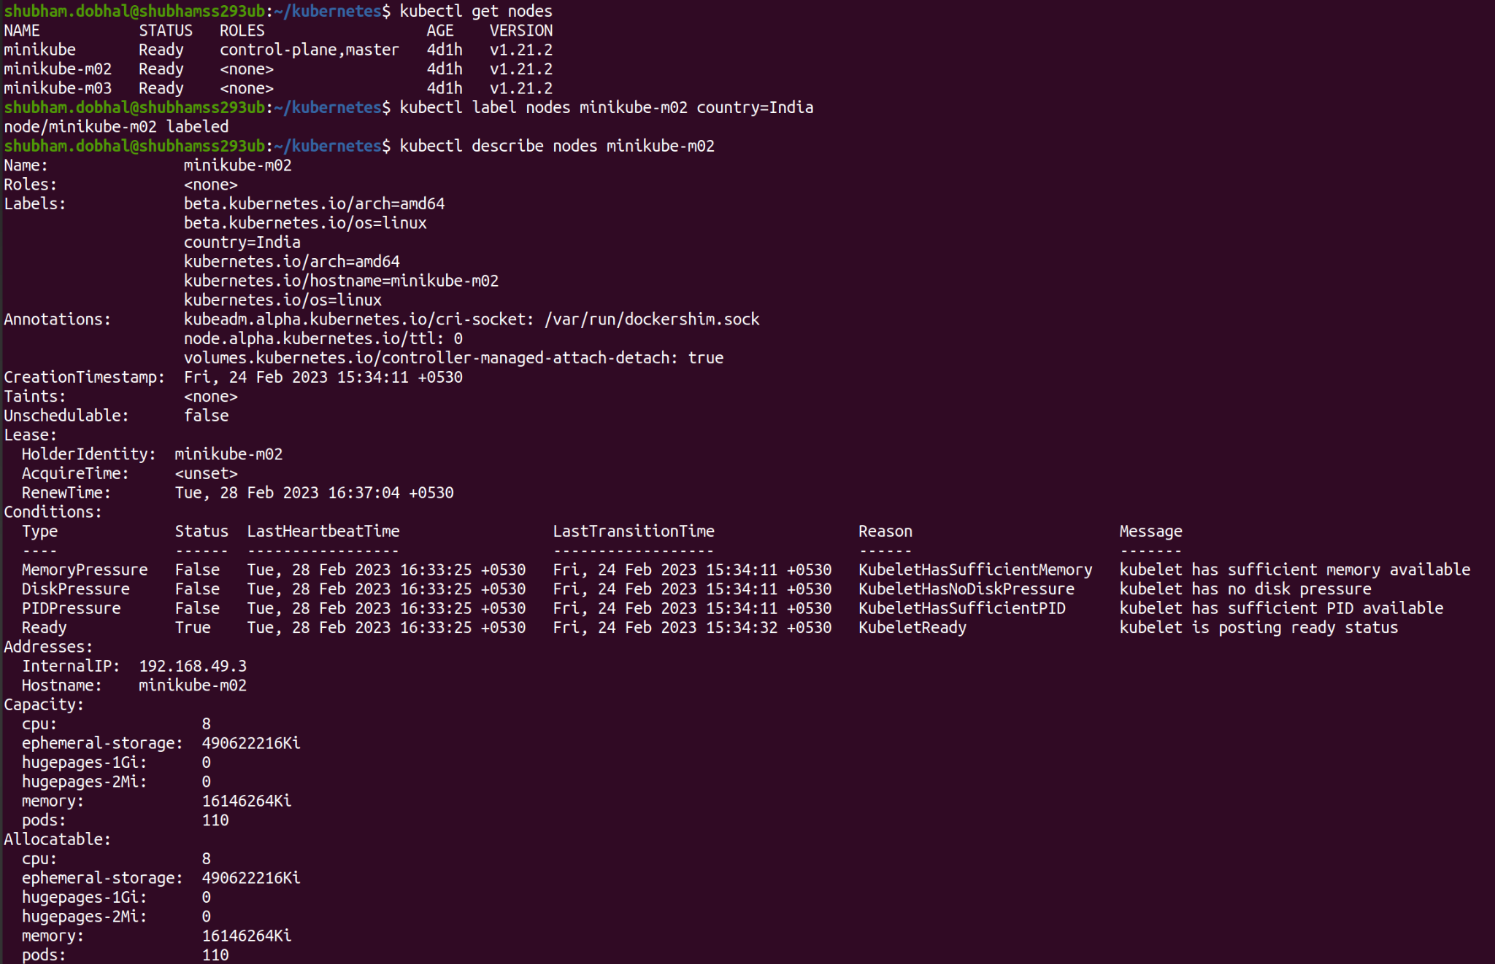

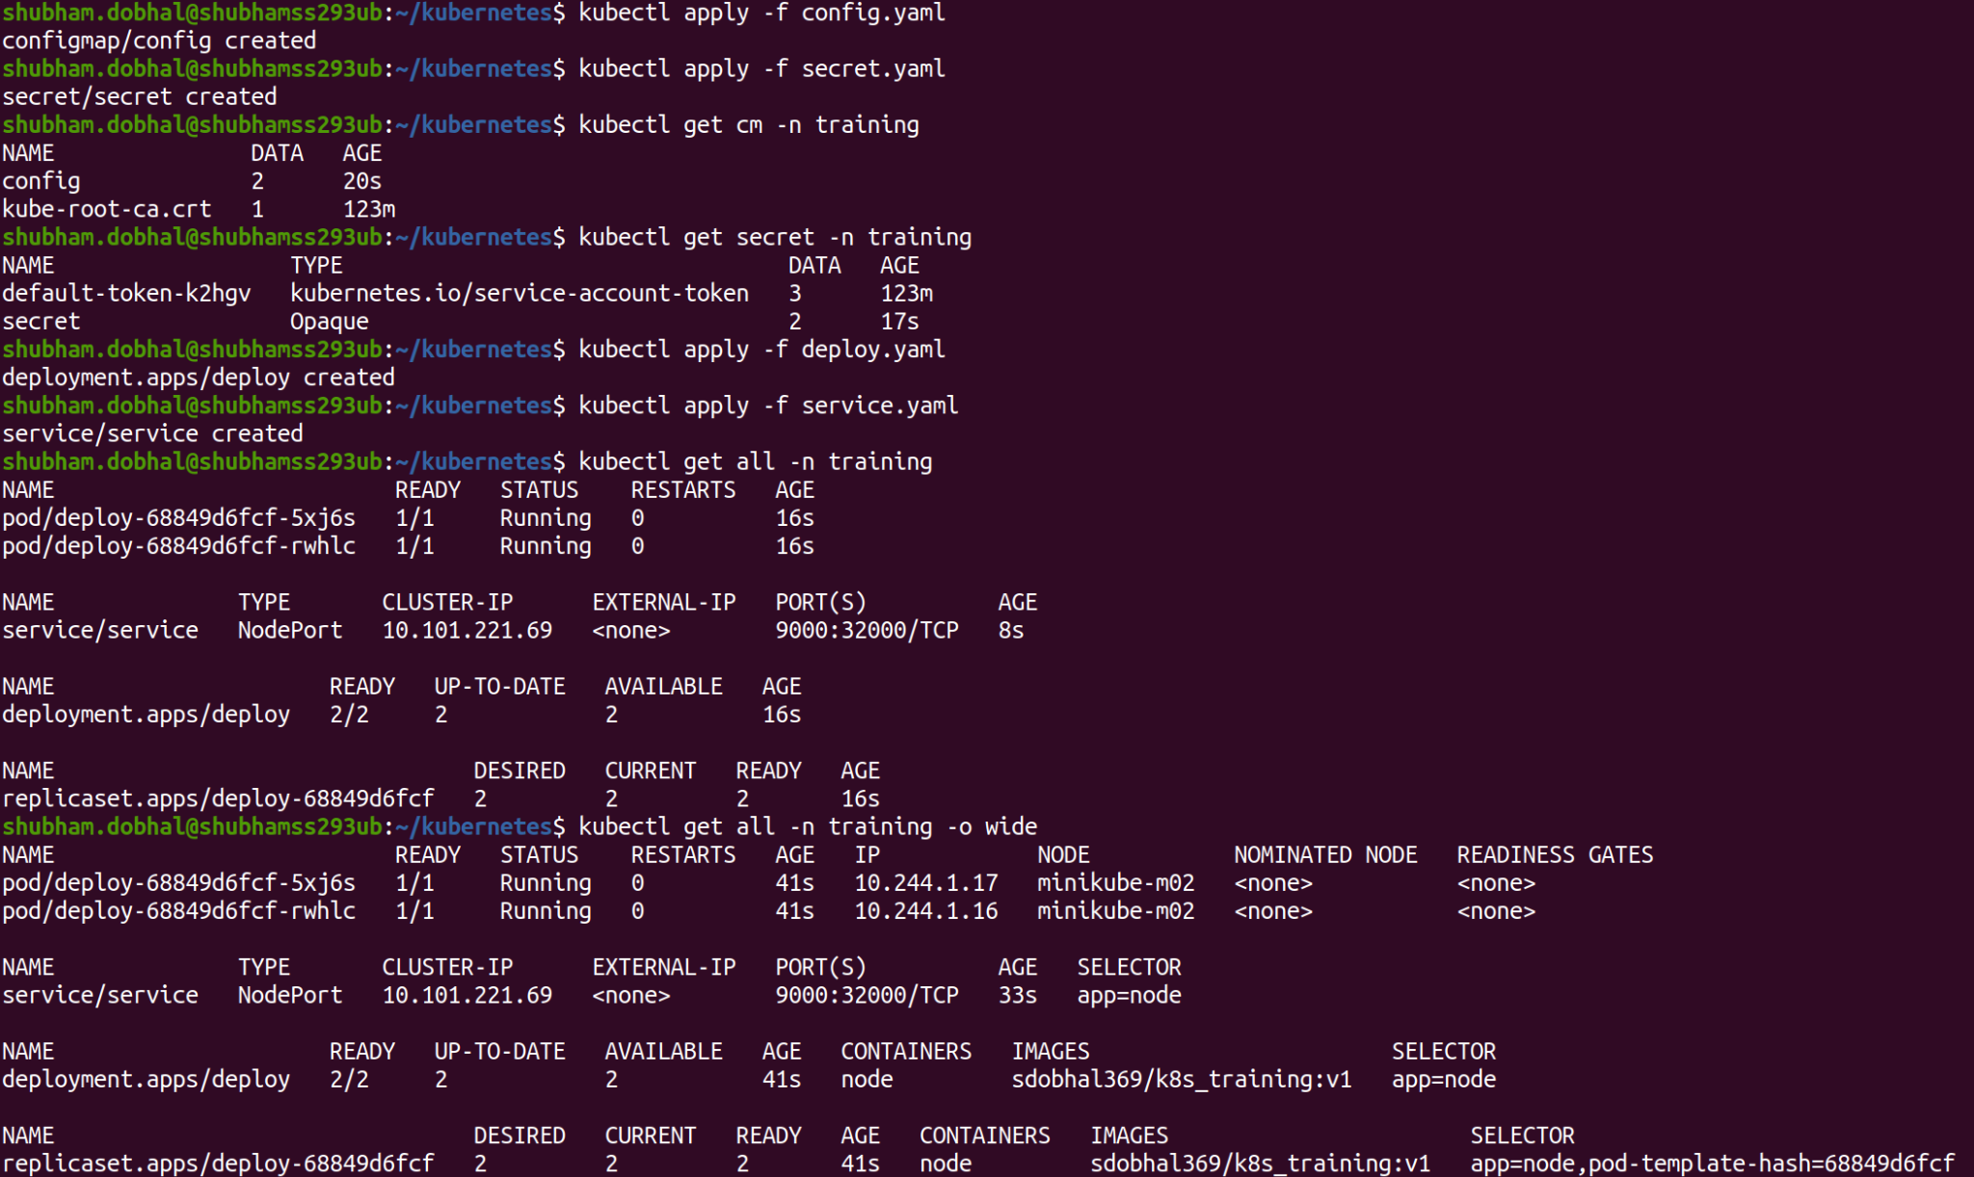

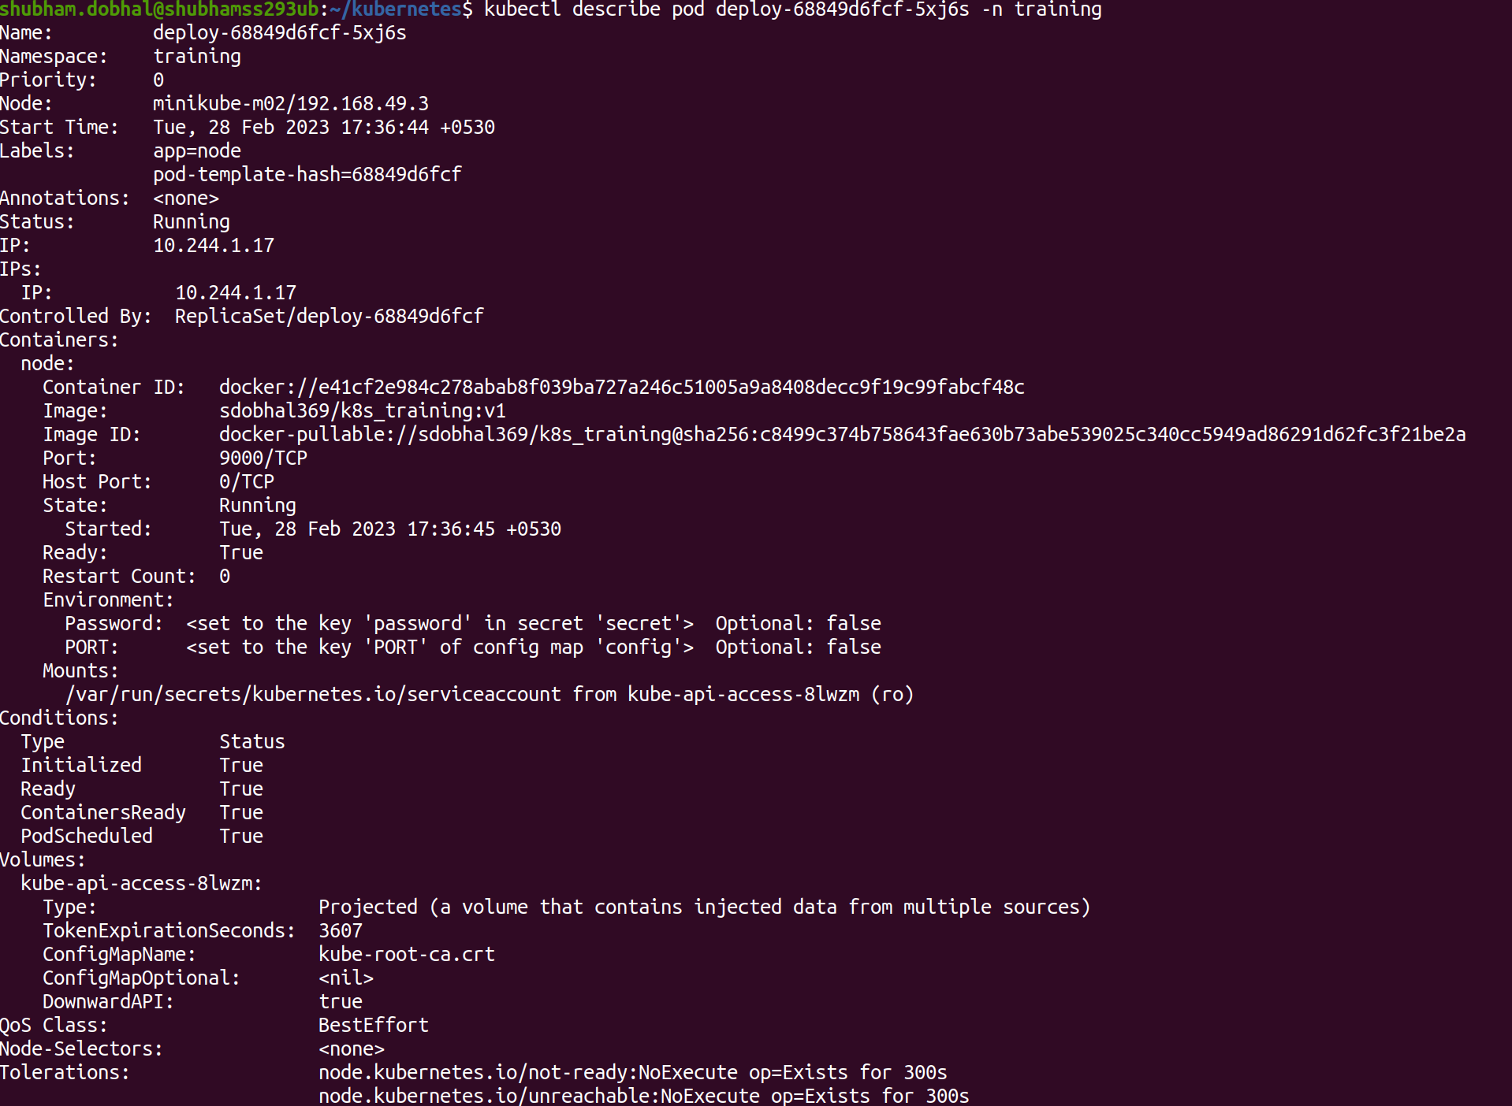

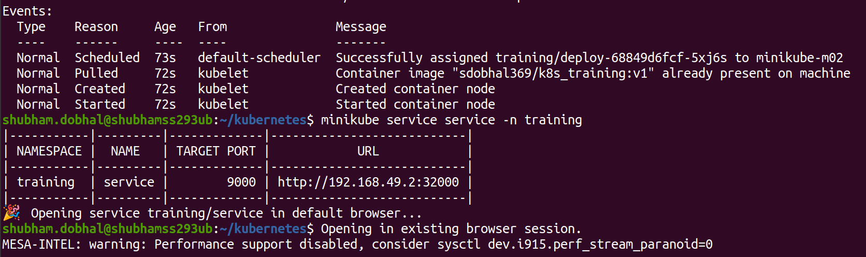

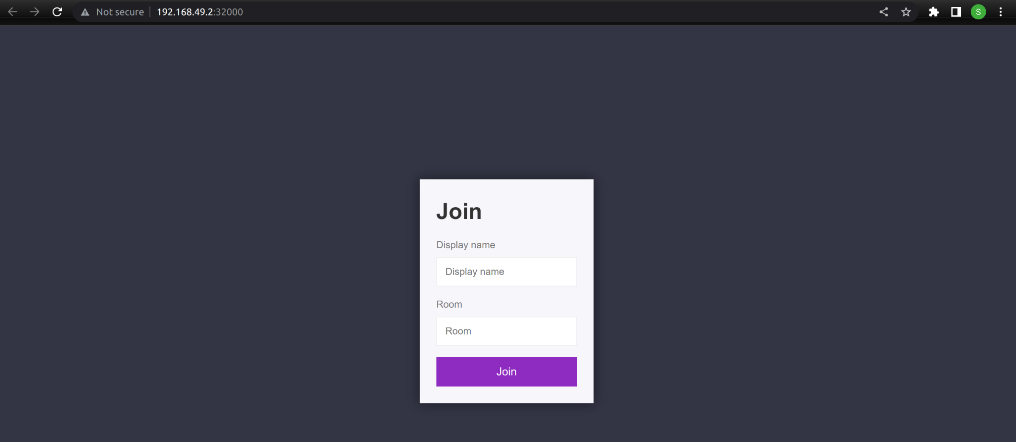

* Create a cron job that will have two containers one will generate the output of the command "df -T -h" in a text file and the second container should print that value. First container should be the init container.

**→ Command:-**

kubectl apply -f cronjob.yaml

kubectl get cronjob -n training

kubectl describe cronjob cron-test -n training

kubectl get pod -n training

kubectl logs cron-test-27959700-sb4s9 -n training

**→ Screenshot:-**

